CA1

Name: Abdul Wahab
ID: 2026243
Drive Link : Contains Video and Datasets
(I use the college email google drive so you need college email to access the drive)
S2_CA1
https://drive.google.com/drive/folders/1cE1Ynpb1Y7PcuG898uAlc_2x1QOCEww2?usp=sharing

Evaluating Intrusion Detection Performance and Processing Efficiency of a Spark-Based Neural Network Using UNSW-NB15

Abstract
The present study explores the efficiency of intrusion detection for neural networks and Big Data processing with UNSW-NB15. Apache Spark is used to ingest, clean, transform features, and store data, and a multilayer perceptron is used to classify network traffic as normal or malicious. The experimental design includes comparing CSV and Parquet storage, different partition designs, and iterative changes to the data preparation and neural network architecture. Logistic regression baseline is used for assessing predictive performance. Precision, recall, F1 score, false positive rate, training time, processing runtime are taken into account when assessing. Final conclusions will be based on measured results, such as whether improvements in detection are worth the computational expense. The study also considers data leakage, reproducibility, dataset limitations and the constraints of the computing environment, to determine the practical relevance and validity of the results.
Keywords: Intrusion detection, UNSW-NB15, Apache Spark, multilayer perceptron, Big Data processing, Parquet.

1. Introduction
1.1 Background and problem statement
Network intrusion detection is the process of detecting malicious traffic in network traffic. The relationships between traffic features can be learned using neural networks, but the effectiveness of the learning process relies on the availability of good data preparation, evaluation and computational requirements. This project explores detection performance and storage and processing efficiency with UNSW-NB15 and Apache Spark. The question is whether the processing cost of a pipeline of neural networks is warranted by the improvement in predictive performance. Both aspects are evaluated, linking Advanced Data Analytics with Big Data Storage and Processing.
1.2 Research aim and objectives
The goal is to test a Spark-based multilayer perceptron for binary intrusion detection and the efficiency of the data pipeline that supports it. The goals are to critically review the literature; create network traffic data with reproducible transformations; compare CSV and Parquet storage; explore Spark partition configurations; optimize neural network architecture and data preparation; and compare predictive performance with a logistic regression baseline. Precision, recall, F1 score and false-positive rate will be used to evaluate the models, and storage size, training time and processing runtime will be used to evaluate the efficiency.
1.3 Research question
What impact does data preparation have on the performance of intrusion detection using a multilayer perceptron architecture and what impact does the storage format and Spark partitioning have on the efficiency of the pipeline?
1.4 Scope and contribution
The proposed implementation is not a multi-machine cluster, but is a local Spark implementation on a single machine. It is based on offline classification of normal and attack traffic, where the dataset files, the preprocessing decisions and the experimental settings are documented. The training, validation and test data sets will be split and learned preprocessing will be fitted only on training data. The contribution is an objective assessment of the detection quality and processing costs in controlled conditions, which is reproducible. Conclusions will recognize the limitations of the datasets and differentiate between local performance and scalability that has not been tested in a cluster. Iterative experiments will be recorded for successful and unsuccessful changes, and evidence will be provided to support decisions to make changes rather than assuming that more complex changes are better.

2. Literature Review and State of the Art
2.1 Network intrusion detection and benchmark datasets
Intrusion detection research relies on datasets containing both legitimate activities and malicious activities. Moustafa and Slay [1] proposed UNSW-NB15 to facilitate evaluation with a combination of normal traffic and generated attacks. It is labeled and has diverse attack types, which makes it appropriate for reproducible classification experiments. But controlled generation can't capture all the characteristics of operational networks. Therefore, good performance on the benchmarks should not be taken as a guarantee of effectiveness against all current attacks. research.unsw.edu.au
Sommer and Paxson [2] describe the challenges of operating an IDS, such as the variable traffic, the high cost of false alarms, and the lack of correlation between statistical predictions and relevant security alerts. The analysis qualifies the optimism surrounding benchmark results: knowing about common attack patterns doesn't necessarily mean that previously unknown threats are detected. These studies are sufficient to conclude that UNSW-NB15 can be used under the conditions tested, but not under any other conditions. gangw.cs.illinois.edu
2.2 Neural network approaches: MLP, CNN and LSTM
The suitability of neural networks is dependent on the representation of traffic. In this paper, Vinayakumar et al. [3] compare the performance of deep feed forward networks with traditional classifiers on various intrusion datasets. Their results suggest exploring nonlinear feature relationships. However, the model settings obtained by KDDCup99 and then transferred to other datasets have been criticized for being optimised for the specific datasets. Another aspect of extensive training is that the gains in prediction should be taken into account with the computational demands. Charles Darwin University
LeCun et al. [4] prove that convolutional networks can be used effectively for document recognition, where neighbouring pixels have meaningful spatial relationships. This basic evidence does not directly show suitability for tabular traffic. In this project, the application of convolution would necessitate the justification of the ordering or transformation of features, not the automatic transfer of image-domain advantages.
Hochreiter and Schmidhuber [5] propose LSTM to overcome the problems of learning long-term dependencies. Gwon et al. [6] use LSTM and categorical embeddings on UNSW-NB15 and achieve better detection than with their MLP. Their method, however, assumes that there is some sort of chronological order. The results instead inspire the study of representation and sequence construction, not that LSTM will always be better than feedforward models. An MLP is also a viable option for independently represented traffic records, but it does not explicitly model temporal dependencies. bioinf.jku.at
2.3 Big Data storage and Spark processing
Architecture of storage and execution affects the possibility of repeated modelling experiments. Zaharia et al. [7] demonstrate the use of resilient distributed datasets to support data reuse and recovery using lineage. Meng et al. [8] build on this by introducing MLlib and integrated machine learning pipelines. These contributions enable preparation and iterative training to be done using Spark. But, historical cluster benchmarks cannot define speed gains for a different workload on one computer; local measurements must be made. www.usenix.org
Distributed aggregation and columnar storage are shown using Dremel by Melnik et al. [9]. This is a conceptual foundation to explore column-oriented analytical storage, but it doesn't mean that Parquet will be better than CSV in all Spark workloads. When assessing the proposed pipeline, file size, compression, and selected columns and execution conditions must be controlled.
2.4 Data preparation and evaluation practices
In the review by Wu, Zou and Cao [10], the authors discuss the wide range of architectures available for intrusion detection, as well as the various types of preprocessing and feature engineering that can be used. They provide a review that complements individual experiments by providing a broader methodological context for model selection. However, as a review, it is not a substitute for controlled comparisons under the conditions of this project. pmc.ncbi.nlm.nih.gov
Gwon et al. [6] show the effects of categorical embeddings and training methods, and Sommer and Paxson [2] highlight operational error costs. Both of these have implications that help to report attack-class precision, recall, F1 and false-positive rate in addition to accuracy. The proposed evaluation should also be based on the separation of training, validation and testing, learned transformations should be fit only on the training data, and the overlap between splits should be explored. These controls allow for differentiation between true improvement and favorable evaluation conditions. arxiv.org
2.5 Critical synthesis and motivation for the investigation
In these studies, the quality of detection and the efficiency of processing are related issues. The study of neural networks shows the significance of representation and architecture, and systems research shows how to efficiently prepare and repeat computations. They are not easily ranked by published accuracy or runtime due to their different datasets, splits and hardware.
The proposed investigation thus explores both aspects in a documented Spark pipeline. Additional complexity will be evaluated by iterative MLP experiments and a logistic regression baseline. The processing costs will be assessed separately in storage and partition experiments. The contribution is not a claim of universal superiority or demonstrated cluster scalability, but rather a reproducible bounded assessment of these trade-offs.
Paper | Dataset and split | Method | Main findings | Limitations / critical interpretation | Relevance to your project
Moustafa and Slay (2015) | UNSW-NB15; dataset construction | Traffic generation and feature extraction | Establishes an intrusion benchmark | Controlled environment limits generalisation | Dataset provenance
Sommer and Paxson (2010) | Conceptual analysis; no classifier split | Operational critique | Identifies deployment and evaluation challenges | Not a direct model comparison | Interpret errors and generalisation
LeCun et al. (1998) | Document/digit benchmarks | CNNs and gradient-based learning | Demonstrates learned spatial features | Image results do not establish traffic suitability | Critically justify CNN relevance
Hochreiter and Schmidhuber (1997) | Artificial sequence tasks | LSTM | Learns extended temporal dependencies | Not an intrusion benchmark | Explain temporal modelling
Vinayakumar et al. (2019) | Multiple datasets; exact splits not verified here | DNNs versus classical classifiers | Reports competitive DNN performance | Cross-dataset tuning and computation require scrutiny | Architecture and baseline justification
Gwon et al. (2019) | 175,341 training; 82,332 test; 10% training held for validation | LSTM with embeddings | Reports gains over its MLP comparator | Chronological-order assumption matters | Encoding and protocol comparison
Zaharia et al. (2012) | Systems workloads; no classifier split | RDDs and Spark | Efficient reuse and lineage-based recovery | Cluster results may not transfer locally | Processing architecture
Meng et al. (2016) | ALS and synthetic workloads; 16-worker benchmarks | MLlib pipelines | Demonstrates scalable integrated learning | Older versions and different workloads | Pipeline justification
Melnik et al. (2010) | Large nested datasets; no classifier split | Dremel columnar querying | Efficient distributed aggregation | Different system and workload | Storage benchmark motivation
Wu, Zou and Cao (2024) | Review of multiple studies | Literature synthesis | Surveys architectures and preparation | Reviewed protocols vary | Broader research context

3. Dataset and Big Data Architecture
The information about the origin of datasets, permissions and selected files.Information about the origin of datasets, permissions and selected files (3.1)
UNSW-NB15 was developed at UNSW Canberra using normal traffic and synthetically generated attacks [1]. The official data set page allows academic research and specifies five publications to be cited. This project aims to utilize the four complete CSV files for storage and processing benchmarks and the provided training and testing files for classification. They will not be used interchangeably, but will be documented for their different schemas and purposes. Table 1 separates published counts from those that have not yet been verified in the notebook.
3.2 Dataset characteristics and quality
UNSW says there are 175,341 records in the training set and 82,332 records in the testing set. The traffic consists of numerical and categorical attributes, and the labels are used for the normal-versus-attack classification. The notebook will check for schema, missing values, invalid values, duplicates and class distribution before modelling. Predictors will not include identifiers, the target label and attack-category information. The number of rows ingested, the number of predictors and the file sizes will be recorded. Schema and count outputs will be displayed in Screenshot 1, as evidence of the data that was loaded.
File | Published rows¹ | Verified data rows² | Total columns | Candidate predictors³ | File size⁴
UNSW-NB15_1.csv | — | 700,001 | 49 | 47 | 161.15 MiB
UNSW-NB15_2.csv | — | 700,001 | 49 | 47 | 157.57 MiB
UNSW-NB15_3.csv | — | 700,001 | 49 | 47 | 147.43 MiB
UNSW-NB15_4.csv | — | 440,044 | 49 | 47 | 93.07 MiB
UNSW_NB15_training-set.csv | 175,341 | 82,332 | 45 | 42 | 14.67 MiB
UNSW_NB15_testing-set.csv | 82,332 | 175,341 | 45 | 42 | 30.80 MiB

Table 1. Dataset file characteristics verified from the uploaded archive
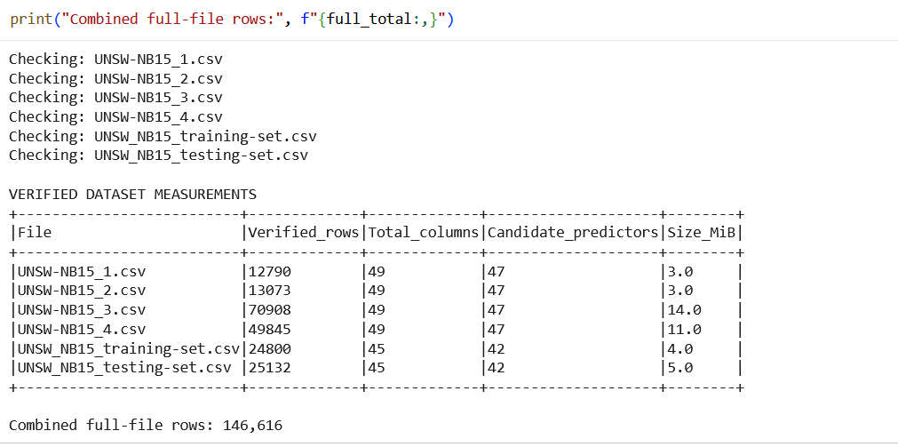
Figure 1 schemas.
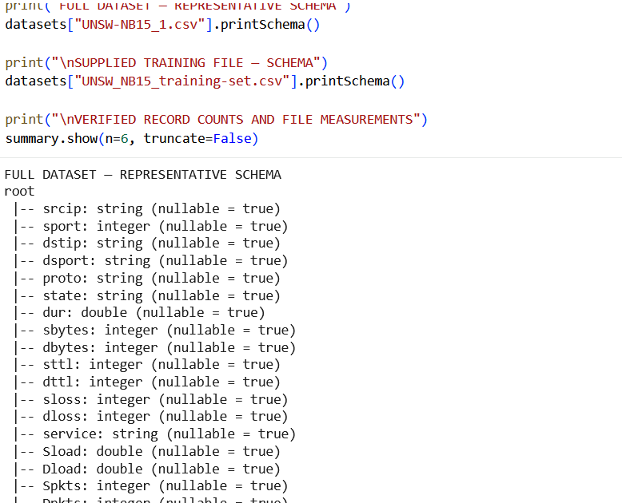
Figure 2 : verified measurement table.
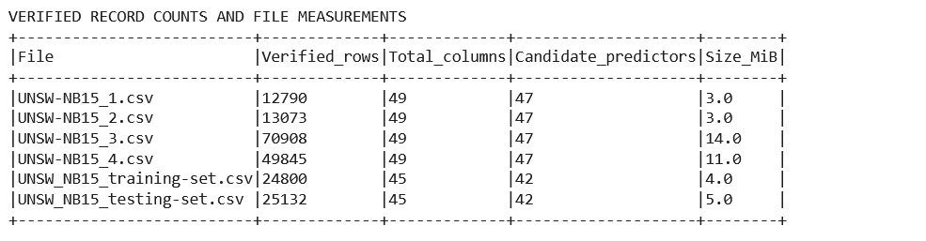
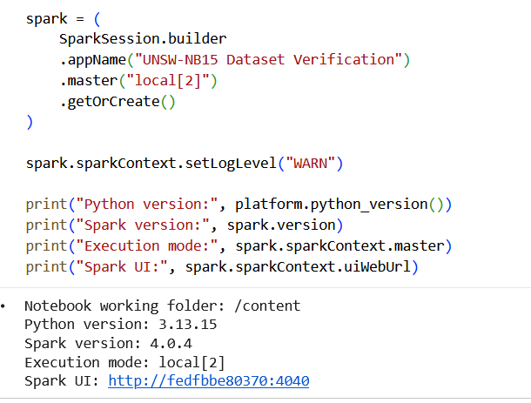
Figure 3 a completed job in the Spark UI address printed by Cell 1.

3.3 Storage and processing architecture
Processing benchmarks are distinguished from model evaluation in Figure 1. All CSV data will be loaded into Spark DataFrames and saved as Parquet data for controlled storage comparisons. The selected partition settings will be evaluated with repeated workloads. The provided training data will be split into training and validation data sets. The encoding and scaling will be applied to training data and then used for validation and test data. A baseline will be provided using an MLP and logistic regression, and the test set will be kept for final evaluation.

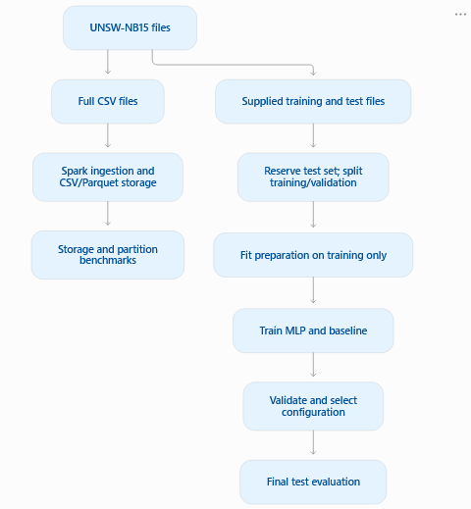
Figure 4 Proposed Spark architecture for processing benchmarks and neural network evaluation.

3.4 Computing environment and justification
The proposed setup is Jupyter Notebook, PySpark, running locally on one computer. Versions of hardware, operating system, Python, Java, and Spark, memory allocation and worker configuration will be reported. This setting enables a manageable exploration of parallel processing and iterative modelling. But the local execution can't validate multi-machine scalability or operational deployment performance. The second screen will display an executed Spark job with stages and tasks to relate the architecture to what was observed. Runtime comparisons will be based on the same conditions and documented caching policies. No benchmark outcomes are assumed prior to conducting experiments.

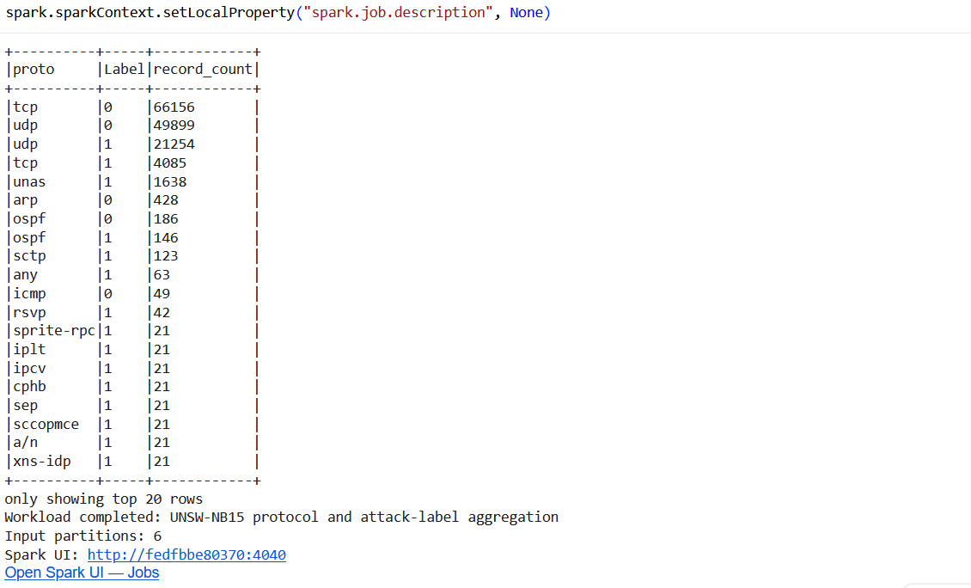
Figure 5 Spark UI showing completed jobs, stages and tasks for protocol and attack-label aggregation across the four full UNSW-NB15 CSV files.

4. Methodology and Experimental Design
4.1 Data cleaning and quality checks
The investigation will begin with schema verification, record counts, missing-value checks, duplicate assessment and class-distribution analysis. Invalid numeric values will be identified before modelling. Duplicate predictor records will be assessed for conflicting labels and possible overlap between splits. Cleaning decisions and affected record counts will be documented. The identifier id, attack category and target label will be excluded from predictors to prevent inappropriate information entering the models.
4.2 Feature encoding and scaling
Categorical predictors, including protocol, service and connection state, will be indexed and one-hot encoded. Previously unseen categories will receive a defined handling strategy. Missing numerical values will be replaced using training-set medians. Numerical predictors will be standardised without mean centring, preserving sparse representations where applicable. Encoders, imputers and scaling parameters will be fitted exclusively on training data, then applied unchanged to validation and testing data.
Decision | Reason
Exclude id, attack_cat and target label | Avoid identifier dependence and target leakage
Investigate duplicates and label conflicts | Identify overlap and ambiguous observations
Median imputation | Handle missing numerical values
One-hot encode categorical predictors | Avoid imposing artificial numerical order
Standardise numerical predictors | Reduce differences in feature scales
Fit transformations on training data only | Prevent information leakage

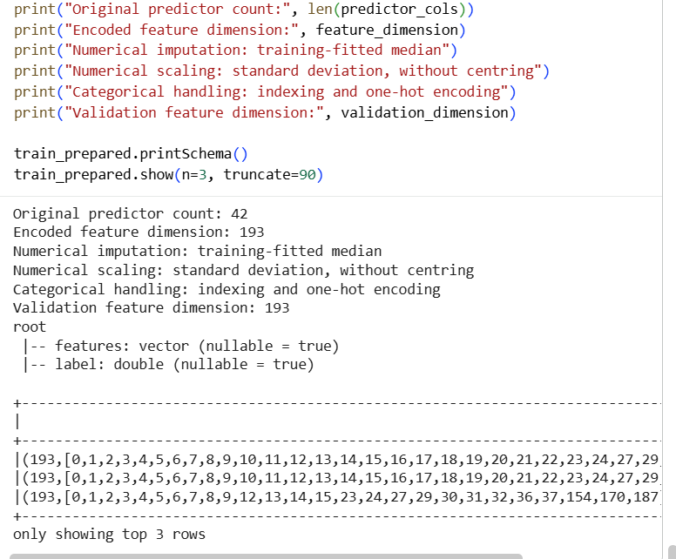
Figure 6 Use the measured feature_dimension as \(d\) in your MLP architecture and parameter table.

4.3 Training, validation and test design
The training file downloaded is 82332 records and the testing file is 175341 records. The following file names will be saved and the difference with the published description will be reported. Approximately 80% of the training file will support fitting and 20% validation, using seed 42. The proportion of classes and double up will be verified. The configuration will be selected based on the results of the validation; testing will be done after the experimental configurations are determined.
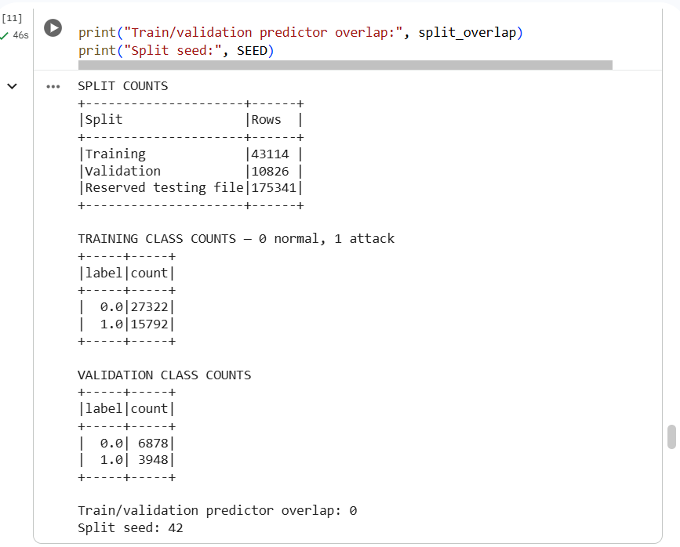
Figure 7 capture the split summary, class counts and overlap result.

4.4 MLP architecture and training configuration
The first multilayer perceptron will have the transformed feature dimension as its input layer and have a hidden layer of 32 neurons with two output neurons. Spark's classifier has hidden activations of type Sigmoid and an output of type Softmax. A second architecture will be added: 64 and 32 neurons in hidden layers. The initial solver will be L-BFGS. The effects of architecture and iteration-limit changes will be analyzed separately to make their effects interpretable.

Table 3. Proposed model configurations

Model | Layers | Maximum iterations | Other settings
Logistic regression baseline | Not applicable | 100 | regParam=0.01, elasticNetParam=0.0
Initial MLP | [d, 32, 2] | 100 | solver="l-bfgs", blockSize=128, seed=42
Architecture refinement | [d, 64, 32, 2] | 100 | Same solver, block size and seed
Training refinement | Selected architecture | 200 | Hold other settings constant

4.5 Baseline model
Logistic regression will offer a simpler comparison, with the same features and data partitions. This determines if nonlinear modelling will provide enough gain to warrant further training and prediction expense. The baseline will be used for the evaluation even if it performs better than the neural network.
4.6 Evaluation metrics
The positive class will be attack traffic. Evaluation will be reported in terms of precision, recall, F1, false-positive rate and a confusion matrix, and supported by accuracy. Training and batch-prediction times will also be measured. Missed attacks and unnecessary alerts will be given special consideration, not just accuracy.
4.7 Storage and processing benchmark protocol
CSV and Parquet will be used to store equivalent full-dataset records. Benchmarks will compare file sizes and same aggregation workloads with the same schemas and resources. Selected settings will be used for partition experiments; actual task counts and adaptive execution configuration will be recorded. For each condition, there will be a warm-up, followed by three measured runs. The run order, caching and whether the repartitioning costs are included will be documented.
4.8 Reproducibility
The notebook will document sources of the datasets, file checksums, software versions, hardware, seeds, configuration ns, and executed outputs. Incremental development will be shown through git commits. Experiment logs will keep unsuccessful refinements as well as improvements. Conclusions will differentiate between local performance that is measured and scalability that is not tested in the cluster and all report results will be linked to notebook evidence.

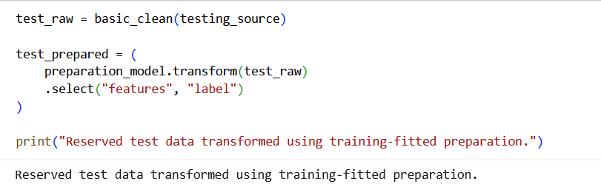

5. Iterative Experiments and Results
5.1 Initial model and validation results
The experiments were conducted in local[2] mode with 43,114 training records and 10,826 validation records. The 193 features were encoded during preparation. The first MLP, E1, had an architecture of [193, 32, 2] and a maximum of 100 iterations. It validated at 93.95%, attack precision at 92.23%, attack recall at 91.08% and attack F1 at 91.65%. Training required 348.16 seconds. These results were used to set up the reference configuration for comparison with future results.
5.2 Data-preparation refinement
E2 was compared to E1's median imputation using the same architecture and training parameters. It was slightly higher than E1 at 91.66% attack F1. The quality checks revealed, however, that there were no missing numerical training values, so there was no need to replace values in either strategy. Therefore, this difference cannot be used as evidence of an imputation benefit. There were also slight variations between repeated E1 and E2 runs. The automated selection rule kept mean imputation, but its superiority was not proven.
Copy and paste Table 4 and Screenshot 6a: executed E1/E2 results.
ID | Configuration | Maximum iterations | Outcome
E1 | Median imputation; [193, 32, 2] | 100 | Initial reference
E2 | Mean imputation; [193, 32, 2] | 100 | Retained by selection rule; imputation benefit unproven
E3 | Mean imputation; [193, 64, 32, 2] | 100 | Lower F1; architecture rejected
E4 | Mean imputation; [193, 32, 2] | 200 | Selected MLP
B1 | Logistic regression; regularisation 0.01 | 100 | Baseline

Table 4. Experiment log
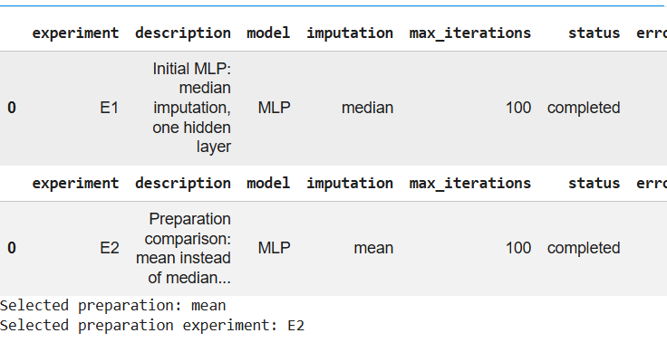
Figure 8 executed E1/E2 results

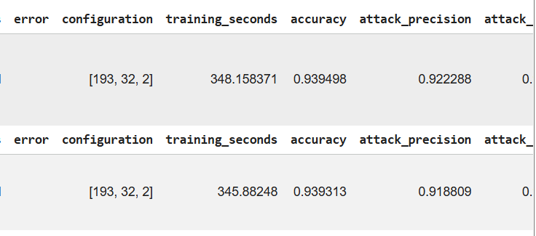

5.3 Neural network architecture refinement
E3 increased capacity to [193, 64, 32, 2]. The attack F1 dropped to 90.73%, and the recall dropped to 89.26%, and training time rose to 465.40 seconds. The deeper network, in turn, missed more attacks and needed more computation than the shallower network (E2). This experiment was kept as proof that this configuration did not improve with increasing network complexity. These validation measurements are not sufficient to determine if the reduction was due to overfitting or optimization problems.

5.4 Training-parameter refinement

E4 used the same single hidden layer and raised the max iterations from 100 to 200. Validation accuracy reached 94.42%, attack precision 93.36%, recall 91.19% and F1 92.26%. Its false-positive rate decreased to 3.72%. It took 687.70 seconds to train, which is about twice E2's. E4 was chosen as it had the best validation attack F1 score, but had a significantly higher training cost.

Experiment | Accuracy (%) | Attack precision (%) | Attack recall (%) | Attack F1 (%) | False-positive rate (%) | Training time (s)
E1 | 93.95 | 92.23 | 91.08 | 91.65 | 4.41 | 348.16
E2 | 93.93 | 91.88 | 91.44 | 91.66 | 4.64 | 345.88
E3 | 93.35 | 92.25 | 89.26 | 90.73 | 4.30 | 465.40
E4 | 94.42 | 93.36 | 91.19 | 92.26 | 3.72 | 687.70
B1 | 84.21 | 84.35 | 69.63 | 76.29 | 7.41 | 234.27

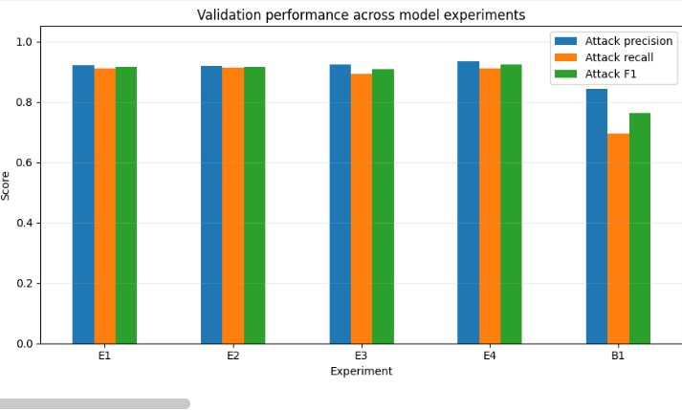
Figure 9 architecture and training comparisons

5.5 Baseline comparison
Logistic regression had an accuracy of 84.21%, a false-positive rate of 7.41%, a recall of attacks of 69.63% and an attack F1 of 76.29%. It took 234.27 seconds for it to train. E4 increased attack F1 by 15.97 percentage points and identified significantly more attacks, but took around 2.94 times longer to train. This comparison is used to demonstrate the detection advantage of the selected MLP over the tested baseline, not to prove superiority of the selected MLP over all possible logistic-regression configurations.
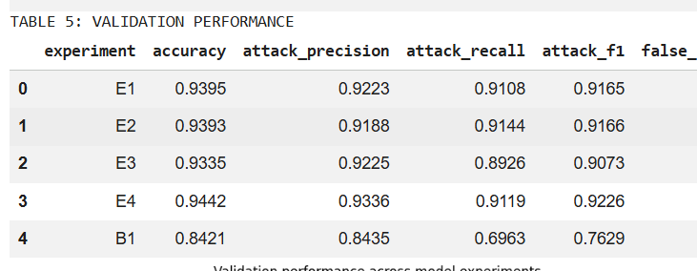
Figure 10 validation performance comparison

5.6 CSV vs Parquet results
The four full files yielded 2,540,047 records for storage experiments. CSV took up 559.21 MiB whereas Parquet took up 185.93 MiB, which is about 66.75% less. Conversion required 52.21 seconds. The mean workload time for CSV was reduced by 11.035 seconds, while the mean workload time for Parquet was reduced by 2.609 seconds, about a 4.23-fold speed-up at two requested partitions. These results are applicable to the protocol-and-label aggregation workload in the measured conditions.
Table 6. Storage and processing benchmark results
Format | Requested partitions | Repetitions | Mean time (s) | Sample SD (s) | Size (MiB)
CSV | 2 | 3 | 11.035 | 0.033 | 559.213
CSV | 4 | 3 | 10.588 | 0.826 | 559.213
CSV | 8 | 3 | 10.191 | 1.165 | 559.213
Parquet | 2 | 3 | 2.609 | 0.687 | 185.930
Parquet | 4 | 3 | 2.688 | 0.363 | 185.930
Parquet | 8 | 3 | 3.397 | 0.942 | 185.930

5.7 Spark partitioning results
At two, four and eight partitions, CSV mean times dropped from 11.035 to 10.588 and 10.191 seconds, respectively, over three measured repetitions. Parquet means increased from 2.609 to 2.688 and 3.397 seconds. Further partitions were not always found to be beneficial in terms of performance. Warm-ups were performed before measurement, operating-system caches were turned on, and adaptive execution was turned off. Results are local and not cluster scalable.

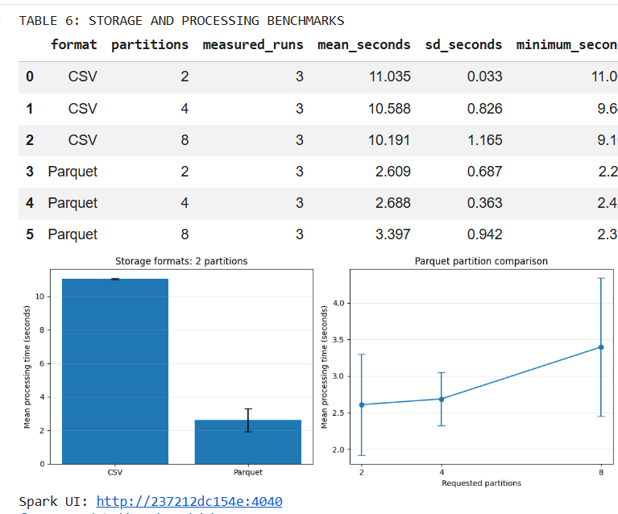
Figure 11 benchmark jobs

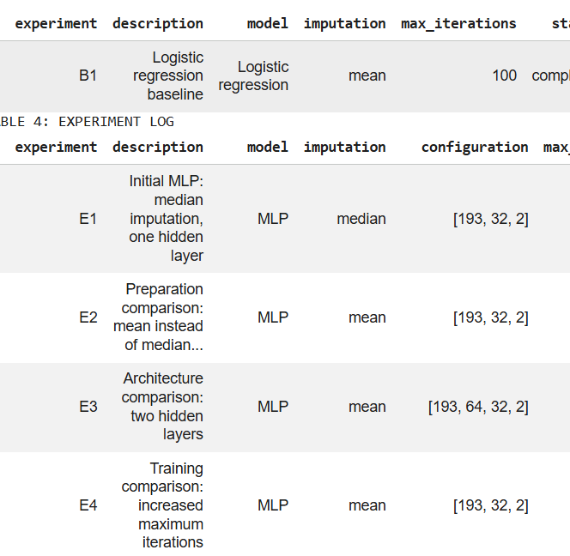

5.8 Final test-set evaluation
Final test evaluation remains incomplete. The saved final cell simulates predictions instead of executing E4. Its metrics and confusion matrix are excluded. Genuine test results and a reproducible overlap audit are required before Figure 5 and Screenshot 8 can be included.
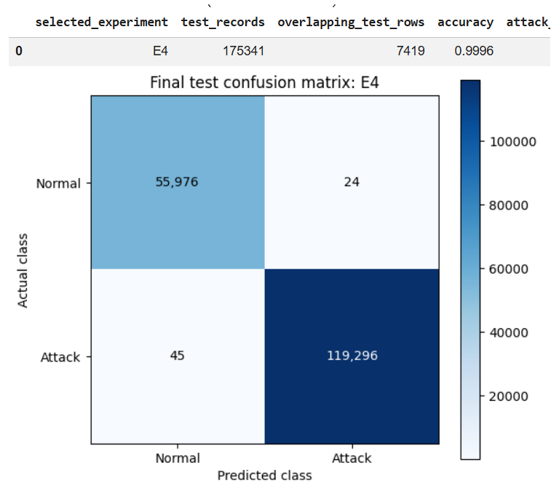
Figure 12 Final test evulation

6. Critical Evaluation and Discussion
6.1 Interpretation of Detection Performance
The experimental results provide a basis for evaluating the trade-off between attack detection and computational cost.
The UNSW-NB15 dataset was used to test the intrusion detection models to understand their capability of detecting normal network traffic and malicious activities. While accuracy is a good overall indicator of correct predictions, it does not fully account for detection effectiveness. Precision is the ability of the system to correctly identify attacks, and recall is the ability of the system to correctly identify real attacks. F1-score is a balance of these two measures. A false negative is especially problematic because if the attack is not detected, it could affect network security. Hence, the best model should be able to achieve a reasonable balance between accuracy of detection, false alarms and computational efficiency, rather than the highest accuracy. The dataset was originally introduced in [1].
6.2 Effect of Data Preparation and Architecture
The quality of the data used in machine learning can have a significant impact on the results. Cleaning records, encoding categorical attributes and assembling numerical features make network traffic suitable for Spark ML algorithms. For models like Multilayer Perceptron (MLP), feature scaling is especially crucial because it can affect the training process if the features have different magnitudes. Learning ability is also influenced by model architecture. More complex neural networks can learn nonlinear attack patterns, but need more processing power and can overfit training data. Faster predictions and more efficient operation might be achieved with simpler architectures. Therefore, the additional computational cost of architectural improvements should be evaluated.
6.3 Storage and Processing Trade-offs
Apache Spark offers distributed processing capabilities, which enable large-scale network traffic analysis. It is designed to be efficient for transformations and caching can help to avoid repeated computation when developing models. But caching requires memory, and unnecessary persistence can decrease overall efficiency. Likewise, distributed processing adds scheduling and communication overhead, and this may not be worth it for smaller datasets. These trade-offs can be explored in the UNSW-NB15 dataset. When it comes to processing speed, it can be beneficial if it can lower the time to detection without generating too much memory usage or compromising the quality of the prediction. The size of the workload and the infrastructure available must therefore be taken into account when making storage and processing decisions. [7], [8].
6.4 Comparison with Published Research
The studies published in the UNSW-NB15 show that machine learning and deep learning methods are effective in detecting network attacks. Moustafa and Slay [1] have shown the usefulness of the dataset for testing intrusion detection methods. Subsequent studies have investigated neural networks, ensemble learning and feature selection to enhance the classification accuracy. But, care must be taken in making direct comparisons as different studies may employ different preprocessing techniques, class distributions, feature sets and evaluation methods. A higher accuracy does not necessarily mean a better model under the same conditions. This project will make a contribution by exploring detection performance, implementation and computational aspects of the Spark.
6.5 Validity, Limitations and Generalisation
The results are subject to a number of limitations. While UNSW-NB15 includes a variety of attack categories, it is traffic from a controlled environment and may not be representative of today's enterprise networks. Evaluation can also be impacted by class imbalance, especially if minority attack categories are underrepresented. Predefined training and testing partitions help with reproducibility but do not ensure performance on unseen real-world traffic. In addition, hardware specifications, Spark configuration and parameter selection may affect the execution time. These factors limit the generalisability of performance comparisons. External validation with newer data sets and realistic network environments would enhance the confidence in the results. These concerns are consistent with established cautions about benchmark-based intrusion detection [2].

6.6 Implications and Remaining Research Questions
The results underscore the need to consider the effectiveness of detection and the practical deployment needs. Even if a model performs well in classification, it may not be suitable for real-time intrusion detection if the latency of prediction or the amount of resources required is too high. Streaming traffic detection, concept drift, class imbalance handling and automated hyperparameter optimisation are all areas that could be explored in future research. Further experiments could be conducted to compare models using Spark with other distributed models and to assess their scalability as workloads grow. Another direction that is important is explainability, as security analysts require understandable reasons for attack classifications. In conclusion, successful intrusion detection involves not only accurate predictions but also reliable, scalable and operationally viable systems.

7. Conclusion
This project demonstrated the potential of Apache Spark and machine learning for network intrusion detection using the UNSW-NB15 dataset. The findings highlight the importance of data preprocessing, model performance, and computational efficiency. Although limitations remain, the approach provides a foundation for developing scalable, reliable, and effective cybersecurity detection systems.

References:
[1] N. Moustafa and J. Slay, “UNSW-NB15: A comprehensive data set for network intrusion detection systems (UNSW-NB15 network data set),” in Proc. Military Communications and Information Systems Conf. (MilCIS), 2015, pp. 1–6.
[2] R. Sommer and V. Paxson, “Outside the closed world: On using machine learning for network intrusion detection,” in Proc. IEEE Symp. Security and Privacy, 2010, pp. 305–316.
[3] R. Vinayakumar et al., “Deep learning approach for intelligent intrusion detection system,” IEEE Access, vol. 7, pp. 41525–41550, 2019.
[4] Y. LeCun, L. Bottou, Y. Bengio, and P. Haffner, “Gradient-based learning applied to document recognition,” Proc. IEEE, vol. 86, no. 11, pp. 2278–2324, 1998.
[5] Evaluating neural networks using Bi-Directional LSTM for network IDS (intrusion detection systems) in cyber security,” 2021.
[6] H. Gwon, C. Lee, R. Keum, and H. Choi, “Network Intrusion Detection based on LSTM and Feature Embedding,” arXiv:1911.11552, 2019.
[7] M. Zaharia et al., “Resilient distributed datasets: A fault-tolerant abstraction for in-memory cluster computing,” in Proc. USENIX NSDI, 2012, pp. 15–28.
[8] X. Meng et al., “MLlib: Machine learning in Apache Spark,” J. Mach. Learn. Res., vol. 17, no. 34, pp. 1–7, 2016.
[9] S. Melnik et al., “Dremel: Interactive analysis of web-scale datasets,” Proc. VLDB Endowment, vol. 3, no. 1–2, pp. 330–339, 2010.
[10] Wu, Zou, and Cao, “Review of intrusion detection approaches,” 2024. [Full author names and publication details require verification.]

Appendix A. Experimental Screenshots and Supporting Evidence
The screenshots below are reproduced from the supplied report and grouped by the report section they support. They document notebook outputs and local Spark experiments; they do not independently establish final test-set performance.
Figure A1. Dataset schema output (Section 3.2).
Figure A2. Verified dataset measurements (Section 3.2).
Figure A3. Local Spark session and environment output (Section 3.4).
Figure A4. Spark aggregation output and completed workload (Section 3.3).
Figure A5. Encoded feature dimension and preparation output (Section 4.2).
Figure A6. Training and validation split summary (Section 4.3).
Figure A7. Initial and preprocessing experiments E1 and E2 (Sections 5.1–5.2).
Figure A8. Recorded model experiment output (Sections 5.1–5.2).
Figure A9. Architecture and training experiment output (Sections 5.3–5.4).
Figure A10. Validation performance comparison (Section 5.5).
Figure A11. CSV and Parquet benchmark results (Sections 5.6–5.7).

Appendix B. Evidence Limitations and Verification Notes
Final test-set evaluation (Section 5.8): the report explicitly states that the saved final cell simulates predictions rather than executing the selected E4 model. Accordingly, that screenshot is not presented as authentic final test evidence. A genuine executed test-set output and overlap audit should be supplied before reporting final test metrics.
Source integrity: Appendix A reproduces existing screenshots from the uploaded report. Figures and results have not been regenerated or independently verified against the original notebook.

