CCT College Dublin
Continuous Assessment

NYC Taxi Trip Duration Prediction Using Apache Spark and Neural Networks
Student name Imtiaz Mubarik Butt
Student ID 2026244
Programme MSc in Data Analytics
Assessment Integrated CA1 Semester 2
Modules Advanced Data Analytics; Big Data Storage and Processing
Lecturers David McQuaid; Muhammad Iqbal
Deadline in brief 11 October 2026
Report length Approximately 4,000 words of main prose, excluding references and appendices
Drive Link https://drive.google.com/drive/folders/1LlM_BSiuOApoZgc8Xe4zWHrom8riUVT4?usp=sharing

Abstract
Accurate journey-time estimates support passenger planning and transport operations, but useful prediction requires both appropriate models and reliable data processing. This study combines Apache Spark with feed-forward neural networks to estimate New York City yellow-taxi journey duration from pickup time and origin and destination zones. January 2024 records were downloaded from the Taxi and Limousine Commission. Spark processed 2,964,624 records, retaining 2,898,428 after documented filtering. Chronological training, validation and test windows were sampled to control computation. Three neural configurations were compared with median and ridge-regression baselines. The selected network achieved a test mean absolute error of 3.774 minutes, compared with 7.481 for the median baseline. However, its error increased to 10.500 minutes for journeys exceeding thirty minutes. A separate storage experiment found smaller files and faster warm-cache aggregation with Parquet than CSV. These results demonstrate a reproducible integration of large-scale preparation and modest neural modelling, while remaining limited to one month, one random initialization and a single-machine execution environment.

Contents
Abstract 2
1 Introduction 4
2 Literature review and research context 4
2.1 Travel-time modelling 4
2.2 Processing architecture and learning software 5
2.3 Synthesis and research gap 6
3 Dataset and system architecture 7
3.1 Source and preparation 7
3.2 Execution design 7
4 Experimental methodologies 8
4.1 Chronological evaluation and features 8
4.2 Baselines and neural iterations 8
4.3 Metrics and storage protocol 9
5 Results 9
5.1 Predictive performance 9
5.2 Error concentration 10
5.3 Storage and query performance 11
6 Critical evaluations 11
6.1 Interpretation and practical implications 11
6.2 Validity and limitations 11
6.3 Reproducibility and responsible use 12
7 Conclusion 12
References 13
Appendix Reproducibility and submission record 14

1 Introduction
Journey duration is an understandable but demanding prediction problem. Two journeys between similar locations can take different amounts of time because departure time, congestion, route choice and exceptional events affect movement. A useful estimate should be available before the journey finishes. This requirement determines which recorded variables are legitimate predictors and which would reveal information unavailable at the intended prediction moment. The present study therefore treats prediction as occurring at pickup, with the intended destination assumed known.
The objective is to construct and critically evaluate an integrated processing and prediction workflow using public taxi records. The research question is: how do temporal feature representation and neural-network architecture affect journey-duration prediction, and how does storage format affect the cost of processing the associated trip data? The question connects Advanced Data Analytics with Big Data Storage and Processing through a common dataset and an explicitly reproducible experimental design.
The neural component examines whether a small multilayer perception can model nonlinear relationships between location and departure time. The storage component examines whether a column-oriented representation reduces the size and query time of a processed analytical table. These objectives are related but separately measured. Better predictive accuracy does not establish distributed scalability, and faster aggregation does not establish better predictions. Keeping these outcomes distinct prevents a technically impressive component from obscuring weaknesses elsewhere.
The contribution is a bounded empirical comparison rather than a new prediction algorithm. Published trajectory models often require detailed sequences of GPS observations or road segments. The chosen public records provide trip summaries instead. A compact feed-forward network therefore offers a practical starting point whose assumptions can be examined directly. The investigation records cleaning counts, temporal splits, architecture changes, validation histories, final errors and repeated query timings. These records make unsuccessful improvements and remaining weaknesses visible alongside successful results.
The scope is deliberately restricted to January 2024 yellow-taxi trips and local execution. The experiment does not forecast live traffic, choose routes, evaluate a production service or train across multiple machines. It also does not claim that January represents every season or transport mode. Within these boundaries, the study can test whether the selected inputs carry useful predictive information and whether storage choices materially affect a repeatable workload. Broader deployment would require additional evidence.

2 Literature review and research context

2.1 Travel-time modelling
Wang et al. (2018) introduce DeepTTE, an end-to-end approach that combines geographic convolution with recurrent modelling and learns both complete-path and local-path travel times. Its contribution is to represent spatial and temporal dependencies together instead of simply adding independent segment estimates. This supports investigating nonlinear interactions in transport prediction. However, its path-based inputs differ substantially from the zone-level summaries used here. Its published results cannot serve as a numerical benchmark for this experiment without reproducing the same data and evaluation protocol.
Zhang et al. (2018) propose Deep Travel, which uses trajectory features and auxiliary temporal supervision. Intermediate observations provide additional learning signals beyond a single final journey duration. This is a useful methodological contrast: more informative supervision can improve learning without relying only on a larger final network. The present dataset does not expose the timestamped intermediate path needed to reproduce that design. Its lesson is therefore to match modelling ambition to available information rather than imitate architecture names while omitting essential inputs.
Fu and Lee (2019) represent paths as generalized images in DeepIST, allowing convolutional networks to model spatial movement patterns and their temporal relationships. This approach changes the input representation as well as the predictive model. Consequently, any gain cannot automatically be attributed to depth alone. For the present study, the relevant implication is that feature representation deserves a controlled experiment. Comparing ordinary time values with cyclic time encoding offers a smaller, interpretable representation change suitable for tabular trip summaries.
Li, Feng and Wu (2024) develop AttentionTTE using attention for global spatial relationships, recurrent modelling for temporal dependencies, and joint estimation of local and whole-path travel time. This more recent work shows that identifying dependencies across a route remains a central concern. It also illustrates a practical limitation of transferring research systems: richer architectures require richer path descriptions and more implementation choices. A zone-level MLP cannot represent every intervening road segment and should not be described as an equivalent implementation.
Jayasuriya and Sumanathilaka (2025) review route planning and travel-time estimation in relation to changing user preferences, data integration and emerging AI approaches. Their preprint broadens the discussion from prediction error to operational adaptability and responsible use. It is contextual evidence rather than a peer-reviewed validation of the present model. In particular, prediction from historical trip summaries should not be presented as personalized navigation, real-time adaptation or successful handling of unexpected incidents.

2.2 Processing architecture and learning software
Zaharia et al. (2012) introduce resilient distributed datasets as fault-tolerant abstraction for reusable, parallel computation. Their central contribution addresses repeated processing and iterative workloads through partitioned data and lineage. This provides the architectural rationale for selecting Spark. Nevertheless, evidence from their cluster experiments does not prove that a small local Spark job is faster than an optimized single-process alternative. This study tests a storage-format comparison inside Spark and limits its performance claims accordingly.
Armbrust et al. (2015) describe Spark SQL as an integration of relational processing and procedural analytics. Data Frames and query optimization are relevant because taxi preparation consists largely of typed column operations, filters and aggregations. Expressing these operations through Spark SQL functions exposes their structure to the execution engine. This motivates avoiding unnecessary row-by-row Python processing. The paper supports the architecture choice, while actual performance still depends on data layout, workload, caching and the execution environment.
Meng et al. (2016) describe MLlib and the role of scalable learning pipelines within Spark. Their work demonstrates that preparation and modelling can share a distributed platform. The present implementation instead crosses an explicit boundary: Spark prepares the full analytical population, then a bounded sample is transferred for local neural training. This choice reduces experimental complexity but introduces a scalability ceiling. It would be inaccurate to cite MLlib as evidence that the particular neural networks tested here were trained in a distributed manner.
Pedregosa et al. (2011) emphasize consistent interfaces and accessible machine learning in scikit-learn. That design supports comparable preprocessing and evaluation across regression baselines and neural networks. The current experiment uses its MLPRegressor implementation, not TensorFlow, because it supports the required feed-forward regression with modest dependencies. The historical software paper establishes the broader library context; current implementation settings and versions are reported separately rather than attributed to features present in the original publication.
Kingma and Ba (2015) introduce Adam, an optimizer that adapts updates using estimates of gradient moments. Adam provides a practical training method for the neural models in this study. Its use does not remove the need to select a learning rate, monitor validation behaviour or investigate instability. All neural configurations therefore use the same initial learning rate and optimizer settings, while the experiment changes time representation or hidden-layer structure. This makes the resulting comparisons easier to interpret.
Kapoor and Narayanan (2022) examine leakage and reproducibility failures across machine-learning research. Their analysis supports specifying the prediction moment, protecting test data and documenting preprocessing. Taxi duration is particularly vulnerable to leakage because drop-off time mathematically determines the target and metered charges may encode elapsed time. Excluding such fields is necessary even when their inclusion would improve apparent accuracy. The study therefore evaluates a restricted information set rather than pursuing the lowest possible error with every recorded column.

2.3 Synthesis and research gap
Literature presents two complementary priorities. Travel-time research seeks better representations of movement and dependencies, while processing research seeks efficient and reproducible operations over substantial datasets. A common difficulty is that stronger published models may depend on information unavailable in a convenient public dataset. Another is that prediction comparisons often receive more attention than the cost and validity of preparing their inputs. This study addresses practical intersection through a simple model family and a measured processing experiment.
There is also a tension between complexity and interpretability. Rich path models may capture mechanisms that zone summaries omit, but their advantages cannot be assumed under a different information budget. Conversely, an accessible MLP may produce useful estimates while failing systematically on unusual journeys. The empirical question is therefore conditional: what can this restricted representation achieve, at what processing cost, and where does it fail? The study does not claim an exhaustive search of all travel-time research or a universal ranking of algorithms.
Table 1 Literature comparison
Study | Contribution | Boundary
Wang et al. 2018 | Geo-convolution and recurrence | Needs detailed paths
Zhang et al. 2018 | Auxiliary temporal supervision | Needs intermediate observations
Fu and Lee 2019 | Path images and CNNs | Representation differs from zones
Li et al. 2024 | Attention and recurrence | Richer inputs and complexity
Jayasuriya and Sumanathilaka 2025 | Adaptability and integration review | Preprint; contextual evidence
Zaharia et al. 2012 | Reusable distributed partitions | Cluster findings do not prove local gains
Armbrust et al. 2015 | Relational query optimization | Performance is workload-dependent
Meng et al. 2016 | Distributed learning pipelines | Current MLP training is local
Pedregosa et al. 2011 | Consistent model interfaces | Historical library paper
Kingma and Ba 2015 | Adaptive optimization | Still requires validation
Kapoor and Narayanan 2022 | Leakage and reproducibility | Motivates strict evaluation

3 Dataset and system architecture

3.1 Source and preparation
The source is the January 2024 yellow-taxi Parquet file published through the NYC Taxi and Limousine Commission website. It contains 2,964,624 rows and nineteen columns and occupies 49,961,641 bytes. The official documentation identifies pickup and drop-off timestamps, taxi zones and metered journey information (NYC TLC, n.d.; 2025). A SHA-256 checksum, source URL and software versions are recorded in the accompanying metadata so that the exact input can be distinguished from later replacements.
Duration is calculated as the difference between drop-off and pickup timestamps in minutes. The first filter retains pickups within January, removing eighteen out-of-period rows. The second retains durations from one to 120 minutes, and the third requires origin and destination zone identifiers between one and 263. Together these operations remove 66,196 rows, or 2.23 percent of the source. The remaining population contains 2,898,428 records, with a mean duration of 14.886 minutes and an approximate median of 11.717 minutes.
The duration limits define the population studied; they are not evidence that every excluded long journey was erroneous. Likewise, excluding unknown zone codes reduces uncertainty but narrows coverage. No claim is made that all data-quality issues have been corrected. Duplicate records were not removed because these summary fields do not reliably distinguish duplicate reporting from separate journeys with coinciding attributes. Chronological separation prevents an identical pickup timestamp from crossing the training and test windows, but repeated patterns remain possible.

3.2 Execution design
Spark 3.5.3 runs with local [2], two local worker threads, a two-gigabyte driver allocation and eight shuffle partitions. Python 3.12.14 and scikit-learn 1.8.0 support the modelling stage. Spark first reads the original Parquet file, applies typed transformations and creates an analytical table. It then supplies storage benchmarks and bound modelling samples. The architecture is shown in Figure 1. The execution log and physical-plan text provide evidence of the processing performed.
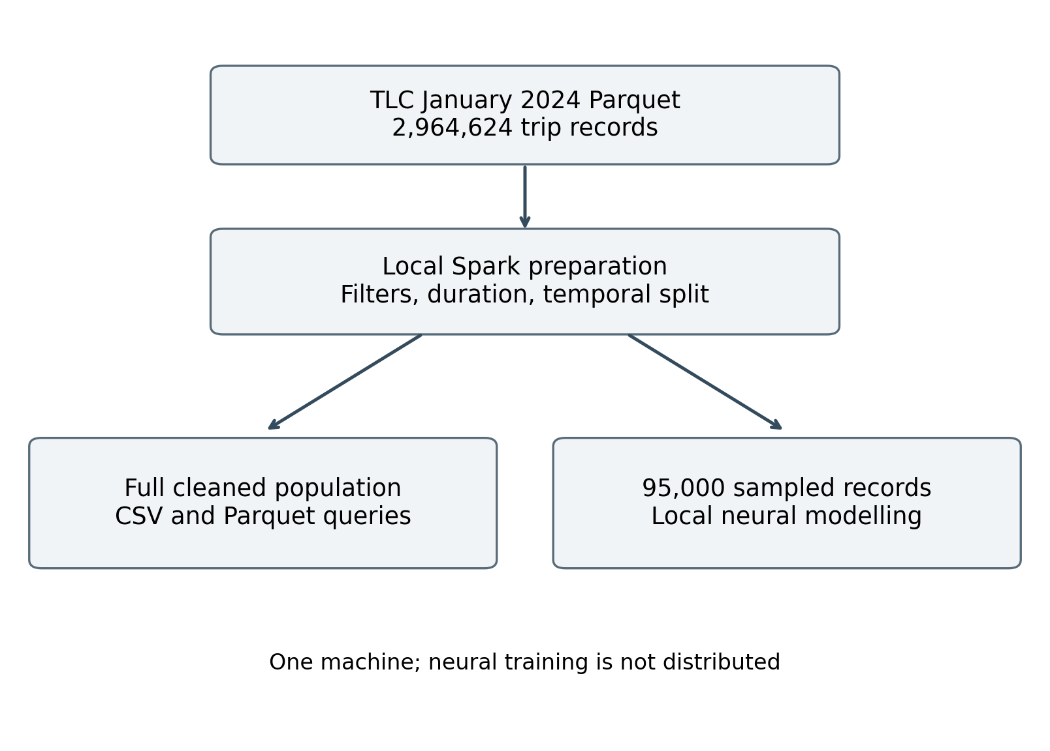
Figure 1 Processing and modelling architecture
The local driver coordinates the job and scheduling, while Spark executes partitioned tasks within the same machine. This exercises Spark's programming and execution model without testing network communication or resilience across separate hosts. Caching is used during repeated preparation and released before storage benchmarking. Only selected samples are collected into local memory. Collecting the full population would undermine the intended separation between scalable preparation and resource-bounded model development.

4 Experimental methodologies

4.1 Chronological evaluation and features
Training uses pickups from January 1 to 20, validation uses January 21 to 25, and testing uses January 26 to 31. The eligible populations are 1,839,253, 474,706 and 584,469 records respectively. Deterministic hash ordering selects 60,000 training records, 15,000 validation records and 20,000 test records. Sampling is performed separately inside each time window. This design approximates learning from the past and predicting subsequent journeys while keeping local training manageable.
The feature set contains pickup hour, weekday, pickup zone and destination zone. The destination field records where a completed trip ended; using it operationally assumes that an equivalent intended destination is supplied at pickup. That assumption must remain explicit. Actual metered distance, final rate code, fare, tips, total charge and drop-off timestamp are excluded as predictors. No weather, road-network sequence, driver identity or contemporaneous traffic measurement is added.
Zone identifiers are one-hot encoded rather than treated as quantities with meaningful numerical distances. Unknown categories are ignored by the fitted encoder, which permits evaluation but loses information for zones absent from the training sample. Time variables are standardized using training statistics. In the cyclic variants, hour and weekday become sine and cosine pairs with periods of twenty-four and seven. All encoders and scaling parameters are fitted on training records only.

4.2 Baselines and neural iterations
The first benchmark predicts the training media for every journey. It establishes whether a model improves on a simple constant estimate under mean absolute error. Ridge regression provides a stronger linear comparison using cyclic time features and encoded zones, with regularization strength ten. It tests whether nonlinear interactions add value beyond additive effects. Neither baseline is described as an exhaustive representation of the strongest possible conventional methods.
MLP1 uses one hidden layer of thirty-two ReLU units and ordinary hour and weekday variables. MLP2 retains the same hidden-layer size but replaces those time inputs with cyclic features. This isolates a preparation change. MLP3 retains cyclic features and uses two hidden layers of sixty-four and thirty-two units. It tests a larger nonlinear representation. The resulting input dimensions are 460 for MLP1 and 462 for the cyclic models, reflecting categories observed in training.
All networks use Adam, a learning rate of 0.001, L2 regularization of 0.001, batches of 256 and initialization seed forty-two. Training targets are standardized using the training mean and standard deviation, and predictions are converted back to minutes. Optimization uses squared error, whereas model selection uses validation MAE. These objectives emphasize errors differently; that distinction helps explain why MAE and RMSE need not improve together.
Training proceeds one epoch at a time for up to forty epochs. The best validation checkpoint is retained when MAE improves by at least 0.001 minutes. Training stops after six epochs without such improvement. The winning neural configuration is selected by validation MAE, not test performance. Test statistics are reported for all prespecified configurations for transparency; no further architecture is introduced after inspecting them. Validation histories preserve the evidence behind checkpoint selection.

4.3 Metrics and storage protocol
MAE measures the average absolute difference between predicted and observed minutes and is the primary performance measure. RMSE gives greater influence to large errors, while R-squared compares squared error with a mean-based reference. All models use the same test sample. Additional summaries examine morning pickups, evening pickups, other hours and journeys longer than thirty minutes. The long-journey subset overlaps the time groups and is diagnostic rather than a separate experimental population.
For storage evaluation, the same cleaned six-column table is written into four-part files in CSV and Parquet. The query filters pickup hours from seven to nine, groups by pickup zone, and calculates average duration and trip count. An explicit schema avoids charging CSV for schema inference. Each format receives a warm-up query, followed by three timed runs in alternating order. Results are checked for equal counts and numerically equivalent averages. Measurements describe warm-cache, end-to-end read-and-query behavior, not cold-disk throughput.

5 Results

5.1 Predictive performance
Table 2 reports the measured model results. The median baseline achieved test MAE of 7.481 minutes and RMSE of 11.550 minutes. Ridge regression reduced these to 6.085 and 8.805 minutes. All three neural configurations improved further under this protocol. MLP1 achieved MAE of 3.865 minutes; cyclic encoding in MLP2 reduced it to 3.834 minutes. The absolute change was approximately 0.031 minutes, which is small and should not be overstated.
Table 2 Model performance in minutes
Model | Val MAE | Test MAE | Test RMSE
Median | 7.906 | 7.481 | 11.550
Ridge | 6.313 | 6.085 | 8.805
MLP1 | 4.001 | 3.865 | 6.160
MLP2 | 3.982 | 3.834 | 6.136
MLP3 | 3.910 | 3.774 | 5.999

MLP3 had the lowest validation MAE, 3.910 minutes, and was selected before interpreting test outcomes. Its test MAE was 3.774 minutes, RMSE 5.999 minutes and R-squared 0.708. Relative to the median baseline, its MAE was 49.55 percent lower; relative to ridge, it was 37.97 percent lower. These percentages describe this specific sample and protocol. They are not evidence of superiority to all conventional approaches or to the published trajectory models reviewed earlier.
The first two networks completed forty epochs, with their retained checkpoints at thirty-eight epochs and forty. MLP3 stopped at epoch twenty-one and retained epoch fifteen. Recorded fitting-loop times were approximately 3.94, 3.66 and 3.76 seconds respectively. These include validation and checkpoint copying but exclude Spark preparation and feature transformation. The deeper network therefore did not take longer overall in this run, because it trained for fewer epochs. Figure 2 shows the validation histories.
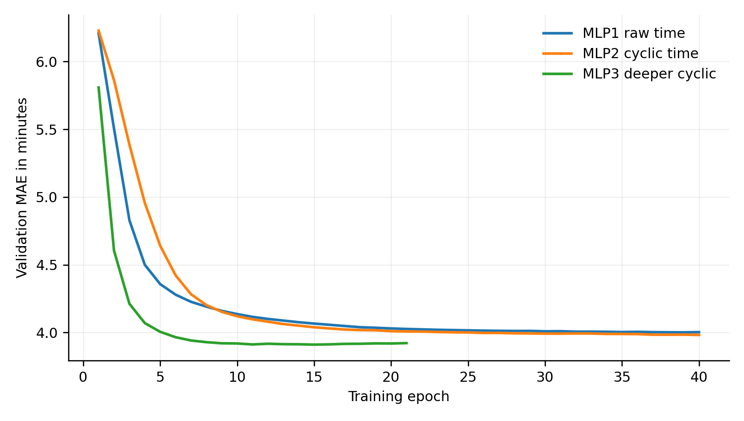
Figure 2 Validation MAE across training epochs

5.2 Error concentration
The selected model's morning-group MAE was 4.470 minutes across 2,252 test journeys. Evening-group MAE was 3.683 minutes across 5,220 journeys, and the remaining hours produced 3.687 minutes across 12,528 journeys. The difference indicates uneven performance, although these descriptive comparisons do not isolate congestion as a cause. Journey mix, locations and other unmeasured factors differ across time periods and could contribute to the errors observed.
For 1,707 journeys longer than thirty minutes, MAE increased to 10.500 minutes and RMSE to 14.948 minutes. R-squared was negative within this subset, showing that the overall result conceals a substantial weakness for longer journeys. Figure 3 compares prediction errors across models. The subgroup result is particularly relevant for passengers planning connections or appointments: a useful average over all trips does not imply adequate reliability for demanding journeys.
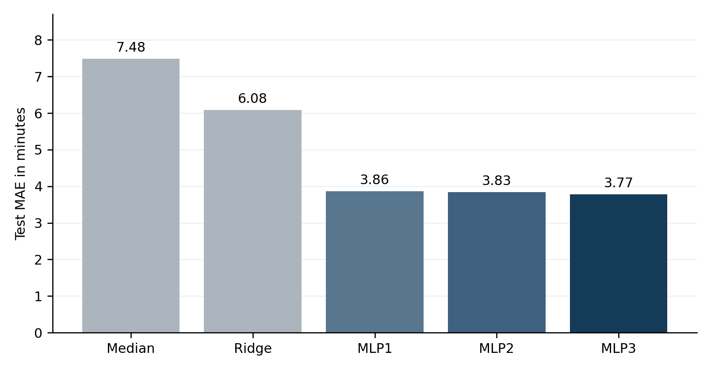
Figure 3 Test MAE for the prespecified models

5.3 Storage and query performance
The processed CSV table occupied 84,721,720 bytes, whereas Parquet occupied 10,874,059 bytes, an 87.16 percent reduction. These figures concern the same selected six-column table, not the original nineteen-column source file. Median warm-query time was 1.033 seconds for CSV and 0.209 seconds for Parquet, approximately a 4.95-fold difference. Both formats returned to 238 grouped rows with matching counts and equivalent average durations.
The individual CSV timings were 0.961, 1.033 and 1.117 seconds; Parquet timings were 0.209, 0.209 and 0.180 seconds. The observed advantage is consistent with more compact typed storage and reduced parsing, but the experiment does not separate each mechanism. Compression, encoding, reader implementation and caching contribute together. Three repetitions demonstrate a local pattern; they do not establish confidence intervals, multi-machine scalability or performance on arbitrary queries.

6 Critical evaluations

6.1 Interpretation and practical implications
The strongest supported finding is that a compact nonlinear model extracts useful information from origin, destination and departure time. Its advantage over ridge suggests that an additive representation leaves important relationships unexplained. For example, the effect of an origin may depend on the destination and time. However, this explanation remains an interpretation of model behavior rather than a measured causal mechanism. Feature-attribution analysis and controlled subgroup comparisons would be needed to investigate interactions.
The iterative comparison provides a more cautious conclusion about feature engineering. Cyclic encoding has a clear conceptual justification because midnight is adjacent to the previous hour, but its measured MAE improvement was modest. On validation data, MLP2 improved MAE while worsening RMSE relative to MLP1. This disagreement shows why reporting multiple metrics matters: typical errors and sensitivity to large mistakes answer different questions. A preparation change should be judged against the intended operational objective rather than a single favorable statistic.
Increasing network capacity produced another modest improvement over the already effective shallow model. The deeper model reduced test MAE by about 0.060 minutes compared with MLP2. That difference is much smaller than the remaining errors for long journeys. Additional layers alone therefore do not solve the information limitations of trip summaries. This is consistent with the reviewed research emphasis on richer path representations, while not proving that a specific published architecture would improve this dataset.
The processing results show a substantial benefit for Parquet within the tested workload. Smaller analytical files can reduce storage demand and repeated reading costs. Nevertheless, this is a comparison between two representations in Spark, not a comparison proving Spark is necessary for a roughly fifty-megabyte source file. An optimized local data frame engine could also process this workload effectively. Spark's value here includes a transferable partitioned workflow and explicit execution evidence, while genuine scale-out benefits remain untested.

6.2 Validity and limitations
The chronological split is stronger than randomly mixing future and past observations for this prediction scenario, but one January window is insufficient to establish year-round generalization. Weather, holidays, demand patterns and infrastructure changes can alter travel times. The final six days may also be easier or harder than other periods. Rolling evaluations across several months would provide more reliable evidence, and all feature learning would need to remain confined to the corresponding historical training window.
Sampling creates a further trade-off. Spark handles the full eligible population, but neural results describe a training sample of sixty thousand records and a test sample of twenty thousand. Rare routes may be poorly represented or absent. The sample is reproducible, yet reproducibility alone does not guarantee representative coverage. Future experiments should examine zone-pair frequencies, sample-size learning curves and performance on uncommon journeys before increasing confidence in operational use.
Only one neural initialization was evaluated. The small differences between model variants may therefore reflect optimization variability as well as architecture or representation. No statistical-significance claim is justified. Repeated seeds and paired resampling of test errors would help assess uncertainty. Additional baselines, particularly gradient-boosted trees, would also strengthen the comparison. The present results establish improvement over the chosen median and ridge references, not general neural-network superiority for tabular data.
Data filtering affects external validity. Excluding durations outside one to 120 minutes and unidentified zones makes the target population easier to define but removes situations a deployed system would encounter. An operational system would require explicit handling of unsupported or unusual requests. The model also supplies point estimates without prediction intervals, so users cannot assess uncertainty for an individual journey. Prediction intervals and calibrated error warnings are more defensible future improvements than presenting a point estimate as guaranteed arrival time.
The storage benchmark has analogous limits. Local worker threads share hardware and operating-system caches; neither remote storage nor communication overhead is represented. The experiment measures one aggregation, one table width and four output parts. Partition count, compression configuration, wider schemas and different filters could change results. A stronger systems evaluation would report repeated workloads, hardware details, cold and warm conditions, and several data volumes. The current timings should be interpreted only within the recorded setup.

6.3 Reproducibility and responsible use
The accompanying materials retain source identification, a checksum, preprocessing code, model settings, validation histories and numerical outputs. These artifacts permit inspection and rerunning rather than relying solely on prose claims. The notebook distinguishes the full-population Spark stage from sample-based modelling, and reported timings identify their measurement boundaries. Such documentation addresses the reporting concerns raised by Kapoor and Narayanan (2022), although independent replication remains necessary to establish portability across environments.
Responsible interpretation also requires restraint about people and places. Taxi-zone identifiers describe recorded journeys and should not be used to infer individual identities or sensitive personal characteristics. Performance differences across areas may reflect uneven coverage rather than inherent properties of residents. A practical service would need coverage monitoring, suitable retention policies and transparent explanations of uncertainty. The experiment is an educational prediction study; it provides no evidence that automated decisions affecting passengers or drivers would be fair or operationally safe.

7 Conclusion
This study integrated Spark data preparation with neural regression for NYC taxi journey duration. The pipeline processed 2,964,624 January 2024 records and retained 2,898,428 under explicit temporal, duration and location rules. A chronologically separated sample enabled controlled comparison of temporal encoding and network architecture. The selected two-hidden-layer model achieved test MAE of 3.774 minutes and outperformed the median and ridge baselines. However, errors on journeys longer than thirty minutes remained substantial, limiting practical confidence.
The research question receives two bounded answers. Cyclic time encoding and greater network capacity produced small additional improvements within the tested neural family, while the larger gain came from nonlinear modelling relative to the selected baselines. Parquet substantially reduced analytical-table size and warm aggregation time compared with CSV in the local Spark experiment. Neither result establishes universal superiority, real-time readiness or distributed neural training. The next priorities are multi-month temporal evaluation, repeated seeds, stronger baselines, uncertainty estimates and broader processing benchmarks. These steps would test whether the observed benefits survive more demanding conditions and support decisions beyond this controlled educational study.

References
Armbrust, M. et al. (2015) “Spark SQL: Relational Data Processing in Spark”, Proceedings of SIGMOD. Available at: https://people.csail.mit.edu/matei/papers/2015/sigmod_spark_sql.pdf (Accessed: 11 October 2026).
Fu, T.-Y. and Lee, W.-C. (2019) “DeepIST: Deep Image-based Spatio-Temporal Network for Travel Time Estimation”, arXiv:1909.05637. Available at: https://arxiv.org/abs/1909.05637 (Accessed: 11 October 2026).
Jayasuriya, N. and Sumanathilaka, D. (2025) “A Systematic Decade Review of Trip Route Planning with Travel Time Estimation based on User Preferences and Behavior”, arXiv:2503.23486. Available at: https://arxiv.org/abs/2503.23486 (Accessed: 11 October 2026).
Kapoor, S. and Narayanan, A. (2022) “Leakage and the Reproducibility Crisis in ML-based Science”, arXiv:2207.07048. Available at: https://arxiv.org/abs/2207.07048 (Accessed: 11 October 2026).
Kingma, D.P. and Ba, J. (2015) “Adam: A Method for Stochastic Optimization”, ICLR. Available at: https://arxiv.org/abs/1412.6980 (Accessed: 11 October 2026).
Li, M., Feng, Y. and Wu, X. (2024) “AttentionTTE: a deep learning model for estimated time of arrival”, Frontiers in Artificial Intelligence, 7, 1258086. doi: 10.3389/frai.2024.1258086.
Meng, X. et al. (2016) “MLlib: Machine Learning in Apache Spark”, Journal of Machine Learning Research, 17(34), pp. 1–7. Available at: https://jmlr.org/papers/v17/15-237.html (Accessed: 11 October 2026).
NYC Taxi and Limousine Commission (NYC TLC) (n.d.) TLC Trip Record Data. Available at: https://www.nyc.gov/site/tlc/about/tlc-trip-record-data.page (Accessed: 11 October 2026).
NYC Taxi and Limousine Commission (NYC TLC) (2025) Data Dictionary – Yellow Taxi Trip Records. Available at: https://www.nyc.gov/assets/tlc/downloads/pdf/data_dictionary_trip_records_yellow.pdf (Accessed: 11 October 2026).
Pedregosa, F. et al. (2011) “Scikit-learn: Machine Learning in Python”, Journal of Machine Learning Research, 12(85), pp. 2825–2830. Available at: https://jmlr.org/papers/v12/pedregosa11a.html (Accessed: 11 October 2026).
Wang, D., Zhang, J., Cao, W., Li, J. and Zheng, Y. (2018) “When Will You Arrive? Estimating Travel Time Based on Deep Neural Networks”, Proceedings of the AAAI Conference on Artificial Intelligence, 32(1). doi: 10.1609/aaai.v32i1.11877
Zaharia, M. et al. (2012) “Resilient Distributed Datasets: A Fault-Tolerant Abstraction for In-Memory Cluster Computing”, Proceedings of NSDI, pp. 15–28. Available at: https://www.usenix.org/conference/nsdi12/technical-sessions/presentation/zaharia (Accessed: 11 October 2026).
Zhang, H., Wu, H., Sun, W. and Zheng, B. (2018) “DeepTravel: a Neural Network Based Travel Time Estimation Model with Auxiliary Supervision”, Proceedings of IJCAI, pp. 3655–3661. doi: 10.24963/ijcai.2018/508.

Appendix Reproducibility and submission record
Raw data SHA-256 c4d59da7bbc8abaeeeb1727947ee93d9891a71acb42854bd80db1571b2030510
Runtime Python 3.12.14; PySpark 3.5.3; scikit-learn 1.8.0; Java 17; Spark local [2]; driver memory 2 GB; eight shuffle partitions. Neural training uses two numerical-library threads and seed 42.
Evidence metadata. Json contains cleaning counts, sampling sizes and storage timings. models. Json contains all model results and epoch histories. test_predictions.csv records the selected neural model’s test predictions. execution.log and spark_physical_plan.txt document processing. The notebook contains the complete rerunnable implementation and a clearly labelled captured-results summary.

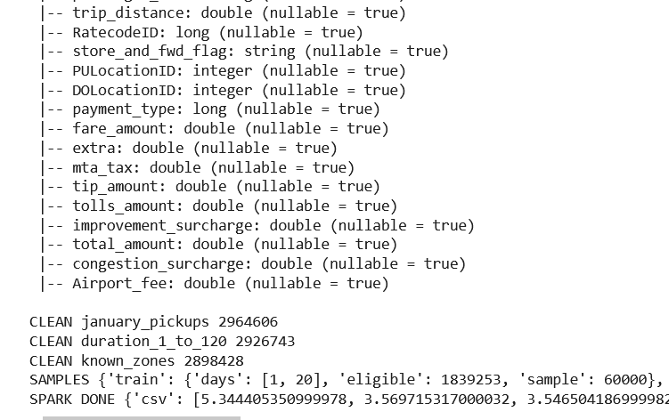
Figure 1 Spark preparation and storage experiment

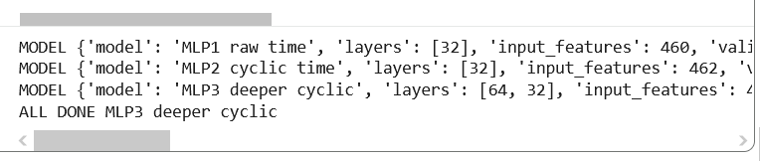
Figure 2 Baselines and iterative neural experiments

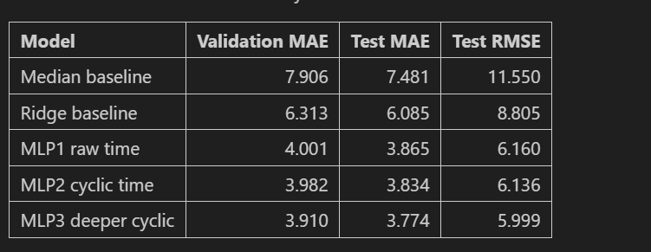
Figure 3 Recorded results

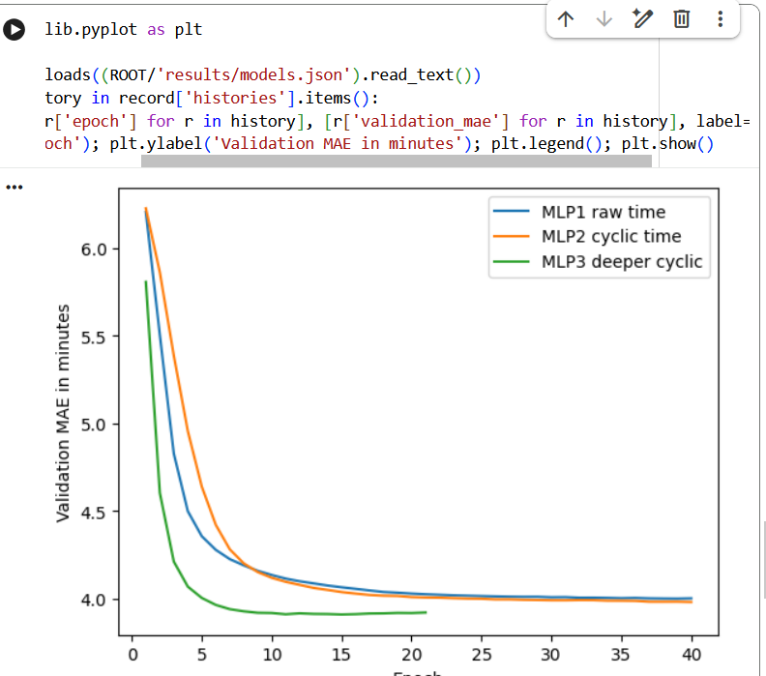
Figure 4 Visual Inspection after running

