
Assessment Cover Page
Student Full Name | Dashzeveg Purevtogtokh
Student Number | 2026328
Module Title | Machine Learning
Assessment Title | CA1 - Apartment Asking Price Prediction in Mongolia
Lecturer/Supervisor | Dr. Muhammad Iqbal
Assessment Due Date | 15 November 2026
Date of Submission | 15 November 2026, 23:59
GitHub Link | https://github.com/2026328-Dashzeveg-Purevtogtokh/Machine-Learning-Sep26
Google Drive Link (If required)

1. Introduction and aim
Apartment asking prices can vary a lot in Mongolia. Size, location and building year may help explain these differences. I worked with real listings collected from Unegui.mn. My aim was to estimate apartment asking prices in Mongolian tugrik (MNT), compare two regression models and find which features matter most. I used regression because price is a continuous number. These are advertised prices, not confirmed selling prices (Unegui.mn, 2026).

2. Dataset and preprocessing
The raw dataset had 3,771 listings and 31 columns. I used an Excel reference with 254 apartment names to identify the residential complex from listing text. This matched 976 records. I then cleaned missing values, standardised category names, checked unusual prices and areas, removed invalid floor details and applied IQR outlier filters. The final dataset had 876 rows and 17 columns. For modelling, I used four features: rooms, building_year, area_m2 and complex_name_clean.
Table 1. Dataset Cleaning Summary
Data stage | Records
Original records | 3,771
Matched complex names | 976
Final cleaned records | 876

For model training, I selected four features to predict apartment prices.
Table 2. Selected Features
Feature Name | Description
rooms | Number of rooms in the apartment
building_year | Year the building was constructed
area_m2 | Apartment size in square metres (m²)
complex_name_clean | Cleaned name of the apartment or residential complex
The target variable was price_mnt, which represents the advertised apartment price in Mongolian tugrik (MNT).

During model comparison, I used a preprocessing pipeline. It fills missing numerical values and uses one-hot encoding for apartment names inside cross-validation. This reduces leakage from the validation folds. Some earlier cleaning steps were done before splitting, which is a limitation discussed later.

3. Exploratory data analysis
Exploratory Data Analysis (EDA) was used to understand the dataset and identify patterns in apartment prices. I compared apartment prices across different districts and examined the relationship between apartment size and price. The results showed that Khan-Uul had the highest median asking price in the cleaned dataset. The analysis also suggested that larger apartments generally had higher asking prices. This indicates that apartment size and location may be important factors in price prediction. However, the number of listings was different across districts, which may affect the comparison. Therefore, these results should be interpreted carefully.
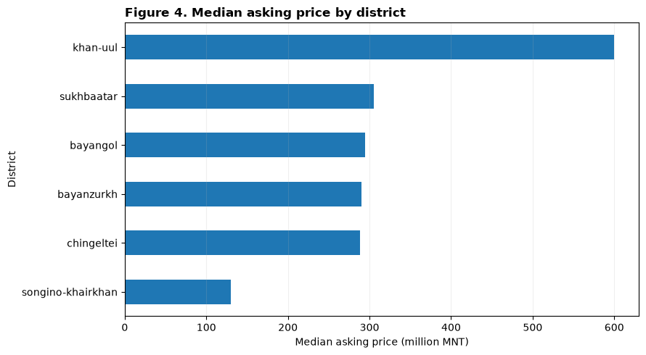
Figure 1. Median asking price by district, from the notebook. (Million MNT)

4. Model comparison and cross-validation
I selected Linear Regression as a simple baseline and Random Forest to capture more complex patterns. Each model used the same four features. I trained both models with 5%, 15% and 25% of the data, using five-fold cross-validation in each training set. I measured MAE, RMSE and R². Lower MAE and RMSE mean smaller errors; higher R² means the model explains more variation in prices.
Train size | Rows | Linear CV MAE | Forest CV MAE | Linear R² | Forest R²
5% | 43 | 87.43M | 95.08M | 0.387 | 0.316
15% | 131 | 62.15M | 71.80M | 0.881 | 0.804
25% | 219 | 56.34M | 58.34M | 0.898 | 0.872

Both models became better when they had more training records. Linear Regression had lower validation MAE at all three sizes. At 25%, it reached an MAE of 56.34 million MNT and an R² of 0.898. The 5% experiment had only 43 training records and much weaker results.
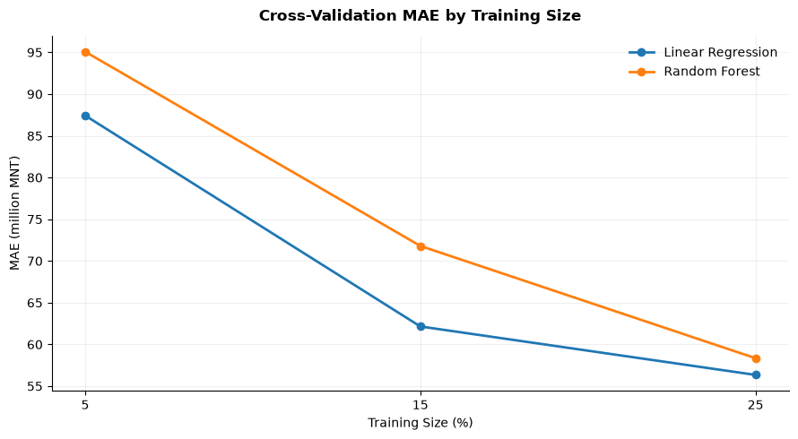
Figure 2. Five-fold CV MAE by training size; lower is better.

5. Hyperparameter tuning
The purpose of hyperparameter tuning is to find useful model settings before final testing. I used GridSearchCV on the 25% training split (219 rows) and kept 657 rows for testing. The search compared fit_intercept for Linear Regression and n_estimators, max_depth and min_samples_leaf for Random Forest. The best settings were chosen using validation MAE.
Model | Best settings | CV MAE | CV R²
Linear Regression | fit_intercept=True | 56.34M | 0.8981
Random Forest | Full values: confirm in notebook | 58.34M | 0.8723

Linear Regression remained the best choice by cross-validation MAE. The scores did not clearly improve after this parameter search. Random Forest's complete best-parameter dictionary is not visible in the saved output and must be checked before submission.
6. Final test results and error analysis
After tuning, I evaluated the selected Linear Regression model on 657 held-out records. Its test MAE was 60.05 million MNT, RMSE was 87.31 million MNT and R² was 0.8940. The validation R² was 0.8981, which is close to the test result. This suggests reasonable generalisation, although the prediction error is still large in MNT.
Final model | Test MAE | Test RMSE | Test R²
Linear Regression | 60.05 million MNT | 87.31 million MNT | 0.8940

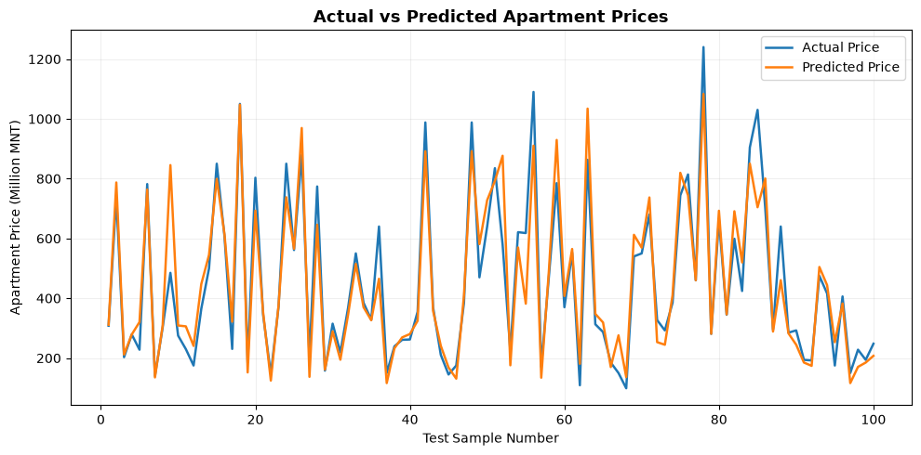
Figure 3. Actual and predicted prices for the first 100 test records.

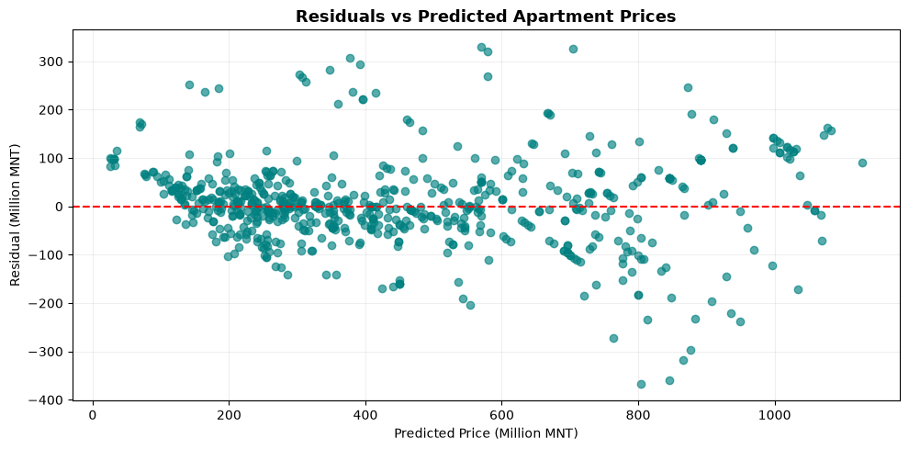
Figure 4. Residuals against predicted prices for the held-out test set.
The lines are often close, but some apartments have large differences. The residual plot also shows several large errors for expensive properties. For example, the model predicted 399.37 million MNT for a 56 m², two-room apartment built in 2019 in the King Tauer complex. This is a model estimate, not a verified market value.
7. Feature importance, limitations and conclusion
In a separate 80/20 Random Forest baseline, area_m2 had 80.40% of the model's impurity-based importance, followed by complex_name_clean at 15.37%. This suggests that size was especially useful for that model, but feature importance does not prove cause and effect. Its test R² was 0.9333. This result should not be directly compared with the tuned model because the training and testing splits were different.
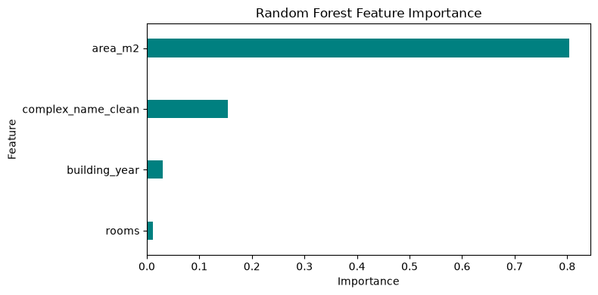
Figure 5. Feature importance for the separate Random Forest baseline.
There are some limits to this work. Many advertisements were excluded because a complex name could not be identified. As a result, the final dataset may not represent every apartment in Mongolia. Also, room filling and IQR limits were calculated before splitting the data, so some information may have affected later model evaluation. A future version should fit these steps using training data only and test on a new independent sample.
In conclusion, Linear Regression gave the lowest cross-validation MAE in the 5%, 15% and 25% experiments. It also gave a similar R² score on the held-out test set. The model can give a useful first estimate of asking prices, but it should not replace a professional property valuation.

References
Pedregosa, F. et al. (2011) ‘Scikit-learn: Machine learning in Python’, Journal of Machine Learning Research, 12, pp. 2825–2830.
Unegui.mn (2026) Apartment listings [online]. Available at: https://www.unegui.mn/

