────────────────────────────────────────
CA1 - Statistical Analysis of Credit Card Default Data
Statistical Techniques for Data Analysis
──────
Student Full Name: | Dashzeveg Purevtogtokh
Student Number: | 2026328
Module Title: | Statistical Techniques for Data Analysis
Assessment Title: | CA1 – Statistical Analysis of Credit Card Default Data
Lecturer / Supervisor: | Taufique Ahmed
Assessment Due Date: | 25 October 2026
Date of Submission: | 01 November 2026
GitHub Repository: | https://github.com/2026328-Dashzeveg-Purevtogtokh/Statistical-Techniques-Sep26

Student Signature: ______________________________ | Date: ______________

1. Introduction
This report analyses the Default of Credit Card Clients dataset using statistical techniques in Python. The dataset was developed from credit card customers in Taiwan and contains 30,000 records with demographic, credit, repayment, bill, payment and default information (Yeh, 2009). The main purpose of this report is to describe the dataset clearly and apply Binomial, Poisson and Normal distributions to suitable variables. The analysis also compares the observed data with theoretical distributions and explains the limitations of each model.
The dataset was selected because it contains both categorical and numerical variables. This matches the CA1 requirement for a mixed dataset and allows different statistical methods to be demonstrated. All calculations and visualisations were completed in Python, and the full code is provided in the accompanying Jupyter Notebook.

2. Dataset Overview and Data Quality
The dataset contains 30,000 rows and 25 columns when the identifier and target variable are included. Important categorical variables are sex, education, marriage and default status. Important numerical variables include credit limit, age, monthly bill amounts and previous payment amounts. The default variable is binary, where 0 represents no default and 1 represents default in the following month.
A data quality check found no missing values and no exact duplicate rows. Therefore, major cleaning was not required. However, the repayment-status variables are coded variables rather than normal continuous measurements, so they were treated carefully during the analysis. The column names were standardised in Python to make the code easier to read.

3. Descriptive Statistics and Visual Analysis
Descriptive statistics were calculated for credit limit, age, first bill amount and first payment amount. The average credit limit was 167,484, while the median was 140,000. Its skewness was 0.99, showing a positive skew. This means that most customers had lower or medium credit limits, while a smaller number had very high limits.
Customer age had a mean of 35.49 years, a median of 34 years and a standard deviation of 9.22 years. The skewness was 0.73, which indicates a moderate positive skew. Age was less skewed than the financial variables and was therefore a reasonable candidate for later Normal distribution analysis.
The first bill amount had a mean of about 51,223 and a median of about 22,382, with a skewness of 2.66. The first payment amount was even more strongly skewed. Its mean was 5,664, its median was 2,100 and its skewness was 14.67. These differences show that a small number of very large financial values strongly influenced the averages.
Variable | Mean | Median | Std. Dev. | Skewness
limit_bal | 167,484.32 | 140,000.00 | 129,747.66 | 0.99
age | 35.49 | 34.00 | 9.22 | 0.73
bill_amt1 | 51,223.33 | 22,381.50 | 73,635.86 | 2.66
pay_amt1 | 5,663.58 | 2,100.00 | 16,563.28 | 14.67
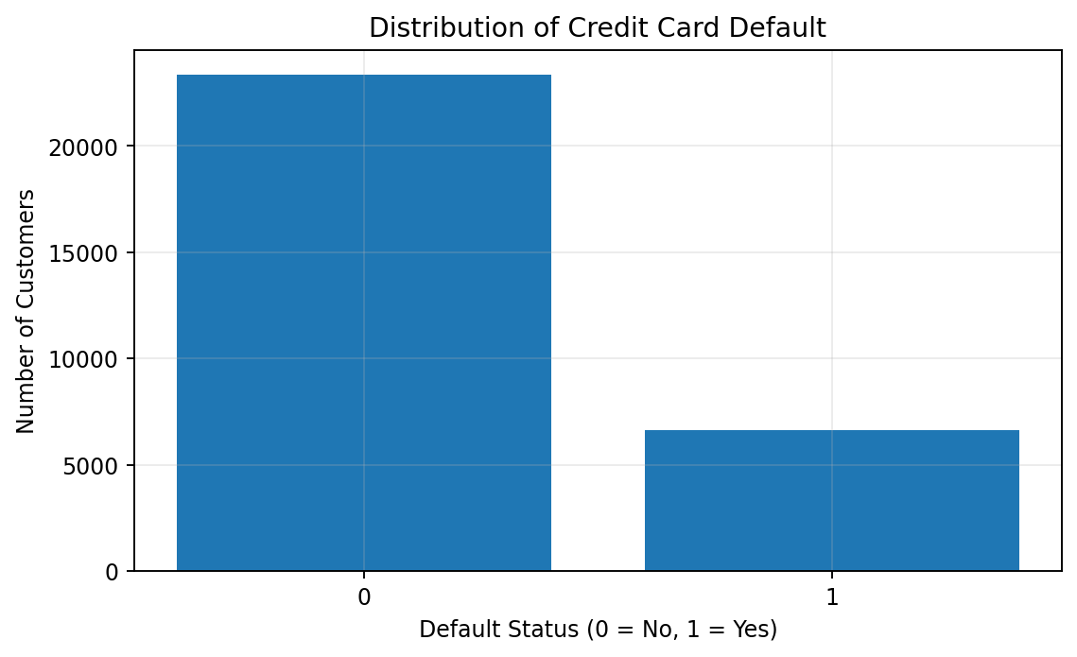
Figure 1. Distribution of credit card default.
The default graph shows a clear difference between the two classes. A total of 23,364 customers did not default and 6,636 customers defaulted. This gives an observed default rate of 22.12%, while 77.88% did not default. The age and credit-limit histograms also support the descriptive statistics by showing positive skewness in both variables.
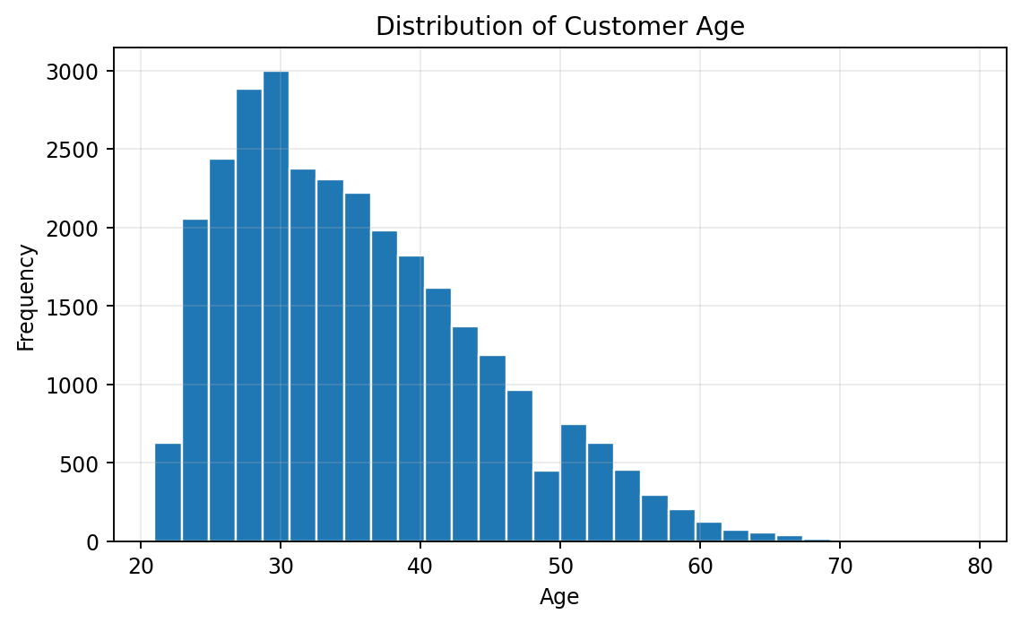
Figure 2. Distribution of customer age.
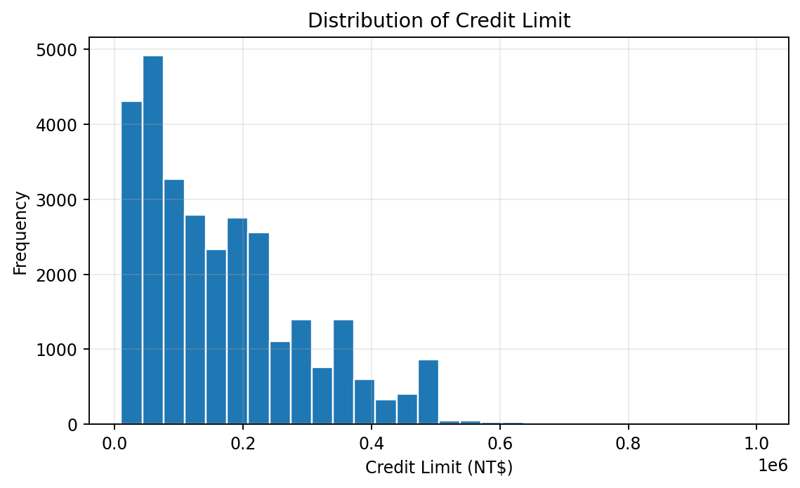
Figure 3. Distribution of customer credit limit.

4. Binomial Distribution
The Binomial distribution was applied to the default variable because each customer has two possible outcomes: default or no default. The observed probability of default was p = 0.2212. For a group of 10 customers, the expected number of defaults is np = 10 × 0.2212 = 2.212. The probability of exactly three defaults was approximately 0.2257. The probability graph also showed that outcomes around two or three defaults were the most likely.
A larger sample of 100 customers was then examined. The expected number of defaults increased to 22.12. The distribution became smoother and more bell-shaped around this value. This is important because a Binomial distribution can approach a Normal shape when the number of trials is large and the probabilities are not too close to zero or one. The result demonstrates the effect of sample size using the observed default probability from the dataset.
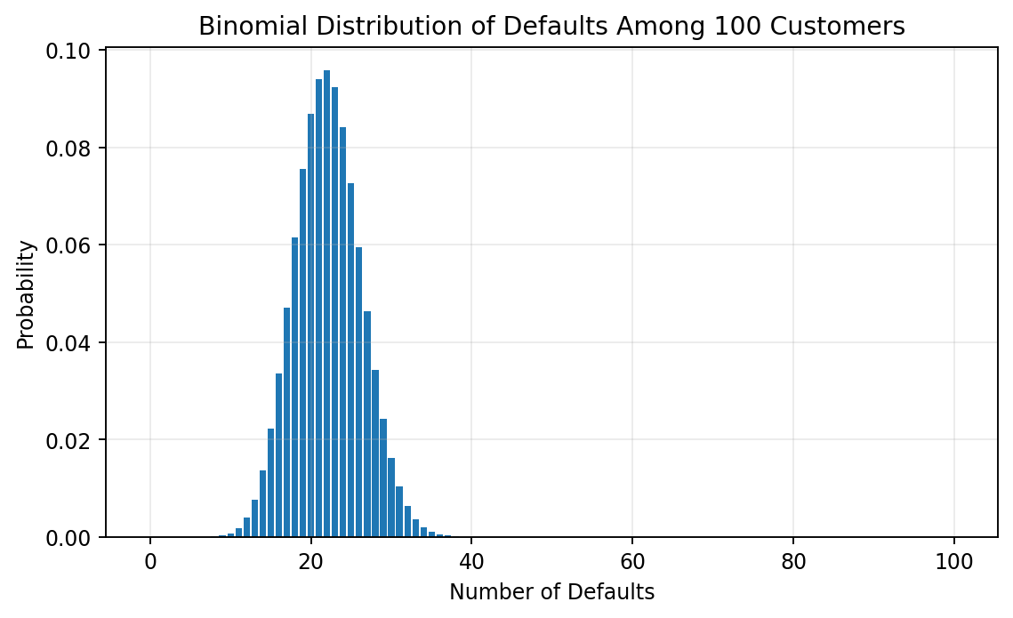
Figure 4. Binomial distribution for 100 customers.

5. Poisson Distribution
For the Poisson analysis, a new variable called late_payment_count was created from the six repayment-status months. A month was counted as late when the repayment-status code was greater than zero. The new variable ranged from 0 to 6. The average count was 0.8342, which was used as the Poisson parameter λ.
The observed distribution was then compared with the fitted Poisson probabilities. The model did not fit the data closely. For zero late-payment months, the observed probability was 0.6644, while the Poisson model predicted about 0.4342. The model also predicted almost no customers with six late-payment months, while the observed value was 0.0447. This difference is clearly visible in Figure 5.
This result shows an important limitation of the model. Poisson data are normally expected to represent event counts with a stable average rate and independent events. Late-payment behaviour may be related across months, because a customer who is late in one month may also be late in the next month. The count is also limited to six months. Therefore, the Poisson distribution is useful for exploring the count variable, but it is not a close model of the observed repayment behaviour.
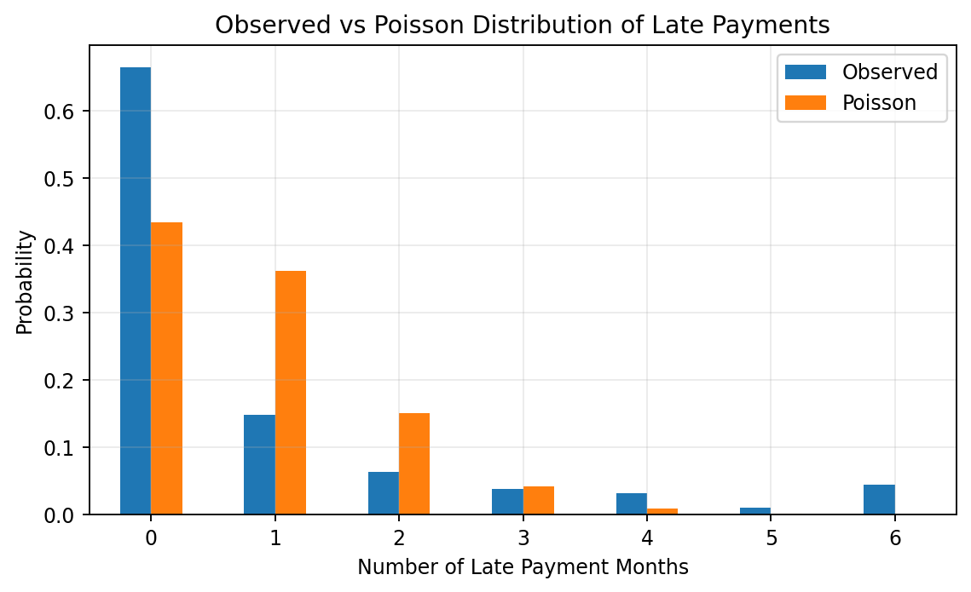
Figure 5. Observed late-payment probabilities compared with the fitted Poisson distribution.

6. Normal Distribution
Age was selected for the Normal distribution because it is continuous and was less skewed than the selected financial variables. The mean age was 35.49 years and the standard deviation was 9.22 years. The histogram with a fitted Normal curve showed that the centre of the age distribution was reasonably close to a Normal shape, but the data had a longer right tail.
The Q-Q plot supported this finding. If age were perfectly Normal, the points would follow the reference line closely. In this dataset, the middle points were reasonably close to the line, but there were differences at the lower and upper ages. Therefore, age should not be described as perfectly normally distributed. It is more accurate to describe it as approximately Normal in the centre with positive skewness overall.
A probability example was used to compare the Normal model with the real data. The fitted Normal model estimated that 41.20% of customers were aged between 30 and 40. The observed proportion was 40.36%. The difference was only 0.84 percentage points. This shows that the Normal model gives a useful approximation for this central age range, even though it does not fully describe the whole distribution.
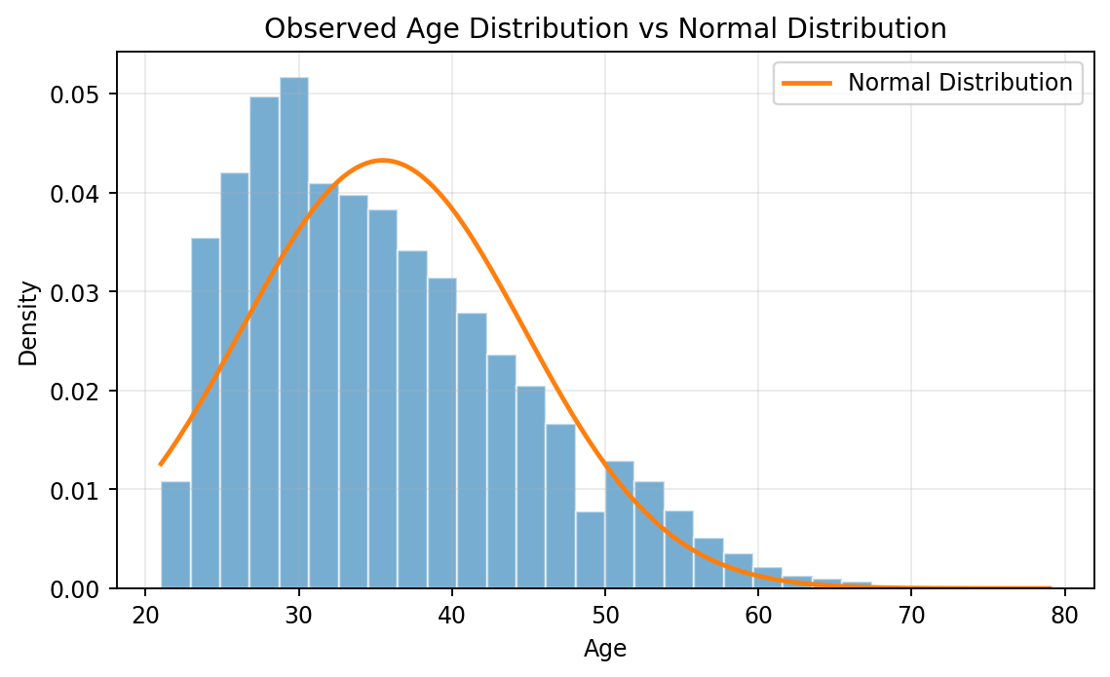
Figure 6. Observed age distribution with fitted Normal curve.
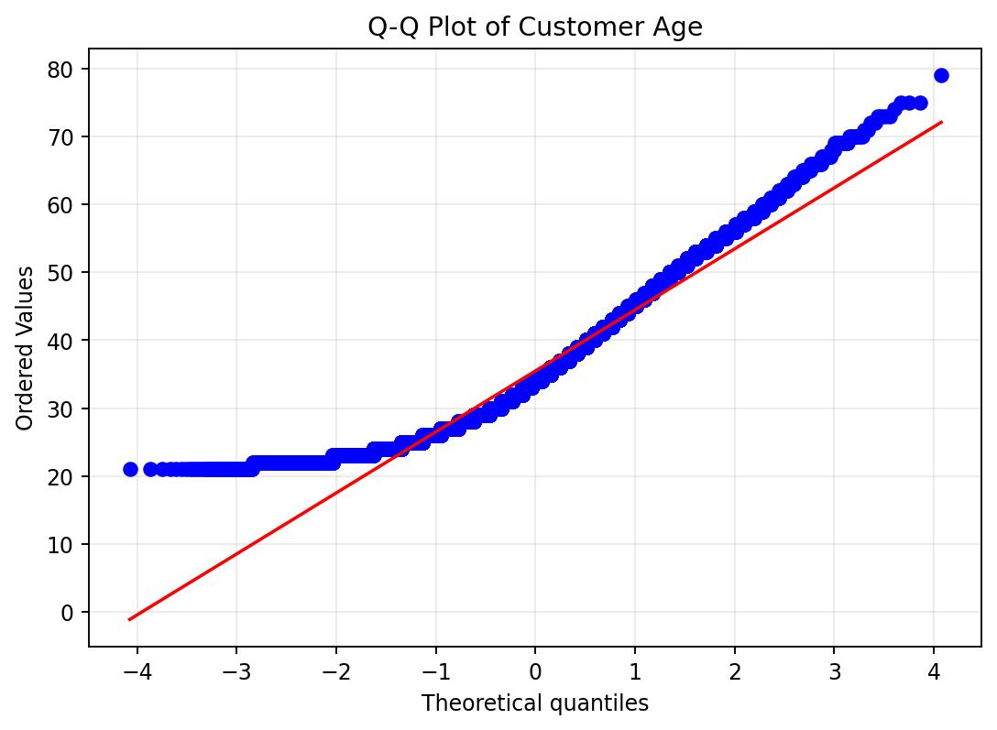
Figure 7. Q-Q plot of customer age.

7. Comparison and Importance of the Distributions
The three distributions were selected because they represent different variable types. The Binomial distribution was the most natural choice for default because it is a binary variable. The Poisson distribution was used for late-payment counts because it is designed for count data, although the observed results showed that its assumptions were not fully met. The Normal distribution was used for age because age is continuous and had a shape closer to Normal than the financial variables.
The variables used for the discrete distributions should not be directly treated as Normal variables in this analysis. Default only contains 0 and 1, while late_payment_count contains integer values from 0 to 6. These variables do not have the continuous range expected for a Normal distribution. However, the distribution of the total number of defaults in a large Binomial sample can become approximately Normal, as shown in the 100-customer example.
Distribution | Variable | Type | Parameter | Result
Binomial | default | Binary discrete | p = 0.2212 | Good conceptual fit
Poisson | late_payment_count | Count discrete | λ = 0.8342 | Weak observed fit
Normal | age | Continuous | μ = 35.49, σ = 9.22 | Reasonable central approximation

8. Conclusion
The analysis showed that the credit default dataset contains clear statistical patterns and different variable types. Descriptive statistics identified positive skewness in the main financial variables. The Binomial distribution provided a clear model for the binary default outcome and showed how the distribution becomes smoother with a larger sample. The Poisson analysis demonstrated that a theoretical distribution may not always fit real behaviour, especially when events are dependent or the count is bounded. The Normal analysis showed that age is not perfectly Normal but can still be approximated reasonably well in its central range. Overall, the results demonstrate why distribution choice should be based on the type, shape and behaviour of the variable rather than using one model for all data.

