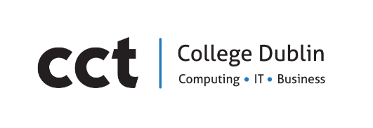

Assessment Cover Page
Student Full Name | Fabiana Scanferla Sandoval
Student Number
Sba24440
Module Title | Strategic Thinking
Assessment Title | Predictig Daily Product Demand To Reduce Overstock and Stockouts in a Small Online Retailer
Lecturer/Supervisor  Muhammad lqbal | Taufique Ahmed
Assessment Due Date
12/03/2026
Date of Submission | 25/10/26

Use of AI Tools
Choose the statement that fits your work and delete the other.
I acknowledge the use of [enter name of the AI tool you used] for the purpose of [provide a brief explanation of how you used the tool].
I have not used any AI tools or technologies in the preparation of this assessment

Student: Fabiana Scanferla
Declaration
By submitting this assessment, I confirm that I have read the CCT policy on academic misconduct and understand the implications of submitting work that is not my own or does not appropriately reference material taken from a third party or other source.
I declare it to be my own work and that all material from third parties has been appropriately referenced.
I further confirm that this work has not previously been submitted for assessment by myself or someone else in CCT College Dublin or any other higher education institution.

