

Assessment Cover Page
Student Full Name
Ariunzaya Enkhbold
Student Number
2026349
Module Title
Strategic Thinking
Assessment Title
CA1-Capstone Project Proposal
Lecturer/Supervisor
Taufique Ahmed
Assessment Due Date/ Date of Submission
25/10/2026

Contents
Introduction 1
Problem Definition 1
Aim and Objectives 1
Project Scope 2
Methodology 2
References 2
Appendix 3

Fashion Product Attributes, Sales Forecasting and Unsold Inventory Risk

Introduction

One of the main challenges in fashion retail is accurately predicting product demand. Poor forecasts can lead to excess inventory. This project analyses fashion product attributes and purchasing data to forecast demand and explore potential risks from unsold stock. The findings aim to support better demand planning, product selection, and inventory management decisions.

Problem Definition

Changing fashion trends and customer preferences make product demand difficult to predict. Purchase data can provide useful insights into customer buying behaviour. This project evaluates how these data can support better-informed decisions on demand planning and inventory management in fashion retail.

Aim and Objectives

The aim of this project is to analyse purchase data and product information to identify product patterns and forecast demand.
The objectives are to:
- Explore purchase and product data and prepare them for analysis.
- Identify sales trends and low demand product categories through exploratory data analysis.
- Examine relationships between product attributes and customer buying behaviour.
- Develop and evaluate a suitable Machine Learning model to forecast product demand.
- Use the findings to support demand forecasting and inventory planning.

Project Scope
This project focuses on analysing purchase and product data from the H&M Personalized Fashion Recommendations dataset. Python and related data analysis libraries will be used to identify low demand product categories and explore relationships between products and purchases. As the data lack actual unsold stock, inventory levels, production volumes, and storage costs, the project will examine how sales and product attributes can support demand forecasting and inventory planning.

Methodology

The methodology consists of the following stages:
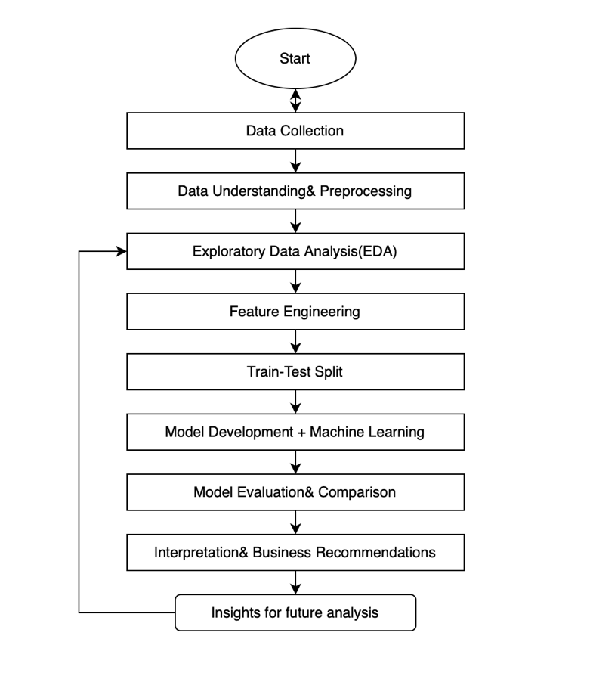

References

Please list all the references you have used in your assignment alphabetically and in the Harvard style. You can find information on how to correctly reference in Harvard at this link: https://library.cct.ie/referencing/harvard

Appendix

If you have used AI tools in your work, you must include screenshots of your requests in the appendix.
The appendix serves as a repository for additional or supplementary information that is deemed too extensive or detailed for integration into the main body of the text. This supplementary content can encompass data tables, charts, graphs, questionnaires, or any other supporting materials that contribute to a comprehensive understanding of the research.
If you haven't used AI tools and there's no need for supplementary data, you can remove the appendix section entirely.

