

Student Full Name
Ariunzaya Enkhbold
Student Number
2026349
Module Title
Strategic Thinking
Assessment Title
AI Declaration
Lecturer/Supervisor
Taufique Ahmed
Assessment Due Date/ Date of Submission

25/10/2026
Use of AI Tools

I acknowledge the use of Grammarly and ChatGPT for the purpose of improving spelling, grammar and clarity, brainstorming project ideas, planning the assignment structure, and finding information to identify a suitable dataset.
Declaration
By submitting this assessment, I confirm that I have read the CCT policy on academic misconduct and understand the implications of submitting work that is not my own or does not appropriately reference material taken from a third party or other source.
I declare it to be my own work and that all material from third parties has been appropriately referenced.
I further confirm that this work has not previously been submitted for assessment by myself or someone else in CCT College Dublin or any other higher education institution.

Appendix A:

Grammar checking
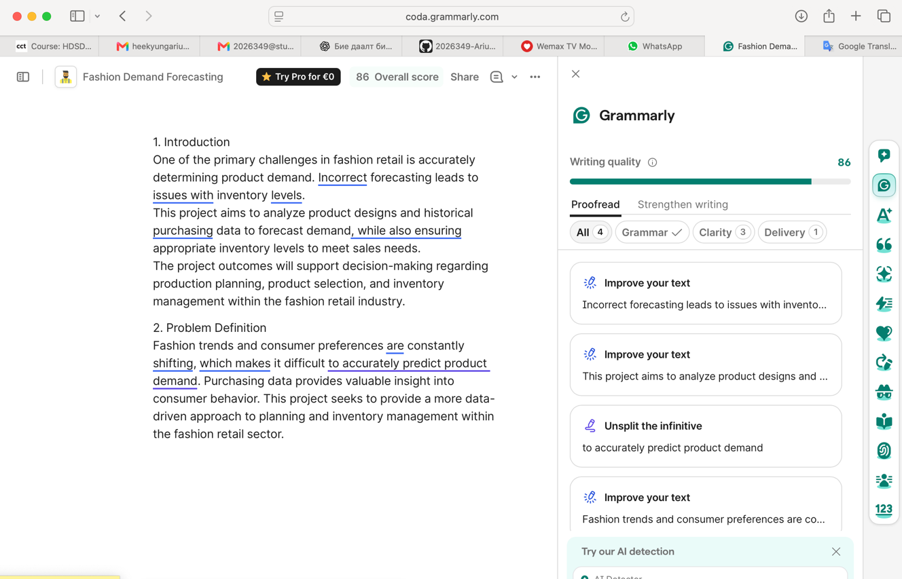

Appendix B: Writing and Translation Support

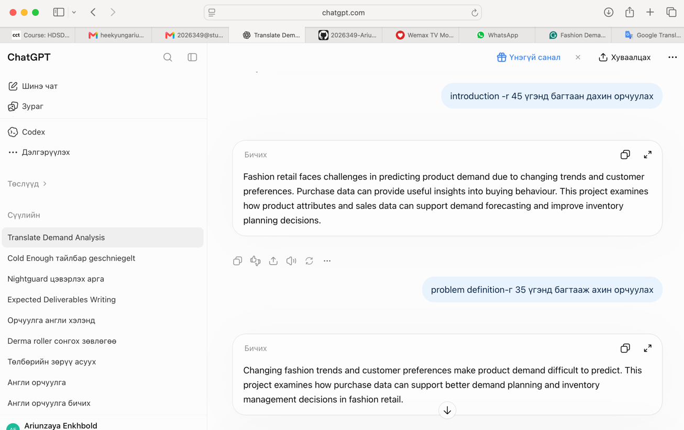

Appendix C: Project planning
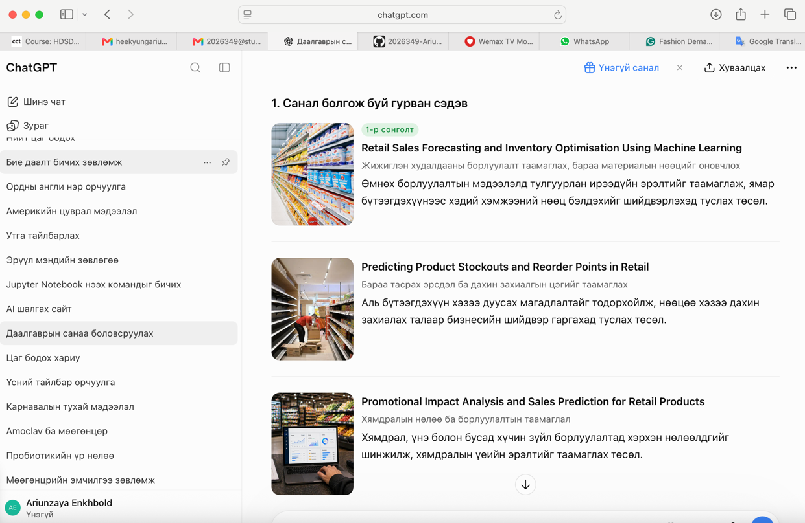
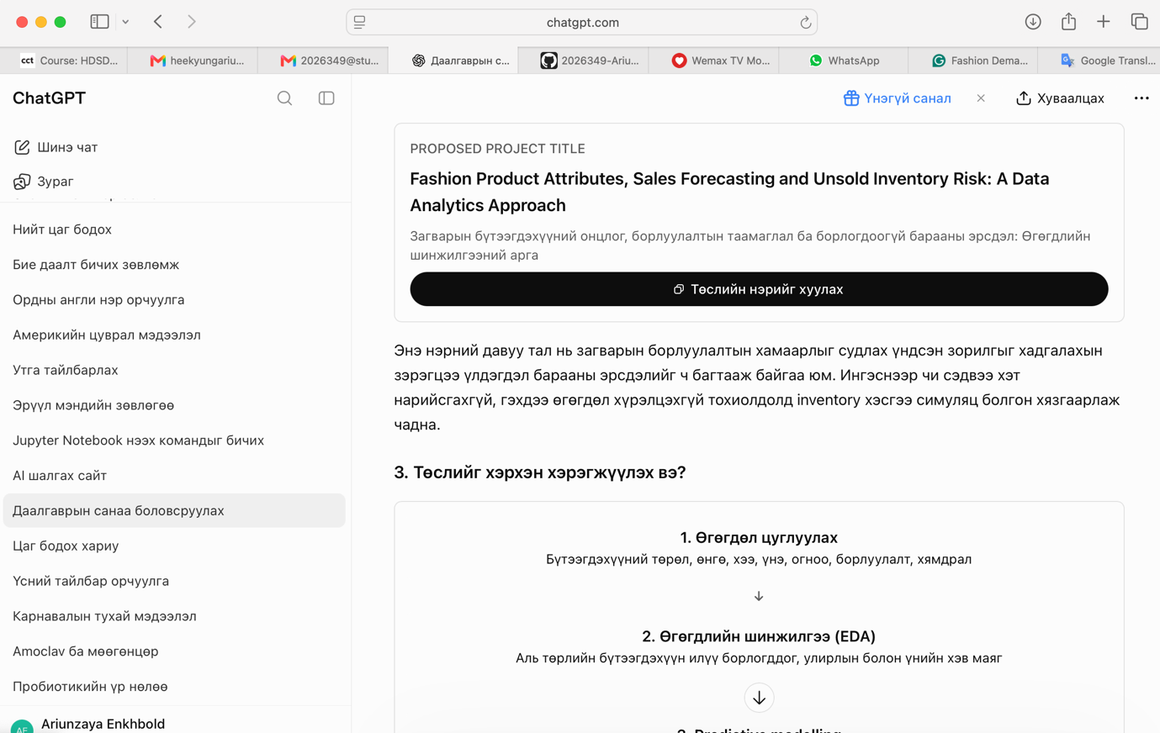

Appendix D: Dataset research

