

Assessment Cover Page
Student Full Name
Silvia Elena Solano Marchini
Student Number
2026362
Module Title
Machine learning
Assessment Title
Machine Learning for Businness
Lecturer/Supervisor
Muhammad lqbal
Assessment Due Date
15/11/2026
Date of Submission
15/11/2026

Use of AI Tools

I acknowledge the use of Gemini and Grammarly for the purpose of checking some mistakes and the meaning of some codes and for checking the orthography.
Declaration
By submitting this assessment, I confirm that I have read the CCT policy on academic misconduct and understand the implications of submitting work that is not my own or does not appropriately reference material taken from a third party or other source.
I declare it to be my own work and that all material from third parties has been appropriately referenced.
I further confirm that this work has not previously been submitted for assessment by myself or someone else in CCT College Dublin or any other higher education institution.

Contents
Introduction 1
Chapter 1 1
Chapter 1.1 1
Chapter 1.1.1. 1
References 2

[NOTE: The table of contents above has been included for your convenience. To refresh the table, simply click on it, then select 'Update Table' using the mouse. You can choose to update either the page numbers exclusively or the entire table as needed.]

Introduction

This project focuses on the Health sector; the dataset was sourced from UCI.
The dataset is: Estimation of Obesity Levels Based on Eating Habits and Physical Condition (Unknown, 2019).
This dataset includes data for the estimation of obesity levels from Mexico, Peru and Colombia, based on their eating habits and physical condition. Contains 17 attributes and 2111 records.
This project addresses a multiclass supervised learning problem to predict 7 weight categories, from insufficient weight to obesity type III. The machine learning was implemented with exploratory data analysis, categorical feature encoding, Z-score standardisation, and comparison across 3 paradigms: Support Vector Classifier (SVC), K-Nearest Neighbors (KNN) and Random Forest (RF).
Four questions for the project:
- What are the most important predictor features (X) for classifying obesity levels (y)?
- Which classification approach is preferred for predicting the target variable (y), and does it outperform alternatives?
- How do varying train_test splits (5%, 15%, and 25%) and hyperparameter tuning impact generalisation?
- Why is dimensionality reduction important in this specific case, and where does class overlap occur?

Characterisation of the dataset

Import and verification

Import dataset
The dataset imported is called: ObesityDataSet_raw_and_data_sinthetic.csv, using pd.read_csv().

Head, Tail and Shape
The first step was to verify the data integrity, rows and columns. The dataset contains categorical and numerical variables such as Gender and Age. Besides, .shape demonstrated that the dataset contains 2111 rows and 17 columns.
The target variable for this project is NObeyesdad, because is the feature which has the different types of obesity and it is implicate whit all the rest of the data.

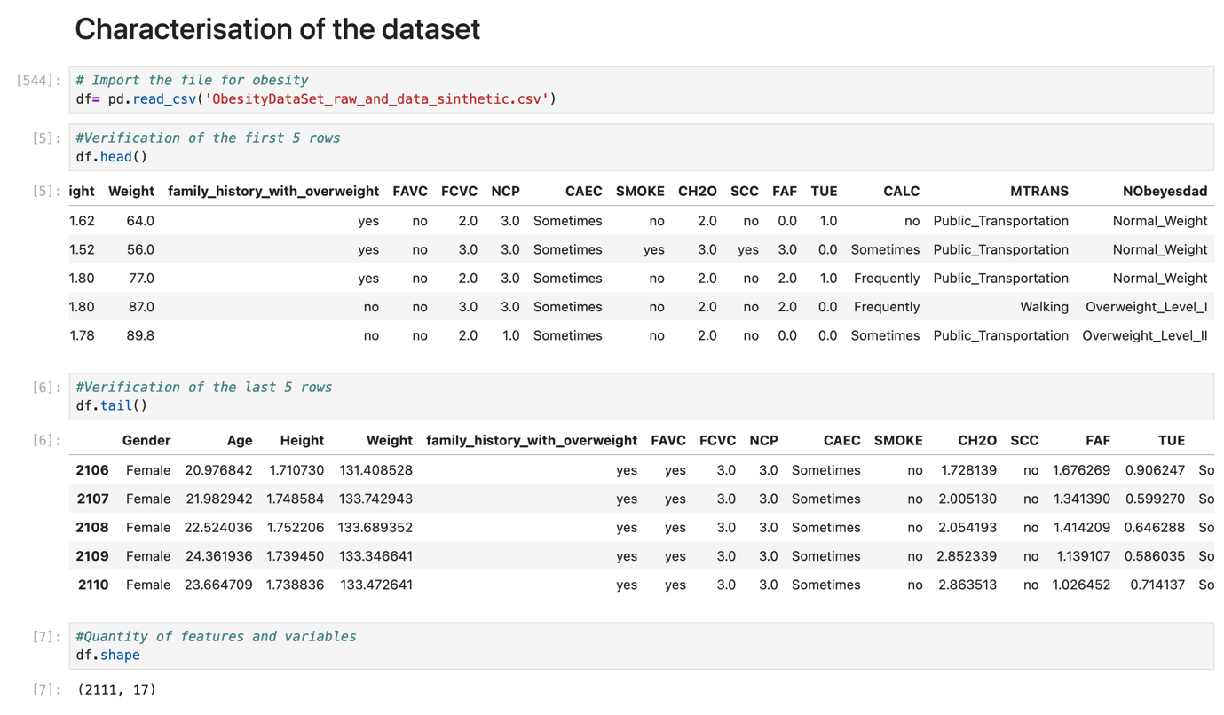

Application of Data Preparation

Evaluations methods and EDA

Missing values
The output confirmed zero missing values per feature; therefore, the dataset does not need imputation or row deletion.

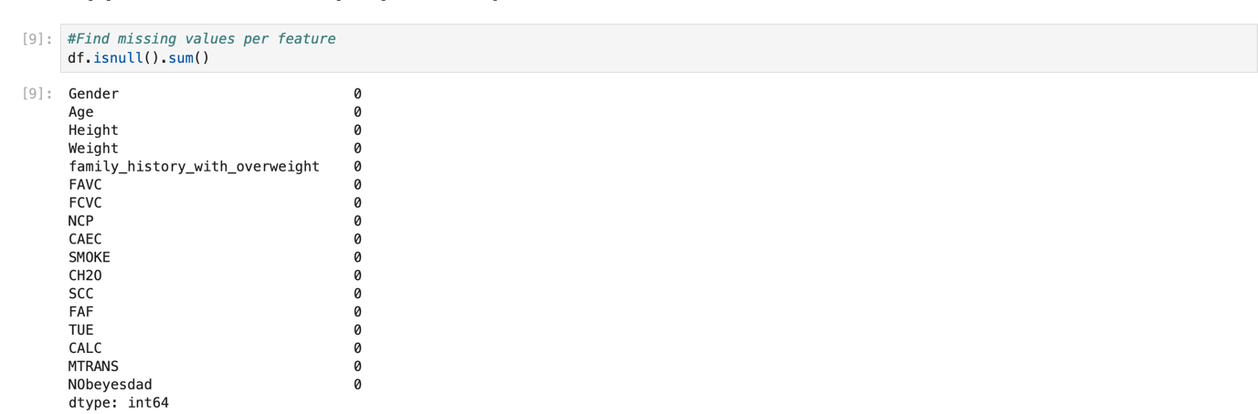

Describe
Describe checks the performed on the dataset, like metrics of central tendency in all the numerical features, for instance:
- Age: mean is 24.31, which means the adults are younger.
- Height: mean is 1.70, with the range from 1.45 to 1.98 cm.
- Weight: mean is 86.5, with the range from 39 to 173 kg.
- Lifestyle: such as FCVC (Frequency of Consumption of Vegetables), NCP (Number of Main Meals) and CH2O (Consumption of Water Daily), with a minimum of 1 and a maximum of 3-4.
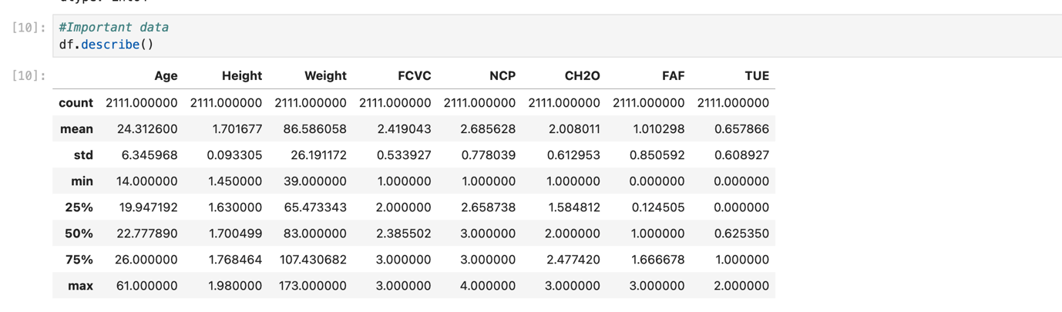

Histograms
For the histograms the features selected were Age, Height and Weight because are the factors which can determinate the obesity in people.
- Age: is right-skewed, with some peaks at 18, 21 and 26.
- Height: is a multimodal distribution, with some peaks around 1.62 and 1.76.
- Weight: is a multimodal distribution, with some peaks around 80 and 118.
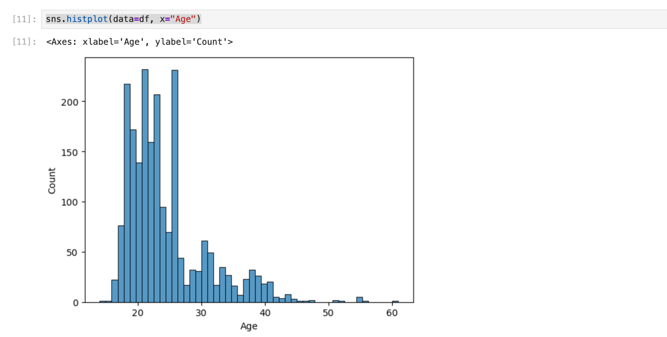

Unique values
The dataset had a double-check for null values in the 8 quantitative features.

Feature Encoding
Due to the project focusing on using 2-3 machine learning models, every categorical variable must be converted to numerical.
- NObeyesdad: define as a target_map contains 7 categories (Insufficient_Weight, Normal_Weight, Overweight_level_I, Overweight_level_II, Obesity_type_I, Obesity_type_II, Obesity_type_III).
- Binary_map: all the variables whose answer was no (0) or yes (1) (family_history_with_overweight, FAVC, SMOKE, SCC)
- Gender: has its own category with female and male (0-1)
- Ordinal_map: all the variables whose answer was no (0), sometimes (1), frequently (2) and always(3) (CAEC and CALC)
- MTRANS: is mapped numerically from 0 – 4 (Public_transport, Walking, Automobile, Motorbike and Bike)
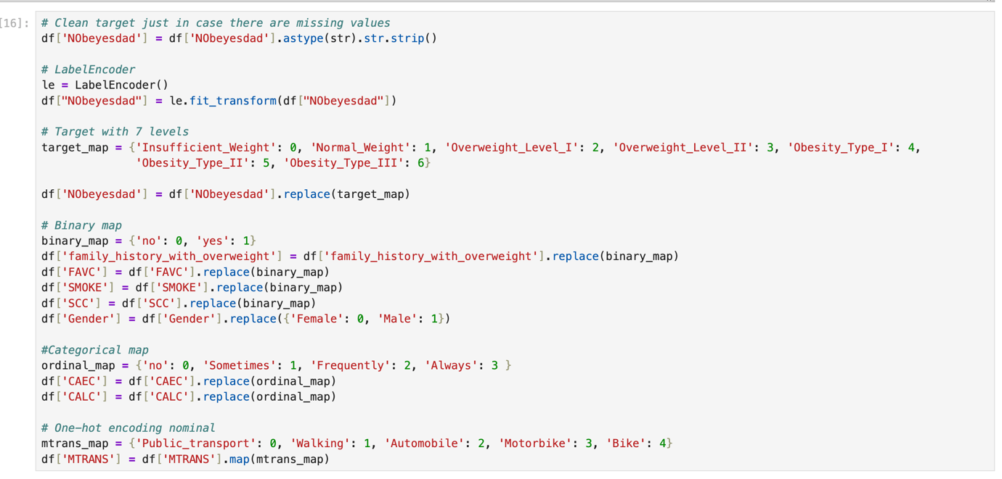

Continuous variables analysis
8 quantitative features (Age, Height, Weight, FCVC, NCP, CH2O, FAF, TUE) were converted to numeric format via .apply(pd.to_numeric, errors= “coerce”).
- Age: right- skewed pattern, with a peak between 18 and 25 years, with almost 490 observations.
- Height: nearly normal distribution, with a cluster between 1.60 cm and 1.80 cm, with a peak around 1.74 - 1.76.
- Weight: multimodal distribution from 40kg to 170 kg, with a prominent peak around 80 kg – 86 kg.
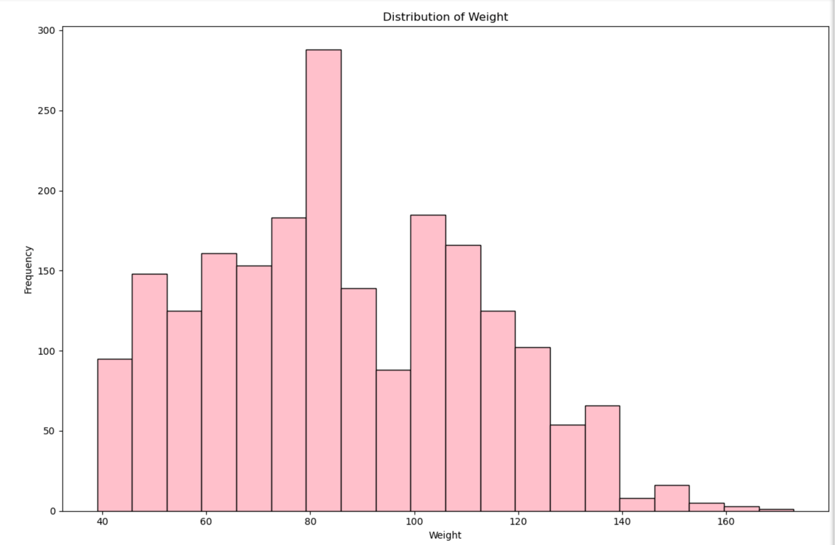

Discrete and Encoded variables analysis
13 discrete and encoded features ('Gender', 'family_history_with_overweight', 'FAVC', 'FCVC', 'NCP', 'CAEC', 'SMOKE', 'CH2O', 'SCC', 'FAF', 'TUE', 'CALC', 'MTRANS').
- Family History with Overweight: pronounced a binary imbalance; more than 1.700 participants report a family history of overweight compared to fewer than 400 participants without, that is demonstrating a strong familial predisposition.
- Frequency of Consumption of Vegetables (FCVC): has 2 peaks near 2.0 and 3.0, which demonstrate a consumption of vegetables moderately or frequently.
- Mode of Transportation (MTRANS): has a strong peak at 2.0 with more than 450 observations, whereas walking (1.0), motorbike (3.0), or bike (4.0) have a smaller fraction of the population.
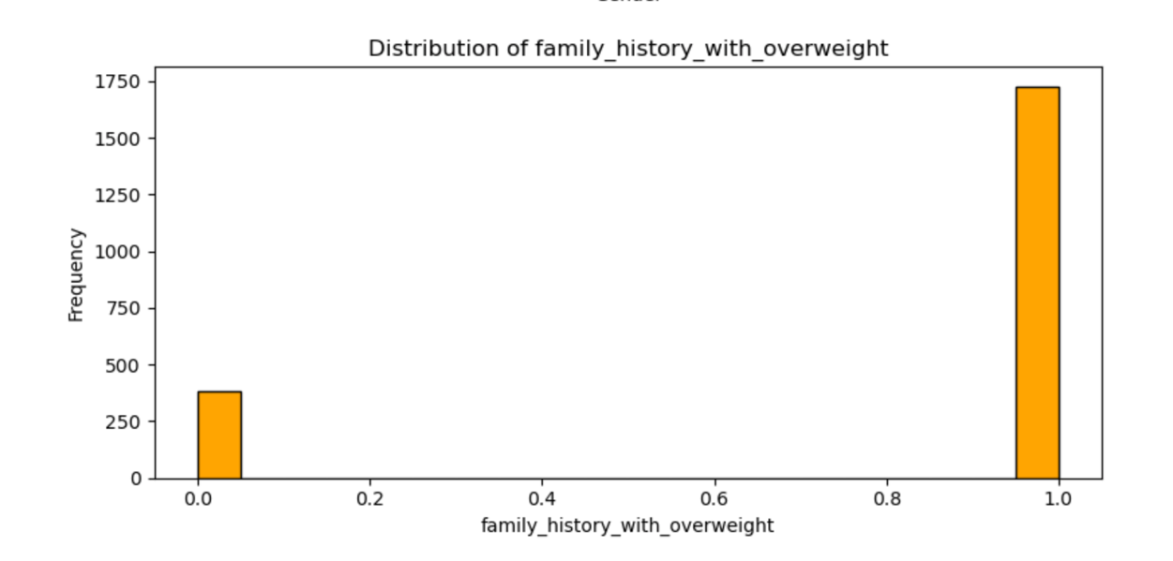

Boxplot
It uses a loop to iterate over the columns listed; it is used because it facilitates the evaluation of quartiles, medians and outliers.
- Number of Main Meals (NCP): is a display with a narrow IQR concentrated between 2.6 and 3.0, which means that consuming around 3 meals daily is the most frequent. Observations below 2.5 and above 3.5 are outliers.
- Daily Water Consumption (CH2O): the mean is exactly 2.0.
- Physical Activity Frequency (FAF): does not have any outliers; the mean sits at 1.0, also demonstrating low physical activity.
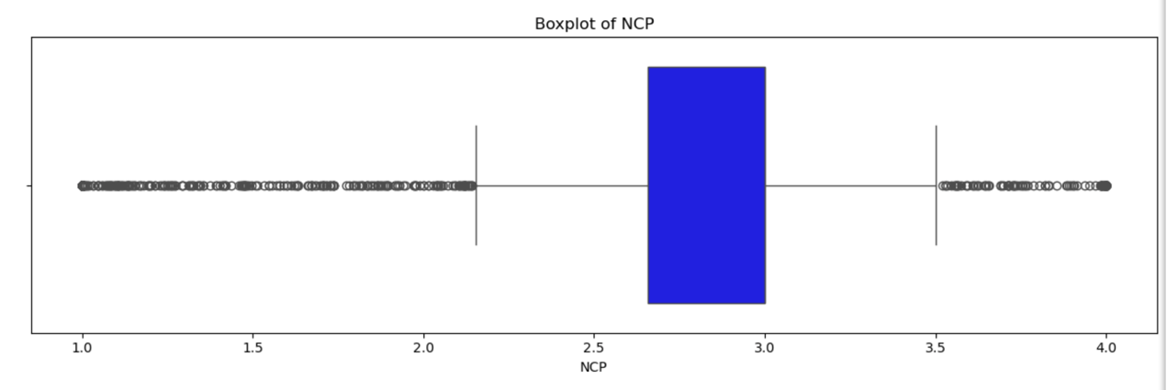

Heatmap
Correlations with the Target_variable (NObeyesdad):
- Weight and family_history_with_overweight: confirm that body mass and familial predisposition are primary drivers.
- Age and Weight: tend to be more prevalent; as age increases, weight also increases.
- Consumption of Food between Meals (CAEC) and target_variable: have a negative correlation.
Inter-Feature Correlations:
- Gender vs Height: with 0.62, demonstrates a high physiological difference between males and females.
- Weight vs Family_history_with_overweight: has a strong relationship with human biometrics. The same is happening with Weight vs Height.
- Age vs Time using technology (TUE): indicates that the younger participants spend more time using technological devices.
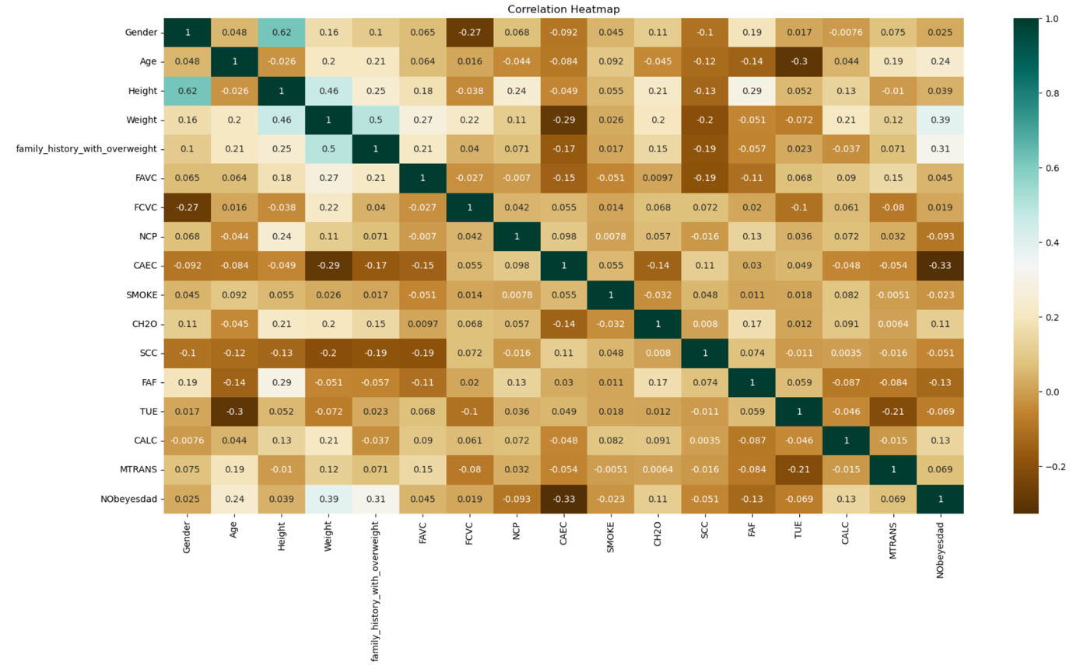

Systematic Dispersion Analysis
- CH20 vs Target_variable: the normal_weight contains integer values from 1.0 to 3.0, and the obesity_type_I presents higher point density in the intake range between 2.0 and 3.0.
- TUE vs Target_variable: class 1 of the target presents values from 0.0 to 2.0; class 4 has a distribution between 0.0 and 1.0, but classes 0, 2, 3, 5 and 6 extend the values until 2.0.
- MTRANS vs Target_variable: the category 2.0 has the highest cross-class across all the levels of obesity.

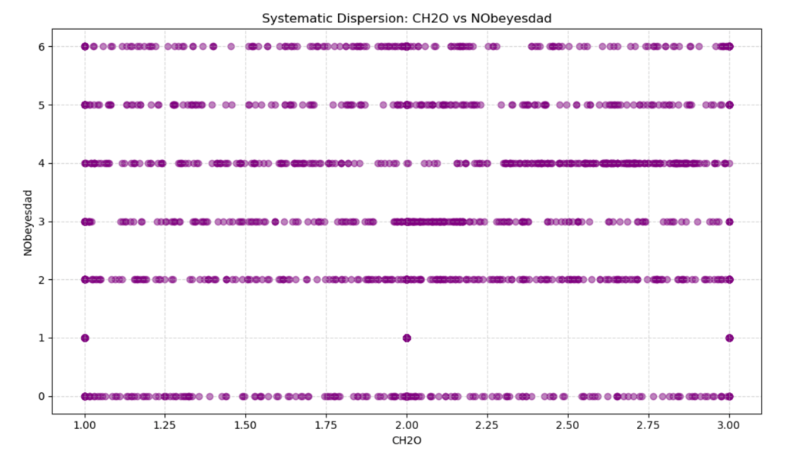

Z-Score
Comparing the standardised plots against the raw histograms confirms that linear Z-Score preserves the original distribution.
- Age: right-skewed, with a peak cluster between -1 and 0.
- Height: symmetric bell-shaped, centred at 0.
- Weight: multimodal structure around 0

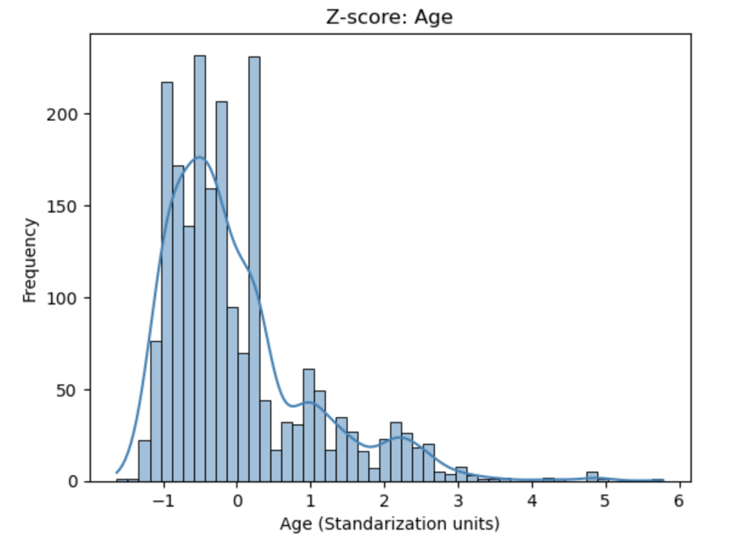

Supervised Learning

Data Splitting and Feature Scaling

Feature and target_variable
The dependent target variable (y) is NObeyesdad, and the independent predictor features (X) are all the features less the target_variable. Shape verification confirmed a feature of 2.100 rows and 15 columns paired with 2.111 elements in the target_variable.

5%, 15% and 25% Test-Train Splits
- 5% Test Split - 95% Train: 2.005 training samples and 106 testing samples.
- 15% Test Split - 85% Train: 1.794 training samples and 317 testing samples.
- 25% Test Split - 75% Train: 1.583 training samples and 528 testing samples.
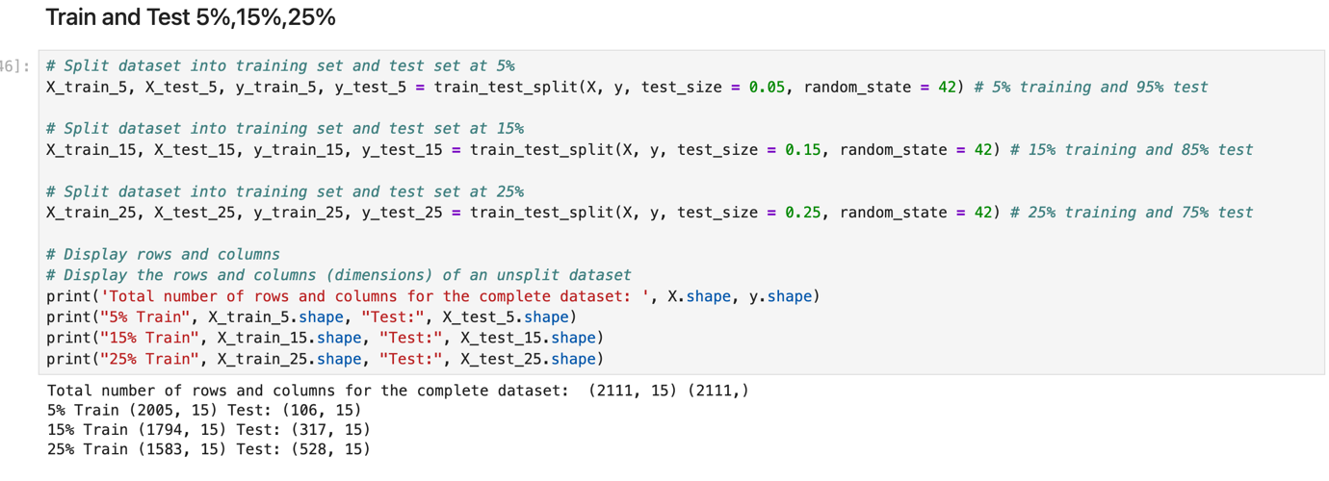

Scaling (StandardScaler)
The data was scaled on each training split (X_train_5, X_train_15, X_train_25) with each corresponding test (X_test_5, X_test_15, X_test_25).
To address 7 categories of obesity (NObeyesdad) across 15 features, 3 supervised models were selected:
- SVC is a multidimensional space, finding an optimal decision hyperplane; furthermore, testing linear and rbf kernels allows evaluating whether standardised obesity is linearly separable or needs a non-linear mapping.
- KNN is a non-parametric but learning-based classifier that classifies according to their Euclidean proximity to K; it was selected to benchmark how the distance metrics behave in 15 variables combining continuous and encoded categorical.
- RF was chosen for 3 important points: strong resistance to overfitting, modelling complex non-linear relationships, and model explainability.

SVC (Support Vector Classifier)

Implementation and Evaluation

Classification Report with 25% Test
SVC were trained using radial (rbf) and linear (cls_svc= SVC (kernel=” linear”)).
The linear classifier achieved an Accuracy of 0.952 with weighted precision of 0.954, recall of 0.952 and an F1 score of 0.952. Class 4 F1 scores of 0.99 and precision of 1.00, class 2 and 3 F1 score of 0.97 each one and class 1 F1 score of 0.90 and the recall of 0.83.

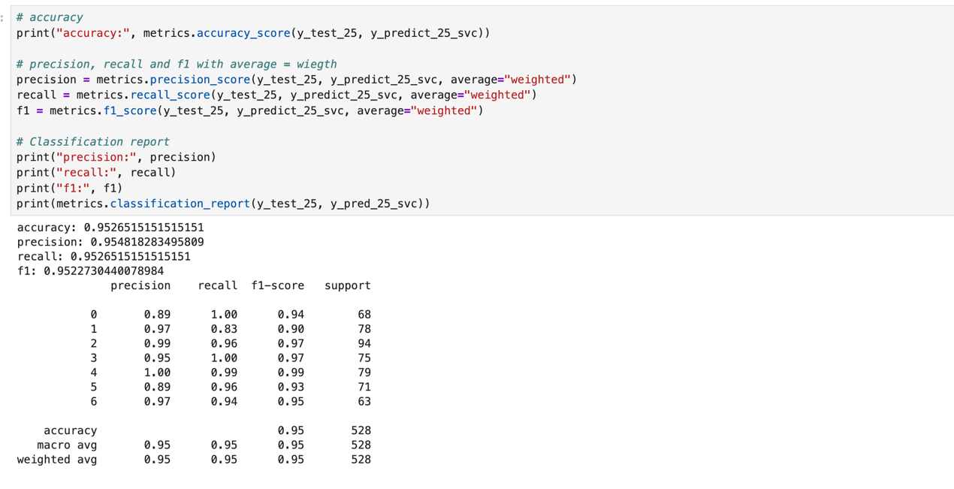

Confusion Matrix with 25% Test
Comparing y_test_25 against y_predict_25_svc reveals a diagonal with 503 correct predictions out of 528 test samples.
- 8 instances of class 1 were predicted as class 0.
- 5 instances of class 1 were predicted as class 5.
- Classes 0 and 3 achieved 100% recall.
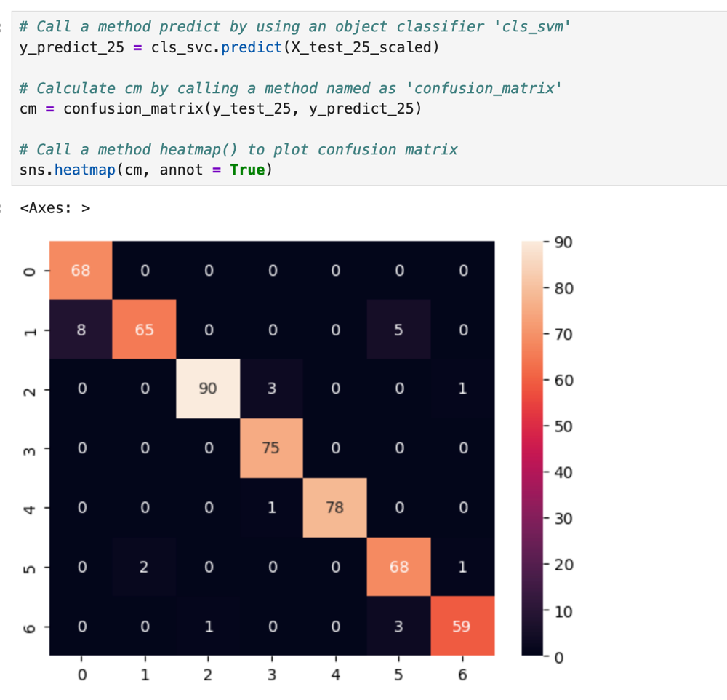

Hyperparameters across 5%, 15% and 25%
The hyperparameters configuration was {“C”: 100, “gamma”: “scale”, “kernel”: “linear”}.
- 5% split: accuracy 96.56%
- 15% split: accuracy 96.38%
- 25% split: accuracy 95.89%
This confirms that obesity is strongly linearly separable in the standardised feature space.
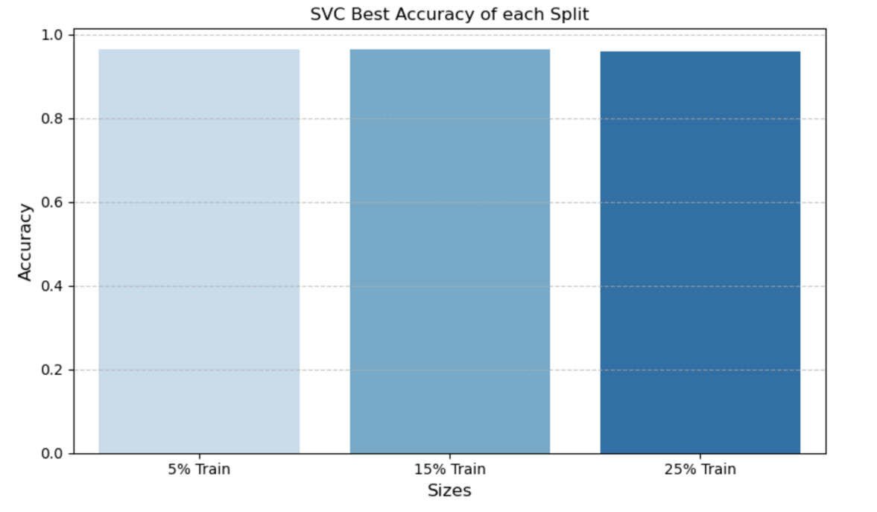

Cross-Validation across 5%, 15% and 25%
To verify the model with 5-fold cross-validation.
- 5% split: accuracy 0.952
- 15% split: accuracy 0.945
- 25% split: accuracy 0.941
The low std (≤0.0102) confirms strong stability across the model.
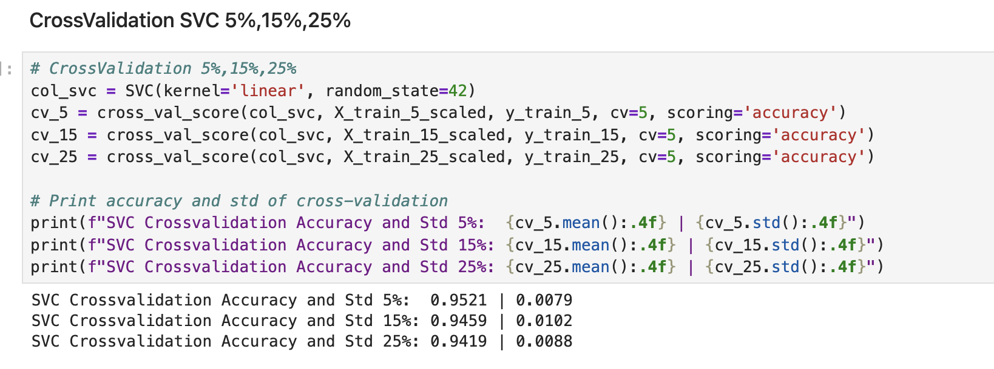

KNN (K-Nearest Neighbor)

Implementation and Evaluation

Classification Report with 25% Test
KNN classifier was initialised with k=3
The base model achieved an Accuracy of 0.81 with a weighted F1 score of 0.80. It shows an extreme obesity tier Class 4 F1 score of 0.99 and recall of 1.00; Class 3 F1 score of 0.93 and Class 1 F1 score of 0.56 and recall of 0.47, revealing a drop.
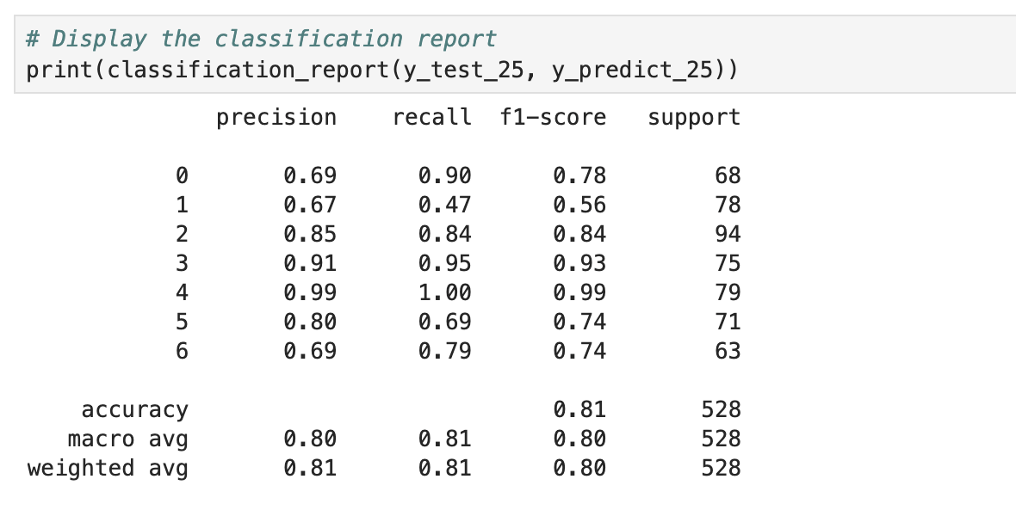

Confusion Matrix with 25% Test
Comparing y_test_25 against y_predict_25_svc reveals a diagonal with 426 correct predictions out of 528 test samples.
- 37 instances of class 1 were predicted incorrectly.
- 49 instances of class 5 were predicted correctly.
- 18 instances of class 1 were predicted as class 0.
- 11 instances of class 5 were predicted as class 1.

- 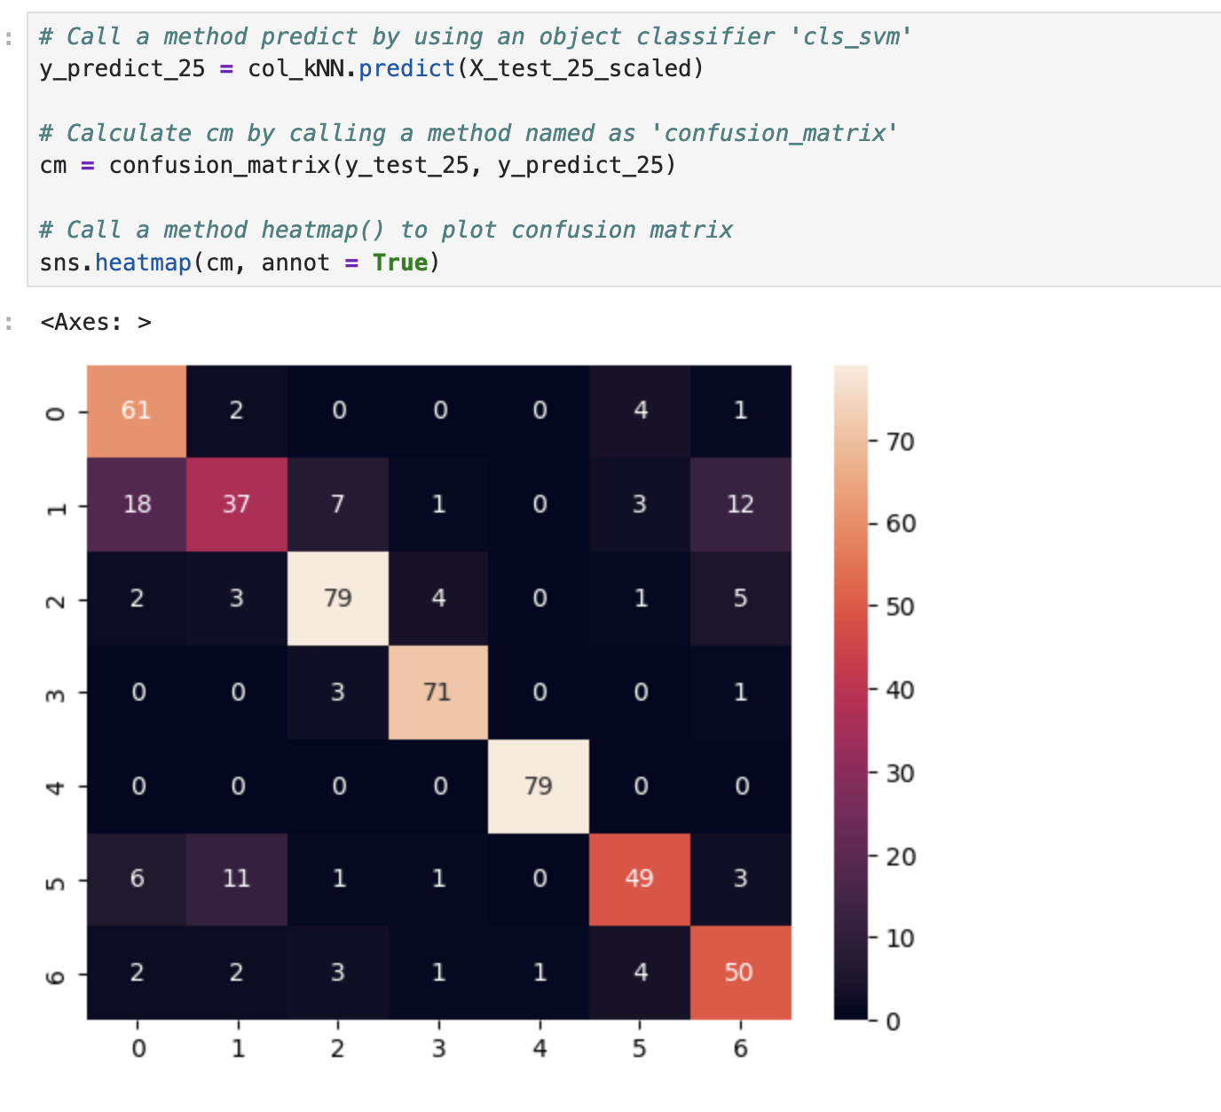

Hyperparameters across 5%, 15% and 25%
The hyperparameters configuration across k values from 1 to 10. K=1: train accuracy 100% (overfitting) meanwhile testing around 80%.
- 5% split k=6: accuracy approximately 83%
- 15% split k=5: accuracy approximately 83%
- 25% split k=4: accuracy approximately 82%
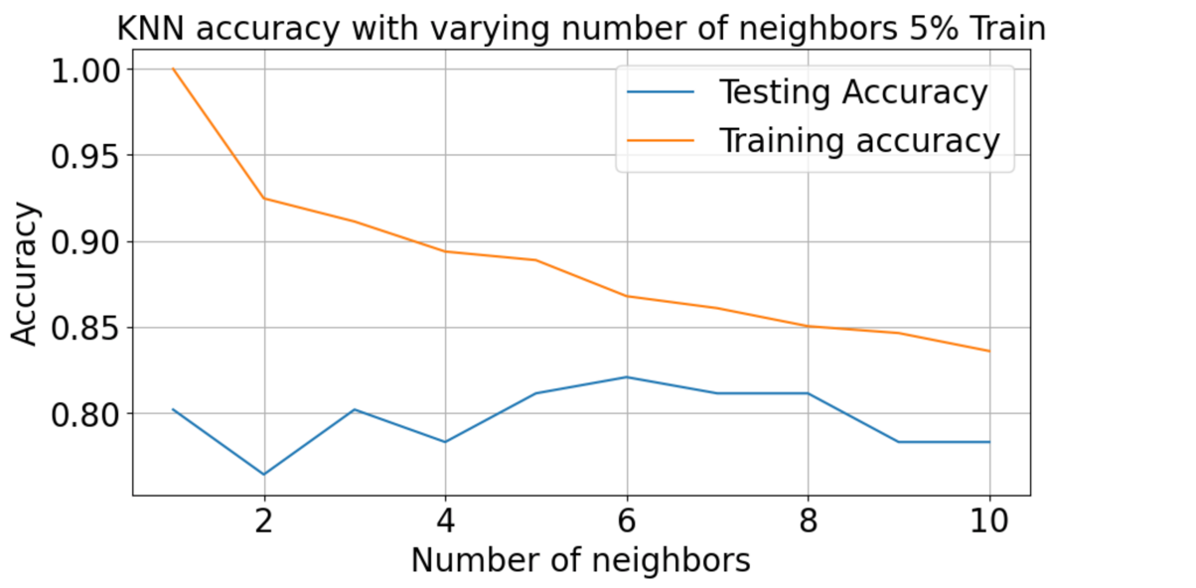

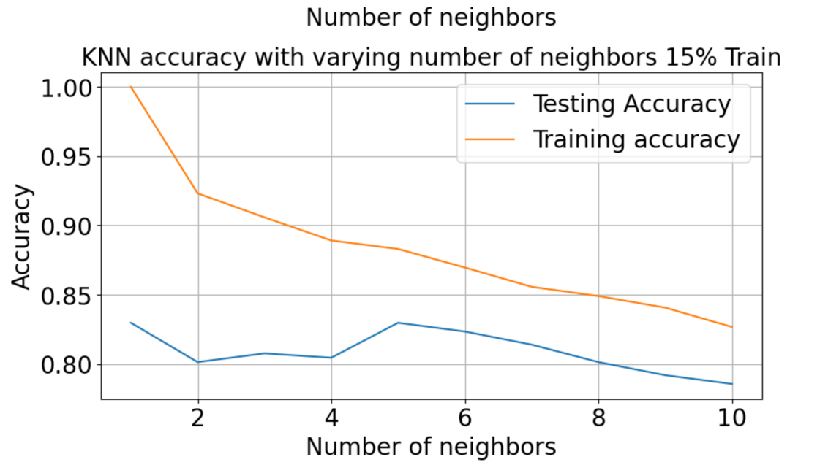

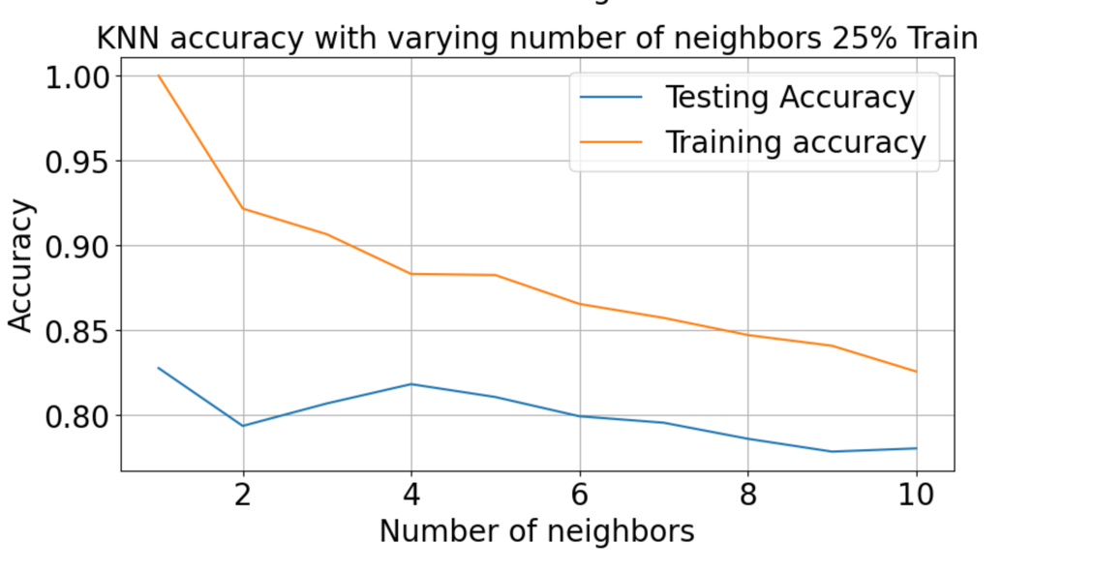

Cross-Validation across 5%, 15% and 25%
To verify the model with 5-fold cross-validation.
- 5% split: accuracy 0.79
- 15% split: accuracy 0.79
- 25% split: accuracy 0.80
KNN generalisation ceiling remains around 80%.
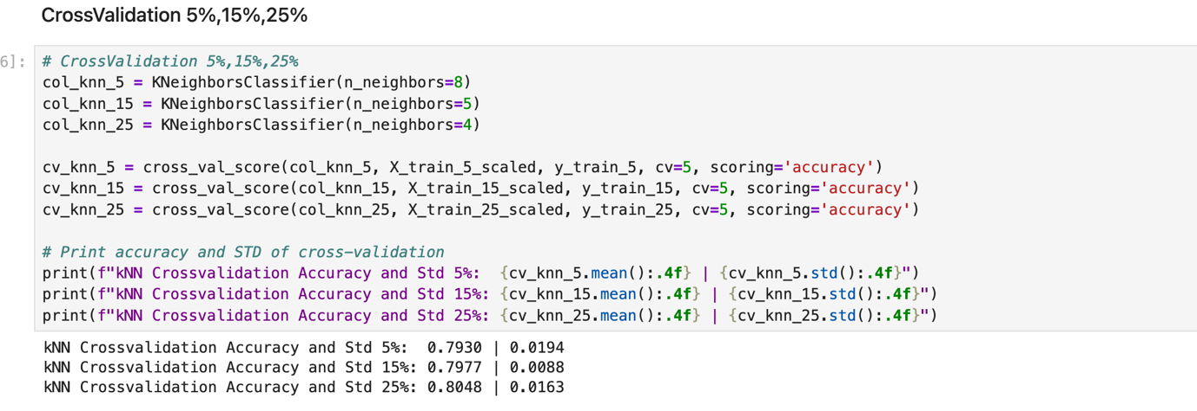

RF (Random Forest)

Implementation and Evaluation

Classification Report with 25% Test
RF was constructed using RandomForestClassifier(n_estimators=1000).
The baseline model achieved an Accuracy of 0.937.
Gini importance scores were extracted and sorted in descending order. Weight (3) accounts for 0.3171 of the total feature importance; Age (1) accounts for 0.1036 of the total feature importance; Height (2) accounts for 0.1002 of the total feature importance.

Confusion Matrix with 25% Test
Comparing y_test_25 against y_predict_25_svc reveals a diagonal with 495, confirming accurate predictions out of 528.
- 78 instances of class 4 out of 79 were predicted correctly.
- 74 instances of class 3 out of 75 were predicted correctly.
- 9 instances of class 5 were predicted as class 1.
- 5 instances of class 0 were predicted as class 1.

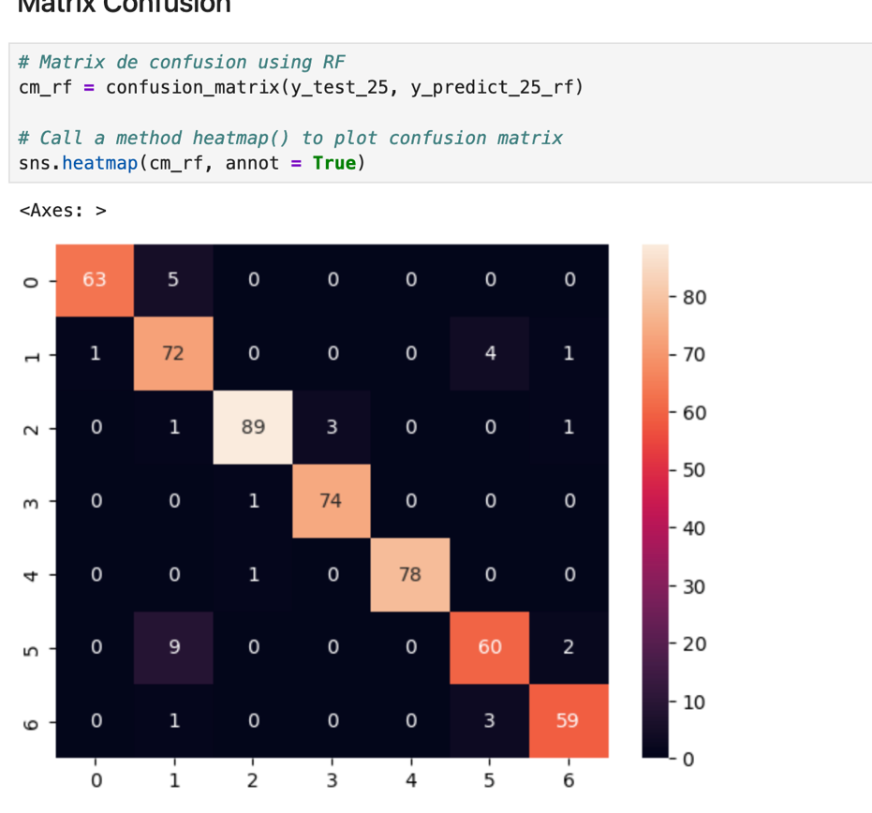

Hyperparameters across 5%, 15% and 25%
The hyperparameters across the 3 splits with the configuration {"criterion”: “entropy”, “max_depth”: “None”, “n_estimators”: 200}. Leveraging information gain using entropy with unrestricted tree depth.
- 5% split: accuracy approximately 95.46%
- 15% split: accuracy approximately 95.54%
- 25% split: accuracy approximately 95.58%
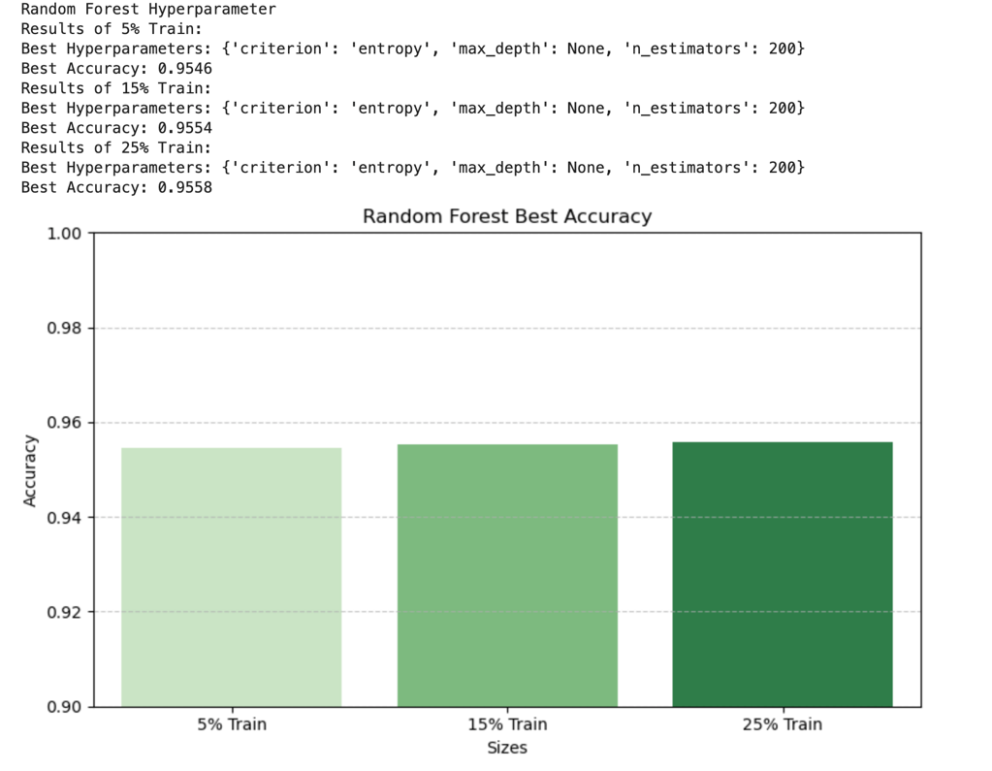

Cross-Validation across 5%, 15% and 25%
To verify the model with 5-fold cross-validation.
- 5% split: accuracy 0.948
- 15% split: accuracy 0.944
- 25% split: accuracy 0.949
Std. deviation below 1% confirms overfitting.
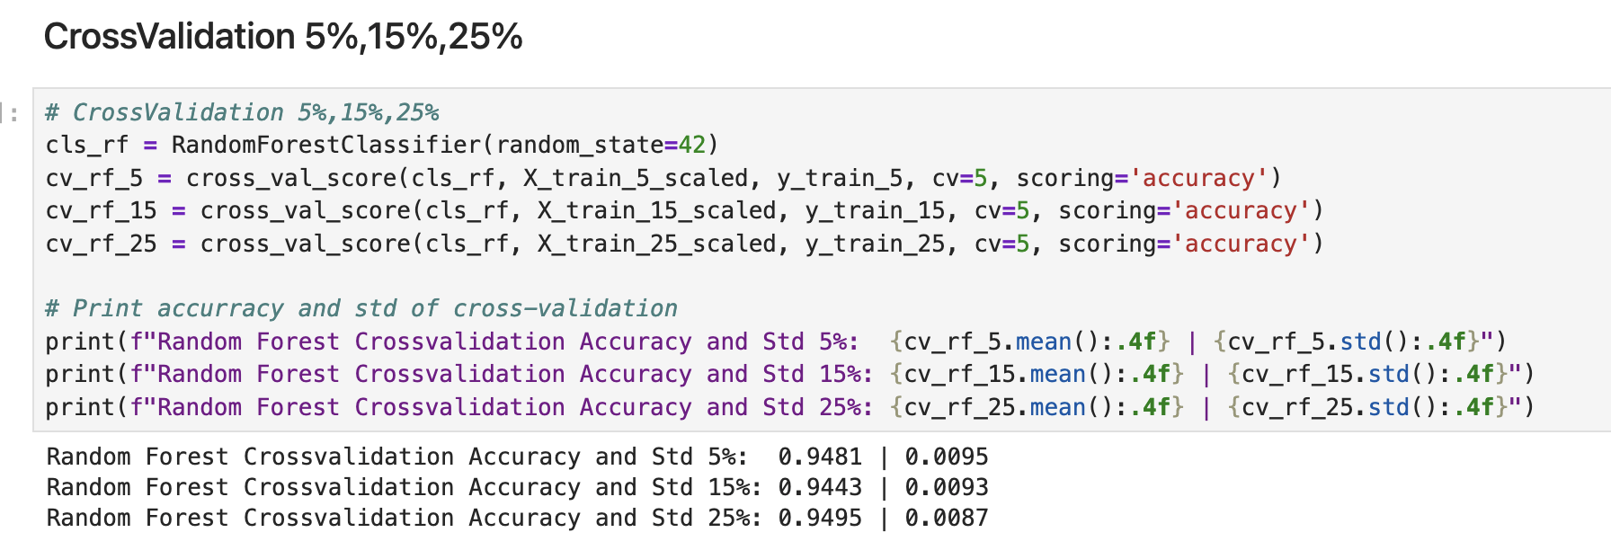

Comparison of KNN, SVC and Random Forest

Accuracy and F1-score comparison

Consolidation and visualisation
X_test_scaled is used for SVC and KNN, and X_test_raw for Random Forest; the three of them with y_test across the three experimental splits: 5%, 15%, and 25%.
Test Split | SVC Accu | SVC F1M | KNN Accu | KNN F1M | RF Accu | RF F1M
5% test | 0.9623 | 0.9560 | 0.8208 | 0.8102 | 0.9623 | 0.9527
15% test | 0.9748 | 0.9717 | 0.8297 | 0.8196 | 0.9495 | 0.9474
25% test | 0.9773 | 0.9759 | 0.8277 | 0.8209 | 0.9318 | 0.9309
Using the loop with a best_(svc,knn,rf)_models computing accuracy and macro F1-score with equal weight across the 7 obesity categories.

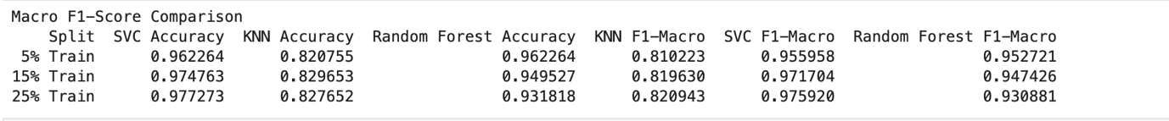

Discussion and Answer to Research Questions
- What are the most important predictor features (X) for classifying obesity levels (y)?

A/ Linear correlation and Random Forest confirm that biometric attributes dominate predictive power:
  - Weight is the principal predictor, accounting for 31.71% of the total feature importance in RF and the highest positive correlation with the target_variable.
  - Age and Height account for 10.36% and 10.02%, respectively. The interaction between Weight and Height defines the BMI (body mass index).
  - FCVC and family_history_with_overweight account for 9.25% respectively.

- Which classification approach is preferred for predicting the target variable (y), and does it outperform alternatives?

A/ SVC is the preferred model; on the 25% test set, it achieved 97.73% accuracy and 97.59% macro F1-score. Meanwhile, RF has an accuracy of 93.18% and a macro F1-score of 93.09%, and KNN has an accuracy of 82.77% and a macro F1-score of 82.09%.

- How do varying train_test splits (5%, 15%, and 25%) and hyperparameter tuning impact generalisation?

A/ Applying 5-fold (GridSearchCV) substantially improved generalization over the default. For SVC, at 25% accuracy increased from 95.27% to 97.73%; meanwhile, RF switching to entropy with 200 estimators increased cross-validation accuracy to 95.58%, and finally, KNN tuning K prevented huge overfitting.

- Why is dimensionality reduction important in this specific case, and where does class overlap occur?

A/ The dataset comprises 15 features, a combination of continuous and encoded categorical features. While models such as SVC and RF can handle 15 features, KNN suffers from the curse of dimensionality, so it is recommended to implement PCA to eliminate redundancy and boost distances.
The confusion matrices demonstrate almost perfect separation in severe obesity categories (Classes 3 and 4 with F1-score of 0.97 and 0.99, respectively, whereas misclassifications concentrate near Class 1 due to overlapping lifestyle patterns.

Comparative interpretation and conclusion
- SVC is considered the top-performing model, leading every metric across all three splits and peaking at 97.73% and macro F1-Score 97.59% on the 25%.
- KNN remains stable at roughly 82%- 83% accuracy and a macro F1-Score of 81% - 82% across all splits. Its lower performance stems from Euclidean distance across 15 features.
- Random Forest accuracy is 96.23% at 5% of the dataset; however, it gradually declines to 94.45% at 15% and 93.18% at 25%.
To conclude SVC is recommended as the principal predictive model for taking decision-support in obesity risk, and can be complemented with Random Forest.

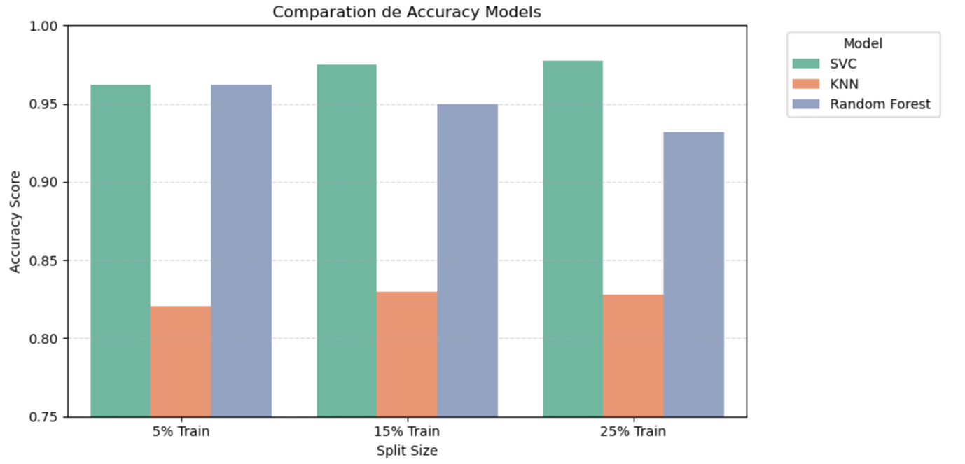

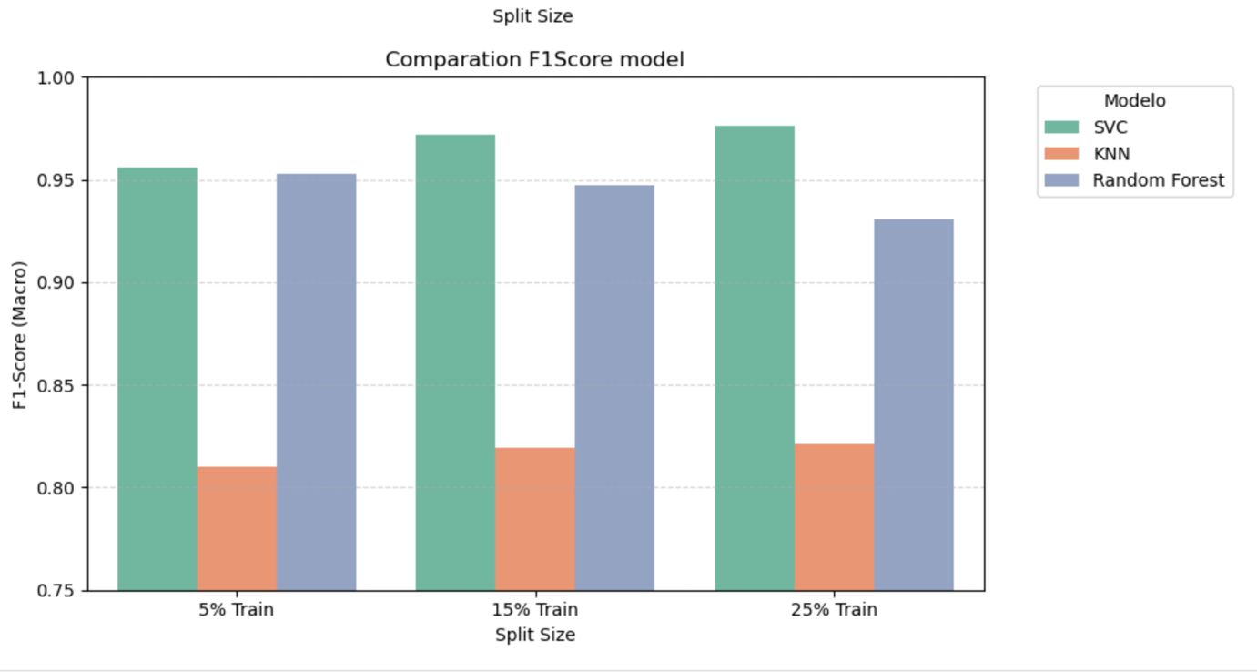

References

Please list all the references you have used in your assignment alphabetically and in the Harvard style. You can find information on how to correctly reference in Harvard at this link: https://library.cct.ie/referencing/harvard

Appendix

If you have used AI tools in your work, you must include screenshots of your requests in the appendix.
The appendix serves as a repository for additional or supplementary information that is deemed too extensive or detailed for integration into the main body of the text. This supplementary content can encompass data tables, charts, graphs, questionnaires, or any other supporting materials that contribute to a comprehensive understanding of the research.
If you haven't used AI tools and there's no need for supplementary data, you can remove the appendix section entirely.

