
Assessment Cover Page
Student Full Name | Silvia Elena Solano Marchini
Student Number | 2026362
Module Title | Statistic Techniques in Data Analytics for Business
Assessment Title | CA 1 – Capstone
Lecturer/Supervisor | Taufique Ahmed
Assessment Due Date | 01.11.2026
Date of Submission | 31.10.2026

Use of AI Tools

I acknowledge using Grammarly to check my orthography for this project.

Declaration
By submitting this assessment, I confirm that I have read the CCT policy on academic misconduct and understand the implications of submitting work that is not my own or does not appropriately reference material taken from a third party or other source.
I declare it to be my own work and that all material from third parties has been appropriately referenced.
I further confirm that this work has not previously been submitted for assessment by myself or someone else in CCT College Dublin or any other higher education institution.

Contents

Project Title 3
Introduction 3
Brief Overview 3

Movie Dataset

This Dataset is from (Madongo, 2020), the full title is Movie Box Office Revenue Prediction.

Dataset Structure Overview

Read data

The first exploratory phase of the IMDb dataset informed a structure of 1.608 rows and 28 features. The dataset contains continuous (e.g., budget), discrete (e.g., director_facebook_likes), and categorical (e.g., genres) variables.

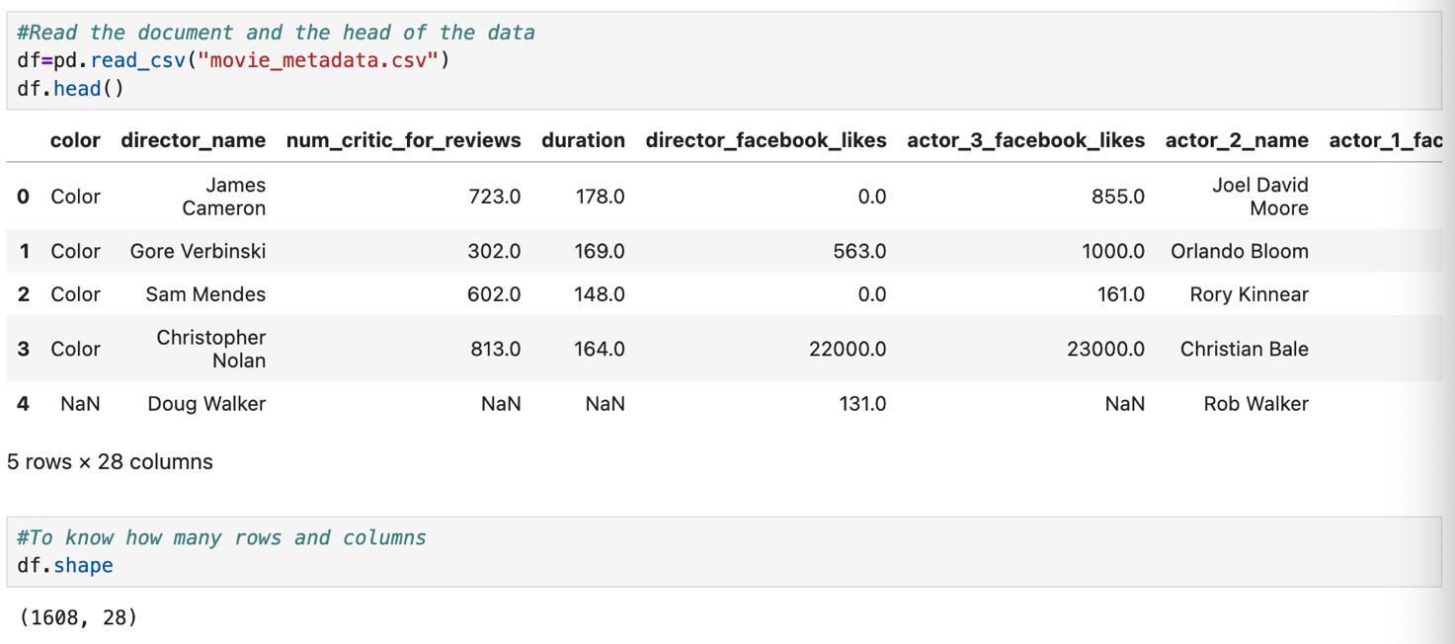

Clean the data

The second phase of the dataset started with cleaning; it consists of determining how many null values are in the data. Also, I located “NAN” values and converted them to 0 in the different rows and dropped some of the useless information for the project
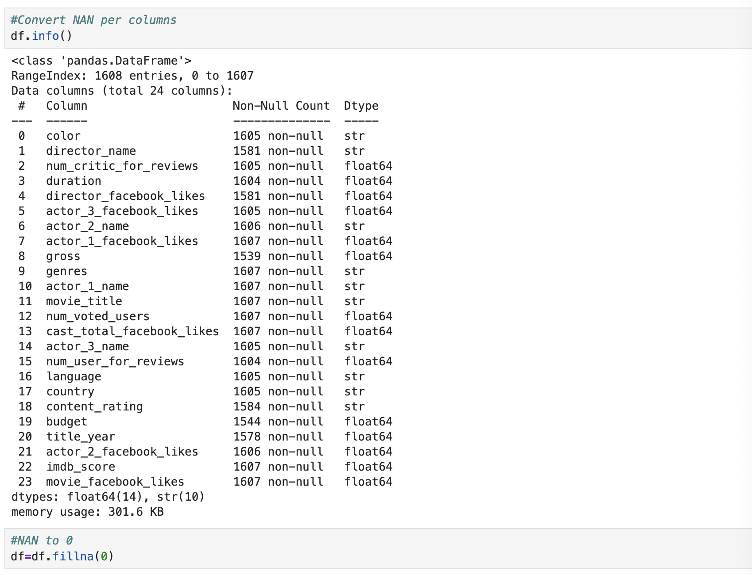

Exploratory Data Analysis and Descriptive Statistics

Measures Of Central Tendency

Mean, Median and Mode

Although central tendency and descriptive statistics metrics were done across the whole dataset, the project is focused on the engagement metrics (e.g., director_facebook_likes, actor_1_facebook_likes, etc.); the measures of central tendency reveal a positively skewed distribution.
- Director_facebook_likes: illustrates a mean of 1,109.12, whereas the median drops drastically to 87.0, and the mode is 0.
- Actor_1_facebook_likes: illustrates a mean of 9,770.612, whereas the median drops drastically to 8,000.0, and the mode is 0.
- Actor_2_facebook_likes: illustrates a mean of 2,870.91, whereas the median drops drastically to 826.0, and the mode is 0.
- Actor_3_facebook_likes: illustrates a mean of 1,117.778, whereas the median drops drastically to 532.0, and the mode is 0.
- Cast_total_facebook_likes: illustrates a mean of 1,5033.43, whereas the median drops drastically to 11,294.0, and the mode is 0.
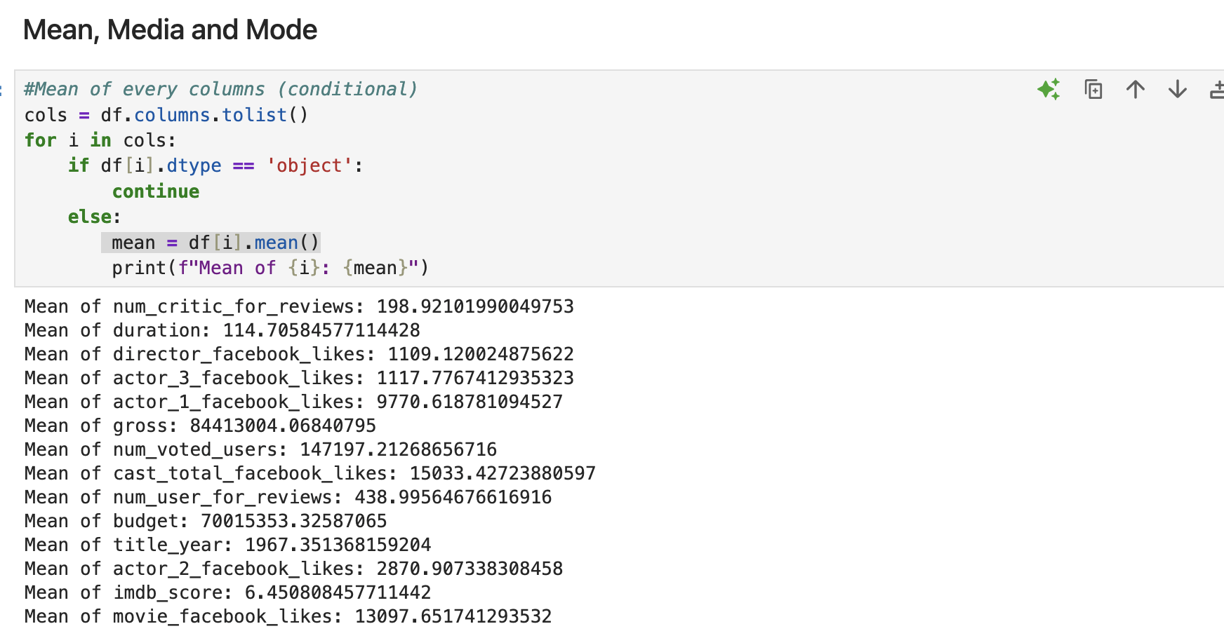
The loop used in the project is from (4. More Control Flow Tools, no date).

Plot the distribution

The distribution plot was made for the complete dataset, even though the analysis will focus on the engagement variables.
- Director_facebook_likes: illustrates a right-skewed distribution; the observations are concentrated on the right side, reflecting that the majority have very little to no social media popularity, but the long tail represents a small cluster of highly famous directors.
- Actor_1_facebook_likes: illustrates a mean of 9,770.612, whereas the median drops drastically to 8,000.0, and the mode is 0.
- Actor_2_facebook_likes: illustrates a mean of 2,870.91, whereas the median drops drastically to 826.0, and the mode is 0.
- Actor_3_facebook_likes: illustrates a mean of 1,117.778, whereas the median drops drastically to 532.0, and the mode is 0.
- Cast_total_facebook_likes: illustrates a mean of 1,5033.43, whereas the median drops drastically to 11,294.0, and the mode is 0.

References
4. More Control Flow Tools (no date) Python documentation. Available at: https://docs.python.org/3/tutorial/controlflow.html (Accessed: 22 October 2026).
Madongo, C. (2020) ‘Movie Box Office Revenue Prediction’, 2. Available at: https://doi.org/10.17632/xv9wtc9gdk.2.

Use of Artificial Intelligence
This assessment applies the AI Fluency Framework — four interconnected competencies for effective, efficient, ethical and safe AI use. Your engagement with AI will be reviewed across all four dimensions:

Delegation  Setting goals and deciding whether, when and how to engage with AI. | Description  Effectively describing goals to prompt useful AI behaviours and outputs.
Discernment  Accurately assessing the usefulness of AI outputs and behaviours. | Diligence  Taking responsibility for what we do with AI and how we do it.

AI tools may be used in this assessment. Your use of AI will be assessed across the four ‘D’ competencies of the AI Fluency Framework.
Please see below. Note that for Software Development Fundamentals you are required to include an Appendix to show how you used AI. A sample has been provided.

AI Declaration using the AI Fluency Framework
For use in assessment briefs and student submissions. Lecturers complete the Lecturer Expectations column per assessment; students complete the Student Response column.

AI competence | Reflective prompts (to students) | Lecturer expectations | Student response
Delegation  Deciding whether & when to use AI | Identify the specific tasks in this assessment where you chose to use AI, and explain your reasoning. Where did AI add value? Where did you decide not to use it, and why? | You may use AI to support your learning and development of the application. Clearly identify where you used AI and where you completed the work independently. | Grammarly check the orthography of the completely document, I decided to use it because I know that I could have too many mistakes.
Description  How you prompted the AI | Include the exact prompts you used in your appendix (recorded on the AI Tools declaration). Reflect on how you communicated your goals to the AI — did you need to iterate or refine your prompts to get useful output? | You must provide the exact prompts and relevant AI outputs used during the development of your application. | I just did a document in Grammarly when I had finished to write the project.
Discernment  Evaluating what the AI produced | In your reflection, critically evaluate the AI output: what did you accept, modify, or reject — and why? Assess accuracy, relevance, and quality. You are responsible for verifying all AI-generated content before submitting. | You are responsible for checking, testing and understanding any AI-generated code or suggestions before using them in your work. | I accepted all the orthography modify that the program suggested.
Diligence  Responsibility for your AI use | Declare all AI tools used and cite them here. Briefly outline how you considered data protection, copyright, and ethical responsibilities when choosing what to input into any AI system. Unauthorised use is subject to CCT disciplinary procedures. | Declare all AI tools used. Do not enter personal, confidential or sensitive information into AI tools. Any external sources used should be appropriately referenced. | Grammarly

Adapted from the AI Fluency Framework (Dakan, Feller, Anthropic, 2025).

Appendix

