
Student full name
Nicolas Anibal Pizarro Puebla
Student Number
2026491
Module Title
Strategic thinking
Assessment Title
CA 1 – Capstone Project Proposal
Lecture / Supervisor
Taufique Ahmed
Assessment Due Date
25-10-2026
Date Of Submission
24-10-26

Contenido
Predictive Analytics of Pedestrian Footfall to Support Retail and Hospitality Business Planning in Dublin City Centre 3
2. Introduction 3
3. Problem Definition 4
4. Aim 4
5. Scope 4
6. Methodology 4
7. Data Sources 5
8. Expected Deliverables 5
9. Project Timeline 6
10. Ethical and Legal Considerations 6
Use of AI Tools 7
Delegation 7
Discernment 8
Diligence 8
References 8
Appendix: AI prompts and outputs 9
A1 9
A2 10
A3 11
A4 12
A5 13
A6 15
A7 16

Predictive Analytics of Pedestrian Footfall to Support Retail and Hospitality Business Planning in Dublin City Centre

2. Introduction
Pedestrian activity in the city center varies in location, day, and time, thereby creating challenges for retail and hospitality planning. This project proposes to analyse the historical pedestrian flows and to develop a predictive model to predict the future. In this way, the local businesses could plan their staffing, their inventories and their promotions.

3. Problem Definition
The business sector in the city centre, which includes many retail and food service businesses, could have difficulties managing staff, stock and promotions, which are critical to their operational planning. The project will investigate whether historical pedestrian counts can identify patterns and predict busy and quiet periods at selected locations. But a footfall count does not tell you how many people enter the shop or buy anything, so this project is intended to provide useful information for planning, not to predict demand or sales. Consequently, if you have too much stock during a quiet time, it could lead to more waste, and if there isn't enough staff at a busy time, you might be in trouble with your customers.

4. Aim
To analyse and predict pedestrian footfall in certain areas of the city centre, to aid the operational planning of retail and hospitality businesses
  - Objectives
- Assess data quality and prepare historical pedestrian counts for analysis.
- Identify hourly, weekly and seasonal footfall patterns at selected locations.
- Develop and evaluate a predictive model against a simple baseline.
- Present findings through clear visualisations and discuss their implications for staffing, stock and promotion planning.

5. Scope
This study will analyse hourly pedestrian traffic data from the year 2025, at selected sites in the city centre with the necessary data quality. This includes data cleaning, exploration, visualisation and statistical modelling of the data. The study does not involve direct sales forecasting, customer behaviour analysis or tracking. The result will be used to assist with the planning of staffing, promotions and stock. This study is based on selected reliable data from 2025. By selecting just a small number of reliable counters, the project will be manageable and comparisons between locations will be more meaningful. As only one year is used, any findings on the seasonal patterns will be interpreted cautiously and will not be able to determine whether the same pattern repeats year after year.

6. Methodology
In the upcoming steps, preparation of data, exploratory analysis and prediction will be supported by the notebook in the python environment in Jupyter. For organizing the data, we will use the pandas library, for visualizing Matplotlib, and for learning, we use scikit-learn.
Data preparation will address missing observations, duplicate timestamps, inactive counters, and suspected measurement irregularities. A small number of data-collection points will be selected based on their sufficiently complete and consistent records. Lost data will not be automatically set to zero, and all data preparation decisions will be accounted for.
The exploratory examination of the data will compare the hourly, weekday, and monthly patterns by means of line graphs, bar graphs and heat maps. These graphic results will reveal recurrent busy and quiet times.
Random Forests will be investigated because they can find nonlinear relationships between calendar features, previous counts, and future footfall. (scikit-learn developers, n.d.-b)
The task is to predict the pedestrian traffic at one hour from the current hour using only the information available at the current time. For the training, we use the earlier observations, for the evaluation, the later observations (scikit-learn developers, n.d.-c)
The model is compared with a seasonal base line which predicts the count observed at the same time, a week earlier. An average absolute prediction error for pedestrian counts will be calculated from the data and expressed as the average absolute deviation from pedestrian count (scikit-learn developers, n.d.-a). The seasonal baseline will give a simple reference for judging whether Random Forest adds predictive value, and a lower MAE on the same test observations would indicate more accurate predictions. In other words, if Random Forest fails to improve the average prediction error on the baseline, this will be reported and discussed as a useful result
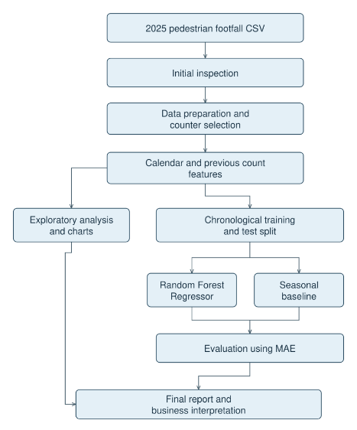
Figure 1. Proposed project workflow

7. Data Sources
In this project, we will use a Dublin City Council Pedestrian Footfall Dataset that is published on data.gov.ie. This contains 8,760 hourly data records from a network of counters across central Dublin, with timestamps and counts of pedestrians, suitable for pattern analysis and prediction modelling. The set is available under a Creative Commons license and will be used in conformity with that license, including acknowledgment of its source (Dublin City Council, n.d.).
8. Expected Deliverables
This project will end with a cleansed and described data set, a Jupyter notebook containing the analysis and a predictive model, and an evaluation of the model against a seasonal base line by mean absolute error (MAE). Clear visualizations will compare selected locations, illustrate observed foot traffic patterns and predict future numbers for peak and off-peak times. A final report will explain the findings, the errors and limitations of the models and discuss the possible use in the staffing, stock and promotions department and explain where caution is necessary.

9. Project Timeline
This project will take place over the course of two semesters: the first semester, from October to February, will focus on defining the problem, locating data sources, checking the quality of the data and conducting an initial data exploration. The second semester, February to July, will involve building the forecasting model, comparing it to the seasonal baseline, generating the final visualizations and interpreting the results for business use. The work will be kept up to date throughout the project, with the final report and deliverables being completed by the deadline of semester 2.
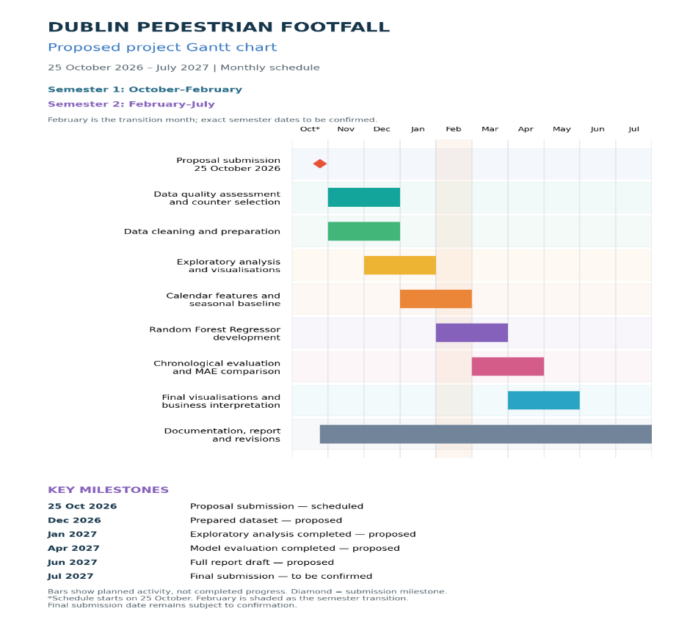
Figure 2. Project Gantt chart

10. Ethical and Legal Considerations
The work is based on public information on the number of people. The project uses data that is publicly available, without identifying or recognizing individual persons. It will respect the attribution of the licence, it will make references to external sources, it shall protect its own records against unauthorised alteration and it shall present figures as estimates only, and not as absolute data, and footfall will not be treated as evidence of purchases or increased sales. Missing figures, the accuracy of the counters, the difference in coverage will be duly taken into account in order not to deceive in comparisons. Artificial intelligence will be declared and recorded, as will the help rendered in the prompting, the extraction and the verification.
Use of AI Tools
I acknowledge the use of ChatGPT to help draft, shorten and revise parts of my project proposal, discuss dataset suitability, and create and format the architecture diagram and Gantt chart. The appendix includes prompts, relevant outputs and my evaluation of this assistance. I remain responsible for understanding, checking and deciding what to include in the final submission.
Declaration
By submitting this assessment, I confirm that I have read the CCT policy on academic misconduct and understand the implications of submitting work that is not my own or does not appropriately reference material taken from a third party or other source.
I declare it to be my own work and that all material from third parties has been appropriately referenced.
I further confirm that this work has not previously been submitted for assessment by myself or someone else in CCT College Dublin or any other higher education institution.

Delegation
I chose ChatGPT to improve the clarity of my proposal and to assist in organizing my work. I used Chat GPT to formulate, shorten, and revise the proposal text, discuss the suitability of the dataset, and create and format the architecture diagram and the Gantt chart. I compared suggestions and maintained responsibility for the project decisions and the content of my own proposal.
Description
I asked GPT for help with getting my proposal under the one-thousand-word limit and whether I should use a data set of 8,760 rows and 118 columns. In addition, I asked for an example of a Gantt chart, instructions for creating diagram boxes in a Google doc, and help with the graphical architecture. In response to GPT's prompts, I also requested a monthly Gant chart with month labels.

Discernment
I accepted the guidance and help that Chat GPT give me to keep within the thousand-word limit. I accepted amendments to the scope of the project which made it more definite, examined the architecture diagram to make sure it conformed to the intended phases of development, and asked for a redrawn version to improve the presentation. I changed the Gantt chart to show the expected months and semesters, realizing that some dates could not be confirmed without further notice. I classified the evaluation of the data set as an initial recommendation, because its suitability depends on data quality, not only on the 8,760 rows and 118 columns.

Diligence
For help with text editing, I acknowledge ChatGPT, which helped me review the data set, review the scope and create and format a system architecture diagram and Gantt chart. I have provided a log of relevant inputs, outputs and screens in the appendix. Before submitting, I shall check the word count, references, diagram stages and chronology. I shall make a distinction between the conclusions reached by the AI and those arrived at by me. Respect the data license and refrain from revealing anything further confidential or personal. I will take full responsibility for understanding and verifying the content.
References
Dublin City Council (n.d.) 2025 Pedestrian Footfall DCC. Available at: https://data.gov.ie/en\_GB/dataset/dublin-city-centre-footfall-counters/resource/ca145381-cedf-475a-9b96-6e43b76c8a98 (Accessed: 14 October 2026)
scikit-learn developers (n.d.-a) mean_absolute_error. Available at: https://scikit-learn.org/stable/modules/generated/sklearn.metrics.mean\_absolute\_error.html (Accessed: 21 October 2026).
scikit-learn developers (n.d.-b) RandomForestRegressor. Available at: https://scikit-learn.org/stable/modules/generated/sklearn.ensemble.RandomForestRegressor.html (Accessed: 21 October 2026).
scikit-learn developers (n.d.-c) TimeSeriesSplit. Available at: https://scikit-learn.org/stable/modules/generated/sklearn.model\_selection.TimeSeriesSplit.html(Accessed: 21 October 2026).

Appendix: AI prompts and outputs
A1
AI Tool: ChatGPT
Date: 14 October 2026
Purpose: To understand how to create a Gantt chart for the project timeline.
Exact prompt:
could you show me some Gantt chart examples so I can lear how to make one ?
My evaluation and use:
The explanation and examples helped me understand activity durations, overlapping tasks and milestones. I will use them as guidance for creating my project timeline. The example dates were illustrative and will not be treated as confirmed academic deadlines.
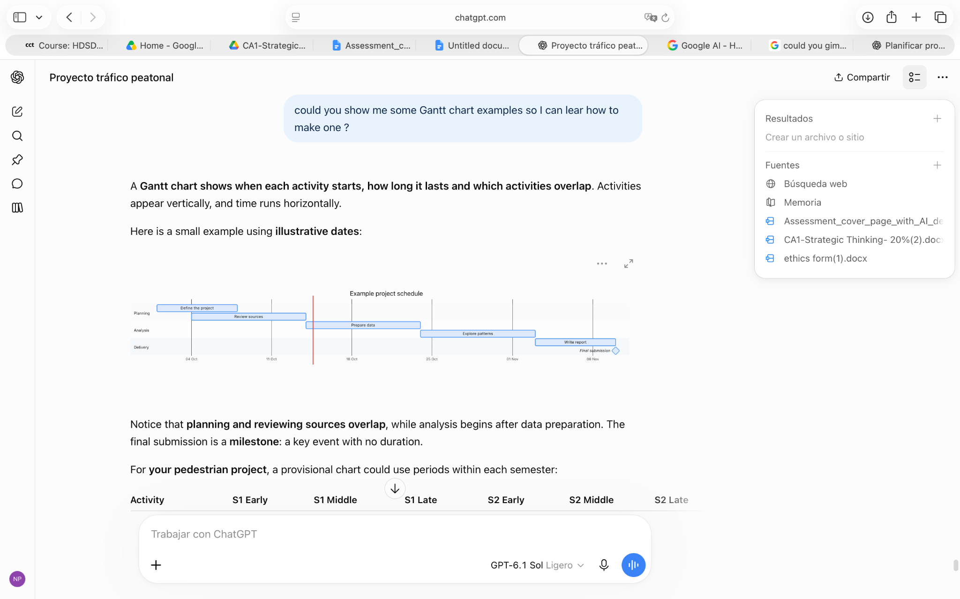

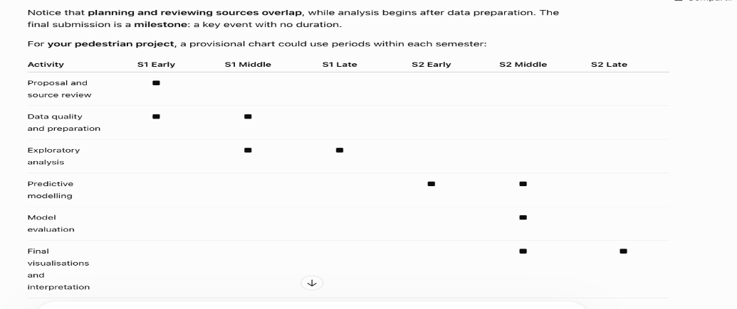

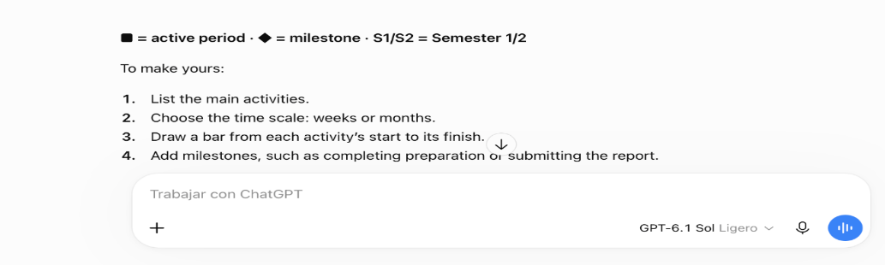

A2
AI tool: ChatGPT
Date: 14 October 2026
Purpose To assess whether the dataset is suitable for a project spanning two semesters.
Exact prompt:
I've checked the rows and columns (8760, 118) in the data I shared. do you think it's a good dataset for a one year project?
My evaluation and use:
The response explained that dataset dimensions alone do not establish suitability. It highlighted data quality, selecting reliable counters and the limitations of having only one year of observations. This helped me understand what must be assessed before finalising the selected locations.
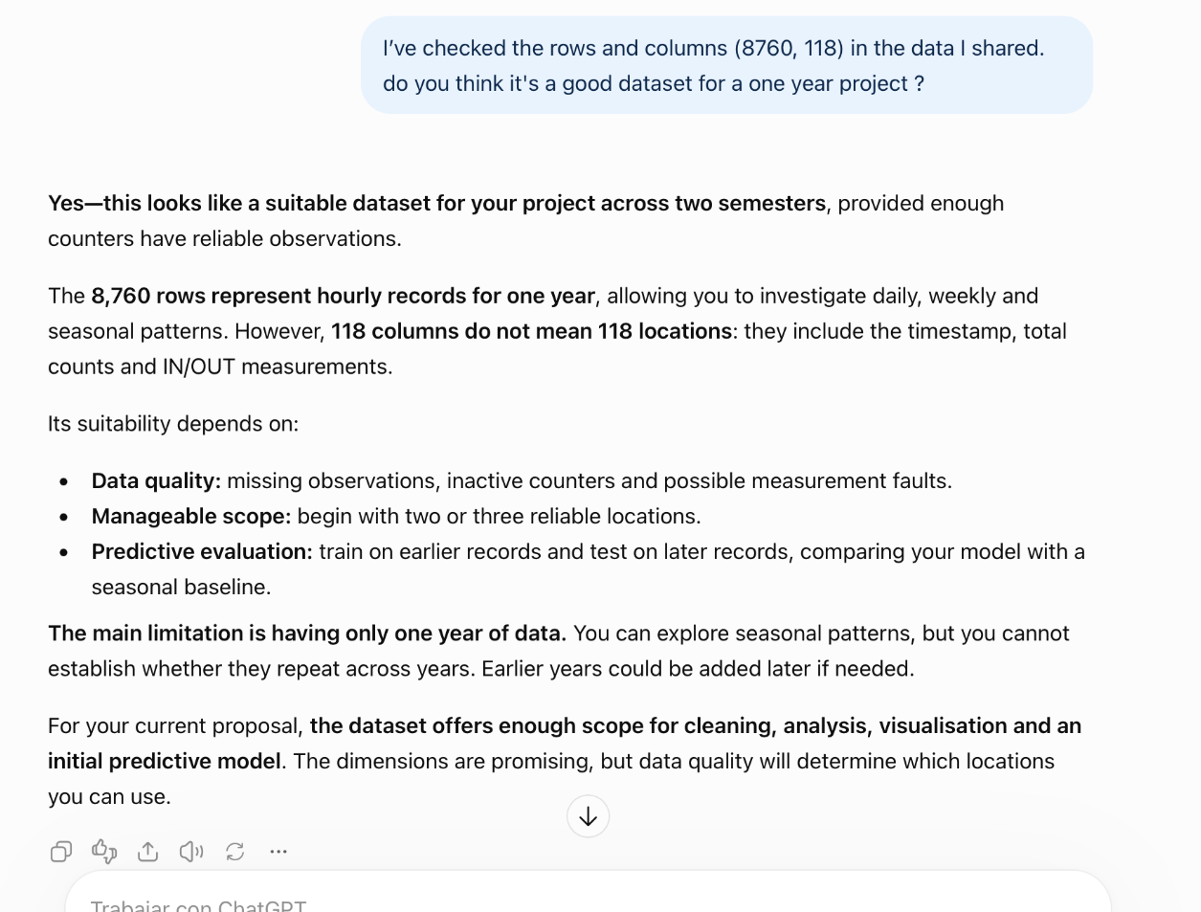

A3
AI tool: ChatGPT
Date: 18 October 2026.
Purpose: To learn how to create boxes and connectors for the project architecture diagram in Google Docs.
Exact prompt: I am making the architecture diagram for my project, but I don't know how to create the boxes to generate the diagram. I am working from google drive
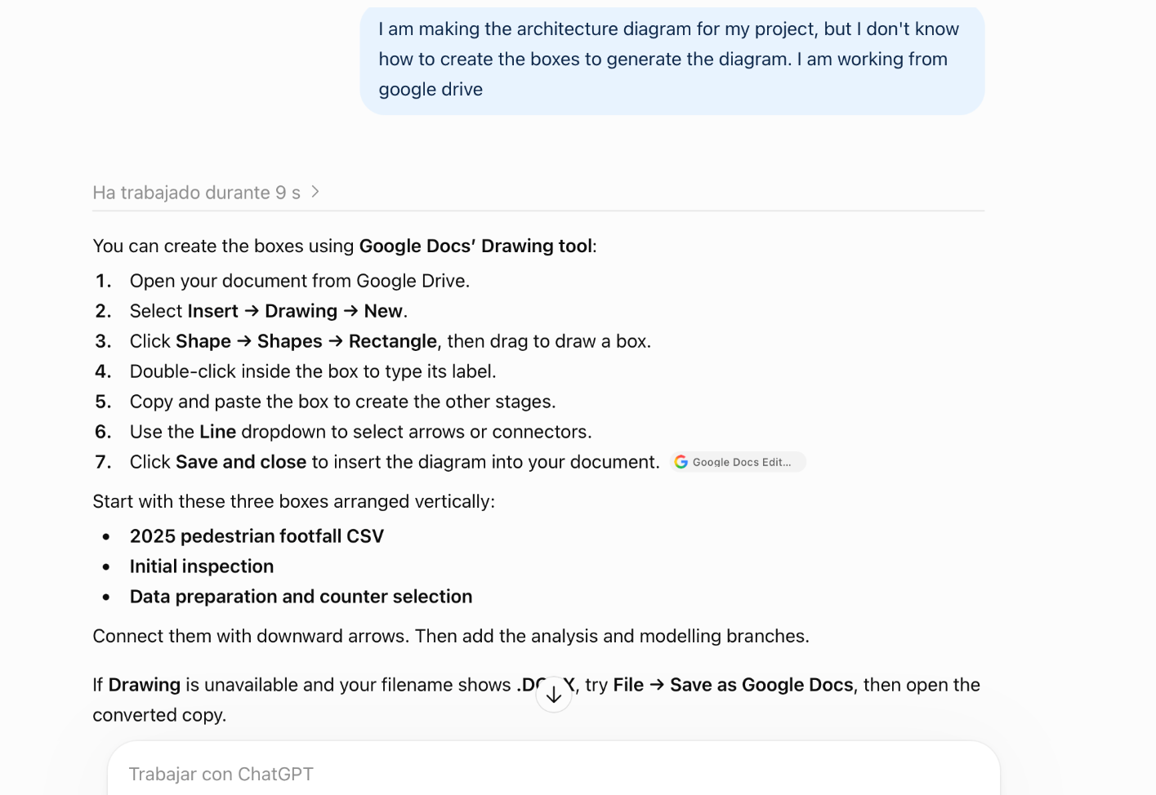
Relevant AI output:

My evaluation and use:
I followed ChatGPT's instructions to create the boxes and connectors for my architecture diagram in Google Docs. However, I had difficulty fitting the diagram onto a Word page, so I asked ChatGPT to adjust its layout and provide an image version. I checked that the revised diagram kept my project's stages and connections

A4
AI tool: ChatGPT
Date: 20 October 2026
Purpose: To improve the layout of my architecture diagram while keeping the project stages
Exact prompt:
I will send you my architecture diagram for you to modify only its format while maintaining my project's stages. Send it to me as an image since mine has issues fitting into Word because it's too big.

Input:
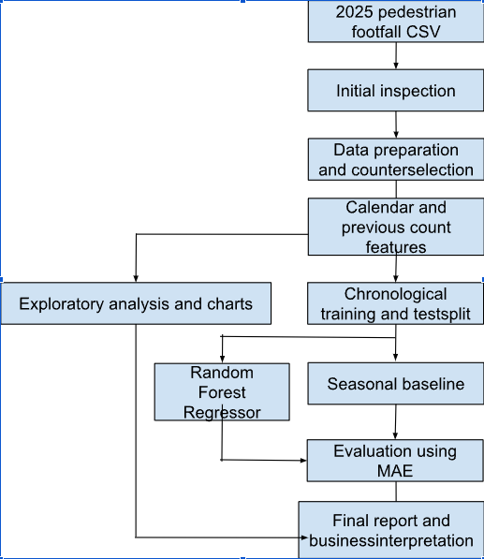
Relevant AI output:
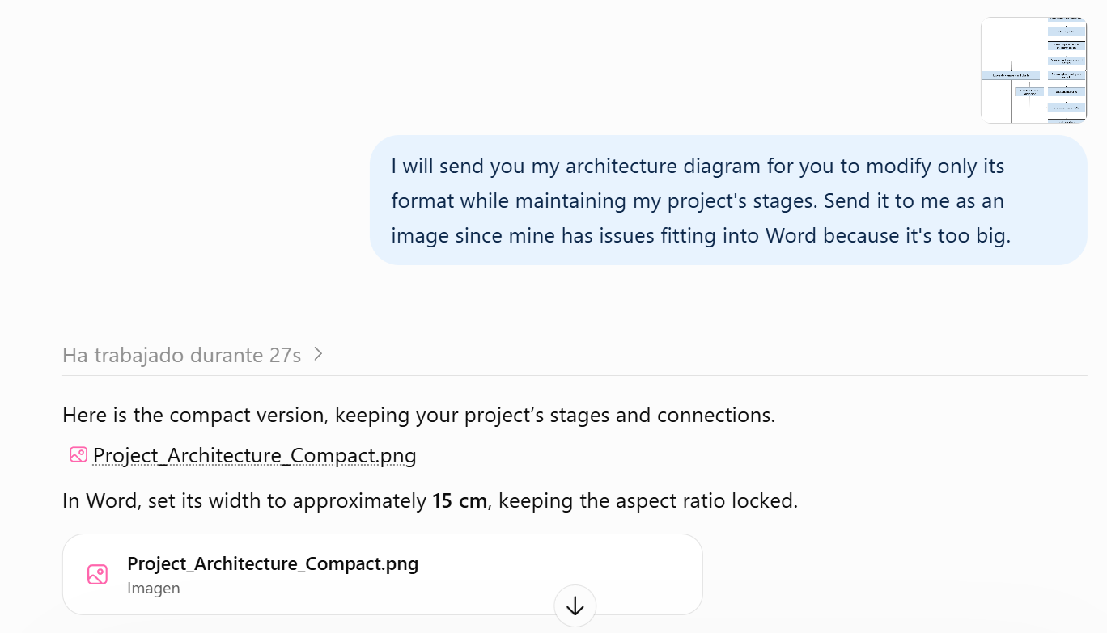
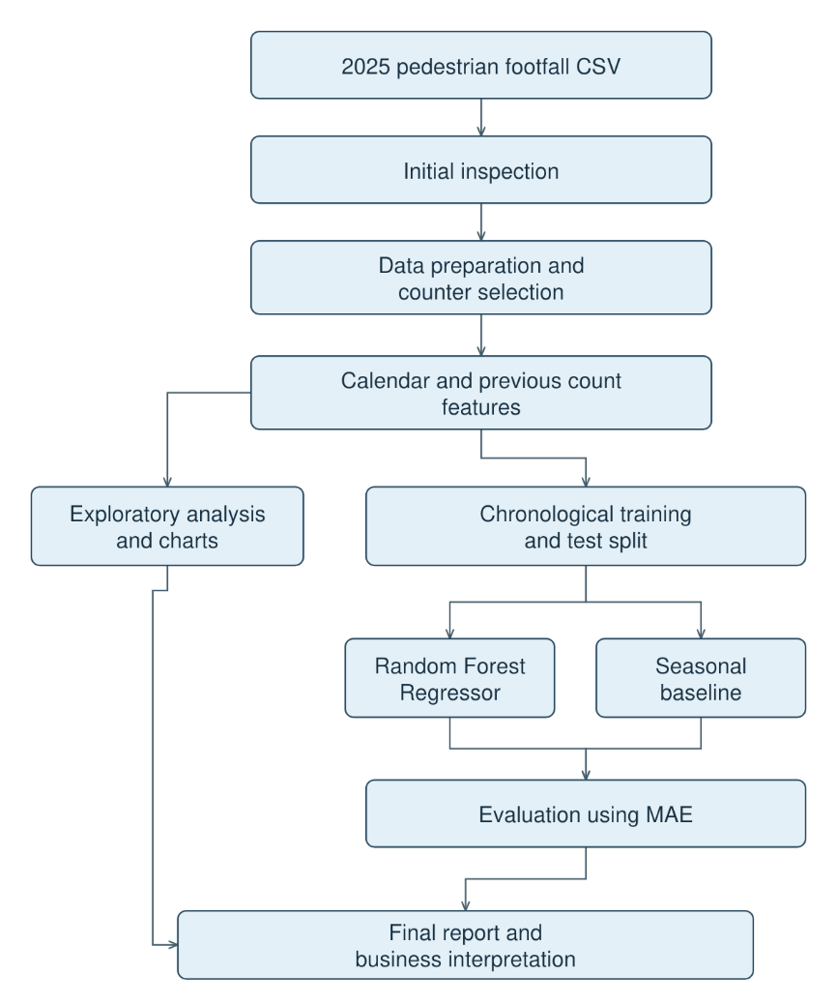
My evaluation and use:
I requested a clearer layout because my original diagram was difficult to fit into Word. I then requested an editable version because the first output did not display fully for me. The revised version allows me to adjust the boxes, text and arrows while keeping the project stages.
A5
AI tool: ChatGPT
Date: 20 October 2026
Purpose: To create a proposed monthly project schedule based on the proposal sections.
Exact prompt:
Could you create a vertical Gantt chart using my paragraphs for Aim and Objectives, Scope, Methodology, and Expected Deliverables, distributed from October 25, 2026, to July 2027, to show my full progress? Please provide it in an image format
Relevant AI output:
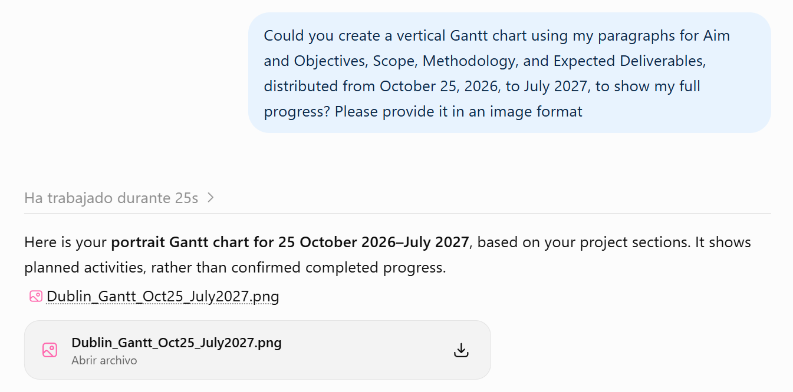
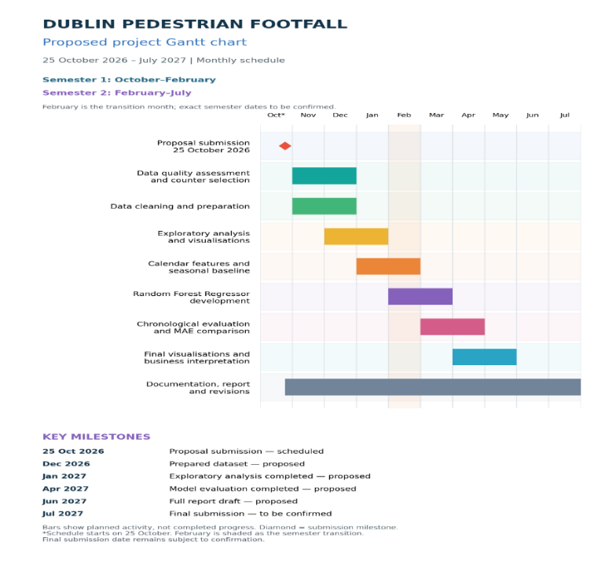
My evaluation and use:
I reviewed the proposed chart against the activities in my proposal. It helped organise the work into monthly phases and identify milestones. I understand that the bars represent planned activities rather than completed progress, and that the final deadline and semester boundaries still require confirmation.
A6
AI tool: ChatGPT
Date: 22 October 2026
Purpose: To review the proposal's length and improve wording while preserving my main ideas.
Exact prompt:
Please keep the paragraphs concise while preserving my main ideas, so that the complete proposal stays close to 1,000 words
Input:
The attached proposal, CA1- Strategic thinking (1).docx.
My evaluation and use:
I accepted the suggestion to keep most paragraphs unchanged because the proposal was already close to 1,000 words. I also accepted the revised example in the Problem Definition because it expressed the business implications more clearly without changing my main ideas. I will correct the title and figure captions and add the missing references

