

Assessment Cover Page
Student Full Name Valeria Cantu Angel
Student Number
2026679
Module Title
astistical Techniques for Data AnalysisStatisticals Techniques for Data Analysis
Assessment Title
CA-1 Statisticals Techniques
Lecturer/Supervisor
Taufique Ahmed
Assessment Due Date
01/11/2026
Date of Submission 01/11/26
GitHub: https://github.com/2026679-arch/Statistical-Tech-679
Link for access to Github
https://github.com/2026679-arch/Strategic-Thinking679
Use of AI Tools
I acknowledge the use of ChatGPT for the purpose of dataset preparation, python code generation, explanation of statistical methods and revision of sections of this report.
Declaration
By submitting this assessment, I confirm that I have read the CCT policy on academic misconduct and understand the implications of submitting work that is not my own or does not appropriately reference material taken from a third party or other source.
I declare it to be my own work and that all material from third parties has been appropriately referenced.
I further confirm that this work has not previously been submitted for assessment by myself or someone else in CCT College Dublin or any other higher education institution.

Forecasting First- Year Business Survival Rates in Ireland by Sector in Ireland.

AI Use Declaration and Prompt Record.

Delegation
I used ChatGPT solely as a support tool to help me find information and to verify whether my project topic was viable and feasible. I select the topic, reviewed official data from the CSO to assess its feasibility for the project, and the drafted the content based on my own understanding to develop the project.

Description
I drafted my prompts as brief, specific questions addressing one objective at time: understanding the task requirements, assessing the feasibility of the topic regarding business survival, locating official sources of information, and requesting ideas for the architecture diagram and project timeline.

Discernment
I did not accept the AI responses without checking item. ChatGPT helped me locate and review official information from the CSO (Central Statistics Office), but I verified it myself on the official website and confirmed that the data was authentic and usable before proceeding with the project.

Diligence
The only AI tool used was ChatGPT (OpenAI). I did not enter any personal or private data into the tool, I verified the information against official sources, and the sources that informed my work are referenced in the project.
One Year Business Survival in Ireland
A Statistical Analysis of Birth Cohorts 2019-2023

Table of Contents
1. Delegation. 1
2. Description. 1
3. Discernment. 1
4. Diligence. 2
AI Use Declaration and Prompt Record. 3
Prompt 1. Date 20/10/2026. 3
Prompt 2. Date 24/10/2026. 4
Prompt 3. Date 30/10/2026. 4
Prompt 4. 30/10/2026 5
Prompt 5. Date 30/10/2026 7
Prompt 6. Date 31/10/2026 8

Delegation.

AI tools ChatGPT, used in this evaluation, they served as support for preparing the dataset, generating and debugging python code explaining statistical methods, and drafting and reviewing sections of the report.
The selection of the data set, all statistical decisions, and the final review were my sole responsibility. AI was not used to replace the analysis or the decision making required to complete this work.

Description.

Throughout the learning process, the prompts were written in English, and the requested outputs for both the report and the Jupyter Notebook, also had to be in English.
An iterative refinement process was required. The prompts were adjusted to simplify certain sections, ensure task requirements were met, shorten explanations, and request simpler responses whenever necessary.

Discernment.

The results generated by the AI were verified before use. The code was executed in a Jupyter notebook, and the results were compared against the data set to ensure everything was correct. Statistical explanations were cross referenced with the documentation used in the report.
Some results were discarded, certain sections were clarified, an explanation regarding large samples was removed, and alternative approaches that did not meet the requirements of the task were rejected. I take responsibility for the all material presented, including the interpretation of the statistical analysis.

Diligence.
All AI tools used in this assessment are disclosed in this document, no personal confidential or sensitive information was entered into any AI tool. The dataset CSO BRA36 and SciPy documentation were used as sources, third party material is cited according to the Harvad referencing system.
The use of AI remained within the limits permitted for this assignment, I take responsibility for the work submitted and confirm that all material complies with CCT academic integrity policy.

AI Use Declaration and Prompt Record.

Prompt 1. Date 20/10/2026.
Lets start from scratch step by step following the requirements of the brief.
Relevant output: An explanation of the four criteria for CA1, descriptive and graphical analysis, discrete distributions, normal, Poisson and comparison and conclusion.
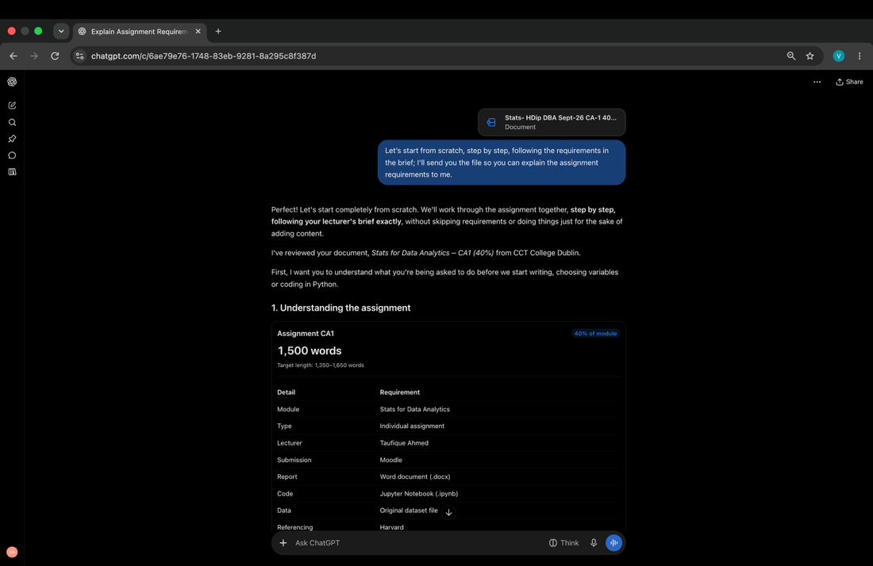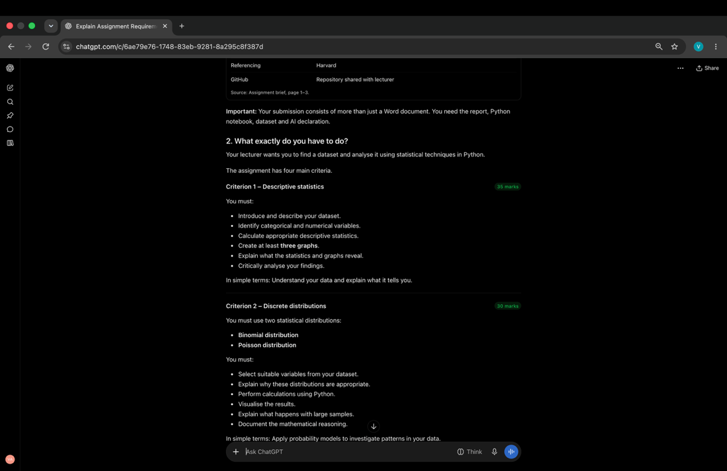
I verified this summary against the assignment brief before starting the analysis.

Prompt 2. Date 24/10/2026.
Help me understand the dataset I have.
Summary of the BRA36 csv, 80k rows 6 columns, year 2019-2024 and so must 19k missing value entries.
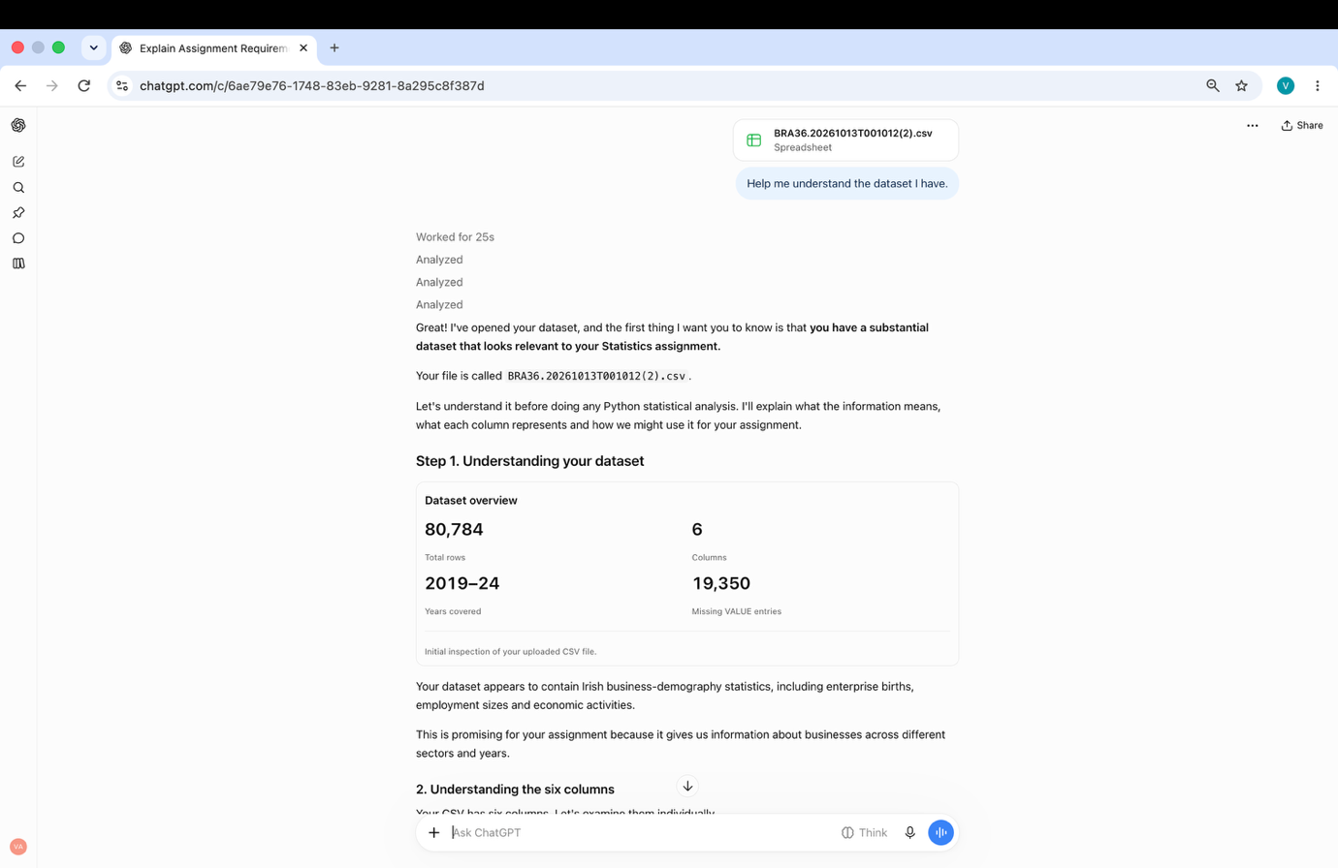

I checked this summary against the CSV before using the dataset in my analysis.

Prompt 3. Date 30/10/2026.
Could you please provide some SciPy code that I can use for my dataset? I'm not asking you to do the work on the dataset itself, just let me know which code snippets I should use, and please include links to the relevant SciPy documentation.
Code for importing pandas, NumPy, matplotlib, and SciPy including binomial, Poisson and norm with links to the corresponding docs.

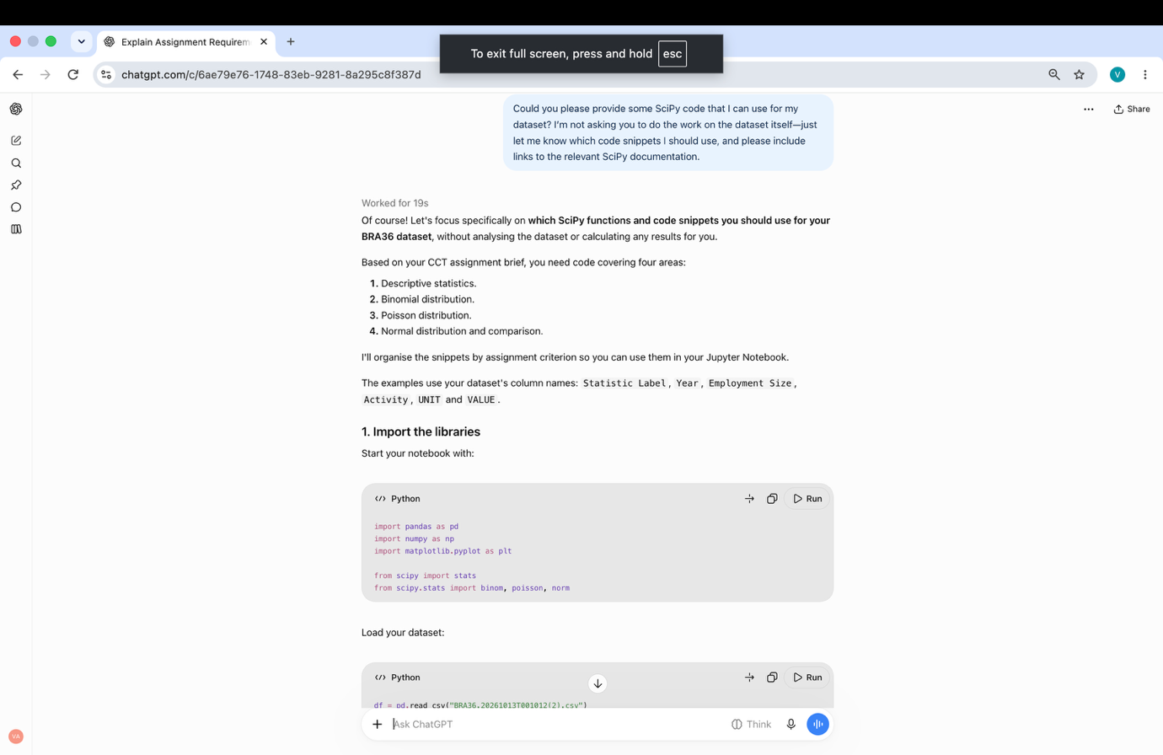

I executed this code in Jupyter notebook and compared the outputs with my dataset before including them in the report.

Prompt 4. 30/10/2026
Explain the Poisson and normal distributions to me and distributions in general in a way that's easy to grasp.

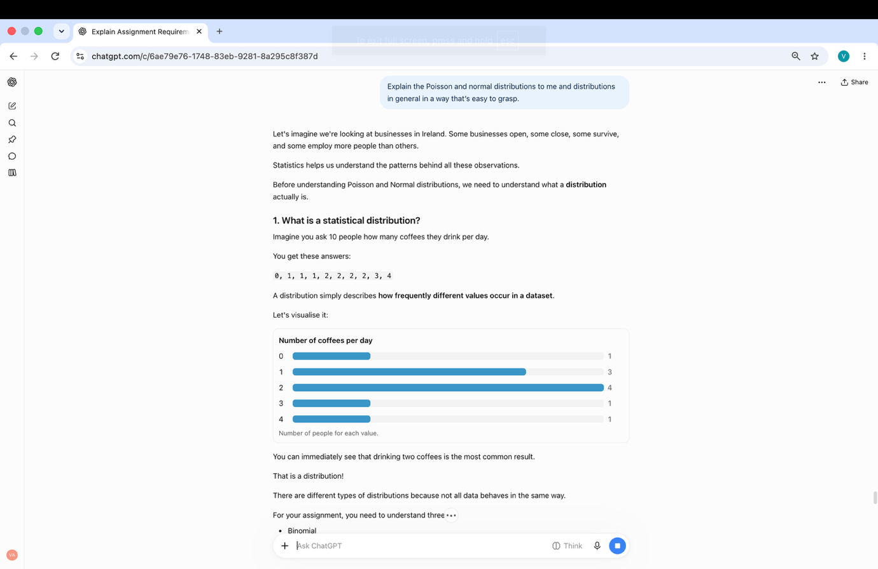

I used this explanation to understand the concepts before applying them to myy own analysis.

Prompt 5. Date 30/10/2026
Help me understand it so I can write it myself.
Explanation of how to read the survival plots including the axes and their meaning.

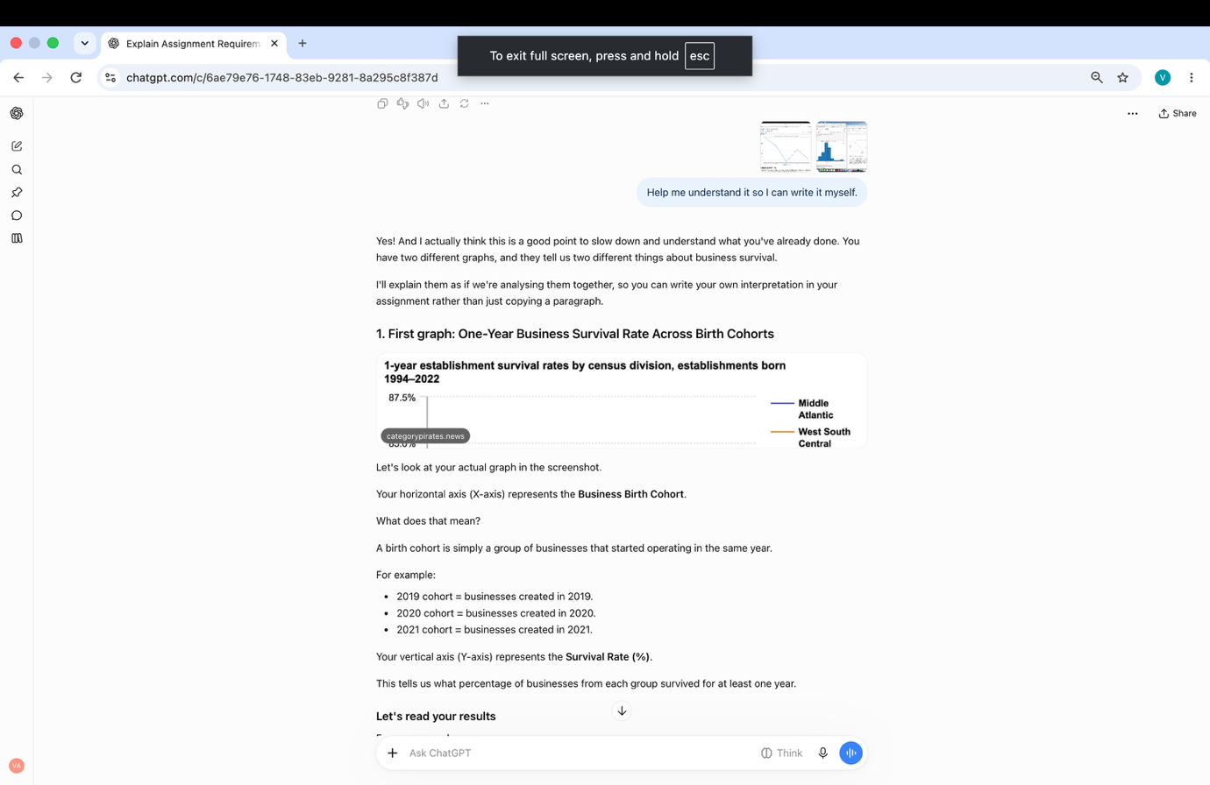

I interpreted the results myself and wrote the corresponding section of the report.

Prompt 6. Date 31/10/2026
Check grammar please.
I reviewed each correction and accepted only those that preserved my original meaning.



