 | 

CA1: Data Analytics for Agriculture and rice production
Elienai Simon Mier

https://github.com/2026726-dotcom/STDA



I. Introduction

Agriculture is one of the biggest fields that must be worked in an effective way. In this project, it will be studied the paddy yield production, where many factors might be considered to analyse them and apply statistics functions. The dataset includes data like size of the fields, variety of rice,, temperature, nutrients, rubbish, and paddy yield; all these characteristics can help or reduce the grow up of rice. Statistics description will be used, in addition to the meaning of each main code and mean of the results. The analysis will be conducted from basic statistics, then some plotting about some main features and, discrete distribution (Binomial and Poisson), and Normal distribution.

II. Summary and statistics description of the dataset

a. Exploration of the dataset
This project is firstly explored using basis reading code lines in python to read and the expected use of some libraries. For this first step it had been added pandas library which is to manipulate, read and analyse the dataset, as well numpy is used to read array and easy way to be computed; matplotlib is a tool used for plotting. The next step is reading the dataset using pd (pandas). The next figure shows these two steps.
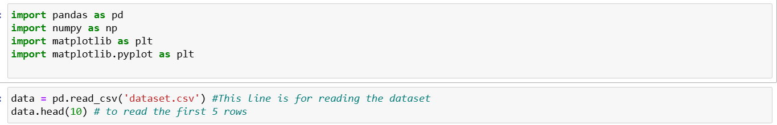
As a result of data.head(10), it is get the first ten rows of the dataset. Next image shows the output of this previous line code. Also, the output shows the total of columns.
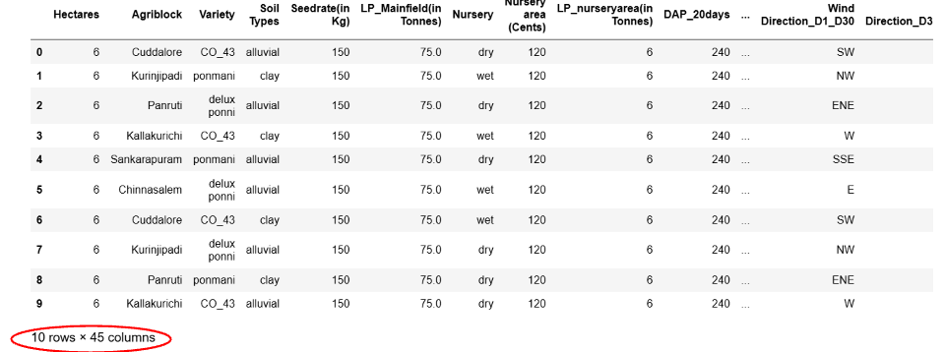
Next three lines (data.shape, data.isnull().sum(), data.info()) show the number of rows and columns in the dataset. Additionally, possibles null values in the dataset, in this case there are not null values. Also, it is checked the type of values for each feature (categorical are object and numerical are float64 and int). This lines can be see it in the python file.

b. Descriptive statistics
There is a line command to summarise basic statistics, these are measures of central tendency and variability. The next figure shows the statistics for numerical values. The value ‘mean’ is given, ‘std’ is standard deviation, ‘min’ and ‘max’ are minimum and maximum values, and three percentiles are also given, 25%, 50% and 75, which means the values below this percentage.
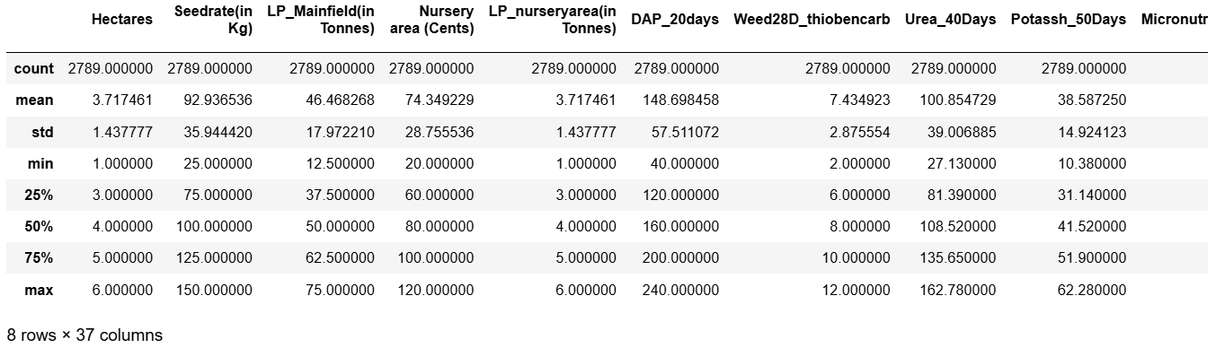
Now, it will be obtained measures of central tendency for the dataset (mean, median and mode). The next figure shows the result for three features (Hectares, Nursery area (Cents), Trash(in bundles) and Paddy yield(in Kg)). The code print the result only with two decimals. The mean is the central value in the feature, also known as average. This value can be affected for outlier values, in contrast to the median that can be not susceptible, but the median is used also to divide into two groups the dataset. Also, the mode is measured for them, which indicates the value that appear more often. Let’s consider the results for Trash, in this case the media is 335.51, the median is 360 and the mode is 400 of bundles. We could conclude that this data can have a negative trend, but this data will be confirmed forward on.
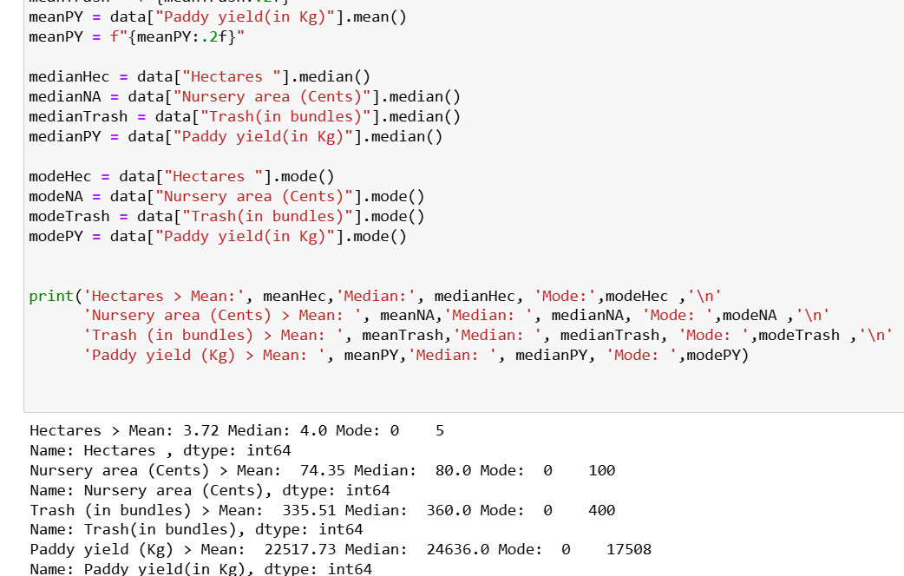

There are more descriptive values known as measures of dispersion or variability. These values are called minimum, maximum, range, standard deviation and can be calculated as the figure. The example says that the Paddy yield has a deviation of 9199.66 units from the mean (22517.73), the maximum and range value are 38815 and 33404 kg, respectively.
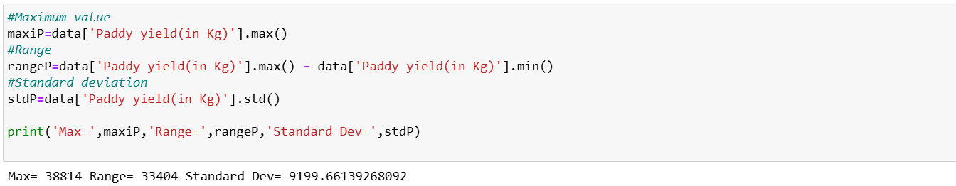
Other value is the percentage which shows the contribution on the total of a value. In this case we can consider the contribution of the feature variety to the percentage of the total of Paddy yield. The next image shows this fact. To get this value, firstly is calculated the total of Paddy yield, then the value expected is calculated dividing the value in paddy yield by the total and multiply per 100. After that, the confirmation is a sum of all the values of this new column called PaddyYield_Percentage, which the output is 100 as is expected.
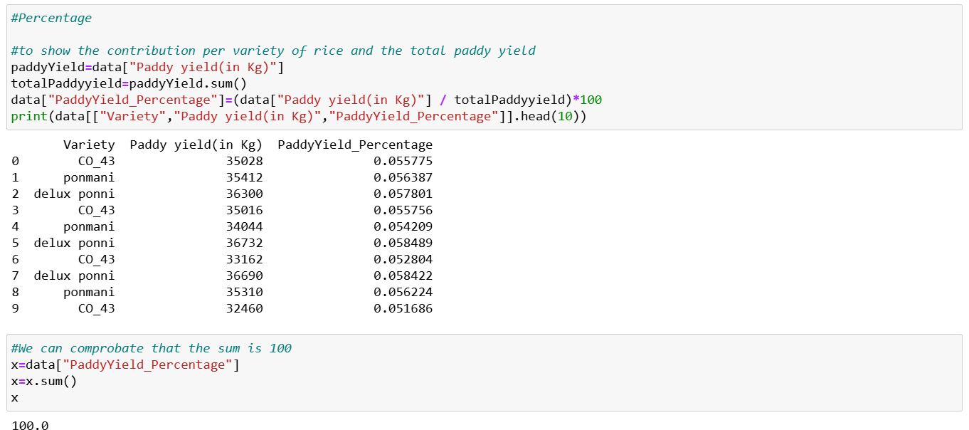
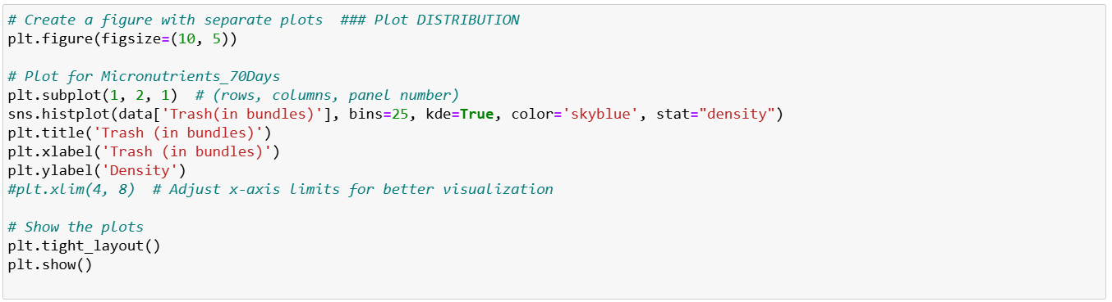
Next values are called Skewness and Kurtosis. These values are easily calculated, the values presented are negatives. When the skewness is < 0 =, the distribution negatively skewed (values on the left side). And when the kurtosis is < 0 the distribution is called platykurtic, which means that is flatter rather a normal distribution. We can observe that effect in the next figures. It is given the code using Trash feature using sns (seaborn library). The graph represents more data on the left side, that can be confirmed as negatively skewed and flatter distribution.
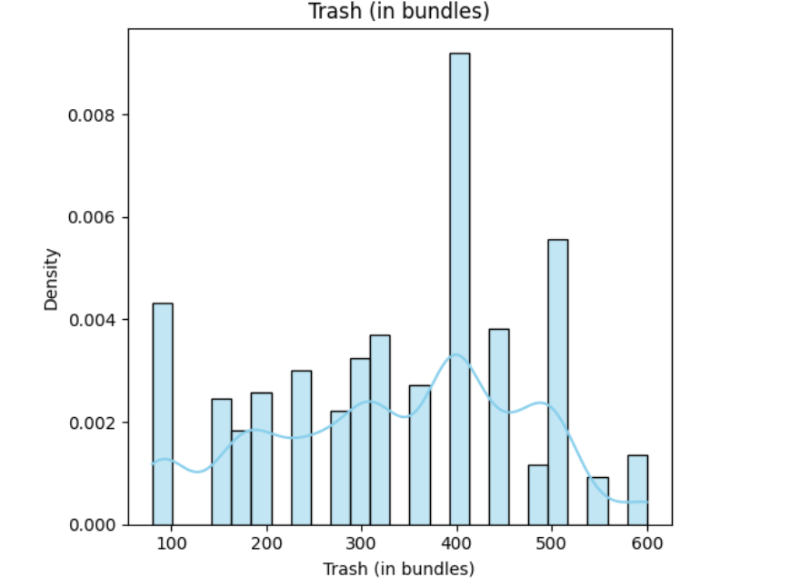

It is also possible get more information about the dataset using a box plot, this type of plot says the values that can be find inside of an interquartile IQR, the median and outliers. This box has the 1st quartile (q1) in the inferior value, the middle is de 50% of the values and the superior values is de 3rd quartile (q3), this range is known as IQR. In this context, values outside of this region are considered outliers. The next figures show the code and the box plot. The box plot shows all the values in the box, not showing outliers (values out from the IQR), this vales can be confirmed calculating the lower bound and upper bound. Values are calculated using Q1, Q3 and IQR. The lower and upper bound are calculated using the next equation:
Lower bound = Q1 – 1.5 * IQR
Upper bound = Q3 + 1.5 * IQR

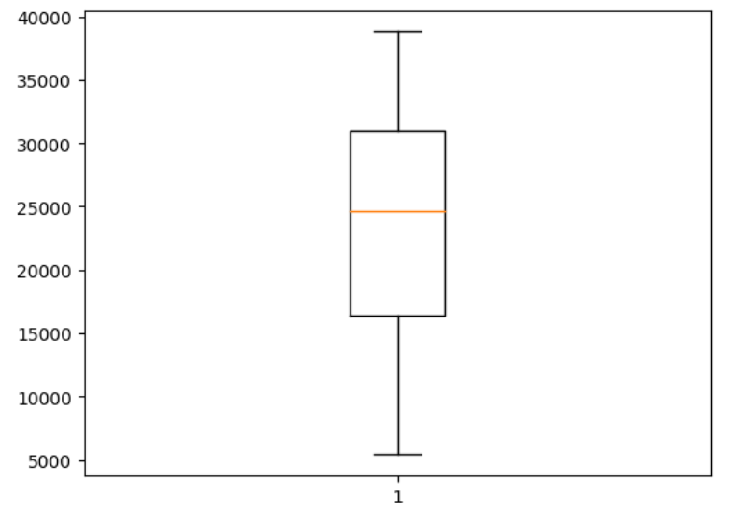

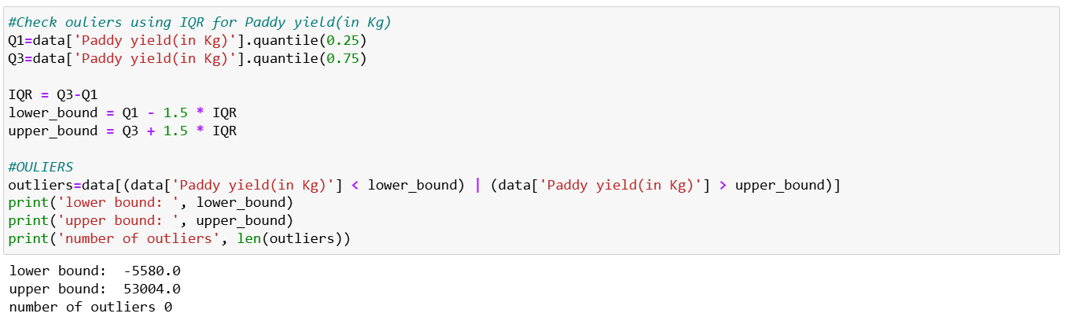

Following with the analysis of the dataset, it had been plotted the target feature (Paddy yield in kg), it is being a uniform distribution if it is supposed a uniformity in the values, as consequence means that the probability is equal in that range of appearing. This graph created random values in a range of the feature, and takes 1000 samples, showing uniformity as property of the sample dataset. The next figure illustrates the output of python.
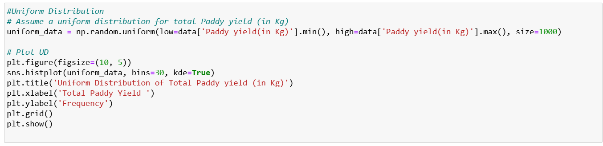

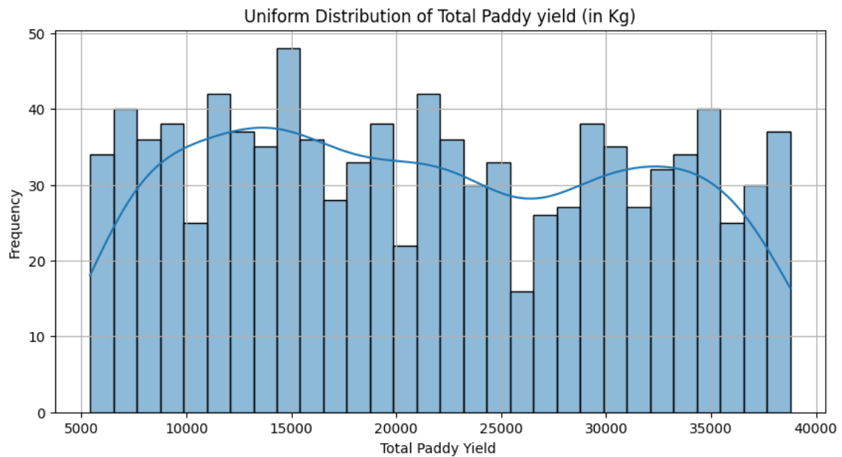

III. Binomial and Poisson distribution

a. Binomial distribution

Binomial distribution is and discrete distribution and binary, it means that can only take two values. This distribution gives an output of only success values in a range. For example here, the number of agricultors that will get a higher production than the average, this value is 1, other way the value is 0.
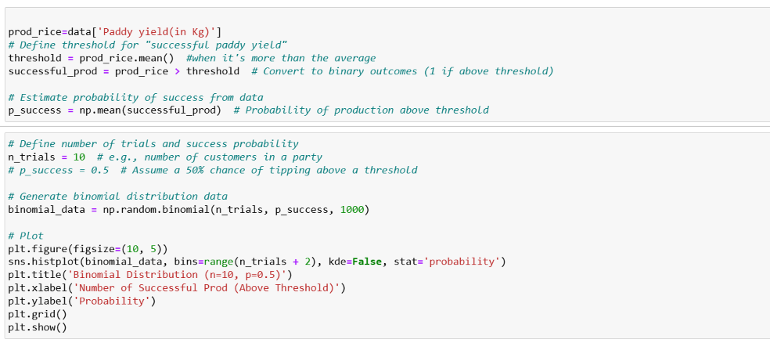
The next binomial graph shows the agricultors with a successful production. For example, four agricultors have a probability of production of rice bigger than the average of 0.06 and eight agricultors have more than 0.20 of probability of getting a good production.

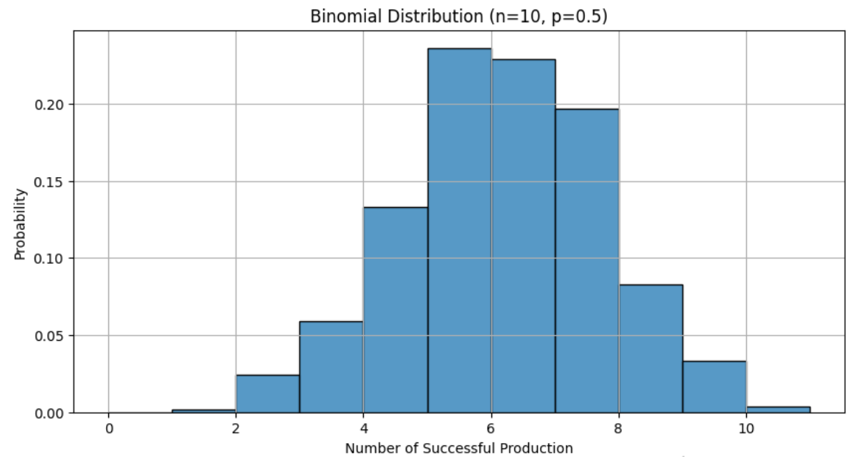
b. Poisson distribution
Poisson distribution is used to know how many times an event can occur in a specific interval of time. Lambda is a known mean rate parameter. For this example, we can calculate how many agricultors n can have certain hectares N.
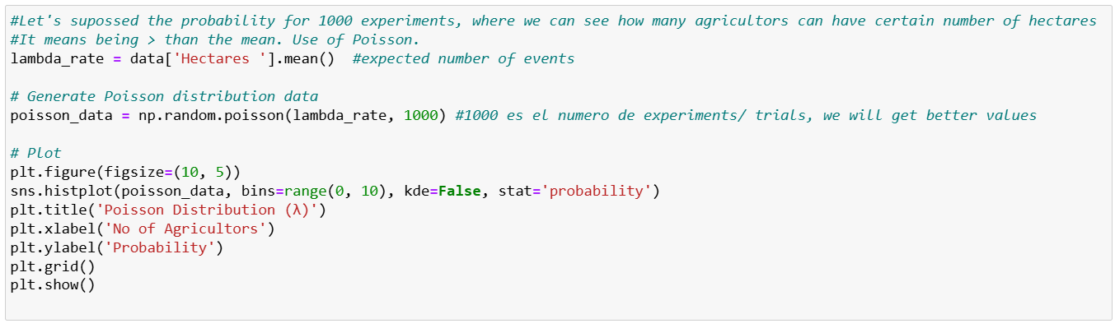
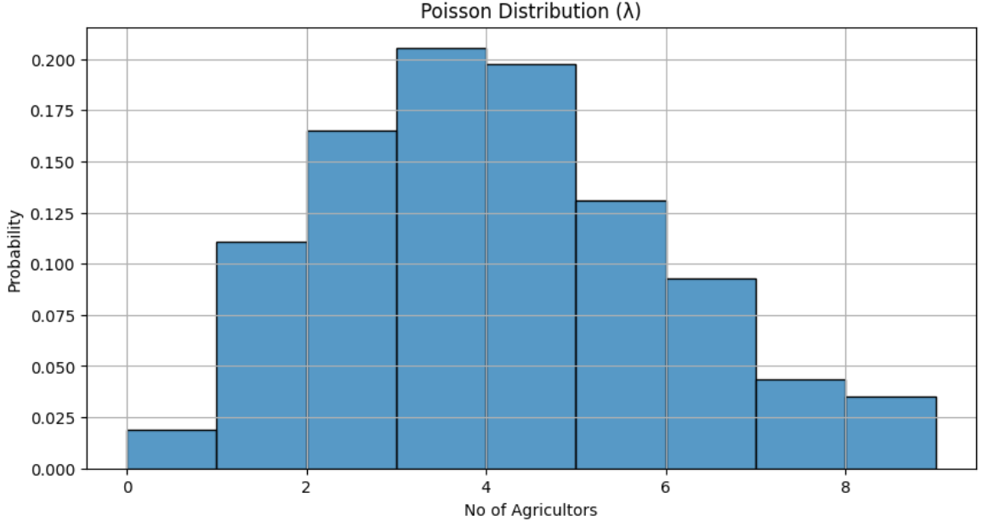
The previous graph shows the number of agricultors and the probability that can get that value of lambda hectares.

III. Normal distribution

This type of distribution can be apply for dataset where vales are normal distributed and values are continuos, that means values are not far from the mean value, the shape of this distribution is like a bell. The mean is the central value of the distribution, and the values on the sides are inside of the standard deviation values, these values show how can be spread the bell. Although this analysis is for symmetric values, it is also possible get this distribution with a proper normalisation. As we had observed in the previous results, the dataset does not show a normal distribution, it is more a flat distribution; in this case is considered a transformation to normalise these values. Firstly, it had been applied sklearn and quantile transformation, these quantiles vales are randomly generated for a normal distribution. Let see the next figure with the code. It takes only 1000 quantiles for the feature of Trash. An extra column is created with normalised values.
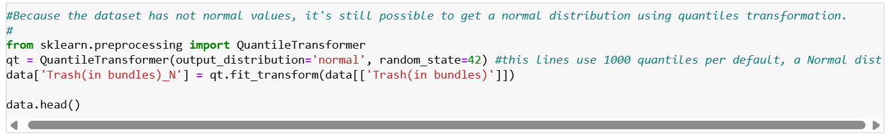
The next step is to plot the normal distribution using the new column of rice trash production. In the graph the shape is quite similar to a normal distribution, but it is also created some outliers. However, data are better distributed under the smooth line.
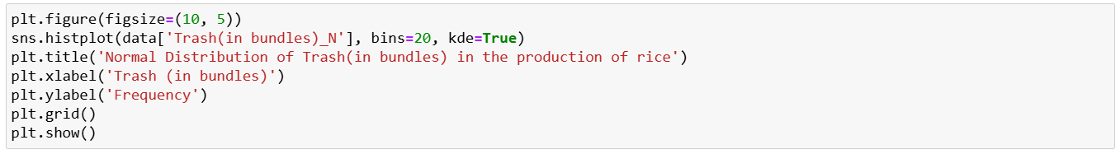
f

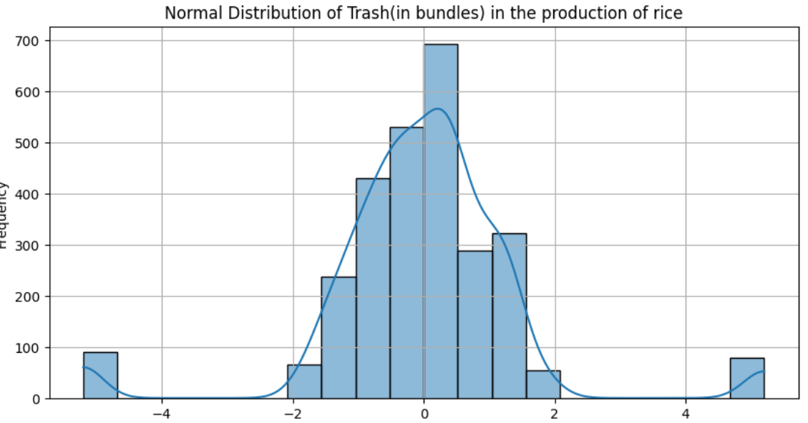
IV. Importance of distributions

Binomial distribution is a discrete plot, however can be apply when we want to determinate the probability of an event of success or failure. In the present dataset values are continuous, however, a success was defined as 1 when the paddy yield was bigger than the average. The probability increase if we increase the number of trials or experiments, giving us a value close to 1, and all the trials have the same probability of success. The Paddy yield variable was analysed because is the target in the dataset, and as consequence their success is easily to apply in the binomial distribution.
In contrast, the Poisson distribution predict certain events in a fixed interval, it means that a given value (hectares for the example) is known in the dataset, so it is possible to calculate the probability of events (agricultors) with those values or different. This analysis can be considered as forecasting of hectares per agricultor. In the future, those values might be useful to understand the size and type o soil where rice is cultivated.
Normal distribution is was considered because we expect to show the quantity of rubbish (trash) can be reduced (per hectare and more features like temperature, micronutrients, type of seed and more climate conditions) in the future, It is expected normal values, because their nature of the other features, however was not possible to identify yet the main correlation of its cause. So it was needed to transform the values in a normalisation type, showing a normal distribution.

