

CCT College Dublin Continuous Assessment

Programme Title: | Higher Diploma in Data Analytics for Business
Delivery Mode: | Offline/Online
Cohort Details: | Higher Diploma Data Analytics Sep2026 FT/PT Semester 1
Module Title(s): | Strategic Thinking
Assignment Type: | Individual | Weighting(s): | 20 %
Assignment Title: | CA 1 – Capstone Project Proposal
Lecturer(s): | Taufique Ahmed
Issue Date:
Submission Deadline Date:
Late Submission Penalty: | Late submissions will be accepted up to 5 calendar days after the deadline. All late submissions are subject to a penalty of 10% of the mark awarded.  Submissions received more than 5 calendar days after the deadline above will not be accepted and a mark of 0% will be awarded.
Method of Submission: | This assignment is submitted via Moodle.
Instructions for Submission: | Your work must be uploaded to Moodle.  • Capstone Project Proposal in Word format ONLY. The word count is 1,000.  • Ethics form signed by all students and submitted as PDF.  • ZIP or RAR files will not be accepted. Files must be submitted separately.  Create your own GitHub repository and provide the access to tahmed1986 GitHub account. Add the link to the first page of the report.  Word document, which covers the use of AI.
Feedback Method: | Results posted in Moodle gradebook
Feedback Date:

GitHub link: https://github.com/2026726-dotcom/Strategic-Thinking

Nutritional meals in the market

Introduction

This capstone project is focused on the research and market analysis for available purchases of food and/or meals which are known as healthy and labelled as high protein, low-fat, low-sugar, gluten-free, organic and so on. Knowing that this new labelling has enriched the way of thinking and eating a meal in the daily life. Although these meals might not be popular in some places, these characteristics have attracted more people recently, this is due to the marketing, athletes endorsements and healthy life style promotion. In addition, convincing labelling in shops can be very persuasive and compelling evidence to increase sales of these products. This research will show information about how costumers can be persuaded and tempted to buy these meals. Ultimately, consumers of these products might believe that their health and investment is truly worthy.

Problem Definition

The problem is based on many healthy products which are labelled in such a way that have created authenticity and as a consequence an increase in sales. However, the rise must consider the way of how the community can decide which product to pick. These decisions can be determined by many factors, including perceptions (or illusions) and triggering advertisements. In this context a thorough analysis will be conducted using different sources in business data analytics.

Aim and Objectives

The aim is to analyse and predict sales in healthy food and their labelling.
- Study the main products sold as healthy options with selected captions which are considered as organic, high-protein, low-fat or similar.
- Analyse the popularity of these products related to age and content.
- Evaluate the most common labelling and their increasing sales.
- Predict sales using data analytics and suggestions for future labelling in healthy products.

Scope

The present project will involve a vast information about consumers of healthy food as consequence of their availability in shops and their promotion due to labelling. Currently, there are researches about some more other factors that can promote their increase in sales, such as flavour, texture, sweetness, taste, bitterness, etc. These factors might be considered as positive or negative trend in buying these products and not only their labelling.
In this context, the exploration through choices carried on by consumers is needed with the aim to understand. Thakur et al (2022) found how these claims can persuade them to make their daily food purchases, also current regulations for such type of products are important to be considered. Besides that, the increment in sales will be studied according to the availability of dataset and research studies.

Methodology

This project will be developed in four main stages, the next diagram shows the methodology of this research:

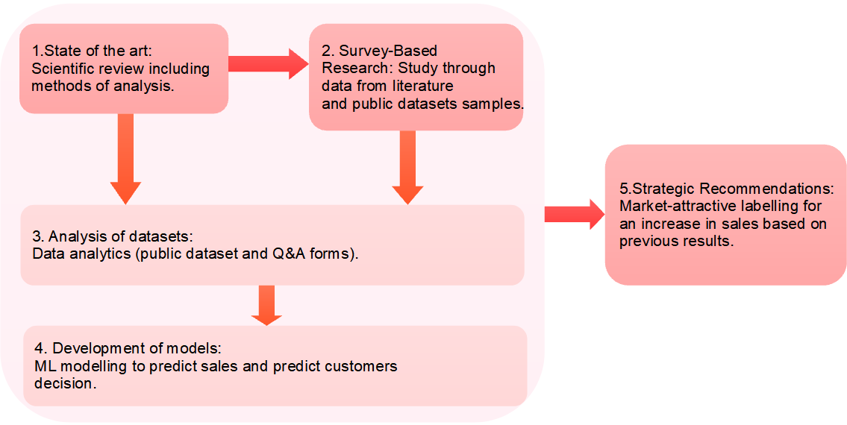
Figure 1: Methodology diagram.

- State of the art: Research study through available information in scientific articles, where is possible obtain dataset of small groups and statistics information. This section will show a forecasting about the limits and future work which can be developed. Additionally, it will be studied different factors correlation and their efficacy in the choice of products. The importance of this field in business will show the main advantages of having an effective claims in its products.
- Survey-Based Research: The study will be carried out among small dataset samples which are available on scientific articles and public statistics reports. These data will be important to understand the current market and the recent increase in sales. The main target considered for this study involve small markets reports, small shops (from local farms if dataset are available), sport nutrition shops (shops with high sales for athletes), and health food shops (shops like Holland & Barrett). In this context, questionaries might be an option and useful tool to study.
- Analysis of datasets: The research will be developed using tools for the data analytics, statistics and coding in python will be used. This section will show the statistics of many variables (including the main target which is decision customer to buy a product), focusing on the context of age, content and characteristics of the product, sport life, and labelling. Some of these analysis will be: description of the dataset, correlation, different types of distribution, classification and clustering, and graphs and charts.
- Development of models: Machine Learning model will be used for the analysis of the target, in order to know whether customers are or not convinced to buy a healthy product and the satisfaction of themselves.
- Strategic Recommendations: Suggestion of content labelling will be available for business involved, as well the ethical retail over the customers and the benefits in their health. Summarizing the previous data analysis results and their impact in the increase in the sales.

Data Sources
In this research is needed to have dataset with enough observations where will be possible to read, analyse and apply statistics and machine learning models. The features might include type of foods/meals, type of labelling, claims content, and other features. In addition, these dataset will use public dataset, including available scientific papers online. According to dataset analysed through Growth Market Reports, the market is expected to grow twice in five years. In this context, the importance of this research is considered as important as the possible profits. In the case of organic meals, the ‘Global Market Research’ says that revenue for organic food will be triplicate in 2035. Unfortunately, in this moment datasets are limited, reducing their analysis. However, there is a chance to get some free samples of this dataset online, this task will be evaluated in the next stages of this project.

Expected Deliverables

The expected results are the next ones: Study and cleaning of dataset, and show some type of distribution (might be normal or binomial for example). Considering the previous results, it will be presented a prediction modelling (Machine Learning tools), and different tools to predict and visualise among these products (k-means is one of the tools expected to use). It is also pretended to develop a python dashboard to analyse different dataset and predict new results.

Project Timeline

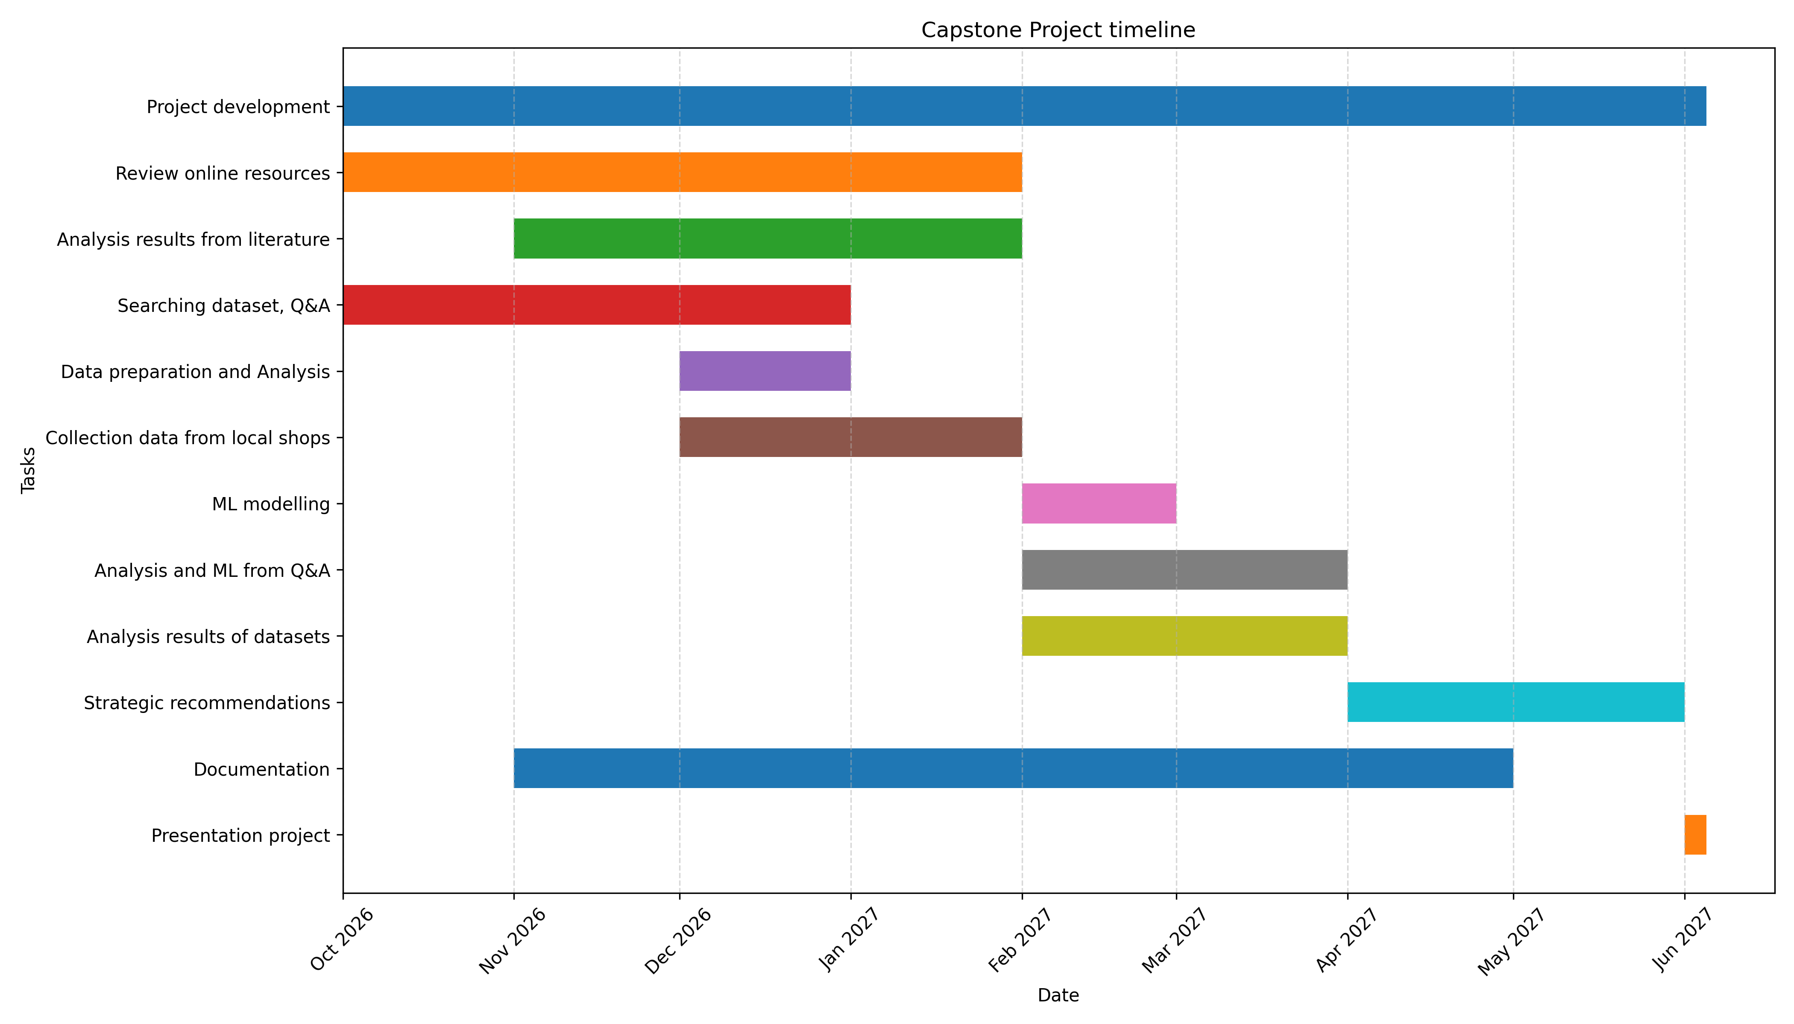
Ethical and Legal Considerations

This capstone project will be only an academic research project, it means that it is not biased for any other reason. Hence the research, study and analysis will be carried on using public dataset and will use only free access sample data. In addition, personal information is not considered for any case of study. Machine learning will be used for testing and technical support in the project, in this sense it is not considered as a tool to develop any other purpose than academic.

References

Thakur, M., Sharma, C., Mehta, A. and Torrico, D.D. (2022) ‘Health claim effects on consumer acceptability, emotional responses, and purchase intent of protein bars’, Journal of Agriculture and Food Research, 8, article 100291. Available at: https://doi.org/10.1016/j.jafr.2022.100291.

