

CCT College Dublin Continuous Assessment

Programme Title: | HDIP Data Analytics
Cohort: | HDipData_Sept26_ FT Stage 1 Sem1
Module Title(s): | Data Preparation
Assignment Type: | Individual | Weighting(s): | 40%
Assignment Title: | CA1_DataPrep_HDip
Issue Date: | 6th October 2026
Lecturer(s): | David McQuaid
Late Submission Penalty: | Late submissions will be accepted up to 5 calendar days after the deadline. All late submissions are subject to a penalty of 10% of the mark awarded.
Method of Submission: | Moodle
Instructions for Submission: | All files to be uploaded to Moodle separately (Do NOT Zip your submission)  Expected files : Jupyter Notebook File Must be saved as “YourName_DPrepHDip_CA1.ipynb”  AI Declaration Document Word File, No PDF’s (See Use of Artificial Intelligence Section)
Submission Date: | 8th November 2026 | Feedback Date: | Three weeks after final submission [Including late and PMCs]

Description of Assessment Task
Students are advised to review and adhere to the submission requirements documented after the assessment task.
It is Required that you use GitHub Classroom as your version control repository etc with regular commits of code and report versions. You may be called to a Viva to defend your work.
You may ONLY use your CCT email address as your login, NO OTHER EMAIL WILL BE ACCEPTED
The Git Classroom link for this assignment is: https://classroom50.org/CCT-Dublin/hdipdata-sept26-ft-stage-1-sem1/onboard

All data wrangling, analysis, and visualizations must be generated using python in a Notebook.

Minimum Requirements

You are required to use the dataset contained within the file “student_data.csv”, conduct the following analysis and report on your findings:

- Characterisation of the data set: size; number of attributes; has/does not have missing values, number of observations etc. and what these Characterisation mean in the context of this data.

- Application of Data preparation/evaluation methods (Cleaning, renaming, etc) and EDA visualizations (plural), including a clear and concise explanation of your rationale for what you are doing with the data and why you are doing it in the context of this data.

- Use PCA to establish the minimum number of features needed for retaining 99.5% variance in the data and then implement PCA to dimensionally reduce the data to the number of features that you have discovered. Include a clear and concise explanation of your rationale for what you are doing with the data and why you are doing it in the context of this data.

- Explain in your own words what the “Curse of Dimensionality ” is and how it may affect your analysis going forward in the context of this problem.

- Testing your dimensionally reduced dataset practically and discuss your results in the context of this data.

Conclusions, Findings of data set and references (HARVARD style).

Data Dictionary

Please Review the Excel File “student_data_dictionary.xlsx”

NOTE your dependant feature is called “Target” and has 3 categories: dropout, enrolled, and graduate.

All Project files MUST be uploaded into MOODLE, this is your responsibility, if any files are not uploaded to MOODLE, even if they are available on GITHUB, they will NOT BE GRADED.
CA1 NOTE DO NOT ZIP YOUR SUBMISSION FILES, ALL FILES MUST BE SUBMITTED INDIVIDUALLY

Learning Outcomes:
This assessment addresses the following module learning outcomes for this module:

This assessment addresses the following module learning outcomes for this module:
- Develop strategies, incorporating basic programming skills (input / output and basic data structures) for identifying and handling missing and out-of-range data. (linked to PLO 4)
- Programmatically implement graphical methods to identify issues within a data set (missing, out of range, dirty data) (linked to PLO 2, PLO 3)
- Perform a critical analysis of a data set to optimise the data for a given problem space.
Document the rationale behind the decisions to peers and stakeholders. (linked to PLO 1,PLO 3, PLO 6)

Use of Artificial Intelligence
This assessment applies the AI Fluency Framework — four interconnected competencies for effective, efficient, ethical and safe AI use. Your engagement with AI will be reviewed across all four dimensions:
Delegation  Setting goals and deciding whether, when and how to engage with AI. | Description  Effectively describing goals to prompt useful AI behaviours and outputs.
Discernment  Accurately assessing the usefulness of AI outputs and behaviours. | Diligence  Taking responsibility for what we do with AI and how we do it.

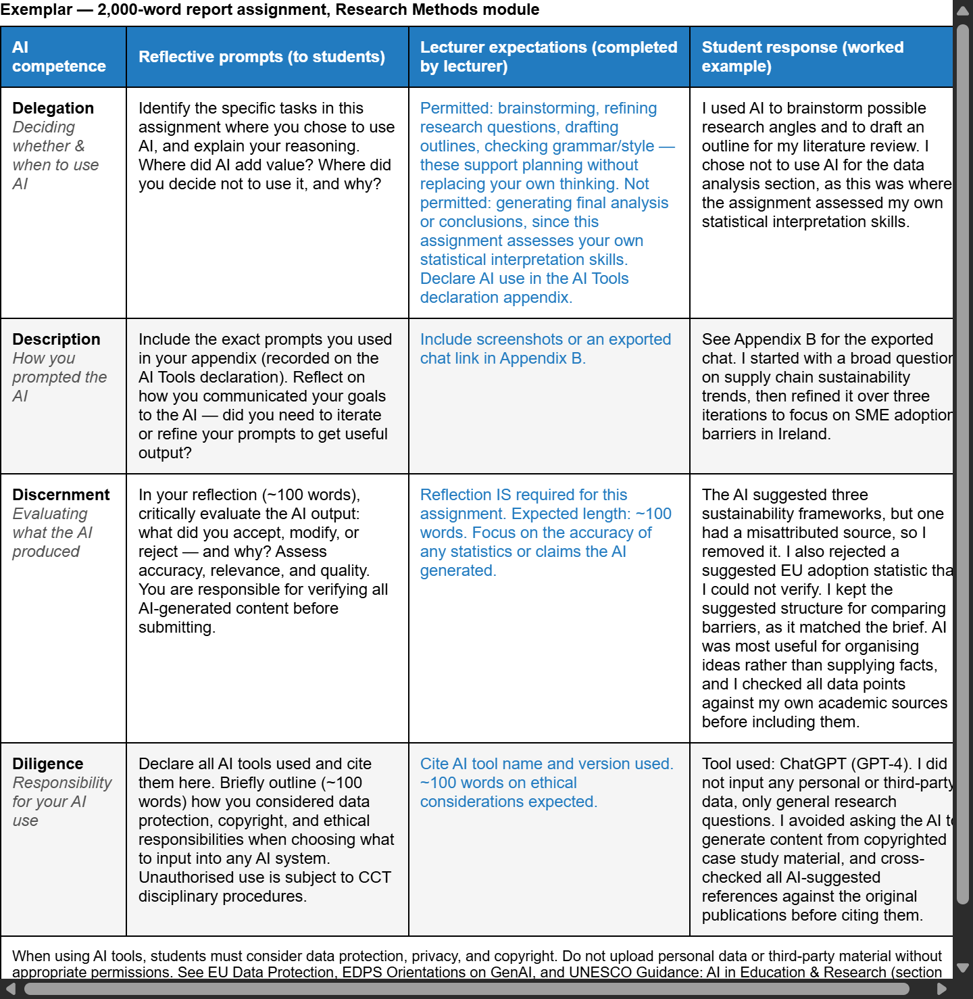

AI tools may be used in this assessment. Your use of AI will be assessed across the four ‘D’ competencies of the AI Fluency Framework.
Please complete column four and submit as an appendix to your assessment . Exemplar below.

AI Declaration using the AI Fluency Framework
AI competence | Reflective prompts (to students) | Lecturer expectations | Student response
Delegation  Deciding whether & when to use AI | Identify the specific tasks in this assessment where you chose to use AI and explain your reasoning. Where did AI add value? Where did you decide not to use it, and why? | For this assessment, Generative AI may be used only as a supporting tool for brainstorming and refining ideas, fine-tuning research questions, finding relevant information, drafting an outline, checking grammar, clarity and writing style, and other uses explicitly approved by the lecturer.  These uses support planning, research and communication. GenAI must not replace the student's own technical implementation, analysis, modelling, evaluation or interpretation, as these directly assess the learning outcomes. You may not copy and paste GenAI output in your submission. All GenAI use must be declared in the GenAI Tools Declaration (Appendix A). Failure to do so is considered to be academic misconduct. | [Student response]
Description  How you prompted the AI | Include the exact prompts you used in your appendix (recorded on the AI Tools declaration). Reflect on how you communicated your goals to the AI — did you need to iterate or refine your prompts to get useful output? | Students must provide evidence of prompting for all permitted GenAI use. The exact prompts used, together with relevant links, screenshots or evidence of prompt refinement where applicable, must be provided in Appendix B. Failure to do so is considered to be academic misconduct. | [Student response]
Discernment  Evaluating what the AI produced | In your reflection (~100 words), critically evaluate the AI output: what did you accept, modify, or reject — and why? Assess accuracy, relevance, and quality. You are responsible for verifying all AI-generated content before submitting. | A reflection is required for this assessment. In approximately 100 words, students must critically evaluate the accuracy, relevance and quality of any GenAI-assisted outputs, explaining what they accepted, modified or rejected and why. Failure to do so is considered to be academic misconduct. | [Student response]
Diligence  Responsibility for your AI use | Declare all AI tools used and cite them here. Briefly outline (~100 words) how you considered data protection, copyright, and ethical responsibilities when choosing what to input into any AI system. Unauthorised use is subject to CCT disciplinary procedures. | Students must declare all GenAI tools used and cite them appropriately. In approximately 100 words, students must explain how they considered data protection, copyright and ethical responsibilities when using GenAI. Unauthorised GenAI use is subject to CCT disciplinary procedures. Failure to do so is considered to be academic misconduct. | [Student response]

For use in assessment briefs and student submissions. Lecturers complete the Lecturer Expectations column per assessment; students complete the Student Response column.
Adapted from the AI Fluency Framework (Dakan, Feller, Anthropic, 2025)

Additional Information
- Lecturers are not required to review draft assessment submissions.
- In accordance with CCT policy, feedback to learners may be provided in written, audio or video format and can be provided as individual learner feedback, small group feedback or whole class feedback.
- Results and feedback will only be issued when assessments have been marked and moderated / reviewed by a second examiner.
- Additional feedback may be requested by contacting your lecturer AFTER the publication of results, Additional feedback may be provided as individual, small group or whole class feedback. Lecturers are not obliged to respond to email requests for additional feedback where this is not the specified process or to respond to further requests for feedback following the additional feedback.
- Following receipt of feedback, where a student believes there has been an error in the marks or feedback received, they should avail of the recheck and review process and should not attempt to get a revised mark / feedback by directly approaching the lecturer. Lecturers are not authorised to amend published marks outside of the recheck and review process or the Board of Examiners process.
- Students are advised that disagreement with an academic judgement is not grounds for review.
- For additional support with academic writing and referencing students are advised to contact the CCT Library Service or access the Essentials Modules in Moodle.
- For additional support with subject matter content students are advised to contact the CCT Student Mentoring Academy
- For additional support with IT subject content, students are advised to access the CCT Support Hub.

Marking Rubric

Criteria | Characterization of the Data Set | Application of Data Preparation and EDA | PCA Implementation | Explanation of the “Curse of Dimensionality” | Testing and Discussion of Results
Weighting per criteria | 10 marks | 35 marks | 25 marks | 10 marks | 20 marks
Excellent (+70%) | Comprehensive and insightful analysis; thoroughly contextualized characterization with significant implications. | Excellent preparation with multiple insightful visualizations; rationale is thorough and contextualized effectively. | Comprehensive PCA analysis; thorough rationale for variance retention; insightful application of dimensionality reduction. | Excellent, insightful explanation; thoroughly connects the concept to the data analysis context and implications. | Comprehensive testing with thorough discussion; insightful analysis of results in the context of the data.
Very Good (60 - 69%) | Thorough characterization with good context; clear explanation of implications. | Good preparation and a variety of clear visualizations; rationale is mostly well explained. | PCA performed effectively; clear explanation of feature selection and rationale provided. | Good explanation with clear relevance to the analysis; shows understanding of implications | Good testing with relevant discussion; insights drawn from results.
Good (50 - 59%) | Adequately describes size, attributes, missing values, and observations, but lacks contextual analysis. | Basic preparation and some EDA visualizations; rationale is present but lacks depth. | PCA performed; explanation of variance retention is present but lacks detail in rationale. | Satisfactory explanation of the concept; some relevance to the analysis context. | Adequate testing with some discussion of results; relevance is somewhat clear.
Acceptable (40 - 49%) | Some relevant details provided but lacks clarity or depth. | Some data preparation done, but visualizations are unclear or poorly explained. | PCA attempted but lacks clarity in rationale or explanation. | Basic understanding, but explanation is unclear or incomplete. | Some testing done, but results discussion is weak or unclear.
Fail (> 39%) | Incomplete characterization; lacks key details. | Minimal data preparation; no visualizations or rationale. | No PCA conducted or poorly explained; no rationale. | Incorrect or vague explanation; lacks understanding of the concept. | Minimal testing; discussion lacks clarity or relevance.

