Sensorless Drive Diagnosis
ML Assignment 2. Verified local backup prepared 2026-11-08 00:53.

1. GitHub repository link
https://github.com/2026ak05140-dev/MLAssignment2
The public repository is accessible, but its published README differs from this local revision.
Publish the current source, test CSV, fitted models, and README before submission.

2. Live Streamlit app link
https://mlassignment2-nz97nufqwetuqsaxhdjt6c.streamlit.app/
Deployment verification is incomplete. This environment redirects the URL to a network
Site Blocked page; a separate fetch returned HTTP 403. This does not prove the app itself is
unavailable. Redeploy and verify the interactive frontend from an allowed network.

3. BITS Virtual Lab execution evidence
BITS Virtual Lab evidence is unavailable. Replace this paragraph and the following
supporting local evidence with one genuine BITS execution screenshot after a successful lab run.
Local screenshots do not fulfill the rubric's 1-mark lab requirement.
Local checks on 2026-11-08: the final six-test regression run passed in approximately 161 seconds.
The full 11,702-row app comparison reproduces all 30 stored metrics within 1e-12.
Lint, formatting, and compilation checks passed. All five model selections render six
metrics and an 11-class report. The browser accepts the test CSV and rejects missing features.
The experiment uses 58,509 source records, 48 inputs, and 11 classes without subsampling.
Word is an editing copy. The assignment requires one final PDF in this section order.
Recheck links and layout after edits. Local validation does not certify originality or public
deployment; review the assignment's AI-use rules and understand the implementation.

Supporting local evidence 1
Five-model comparison and six Logistic Regression metrics on 11,702 test records.
Captured locally on 2026-11-08. Not BITS Virtual Lab evidence.
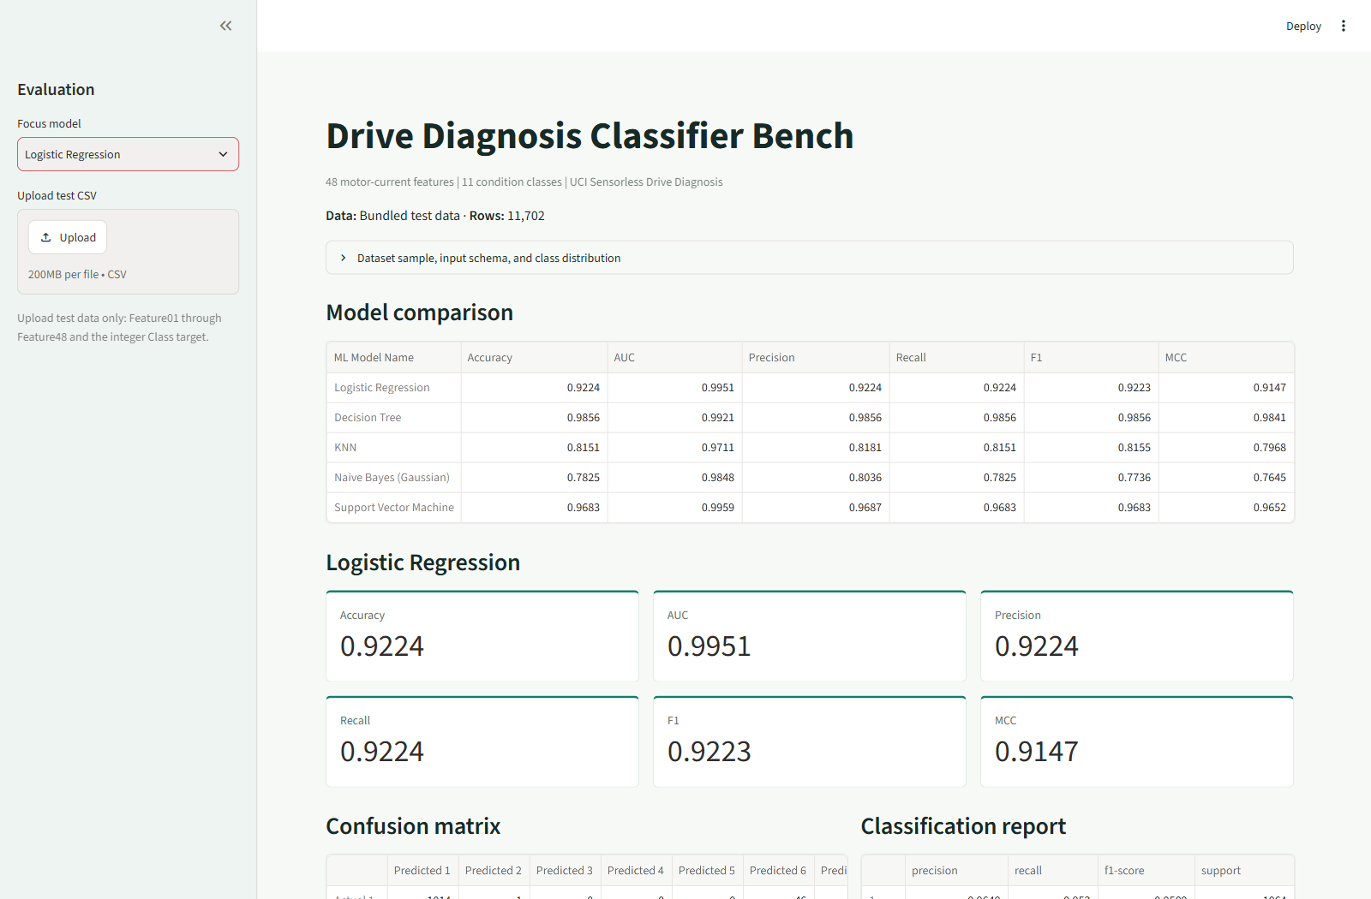
Five-model comparison and six Logistic Regression metrics on 11,702 test records.

Supporting local evidence 2
Winning Decision Tree: six metrics, all 11 confusion-matrix rows, and classification report.
Captured locally on 2026-11-08. Not BITS Virtual Lab evidence.
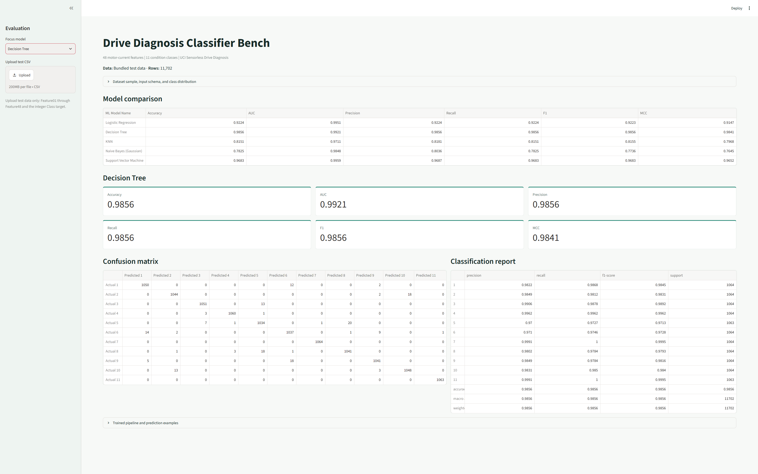
Winning Decision Tree: six metrics, all 11 confusion-matrix rows, and classification report.

Supporting local evidence 3
Calibrated RBF SVM: six metrics, 11-class confusion matrix, and classification report.
Captured locally on 2026-11-08. Not BITS Virtual Lab evidence.
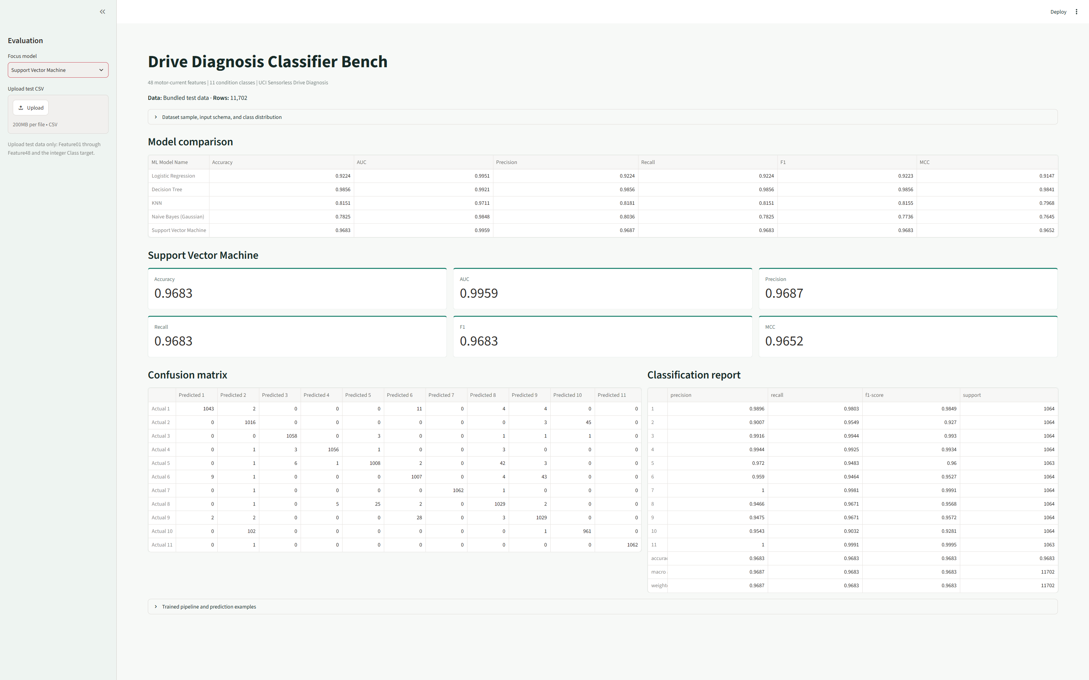
Calibrated RBF SVM: six metrics, 11-class confusion matrix, and classification report.

Supporting local evidence 4
Actual feature samples, all 48 column names, and the 11-class test distribution.
Captured locally on 2026-11-08. Not BITS Virtual Lab evidence.
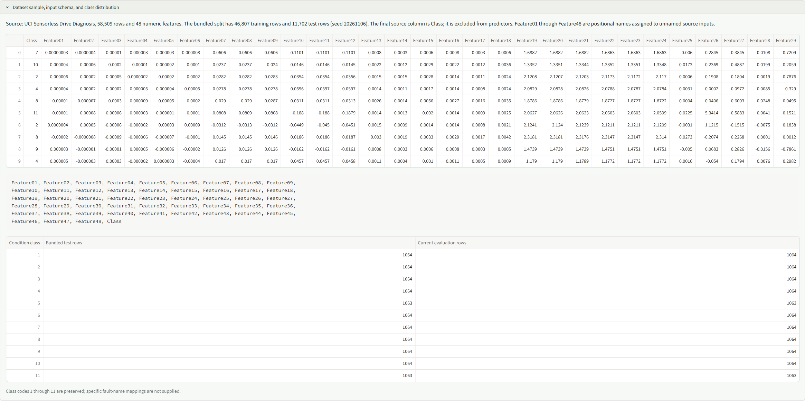
Actual feature samples, all 48 column names, and the 11-class test distribution.

Supporting local evidence 5
Saved fitted SVM pipeline and ten actual-versus-predicted condition classes.
Captured locally on 2026-11-08. Not BITS Virtual Lab evidence.
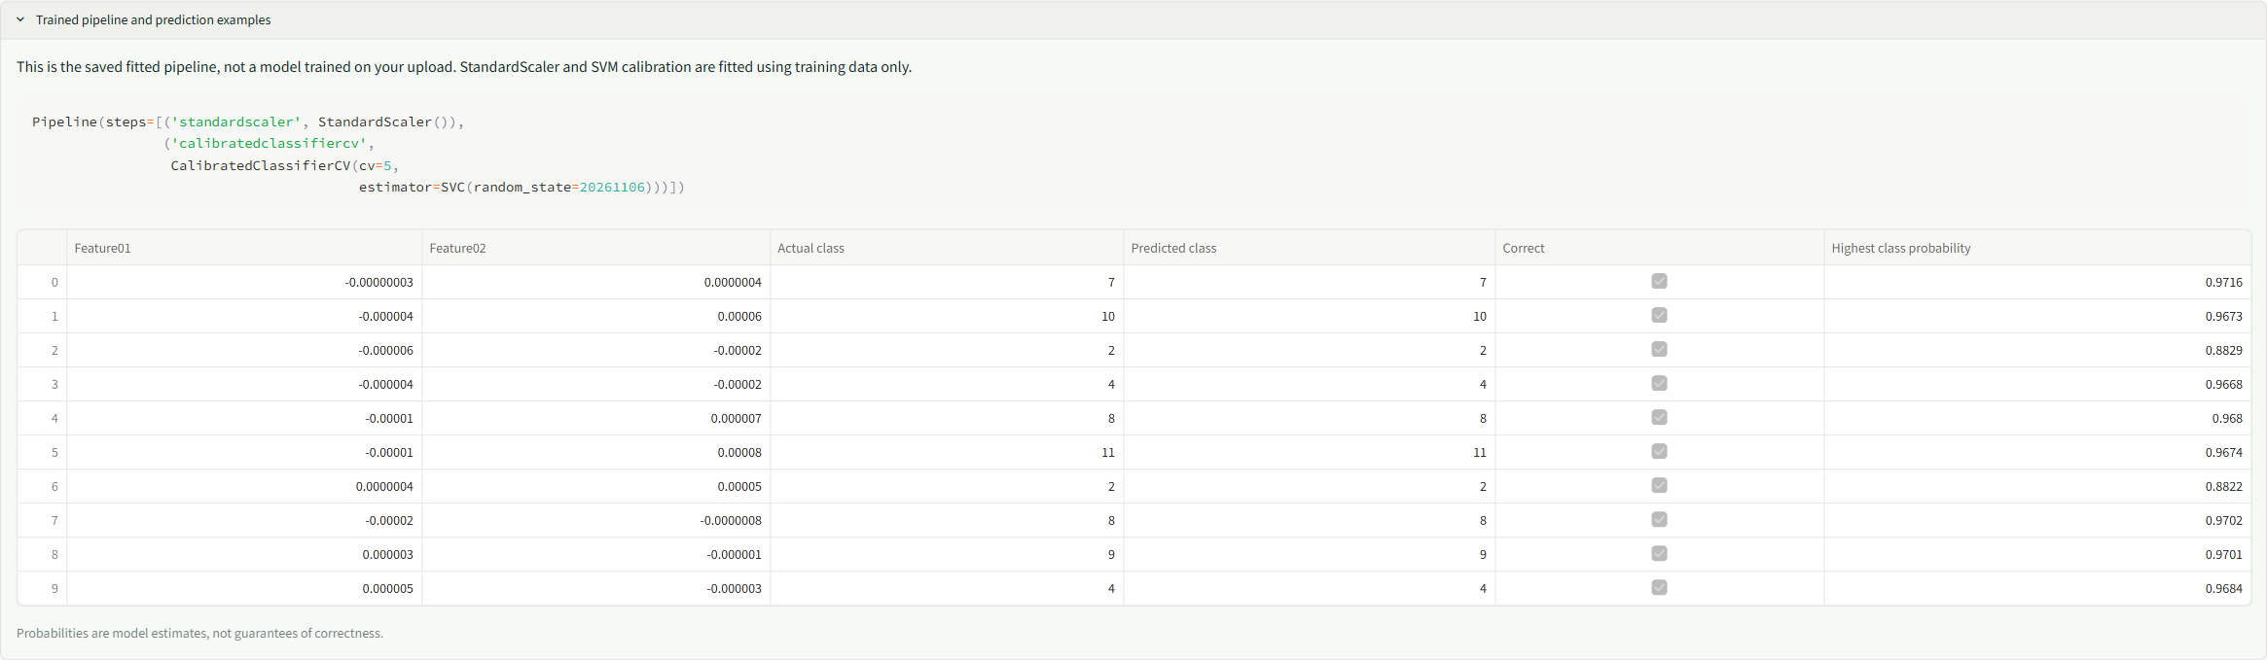
Saved fitted SVM pipeline and ten actual-versus-predicted condition classes.

Supporting local evidence 6
Successful upload of test_data.csv with all five models evaluated without retraining.
Captured locally on 2026-11-08. Not BITS Virtual Lab evidence.
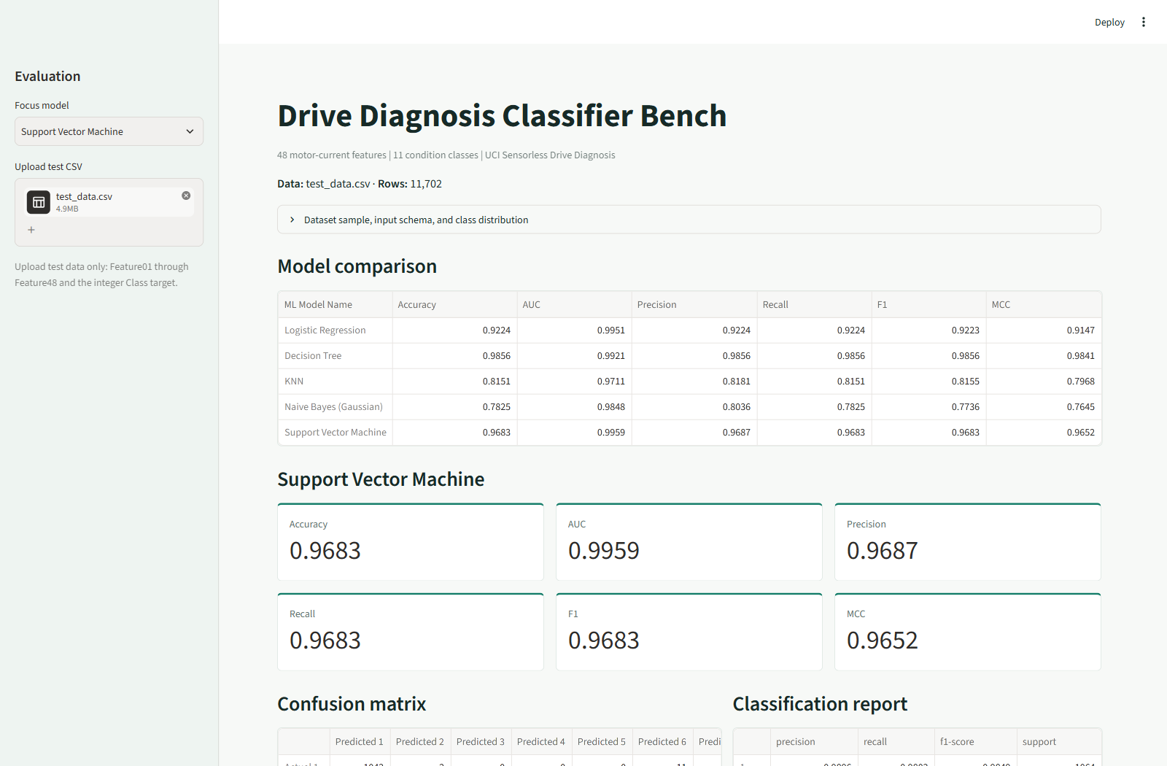
Successful upload of test_data.csv with all five models evaluated without retraining.

4. README content

Problem Statement
Predict one of 11 drive-condition classes from 48 features extracted from motor
current signals. Train the five required classifiers on the same training rows,
evaluate six metrics on the same held-out test rows, and inspect predictions in
a Streamlit application. This is classification of supplied tabular features,
not processing of live motor signals or a deployed safety-monitoring system.

Dataset Description
The UCI Dataset for Sensorless Drive Diagnosis
contains 58,509 records. The downloaded file was verified to contain 48 numeric
input columns plus one integer target column. It exceeds the assignment minimums
of 500 instances and 12 features. UCI reports no missing values; preparation also
checks for missing and non-finite values. No exact duplicate full records were
found. The full dataset is used, with no sampling or reduction in feature count.
UCI describes intact and defective motor components measured repeatedly under
12 operating conditions involving speed, load moment, and load force. Features
were extracted from two-phase current signals using empirical mode decomposition
(EMD), intrinsic mode functions and residuals, and statistical summaries such as
mean, standard deviation, skewness, and kurtosis.
The source file, Sensorless_drive_diagnosis.txt, has no header. Its first 48
columns become Feature01 through Feature48, preserving source order. These
are project-assigned positional names, not official physical feature names.
The final column becomes Class. The target is excluded from model inputs.
The available metadata does not establish an exact per-column physical mapping
or a reliable fault-name mapping for each class code, so neither is invented.
The exact CSV feature names are:
Feature01,Feature02,Feature03,Feature04,Feature05,Feature06,Feature07,Feature08,Feature09,Feature10,Feature11,Feature12,Feature13,Feature14,Feature15,Feature16,Feature17,Feature18,Feature19,Feature20,Feature21,Feature22,Feature23,Feature24,Feature25,Feature26,Feature27,Feature28,Feature29,Feature30,Feature31,Feature32,Feature33,Feature34,Feature35,Feature36,Feature37,Feature38,Feature39,Feature40,Feature41,Feature42,Feature43,Feature44,Feature45,Feature46,Feature47,Feature48
Append Class, with integer codes from 1 through 11. Preserve column names and
source order when preparing upload data.

Split and Class Distribution
A stratified 80/20 split with random state 20261106 produces 46,807 training
records and 11,702 test records. Each original class contains exactly 5,319
records; rounding creates a one-record difference in the split counts.
Condition class | Total rows | Training rows | Test rows
1 | 5,319 | 4,255 | 1,064
2 | 5,319 | 4,255 | 1,064
3 | 5,319 | 4,255 | 1,064
4 | 5,319 | 4,255 | 1,064
5 | 5,319 | 4,256 | 1,063
6 | 5,319 | 4,255 | 1,064
7 | 5,319 | 4,255 | 1,064
8 | 5,319 | 4,255 | 1,064
9 | 5,319 | 4,255 | 1,064
10 | 5,319 | 4,255 | 1,064
11 | 5,319 | 4,256 | 1,063
Total | 58,509 | 46,807 | 11,702

Always predicting one of the largest test classes yields 1,064/11,702 = 0.0909
accuracy. Macro metrics give each condition equal weight; balanced class counts
make macro recall close to accuracy, but precision and F1 can still differ.

Example Input Records
The first five actual rows of test_data.csv, with four of the
48 input features shown in scientific notation:
Feature01 | Feature02 | Feature03 | Feature04 | Class
-3.9621e-08 | 4.4180e-07 | 1.4261e-05 | -3.1874e-06 | 7
-3.5416e-06 | 6.3153e-05 | 2.4527e-04 | 1.2673e-05 | 10
-5.5443e-06 | -1.6878e-05 | 4.6425e-05 | 2.6462e-07 | 2
-3.9820e-06 | -2.3080e-05 | -2.0704e-05 | 5.3406e-06 | 4
-1.3885e-05 | 7.1854e-06 | 3.0758e-04 | -9.2797e-06 | 8

Dataset Selection
Sensorless Drive Diagnosis was selected for its engineering interpretation,
48-feature input space, balanced 11-class target, and larger number of records.
The following official sources were considered; this is a suitability comparison,
not an experiment on those alternatives or a survey of classmates' datasets.
Dataset | Rows | Features | Classes | Consideration
Sensorless Drive Diagnosis | 58,509 | 48 verified | 11 | Selected: motor-current condition classification with balanced classes.
Steel Plates Faults | 1,941 | 27 | 7 | Smaller industrial dataset; superseded at the user's request.
Image Segmentation | 2,310 | 19 | 7 | Suitable dimensions, but regions originate from only seven images.
Landsat Satellite | 6,435 | 36 | 6 observed | Suitable dimensions; spatially related neighborhoods and no examples of class 6.

Dataset popularity among other submissions is unknown. Choosing another public
dataset does not establish originality. All CSVs, models, metrics, screenshots,
and reports in this experiment replace the earlier Steel Plates/Dry Bean work;
their scores are not reused.
Citation: Bator, M. (2013). Dataset for Sensorless Drive Diagnosis [Dataset].
UCI Machine Learning Repository.
DOI: 10.24432/C5VP5F.
Licensed under CC BY 4.0.

GitHub Repository Link
GitHub Repository
MLAssignment2/
|-- app.py
|-- prepare_data.py
|-- train_models.py
|-- test_project.py
|-- requirements.txt
|-- README.md
|-- test_data.csv
|-- model_metrics.csv
|-- model/
|-- logistic_regression.joblib
|-- decision_tree.joblib
|-- knn.joblib
|-- gaussian_naive_bayes.joblib
|-- support_vector_machine.joblib
The training CSV is generated locally and excluded from Git. Regenerate it
before retraining or running the regression tests.
The public repository was accessible during verification on 2026-11-08.
Its published README differed from the local Sensorless Drive README.
The current local changes still need to be committed and published; an accessible
repository link alone does not prove the latest experiment is available there.

Models Used
All five models use 46,807 training rows and 11,702 held-out test rows.
Hyperparameters are fixed baselines, not selected by optimizing test scores.

Pipeline Configurations
Model | Preprocessing | Estimator configuration
Logistic Regression | StandardScaler fitted on training rows | C=1.0, L2 regularization, solver=lbfgs, max_iter=2000, random_state=20261106
Decision Tree | None | criterion=gini, max_depth=None, min_samples_split=2, min_samples_leaf=1, random_state=20261106
KNN | StandardScaler fitted on training rows | n_neighbors=5, weights=uniform, metric=minkowski, p=2
Naive Bayes (Gaussian) | None | GaussianNB, var_smoothing=1e-9
Support Vector Machine | StandardScaler fitted on training rows | SVC with C=1.0, kernel=rbf, gamma=scale, random_state=20261106; CalibratedClassifierCV with method=sigmoid, cv=5

Scaling makes Logistic Regression regularization and KNN/SVM distance calculations
less dependent on input magnitudes. Trees split on individual feature thresholds
and do not require scaling. SVM probability calibration uses training folds only,
not test records; the saved estimator is a calibrated cross-validation pipeline.

Held-Out Results
Precision, recall, and F1 use macro averaging. AUC is macro one-vs-rest AUC from
binarized class labels and predicted probabilities. MCC is multiclass Matthews
correlation coefficient. model_metrics.csv stores full
precision; the report displays four decimal places.
ML Model Name | Accuracy | AUC | Precision | Recall | F1 | MCC
Logistic Regression | 0.9224 | 0.9951 | 0.9224 | 0.9224 | 0.9223 | 0.9147
Decision Tree | 0.9856 | 0.9921 | 0.9856 | 0.9856 | 0.9856 | 0.9841
KNN | 0.8151 | 0.9711 | 0.8181 | 0.8151 | 0.8155 | 0.7968
Naive Bayes (Gaussian) | 0.7825 | 0.9848 | 0.8036 | 0.7825 | 0.7736 | 0.7645
Support Vector Machine | 0.9683 | 0.9959 | 0.9687 | 0.9683 | 0.9683 | 0.9652

Model Observations
ML Model Name | Observation about model performance
Logistic Regression | Accuracy is 0.9224 and AUC is 0.9951. Linear decision boundaries give a strong baseline but lag Tree and SVM on final class decisions. Standardization keeps regularization from depending primarily on measurement magnitude.
Decision Tree | Leads accuracy, precision, recall, F1 (all approximately 0.9856), and MCC (0.9841). Feature-specific threshold rules work well on this split. The fitted tree has depth 35 and 613 leaves. Its lower AUC than SVM reflects weaker probability ranking despite better final predictions. An unrestricted tree's variance remains a risk, not a demonstrated failure on this test set.
KNN | Accuracy is 0.8151, macro F1 is 0.8155, and AUC is 0.9711. Scaling prevents large-valued features from dominating Euclidean distances, but uniform five-neighbor voting in 48 dimensions can still struggle with redundant dimensions or overlapping neighborhoods. No dimensionality-reduction or neighbor-count ablation was performed.
Naive Bayes (Gaussian) | Lowest accuracy (0.7825), F1 (0.7736), and MCC (0.7645), although AUC is 0.9848. Probability ranking can remain useful while final class decisions are weaker. Current-signal statistical summaries may be dependent and non-Gaussian, challenging its assumptions. Those explanations are hypotheses, not verified causal findings.
Support Vector Machine | Second-highest accuracy (0.9683) and macro F1 (0.9683), and highest AUC (0.9959). Standardized RBF distances allow nonlinear separation, and training-only sigmoid calibration supplies class probabilities. Five-fold calibration increases training and inference costs compared with a single model.
Overall winner for this dataset | Decision Tree on this fixed split, based on the highest label-based metrics and MCC. SVM leads AUC, which evaluates probability ranking rather than final predicted labels. No repeated-split evaluation or significance test establishes universal superiority.

Decision Tree correctly classifies 11,533 of 11,702 test records. Per-class recall
ranges from 0.9727 (class 5) to 1.0000 (classes 7 and 11). The high aggregate score
is therefore not confined to one dominant class, but perfect class recall on
this split does not guarantee performance on future measurements.
The record-level random split does not demonstrate generalization to a new motor,
unseen operating condition, or independent measurement session. UCI reports
repeated measurements under multiple operating conditions, but the published
table does not provide a verified session/group identifier for a grouped split.
High held-out scores must be interpreted within that limitation.

Experiment Workflow
- Install pinned dependencies in Python 3.11.
- Run prepare_data.py to download the full UCI source,
validate 49 columns, assign positional feature names, and make a stratified
training/test split.
- Run train_models.py to fit all five pipelines on training
rows only. Scaling and SVM calibration never use held-out test rows.
- Calculate six test metrics and save fitted pipelines and full-precision results.
- Run test_project.py to validate source parsing, labels,
split separation, scalers, saved metrics, and all five UI model selections.
- Start app.py and inspect sample data, class counts, the comparison,
selected model metrics, confusion matrix, classification report, and predictions.
- Upload labeled test data only. The app performs inference without retraining.
Comparisons are cached by input data and model modification times so selecting
a different model does not repeat full-dataset inference.
- Publish the replacement artifacts, redeploy, verify both public links, and
assemble the final PDF with genuine BITS Virtual Lab evidence if available.

Reproduce the Local Run
uv venv .venv --python 3.11
uv pip install --python .venv\Scripts\python.exe -r requirements.txt
.venv\Scripts\python.exe prepare_data.py
.venv\Scripts\python.exe train_models.py
.venv\Scripts\python.exe -m unittest test_project -v
.venv\Scripts\python.exe -m streamlit run app.py
Training on the full dataset, particularly five-fold calibrated SVM, takes
longer than the earlier smaller datasets. The first app evaluation also performs
inference for all five models; subsequent focus changes reuse cached comparisons.
The latest verification on 2026-11-08 completed all six regression tests in
approximately 161 seconds, including one full-data app comparison. Earlier
runs took approximately 61 and 334 seconds, demonstrating that elapsed time varies
with machine load and cache state. Public cloud runtime and memory limits still
need verification; local timing does not certify acceptable cloud response time.
Use pinned dependencies, including scikit-learn==1.9.1, to reproduce the saved
models. Another scikit-learn version may warn or fail to reproduce behavior.
For BITS Virtual Lab, install the same dependencies and run preparation, training,
and the app there. If downloads are blocked, transfer the generated CSVs and
run training in the lab. Capture genuine lab execution evidence.

Streamlit App
The intended public link is
Drive Diagnosis Classifier Bench.
During verification on 2026-11-08, the browser was redirected to a network
"Site Blocked" page; a separate fetch returned HTTP 403. This prevents verification
from this environment and does not establish whether the deployed application
itself is unavailable. Local artifacts are not published automatically.
Commit/push, redeploy, and check the URL from an allowed network before submission.
The app provides:
- Test CSV upload with 48 numeric features and the integer Class target.
- Five-model comparison, focus-model selection, and six evaluation metrics.
- An 11-class confusion matrix and classification report.
- Actual input samples, exact schema, and evaluation class distribution.
- The fitted pipeline and ten actual-versus-predicted examples with estimated
maximum class probabilities, which are not guarantees of correctness.
All condition classes 1 through 11 must be present in the evaluation CSV.
Missing required columns, missing/non-finite values, nonnumeric inputs, and
unknown/noninteger classes are rejected explicitly.

Submission Checklist
The final PDF must contain:
- GitHub repository link with source, dependencies, README, saved models, and
experiment test CSV.
- A working live Streamlit app link.
- One genuine BITS Virtual Lab execution screenshot.
- The GitHub README content.
Important:
Local screenshots are not BITS Virtual Lab evidence. Without genuine lab
evidence, the backup does not meet the 1-mark execution requirement. An
inaccessible public app may affect additional deployment-related marks.
Review and understand the implementation before submission. The assignment
permits AI for learning support, not direct copy-paste submissions. Retain
genuine commit history; a dataset change does not prove originality.

Guideline Verification
These checks apply to the current local Sensorless Drive experiment. They are
not a guarantee of marks or a certification of originality.
Assignment requirement | Verification result
One public classification dataset, at least 500 instances and 12 features | Verified: UCI Sensorless Drive Diagnosis, 58,509 records, 48 inputs, and 11 classes.
Five required classifiers on the same dataset | Verified: Logistic Regression, Decision Tree, KNN, Gaussian Naive Bayes, and RBF SVM use the same 46,807 training and 11,702 test records.
Six metrics for every classifier | Verified: all 30 saved values match app calculations to a tolerance of 1e-12; the README table matches their four-decimal rounding.
Observations for every model and an overall winner | Included: five analytical observations, Decision Tree winner, and evaluation limitations.
Source, dependencies, test CSV, and five saved models | Present locally. Public repository is accessible, but the current local revision has not been published.
Test CSV upload without retraining | Verified in the browser using the bundled test CSV; missing-feature input is rejected explicitly. Model files are unchanged by inference.
Model dropdown, comparison, six metrics, confusion matrix/report | Verified for all five choices in regression tests and shown in fresh local screenshots.
Single PDF ordered as repository link, live app link, BITS evidence, README | Backup uses these section positions; the BITS section states that genuine lab evidence is unavailable. Word is an editing copy, not the final submission format.
Live Streamlit app opens an interactive frontend | Not verified: this environment blocks the public URL. Check the redeployed app from an allowed network.
One genuine BITS Virtual Lab screenshot | Not fulfilled: all included images are explicitly local evidence. Replace the evidence section after a genuine lab run.
Academic integrity and genuine history | Must be reviewed by the author; tests and a dataset change cannot establish originality or compliance with the AI-use policy.

Before final submission, publish the current artifacts, verify the live app,
replace the evidence section if a BITS run succeeds, and export the edited Word
document as a single PDF. Recheck the PDF links and tables after any manual edits.

Local Backup Evidence
The backup PDF and
editable Word backup contain the current experiment.
Replace the local execution section with genuine BITS evidence if a run succeeds.
All screenshots below were refreshed from genuine local execution on 2026-11-08.
They show the same Sensorless Drive test split and models as the result table.
Local model comparison and Logistic Regression metrics
Local winning Decision Tree metrics, confusion matrix, and report
Local calibrated SVM metrics, confusion matrix, and report
Local current-signal features, exact schema, and class counts
Local fitted pipeline and actual-versus-predicted classes
Local successful test CSV upload with model comparison

