OIL RIG PLC MONITORING
& MOTOR CONTROL SYSTEM
Implementation & Deployment Guide
DVP-10SX PLC → USR-W630 → Python Bridge → ThingsBoard CE
Prepared for: Oomnieye Digital Twin Solutions Pvt Ltd
Document version 1.0 | August 2026

Table of Contents

1. Project Overview
This system monitors a rig skid's environmental sensors (temperature, humidity, barometric pressure, gas resistance / air quality), wind speed and direction, and a 12V DC diaphragm pump motor (voltage, current, power, runtime), and exposes it all as live telemetry on a ThingsBoard dashboard. The same dashboard can also switch the motor ON/OFF remotely via an RPC command that is written back to the PLC.
A Delta DVP-10SX PLC is the field controller. It aggregates readings from an RS-485 environmental sensor (7Semi ENV-485: temperature/humidity/pressure/gas), an RS-485 anemometer, an analog current-amplifier + shunt (motor current), and an analog voltage sensor (motor voltage) into a contiguous block of Modbus holding registers. A USR-W630 serial-to-Ethernet converter exposes the PLC's RS-232 programming/Modbus port over TCP, which a Python script on a PC/gateway polls, converts to engineering units, and forwards to ThingsBoard over MQTT.

1.1 Key Capabilities
- Live environmental telemetry: temperature, humidity, pressure, gas resistance, derived IAQ index
- Wind speed and direction monitoring
- Motor voltage, current and computed power (P = V × I)
- Motor uptime, downtime and all-time cumulative runtime (persisted across restarts)
- Remote motor ON/OFF control from the ThingsBoard dashboard (RPC)
- Automatic stale-connection detection and Modbus TCP reconnect
- Standalone diagnostic tool for isolating sensor/link freeze issues

2. System Architecture
The diagram below shows the full signal and power chain from mains AC through to ThingsBoard.
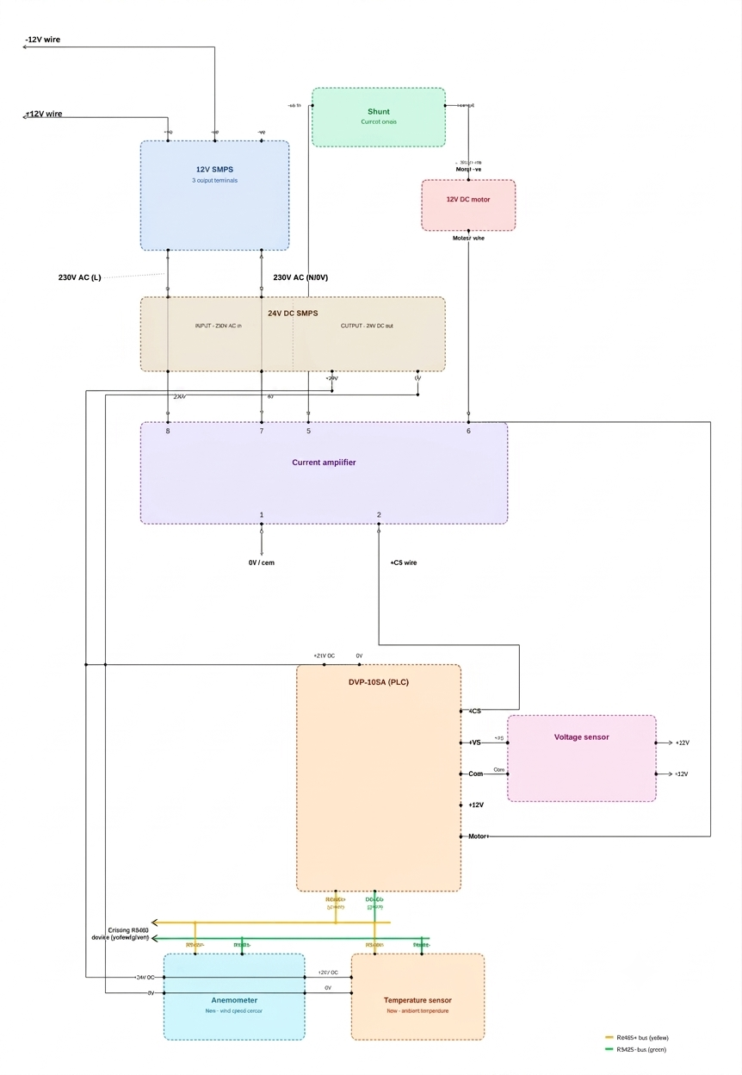
Figure 1 — Overall block diagram (power, sensors, PLC, Modbus/RS-485 wiring)

2.1 Data Flow
- Sensors (ENV-485, anemometer) and analog modules (current amplifier, voltage sensor) feed the DVP-10SX PLC.
- PLC ladder logic mirrors all live values into holding registers 4096–4107.
- USR-W630 bridges the PLC's serial Modbus port to TCP/IP (Server mode, port 8899).
- oil_rig.py polls all 12 registers every 2 seconds over Modbus TCP (ASCII framer).
- Raw values are scaled into engineering units and derived fields are computed (power, flow rate, runtime, IAQ).
- The resulting JSON payload is published to ThingsBoard over MQTT as device telemetry.
- ThingsBoard dashboard widgets display telemetry and can send an RPC (setMotorState) back through the same script to switch the motor via a PLC register write.

3. Hardware Components
Component | Role | Notes
Delta DVP-10SX | Field PLC / register aggregator | 12V0 / A-D module, RS-485 port, C0/Y0 output drives motor
USR-W630 | RS-232 → TCP/IP converter | Server mode, TCP port 8899, connects to PLC programming/Modbus port
7Semi ENV-485 | Temp / humidity / pressure / gas sensor | RS-485, registers confirmed against datasheet
Anemometer | Wind speed & direction | RS-485, shares bus with ENV-485 (yellow +, green −)
Current amplifier + shunt | Motor current sensing | Isolation amplifier, feeds PLC analog input channel
Voltage sensor module | Motor voltage sensing (±12V) | Feeds PLC analog input channel
TOPSFLO TM30A | 12V DC diaphragm pump (the “motor”) | Rated ~0.4A no-load; ~0.8–1A under load (estimated)
12V SMPS | Motor / sensor 12V rail | 230V AC input
24V DC 2.5A SMPS (60W) | PLC 24V rail | 230V AC input

4. Wiring Reference
Use these two diagrams together with Circuit_Diagram_of_PLC.pdf (3-page EPLAN schematic) for the physical build or for verifying an existing installation.
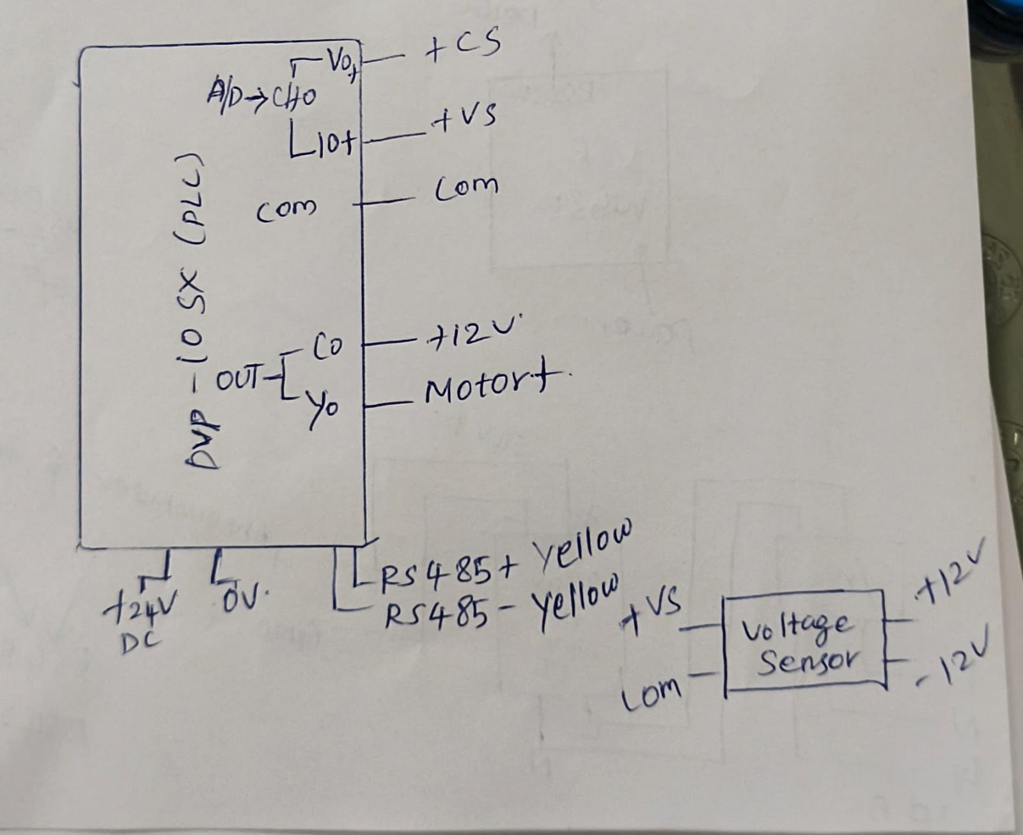
Figure 2 — DVP-10SX pinout: A/D inputs (+CS, +VS, COM), 24V DC supply, RS-485 (yellow), C0/Y0 motor output
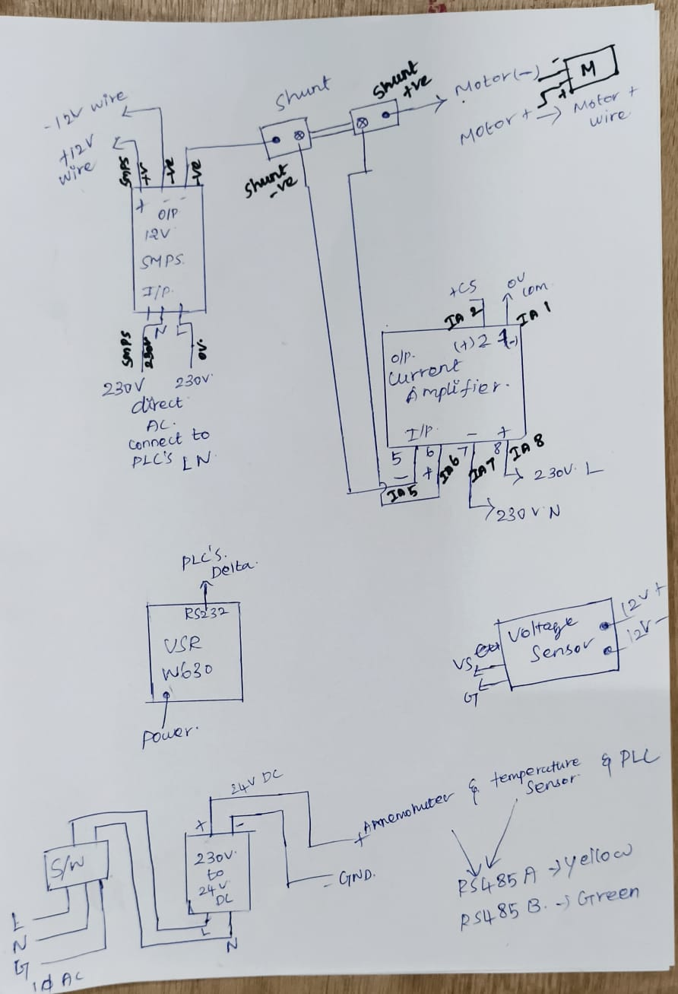
Figure 3 — Hand-marked wiring: SMPS, shunt polarity, current amplifier terminal numbers, voltage sensor, USR-W630
NOTE: Circuit_Diagram_of_PLC.pdf pages 1–3 contain the clean EPLAN version of the same wiring (power distribution, voltage sensor, current amplifier + shunt + motor) with cross-reference page/line numbers — use it as the authoritative reference when the hand sketches are ambiguous.

5. PLC Register Map
Base address 4096, 12 contiguous holding registers, read as one block on every poll cycle.
Address (index) | Field | Scaling | Unit | Status
4096 (0) | temperature | raw / 100 | °C | Confirmed
4097 (1) | humidity | raw / 100 | %RH | Confirmed
4098-4099 (2,3) | pressure | (Hi<<16 | Lo) / 100 | hPa | Confirmed
4100-4101 (4,5) | gas_resistance | (Hi<<16 | Lo) | Ohm | Confirmed
4102 (6) | wind_speed | raw / 10 | m/s | Unconfirmed
4103 (7) | wind_direction | 2=Right, 3=Left | - | Confirmed (rotation sense only)
4104 (8) | motor_voltage | raw x 1 (whole volts) | V | Unconfirmed
4105 (9) | motor_current | raw x 0.08 | A | Rescaled estimate
4106 (10) | motor_power_plc_raw | raw x 1 | W | Diagnostics only, not used
4107 (11) | motor_control | 0 / 1 | - | Also write address for ON/OFF
CALIBRATION WARNING: Wind speed, motor voltage and motor current scale factors are not yet confirmed against a manufacturer datasheet or clamp-meter reading. CURRENT_SCALE (currently 0.08) in particular is a single-point estimate — recalibrate with a real clamp-meter reading under running load if accuracy matters for reporting.

6. Software Prerequisites

6.1 Requirements
- Python 3.8 or newer
- Network access from the PC/gateway to the USR-W630's IP on TCP port 8899
- A ThingsBoard CE instance and a device access token

6.2 Install Dependencies
pip install pymodbus paho-mqtt --break-system-packages
# (drop --break-system-packages on Windows / inside a venv)

7. Configuration
Open oil_rig.py and set the connection block at the top of the file before first run:
PLC_IP = "10.158.91.46" # USR-W630 IP, Server mode, TCP
PLC_PORT = 8899
PLC_SLAVE_ID = 1
THINGSBOARD_HOST = "allcad-chennai.selfip.com"
THINGSBOARD_MQTT_PORT = 1883
THINGSBOARD_ACCESS_TOKEN = "<device access token>"
READ_INTERVAL_SEC = 2
NOTE: Do this once for a new deployment/device: confirm PLC_IP matches the USR-W630's configured static IP, and generate a fresh device access token in ThingsBoard (Devices → your device → Manage credentials) rather than reusing a token from another unit.

8. Step-by-Step Setup Procedure
- Wire the panel per Section 4 (Wiring Reference) and Circuit_Diagram_of_PLC.pdf. Double-check shunt polarity (+ve/−ve) and current-amplifier terminal numbers (5,6,7,8 input / 1,2 output) before powering on.
- Power up the 12V SMPS and 24V DC SMPS. Confirm the PLC's POWER and RUN LEDs are lit.
- Confirm PLC ladder logic mirrors ENV-485, anemometer, current-amplifier and voltage-sensor readings into holding registers 4096–4106, and that register 4107 accepts a motor ON/OFF write.
- Configure the USR-W630 as a TCP Server on port 8899, matching the PLC's serial port baud rate.
- On the gateway PC, verify network reachability: ping the USR-W630's IP, then confirm TCP port 8899 is open.
- Install Python dependencies (Section 6.2).
- Set PLC_IP, THINGSBOARD_HOST and THINGSBOARD_ACCESS_TOKEN in oil_rig.py (Section 7).
- Create the device in ThingsBoard and note its access token; add telemetry widgets for the keys listed in Section 9.2.
- Run: python oil_rig.py — confirm the console prints “Connected to PLC via USR-W630” and “Connected to ThingsBoard, rc = 0”.
- Watch the console telemetry print-out for 1–2 minutes and cross-check a couple of values (temperature, motor_voltage) against a known-good reference before trusting the feed.
- From the ThingsBoard dashboard, test the motor ON/OFF switch widget once and confirm the physical pump responds.

9. Running the System

9.1 Main Bridge — oil_rig.py
Run with: python oil_rig.py
- Loads any previously persisted motor_runtime_state.json on startup.
- Connects to the PLC over Modbus TCP and starts the ThingsBoard MQTT client on a background thread.
- Every READ_INTERVAL_SEC (default 2s): reads 12 registers, converts to engineering units, computes motor_power / flow_rate / uptime / downtime / total runtime / IAQ, and publishes to ThingsBoard.
- Listens for RPC calls (getValue, setMotorState) from the dashboard and writes motor ON/OFF back to register 4107.
- If the wind_speed register repeats an identical value for 10 consecutive reads, the script automatically closes and reopens the Modbus TCP connection.
- On exit (Ctrl+C), flushes the runtime counters to motor_runtime_state.json before closing connections.

9.2 ThingsBoard Telemetry Keys
Key | Description
temperature, humidity, pressure, gas_resistance | Environmental readings
iaq_index, iaq_label | Derived air-quality score (0–500) and label
wind_speed, wind_direction, wind_direction_text | Anemometer readings
motor_voltage, motor_current, motor_power | Motor electrical telemetry
motor_control, flow_rate | Motor ON/OFF state and derived flow rate (L/min)
motor_uptime_min, motor_downtime_min, motor_total_running_min | Runtime counters

9.3 Diagnostic Tool — wind_speed.py
Run with: python wind_speed.py
A safe, read-only tool that logs all 12 raw registers with timestamps to wind_speed_diagnostic_log.csv, without writing to the PLC or publishing to ThingsBoard. Run it alongside or instead of oil_rig.py for at least 15–30 minutes, ideally while conditions are actually changing (e.g. real wind blowing), then press Ctrl+C to print a per-register “% of reads changed” summary.
HOW TO READ THE SUMMARY: If a register changes on 0% of reads across a long run while others (e.g. motor_current) change normally, that register's source is not being refreshed — check the RS-485 wiring/PLC ladder logic for that sensor rather than the Python/TCP link. If ALL registers freeze together, or error_count climbs, suspect the USR-W630 ↔ PLC link instead.

10. Motor Runtime Tracking
motor_runtime_state.json stores a single field, total_running_sec, which persists cumulative pump runtime across script restarts, crashes and reboots. It is written roughly once a minute (every 30 reads at a 2-second interval) and flushed on clean shutdown.
{"total_running_sec": 2982.0} // ≈ 49.7 minutes cumulative at last save

11. Troubleshooting

11.1 Registers appear frozen
Run wind_speed.py per Section 9.3. In prior diagnostic runs, every register except motor_current and motor_power_raw froze for the full session — this points to the RS-485/PLC refresh path (ENV-485, anemometer, voltage sensor mirroring) rather than the TCP link, since motor_current (fed through the current amplifier's own analog channel) kept changing normally throughout.

11.2 Modbus read errors / connection drops
- Confirm the USR-W630 is powered and its TCP Server is listening on the configured port.
- Check the framer setting (‘ascii’) matches the PLC's serial configuration.
- A high error_count in wind_speed.py's summary points to the USR-W630 ↔ PLC serial link rather than individual sensors.

11.3 Motor current / voltage look wrong
- motor_voltage and motor_current scale factors are estimates (Section 5) — recalibrate against a multimeter/clamp-meter reading taken while the pump is actually running under load.

11.4 ThingsBoard shows no telemetry
- Verify THINGSBOARD_ACCESS_TOKEN matches the device in ThingsBoard exactly.
- Confirm outbound MQTT (port 1883) isn't blocked by a firewall.
- Check the console for “Connected to ThingsBoard, rc = 0” — any non-zero rc indicates an auth or connection problem.

12. File Reference
File | Purpose
oil_rig.py | Main PLC → ThingsBoard bridge (telemetry + RPC motor control)
wind_speed.py | Standalone read-only register diagnostic tool
motor_runtime_state.json | Persisted cumulative motor runtime
wind_speed_diagnostic_log.csv | Raw register log produced by wind_speed.py
overall_circuit.jpeg / Plc diagram.jpeg | Hand-marked wiring references
reference Diagram.png | Clean digital block diagram
Circuit_Diagram_of_PLC.pdf | 3-page EPLAN-style formal schematic

