Cloud Computing EC1 — Assignment 1 Submission
BITS ID (custom shell prompt): 2026NS03024
Telemetry agent: cloud_monitor.sh — collects disk/CPU metrics, parses access.log for HTTP anomalies, prints structured JSON, optional webhook alert, audit history, and log rotation.

1. JSON data format explanation
JSON field | Meaning
timestamp | ISO-style local time when the scan started
hostname | Host running the agent
metrics.disk_mount | Filesystem mount checked (root /)
metrics.disk_usage_percent | Used space percentage from df -P
metrics.cpu_load_1m / 5m / 15m | Load averages (proc/loadavg or sysctl on macOS)
log_analysis.log_file | Configured access log file name
log_analysis.total_requests | Log lines with a valid 3-digit HTTP status
log_analysis.count_2xx / 4xx / 5xx | HTTP status class counts
log_analysis.error_samples | Up to five sample 5xx rows (status, path, timestamp)
thresholds.max_disk_percent | MAX_DISK from ~/.monitor_conf
thresholds.error_limit | ERROR_LIMIT from ~/.monitor_conf
alerts.disk_exceeded | True when disk usage >= MAX_DISK
alerts.error_limit_exceeded | True when count_5xx > ERROR_LIMIT
alerts.webhook_sent | True when curl POST to WEBHOOK_URL succeeded during an alert
Webhook rule: when disk_exceeded or error_limit_exceeded is true, the agent POSTs the same JSON body to WEBHOOK_URL via curl.

2. Live terminal session (proof)
Excerpt from interactive run with customized prompt and automated test suite:
2026NS03024> ./cloud_monitor.sh
Proceed with system scan? (y/n): y
{
"timestamp": "2026-10-01T01:30:43+0530",
"hostname": "MW659VFKXRD.cohesity.com",
"metrics": {
"disk_mount": "/",
"disk_usage_percent": 5,
"cpu_load_1m": 3.41,
"cpu_load_5m": 3.66,
"cpu_load_15m": 3.49
},
"log_analysis": {
"log_file": "access.log",
"total_requests": 1200,
"count_2xx": 848,
"count_4xx": 196,
"count_5xx": 156,
"error_samples": [ ... ]
},
"thresholds": { "max_disk_percent": 80, "error_limit": 5 },
"alerts": {
"disk_exceeded": false,
"error_limit_exceeded": true,
"webhook_sent": false
}
}

2026NS03024> ./run_tests.sh
All automated tests passed.

3. Screenshot evidence (rubric)
- Core (8 marks): Valid JSON report after system metrics and log analysis.
- Core guardrail (2 marks): y/n prompt before scan; user entered y.
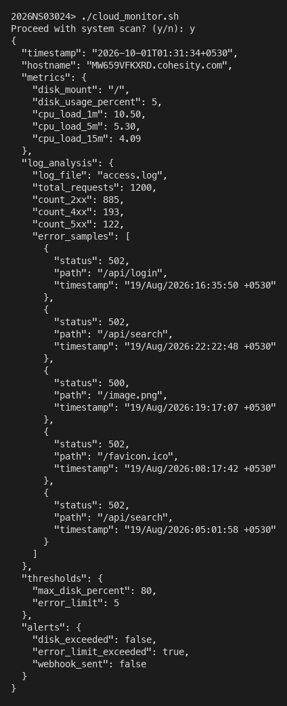
- Add-on #2 — Configuration file: thresholds read from ~/.monitor_conf.
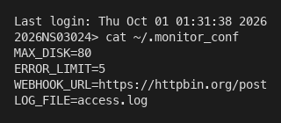
- Add-on #3 — Audit logging: ~/.monitor_history run timestamp, 5xx count, duration.
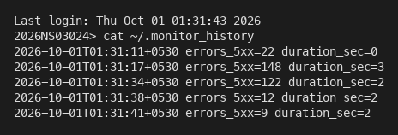
- Add-on #4 — Log archival: compressed access logs in ~/archive with date stamp.
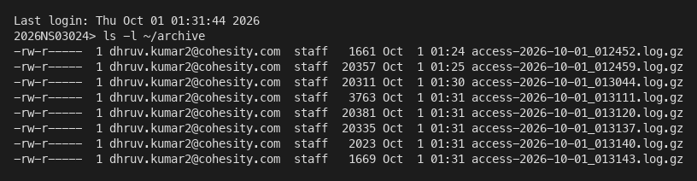
- Add-on #1 — Webhook alerting: JSON POST when error_limit_exceeded (receiver URL in config).
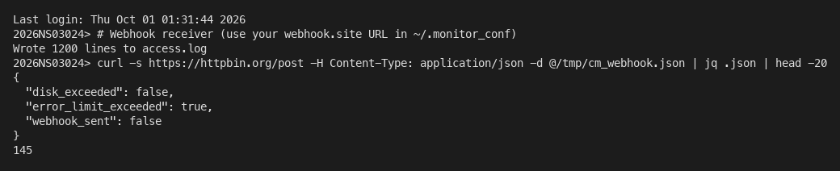

4. Complete source code — cloud_monitor.sh
#!/usr/bin/env bash
# cloud_monitor.sh — BITS WILP Cloud Computing EC1 telemetry agent
set -u

SCRIPT_DIR="$(cd "$(dirname "${BASH_SOURCE[0]}")" && pwd)"
CONF_FILE="${HOME}/.monitor_conf"
HISTORY_FILE="${HOME}/.monitor_history"
ARCHIVE_DIR="${HOME}/archive"

MAX_DISK=""
ERROR_LIMIT=""
WEBHOOK_URL=""
LOG_FILE=""

die() {
echo "error: $*" >&2
exit 1
}

require_cmd() {
command -v "$1" >/dev/null 2>&1 || die "required command not found: $1"
}

load_config() {
[[ -f "$CONF_FILE" ]] || die "missing config $CONF_FILE (see monitor_conf.sample)"
while IFS= read -r line || [[ -n "$line" ]]; do
line="${line%%#*}"
line="$(echo "$line" | sed 's/^[[:space:]]*//;s/[[:space:]]*$//')"
[[ -z "$line" ]] && continue
[[ "$line" != *=* ]] && die "invalid config line (expected KEY=VALUE): $line"
key="${line%%=*}"
val="${line#*=}"
key="$(echo "$key" | sed 's/[[:space:]]//g')"
val="$(echo "$val" | sed 's/^[[:space:]]*//;s/[[:space:]]*$//')"
case "$key" in
MAX_DISK) MAX_DISK="$val" ;;
ERROR_LIMIT) ERROR_LIMIT="$val" ;;
WEBHOOK_URL) WEBHOOK_URL="$val" ;;
LOG_FILE) LOG_FILE="$val" ;;
*) die "unknown config key: $key" ;;
esac
done <"$CONF_FILE"

[[ -n "$MAX_DISK" ]] || die "MAX_DISK not set in $CONF_FILE"
[[ -n "$ERROR_LIMIT" ]] || die "ERROR_LIMIT not set in $CONF_FILE"
[[ -n "$WEBHOOK_URL" ]] || die "WEBHOOK_URL not set in $CONF_FILE"
[[ -n "$LOG_FILE" ]] || die "LOG_FILE not set in $CONF_FILE"

[[ "$MAX_DISK" =~ ^[0-9]+$ ]] || die "MAX_DISK must be an integer percent"
[[ "$ERROR_LIMIT" =~ ^[0-9]+$ ]] || die "ERROR_LIMIT must be a non-negative integer"
}

resolve_log_path() {
if [[ "$LOG_FILE" = /* ]]; then
LOG_PATH="$LOG_FILE"
else
LOG_PATH="${SCRIPT_DIR}/${LOG_FILE}"
fi
}

get_disk_usage() {
local mount="/"
local line pct
line="$(df -P "$mount" 2>/dev/null | awk 'NR==2 {print}')"
[[ -n "$line" ]] || die "df failed for $mount"
pct="$(echo "$line" | awk '{gsub(/%/,"",$5); print $5}')"
DISK_MOUNT="$mount"
DISK_PCT="$pct"
}

get_load_averages() {
if [[ -r /proc/loadavg ]]; then
read -r LOAD_1 LOAD_5 LOAD_15 _rest < /proc/loadavg
else
local raw
raw="$(sysctl -n vm.loadavg 2>/dev/null || true)"
raw="$(echo "$raw" | tr -d '{}')"
LOAD_1="$(echo "$raw" | awk '{print $1}')"
LOAD_5="$(echo "$raw" | awk '{print $2}')"
LOAD_15="$(echo "$raw" | awk '{print $3}')"
fi
[[ -n "$LOAD_1" ]] || die "could not read CPU load averages"
}

parse_access_log() {
local f="$LOG_PATH"
local stats_file samples_file
stats_file="$(mktemp)"
samples_file="$(mktemp)"

awk -v samples_path="$samples_file" '
function extract_ts(line, t) {
if (match(line, /\[/)) {
start = RSTART + 1
end = index(substr(line, start), "]")
if (end > 0) return substr(line, start, end - 1)
}
return ""
}
function extract_path(line, p) {
if (match(line, /"[A-Z]+ /)) {
start = RSTART + 1
rest = substr(line, start)
sub(/ HTTP.*/, "", rest)
sub(/^[^ ]+ /, "", rest)
return rest
}
return ""
}
BEGIN { t2 = 0; t4 = 0; t5 = 0; total = 0; samples = 0 }
{
st = $(NF - 1)
if (st !~ /^[0-9][0-9][0-9]$/) next
total++
if (st >= 200 && st < 300) t2++
else if (st >= 400 && st < 500) t4++
else if (st >= 500 && st < 600) {
t5++
if (samples < 5) {
ts = extract_ts($0)
path = extract_path($0)
gsub(/"/, "\\\"", path)
gsub(/"/, "\\\"", ts)
printf "{\"status\":%s,\"path\":\"%s\",\"timestamp\":\"%s\"}\n", st, path, ts >> samples_path
samples++
}
}
}
END {
printf "%d %d %d %d\n", total, t2, t4, t5
}
' "$f" >"$stats_file"

read -r TOTAL_REQUESTS COUNT_2XX COUNT_4XX COUNT_5XX <"$stats_file"
if [[ -s "$samples_file" ]]; then
ERROR_SAMPLES_JSON="$(jq -s '.' "$samples_file")"
else
ERROR_SAMPLES_JSON="[]"
fi
rm -f "$stats_file" "$samples_file"
}

build_json() {
local disk_exceeded_json error_exceeded_json
disk_exceeded_json=false
error_exceeded_json=false

if ((DISK_PCT >= MAX_DISK)); then disk_exceeded_json=true; fi
if ((COUNT_5XX > ERROR_LIMIT)); then error_exceeded_json=true; fi

JSON_REPORT="$(jq -n \
--arg timestamp "$REPORT_TS" \
--arg hostname "$HOSTNAME_VAL" \
--arg disk_mount "$DISK_MOUNT" \
--argjson disk_usage_percent "$DISK_PCT" \
--argjson cpu_load_1m "$LOAD_1" \
--argjson cpu_load_5m "$LOAD_5" \
--argjson cpu_load_15m "$LOAD_15" \
--arg log_file "$LOG_FILE" \
--argjson total_requests "$TOTAL_REQUESTS" \
--argjson count_2xx "$COUNT_2XX" \
--argjson count_4xx "$COUNT_4XX" \
--argjson count_5xx "$COUNT_5XX" \
--argjson error_samples "$ERROR_SAMPLES_JSON" \
--argjson max_disk_percent "$MAX_DISK" \
--argjson error_limit "$ERROR_LIMIT" \
--argjson disk_exceeded "$disk_exceeded_json" \
--argjson error_limit_exceeded "$error_exceeded_json" \
--argjson webhook_sent false \
'{
timestamp: $timestamp,
hostname: $hostname,
metrics: {
disk_mount: $disk_mount,
disk_usage_percent: $disk_usage_percent,
cpu_load_1m: $cpu_load_1m,
cpu_load_5m: $cpu_load_5m,
cpu_load_15m: $cpu_load_15m
},
log_analysis: {
log_file: $log_file,
total_requests: $total_requests,
count_2xx: $count_2xx,
count_4xx: $count_4xx,
count_5xx: $count_5xx,
error_samples: $error_samples
},
thresholds: {
max_disk_percent: $max_disk_percent,
error_limit: $error_limit
},
alerts: {
disk_exceeded: $disk_exceeded,
error_limit_exceeded: $error_limit_exceeded,
webhook_sent: $webhook_sent
}
}')"
}

send_webhook_if_needed() {
local disk_exceeded error_exceeded
disk_exceeded=false
error_exceeded=false
if ((DISK_PCT >= MAX_DISK)); then disk_exceeded=true; fi
if ((COUNT_5XX > ERROR_LIMIT)); then error_exceeded=true; fi

WEBHOOK_SENT=false
if [[ "$disk_exceeded" == true || "$error_exceeded" == true ]]; then
if curl -sS -X POST "$WEBHOOK_URL" \
-H "Content-Type: application/json" \
-d "$JSON_REPORT" >/dev/null 2>&1; then
WEBHOOK_SENT=true
fi
fi

JSON_REPORT="$(echo "$JSON_REPORT" | jq --argjson webhook_sent "$WEBHOOK_SENT" '.alerts.webhook_sent = $webhook_sent')"
}

append_history() {
local duration="$1"
printf '%s errors_5xx=%s duration_sec=%s\n' "$REPORT_TS" "$COUNT_5XX" "$duration" >>"$HISTORY_FILE"
}

rotate_log() {
mkdir -p "$ARCHIVE_DIR"
local stamp archived
stamp="$(date '+%Y-%m-%d_%H%M%S')"
archived="${ARCHIVE_DIR}/access-${stamp}.log.gz"
gzip -c "$LOG_PATH" >"$archived"
rm -f "$LOG_PATH"
}

main() {
require_cmd awk
require_cmd df
require_cmd jq
require_cmd curl
require_cmd gzip
require_cmd sed

load_config
resolve_log_path

read -r -p "Proceed with system scan? (y/n): " confirm
confirm="$(echo "$confirm" | tr '[:upper:]' '[:lower:]')"
case "$confirm" in
y|yes) ;;
n|no)
echo "Scan cancelled."
exit 0
;;
*)
die "invalid response; expected y or n"
;;
esac

[[ -f "$LOG_PATH" ]] || die "log file not found: $LOG_PATH"

START_EPOCH="$(date +%s)"
REPORT_TS="$(date '+%Y-%m-%dT%H:%M:%S%z')"
HOSTNAME_VAL="$(hostname 2>/dev/null || echo unknown)"

get_disk_usage
get_load_averages
parse_access_log
build_json

echo "$JSON_REPORT"

send_webhook_if_needed
END_EPOCH="$(date +%s)"
DURATION="$((END_EPOCH - START_EPOCH))"
append_history "$DURATION"
rotate_log
}

main "$@"

5. Setup commands used
cp monitor_conf.sample ~/.monitor_conf
./generate_access_log.sh access.log 1200
export PS1='2026NS03024> '
./cloud_monitor.sh
./run_tests.sh
./capture_screenshots.sh

