
Department of Computer Science and Information Systems
Distributed Computing (CCZG 526)
Lab Assignment II
Distributed Resource Sharing and Processing System
using Peer-to-Peer and Cluster Computing
Name: Dhruv Kumar
Registration No.: 2026NS03024

1. Introduction
This report describes a distributed system that combines peer-to-peer (P2P) resource sharing with cluster-based parallel processing. Four peer nodes run the same Python program (node.py) and communicate over TCP using JSON messages. Each peer stores a named resource (sensor-1 through sensor-4). One peer acts as the cluster master; the others serve as workers for a prime-counting job split across machines.

2. System design
Peer layer: join/gossip for membership, flooded lookup for get <key>, direct owner reply (no central coordinator for resource access).
Cluster layer: compute <start> <end> sends a job to the master, which partitions the range across live workers and aggregates results.
Resource sharing is demonstrated using sensor data sharing like temperature and humidity.
Parallel processing is demonstrated as parallel prime number count in the provided range.

3. Requirements and demonstration

3.1 Four peer nodes
Four VMs (in1xxavv009–012) with ids p1–p4; peers command lists three neighbours.
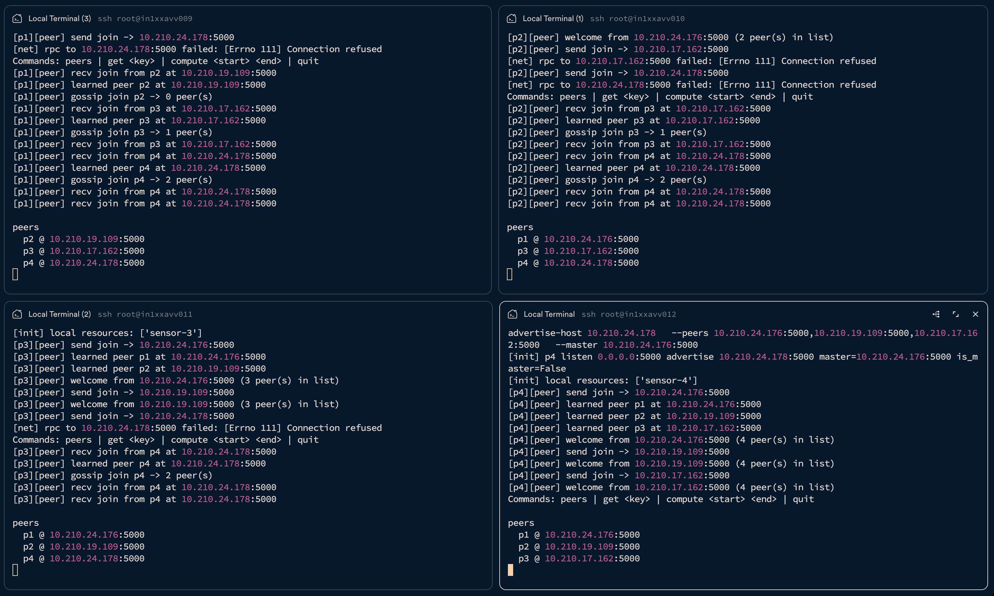

3.2 Direct P2P communication & Resource Sharing
get sensor-1 from p4: lookup flood on p2/p3/p1 logs; owner p1 replies to p4.
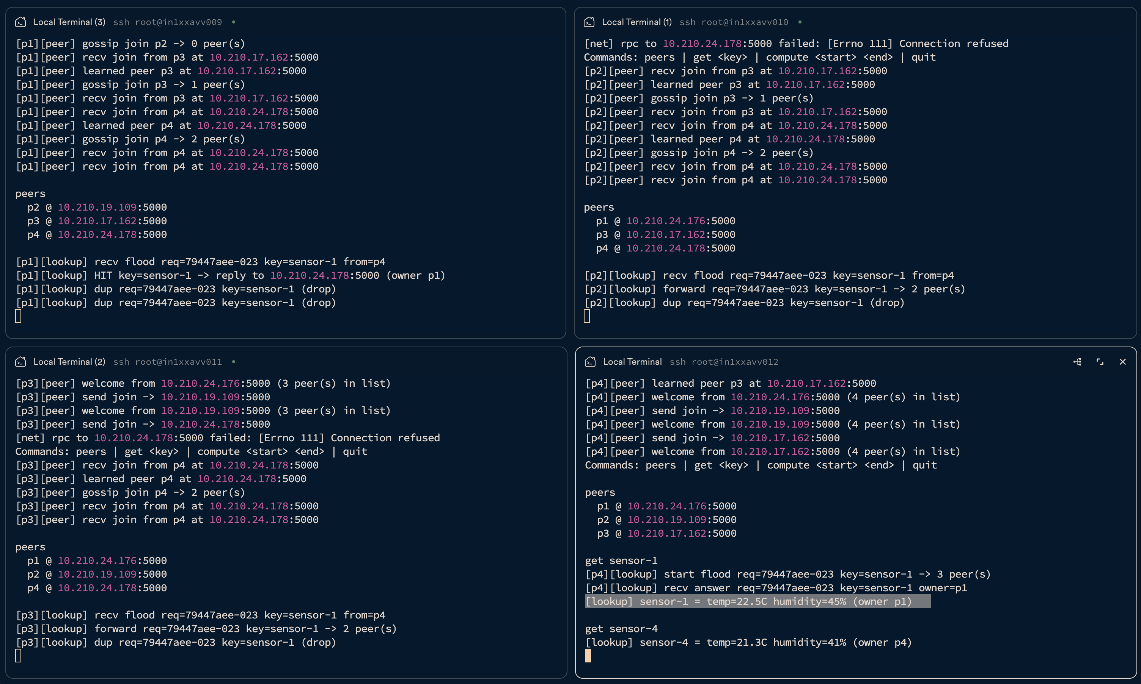

3.4 Master and workers
p1 is_master=True; p2, p3, p4 is_master=False.

3.5–3.6 Task distribution and parallel execution
compute 1 1000 on master path; per-worker chunk lines (p2, p3, p4).
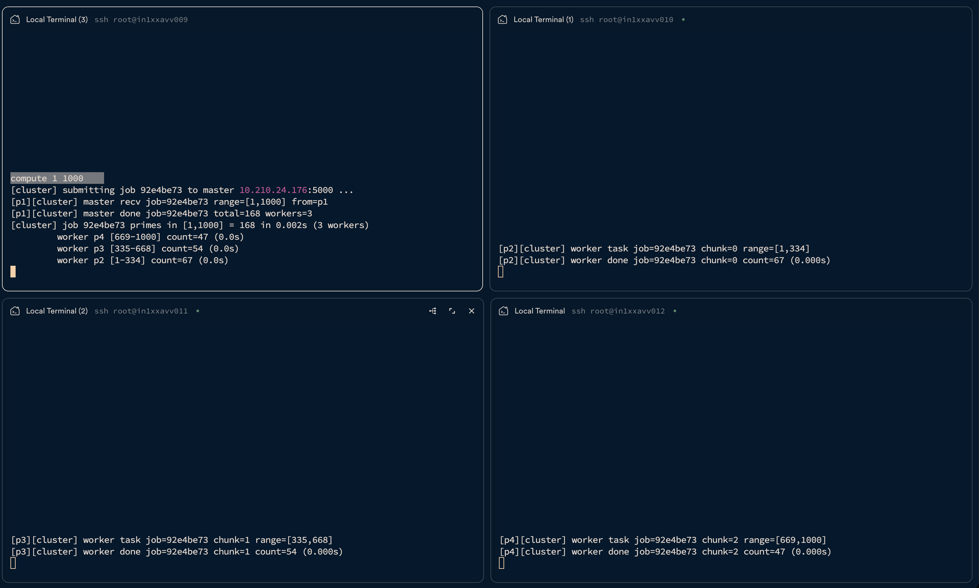

3.7 Peer uses cluster
compute run from p4; submitting job to master (p1).
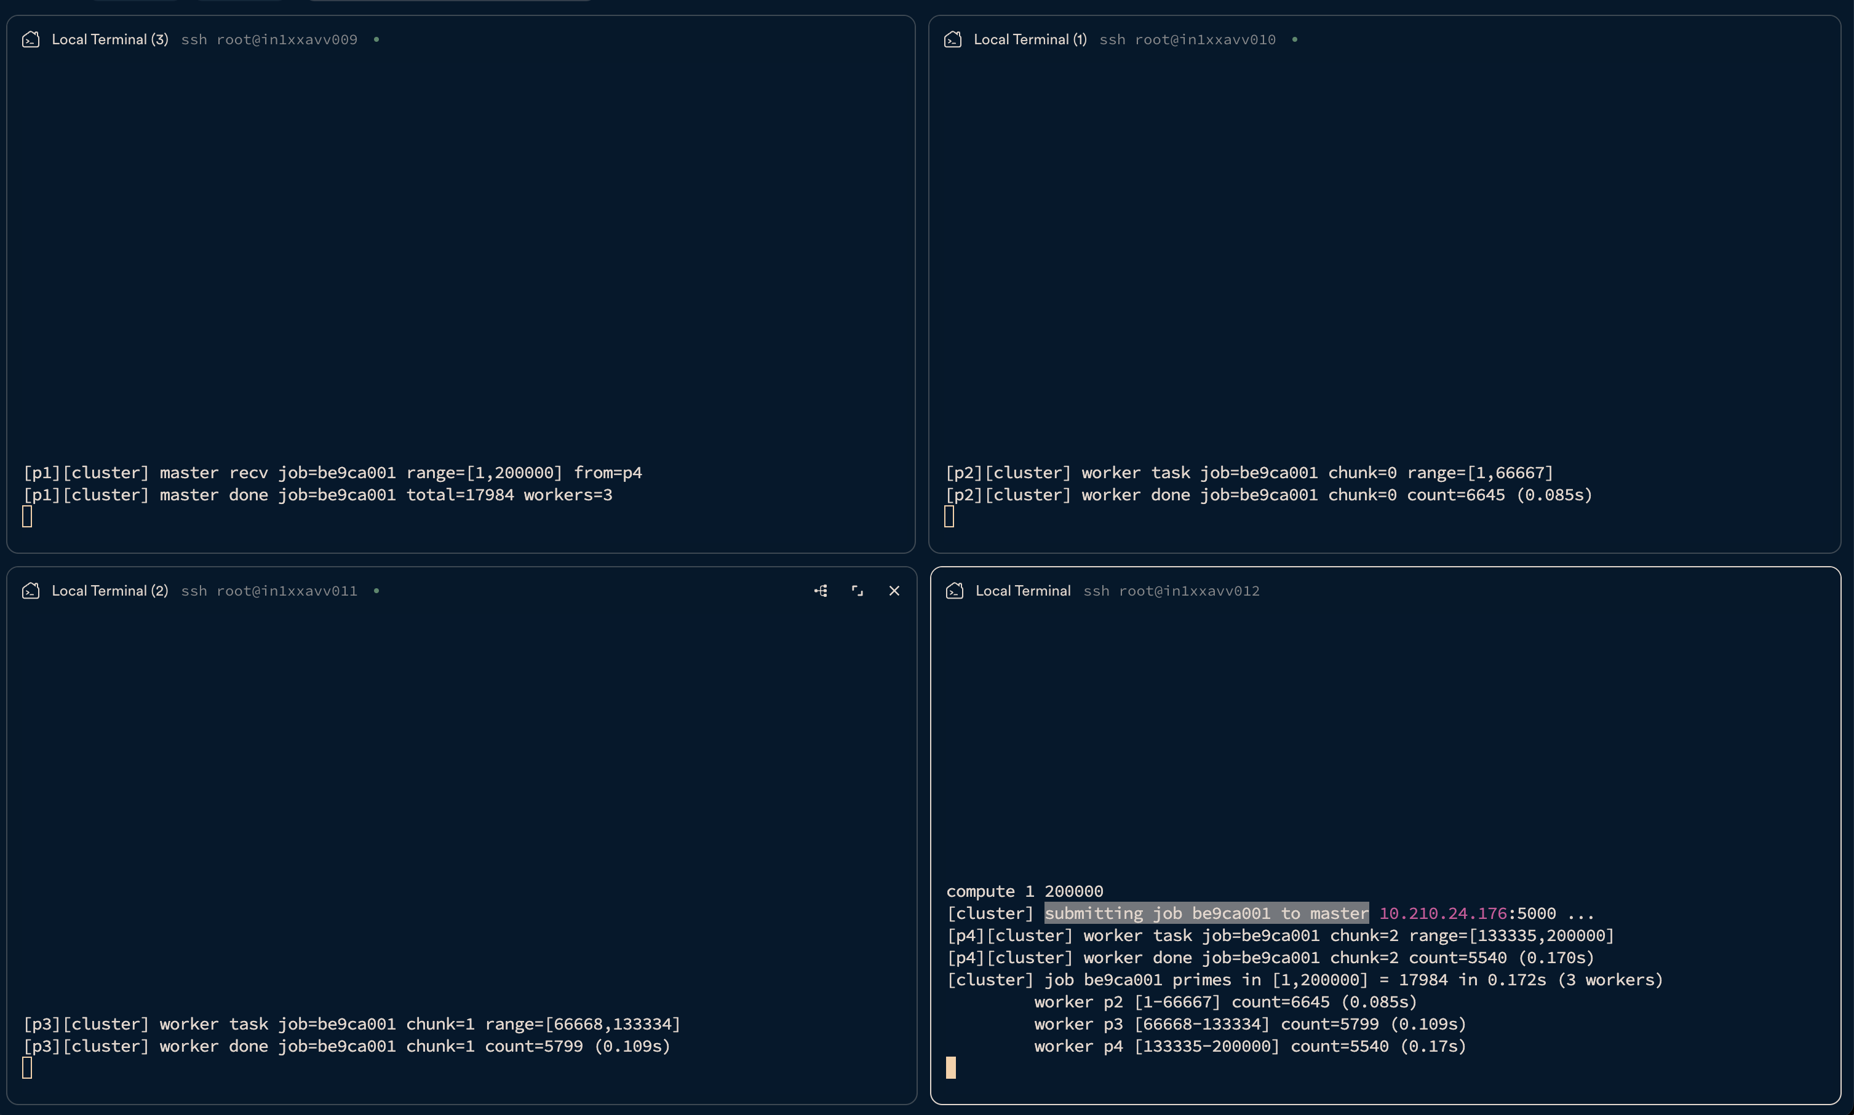

3.8 Node removal / addition
quit on node p4 and then join again
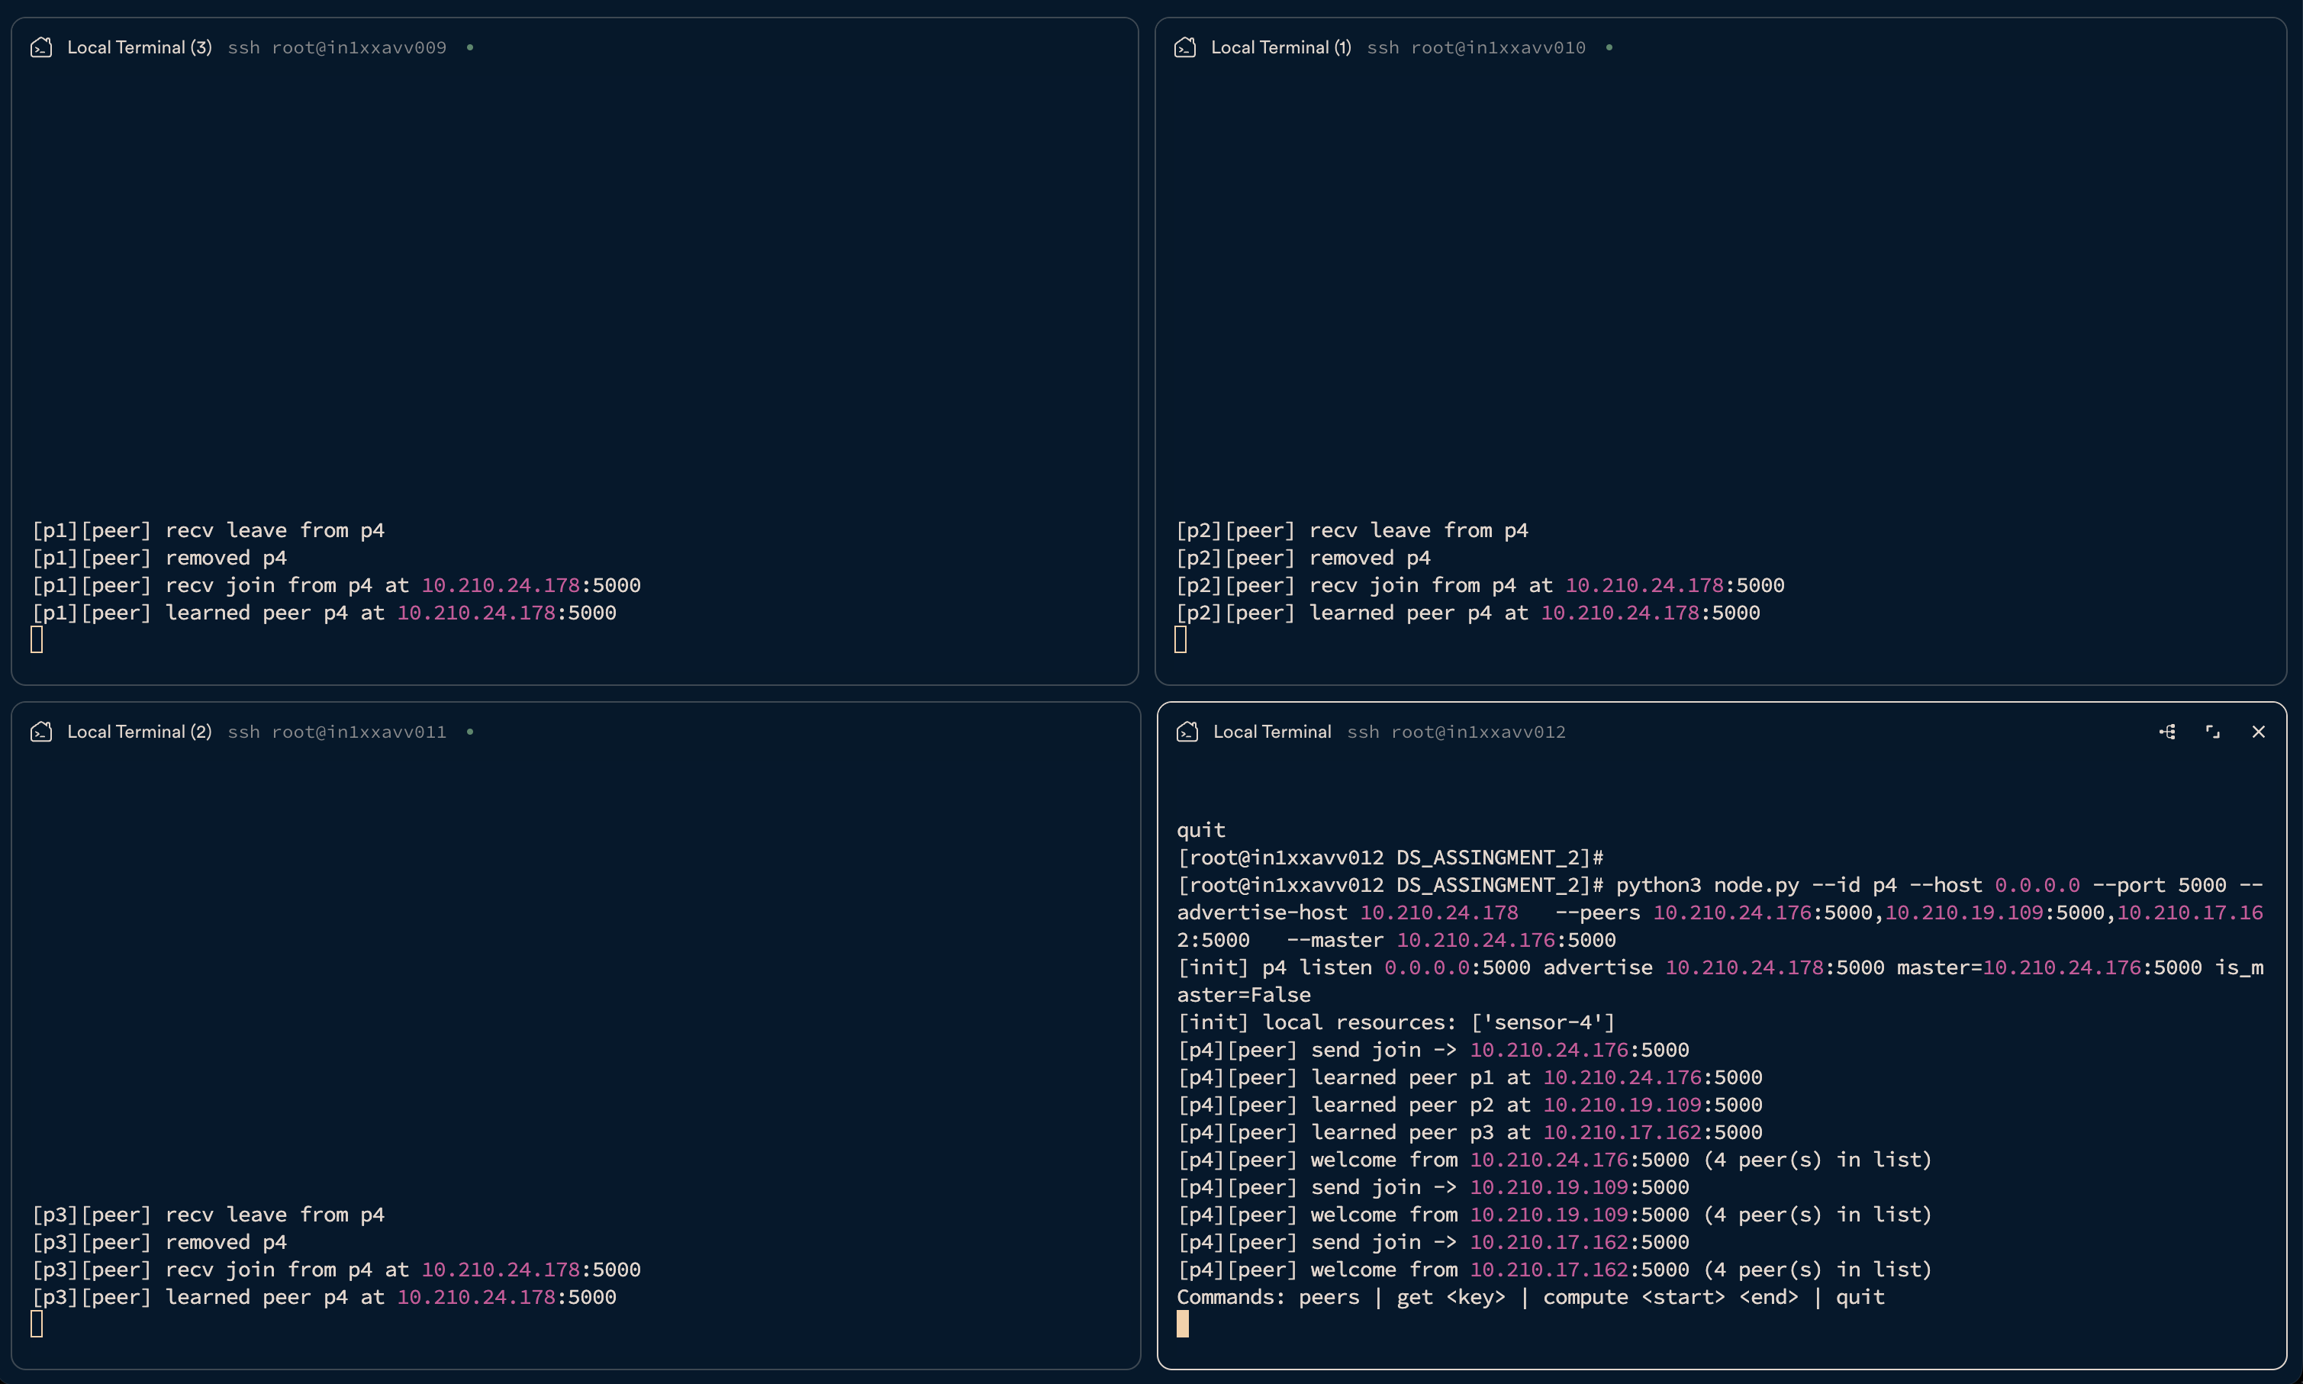

5. P2P vs cluster computing
Aspect | Peer-to-peer | Cluster
Communication | Many-to-many; lookup flood and direct hit reply | Peers → master → workers
Resource sharing | Each peer owns local key/value data | Shared CPU via range chunks
Scalability | More peers → more data, more lookup traffic | More workers → faster compute
Processing | Needs owner online for get | Job continues with remaining workers if one fails

6. Conclusion
The system satisfies the assignment goals: decentralized peer resource lookup and centralized parallel compute on the same four nodes, with observable join, flood, cluster fan-out, and membership change behaviour.

Appendix A — Source code (node.py)
Full implementation (Python 3 standard library only).
#!/usr/bin/env python3
"""Distributed peer node with optional cluster master/worker compute."""
import argparse
import errno
import json
import socket
import sys
import threading
import time
import uuid
from typing import Any, Dict, Optional, Set, Tuple
PeerAddr = Tuple[str, int] # (host, port)
DEFAULT_RESOURCES = {
"p1": {"sensor-1": "temp=22.5C humidity=45%"},
"p2": {"sensor-2": "temp=19.1C humidity=52%"},
"p3": {"sensor-3": "temp=24.0C humidity=38%"},
"p4": {"sensor-4": "temp=21.3C humidity=41%"},
}
HEARTBEAT_INTERVAL = 8
PEER_TIMEOUT = 25
CONNECT_TIMEOUT = 3
READ_BUF = 65536
def is_prime(n: int) -> bool:
if n < 2:
return False
if n == 2:
return True
if n % 2 == 0:
return False
i = 3
while i * i <= n:
if n % i == 0:
return False
i += 2
return True
def count_primes(start: int, end: int) -> int:
# end is inclusive
if start < 2:
start = 2
count = 0
for n in range(start, end + 1):
if is_prime(n):
count += 1
return count
def parse_host_port(s: str) -> PeerAddr:
if s.count(":") != 1:
raise ValueError(f"expected host:port, got {s!r}")
host, port_s = s.split(":", 1)
return host.strip(), int(port_s.strip())
def addr_key(addr: PeerAddr) -> str:
return f"{addr[0]}:{addr[1]}"
def send_message(host: str, port: int, msg: dict) -> bool:
data = json.dumps(msg) + "\n"
try:
with socket.create_connection((host, port), timeout=CONNECT_TIMEOUT) as sock:
sock.sendall(data.encode())
return True
except OSError as exc:
print(f"[net] send to {host}:{port} failed: {exc}", flush=True)
return False
def ping_peer(host: str, port: int) -> str:
"""Return 'ok', 'refused', or 'error' for liveness checks."""
data = json.dumps({"type": "ping"}) + "\n"
try:
with socket.create_connection((host, port), timeout=CONNECT_TIMEOUT) as sock:
sock.sendall(data.encode())
sock.settimeout(5.0)
buf = b""
while b"\n" not in buf:
chunk = sock.recv(READ_BUF)
if not chunk:
return "error"
buf += chunk
line = buf.split(b"\n", 1)[0]
if line:
resp = json.loads(line.decode())
if resp.get("type") == "pong":
return "ok"
except ConnectionRefusedError:
return "refused"
except OSError as exc:
if exc.errno in (
errno.EHOSTUNREACH,
errno.ENETUNREACH,
errno.EHOSTDOWN,
errno.ETIMEDOUT,
errno.ENETDOWN,
):
return "transient"
return "error"
except json.JSONDecodeError:
return "error"
return "error"
def send_and_receive(host: str, port: int, msg: dict, timeout: float = 120.0) -> Optional[dict]:
data = json.dumps(msg) + "\n"
try:
with socket.create_connection((host, port), timeout=CONNECT_TIMEOUT) as sock:
sock.sendall(data.encode())
sock.settimeout(timeout)
buf = b""
while b"\n" not in buf:
chunk = sock.recv(READ_BUF)
if not chunk:
break
buf += chunk
line = buf.split(b"\n", 1)[0]
if line:
return json.loads(line.decode())
except OSError as exc:
print(f"[net] rpc to {host}:{port} failed: {exc}", flush=True)
except json.JSONDecodeError as exc:
print(f"[net] bad json from {host}:{port}: {exc}", flush=True)
return None
class Node:
def __init__(
self,
node_id: str,
host: str,
port: int,
bootstrap_peers: list[PeerAddr],
master_addr: PeerAddr,
bind_host: Optional[str] = None,
verbose: bool = True,
):
self.verbose = verbose
self.bind_host = bind_host if bind_host is not None else host
self.bootstrap_peers = bootstrap_peers
self.node_id = node_id
self.host = host
self.port = port
self.addr: PeerAddr = (host, port)
self.master_addr = master_addr
self.is_master = addr_key(self.addr) == addr_key(master_addr)
self.resources = dict(DEFAULT_RESOURCES.get(node_id, {}))
self.peers: Dict[str, dict] = {} # peer_id -> {id, host, port, last_seen}
self.lock = threading.Lock()
self.seen_lookups: Set[str] = set()
self.seen_joins: Set[str] = set()
self.running = True
self.pending_lookups: Dict[str, threading.Event] = {}
self.lookup_results: Dict[str, dict] = {}
self._server_sock: Optional[socket.socket] = None
self._threads: list[threading.Thread] = []
def vlog(self, tag: str, message: str) -> None:
if self.verbose:
print(f"[{self.node_id}][{tag}] {message}", flush=True)
def peer_list(self) -> list[dict]:
with self.lock:
return [dict(p) for p in self.peers.values()]
def add_peer(self, peer_id: str, host: str, port: int) -> bool:
if peer_id == self.node_id:
return False
key = addr_key((host, port))
with self.lock:
if peer_id in self.peers:
self.peers[peer_id]["last_seen"] = time.time()
return False
self.peers[peer_id] = {
"id": peer_id,
"host": host,
"port": port,
"last_seen": time.time(),
"fail_count": 0,
}
self.vlog("peer", f"learned peer {peer_id} at {host}:{port}")
return True
def remove_peer(self, peer_id: str) -> None:
with self.lock:
if peer_id in self.peers:
del self.peers[peer_id]
self.vlog("peer", f"removed {peer_id}")
def all_peer_addrs_except(self, skip_id: Optional[str] = None) -> list[PeerAddr]:
out = []
with self.lock:
for p in self.peers.values():
if skip_id and p["id"] == skip_id:
continue
out.append((p["host"], p["port"]))
return out
def broadcast(self, msg: dict, skip_id: Optional[str] = None) -> None:
for host, port in self.all_peer_addrs_except(skip_id):
send_message(host, port, msg)
def start(self) -> None:
self._server_sock = socket.socket(socket.AF_INET, socket.SOCK_STREAM)
self._server_sock.setsockopt(socket.SOL_SOCKET, socket.SO_REUSEADDR, 1)
self._server_sock.bind((self.bind_host, self.port))
self._server_sock.listen(32)
print(
f"[init] {self.node_id} listen {self.bind_host}:{self.port} "
f"advertise {self.host}:{self.port} "
f"master={addr_key(self.master_addr)} is_master={self.is_master}",
flush=True,
)
print(f"[init] local resources: {list(self.resources.keys())}", flush=True)
accept_t = threading.Thread(target=self._accept_loop, daemon=True)
heartbeat_t = threading.Thread(target=self._heartbeat_loop, daemon=True)
accept_t.start()
heartbeat_t.start()
self._threads.extend([accept_t, heartbeat_t])
time.sleep(0.3)
self._bootstrap_join()
def stop(self) -> None:
self.running = False
leave_msg = {"type": "leave", "id": self.node_id}
self.broadcast(leave_msg)
if self._server_sock:
try:
self._server_sock.close()
except OSError:
pass
def _welcome_peers(self) -> list[dict]:
out = [{"id": self.node_id, "host": self.host, "port": self.port}]
with self.lock:
for p in self.peers.values():
out.append(
{"id": p["id"], "host": p["host"], "port": int(p["port"])}
)
return out
def _ingest_join_welcome(self, resp: dict) -> None:
if resp.get("type") != "join_welcome":
return
for p in resp.get("peers", []):
self.add_peer(p["id"], p["host"], int(p["port"]))
def _bootstrap_join(self) -> None:
join_msg = {
"type": "join",
"id": self.node_id,
"host": self.host,
"port": self.port,
}
for host, port in self.bootstrap_peers:
if addr_key((host, port)) == addr_key(self.addr):
continue
self.vlog("peer", f"send join -> {host}:{port}")
resp = send_and_receive(host, port, join_msg, timeout=8.0)
if resp:
self._ingest_join_welcome(resp)
self.vlog(
"peer",
f"welcome from {host}:{port} ({len(resp.get('peers', []))} peer(s) in list)",
)
def _accept_loop(self) -> None:
assert self._server_sock
while self.running:
try:
self._server_sock.settimeout(1.0)
conn, _ = self._server_sock.accept()
except socket.timeout:
continue
except OSError:
break
threading.Thread(target=self._handle_connection, args=(conn,), daemon=True).start()
def _read_lines(self, conn: socket.socket) -> list[dict]:
buf = b""
messages = []
while True:
try:
chunk = conn.recv(READ_BUF)
except OSError:
break
if not chunk:
break
buf += chunk
while b"\n" in buf:
line, buf = buf.split(b"\n", 1)
if not line.strip():
continue
try:
messages.append(json.loads(line.decode()))
except json.JSONDecodeError:
pass
return messages
def _handle_connection(self, conn: socket.socket) -> None:
try:
conn.settimeout(120.0)
buf = b""
while True:
if b"\n" in buf:
line, buf = buf.split(b"\n", 1)
else:
chunk = conn.recv(READ_BUF)
if not chunk:
break
buf += chunk
continue
if not line.strip():
continue
msg = json.loads(line.decode())
reply = self._dispatch(msg, conn)
if reply is not None:
conn.sendall((json.dumps(reply) + "\n").encode())
if msg.get("type") in ("compute_job", "worker_task", "join"):
conn.close()
return
except (OSError, json.JSONDecodeError) as exc:
print(f"[net] connection error: {exc}", flush=True)
finally:
try:
conn.close()
except OSError:
pass
def _dispatch(self, msg: dict, conn: socket.socket) -> Optional[dict]:
mtype = msg.get("type")
if mtype == "join":
pid = msg["id"]
host = msg["host"]
port = int(msg["port"])
join_key = f"{pid}:{host}:{port}"
self.vlog("peer", f"recv join from {pid} at {host}:{port}")
if join_key not in self.seen_joins:
self.seen_joins.add(join_key)
if self.add_peer(pid, host, port):
targets = self.all_peer_addrs_except(pid)
self.vlog("peer", f"gossip join {pid} -> {len(targets)} peer(s)")
forward = dict(msg)
self.broadcast(forward, skip_id=pid)
else:
self.add_peer(pid, host, port)
return {"type": "join_welcome", "peers": self._welcome_peers()}
if mtype == "leave":
self.vlog("peer", f"recv leave from {msg['id']}")
self.remove_peer(msg["id"])
return None
if mtype == "ping":
return {"type": "pong", "id": self.node_id}
if mtype == "lookup":
req_id = msg["req_id"]
key = msg["key"]
from_id = msg.get("from_id", "?")
with self.lock:
if req_id in self.seen_lookups:
self.vlog("lookup", f"dup req={req_id} key={key} (drop)")
return None
self.seen_lookups.add(req_id)
self.vlog("lookup", f"recv flood req={req_id} key={key} from={from_id}")
if key in self.resources:
reply_to = msg["reply_to"]
self.vlog(
"lookup",
f"HIT key={key} -> reply to {reply_to} (owner {self.node_id})",
)
hit = {
"type": "lookup_hit",
"req_id": req_id,
"key": key,
"value": self.resources[key],
"owner_id": self.node_id,
}
reply_host, reply_port = parse_host_port(msg["reply_to"])
send_message(reply_host, reply_port, hit)
return None
targets = self.all_peer_addrs_except(msg.get("from_id"))
self.vlog("lookup", f"forward req={req_id} key={key} -> {len(targets)} peer(s)")
fwd = dict(msg)
self.broadcast(fwd, skip_id=msg.get("from_id"))
return None
if mtype == "lookup_hit":
req_id = msg["req_id"]
owner = msg.get("owner_id", "?")
key = msg.get("key", "?")
self.vlog("lookup", f"recv answer req={req_id} key={key} owner={owner}")
with self.lock:
self.lookup_results[req_id] = msg
ev = self.pending_lookups.get(req_id)
if ev:
ev.set()
return None
if mtype == "compute_job":
if not self.is_master:
return {"type": "error", "message": "not master"}
start = int(msg["start"])
end = int(msg["end"])
job_id = msg.get("job_id", str(uuid.uuid4())[:8])
who = msg.get("from_id", "?")
self.vlog(
"cluster",
f"master recv job={job_id} range=[{start},{end}] from={who}",
)
result = self._run_cluster_job(job_id, start, end)
self.vlog(
"cluster",
f"master done job={job_id} total={result.get('total_primes')} "
f"workers={result.get('workers_used')}",
)
return result
if mtype == "worker_task":
start = int(msg["start"])
end = int(msg["end"])
job_id = msg.get("job_id", "?")
chunk = msg.get("chunk_id", "?")
self.vlog(
"cluster",
f"worker task job={job_id} chunk={chunk} range=[{start},{end}]",
)
t0 = time.time()
cnt = count_primes(start, end)
elapsed = time.time() - t0
self.vlog(
"cluster",
f"worker done job={job_id} chunk={chunk} count={cnt} ({elapsed:.3f}s)",
)
return {
"type": "worker_result",
"job_id": msg.get("job_id"),
"chunk_id": msg.get("chunk_id"),
"worker_id": self.node_id,
"start": start,
"end": end,
"count": cnt,
"elapsed_sec": round(elapsed, 3),
}
return None
def _run_cluster_job(self, job_id: str, start: int, end: int) -> dict:
workers = self._live_workers()
if not workers:
return {
"type": "compute_result",
"job_id": job_id,
"error": "no workers available",
"total_primes": 0,
}
n = len(workers)
span = end - start + 1
chunk_size = max(1, (span + n - 1) // n)
tasks = []
cur = start
for i in range(n):
chunk_end = min(end, cur + chunk_size - 1)
if cur > end:
break
tasks.append((i, workers[i], cur, chunk_end))
cur = chunk_end + 1
t0 = time.time()
details: list[dict] = []
threads = []
results_lock = threading.Lock()
result_holder: list[int] = []
def run_one(chunk_id: int, worker: dict, cstart: int, cend: int) -> None:
task = {
"type": "worker_task",
"job_id": job_id,
"chunk_id": chunk_id,
"start": cstart,
"end": cend,
}
resp = send_and_receive(worker["host"], worker["port"], task, timeout=600.0)
with results_lock:
if resp and resp.get("type") == "worker_result":
details.append(resp)
result_holder.append(resp["count"])
else:
details.append(
{
"worker_id": worker.get("id"),
"error": "no response",
"start": cstart,
"end": cend,
}
)
for chunk_id, worker, cstart, cend in tasks:
t = threading.Thread(
target=run_one,
args=(chunk_id, worker, cstart, cend),
daemon=True,
)
threads.append(t)
t.start()
for t in threads:
t.join()
total = sum(result_holder)
elapsed = time.time() - t0
out = {
"type": "compute_result",
"job_id": job_id,
"range": [start, end],
"workers_used": len([d for d in details if "count" in d]),
"total_primes": total,
"elapsed_sec": round(elapsed, 3),
"per_worker": details,
}
return out
def _live_workers(self) -> list[dict]:
master_key = addr_key(self.master_addr)
workers = []
with self.lock:
for p in self.peers.values():
if addr_key((p["host"], p["port"])) == master_key:
continue
workers.append(dict(p))
alive = []
for w in workers:
resp = send_and_receive(w["host"], w["port"], {"type": "ping"}, timeout=5.0)
if resp and resp.get("type") == "pong":
alive.append(w)
return alive
def _heartbeat_loop(self) -> None:
while self.running:
time.sleep(HEARTBEAT_INTERVAL)
now = time.time()
to_remove = []
with self.lock:
peer_ids = list(self.peers.keys())
for pid in peer_ids:
with self.lock:
p = self.peers.get(pid)
if not p:
continue
status = ping_peer(p["host"], p["port"])
if status == "ok":
with self.lock:
if pid in self.peers:
self.peers[pid]["last_seen"] = now
self.peers[pid]["fail_count"] = 0
elif status == "refused":
self.vlog("peer", f"heartbeat {pid} connection refused (removing)")
to_remove.append(pid)
elif status == "transient":
self.vlog(
"peer",
f"heartbeat {pid} unreachable (No route / timeout — keeping peer)",
)
else:
with self.lock:
if pid in self.peers:
self.peers[pid]["fail_count"] = self.peers[pid].get("fail_count", 0) + 1
if self.peers[pid]["fail_count"] >= 5:
self.vlog("peer", f"heartbeat {pid} failed 5x (removing)")
to_remove.append(pid)
for pid in to_remove:
self.remove_peer(pid)
with self.lock:
empty = len(self.peers) == 0
if empty and self.bootstrap_peers:
self.vlog("peer", "no peers known — re-join bootstrap list")
self._bootstrap_join()
def lookup_resource(self, key: str, timeout: float = 10.0) -> Optional[dict]:
if key in self.resources:
return {
"key": key,
"value": self.resources[key],
"owner_id": self.node_id,
"local": True,
}
req_id = str(uuid.uuid4())[:12]
ev = threading.Event()
with self.lock:
self.pending_lookups[req_id] = ev
msg = {
"type": "lookup",
"req_id": req_id,
"key": key,
"from_id": self.node_id,
"reply_to": addr_key(self.addr),
}
targets = self.all_peer_addrs_except(None)
self.vlog(
"lookup",
f"start flood req={req_id} key={key} -> {len(targets)} peer(s)",
)
self.broadcast(msg)
if ev.wait(timeout):
with self.lock:
return self.lookup_results.get(req_id)
print(f"[lookup] timeout for {key}", flush=True)
return None
def submit_compute(self, start: int, end: int) -> None:
host, port = self.master_addr
job_id = str(uuid.uuid4())[:8]
msg = {
"type": "compute_job",
"job_id": job_id,
"start": start,
"end": end,
"from_id": self.node_id,
}
print(f"[cluster] submitting job {job_id} to master {host}:{port} ...", flush=True)
resp = send_and_receive(host, port, msg, timeout=600.0)
if not resp:
print("[cluster] no response from master", flush=True)
return
if resp.get("error"):
print(f"[cluster] error: {resp['error']}", flush=True)
return
print(
f"[cluster] job {resp.get('job_id')} primes in [{start},{end}] "
f"= {resp.get('total_primes')} in {resp.get('elapsed_sec')}s "
f"({resp.get('workers_used')} workers)",
flush=True,
)
for row in resp.get("per_worker", []):
if "count" in row:
print(
f" worker {row['worker_id']} [{row['start']}-{row['end']}] "
f"count={row['count']} ({row.get('elapsed_sec')}s)",
flush=True,
)
else:
print(f" worker {row.get('worker_id')} FAILED {row}", flush=True)
def repl(self) -> None:
print(
"Commands: peers | get <key> | compute <start> <end> | quit",
flush=True,
)
for line in sys.stdin:
line = line.strip()
if not line:
continue
parts = line.split()
cmd = parts[0].lower()
if cmd == "quit":
self.stop()
break
if cmd == "peers":
peers = self.peer_list()
if not peers:
print("[peer] no known peers", flush=True)
for p in peers:
print(f" {p['id']} @ {p['host']}:{p['port']}", flush=True)
continue
if cmd == "get" and len(parts) >= 2:
key = parts[1]
hit = self.lookup_resource(key)
if hit:
owner = hit.get("owner_id", "?")
print(f"[lookup] {key} = {hit.get('value')} (owner {owner})", flush=True)
else:
print(f"[lookup] {key} not found", flush=True)
continue
if cmd == "compute" and len(parts) >= 3:
try:
a, b = int(parts[1]), int(parts[2])
except ValueError:
print("usage: compute <start> <end>", flush=True)
continue
if a > b:
a, b = b, a
self.submit_compute(a, b)
continue
print("unknown command", flush=True)
def main() -> None:
parser = argparse.ArgumentParser(description="P2P resource node with cluster compute")
parser.add_argument("--id", required=True, help="node id, e.g. p1")
parser.add_argument("--host", default="0.0.0.0", help="bind address")
parser.add_argument("--port", type=int, required=True)
parser.add_argument(
"--advertise-host",
help="address other nodes use to reach this host (required if --host is 0.0.0.0)",
)
parser.add_argument(
"--peers",
default="",
help="comma-separated host:port bootstrap peers",
)
parser.add_argument("--master", required=True, help="cluster master host:port")
parser.add_argument(
"--quiet",
action="store_true",
help="hide peer/lookup/cluster activity logs (errors still print)",
)
args = parser.parse_args()
bootstrap_peers: list[PeerAddr] = []
if args.peers.strip():
for item in args.peers.split(","):
item = item.strip()
if item:
bootstrap_peers.append(parse_host_port(item))
adv = args.advertise_host
if not adv:
if args.host in ("0.0.0.0", ""):
print("error: use --advertise-host when binding to 0.0.0.0", file=sys.stderr)
sys.exit(1)
adv = args.host
master_addr = parse_host_port(args.master)
bind_host = args.host if args.host else "0.0.0.0"
node = Node(
args.id,
adv,
args.port,
bootstrap_peers,
master_addr,
bind_host=bind_host,
verbose=not args.quiet,
)
node.start()
try:
node.repl()
except KeyboardInterrupt:
node.stop()
if __name__ == "__main__":
main()

