Họ và tên: Đinh Khắc Hoạt

Lớp: CNTT - 3

Mã sinh viên: 20200184

**Bài tập về nhà**

Môn: Lập trình .NET

**1. Đề bài**

1. Tạo form KhachHang, thực hiện thêm sửa, xóa, tìm kiếm theo ID, sử dụng các thủ tục đã viết.  
2. Tạo form HangHoa, thực hiện thêm sửa, xóa, tìm kiếm theo ID, sử dụng các thủ tục đã viết.  
3. Tạo form HoaDon, thực hiện thêm sửa, xóa, tìm kiếm theo ID, sử dụng các thủ tục đã viết.

**File system**

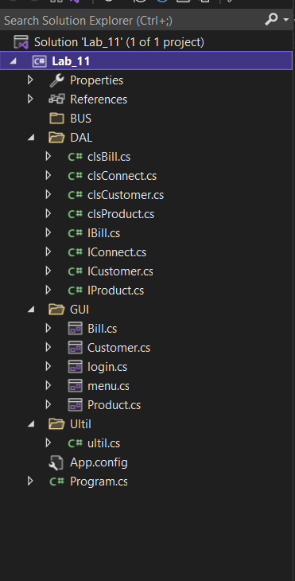

**2. Code**

**Interface**

Iconnect

using System;

using System.Collections.Generic;

using System.Linq;

using System.Text;

using System.Threading.Tasks;

using System.Data.SqlClient;

namespace Lab_11.DAL

{

internal interface IConnect

{

string UserID { get; set; }

string Password { get; set; }

string Database { get; set; }

string Server { get; set; }

string GetConnectionString();

SqlConnection Connect();

}

}

Ibill

using System;

using System.Collections.Generic;

using System.Linq;

using System.Text;

using System.Threading.Tasks;

namespace Lab_11.DAL

{

internal interface IBill

{

string MaHD { get; set; }

string MaKH { get; set; }

string NgayHD { get; set; }

string GhiChu { get; set; }

int addBill(string strSqlConnection);

int updateBill(string strSqlConnection);

int deleteBill(string strSqlConnection);

int findByIDBill(string strSqlConnection);

}

}

Icustomer

using System;

using System.Collections.Generic;

using System.Linq;

using System.Text;

using System.Threading.Tasks;

namespace Lab_11.DAL

{

internal interface ICustomer

{

string MaKH { get; set; }

string TenKH { get; set; }

string SDT { get; set; }

string GhiChu { get; set; }

int addCustomer(string strSqlConnection);

int updateCustomer(string strSqlConnection);

int deleteCustomer(string strSqlConnection);

int findByIDCustomer (string strSqlConnection);

}

}

Iproduct

using System;

using System.Collections.Generic;

using System.Linq;

using System.Text;

using System.Threading.Tasks;

namespace Lab_11.DAL

{

internal interface IProduct

{

string MaH { get; set; }

string TenHang { get; set; }

string DonGia { get; set; }

string GhiChu { get; set; }

int addProduct(string strSqlConnection);

int updateProduct (string strSqlConnection);

int deleteProduct (string strSqlConnection);

int findByIDProduct (string strSqlConnection);

}

}

**Class**

clsConnect

using System;

using System.Collections.Generic;

using System.Linq;

using System.Text;

using System.Threading.Tasks;

using System.Data.SqlClient;

namespace Lab_11.DAL

{

internal class clsConnect : IConnect

{

public string UserID { get; set; }

public string Password { get; set; }

public string Database { get; set; }

public string Server { get; set; }

/// <summary>

/// Phuong thuc khoi dung mac dinh co tham so

/// </summary>

/// <param name="_UserID">Ten tai khoan dang nhap vao SQL Server</param>

/// <param name="_Password">Mat khau dang nhap vao SQL server</param>

/// <param name="_Database">Ten CSDL trong SQL Server</param>

/// <param name="_Server">Ten may chu chua SQL server</param>

public clsConnect(string _UserID, string _Password, string _Database, string _Server)

{

UserID = _UserID;

Password = _Password;

Database = _Database;

Server = _Server;

}

public SqlConnection Connect()

{

SqlConnection Conn = new SqlConnection();

Conn.ConnectionString = GetConnectionString();

try

{

Conn.Open();

}

catch (Exception)

{

Conn = null;

}

return Conn;

}

/// <summary>

/// Tạo chuỗi kết nối.

/// </summary>

/// <returns>Chuỗi kết nối có 4 thông tin Server, Database, UserID, Passwod</returns>

public string GetConnectionString()

{

string strChainConnect;

strChainConnect = "";

strChainConnect += "Data Source =" + Server + ";";

strChainConnect += "Initial Catalog =" + Database + ";";

strChainConnect += "User ID =" + UserID + ";";

strChainConnect += "Password =" + Password + ";";

return strChainConnect;

}

}

}

clsCustomer

using System;

using System.Collections.Generic;

using System.Linq;

using System.Text;

using System.Threading.Tasks;

namespace Lab_11.DAL

{

internal class clsCustomer: ICustomer

{

public string MaKH { get; set; }

public string TenKH { get; set; }

public string SDT { get; set; }

public string GhiChu { get; set; }

public clsCustomer(string _maKH, string _tenKH, string _sdt, string _ghiChu)

{

MaKH = _maKH;

TenKH = _tenKH;

SDT = _sdt;

GhiChu = _ghiChu;

}

public int addCustomer(string strSqlConnection)

{

return Ultil.ultil.ExcuteProcedure(

new string[] { "@MaKH", "@TenKH", "@SDT", "@GhiChu" },

new object[] { MaKH, TenKH, SDT, GhiChu },

strSqlConnection,

"sp_insertCustomer");

}

public int updateCustomer(string strSqlConnection)

{

return Ultil.ultil.ExcuteProcedure(

new string[] { "@MaKH", "@TenKH", "@SDT", "@GhiChu" },

new object[] { MaKH, TenKH, SDT, GhiChu },

strSqlConnection,

"sp_updateCustomer");

}

public int deleteCustomer(string strSqlConnection)

{

return Ultil.ultil.ExcuteProcedure(

new string[] { "@MaKH" },

new object[] { MaKH },

strSqlConnection,

"sp_deleteCustomer");

}

public int findByIDCustomer(string strSqlConnection)

{

return Ultil.ultil.ExcuteProcedure(

new string[] { "@MaKH" },

new object[] { MaKH },

strSqlConnection,

"sp_findByIDCustomer");

}

}

}

clsProduct

using System;

using System.Collections.Generic;

using System.Linq;

using System.Text;

using System.Threading.Tasks;

namespace Lab_11.DAL

{

internal class clsProduct : IProduct

{

public string MaH { get; set; }

public string TenHang { get; set; }

public string DonGia { get; set; }

public string GhiChu { get; set; }

public clsProduct(string _maH, string _tenHang, string _donGia, string _ghiChu)

{

MaH = _maH;

TenHang = _tenHang;

DonGia = _donGia;

GhiChu = _ghiChu;

}

public int addProduct(string strSqlConnection)

{

return Ultil.ultil.ExcuteProcedure(

new string[] { "@MaH", "@TenHang", "@DonGia", "@GhiChu" },

new object[] { MaH, TenHang, DonGia, GhiChu },

strSqlConnection, "sp_insertProduct");

}

public int updateProduct(string strSqlConnection)

{

return Ultil.ultil.ExcuteProcedure(

new string[] { "@MaH", "@TenHang", "@DonGia", "@GhiChu" },

new object[] { MaH, TenHang, DonGia, GhiChu },

strSqlConnection, "sp_updateProduct");

}

public int deleteProduct(string strSqlConnection)

{

return Ultil.ultil.ExcuteProcedure(

new string[] { "@MaH" },

new object[] { MaH },

strSqlConnection, "sp_deleteProduct");

}

public int findByIDProduct(string strSqlConnection)

{

return Ultil.ultil.ExcuteProcedure(

new string[] { "@MaH" },

new object[] { MaH },

strSqlConnection, "sp_findByIDProduct");

}

}

}

clsBill

using System;

using System.Collections.Generic;

using System.Linq;

using System.Text;

using System.Threading.Tasks;

namespace Lab_11.DAL

{

internal class clsBill: IBill

{

public string MaHD { get; set; }

public string MaKH { get; set; }

public string NgayHD { get; set; }

public string GhiChu { get; set; }

public clsBill(string _maHD, string _maKH, string _ngayHD, string _ghiChu)

{

MaHD = _maHD;

MaKH = _maKH;

NgayHD = _ngayHD;

GhiChu = _ghiChu;

}

public int addBill(string strSqlConnection)

{

return Ultil.ultil.ExcuteProcedure(

new string[] { "@MaHD", "@MaKH", "@NgayHD", "@GhiChu" },

new object[] { MaHD, MaKH, NgayHD, GhiChu },

strSqlConnection,

"sp_insertBill");

}

public int updateBill(string strSqlConnection)

{

return Ultil.ultil.ExcuteProcedure(

new string[] { "@MaHD", "@MaKH", "@NgayHD", "@GhiChu" },

new object[] { MaHD, MaKH, NgayHD, GhiChu },

strSqlConnection,

"sp_updateBill");

}

public int deleteBill(string strSqlConnection)

{

return Ultil.ultil.ExcuteProcedure(

new string[] { "@MaHD" },

new object[] { MaHD },

strSqlConnection,

"sp_deleteBill");

}

public int findByIDBill(string strSqlConnection)

{

return Ultil.ultil.ExcuteProcedure(

new string[] { "@MaHD" },

new object[] { MaHD },

strSqlConnection,

"sp_findByIDBill");

}

}

}

**Code form**

Customer

using System;

using System.Collections.Generic;

using System.ComponentModel;

using System.Data;

using System.Drawing;

using System.Linq;

using System.Text;

using System.Threading.Tasks;

using System.Windows.Forms;

using System.Data.SqlClient;

namespace Lab_11

{

public partial class Customer : Form

{

/// <summary>

/// Tạo thêm biến chứa chuỗi kết nối

/// </summary>

public string strConectionString;

/// <summary>

/// Phương thức khởi dựng mặc định với tham số là chuỗi kết nối

/// </summary>

/// <param name="_strConnectionString">Chuỗi kết nối CSDL</param>

public Customer(string _strConnectionString)

{

InitializeComponent();

strConectionString = _strConnectionString;

}

public Customer()

{

InitializeComponent();

}

public void Display()

{

//data.Clear();

SqlConnection connection = new SqlConnection(strConectionString);

//connection.Open();

string text = "select * from KhachHang";

SqlCommand cmd = new SqlCommand(text, connection);

SqlDataAdapter da = new SqlDataAdapter(cmd);

DataTable data = new DataTable();

//var reader = cmd.ExecuteReader();

//data.Load(reader);

da.Fill(data);

//Hiển thị thông tin lên datagridview.

dgvCustomer.DataSource = data;

//DataBinding(data);

//connection.Close();

}

//Display data to textbox when click to record

public void DataBinding(DataTable data)

{

txtCusID.DataBindings.Add("Text", data, "MaKH", true);

string t = txtCusID.Text;

txtCusName.DataBindings.Add("Text", data, "TenKH", true);

txtPhoneNum.DataBindings.Add("Text", data, "SDT", true);

txtNote.DataBindings.Add("Text", data, "Ghichu", true);

}

private void txtIDCus_TextChanged(object sender, EventArgs e)

{

}

private void btnAdd_Click(object sender, EventArgs e)

{

DAL.clsCustomer customer = new DAL.clsCustomer(

txtCusID.Text, txtCusName.Text,

txtPhoneNum.Text, txtNote.Text);

customer.addCustomer(strConectionString);

Display();

}

private void btnUpdate_Click(object sender, EventArgs e)

{

DAL.clsCustomer customer = new DAL.clsCustomer(

txtCusID.Text, txtCusName.Text,

txtPhoneNum.Text, txtNote.Text);

customer.updateCustomer(strConectionString);

Display();

}

private void btnDelete_Click(object sender, EventArgs e)

{

DAL.clsCustomer customer = new DAL.clsCustomer(

txtCusID.Text, txtCusName.Text,

txtPhoneNum.Text, txtNote.Text);

customer.deleteCustomer(strConectionString);

Display();

}

private void btnFind_Click(object sender, EventArgs e)

{

SqlConnection connection = new SqlConnection(strConectionString);

SqlCommand cmd = new SqlCommand("exec sp_findByIDCustomer'" + int.Parse(txtCusID.Text) + "'", connection);

SqlDataAdapter da = new SqlDataAdapter(cmd);

DataTable dt = new DataTable();

da.Fill(dt);

dgvCustomer.DataSource = dt;

}

private void Customer_Load(object sender, EventArgs e)

{

Display();

}

private void lbBackMenu_Click(object sender, EventArgs e)

{

GUI.menu menu = new GUI.menu();

menu.strConectionString = strConectionString;

this.Hide();

menu.ShowDialog();

}

}

}

Product

using System;

using System.Collections.Generic;

using System.ComponentModel;

using System.Data;

using System.Drawing;

using System.Linq;

using System.Text;

using System.Threading.Tasks;

using System.Windows.Forms;

using System.Data.SqlClient;

namespace Lab_11.GUI

{

public partial class Product : Form

{

/// <summary>

/// Tạo thêm biến chứa chuỗi kết nối

/// </summary>

public string strConectionString;

/// <summary>

/// Phương thức khởi dựng mặc định với tham số là chuỗi kết nối

/// </summary>

/// <param name="_strConnectionString">Chuỗi kết nối CSDL</param>

public Product(string _strConnectionString)

{

InitializeComponent();

strConectionString = _strConnectionString;

}

public Product()

{

InitializeComponent();

}

private void Product_Load(object sender, EventArgs e)

{

Display();

}

public void Display()

{

//data.Clear();

SqlConnection connection = new SqlConnection(strConectionString);

//connection.Open();

string text = "select * from Hang";

SqlCommand cmd = new SqlCommand(text, connection);

SqlDataAdapter da = new SqlDataAdapter(cmd);

DataTable data = new DataTable();

//var reader = cmd.ExecuteReader();

//data.Load(reader);

da.Fill(data);

//Hiển thị thông tin lên datagridview.

dgvProduct.DataSource = data;

//DataBinding(data);

//connection.Close();

}

//Display data to textbox when click to record

public void DataBinding(DataTable data)

{

txtIDPr.DataBindings.Add("Text", data, "MaH", true);

string t = txtIDPr.Text;

txtNamePr.DataBindings.Add("Text", data, "TenHang", true);

txtPrice.DataBindings.Add("Text", data, "DonGia", true);

txtNote.DataBindings.Add("Text", data, "Ghichu", true);

}

private void dgvProduct_CellContentClick(object sender, DataGridViewCellEventArgs e)

{

}

private void btnAdd_Click(object sender, EventArgs e)

{

DAL.clsProduct pr = new DAL.clsProduct(

txtIDPr.Text, txtNamePr.Text,

txtPrice.Text, txtNote.Text);

pr.addProduct(strConectionString);

Display();

}

private void btnUpdate_Click(object sender, EventArgs e)

{

DAL.clsProduct pr = new DAL.clsProduct(

txtIDPr.Text, txtNamePr.Text,

txtPrice.Text, txtNote.Text);

pr.updateProduct(strConectionString);

Display();

}

private void btnDelete_Click(object sender, EventArgs e)

{

if(MessageBox.Show("Are you sure to delete!", "Delete Document",MessageBoxButtons.YesNo) == DialogResult.Yes)

{

DAL.clsProduct pr = new DAL.clsProduct(

txtIDPr.Text, txtNamePr.Text,

txtPrice.Text, txtNote.Text);

pr.deleteProduct(strConectionString);

MessageBox.Show("Successfully deleted!");

Display();

}

}

private void btnFind_Click(object sender, EventArgs e)

{

/*

DAL.clsProduct pr = new DAL.clsProduct(

txtIDPr.Text, txtNamePr.Text,

txtPrice.Text, txtNote.Text);

pr.findByIDProduct(strConectionString);

*/

//Display();

SqlConnection connection = new SqlConnection(strConectionString);

SqlCommand cmd = new SqlCommand("exec sp_findByIDProduct'"+int.Parse(txtIDPr.Text)+"'", connection);

SqlDataAdapter da = new SqlDataAdapter(cmd);

DataTable dt = new DataTable();

da.Fill(dt);

dgvProduct.DataSource = dt;

}

private void lbBackMenu_Click(object sender, EventArgs e)

{

GUI.menu menu = new GUI.menu();

menu.strConectionString = strConectionString;

this.Hide();

menu.ShowDialog();

}

}

}

Bill

using System;

using System.Collections.Generic;

using System.ComponentModel;

using System.Data;

using System.Drawing;

using System.Linq;

using System.Text;

using System.Threading.Tasks;

using System.Windows.Forms;

using System.Data.SqlClient;

namespace Lab_11.GUI

{

public partial class Bill : Form

{

/// <summary>

/// Tạo thêm biến chứa chuỗi kết nối

/// </summary>

public string strConectionString;

/// <summary>

/// Phương thức khởi dựng mặc định với tham số là chuỗi kết nối

/// </summary>

/// <param name="_strConnectionString">Chuỗi kết nối CSDL</param>

public Bill(string _strConnectionString)

{

InitializeComponent();

strConectionString = _strConnectionString;

}

public Bill()

{

InitializeComponent();

}

public void Display()

{

//data.Clear();

SqlConnection connection = new SqlConnection(strConectionString);

//connection.Open();

string text = "select * from HoaDon";

SqlCommand cmd = new SqlCommand(text, connection);

SqlDataAdapter da = new SqlDataAdapter(cmd);

DataTable data = new DataTable();

//var reader = cmd.ExecuteReader();

//data.Load(reader);

da.Fill(data);

//Hiển thị thông tin lên datagridview.

dgvBill.DataSource = data;

//DataBinding(data);

//connection.Close();

}

//Display data to textbox when click to record

public void DataBinding(DataTable data)

{

txtIDBill.DataBindings.Add("Text", data, "MaHD", true);

string t = txtIDBill.Text;

txtIDCus.DataBindings.Add("Text", data, "MaKH", true);

txtDateBill.DataBindings.Add("Text", data, "NgayHD", true);

txtNote.DataBindings.Add("Text", data, "Ghichu", true);

}

private void btnAdd_Click(object sender, EventArgs e)

{

DAL.clsBill bill = new DAL.clsBill(

txtIDBill.Text, txtIDCus.Text,

txtDateBill.Text, txtNote.Text

);

bill.addBill(strConectionString);

Display();

}

private void btnUpdate_Click(object sender, EventArgs e)

{

DAL.clsBill bill = new DAL.clsBill(

txtIDBill.Text, txtIDCus.Text,

txtDateBill.Text, txtNote.Text

);

bill.updateBill(strConectionString);

Display();

}

private void btnDelete_Click(object sender, EventArgs e)

{

DAL.clsBill bill = new DAL.clsBill(

txtIDBill.Text, txtIDCus.Text,

txtDateBill.Text, txtNote.Text

);

bill.deleteBill(strConectionString);

Display();

}

private void btnFind_Click(object sender, EventArgs e)

{

SqlConnection connection = new SqlConnection(strConectionString);

SqlCommand cmd = new SqlCommand("exec sp_findByIDBill'" + int.Parse(txtIDBill.Text) + "'", connection);

SqlDataAdapter da = new SqlDataAdapter(cmd);

DataTable dt = new DataTable();

da.Fill(dt);

dgvBill.DataSource = dt;

}

private void Bill_Load(object sender, EventArgs e)

{

Display();

}

private void lbBackMenu_Click(object sender, EventArgs e)

{

GUI.menu menu = new GUI.menu();

menu.strConectionString = strConectionString;

this.Hide();

menu.ShowDialog();

}

}

}

Login

using System;

using System.Collections.Generic;

using System.ComponentModel;

using System.Data;

using System.Drawing;

using System.Linq;

using System.Text;

using System.Threading.Tasks;

using System.Windows.Forms;

namespace Lab_11.GUI

{

public partial class Login : Form

{

public Login()

{

InitializeComponent();

txtPassword.PasswordChar = '*';

}

public string strConnectionString { get; set; }

private void btnLogin_Click(object sender, EventArgs e)

{

DAL.clsConnect conn = new DAL.clsConnect(

txtUser.Text, txtPassword.Text, txtDatabase.Text, cbbServer.Text);

if (conn.Connect() != null)

{

//Gán giá trị cho thuộc tính vừa thêm

strConnectionString = conn.GetConnectionString();

//MessageBox.Show(strConnectionString);

this.Hide();

menu menu = new menu();

//Multi form value string connection

menu.strConectionString = strConnectionString;

menu.ShowDialog();

}

else

{

MessageBox.Show("Login fail!");

}

}

}

}

Menu

using System;

using System.Collections.Generic;

using System.ComponentModel;

using System.Data;

using System.Drawing;

using System.Linq;

using System.Text;

using System.Threading.Tasks;

using System.Windows.Forms;

namespace Lab_11.GUI

{

public partial class menu : Form

{

public menu()

{

InitializeComponent();

}

public string strConectionString;

private void btnProduct_Click(object sender, EventArgs e)

{

Product product = new GUI.Product();

this.Hide();

//Multi form value string connection

product.strConectionString = strConectionString;

product.ShowDialog();

}

private void btnCustomer_Click(object sender, EventArgs e)

{

Customer customer = new Customer();

this.Hide();

//Multi form value string connection

customer.strConectionString = strConectionString;

customer.ShowDialog();

}

private void btnBill_Click(object sender, EventArgs e)

{

Bill bill = new Bill();

this.Hide();

//Multi form value string connection

bill.strConectionString = strConectionString;

bill.ShowDialog();

}

}

}

**3. Kết quả**

Login form

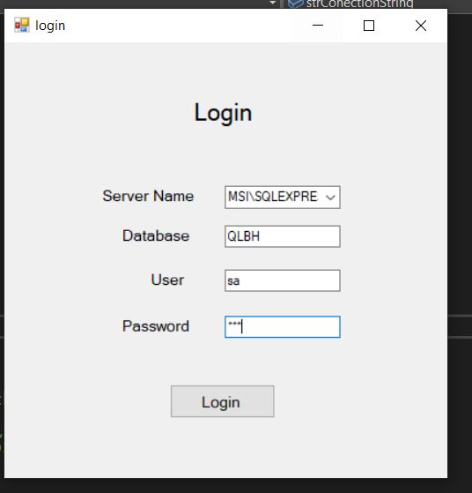

Menu form

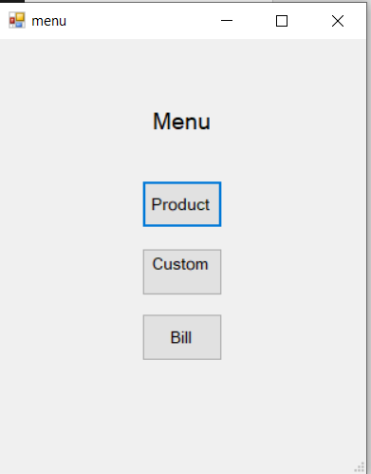

Customer form

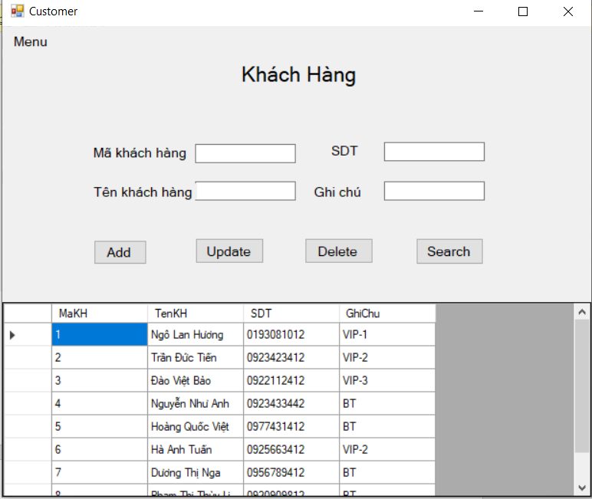

Product form

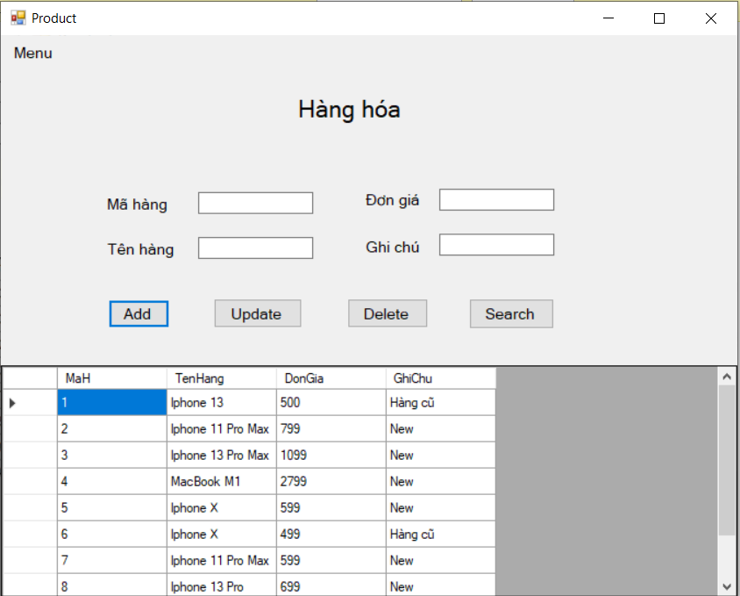

Bill form

