Họ và tên: Đào Việt Bảo

Lớp: CNTT - 3

Mã sinh viên: 20200910

**Bài tập về nhà**

Môn: Lập trình .NET

**1. Đề bài**

Sử dụng CSDL từ Lab 11  
1. Tạo báo cáo toàn bộ khách hàng đã mua hàng  
2. Tạo báo cáo toàn bộ mặt hàng.  
3. Tạo báo cáo hàng hóa đã được bán trong tháng 03.

**File System**

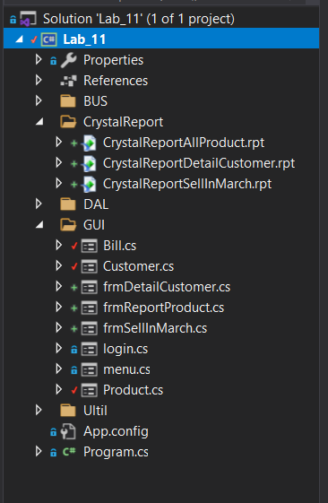

**2. Code**

**BUS.clsReportProduct**

using CrystalDecisions.CrystalReports.Engine;

using CrystalDecisions.Windows.Forms;

using System;

using System.Collections.Generic;

using System.Linq;

using System.Text;

using System.Threading.Tasks;

namespace Lab_11.BUS

{

class cslReportProduct

{

public void reportAllProduct(CrystalReportViewer reportViewer, string CystalReportFilePath)

{

ReportDocument report = new ReportDocument();

report.Load(CystalReportFilePath);

report.SetDatabaseLogon("sa","123", @"MSI\SQLEXPRESS", "QLBH");

reportViewer.ReportSource = report;

}

}

}

**BUS.clsReportDetailCustomer**

using CrystalDecisions.CrystalReports.Engine;

using CrystalDecisions.Windows.Forms;

using System;

using System.Collections.Generic;

using System.Linq;

using System.Text;

using System.Threading.Tasks;

namespace Lab_11.BUS

{

class clsReportDetailCustomer

{

public void reportDetailCustomer(CrystalReportViewer reportViewer, string crystalReportFilePath)

{

ReportDocument report = new ReportDocument();

report.Load(crystalReportFilePath);

report.SetDatabaseLogon("sa", "123", @"MSI\SQLEXPRESS", "QLBH");

reportViewer.ReportSource = report;

}

}

}

**BUS.clsSellInMarch**

using CrystalDecisions.CrystalReports.Engine;

using CrystalDecisions.Windows.Forms;

using System;

using System.Collections.Generic;

using System.Linq;

using System.Text;

using System.Threading.Tasks;

namespace Lab_11.BUS

{

class clsReportSellInMarch

{

public void reportSellInMarch(CrystalReportViewer reportViewer, string crystalReportFilePath)

{

ReportDocument report = new ReportDocument();

report.Load(crystalReportFilePath);

report.SetDatabaseLogon("sa", "123", @"MSI\SQLEXPRESS", "QLBH");

reportViewer.ReportSource = report;

}

}

}

**Form**

frmReportProduct

using System;

using System.Collections.Generic;

using System.ComponentModel;

using System.Data;

using System.Drawing;

using System.Linq;

using System.Text;

using System.Threading.Tasks;

using System.Windows.Forms;

namespace Lab_11.GUI

{

public partial class frmReportProduct : Form

{

public frmReportProduct()

{

InitializeComponent();

}

private void frmReportProduct_Load(object sender, EventArgs e)

{

BUS.cslReportProduct report = new BUS.cslReportProduct();

report.reportAllProduct(crystalReportProduct, @"..\..\CrystalReport\CrystalreportAllProduct.rpt");

}

}

}

frmDetailCustomer

using System;

using System.Collections.Generic;

using System.ComponentModel;

using System.Data;

using System.Drawing;

using System.Linq;

using System.Text;

using System.Threading.Tasks;

using System.Windows.Forms;

namespace Lab_11.GUI

{

public partial class frmDetailCustomer : Form

{

public frmDetailCustomer()

{

InitializeComponent();

}

private void frmDetailCustomer_Load(object sender, EventArgs e)

{

BUS.clsReportDetailCustomer report = new BUS.clsReportDetailCustomer();

report.reportDetailCustomer(crystalReportCustomer, @"..\..\CrystalReport\CrystalReportDetailCustomer.rpt");

}

}

}

frmSellInMarch

using System;

using System.Collections.Generic;

using System.ComponentModel;

using System.Data;

using System.Drawing;

using System.Linq;

using System.Text;

using System.Threading.Tasks;

using System.Windows.Forms;

namespace Lab_11.GUI

{

public partial class frmSellInMarch : Form

{

public frmSellInMarch()

{

InitializeComponent();

}

private void frmSellInMarch_Load(object sender, EventArgs e)

{

BUS.clsReportSellInMarch report = new BUS.clsReportSellInMarch();

report.reportSellInMarch(crystalReportSellInMarch, @"..\..\CrystalReport\CrystalReportSellInMarch.rpt"); ;

}

}

}

**3. Kết quả**

frmReportProduct

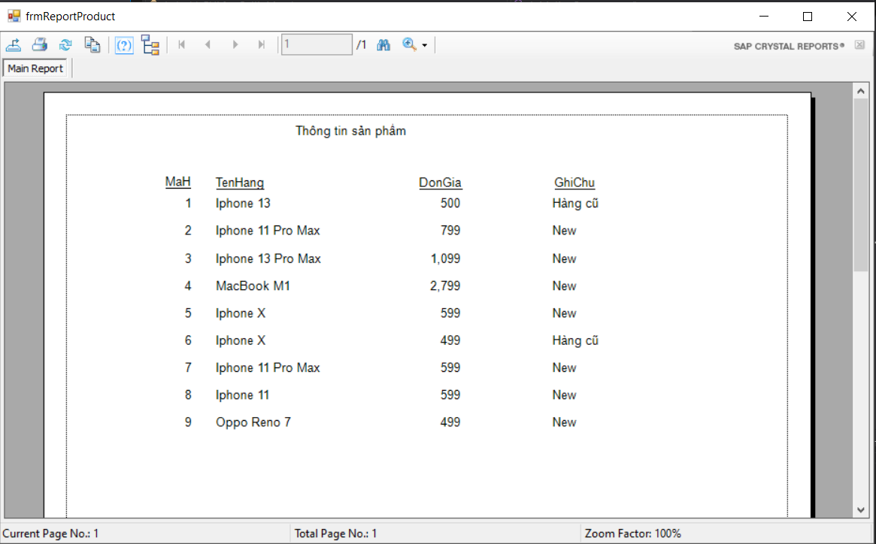

frmDetailCustomer

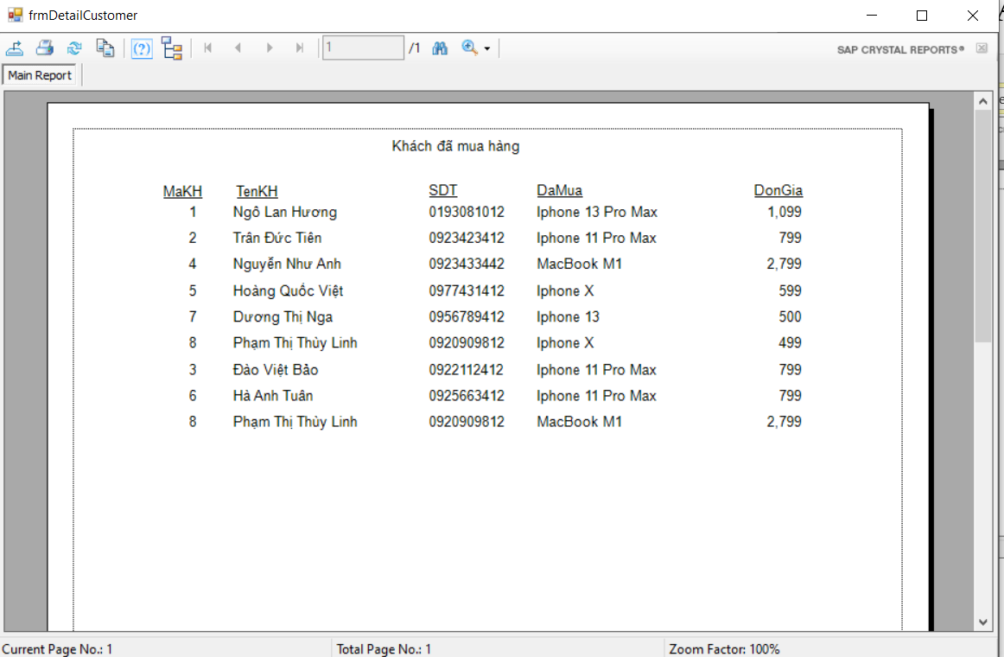

frmSellInMarch

