Họ và tên: Đào Việt Bảo

Lớp: CNTT - 3

Mã sinh viên: 20200910

**Bài tập về nhà**

Môn: Lập trình .NET

**1. Đề bài**

Viết chương trình có 3 tầng DAL, BUS,GUI thực hiện công việc sau:  
**1.** Tính tổng 2 số (trong bài giảng)  
**2.** Nhập vào 3 số thực, xét xem có phải ba cạnh tam giác hay không, tam giác gì, tính chu vi, diện tích tam giác.

**System files**

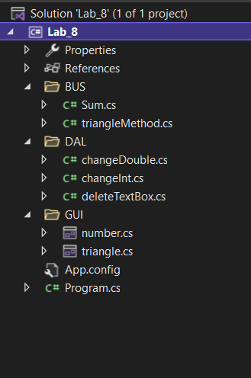

**2. Code**

**GUI**

**Number**

using System;

using System.Collections.Generic;

using System.ComponentModel;

using System.Data;

using System.Drawing;

using System.Linq;

using System.Text;

using System.Threading.Tasks;

using System.Windows.Forms;

namespace Lab_8

{

public partial class number : Form

{

public number()

{

InitializeComponent();

}

private void btnDelete_Click(object sender, EventArgs e)

{

TextBox[] txt = new TextBox[] { txtResult, txtNumber1, txtNumber2 };

DAL.deleteTextBox.delete(txt);

}

private void btnSum_Click(object sender, EventArgs e)

{

BUS.Sum sum = new BUS.Sum(txtNumber1, txtNumber2);

txtResult.Text = sum.Add().ToString();

}

}

}

**triangle**

using System;

using System.Collections.Generic;

using System.ComponentModel;

using System.Data;

using System.Drawing;

using System.Linq;

using System.Text;

using System.Threading.Tasks;

using System.Windows.Forms;

namespace Lab_8.GUI

{

public partial class triangle : Form

{

public triangle()

{

InitializeComponent();

}

private void btnDelete_Click(object sender, EventArgs e)

{

TextBox[] txt = new TextBox[] {txtCheck, txtArea, txtPerimeter, txtSide1, txtSide2, txtSide3};

DAL.deleteTextBox.delete(txt);

}

private void btnCheck_Click(object sender, EventArgs e)

{

BUS.triangleMethod check = new BUS.triangleMethod(txtSide1, txtSide2, txtSide3);

txtCheck.Text = check.checkTriangle().ToString();

}

private void btnTinh_Click(object sender, EventArgs e)

{

BUS.triangleMethod tinh = new BUS.triangleMethod(txtSide1, txtSide2, txtSide3);

if(txtCheck.Text == "Tam giac khong ton tai")

{

MessageBox.Show("Khong ton tai chu vi va dien tich");

}

else

{

txtPerimeter.Text = tinh.perimeter().ToString();

txtArea.Text = tinh.area().ToString();

}

}

}

}

**BUS**

**Class Sum**

using System;

using System.Collections.Generic;

using System.Linq;

using System.Text;

using System.Threading.Tasks;

using System.Windows.Forms;

namespace Lab_8.BUS

{

internal class Sum

{

public int number1 { get; set; }

public int number2 { get; set; }

//Constructor

public Sum() { }

public Sum(TextBox txtNumber1, TextBox txtNumber2)

{

number1 = DAL.changeInt.change(txtNumber1.Text);

number2 = DAL.changeInt.change(txtNumber2.Text);

}

public Sum(int number1, int number2)

{

this.number1 = number1;

this.number2 = number2;

}

public int Add()

{

return number1 + number2;

}

}

}

**Class triangleMethod**

using System;

using System.Collections.Generic;

using System.Linq;

using System.Text;

using System.Threading.Tasks;

using System.Windows.Forms;

namespace Lab_8.BUS

{

internal class triangleMethod

{

public double side1 { get; set; }

public double side2 { get; set; }

public double side3 { get; set; }

//Constructor

public triangleMethod() { }

public triangleMethod(double side1, double side2, double side3)

{

this.side1 = side1;

this.side2 = side2;

this.side3 = side3;

}

public triangleMethod(TextBox txtA, TextBox txtB, TextBox txtC)

{

side1 = DAL.changeDouble.changeDou(txtA.Text);

side2 = DAL.changeDouble.changeDou(txtB.Text);

side3 = DAL.changeDouble.changeDou(txtC.Text);

}

//Tinh chu vi tam giac

public double perimeter()

{

string check;

if (side1 + side2 < side3 && side1 + side3 < side2 && side2 + side3 < side1)

{

return side1 + side2 + side3;

}

else

{

return double.NaN;

}

}

//Tinh dien tich

public double area()

{

string check;

if(side1 + side2 < side3 || side1 + side3 < side2 || side2 + side3 < side1)

{

double p = perimeter() / 2;

return Math.Sqrt(p * (p - side1) * (p - side2) * (p - side3));

}

else

{

return double.NaN;

}

}

public string checkTriangle()

{

double a = side1;

double b = side2;

double c = side3;

string check;

//Kiem tra ba canh cua tam giac

if(a + b > c && a + c > b && b + c > a)

{

//Kiem tra tam giac vuong (pitago)

if (a * a == b * b + c * c || b * b == a * a + c * c || c * c == b * b + a * a)

{

check = "Tam giac vuong";

}

//Kiem tra tam giac deu

else if (a == b && b == c)

{

check = "Tam giac deu";

}

//Kiem tra tam giac can

else if(a == b || a == c || b == c)

{

check = "Tam giac can";

}

//Kiem tra tam giac tu

else if (a * a > b * b + c * c || b * b > a * a + c * c || c * c > a * a + b * b)

{

check = "Tam giac tu";

}else

{

check = "Tam giac nhon";

}

}

else

{

check = "Tam giac khong ton tai";

}

return check;

}

}

}

**DAL**

**Class changeDouble**

using System;

using System.Collections.Generic;

using System.Linq;

using System.Text;

using System.Threading.Tasks;

namespace Lab_8.DAL

{

internal class changeDouble

{

public static double changeDou(string str)

{

double result;

result = Convert.ToDouble(str);

return result;

}

}

}

**Class changeInt**

using System;

using System.Collections.Generic;

using System.Linq;

using System.Text;

using System.Threading.Tasks;

namespace Lab_8.DAL

{

internal class changeInt

{

public static int change(string str)

{

int result;

result = Convert.ToInt32(str);

return result;

}

}

}

**Class deleteTextBox**

using System;

using System.Collections.Generic;

using System.Linq;

using System.Text;

using System.Threading.Tasks;

using System.Windows.Forms;

namespace Lab_8.DAL

{

internal class deleteTextBox

{

public static void delete(TextBox[] txt)

{

for (int i = 0; i < txt.Length; i++)

{

txt[i].Text = " ";

}

}

}

}

**3. Kết quả**

Bài 1:

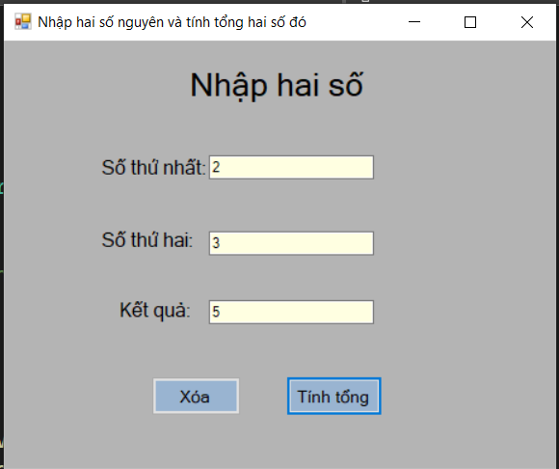

Bài 2:

