======================= CLASSIFICATION RESULTS =======================  
CLASSIFIER: DecisionTree  
Accuracy: 95.27 %   
Feature used : ONLY RAW DATA  
Classification Time: 0.572 seconds

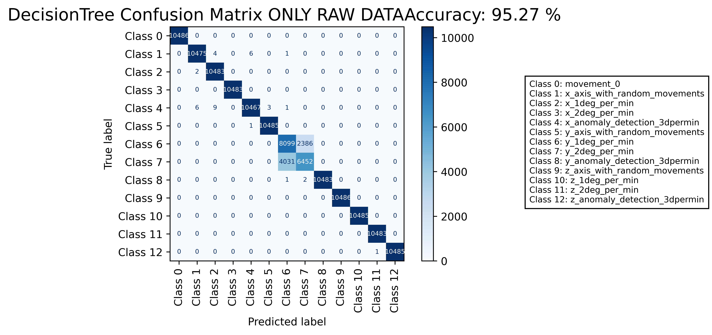

======================================================================

======================= CLASSIFICATION RESULTS =======================  
CLASSIFIER: DecisionTree  
Accuracy: 99.64 %   
Feature used : ALL FEATURES  
Classification Time: 8.446 seconds

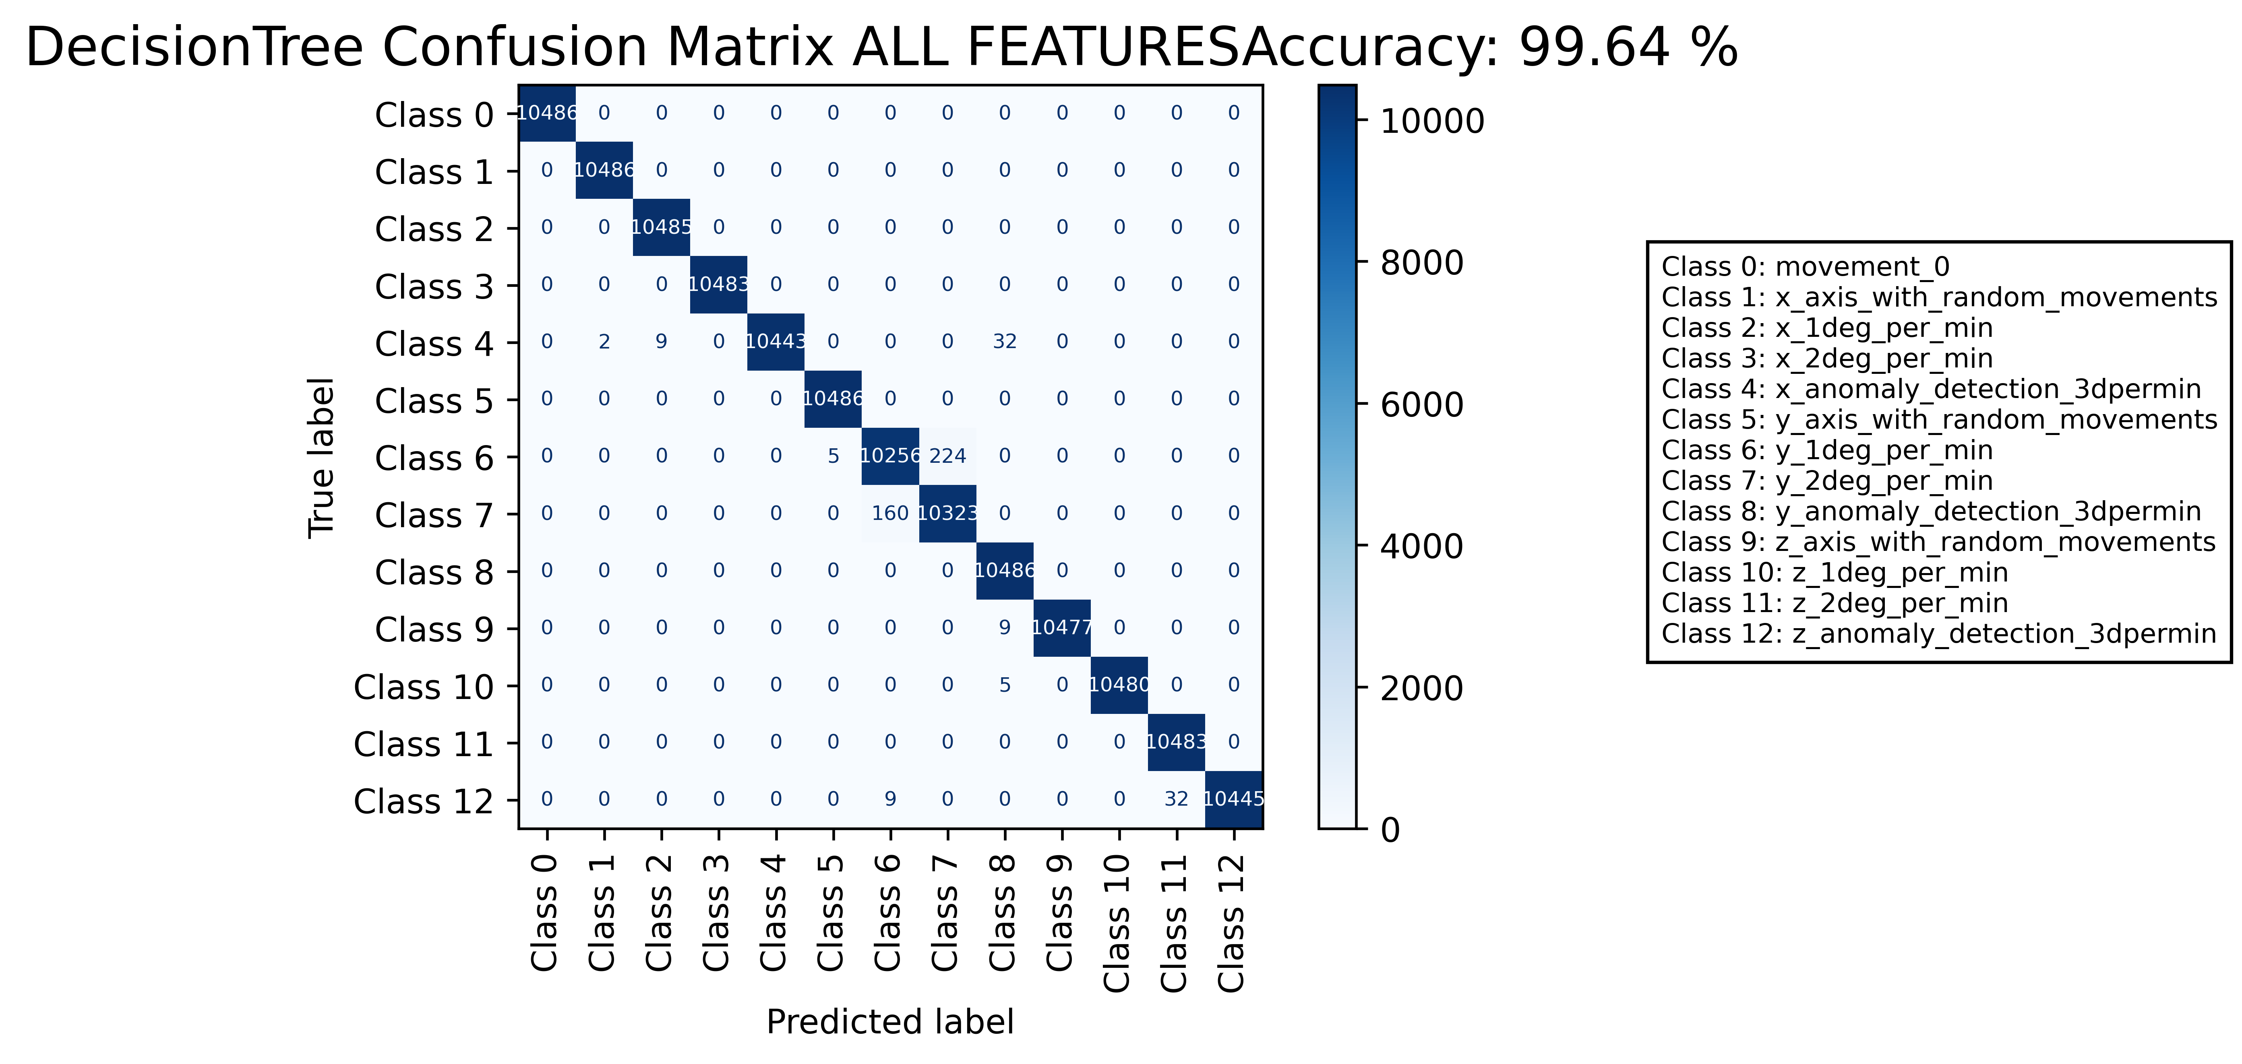

======================================================================

======================= CLASSIFICATION RESULTS =======================  
CLASSIFIER: DecisionTree  
Accuracy: 98.97 %   
Feature used : RELIFF FEATURES 10 Best  
Classification Time: 1.622 seconds

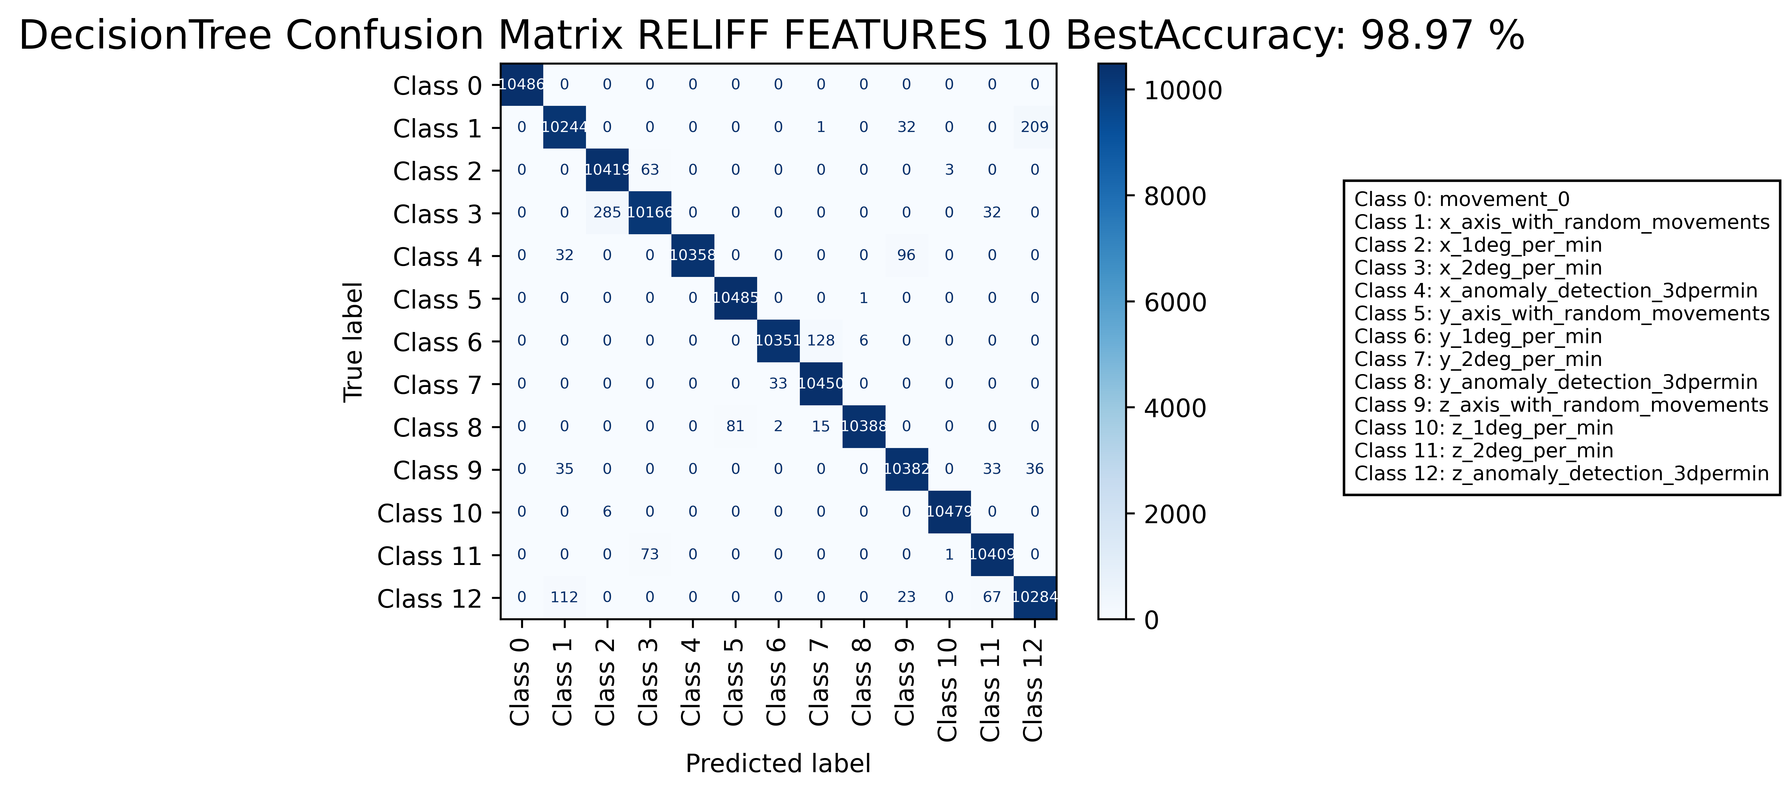

======================================================================

======================= CLASSIFICATION RESULTS =======================  
CLASSIFIER: RandomForest  
Accuracy: 97.94 %   
Feature used : ONLY RAW DATA  
Classification Time: 2.523 seconds

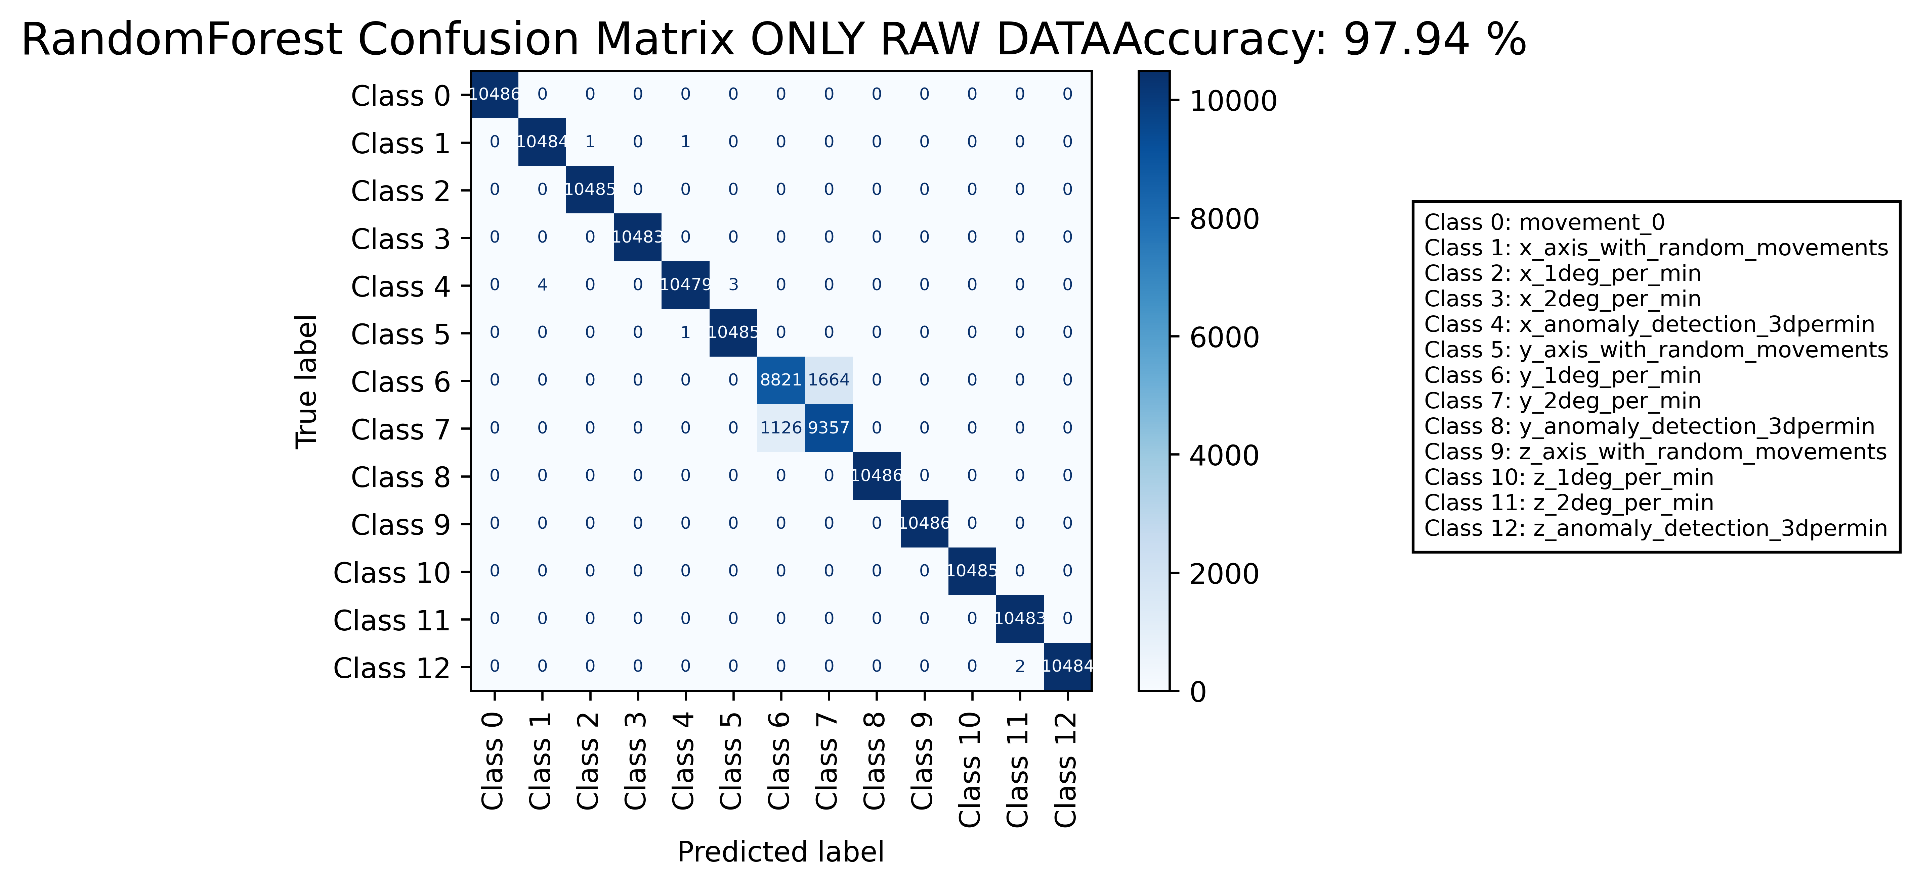

======================================================================

======================= CLASSIFICATION RESULTS =======================  
CLASSIFIER: RandomForest  
Accuracy: 99.85 %   
Feature used : ALL FEATURES  
Classification Time: 9.84 seconds

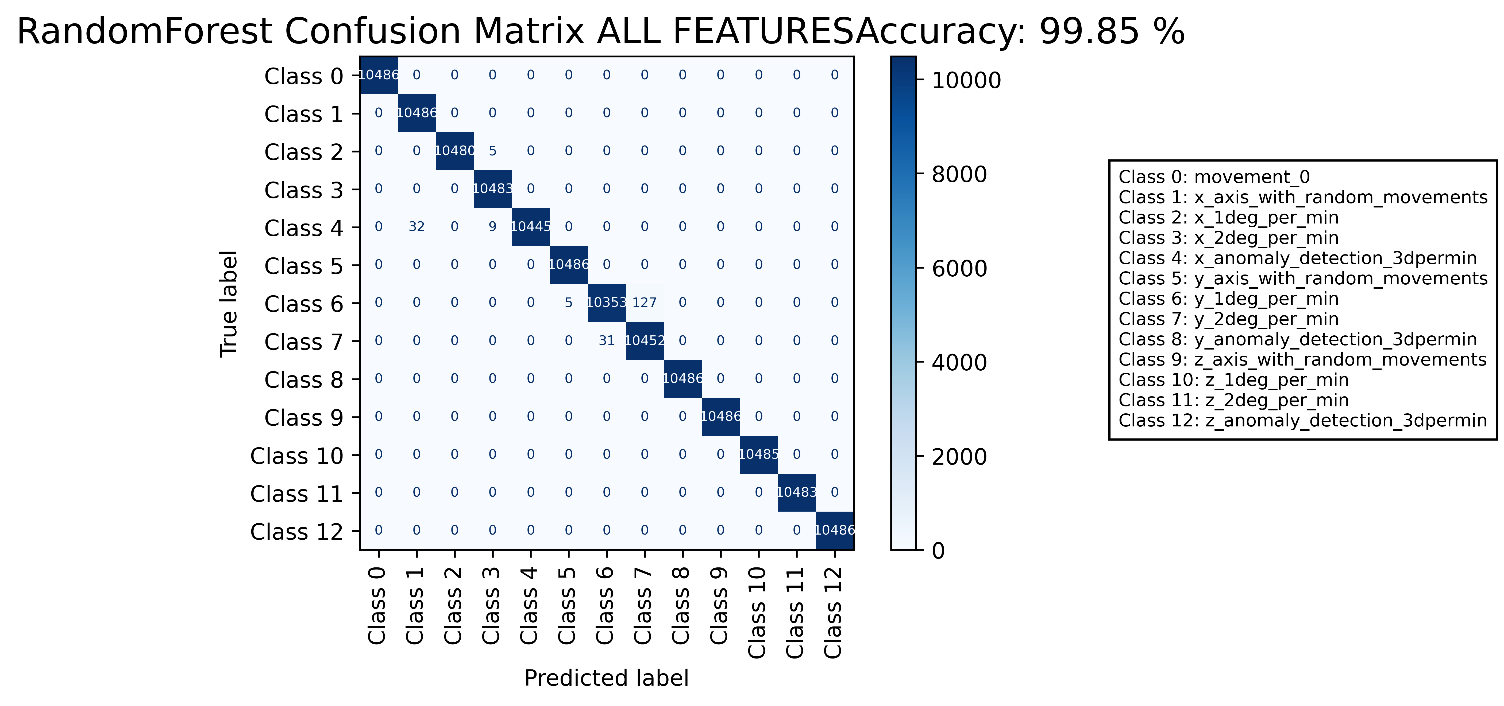

======================================================================

======================= CLASSIFICATION RESULTS =======================  
CLASSIFIER: RandomForest  
Accuracy: 99.39 %   
Feature used : RELIFF FEATURES 10 Best  
Classification Time: 9.939 seconds



