**Git Log Recap**

Let's do a quick recap of the git log command. The git log command is used to display all of the commits of a repository.

$ git log

By *default*, this command displays:

* the SHA
* the author
* the date
* and the message

...of every commit in the repository. I stress the "By default" part of what Git displays because the git log command can display a lot more information than just this.

Git uses the command line pager, Less, to page through all of the information. The important keys for Less are:

* to scroll down by a line, use j or ↓
* to scroll up by a line, use k or ↑
* to scroll down by a page, use the spacebar or the Page Down button
* to scroll up by a page, use b or the Page Up button
* to quit, use q

We'll increase our git log-wielding abilities in the next lesson when we look at displaying more info.

What could we do here to not waste a lot of space and make the output smaller? We can use a **flag**.

TIP: This isn't a course on the command line, but a flag is used to alter how a program functions. For example, the ls command will list all of the files in the current directory. The ls command has a -l flag (i.e. ls -l) that runs the same ls command but alters how it works; it now displays the information in the *long* format (the -l for *long*).

Flags can be used to alter how a program functions and/or what is displayed. To learn more about command line programs and flags, check out our course [**Linux Command Line Basics**](https://www.udacity.com/course/linux-command-line-basics--ud595).

## git log --oneline

The git log command has a flag that can be used to alter how it displays the repository's information. That flag is --oneline:

$ git log --oneline

Remember, the q key gets out of the git log view. We're still using git log but are just passing a flag to change how the information is displayed. So the q key still works and returns the terminal to the command prompt.

**git log --stat Recap**

To recap, the --stat flag is used to alter how git log displays information:

$ git log --stat

This command:

* displays the file(s) that have been modified
* displays the number of lines that have been added/removed
* displays a summary line with the total number of modified files and lines that have been added/removed

s.

**[[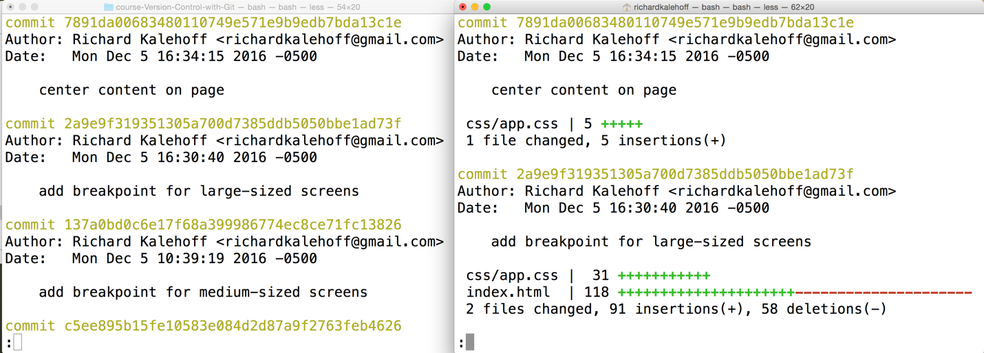](https://classroom.udacity.com/nanodegrees/nd104/parts/912d84b6-bf81-4311-8e00-b3b2f63dc965/modules/90163ae6-479b-42ef-a088-e5c5f4c10101/lessons/2607842d-e61d-49da-8125-16e6884ab656/concepts/7e127ca9-7d0a-414d-ad30-708d60248a96)](https://classroom.udacity.com/nanodegrees/nd104/parts/912d84b6-bf81-4311-8e00-b3b2f63dc965/modules/90163ae6-479b-42ef-a088-e5c5f4c10101/lessons/2607842d-e61d-49da-8125-16e6884ab656/concepts/7e127ca9-7d0a-414d-ad30-708d60248a96)**

***[Two Terminal applications side-by-side. The left one shows the result of the git log command with all of the information while the right one shows the result of the git log --stat command which lists the files that were changed as well as the number of added/removed lines.](https://classroom.udacity.com/nanodegrees/nd104/parts/912d84b6-bf81-4311-8e00-b3b2f63dc965/modules/90163ae6-479b-42ef-a088-e5c5f4c10101/lessons/2607842d-e61d-49da-8125-16e6884ab656/concepts/7e127ca9-7d0a-414d-ad30-708d60248a96)***

**[git log -p](https://classroom.udacity.com/nanodegrees/nd104/parts/912d84b6-bf81-4311-8e00-b3b2f63dc965/modules/90163ae6-479b-42ef-a088-e5c5f4c10101/lessons/2607842d-e61d-49da-8125-16e6884ab656/concepts/7e127ca9-7d0a-414d-ad30-708d60248a96)**

[The git log command has a flag that can be used to display the actual changes made to a file. The flag is --patch which can be shortened to just -p:](https://classroom.udacity.com/nanodegrees/nd104/parts/912d84b6-bf81-4311-8e00-b3b2f63dc965/modules/90163ae6-479b-42ef-a088-e5c5f4c10101/lessons/2607842d-e61d-49da-8125-16e6884ab656/concepts/7e127ca9-7d0a-414d-ad30-708d60248a96)

[$ git log -p](https://classroom.udacity.com/nanodegrees/nd104/parts/912d84b6-bf81-4311-8e00-b3b2f63dc965/modules/90163ae6-479b-42ef-a088-e5c5f4c10101/lessons/2607842d-e61d-49da-8125-16e6884ab656/concepts/7e127ca9-7d0a-414d-ad30-708d60248a96)

[Run this command and check out what it displays.](https://classroom.udacity.com/nanodegrees/nd104/parts/912d84b6-bf81-4311-8e00-b3b2f63dc965/modules/90163ae6-479b-42ef-a088-e5c5f4c10101/lessons/2607842d-e61d-49da-8125-16e6884ab656/concepts/7e127ca9-7d0a-414d-ad30-708d60248a96)

[[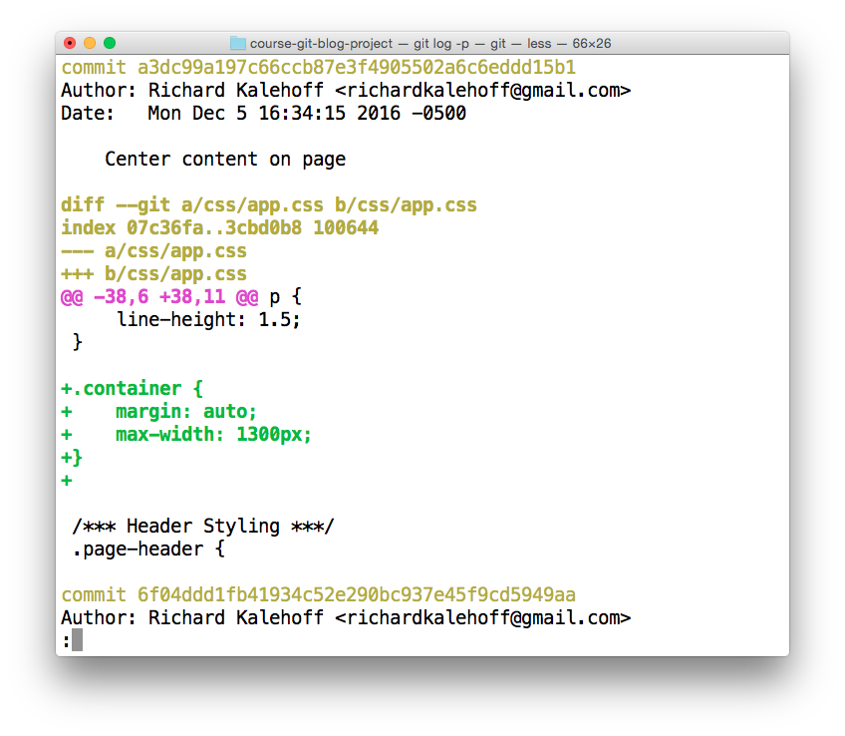](https://classroom.udacity.com/nanodegrees/nd104/parts/912d84b6-bf81-4311-8e00-b3b2f63dc965/modules/90163ae6-479b-42ef-a088-e5c5f4c10101/lessons/2607842d-e61d-49da-8125-16e6884ab656/concepts/dac0d8d4-e9a0-4b6e-bf65-f2d8e7a434c8)](https://classroom.udacity.com/nanodegrees/nd104/parts/912d84b6-bf81-4311-8e00-b3b2f63dc965/modules/90163ae6-479b-42ef-a088-e5c5f4c10101/lessons/2607842d-e61d-49da-8125-16e6884ab656/concepts/dac0d8d4-e9a0-4b6e-bf65-f2d8e7a434c8)

*[The Terminal application showing the output of the git log -p command. Note - the colors in your terminal might differ.](https://classroom.udacity.com/nanodegrees/nd104/parts/912d84b6-bf81-4311-8e00-b3b2f63dc965/modules/90163ae6-479b-42ef-a088-e5c5f4c10101/lessons/2607842d-e61d-49da-8125-16e6884ab656/concepts/dac0d8d4-e9a0-4b6e-bf65-f2d8e7a434c8)*

[[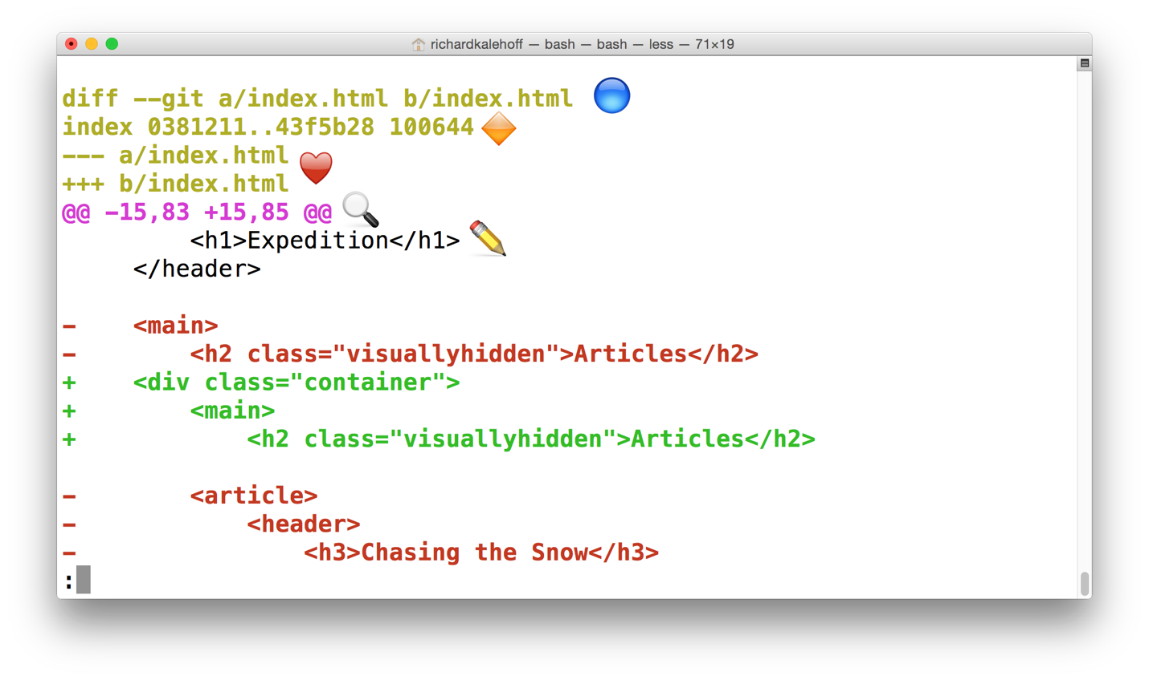](https://classroom.udacity.com/nanodegrees/nd104/parts/912d84b6-bf81-4311-8e00-b3b2f63dc965/modules/90163ae6-479b-42ef-a088-e5c5f4c10101/lessons/2607842d-e61d-49da-8125-16e6884ab656/concepts/dac0d8d4-e9a0-4b6e-bf65-f2d8e7a434c8)](https://classroom.udacity.com/nanodegrees/nd104/parts/912d84b6-bf81-4311-8e00-b3b2f63dc965/modules/90163ae6-479b-42ef-a088-e5c5f4c10101/lessons/2607842d-e61d-49da-8125-16e6884ab656/concepts/dac0d8d4-e9a0-4b6e-bf65-f2d8e7a434c8)

*[The Terminal application showing the output of the git log -p command. Check below for a detailed description of the output.](https://classroom.udacity.com/nanodegrees/nd104/parts/912d84b6-bf81-4311-8e00-b3b2f63dc965/modules/90163ae6-479b-42ef-a088-e5c5f4c10101/lessons/2607842d-e61d-49da-8125-16e6884ab656/concepts/dac0d8d4-e9a0-4b6e-bf65-f2d8e7a434c8)*

**[Annotated git log -p Output](https://classroom.udacity.com/nanodegrees/nd104/parts/912d84b6-bf81-4311-8e00-b3b2f63dc965/modules/90163ae6-479b-42ef-a088-e5c5f4c10101/lessons/2607842d-e61d-49da-8125-16e6884ab656/concepts/7e127ca9-7d0a-414d-ad30-708d60248a96)**

[Using the image above, let's do a quick recap of the git log -p output:](https://classroom.udacity.com/nanodegrees/nd104/parts/912d84b6-bf81-4311-8e00-b3b2f63dc965/modules/90163ae6-479b-42ef-a088-e5c5f4c10101/lessons/2607842d-e61d-49da-8125-16e6884ab656/concepts/7e127ca9-7d0a-414d-ad30-708d60248a96)

* [🔵 - the file that is being displayed](https://classroom.udacity.com/nanodegrees/nd104/parts/912d84b6-bf81-4311-8e00-b3b2f63dc965/modules/90163ae6-479b-42ef-a088-e5c5f4c10101/lessons/2607842d-e61d-49da-8125-16e6884ab656/concepts/7e127ca9-7d0a-414d-ad30-708d60248a96)
* [🔶 - the hash of the first version of the file and the hash of the second version of the file](https://classroom.udacity.com/nanodegrees/nd104/parts/912d84b6-bf81-4311-8e00-b3b2f63dc965/modules/90163ae6-479b-42ef-a088-e5c5f4c10101/lessons/2607842d-e61d-49da-8125-16e6884ab656/concepts/7e127ca9-7d0a-414d-ad30-708d60248a96)
  + [not usually important, so it's safe to ignore](https://classroom.udacity.com/nanodegrees/nd104/parts/912d84b6-bf81-4311-8e00-b3b2f63dc965/modules/90163ae6-479b-42ef-a088-e5c5f4c10101/lessons/2607842d-e61d-49da-8125-16e6884ab656/concepts/7e127ca9-7d0a-414d-ad30-708d60248a96)
* [❤️ - the old version and current version of the file](https://classroom.udacity.com/nanodegrees/nd104/parts/912d84b6-bf81-4311-8e00-b3b2f63dc965/modules/90163ae6-479b-42ef-a088-e5c5f4c10101/lessons/2607842d-e61d-49da-8125-16e6884ab656/concepts/7e127ca9-7d0a-414d-ad30-708d60248a96)
* [🔍 - the lines where the file is added and how many lines there are](https://classroom.udacity.com/nanodegrees/nd104/parts/912d84b6-bf81-4311-8e00-b3b2f63dc965/modules/90163ae6-479b-42ef-a088-e5c5f4c10101/lessons/2607842d-e61d-49da-8125-16e6884ab656/concepts/7e127ca9-7d0a-414d-ad30-708d60248a96)
  + [-15,83 indicates that the old version (represented by the -) started at line 15 and that the file had 83 lines](https://classroom.udacity.com/nanodegrees/nd104/parts/912d84b6-bf81-4311-8e00-b3b2f63dc965/modules/90163ae6-479b-42ef-a088-e5c5f4c10101/lessons/2607842d-e61d-49da-8125-16e6884ab656/concepts/7e127ca9-7d0a-414d-ad30-708d60248a96)
  + [+15,85 indicates that the current version (represented by the +) starts at line 15 and that there are now 85 lines...these 85 lines are shown in the patch below](https://classroom.udacity.com/nanodegrees/nd104/parts/912d84b6-bf81-4311-8e00-b3b2f63dc965/modules/90163ae6-479b-42ef-a088-e5c5f4c10101/lessons/2607842d-e61d-49da-8125-16e6884ab656/concepts/7e127ca9-7d0a-414d-ad30-708d60248a96)
* [✏️ - the actual changes made in the commit](https://classroom.udacity.com/nanodegrees/nd104/parts/912d84b6-bf81-4311-8e00-b3b2f63dc965/modules/90163ae6-479b-42ef-a088-e5c5f4c10101/lessons/2607842d-e61d-49da-8125-16e6884ab656/concepts/7e127ca9-7d0a-414d-ad30-708d60248a96)
  + [lines that are red and start with a minus (-) were in the original version of the file but have been removed by the commit](https://classroom.udacity.com/nanodegrees/nd104/parts/912d84b6-bf81-4311-8e00-b3b2f63dc965/modules/90163ae6-479b-42ef-a088-e5c5f4c10101/lessons/2607842d-e61d-49da-8125-16e6884ab656/concepts/7e127ca9-7d0a-414d-ad30-708d60248a96)
  + [lines that are green and start with a plus (+) are new lines that have been added in the commit](https://classroom.udacity.com/nanodegrees/nd104/parts/912d84b6-bf81-4311-8e00-b3b2f63dc965/modules/90163ae6-479b-42ef-a088-e5c5f4c10101/lessons/2607842d-e61d-49da-8125-16e6884ab656/concepts/7e127ca9-7d0a-414d-ad30-708d60248a96)

you can combine flags! git log -p --stat will display the stats info above the patch info. Actually, the order doesn't matter; git log --stat -p will also show the stats info above the patch info.

git log -p -w will show the patch information, but will not highlight lines where *only* whitespace changes have occurred.

you can supply the SHA of a commit as the final argument for all of these commands? For example:

$ git log -p fdf5493

By supplying a SHA, the git log -p command will *start at that commit*! No need to scroll through everything! Keep in mind that it will *also* show all of the commits that were made *prior* to the supplied SHA.

## New Command: git show

The other command that shows a specific commit is git show:

$ git show

Running it like the example above will only display the most recent commit. Typically, a SHA is provided as a final argument:

$ git show fdf5493

### What does git show do?

The git show command will show only one commit. So don't get alarmed when you can't find any other commits - it only shows one. The output of the git show command is exactly the same as the git log -p command. So by default, git show displays:

* the commit
* the author
* the date
* the commit message
* the patch information

However, git show can be combined with most of the other flags we've looked at:

* --stat - to show the how many files were changed and the number of lines that were added/removed
* -p or --patch - this the default, but if --stat is used, the patch won't display, so pass -p to add it again
* -w - to ignore changes to whitespace