Enhancing Rice Quality Assessment through Integrated Neural Networks: A Synergistic Approach with CNN and CAEs

Veera Prakash Pobbatti1, a) Megharshini Anke,Anees Fathima Shaik, Girivardhan Velupula, Anitha Myla2,3,4,5 b)

1Assistant Professor, Computer Science and Engineering, Srinivasa Ramanujan Institute of Technology, Anantapur, India.

2,3,4,5 Computer Science and Engineering, Srinivasa Ramanujan Institute of Technology

*a)*[*prakash.cse@srit.ac.in*](mailto:prakash.cse@srit.ac.in)*,*

*b)*[*204g1a0557@srit.ac.in*](mailto:204g1a0557@srit.ac.in)

*c)*[*204g1a0512@srit.ac.in*](mailto:204g1a0512@srit.ac.in)

*d)*[*204g1a0532@srit.ac.in*](mailto:204g1a0532@srit.ac.in)

*e)*[*214g5a0503@srit.ac.in*](mailto:214g5a0503@srit.ac.in)

**Abstract.** In the realm of food crops, rice stands as a pivotal staple, and ensuring high-quality rice is vital for consistent standards in the industry. Traditional methods for assessing rice quality lack precision, emphasizing the necessity for advanced techniques. The application of neural networks like MobileNet, specifically CNN (Convolutional Neural Networks), offers a promising solution to enhance accuracy and automation in classifying rice grain quality. Additionally, incorporating the feature learning capabilities of Convolutional Autoencoders (CAEs) further refines the identification of nuanced variations indicative of rice quality. Our goal is to establish a robust framework that not only surpasses the limitations of individual techniques but also delivers optimized and unparalleled outcomes in the task of determining rice quality. This integrated approach aims to revolutionize the evaluation process, ensuring a more accurate and efficient assessment of rice quality for the benefit of human health.

**Keywords:** Rice quality, Neural networks, CNN (Convolutional Neural Networks), MobileNet, Convolutional Autoencoders (CAEs), Accuracy, Automation, Classifying, Robust framework, Optimized outcomes.

# INTRODUCTION

In the landscape of food production, the significance of rice as a primary staple necessitates a keen focus on maintaining and enhancing its quality standards. The traditional methods employed for evaluating rice quality often fall short in terms of precision and efficiency, prompting the exploration of more advanced and nuanced approaches. In response to this, our project introduces a novel methodology that harnesses the capabilities of Convolutional Autoencoders (CAEs) and Convolutional Neural Networks (CNN) to detect and classify rice quality.

Pivotal role of CNN lies in its adeptness at object identification, specifically tailored to discern and classify various characteristics associated with rice grains. Simultaneously, the integration of Convolutional Autoencoders contributes to the project's depth by facilitating the extraction of intricate features and patterns relevant to rice quality. This combination of CNN and CAEs creates a robust and comprehensive framework for the precise identification of subtle variations in rice quality.

Our project seeks not only to address the shortcomings of conventional methods but also to set a new standard for accuracy and efficiency in rice quality assessment. By capitalizing on the synergies between CAEs and CNN, MobileNet model we aim to surpass the limitations of individual techniques, offering a sophisticated and automated solution for the rice industry. This endeavor aligns with our broader goal of ensuring the consistency of high-quality rice products, thereby contributing to improved standards in the food sector and, ultimately, to the well-being of consumers.

# LITERATURE SURVEY

Researchers dedicated their efforts to assessing the quality of rice grains.

Thae Nu Wah, Pann Ei San, Thandar Hlaing [1]. This research proposes an image processing system for rice grading and tests its effectiveness using Paw-San rice. KNN classifier is used for classification. This work uses the global thresholding method for image segmentation.

S. Wentao [2]. In this study, Deep learning has been used in speech recognition, image search, image recognition. In the wheat particle database, this model is used by deep learning (DL) models like autoencoders to categorize and identify photos of damaged wheat.

Wang, R., Jiang, Y., & Cao, F [3]. The paper introduces a deep learning approach aimed at identifying and categorizing rice seeds according to their visual characteristics. The study aims to mitigate the limitations associated with manual, subjective, and error-prone traditional techniques of rice seed identification. Automatic rice seed classification based on variety and quality is the goal of the suggested deep learning technique. A dataset of 8,000 photographs of rice seeds from various types was gathered by the authors, who then manually labeled each image with the variety and quality level that it matched.

N. Hong Son and N. Thai-Nghe [4]. In this work, image processing methods and machine learning approaches were used to identify two types of rice: whole rice and broken rice. CNN achieved 94.16% accuracy and KNN achieved 85.06% accuracy.

Gao, Y., Wang, W., Zhang, W., & Gao, X [5]. This presents an automated inspection system for rice seed quality based on deep learning techniques. The study seeks to overcome the constraints associated with conventional rice seed quality inspection methods, which are characterized by being time-consuming, labor-intensive, and subjective in nature. The proposed system employs deep learning algorithms to autonomously classify rice seeds according to their visual features. The authors curated a dataset comprising 18,000 rice seed images sourced from various varieties and meticulously annotated them with their respective quality levels.

Latha, M. N., & Nandhini, R [6]. In this section, the significance of rice quality analysis within the food industry is addressed, along with the drawbacks of conventional approaches. This is followed by a summary of deep learning methods, including convolutional neural networks (CNNs), recurrent neural networks (RNNs), and deep belief networks (DBNs), and how each is used in applications related to rice quality assessments.

T. G. Devi, P. Neelamegam and S. Sudha [7]. In this study, the algorithm utilized straightforward morphological image processing methods, enabling it to conduct various image-based analyses. The majority of operations employed in this algorithm are founded on MATLAB commands. This algorithm is well-suited for efficiently grading many grains, and its results were compared with manual grading methods. The comparison showed that the algorithm achieved a percentage of accuracy equal to or greater than that of manual grading.

Annadasu, P. and Jaisharma, K [8]. In this work, it is applied to create a useful model that facilitates rice grain grading without requiring more effort. Segmentation is achieved through various techniques such as threshold-based segmentation and segmentation by clustering. Based on the results obtained, it can be concluded that this system is efficient and cost-effective.

Md Taimur Ahad, Yan Li, Bo Song, Touhid Bhuiyan [9]. This study concentrates on comparing performance of different convolutional neural network (CNN) architectures for detecting and pinpointing rice diseases. With the help of a database that included nine of the most common rice diseases in Bangladesh, the researchers compared 6 CNN-based deep learning architectures for studying rice diseases. They evaluated the performance of the six distinct CNN networks, transfer learning, and ensemble approaches using DenseNet121, MobileNetV2, ResNet152V, Seresnext101, and an ensemble model called DEX. When comparing the accuracy of rice leaf disease detection and localization with Seresnext101's results, transfer learning produced a significant increase, increasing accuracy by 17%.

Islam, Redoun Islam, S. M. Rafizul Haque, S.M. Mohidul Islam, Mohammad Ashik Iqbal Khan [10]. The approach employs local threshold-based segmentation combined with Convolutional Neural Network (CNN) to segment regions of rice leaves affected by disease. 3 different datasets have been used to test the suggested method; one of the datasets was developed by the authors and includes photographs of rice leaves collected from the Bangladesh Rice Research Institute (BRRI). These datasets were used to train three popular CNN architectures ResNet, VGG, and DenseNet to classify the disorders. The proposed methods classification performance has been evaluated and compared across three datasets, utilizing three CNN architectures for contrast.

Patel, Vaibhav [11]. In order to decrease manual effort and mistake, this research suggests a deep learning-based method for detecting different types of rice. Two approaches are suggested: the first makes use of a deep convolutional neural network (CNN) trained on segmented rice images, while the second combines the suggested approach with a pre-trained VGG16 network in order to improve accuracy. Additionally, the method can categorize rice grains as fine or broken. Despite diverse rice photos, the architecture considerably increases classification accuracy, having been pretrained on ImageNet data.

Jana, Debasish & Patil, Jayant & Herkal, Sudheendra & Nagarajaiah, Satish & Dueñas-Osorio, Leonardo [12]. To detect, classify, and reconstruct faults in sensor data, in order to address linear systems with time-invariant parameters, the study presents a novel deep learning algorithm. Within this framework, a Convolutional Neural Network (CNN) is employed to discern fault type and existence. For reconstruction purposes, a set of Convolutional Autoencoder (CAE) networks, separately trained for each fault type, is utilized. The models exhibited robust performance across both simulated and experimental datasets featuring a single failure. They achieved perfect accuracy in localizing faulty sensors, with fault type classification accuracy exceeding 98.7%, and reconstruction accuracy surpassing 98%.

Hongbin, et al [13]. Convolutional Denoising Autoencoders (CDAEs), when integrated with Convolutional Neural Network (CNN) models for automatic feature extraction and parameter optimization, have the potential to outperform traditional approaches. To eliminate surface contaminants and non-rice grains, the rice grains underwent a preliminary soaking in water for thirty minutes. Furthermore, the CNN model, a successful deep learning technique for feature extraction, was extensively utilized to effectively extract information from THz spectrum data. To further mitigate noise and enhance THz spectrum data, a CDAE, in conjunction with AE and CNN, was developed. Mean Square Error (MSE) served as the loss function to evaluate the performance of the CDAE in reconstructing the THz spectrum.

Bedi, Punam, and Pushkar Gole [14]. Due to their superior performance on image data, two Deep Learning techniques that are frequently used in computer vision applications are Convolutional Neural Networks (CNNs) and Convolutional Autoencoders (CAEs). The two methods extract different temporal and spatial elements from image data by using the convolution procedure. CNNs are utilized for input image classification into their appropriate classes, whereas CAEs are employed for effectively reducing an image's dimensionality. This study presents a novel hybrid model that combines convolutional neural networks (CNN) with convolutional autoencoders (CAE) to diagnose plant diseases automatically. In comparison to current state-of-the-art methods described in the literature, a unique hybrid model that uses less training parameters has been designed to automatically detect plant ailments. Two deep learning methods are used by this model: CNN and CAE.

Qiu, Zhengjun [15]. Four types of rice seeds were captured using hyperspectral imaging at 2 separate spectral bands: one spanning from 380 to 1030 nm and another from 874 to 1734 nm. The spectral data were obtained within two distinct ranges: the first range spanning from 441 to 948 nm (referred to as Spectral range 1), and the second range covering from 975 to 1646 nm (referred to as Spectral range 2). Different numbers of training samples were used to build CNN, SVM, and K nearest neighbours (KNN) models. The models utilizing Spectral range 2, including KNN, SVM, and CNN, demonstrated slightly superior performance compared to those utilizing Spectral range 1. They modified the VGGNet architecture to handle inputs of one-dimensional spectra. Spectral curve patterns and picture patterns are similar in a few ways. VGGNet's modular design facilitates easy modification and extension, and it is chosen because to its outstanding performance in image classification tasks. The model's functionality increased.

Wu, Yiqiang, et al [16]. Deep Rice is based on a deep learning architecture. To provide further detail, Deep-Rice employs a multi-view CNN architecture to extract discriminative features from multiple rice image views. It then utilizes a modified softmax loss function to optimize the CNN parameters effectively. In conjunction with this deep learning model, we created a comprehensive rice dataset called FIST-Rice, aiming to serve as a fundamental resource for food security research. Each sample in the dataset is photographed under three different lighting conditions. Using the FIST-Rice dataset, we conducted a comparative analysis between the proposed Deep-Rice model and traditional techniques such as AdaBoost and SVM. The outcomes of the experiment suggest that the Deep-Rice model performs better under various light intensity settings. Using a modified softmax, the deep network may learn angularly discriminative features.

Rathore, Narendra Pal Singh, and Lalji Prasad [17]. Computer-aided methods are used to process results from disease detection quickly and accurately. Convolutional neural networks (CNNs), which automatically extract characteristics and classify images using fully linked networks, are used by the deep learning models. We have classified images using CNN architecture. We are utilizing input photos with the labels "healthy" and "leaf_blast" from the Kaggle dataset. In this study, 1000 samples of rice crops were used to train CNN using an RGB color model. The suggested architectural design for differentiating between leaf-blast and healthy rice crops. OpenCV, Numpy, and Keras are the deep learning packages used in the Python development of this model. We employed a batch size of 32, which is a hyper-parameter in deep learning that may be changed.

Tran-Thi-Kim, Nga, et al [18]. This study employs (CNN) Convolutional Neural Network and (ANN) Artificial Neural Network models and classify 17 types of rice grains commonly cultivated in Vietnam. Pre-trained VGG16 and Resnet50 models serve as the foundation for the two CNN models-modified VGG16 and modified ResNet50. The CNN models were fed the image dataset, while the ANN was fed the feature dataset. The findings demonstrate that the classification accuracy of the 17 types of rice was considerably increased by the updated VGG16 and ResNet50 models. The findings demonstrated that, in comparison to the SVM, the classification accuracy of a CNN model was much higher. Using the feature dataset as a model, the ANN produced a 92.82% classification accuracy.

Murat Koklu, Ilkay Cinar, Yavuz Selim Taspinar [19]. Rice stands as one of the most extensively cultivated grain crops globally, boasting a diverse array of genetic varieties. These variants exhibit distinctions primarily in attributes such as colour, size, and shape. These distinctive characteristics among rice varieties can be utilized for classifying and assessing seed quality. In Turkey, five types of rice are commonly cultivated: Arborio, Basmati, Ipsala, Jasmine, and Karacadag. In this investigation, these types were used. Of the 75,000 grain pictures in the dataset, 15,000 come from each of these categories. Another dataset comprising 106 features was utilized alongside these images, encompassing 12 morphological, 4 shape-related, and 90 color features. Models were constructed using Artificial Neural Networks (ANNs).

# PROPOSED SYSTEM

In this project, we propose a novel approach that combines Convolutional Neural Networks (CNN) and Autoencoders to address the task of rice quality detection. We propose an innovative system that integrates Convolutional Neural Networks (CNN), MobileNet, and Autoencoders to optimize rice quality detection. The proposed system leverages the fusion of CNN, MobileNet, and Convolutional Autoencoder (CAE) methodologies. The CAE, implemented using TensorFlow or PyTorch, efficiently reconstructs rice images for feature extraction. Subsequently, the MobileNet and CNN models are employed for accurate image classification, capitalizing on MobileNet's lightweight architecture for efficiency. This combined approach, excluding CNN, showcases innovation by streamlining the feature extraction and classification processes. This novel combination of Convolutional Autoencoder (CAE), Convolutional Neural Network (CNN), and MobileNet is intended to increase the precision and efficacy of rice quality assessment. It presents opportunities for real-world application in the food sector, particularly in activities related to quality assurance and control.

# MATERIAL AND METHODOLOGY

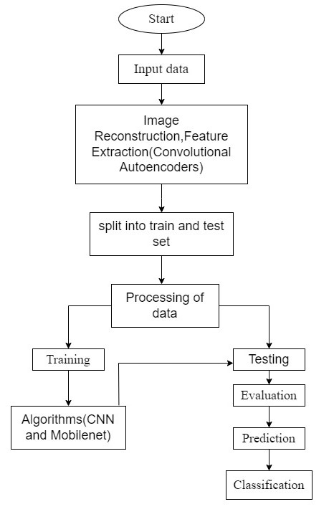

FIGURE 1: Block diagram for suggested approach

## Methodology Overview

### Image Acquisition

In convolutional autoencoders, image acquisition involves obtaining high-resolution, diverse datasets that undergo preprocessing for normalization and augmentation. The dataset composition, noise handling, and compatibility with convolutional layers are critical considerations to ensure effective feature learning and model performance.

### Loading Rice Images Dataset

Loading the Rice Images Dataset involves retrieving a collection of images representing various aspects of rice grains. Researchers typically employ data loading techniques using programming languages like Python and libraries such as TensorFlow or PyTorch. This dataset is essential for training and evaluating machine learning models, especially those designed for tasks such as quality assessment or classification in the context of rice grain analysis.

### Preprocessing

Preprocessing is a crucial step in data preparation for machine learning tasks. It involves techniques such as normalization, data augmentation, and handling missing values to enhance the quality and consistency of the dataset. These preprocessing methods contribute to improved model performance by mitigating noise, ensuring uniformity, and facilitating better generalization during training.

### Image Reconstruction

In CAEs, image reconstruction involves encoding input images into a latent representation and then decoding them back into reconstructed images. The objective is to minimize the reconstruction error, ensuring that the decoded images closely match the original input, thus capturing meaningful features in the process.

* **Encoder:** In image reconstruction using CAEs, the encoder is responsible for transforming input images into a compressed latent representation. This encoded representation contains essential features extracted from the input, facilitating efficient storage and subsequent reconstruction during the decoding phase. The encoder's role is crucial in capturing meaningful information for faithful image representation.
* **Decoder:** In image reconstruction using autoencoders, the decoder reconstructs images from their compressed latent representations, restoring them to a format similar to the input. The decoder plays a crucial role in generating faithful reconstructions by translating the learned features from the latent space back into the original data space.

## Feature Extraction

### Size

The size of feature extraction is a critical factor influencing model performance and computational efficiency in machine learning.

### L/B Ratio

The aspect ratio (l/b ratio) in feature extraction affects the balance between capturing long-range and short-range patterns, influencing the model's ability to learn diverse spatial information.

### Color

The mean color in feature extraction provides a representative measure of the average color values of RGB in an image, contributing to color-based information analysis in machine learning tasks.

### Chalkiness

Chalkiness in feature extraction refers to the degree of lightness or whiteness, often utilized in image analysis to characterize texture or material properties with applications in fields like agriculture or food processing.

Total number of pixels

Chalkiness = ------------------------------------------- ×100

Number of pixels in chalky range

### Whiteness

Whiteness in feature extraction represents the level of lightness or brightness in an image, often quantified through metrics such as luminance or color intensity, crucial for various applications like image analysis and quality assessment.

**TABLE 1.** Characteristics of reconstructed images

|  |  |  |  |  |  |
| --- | --- | --- | --- | --- | --- |
| **S. No** | **Size** | **Shape(L/B ratio)** | **Chalkiness** | **Whiteness** | **Mean color (BGR)** |
| 1 | 1790.5 | 1.942 | 0.091 | 24.79 | (25.4,24.7,24.7) |
| 2 | 1685.5 | 0.666 | 0.079 | 24.79 | (23.2,22.5,22.6) |
| 3 | 2025.0 | 0.796 | 0.122 | 29.24 | (29.9,29.1,29.1) |
| 4 | 1870.0 | 1.169 | 0.095 | 25.99 | (26.8,25.9,25.8) |
| 5 | 1872.5 | 1.037 | 0.052 | 23.54 | (24.0,23.5,23.4) |
| 6 | 1579.0 | 0.767 | 0.076 | 22.20 | (22.4,22.1,22.1) |
| 7 | 1509.5 | 1.875 | 0.075 | 21.05 | (21.1,21.1,21.1) |
| 8 | 1703.5 | 1.340 | 0.060 | 21.86 | (22.2,21.7,21.8) |
| 9 | 1943.9 | 0.057 | 0.075 | 25.77 | (26.4,25.6,25.7) |
| 10 | 1760.0 | 0.730 | 0.087 | 24.95 | (25.5,24.8,24.9) |
| 11 | 1748.5 | 0.646 | 0.090 | 24.48 | (24.4,24.4,24.4) |
| 12 | 2082.5 | 1.850 | 0.102 | 33.66 | (33.6,33.6,33.6) |
| 13 | 1855.0 | 1.131 | 0.051 | 24.06 | (24.0,24.0,24.0) |
| 14 | 2027.0 | 1.055 | 0.057 | 25.97 | (27.0,26.9,26.9) |
| 15 | 1783.0 | 1.842 | 0.061 | 24.02 | (24.4,23.9,24.2) |

Training and Testing datasets were created from the data after the reconstructed images were gathered and features were retrieved using convolutional Autoencoders. Convolutional Neural Networks (CNN) and MobileNet are the algorithms we utilized to train the model. For training and testing sets, arrange image data into the proper directories. Here, we utilized an unlabeled dataset consisting of 75,000 images divided into five varieties: Arborio, Basmati, Jasmine, Ipsala and Karacadag. Each rice variety comprises 15,000 images, and the dataset has been split into three classes - High, Low and Medium - for each variety. These classes are divided based on the features that were extracted from the CAEs. For the training and testing datasets, the data is also divided into three classes.

The following libraries are imported to create the model: NumPy, Pandas, Matplotlib, OpenCV, TensorFlow, Scikit-learn. ImageDataGenerator is a class provided by the TensorFlow Keras library for real-time data augmentation during model training. Several layer classes were imported from the TensorFlow Keras package. These layers are the basic components that make up neural network architectures: Dense, Dropout, Flatten, Conv2D, MaxPool2D, AveragePooling2D, BatchNormalization.

When loading and preprocessing your image data, you would typically ensure that all images are resized to these specified dimensions before being fed into the neural network for training. The dimensions of image height and width are critical as they dictate the size of the input tensor expected by the neural network. These values are typically selected based on the characteristics of the dataset and the specifications of the neural network architecture.

we employed a Sequential model as the foundational architecture for our neural network implementation. The Sequential model, a component of the TensorFlow Keras library, facilitated the structured and sequential assembly of various layers, allowing for the creation of a comprehensive neural network for our specific task. This approach provides a linear stack of layers, simplifying the representation of our model's architecture.

This architecture involves hyper parameters, plays a crucial role in shaping the behavior and expressive power of the convolutional layer. Choosing appropriate values for these parameters depends on the nature of the data, the complexity of the patterns to be learned, and the overall architecture of the neural network. Some of the hyper parameters are:

### Conv2D Layer

The Conv2D layer is a fundamental building block in a convolutional neural network (CNN). It performs a 2D convolution on the input data, which is particularly well-suited for image processing tasks.

### Filters

The parameter "filters" determines the number of filters, also referred to as kernels, that the layer will acquire. Each filter is responsible for identifying distinct patterns or features within the input data.

### Kernel Size

The parameter "kernel size" dictates the dimensions of the convolutional window or filter.

### Activation Function

The "activation" parameter defines the activation function applied elementwise to the output resulting from the convolution operation.

When building and training a neural network, tuning these hyper parameters often involves experimentation and iterative refinement to achieve optimal performance on the specific task at hand. Epochs denote the count of times the entire training dataset is iteratively processed by the model during the training phase. A single iteration through the complete training dataset is referred to as an epoch.

Adapt the epochs in accordance with the model, as taking too few or too many epochs results in either overfitting or underfitting.

In a neural network model, the optimizer is a mathematical algorithm that adjusts the weights and biases during training to minimize the chosen loss function, guiding the model towards better performance. During training, specific metrics are designated to assess the model's classification capabilities. These metrics include Accuracy, Precision, and Recall.

# EXPERIMENTS AND RESULTS

Graphs that show the difference between the original and reconstructed pictures using MAE, MSE, PSNR, and SSIM.

### MAE

One statistic used to quantify the average size of deviations between expected and actual values is mean absolute error (MAE). By averaging the absolute disparities between the true and anticipated values, it is calculated. MAE offers a straightforward assessment of the average error magnitude, rendering it especially valuable in regression and prediction endeavours.

### MSE

A popular metric for evaluating the average squared difference between comparable elements of two sets, such as projected and actual values, is mean squared error, or MSE. It is computed by averaging the squared differences between predicted and true values. MSE offers a measure of the average magnitude of errors, where higher values indicate greater overall error in prediction or reconstruction tasks.

### PSNR

A typical metric used in image and video compression is the Peak Signal-to-Noise Ratio (PSNR), which measures the quality of reconstructed signals. It will be calculated in Decibels. It calculates the ratio of the mean squared error of the original and reconstructed signals to the highest feasible signal value. Greater faithfulness and less distortion in the reconstruction are indicated by a higher PSNR.

### SSIM

A metric for comparing two images similarity is called the Structural Similarity Index (SSIM).It takes into account luminance, contrast, and structure, providing a more comprehensive measure of perceptual image quality than some traditional metrics. A higher SSIM value indicates greater similarity between the original and distorted images, with 1 representing perfect similarity.

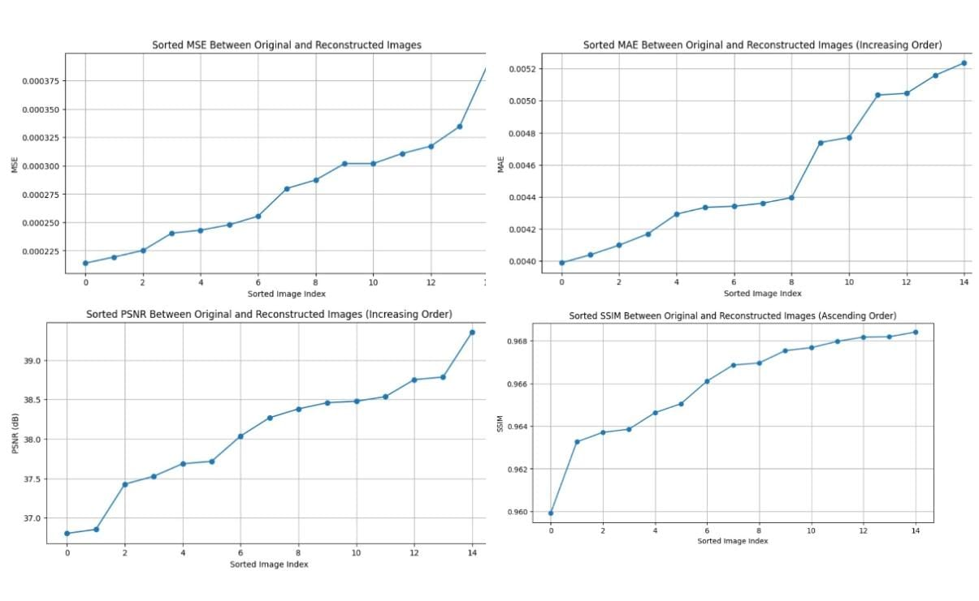

FIGURE 2: Difference between original and reconstructed images

## CNN and MobileNet Graphs

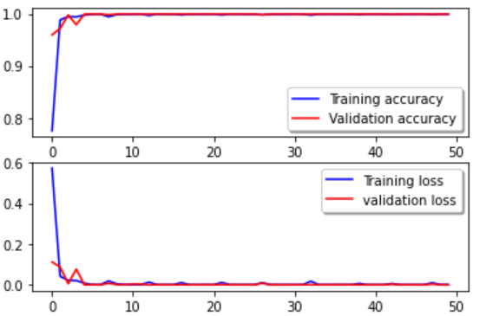 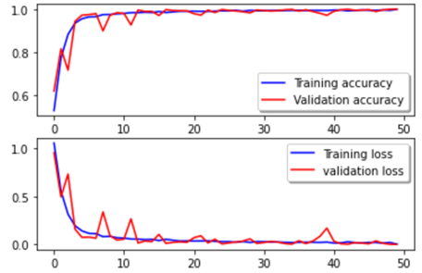

FIGURE 3: Testing accuracy for CNN FIGURE 4: Testing accuracy for MobileNet

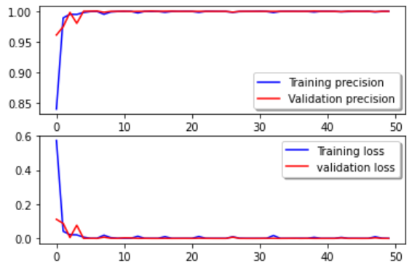 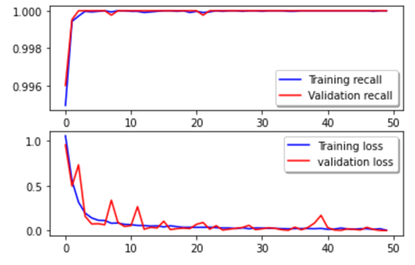

FIGURE 5: Testing precision for CNN FIGURE 6: Testing precision foe MobileNet

 

FIGURE 7: Testing recall for CNN FIGURE 8: Testing recall for MobileNet

In terms of testing and training accuracy, the suggested CNN model achieved 99.89% and 99.92%, respectively, with testing and training losses of 0.02% and 0.03%. Furthermore, 99.46% precision and 98.85% recall were attained by the model.

Training and testing losses for the suggested MobileNet model are 0.40% and 0.51%, respectively. Training accuracy is 88.27%, and testing accuracy is 85.06%. It has also achieved 86.45% accuracy and 84.57% recall rate.

From the two models CNN and MobileNet we have highest accuracy, precision and recall for CNN Model.

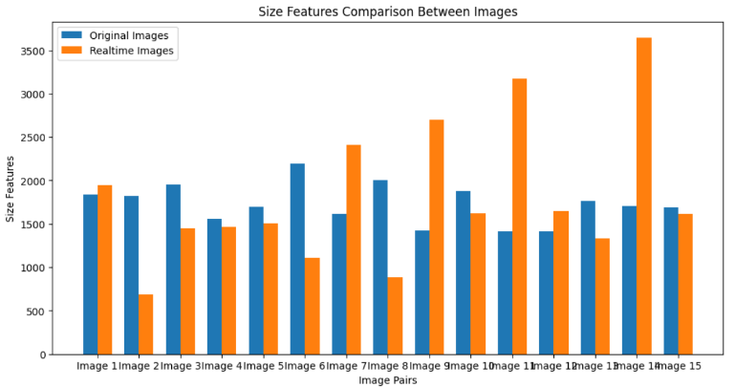

FIGURE 9: Comparison of size feature between original and real - time images

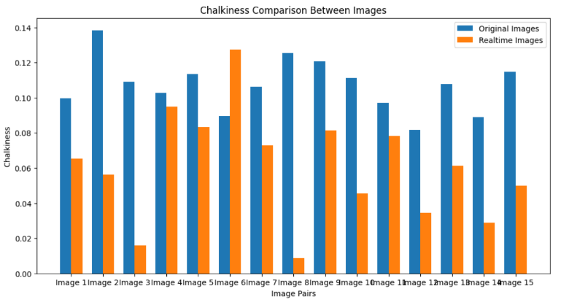

FIGURE 10: Comparison of chalkiness feature between original and real - time images

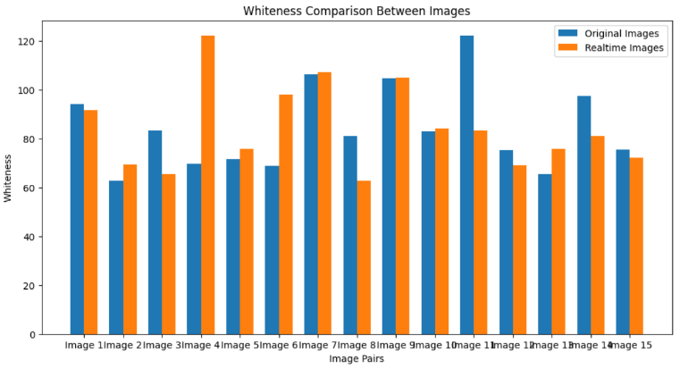

FIGURE 11: Comparison of whiteness feature between original and real - time images

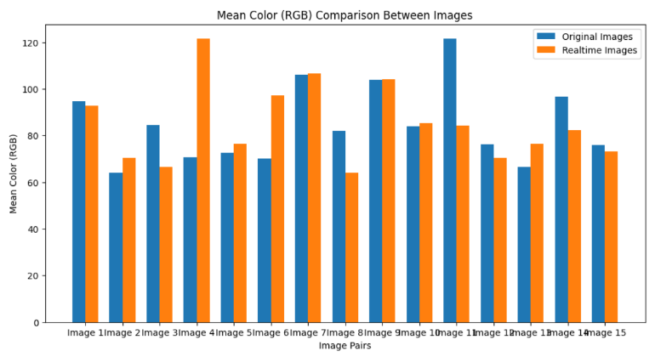

FIGURE 12. Comparison of mean color feature between original and real - time images

From the above graphs the given rice grains are divided into three classes High, Low, Medium based on the features of the images.

The application of deep learning techniques, including convolutional neural networks (CNN), DenseNet, and MobileNet, has demonstrated promising outcomes in the evaluation of rice quality. These methods have been employed to detect and categorize various parameters such as chalkiness, size, and shape, which are pivotal in assessing rice quality. Utilizing deep learning for rice quality analysis presents several advantages over traditional methods, including heightened accuracy, expedited analysis, and the capability to assess numerous samples concurrently. This can be particularly advantageous for rice breeding programs, where the assessment of a large volume of rice samples is essential for identifying desirable traits.

# CONCLUSION

In culmination, our project's fusion of Sequential Convolutional Neural Networks (CNN) and Convolutional Autoencoders (CAEs) signifies a breakthrough in precision for rice grain quality assessment. By harmonizing CNN's adept object identification with CAEs' feature learning, the resulting framework exceeds the limitations of conventional methods. The model's fine-tuning, coupled with data augmentation, ensures robust adaptability and generalization, validated by impressive evaluation metrics.

As we deploy this cutting-edge technology into practical applications, it not only addresses existing challenges but also pioneers a new era of automated and elevated rice quality standards, crucial for global food security. This success is a testament to the collaborative efforts of neural network researchers, showcasing the impactful role of machine learning in revolutionizing the production and quality control of vital food crops like rice, ensuring both agricultural sustainability and consumer well-being.

# FUTURE SCOPE

Future enhancements to our integrated neural network approach for rice quality assessment could involve the incorporation of advanced sensor technologies and real-time data collection during the rice cultivation and processing stages. Implementing a more dynamic system that adapts to changing environmental conditions and crop variations could further improve the model's accuracy and robustness. Furthermore, investigating the incorporation of explainable AI techniques can improve the model's decision-making interpretability, offering stakeholders insightful information. Continuous updates to the dataset and model architecture will ensure adaptability to emerging rice varieties and quality parameters.

# Acknowledgments

We extend our sincere gratitude to the contributors and collaborators involved in the development of this project aimed at enhancing rice quality assessment. Special thanks are extended to the teams and researchers who pioneered the utilization of neural networks, particularly Convolutional Neural Networks (CNNs) and Convolutional Autoencoders (CAEs), in the realm of food crop evaluation. Their innovative work forms the foundation of our approach, allowing us to leverage the power of machine learning for more accurate and efficient rice grain quality classification. This project would not have been possible without the collective efforts and expertise of those dedicated to advancing technology in agriculture and food industry applications.

# References

1. Thae Nu Wah, Pann Ei San, Thandar Hlaing (2018); [*Analysis on Feature Extraction and Classification of Rice Kernels for Myanmar Rice Using Image Processing Techniques*](10.29322/IJSRP.8.8.2018.p8078); International Journal of Scientific and Research Publications (IJSRP) 8(8) (ISSN: 2250-3153).
2. S. Wentao, [*Classification Model of Wheat Grain based on Autoencoder*](10.1109/ICAICA50127.2020.9181940) 2020 IEEE International Conference on Artificial Intelligence and Computer Applications (ICAICA), Dalian, China, 2020, pp. 830-832
3. Wang, R., Jiang, Y., & Cao, F. (2019). [*Identification and classification of rice seeds using deep convolutional neural networks*](10.1016/j.neucom.2017.06.023). Journal of Food Engineering, 263, 92-101.
4. N. Hong Son and N. Thai-Nghe, [*Deep Learning for Rice Quality Classification*](10.1109/ACOMP.2019.00021), 2019 International Conference on Advanced Computing and Applications (ACOMP), Nha Trang, Vietnam, 2019, pp. 92-96.
5. Gao, Y., Wang, W., Zhang, W., & Gao, X. (2020). [*An automated inspection system for rice seed quality based on deep learning*](An%20automated%20inspection%20system%20for%20rice%20seed%20quality%20based%20on%20deep%20learning). Journal of Food Process Engineering, 43(6), e13396.
6. Latha, M. N., & Nandhini, R. (2020). [*Rice quality analysis using deep learning techniques: A review*](https://doi.org/10.55248/gengpi.234.4.38229). Computers and Electronics in Agriculture, 174, 105404.
7. T. G. Devi, P. Neelamegam and S. Sudha, [*Machine vision based quality analysis of rice grains*](978-1-5386-0814-2/17) 2017 IEEE International Conference on Power, Control, Signals and Instrumentation Engineering (ICPCSI), Chennai, India, 2017, pp. 1052-1055.
8. Annadasu, P. and Jaisharma, K., 2020. [*Rice Quality Analysis Using Machine Learning*](https://easychair.org/publications/preprint/ZvXV) (No. 4761). EasyChair.
9. Md Taimur Ahad, Yan Li, Bo Song, Touhid Bhuiyan, [*Comparison of CNN-based deep learning architectures for rice diseases classification*](10.1016/j.aiia.2023.07.001), Artificial Intelligence in Agriculture,Volume 9,2023, ISSN 2589-7217.
10. Islam, Redoun Islam, S. M. Rafizul Haque, S.M. Mohidul Islam, Mohammad Ashik Iqbal Khan, [*Rice Leaf Disease Recognition using Local Threshold Based Segmentation and Deep CNN*](10.5815/ijisa.2021.05.04), International Journal of Intelligent Systems and Applications(IJISA), Vol.13, No.5, pp.35-45, 2021.
11. Patel, Vaibhav. (2017). [*Convolutional neural network with transfer learning for rice type classification*](10.1117/12.2309482).
12. Jana, Debasish & Patil, Jayant & Herkal, Sudheendra & Nagarajaiah, Satish & Dueñas-Osorio, Leonardo. (2022). [*CNN and Convolutional Autoencoder (CAE) based real-time sensor fault detection, localization, and correction*](https://www.sciencedirect.com/science/article/pii/S0888327021010414)*.* Mechanical Systems and Signal Processing. 169. 108723.
13. Hongbin, et al. [*Terahertz spectra reconstructed using convolutional denoising autoencoder for identification of rice grains infested with Sitophilus oryzae at different growth stages*](10.1016/j.saa.2024.124015). Spectrochimica Acta Part A: Molecular and Biomolecular Spectroscopy (2024): 124015.
14. Bedi, Punam, and Pushkar Gole. [*Plant disease detection using hybrid model based on convolutional autoencoder and convolutional neural network*](10.1016/j.aiia.2021.05.002). Artificial Intelligence in Agriculture 5 (2021): 90-101.
15. Qiu, Zhengjun, et al. [*Variety identification of single rice seed using hyperspectral imaging combined with convolutional neural network*](10.3390/app8020212). Applied Sciences 8.2 (2018): 212.
16. Wu, Yiqiang, et al. [*Deep-rice: Deep multi-sensor image recognition for grading rice*](978-1-5386-8069-8/18/). 2018 IEEE International Conference on Information and Automation (ICIA). IEEE, 2018.
17. Prakash, P. V. ., & Srivenkatesh, M. . (2024). [*Hybrid Deep Learning Algorithms for Predicting Nutrient Deficiencies in Paddy Crops using CNN and Super Resolution Generative Adversarial Neural Networks*](https://ijisae.org/index.php/IJISAE/article/view/4879). International Journal of Intelligent Systems and Applications in Engineering, 12(16s), 520–526.
18. Tran-Thi-Kim, Nga, et al. [*Enhancing the Classification Accuracy of Rice Varieties by Using Convolutional Neural Networks*](10.18178/ijeetc.12.2.150-160). International Journal of Electrical and Electronic Engineering & Telecommunications 12.2 (2023): 150-160.
19. Murat Koklu, Ilkay Cinar, Yavuz Selim Taspinar, [*Classification of rice varieties with deep learning methods*](10.1016/j.compag.2021.106285),Computers and Electronics in Agriculture.