**MACHINE LEARNING-BASED ANALYSIS OF CRYPTO CURRENCY MARKET FINANCIAL RISK MANAGEMENT**

**OBJECTIVE**

The main objective of this research is to classify machine learning-based analysis of crypto currency market financial risk management. Here we are going to predict whether it is Risk-found or Risk - not Found.

**ABSTRACT**

Crypto currency is a well-known financial state in the globe, posing a variety of dangers that have an impact on the intrinsic risk assessment of risk auditors. Since its inception, the rise of crypto currencies has presented financial institutions with a wide range of risks in terms of money laundering. In the institution of financial supports such as anti-money laundering, banks, and bank secrecy, continue as a risk specialist, bank manager, and compliance officer who has a provocation for the connected transaction through crypto currencies and the users who conceal the illicit funds. In this study, the crypto currency framework was subjected to Hierarchical Risk Parity and unsupervised machine learning. The professional accounting procedure in terms of the inherent risk associated with bit-coin. The professional crypto currency experience in transaction cause the lower risk comparing the less experienced one. The Hierarchical Risk Parity gives the better output in term of returning the adjusted risk tail to get the better risk management result. The result section shows the proposed model is robust to various intervals which are re-balanced and the co-variance window estimation.

**Keywords**: Machine Learning, Decision tree, Random Forest, MLP Classifier, Adaboost, Extra tree Classifier, ML techniques.

**EXISTING SYSTEM**

In the existing system, implementation of machine learning algorithms is bit complex to build due to the lack of information about the data visualization. The RL was compared to existing research works and the most frequent benchmarks in this area, the two management portfolio algorithms and the basic DQN of the trading system. In terms of bit-coin risk management, the proposed RL algorithms are compared to other existing studies. To overcome all this, we use machine learning packages available in the scikit-learn library.

**Disadvantages:**

* High complexity.
* Time consuming.

**PROPOSED SYSTEM**

Proposed several machine learning models to classify machine learning-based analysis of crypto currency market financial risk management. Also, similar studies that have proposed models for evaluation of such performance .Therefore, we propose a Decision tree, Random Forest, MLP Classifier, Ada boost , Extra tree Classifier to predict the risks.

**Advantages**:

* Highest accuracy
* Reduces time complexity.
* Easy to use

**PROPOSED METHOD**

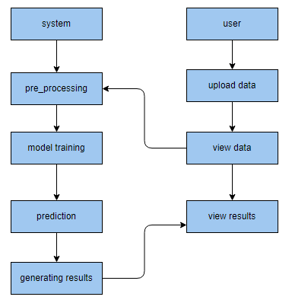

**HARDWARE AND SOFTWARE REQUIREMENTS**

**H/W Configuration:**

Operating system : Windows 7 or 7+

RAM : 8 GB

Hard disc or SSD : More than 500 GB

Processor : Intel 3rd generation or high or Ryzen with 8 GB Ram

**S/W Configuration:**

Software’s : Python 3.6 or high version

IDE : PyCharm.

Framework : Flask, pandas, numpy and Scikit-Learn