**OUTPUT SCREEN SHOTS WITH DESCRIPTION.**

**Home Page:**

Here user view the home page of web application.



**Fig1**: Home Page

**Register:**

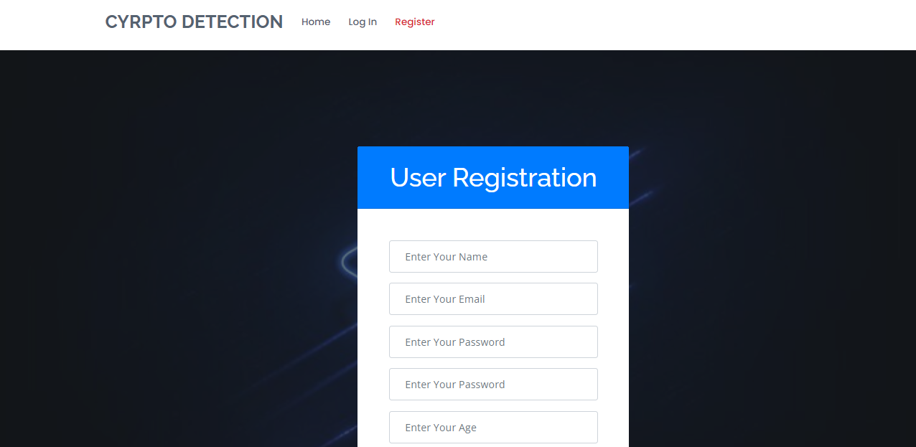

**Login:**

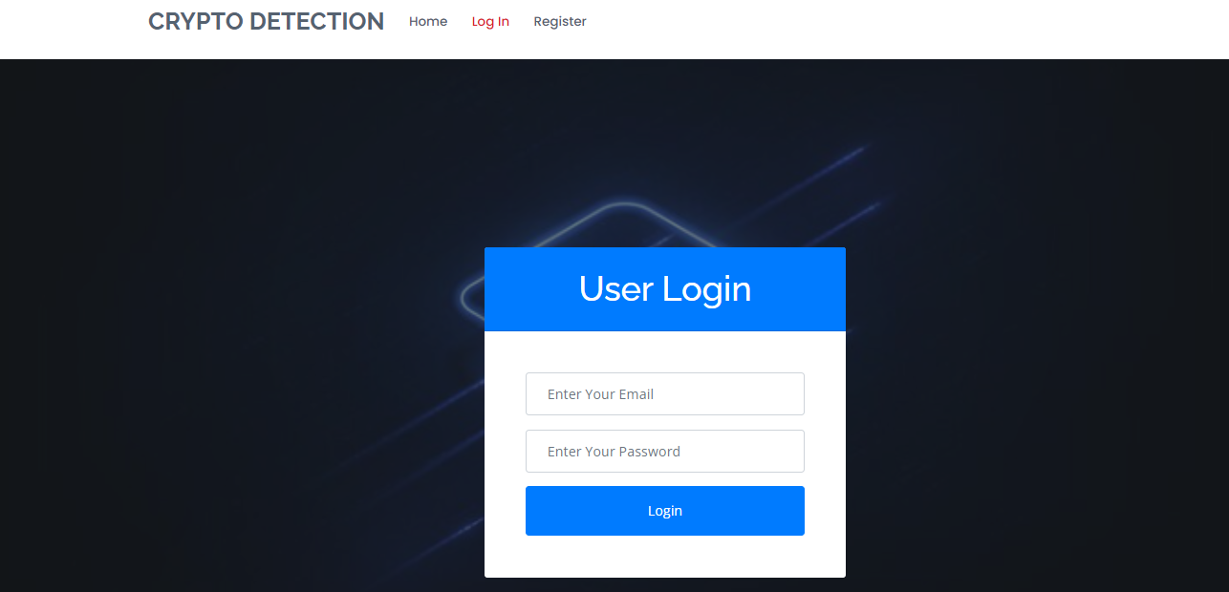

**Load:**

In the load page, users can load the dataset.

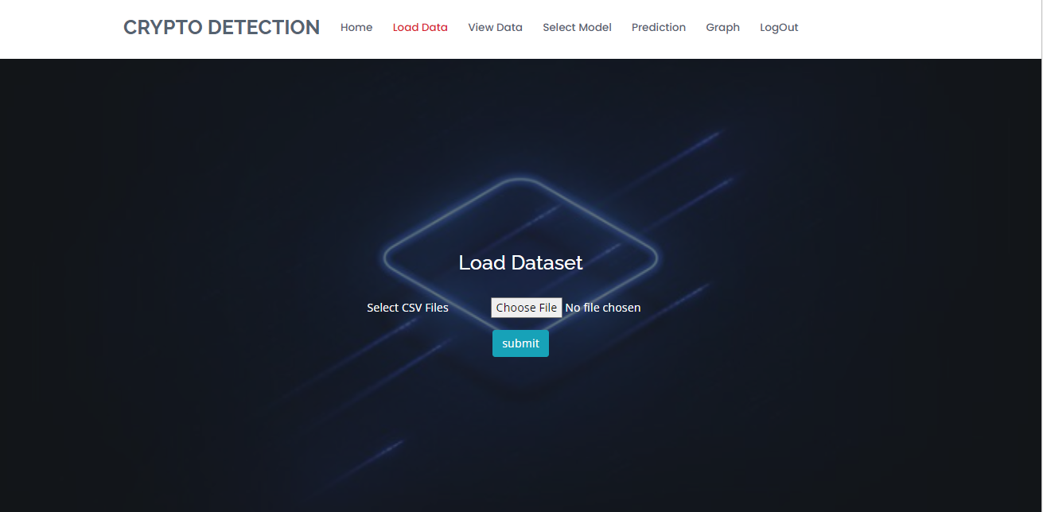

**View:**

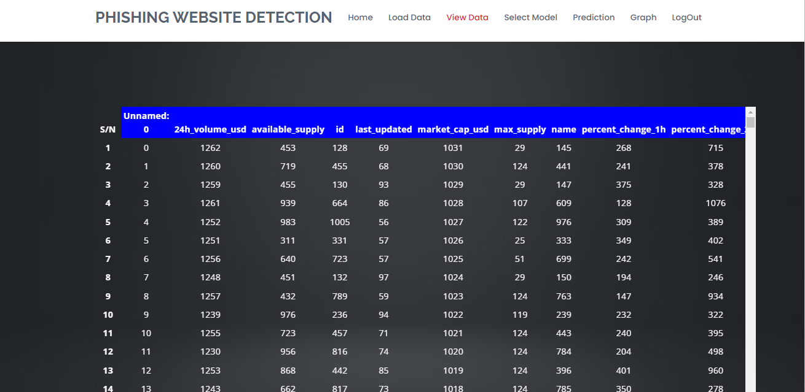

**Model:**

Here we train our data with different ML algorithms.

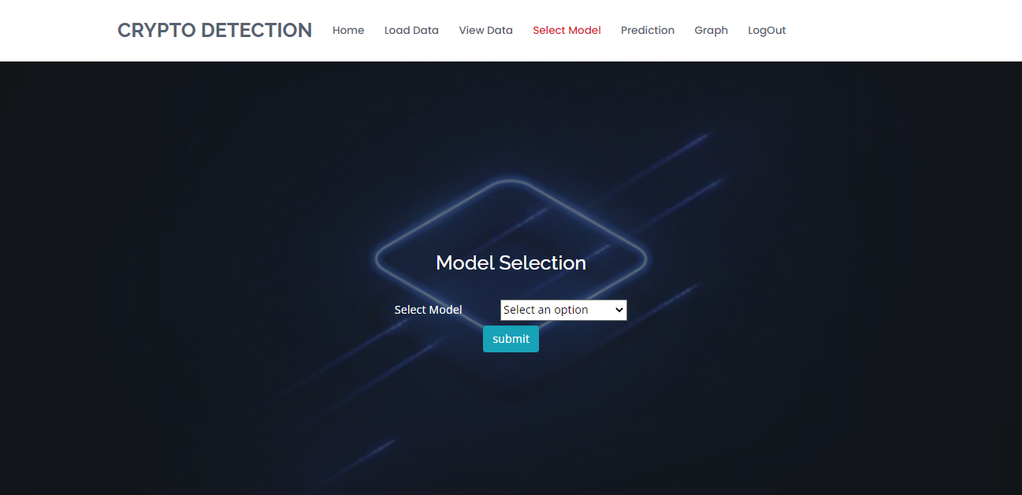

**Prediction:**

This page show the result of the data.

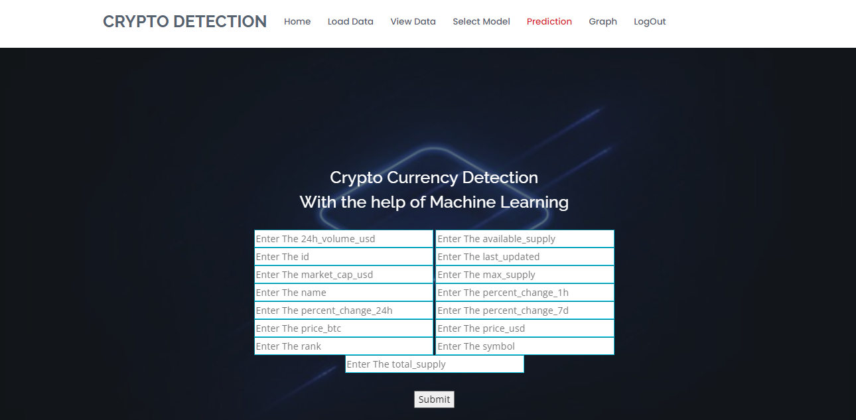

**Graph:**

