Indoor Plant Monitoring System Using IoT

Harichandana Bethapudi1, a) Likhitha Ande, Lalitha Rajaka, Asha Nidhi Kummetha, and Hema Latha Kovuru2, 3,4,5 b)

1Associate Professor, Computer Science and Engineering, Srinivasa Ramanujan Institute of Technology, Anantapur, India.

*2,3,4,5 Computer Science and Engineering, Srinivasa Ramanujan Institute of Technology*

a)[harichandana.cse@srit.ac.in](mailto:harichandana.cse@srit.ac.in),

b)[204g1a0548@srit.ac.in](mailto:204g1a0548@srit.ac.in)

c)[204g1a0547@srit.ac.in](mailto:204g1a0547@srit.ac.in)

d)[204g1a0516@srit.ac.in](mailto:204g1a0516@srit.ac.in)

e)[204g1a0539@srit.ac.in](mailto:204g1a0539@srit.ac.in)

**Abstract.** These days, many people are showing a keen interest in cultivating their own gardens as it offers several benefits, such as producing organic vegetables, incorporating plants into home design, and purifying the air. The primary challenge to indoor gardening is people's hectic schedules. Protecting plants from damage caused by animals and birds often requires hiring a 'plant sitter' when individuals are away on vacation. Automating plant monitoring through the Internet of Things offers a solution for this issue. The Raspberry Pi serves as the primary control unit, managing the functions of moisture and DHT11 sensors and the camera, while also transmitting data for each of these components through the PushBullet.

**Keywords: Raspberry pi, Plant Sitter, Camera module, Moisture sensor, DHT11 sensor and PushBullet.**

# introduction

The Internet of Things (IoT) transforms the indoor plant care system into a dynamic, interconnected environment. In this paradigm, smart devices, sensors, and communication protocols converge to facilitate seamless data exchange and remote management. At the core of this system is the Raspberry Pi-based central unit, serving as a hub for collecting, processing, and analyzing data transmitted from strategically positioned sensor nodes.

Each sensor node, equipped with IoT capabilities, communicates crucial environmental parameters, such as temperature, humidity, and moisture levels, to the central unit in real-time. This bi-directional communication not only provides continuous monitoring of indoor plant conditions but also allows the central unit to send commands to actuators for automatic control.

Actuators, integral to the IoT-based system, enable swift and automated adjustments based on the analyzed data. For example, if the moisture level falls below the optimal threshold, the IoT system triggers an automatic watering mechanism, ensuring the plant receives essential hydration.

Additionally, the IoT framework introduces an analytical layer, endowing the central unit with the ability to process incoming data and offer insights into trends, patterns, and potential issues. This analytical capability empowers users to make informed decisions and take preventive actions to maintain an ideal indoor plant environment. The incorporation of IoT elevates the indoor plant monitoring system by enabling real-time data exchange, remote management, and automated control. This interconnected ecosystem enhances efficiency, promoting optimized care for indoor plants and ensuring their sustained development and overall health.

# Literature survey

The literature survey section offers a comprehensive examination of prior research and findings within the realm of indoor plant monitoring systems, specifically at the convergence of indoor plants, sustainable technology, and the Internet of Things (IoT). The primary objective of this survey is to contextualize the present landscape of indoor plant monitoring, pinpoint knowledge gaps, and lay the groundwork for the proposed methodology. By exploring existing studies, this survey seeks to provide a thorough understanding of the state of the field, thereby informing and guiding the development of the proposed indoor plant monitoring system.

### Raspberry Pi-Centric Integration and Precision Soil Moisture Sensing

In emphasizing the crucial role of Raspberry Pi integration, Zuraida Muhammad, Muhammad Azri and Asyraf Mohd Hafez, position it as the unifying core for the sensor array [1]. This integration, vital for seamless communication and control, aligns precisely with their technical emphasis on efficient data processing. Additionally, the authors highlight the significance of soil moisture sensors in maintaining optimal moisture levels for nutrient absorption and preventing water stress. The concise focus on Raspberry Pi integration resonates with their insights on elevating overall system robustness.

### Technical Insights into the Utilization and Applications of IoT (Internet of Things)

In the work on the Utilization and Applications of IoT (Internet of Things), Prof. Ms. P. V. Dudhe, Prof. Ms. N. V. Kadam, Prof. R. M. Hushangabade, and Prof. M. S. Deshmukh [6] offer profound technical insights. The authors intricately navigate the expansive realm of IoT applications, shedding light on its transformative impact across various sectors. Their analysis spans smart homes, industrial automation, and beyond, presenting a comprehensive understanding of the technical nuances that define the landscape of IoT deployment.

### IoT-Connected Sensor System

Highlighting a sensor-driven system perfected for precise detection of humidity, temperature, and soil moisture, this research, led by Yogeshwari Barhate and Mr. Rupesh Borse, integrates IoT for automated irrigation and real-time plant monitoring [2]. Offering insights into optimal sustainability parameters, the system seamlessly delivers data to users through smartphones or laptops, eliminating the need for manual intervention and reducing the risk of errors [4].

### Domestic life detection and alarm

Structured into three integral components, the system encompasses animal detection and identification (for discerning animal presence), an alarm system (activating a buzzer for animal deterrence), and a GSM module (for notifying authorized personnel) [3]. Upon animal detection, the sensor triggers distance calculation, prompting the camera to capture images. These images, supervised by Selvamuthukumaran and Evangeline Sneha, undergo comparison with a stored dataset for precise animal identification. Upon surpassing a predefined distance threshold, the buzzer activates, and an alert message is transmitted to designated recipients [5].

### PushBullet with IoT

Illuminating the application of PushBullet in plant monitoring systems, the study showcases its widespread adoption as a convenient approach for remotely overseeing and managing plant conditions [4]. The discussion underscores PushBullet's prevalence as a user-friendly and effective IoT platform, empowering users to craft personalized mobile applications tailored to their IoT ventures.

# Objective

The primary objective of this intelligent plant care system is to ensure optimal plant health by meticulously monitoring environmental conditions. Leveraging a DHT11 sensor for temperature control and a soil moisture sensor for precise hydration assessment, the system employs a Raspberry Pi as the central control unit. Upon detecting soil moisture levels below a predefined threshold, the Raspberry Pi activates an automated water pump through a relay module, preventing overheating and facilitating efficient plant hydration. Furthermore, the system integrates a camera utilizing the MobileNetV2 model to detect bird activity, triggering a buzzer for deterrence. Real-time alerts, delivered via PushBullet through in-app notifications and emails, provide users with immediate insights into both environmental and security aspects of plant care.

# proposed system

The system, driven by Raspberry Pi, employs environmental sensors for real-time monitoring of humidity, temperature, and moisture levels. A camera module enhances the system by detecting bird presence and activating a buzzer as a deterrent. This integrated approach enables precise and efficient plant condition monitoring.

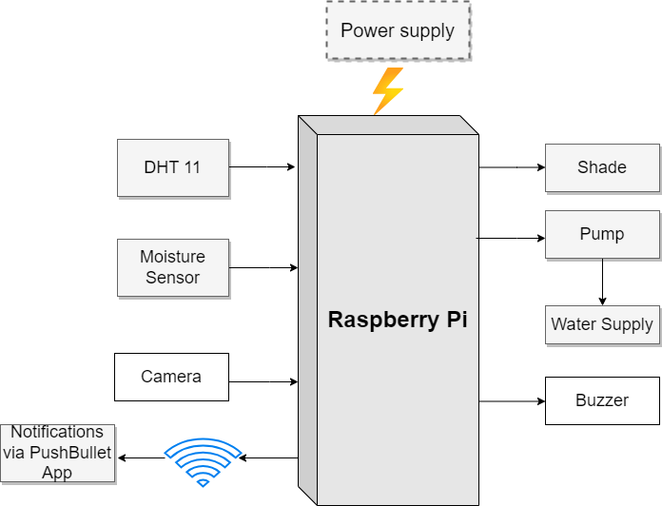

FIGURE 1: Block Diagram of Plant Monitoring System

# methodology

The system incorporates DHT11 and soil moisture sensors for meticulous data acquisition, with the Raspberry Pi serving as the central processing hub for intricate data processing and seamless transmission to PushBullet. The automated watering mechanism, orchestrated by a relay module, is activated when the soil moisture descends below a predefined threshold. Additionally, temperature data retrieved from the DHT11 sensor is seamlessly integrated into the system, contributing to a comprehensive monitoring approach through PushBullet in our indoor plant system.

The relay module establishes a direct interface with the Raspberry Pi, achieving synchronization with a specifically defined set point on the soil moisture sensor. Upon identification of moisture levels below the set threshold, the relay promptly activates the mini-DC pump, initiating a precise and controlled plant hydration process. The Raspberry Pi meticulously oversees this operation, dispatching a signal to the relay module once the desired moisture level is reached, guaranteeing an exact and responsive control mechanism.

Furthermore, the integrated camera system, intricately linked to the Raspberry Pi, employs the sophisticated MobileNetV2 architecture for real-time object detection. This advanced deep convolutional neural network (CNN) model, pretrained on the ImageNet dataset, facilitates the identification of various household animals and birds. The system captures images and conducts a nuanced comparison against pre-programmed data, activating a buzzer for effective bird deterrence. This intricate technical implementation significantly enhances the system's continuous monitoring capabilities and fortifies the defense of indoor plants through advanced object detection functionalities.

## Components

### Raspberry Pi

The Raspberry Pi 4, developed by the Raspberry Pi Foundation, serves as the cornerstone of our indoor plant monitoring system. Featuring dual-band Wi-Fi, USB interfaces, and a quad-core ARM Cortex-A72 CPU with 2GB, 4GB, or 8GB RAM options, it excels in real-time data processing. The Video Core VI graphics engine enables two 4K screens, enhancing multimedia capabilities. The GPIO ports facilitate seamless interfacing with sensors for light intensity and soil conditions tracking. Its compatibility with various operating systems, including Raspberry Pi OS, ensures adaptability for our specific IoT application.

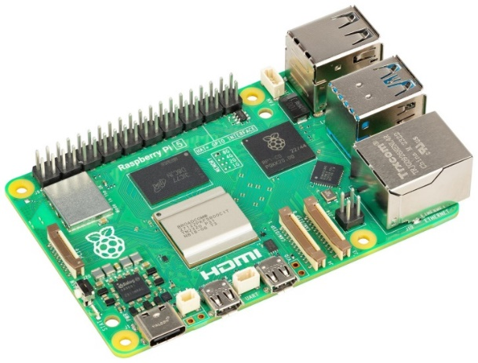

FIGURE 2: Raspberry Pi

### DHT11 Sensor

A prominent digital temperature and humidity sensor in indoor plant monitoring systems is the DHT11. It tracks humidity from 20% to 90% with ±5% precision and operates in the temperature range of 0 to 50 degrees Celsius with an accuracy of ±2°C. The sensor usually runs at 3.3V or 5V and communicates via a single-wire digital interface. It provides consistent temperature and humidity readings with a fast reaction time.

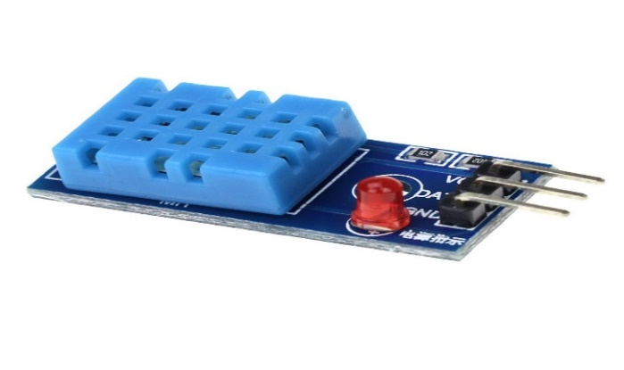

FIGURE 3: DHT11 Sensor

### Soil Moisture

A key element in our indoor plant management system is precise soil moisture monitoring using advanced sensors. Placed strategically in the root zone, these sensors utilize cutting-edge technology to provide real-time soil moisture data. Integrated with General Purpose Input/Output (GPIO) pins, they establish a direct link to the CPU, facilitating seamless data collection and transfer. This ensures timely and accurate information for informed irrigation decisions, optimizing water use, and promoting overall plant health and growth.

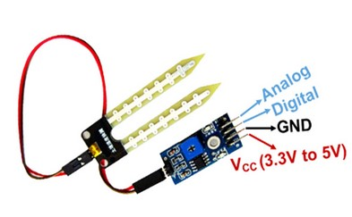

FIGURE 4: Soil Moisture Sensor

### Camera Module

The USB camera integrated into our indoor plant monitoring system is a sophisticated imaging device chosen for its capability to capture high-quality visual data essential for detecting bird activity within the monitored environment. The selected camera model features a high-resolution sensor with 25 megapixels ensuring detailed and sharp imagery. With a frame rate of 30 fps, the camera captures smooth and continuous footage, allowing for precise monitoring of bird interactions.

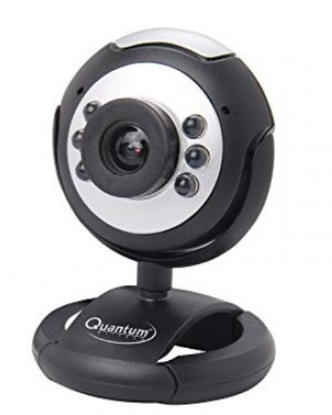

FIGURE 5: USB Camera

### Servo Motors

Servo motors are vital for precise angular control in indoor plant monitoring. Operating at low voltages (4.8V to 6V), they integrate seamlessly with microcontrollers and come in various sizes with distinct torque and speed ratings. Limited to a rotation range of 180 degrees, they adjust sensor positions for targeted data collection. Consideration of torque, speed, and power is crucial when selecting servo motors for optimal performance in monitoring systems.

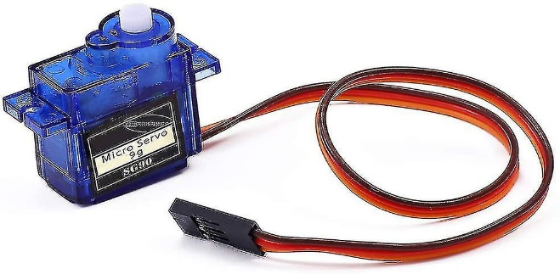

FIGURE 6: Servo Motor

### Water Pump

A reliable water pump, selected for its responsiveness to real-time soil moisture data, plays a crucial role in automated watering within our indoor plant monitoring system. Interfaced seamlessly with the central processing unit, this pump allows dynamic adjustments to watering schedules based on the current soil moisture levels. Engineered for simplicity and smooth integration, the pump ensures uniform and precise watering, a fundamental factor for optimal hydration and health of indoor plants.

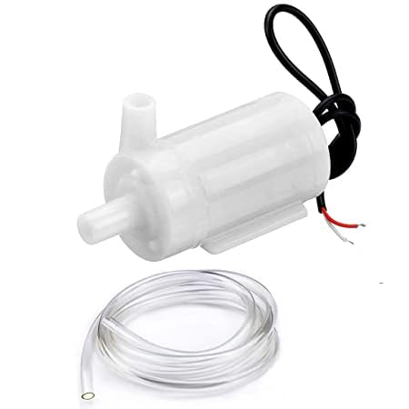

FIGURE 7: Water Pump

### Relay Module

The relay module is a critical component in indoor plant monitoring, acting as an electronic switch for high-power devices. Operating on 5V or 12V with single or multiple channels, it interfaces seamlessly with microcontrollers for integration into plant monitoring projects. Prioritizing safety through isolation between control circuits and loads, relay modules automate device control based on sensor data, enhancing indoor environmental conditions for plants. Their versatility makes them essential for managing various aspects of indoor plant care.

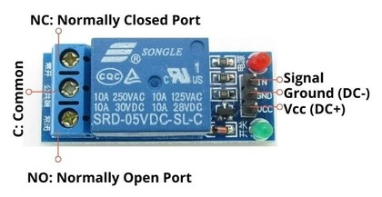

FIGURE 8: Relay Module

## Software Used

### Raspbian OS

Raspbian, a Debian-based Linux distribution, serves as the official operating system for Raspberry Pi single-board computers, tailored to their unique architecture and functionalities. The default and recommended OS for applications like our indoor plant monitoring system, Raspbian provides a user-friendly environment. Renowned for its reliability and pre-loaded applications, it accommodates users of all skill levels. With extensive support for programming languages, developers can easily create and deploy applications. Raspbian's package management simplifies software updates and installations, ensuring compatibility with diverse projects. Its versatility and regular updates from the Raspberry Pi Foundation make Raspbian a robust choice for our system.

### VNC Viewer

The VNC (Virtual Network Computing) Viewer program is pivotal in our indoor plant monitoring system, enabling remote desktop access and control to the Raspberry Pi. It grants users graphical user interface (GUI) access to the Raspberry Pi's desktop interface from remote devices like computers or mobile phones. This access facilitates seamless management, configuration, and troubleshooting of the Raspberry Pi desktop environment, regardless of physical proximity. Operating over secure connections, VNC Viewer ensures data integrity and confidentiality during transmission. Its intuitive interface and cross-platform compatibility enhance accessibility and usability, contributing significantly to the system's smooth operation.

### Push Bullet

Pushbullet, a configurable cross-platform application, facilitates seamless data exchange and communication across diverse devices. Serving as a conduit between desktops, tablets, smartphones, and interconnected devices, Pushbullet enables effortless sharing of files, links, and notifications. In our indoor plant monitoring system, Pushbullet operates as a notification system, promptly alerting users to significant changes or events, such as fluctuations in soil moisture levels, system alarms, or notable plant conditions. Through instantaneous notifications delivered to smartphones or linked devices, users remain informed and can swiftly respond to critical information. Pushbullet's extensive interoperability and streamlined interface enhance the responsiveness and communication capabilities of our indoor plant monitoring system, fostering accessibility and efficiency.

# implementation

This model proposes indoor plant monitoring system which will notify the people about the various conditions of plant. This system is divided into two modules; they are checking environmental conditions and bird detection. The first module is implemented on indoor plants and second module is implemented on birds coming near to the plants. Each module provides notifications and alerts to the mobile via PushBullet.

## Module -1: Checking environmental conditions

This module is to detect the various conditions of the plant and send notification through PushBullet. The DHT11 sensor is used to detect the humidity and temperature of the surroundings and sends information to the raspberry pi and notifies if the humidity and temperature are greater than threshold. The soil moisture sensor detects the moisture content in the soil and this information is sent to raspberry pi then it instructs the water pump to automatically pump the water to the plants if the moisture is low.

### Pump Activation= 1 if moisture<threshold ​

### 0 Otherwise (1)

### Pump Activation Signal=PumpActivation×Relay Signal (2)

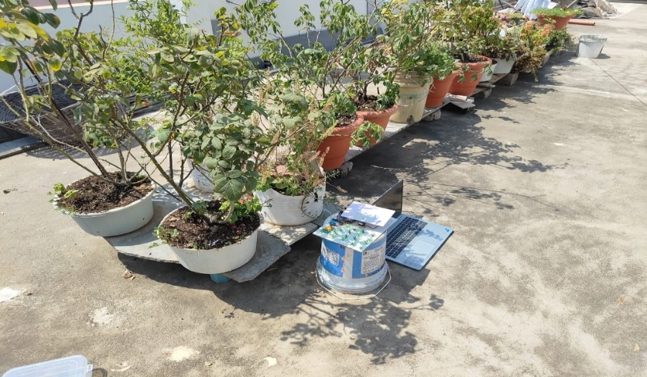

FIGURE 9: Sensor connection

## Module -2: Bird detection

The second module is to detect the bird activity. This is done using the camera module. The camera detects the bird coming near to the plant and sends information to the raspberry pi then it instructs the buzzer to make sound which results in flying away. This prevents the plant from being affected from bird activity.

### if detection confidence>=threshold

### Bird Identified=1 (3)

### 0 otherwise

### model=MobileNetV2(weights=’imagenet’) (4)

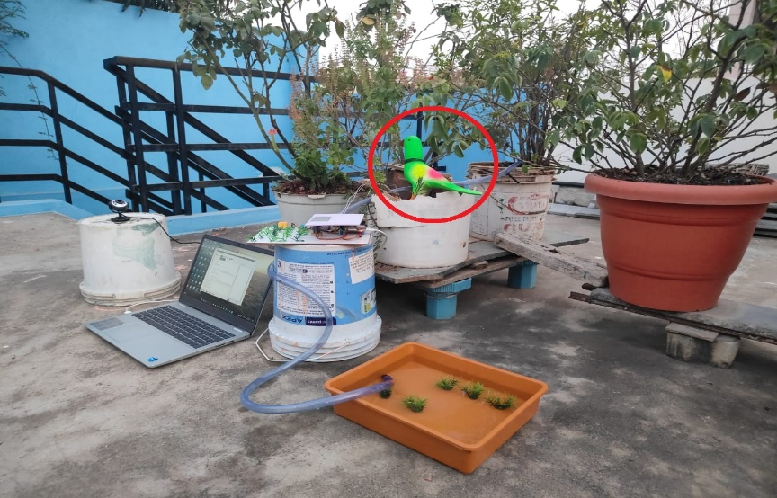

FIGURE 10: Avian Detection

### Real-time Object Detection

### predictions=predict_frame(frame) (5)

### Object-specific Notifications and Buzzer Activation

### notification =send_notification (title, body) (6)

### Pushbullet Notifications push = pb.push_note (title, body ) (7)

### Send Notification=1 if conditions met, 0 otherwise (8)

This multi-faceted technical implementation significantly elevates the system's capabilities, providing a robust defense mechanism for indoor plants through advanced object detection functionalities and comprehensive environmental monitoring.

### Data Flow

### **-** Sensors collect data -> Raspberry Pi processes data -> PushBullet for remote monitoring.

### - Moisture level triggers relay -> Activates mini-DC pump if watering is needed.

### - Camera captures images -> MobileNetV2 identifies birds -> Buzzer activates to deter birds.

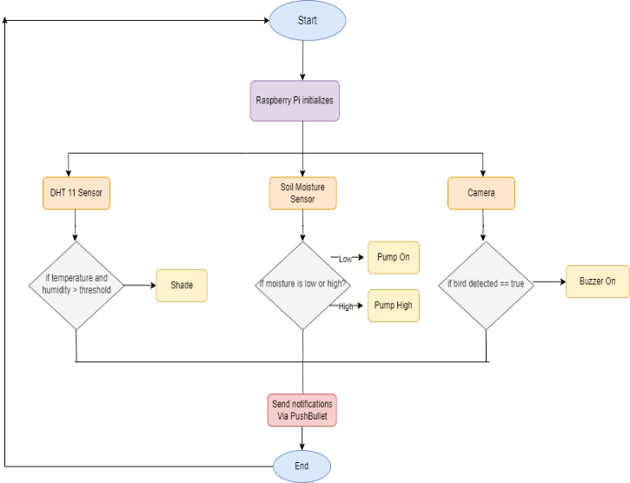

FIGURE 11: Implementation of proposed system

# plants used

The plants being used in the work are different indoor plants. Indoor plants may include flowers, decorative plants and some fruits and vegetables. The plants can be grown inside the house like kitchen and other areas, and balconies or porch of house. We are testing for balconies or porch area plants, as they are likely prone to get attacked by birds. The specific plants on which the model is tested are; Rose, Basil, Brinjal, Chrysanthemum, Table Rose.

The plants are tested for optimal temperature and moisture level where they produce good yield.

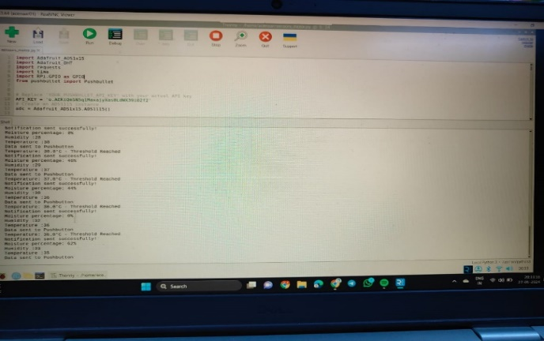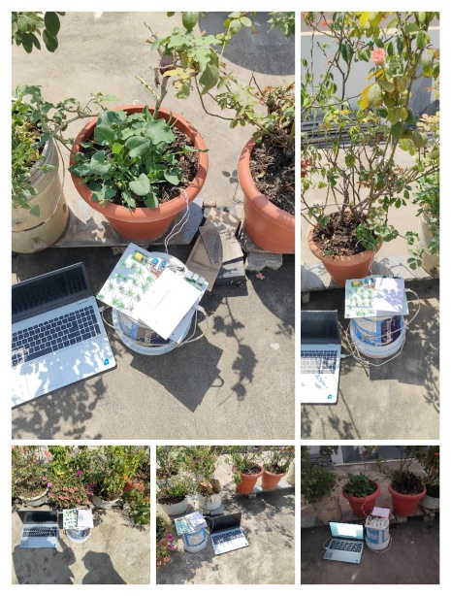 FIGURE 12: Testing for different plants FIGURE 13: Results of testing on plants

# result

The implementation of the Raspberry Pi and IoT-powered automated indoor gardening system yielded successful results in plant care management. Utilizing moisture and DHT11 sensors along with a camera, the system effectively transmitted real-time data to PushBullet for remote monitoring. The user-friendly interface enhanced accessibility, and automated responses, including watering, proved effective in safeguarding plants from animal and bird damage. The bird detection system, triggering a buzzer sound upon detecting birds, provided immediate alerts, significantly enhancing plant protection. This implementation showcases a streamlined and technologically advanced solution for indoor plant cultivation, ensuring precise and timely intervention.

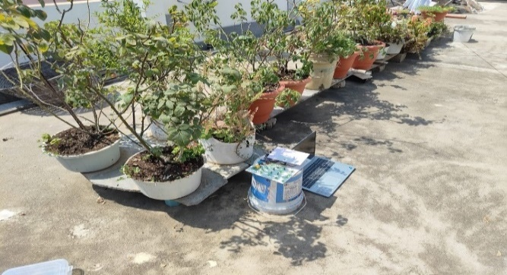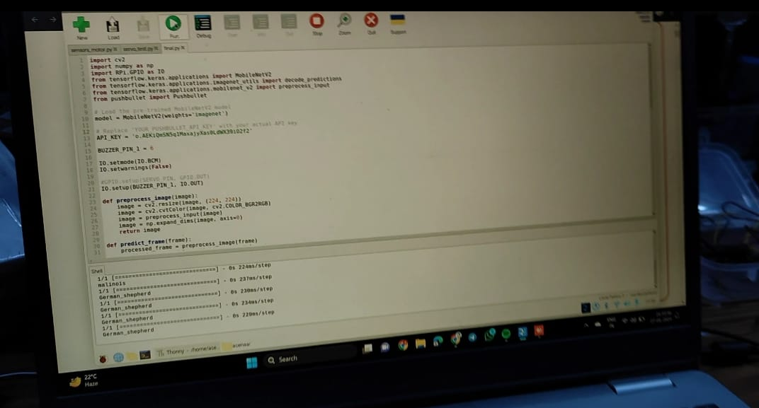

FIGURE 14: Testing FIGURE 15: Detection of avians

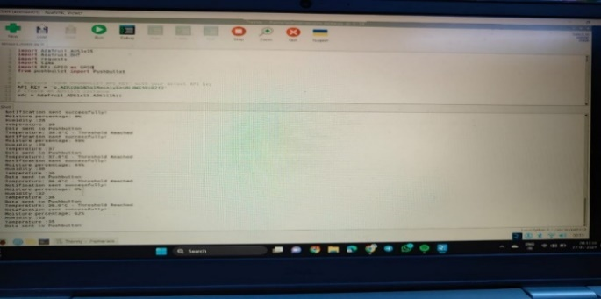

FIGURE 16: Temperature, humidity and moisture values

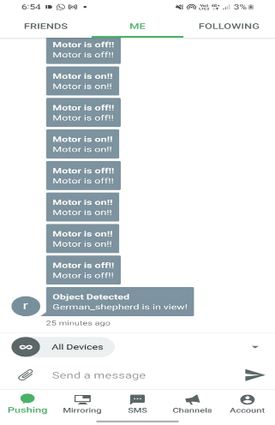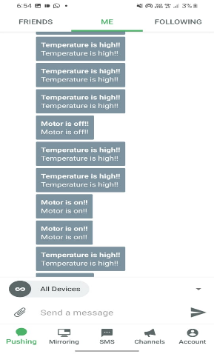

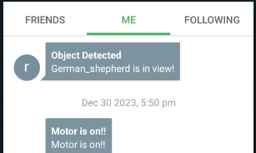

FIGURE 17: SMS Feature

# testing results for plants

**TABLE 1**. Temperature and moisture readings of Rose

|  |  |  |  |
| --- | --- | --- | --- |
| **Number of Days** | **Temperature day** | **Temperature night** | **Moisture Level** |
| Day -1 | 27 | 18 | 52 |
| Day -2 | 31 | 14 | 35 |
| Day -3 | 28 | 15 | 42 |
| Day -4 | 28 | 14 | 73 |
| Day -5 | 33 | 17 | 63 |

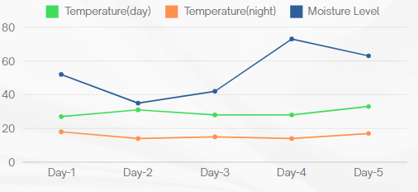

FIGURE 18: Rose plant results

The rose plant grows well in the temperature for the day from 25 to 30 degrees and in night from 15 to 18 degrees. When the moisture is around 60% to 70%, the production of quality flowers is good. When the moisture is 40, it’s time to water the plant.

**TABLE 2.** Temperature and moisture readings of Chrysanthemum

|  |  |  |  |
| --- | --- | --- | --- |
| **Number of Days** | **Temperature day** | **Temperature night** | **Moisture Level** |
| Day -1 | 27 | 18 | 65 |
| Day -2 | 31 | 14 | 53 |
| Day -3 | 28 | 15 | 72 |
| Day -4 | 28 | 14 | 81 |
| Day -5 | 33 | 17 | 45 |

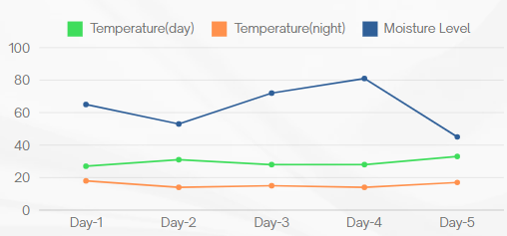

FIGURE 19: Chrysanthemum plant results

The chrysanthemum plant grows well in the temperature for the day from 12 to 30 degrees and in night from 15 to 17 degrees.When the moisture is around 65% to 80%, the plant growth is good. When the moisture is 45, it’s time to water the plant.

**TABLE 3.** Temperature and moisture readings of Basil

|  |  |  |  |
| --- | --- | --- | --- |
| **Number of Days** | **Temperature day** | **Temperature night** | **Moisture Level** |
| Day -1 | 27 | 18 | 45 |
| Day -2 | 31 | 14 | 75 |
| Day -3 | 28 | 15 | 69 |
| Day -4 | 28 | 14 | 83 |
| Day -5 | 33 | 17 | 51 |

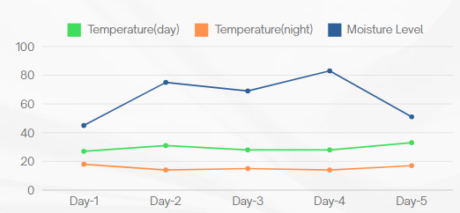

FIGURE 20: Basil plant results

The basil plant grows well in the temperature for the day from 20 to 30 degrees and in night from 10 to 15 degrees.When the moisture is around 40% to 70%, the plant growth is good. When thw moisture is 40, it’s time to water the plant.

**TABLE 4.** Temperature and moisture readings of Table Rose

|  |  |  |  |
| --- | --- | --- | --- |
| **Number of Days** | **Temperature day** | **Temperature night** | **Moisture Level** |
| Day -1 | 27 | 18 | 45 |
| Day -2 | 31 | 14 | 52 |
| Day -3 | 28 | 15 | 39 |
| Day -4 | 28 | 14 | 42 |
| Day -5 | 33 | 17 | 62 |

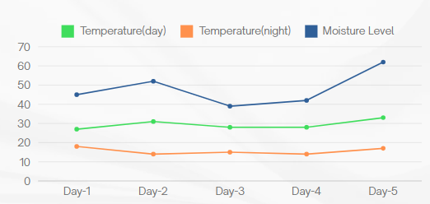

FIGURE 21: Table Rose plant results

The table rose plant grows well in the temperature for the day from 20 to 25 degrees and in night from 13 to 15 degrees.When the moisture is around 40% to 70%, the plant growth is good.

**TABLE 5.** Temperature and moisture readings of Brinjal

|  |  |  |  |
| --- | --- | --- | --- |
| **Number of Days** | **Temperature day** | **Temperature night** | **Moisture Level** |
| Day -1 | 27 | 18 | 55 |
| Day -2 | 31 | 14 | 62 |
| Day -3 | 28 | 15 | 52 |
| Day -4 | 28 | 14 | 75 |
| Day -5 | 33 | 17 | 83 |

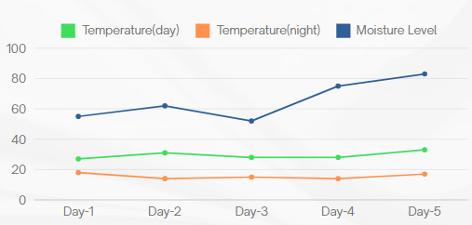

FIGURE 22: Brinjal plant results

The brinjal plant grows well in the temperature for the day from 21 to 26 degrees and in night from 15 to 17 degrees.When the moisture is around 65% to 80%, the plant growth is good. The best temperature for good yeild is 23 and moisture is about 65 to 70.

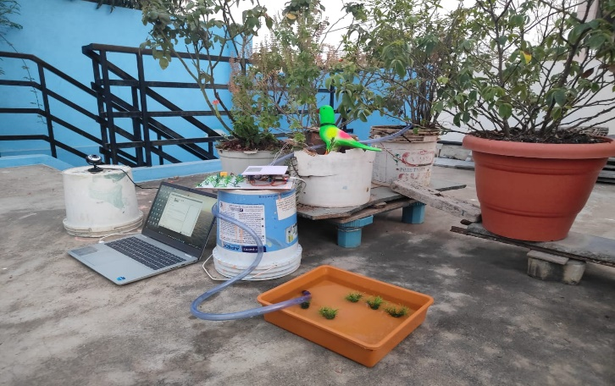

FIGURE 23: Usage of model

The plants are tested for the temperature and moisture. When the moisture level is less than the threshold, the water will be provided automatically and the bord is detected using camera.

# CONCLUSION

The Raspberry Pi and IoT-driven automated indoor plant monitoring system efficiently tackles challenges posed by busy schedules in plant care. Through the automation of monitoring via moisture and DHT11 sensors, alongside a camera, the system enables remote observation and data transmission using PushBullet. This technological advancement not only supports organic vegetable cultivation and improves home aesthetics but also eliminates the necessity for 'plant sitters' during absences. The work highlights the harmonious integration of technology and gardening, providing a practical and efficient solution for modern lifestyles, with potential for further technical enhancements in the future.

# FUTURE SCOPE

The future scope of the automated indoor gardening system includes integrating disease detection features utilizing specialized sensors and image recognition technology. Machine learning algorithms will analyze data patterns, enabling accurate disease diagnosis for timely intervention and automated responses. The system's capabilities will be enhanced through a comprehensive database and integration with external plant health resources, facilitating identification and management of various plant diseases. This expansion strengthens the system's role in plant care and contributes to building a more resilient and informed gardening community. Our work’s potential extends to broader applications, offering assistance in agricultural settings, ultimately benefiting farmers by streamlining tasks and reducing labor requirements.

# References

1. Zuraida Muhammad, Muhammad Azri Asyraf Mohd Hafez, Nor Adni Mat Leh, Zakiah Mohd Yusoff and Shabinar Abd Hamid, [*Smart Agriculture Using Internet Of Things with Raspberry Pi*](https://sci-hub.hkvisa.net/10.1109/ICCSCE50387.2020.9204927) 10th IEEE International Conference on Control System, Computing and Engineering (ICCSCE2020) pp. 85-90, August. 2020.
2. Ms. Yogeshwari Barhate, Mr. Rupesh Borse, Ms. Neha Adkar and Mr. Gaurav Bagul, [*Plant Watering and Monitoring System Using IOT and Cloud Computing*](https://www.ijsdr.org/papers/IJSDR2004025.pdf) International Journal of Scientific Development and Research vol. 5, pp. 157-162, April. 2020.
3. Selvamuthukumaran N, Evangeline Sneha J, Thriambika K B and Vishali Babu B, [*Intelligent Animal Detection System Using IOT and Deep Learning*](https://www.irjmets.com/uploadedfiles/paper/volume3/issue_4_april_2021/8688/1628083357.pdf) International Research Journal of Modernization in Engineering Technology and Science, vol. 3, pp. 2433-2438, April. 2021.
4. Yogesh kumar Jayam, Venkatesh Tunuguntla, Sreehari J B, S Harinarayanan, [*Smart Plant Monitoring System Using IOT*](https://sci-hub.se/10.1109/ICOEI48184.2020.9142980) Fourth International Conference on Trends in Electronics and Informatics (ICOEI 2020), pp. 271-277, July. 2020.
5. Gaurav Patil, Akash Patil, Shashank Pathmudi, [*Plant Monitoring System*](https://www.ijert.org/plant-monitoring-system?amp=1) International Journal of Engineering Research & Technology (IJERT), vol.10, pp. 1-4, September 2021.
6. Prof.Ms.P.V.Dudhe, Prof.Ms.N.V.Kadam, Prof. R. M. Hushangabade, Prof. M. S. Deshmukh, [*Internet of Things (IOT): An Overview and it’s Applications*](https://ieeexplore.ieee.org/document/8389935) International Conference on Energy, Communication, Data Analytics and Soft Computing (ICECDS-2017), pp. 2650-2653, 2017.
7. R Lathesparan, A Shranjah, R Thushanth, S Kenurshan, MNM Nifras and WU Wickramaarachi, [*Real-time Animal Detection and Prevention System for Crop Fields*](https://www.researchgate.net/publication/352539574_Real-time_Animal_Detection_and_Prevention_System_for_Crop_Fields), 13th Internationl Research Conference General Sir John Kotelawala Defence University, pp. 70-78, June 2021.
8. Y. Manoj, T. Sai Naveen Kumar, Sk Adeeb Jainab, T. Sailaja and A. Anasuyamma, [*Greenhouse Monitoring Using Raspberry Pi*](https://www.ijcrt.org/papers/IJCRT2305319.pdf), International Journal of Creative Research Thoughts, vol. 11, pp. 429-433, May 2023.
9. Sachin Kumar, Pryag Tiwari, Mikhail Zymbler, [*Internet of Things is a revolutionary approach for future technology enhancement: a review*](https://journalofbigdata.springeropen.com/articles/10.1186/s40537-019-0268-2), Springer Open, pp. 1-21, 2019.
10. Zainab H. Ali, Hesham A. Ali, Mahmoud M. Badawy, [*Internet of Things (IoT): Definitions, Challenges and Recent Research Directions*](https://www.researchgate.net/publication/320532203_Internet_of_Things_IoT_Definitions_Challenges_and_Recent_Research_Directions), International Journal of Computer Applications, vol. 128-No 1, pp. 37-47, October 2021.
11. Radouan Ait Mouha, [*Internet of Things (IoT)*](https://www.researchgate.net/publication/351003790_Internet_of_Things_IoT), Journal of Data Analysis and Information Processing, pp. 77-101, April 2021.
12. Muthumanickam Dhanaraju, Poongodi Chenniappan, Kumaraperumal Ramalingam, Sellaperumal Pazhanivelan and Raghunath kaliaperumal, [*Smart Farming: Internet of Things (IoT)-Based Sustainable Agriculture*](https://www.mdpi.com/2077-0472/12/10/1745), MPDI, , October 2022.
13. <https://projects.raspberrypi.org/en/projects/raspberry-pi-getting-started>
14. [https://components101.com/sensors/dht11-temperature-sensor](https://components101.com/sensors/dht11-temperature-sensor%20)
15. <https://medium.com/technology-hits/simplified-raspberry-pi-plant-watering-system-942099e4e2cd>
16. <https://www.elprocus.com/soil-moisture-sensor-working-and-applications/>
17. <https://www.instructables.com/Object-Detection-on-Raspberry-Pi/>
18. <https://robu.in/how-to-connect-relay-to-raspberry-pi-3/>
19. <https://www.digikey.com/en/maker/tutorials/2021/how-to-control-servo-motors-with-a-raspberry-pi>
20. <https://raspberrypi-guide.github.io/electronics/using-usb-webcams>