**Faculty Appraisal System**

Ranjit Reddy Midde,a) Sakiya Rabbani S M ,b) Gana Sree Akshaya Reddy P,c)

Sharanya M,d) and Mehboob Arab Khan Pe)

*computer science & engineering, Srinivasa Ramanujan Institute of Technology, Anantapur, Andhra Pradesh , India 515701.*

a)midderanjit@gmail.com

b)204g1a0591@srit.ac.in

c)204g1a05c7@srit.ac.in

d)204g1a0593@srit.ac.in

e)214g5a0508@srit.ac.in

**Abstract:** Faculty performance, appraisal predominantly relies on paper-based assessments and the manual calculation of points based on a range of factors. These factors encompass cognitive abilities, educational achievements, professional accomplishments, and other relevant attributes that contribute to an individual's intellectual prowess. This traditional approach is undergoing a transformation through the integration of technology, specifically utilizing data visualization techniques. Smart appraisal system revolutionizes the assessment of faculty by using data analytics and a dynamic web page. Faculty members log in to provide their achievements through a user-friendly form. The system assigns points to each accomplishment based on predefined weights, offering real-time feedback and visualizations on the final appraisal points.

**Keywords: Faculty Appraisal Performance, Data Visualization, Faculty Appraisal System**

**INTRODUCTION**

The Faculty Appraisal System aims to modernize and streamline the assessment process for academic professionals. By leveraging data analytics and a dynamic web interface, this system offers a user-friendly platform for faculty members to input their achievements. The automated point assignment, guided by predefined weights, ensures fairness and accuracy in the appraisal process. Real-time feedback and visualizations enhance transparency and contribute to a more efficient and effective faculty evaluation system.

Faculty performance appraisal predominantly relies on paper-based assessments and manual calculation of points based on a range of factors. Creating a Faculty appraisal system that assists academic institutions in making informed decisions about promotions, salary adjustments, and recognition necessitates aligning the outcomes with institutional goals and policies. Developing a report generation mechanism that translates accumulated points into clear appraisal insights and potential increments, promoting transparency and trust among faculty and stakeholders.

The Faculty Appraisal System aims to modernize traditional performance assessments through the integration of web technology. This system will provide a dynamic web-based platform where faculty members can log in and submit their achievements via a user-friendly form. The system will employ predefined weights to assign points to each accomplishment, offering real-time feedback and visualizations for a comprehensive and efficient appraisal process.

**LITERATURE SURVEY**

Researchers dedicated their efforts for enhancing the faculty appraisal system. [1], In this paper, the integration of data analytics in faculty performance appraisal systems. The researchers conducted a thorough literature review to assess the current landscape of faculty appraisal methods and identified the growing trend towards incorporating data analytics. The paper emphasizes the need for dynamic systems that go beyond traditional paper-based assessments, highlighting the potential benefits of real-time feedback and visualization in enhancing the appraisal process. The findings provide valuable insights into the transformative impact of data analytics on faculty evaluation.[2], In this study, they conducted a comprehensive survey of recent technological innovations in faculty appraisal systems. The paper reviews various approaches, including the use of dynamic web pages and user-friendly interfaces. The authors emphasize the importance of technology in revolutionizing traditional appraisal methods and discuss how these innovations contribute to a more efficient and transparent evaluation process. The study serves as a valuable resource for institutions seeking to adopt modern faculty appraisal paradigms.[3], In this study present a forward-looking perspective on faculty appraisal systems, with a focus on user-centric design principles. The study investigates the role of intelligent systems in providing a user-friendly experience for faculty members. By incorporating insights from human-computer interaction and design thinking, the authors argue that enhancing the user experience is crucial for the successful implementation of appraisal systems. The paper provides practical recommendations for developing appraisal systems that prioritize usability and engagement.[4], In this study the conduct a meta-analysis to evaluate the impact of technology-enabled faculty appraisal systems. The study synthesizes findings from existing literature to assess the effectiveness of these systems in improving the accuracy and fairness of evaluations. The researchers identify key success factors and challenges associated with the adoption of technology in faculty appraisal. The meta-analysis offers valuable insights for institutions considering the implementation of technology-driven appraisal solutions.[5], In this study the author delve into the current trends and challenges associated with data-driven approaches to faculty appraisal. The paper explores the evolving landscape of appraisal systems, emphasizing the role of data analytics in capturing and analyzing diverse faculty achievements. The authors discuss the potential benefits and address the challenges and ethical considerations associated with data-driven appraisal. The study contributes to the ongoing discourse on the transformative impact of data-driven approaches in shaping the future of faculty evaluation.

**METHODOLOGY**

Our Faculty Appraisal System used react software for the development of the web form and for the data visualization of the marks.

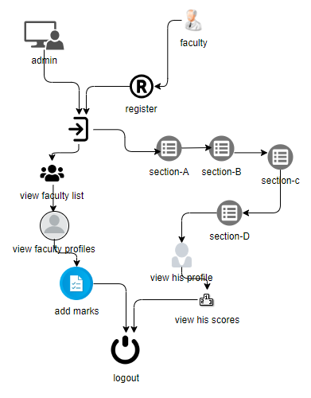

**FIGURE 1:** Faculty Appraisal Architecture

1. Workflow for admin
2. Login:

The admin starts by logging into the system using valid credentials.

1. View Faculty List:

After logging in, the admin has the ability to view a list of all registered faculty members.

1. View Faculty Profile:

The admin can access detailed profiles of individual faculty members, which may include personal information, qualifications, and teaching history.

1. Add Marks (Verify):

The admin has the authority to add and verify the marks of faculty members, ensuring accuracy and consistency in the assessment process.

1. Logout:

Once the necessary tasks are completed, the admin logs out of the system, ensuring the security of the admin account

1. Workflow for Faculty
2. Register:

Faculty members first register into the system by providing necessary information such as personal details, academic qualifications, and contact information.

1. Login:

Registered faculty members log in using their credentials to access the system.

1. Section A (Teaching and Learning Process):

Faculty members input information related to their teaching activities, including courses taught, class schedules, and teaching methodologies.

1. Section B (Professional Related Works):

In this section, faculty members record their professional development activities, workshops attended, conferences participated in, and any other professional achievements.

1. Section C (Research Activities):

Faculty members enter details about their research activities, including ongoing projects, publications, and collaborations with other researchers.

1. Section D (Feedback from Peers):

This section allows faculty members to receive and provide feedback from and to their peers. It fosters a collaborative environment and continuous improvement in teaching and research.

1. View Entire Profile:

Faculty members have the option to view their entire profile, consolidating all the information entered in different sections.

1. View Scores (Data Visualizations):

The system generates visualizations representing the faculty member's scores in various categories, providing a comprehensive overview of their performance.

1. Logout:

After completing the necessary entries and reviews, the faculty member securely logs out of the system.

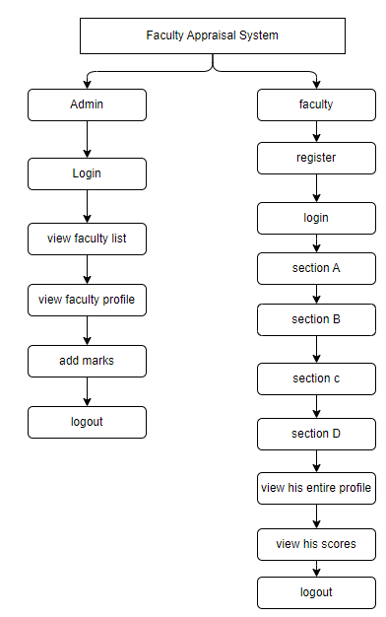

**FIGURE 2:** Faculty Appraisal System Workflow

## FrontEnd

The Front end of the application consists of the web application which contains the faculty appraisal forms. A faculty member has to log into his/her account first to access these forms. After logging in, the user has to give input values for various fields. With the help of react, calculated values will be displayed accordingly which means that the user need not worry about calculations. The data generated after filling the forms is then stored in the MYSQL Server.

1. Backend

In this project, the backend, implemented with Express.js and Node.js, serves as the backbone for handling faculty inputs and performing crucial calculations. Utilizing a MySQL database for data storage, the backend efficiently processes information submitted through a form by faculty members. Express.js routes and middleware manage data validation and storage, ensuring the persistence of relevant details. The backend’s key role lies in computing scores by leveraging the stored data, and it seamlessly communicates the results to the React frontend. This integration demonstrates the backend's pivotal function in managing data flow, executing essential calculations, and ultimately contributing to the project's overall efficiency and functionality.

1. Data visualization

Data visualization plays a pivotal role in enhancing the interpretability of faculty performance metrics. Through the integration of bar graphs, we present a visual representation of the marks obtained by faculty members in each distinct section, providing a comprehensive and accessible overview. This graphical approach facilitates a comparative analysis of performance across different categories, allowing stakeholders to quickly discern strengths and areas for improvement. The bar graphs serve as a user-friendly interface, aiding in the efficient interpretation of complex data. In our project, we leverage the power of data visualization to enhance user understanding and engagement. One key component driving this capability is the integration of ReactApexChart. This React wrapper for the Apex Charts library empowers us to effortlessly create dynamic and visually appealing charts, with the flexibility to choose from a variety of chart types. Through the ReactApexChart component, we seamlessly provide our users with insights through interactive and responsive bar charts, line charts, and more. This not only enhances the overall user experience but also contributes to a more effective communication of complex data trends and patterns. The ease of integration and customization offered by ReactApexChart aligns perfectly with our project's commitment to delivering a visually compelling and informative user interface.

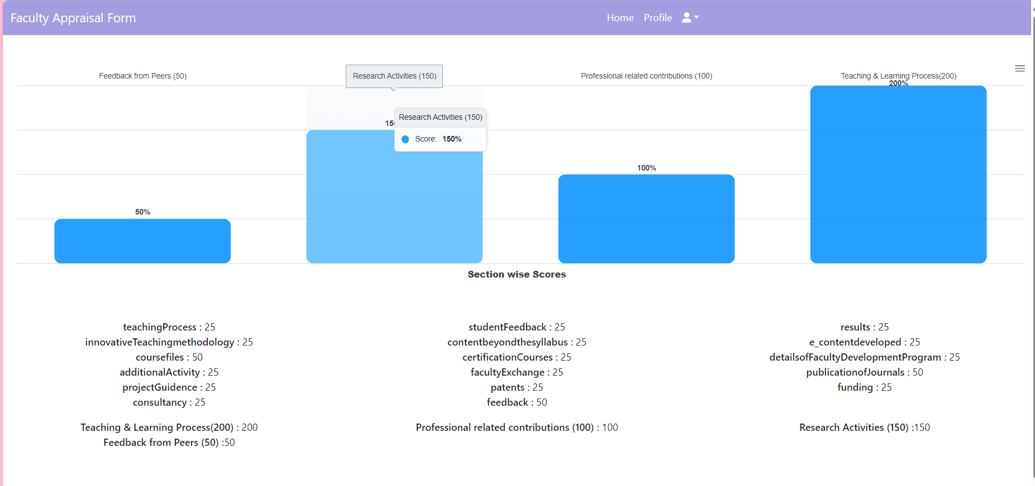

**FIGURE 3:** Data visualization of faculty marks

**RESULTS & Discussions**

The application would help in evaluation of faculty performance and help the organization in collection and evaluation of data process. The access to view or edit the data that is collected from individual faculty is given to authorized admins. The data visualization is implemented and can be seen by user once the data is filled.

**CONCLUSION**

In conclusion, the Faculty Appraisal System represents a transformative shift from traditional paper-based assessments to a dynamic, technology-driven approach. By incorporating data analytics and a user-friendly web interface, the system streamlines the appraisal process, providing real-time feedback and visualizations. This innovative solution not only enhances efficiency but also offers a comprehensive and objective evaluation of faculty performance, contributing to the continuous improvement of academic institutions.

.

**FUTURE WORK**

*Enhancing Machine learning*

The Faculty Appraisal System could be enhanced by incorporating machine learning algorithms to dynamically adjust weights based on evolving academic standards. Integration withnatural language processing could enable a more intuitive and interactive user experience for faculty members.

*Exploring Block chain*

Exploring block chain technology for secure data storage and authentication would further bolster the system's transparency and reliability, ensuring a cutting-edge and comprehensive approach to faculty performance assessment.

**REFERENCES**

[1]. Haidi Bozikovic, Maja Stula , “[Web Design – past , present and future](https://ieeexplore.ieee.org/document/8400266)” , MIPRO , pp 1-6, 21 May 2018.

[2]. Aisha Khanam, Dr. Shabana Mazhar, “[Efficacy of faculty performance appraisal system in higher educational organization](https://www.academia.edu/38616529/EFFICACY_OF_FACULTY_PERFORMANCE_APPRAISAL_SYSTEM_IN_HIGHER_EDUCATIONAL_ORGANIZATION)” , International journal of management and social sciences (IJMSS) , vol 03 ,pp 1 -11, January 2015.

[3]. Patrik Bores, Aishwarya Chinch pure, Rajat Singh Deepak , Dr. Swati Shinde, “[Comprehensive Faculty Appraisal and development system using Data Analytics and Data Visualization](https://ieeexplore.ieee.org/document/8697379)”, Fourth International Conference on computing communication control automation(ICCUBEA), pp 1-6 , 25 April 2019.

[4].Colin Reiff, Stefan Oechsle ,Florain Eger,Alexander, “[Web Platform for data analysis and monitoring](https://www.sciencedirect.com/science/article/pii/S2212827120300093)”, Procedia CIRP, pp 1-36, volume 86,2019.

[5]. Elena, Ioana “Evaluation criteria for performance appraisal of faculty perfromace” International Conference Eduaction and psychology challenges - teachers for the knowledgw society – 3rd edition, EPC-TKS 2015

[6]. Gupta R. (2012). Emerging trends of Corporate Social responsibility in India- An Overview, IJBMR, Vol.2(1), ISSN: 2249-6920, pp.39-49.

[7]. Khanna P, and Gupta G. (2011). “Status of Corporate Social Responsibility: in Indian context”. APJRBM, Volume 2, Issue 1, ISSN. 2229-4104.

[8]. Sharma, Anupam & Kiran, Ravi. (2012). “Corporate Social Responsibility Initiatives of Major Companies of India with Focus on Health, Education and Environment”, African Journal of Basic Applied Sciences 4 (3): 95-105, ISSN 2079-2034.

[9]. Usha, L. (2012). Corporate Social Responsibility in India – A way to Socio Economic Development, Indian journal of applied research, Vol.2(2), ISSN - 2249-555X. 7. [https://economictimes.indiatimes.com/blogs/Responsi bleFuture/sustainability-and-csr-trends-for-india-in2017/](https://economictimes.indiatimes.com/blogs/Responsi%20bleFuture/sustainability-and-csr-trends-for-india-in2017/).

[10]. Prof. Yogesh Kadam, Akhil Goplani, Shubit Mattoo, Shashank Kumar Gupta, Darshan Amrutkar, Prof. Dr. Jyoti Dhanke June (2023). “[Introduction to MERN stack and comparsion to previous technologies](https://www.researchgate.net/publication/371459805_Introduction_to_MERN_Stack_Comparison_with_Previous_Technologies)” European Chemical Bulletin 12 .

[11]. Dr. Santosh Kumar Shukla, Shivam Dubey ,Tarun Rastogi, Nikita Srivastava, June (2022) “[Application using MERN stack](https://www.researchgate.net/publication/361465446_Application_using_MERN_Stack)” International Journal for Modern Trends in Science and Technology.

[12]. Matt Ferisbie “[XML in javascript](https://www.researchgate.net/publication/336195839_XML_in_JavaScript) “October (2019) in book Professional JavaScript® for Web Developers (pp.849-859).

[13]. Santosh vilas Hasure,Dr. Milind Arun Peshave “[STUDY OF PERFORMANCE APPRAISAL SYSTEM FOR FACULTY MEMBERS IN MANAGEMENT INSTITUTES AFFILIATED TO SHIVAJI UNIVERSITY KOLHAPUR”](https://hmct.dypvp.edu.in/Documents/research-papers-publication/Resarch-publications/57.pdf) volume 9, 2020 ISSN NO: 1021-9056

[14]. Ahmed khetre “[Performance Appraisal of Faculty Members Based on Internal Quality Assurance System: A Delphi Study](https://files.eric.ed.gov/fulltext/EJ1277879.pdf)”, International Journal of Higher study, vol 9 no 6(2020)

[15]. Awol Ahmed Mohammed “[Review paper on university teacher performance](https://www.researchgate.net/publication/343232898_Review_Paper_on_University_Teachers_Performance_Appraisal)” Open Access library journal 07(07) January 2020