**EARLY PREDICTION OF LOW BIRTH WEIGHT (LBW) CASES USING MACHINE LEARNING APPROACH**

**OBJECTIVE:**

The main objective of this application is to investigate a specific problem of whether it is valuable or not to use machine learning techniques to predict whether the baby belongs to Low Birth Weight or not belongs to Low Birth Weight.

**ABSTRACT:**

Low Birth weight (LBW) acts as an indicator of sickness in new born babies. LBW is closely associated with infant mortality as well as various health outcomes later in life. Various studies show strong correlation between maternal health during pregnancy and the child’s birth weight. This manuscript exploits machine learning techniques to gain useful information from health indicators of pregnant women for early detection of potential LBW cases. The forecasting problem has been reformulated as a classiﬁcation problem between LBW and NOT-LBW classes using supervised Machine learning for LBW detection as a binary machine classiﬁcation problem. Expectedly, the proposed model achieved better accuracy. Indian health care data was used to construct decision rules to be extrapolated to predictive health care in smart cities. A screening tool based on the decision model is developed to assist health care professionals in Obstetrics and Gynaecology (OBG).

**KEYWORDS:** Low Birth weight (LBW), Smart health informatics, Predictive analytics, Machine Learning (ML), Feature Ranking.

**EXISTING SYSTEM:**

In existing system, model used is Random forest and Xgboost and Decision Tree to estimate whether the baby belongs to the Low Birth Weight or not belongs to the Low Birth. This model employs low accuracy and inaccurate results.

**DISADVANTAGES:**

* Low accuracy.
* Expensive.
* Low reliability.
* Inaccurate.

**PROPOSED SYSTEM:**

In proposed system, we implement supervised machine learning algorithms like Stacking Algorithms, Support Vector classifier for prediction of low Birth Weight babies.

**BLOCK DIAGRAM:**

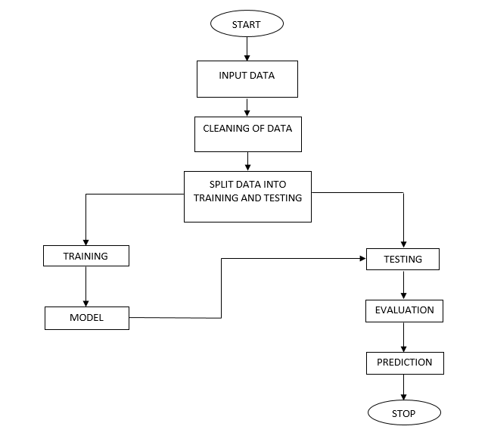

**ADVANTAGES:**

* High accuracy.
* Time Saving.
* Does not require highly trained staff.
* High reliability.
* Low complexities.

**APPLICATIONS:**

* Used in Hospitals
* Used in Humanitarian aid.

**SYSTEM SPECIFICATIONS:**

# H/W SPECIFICATIONS:

# Processor : I3/Intel Processor

* RAM : 4GB (min)
* Hard Disk : 128 GB
* Key Board : Standard Windows Keyboard
* Mouse : Two or Three Button Mouse
* Monitor : Any

**S/W SPECIFICATIONS:**

* Operating System : Windows 7+
* Server-side Script : Python 3.6+
* IDE : PyCharm.
* Libraries Used : Pandas, Numpy, Matplotlib, OS.

**LEARNING OUTCOMES:**

* About Python.
* About PyCharm.
* About Pandas.
* About Numpy.
* About HTML.
* About CSS.
* About JavaScript.
* About Database.
* About Machine Learning.
* About Artificial Intelligent.
* About how to use the libraries.
* Cloud Overview.
* Terminology of cloud.
* Project Development Skills**:**
  + Problem analyzing skills.
  + Problem solving skills.
  + Creativity and imaginary skills.
  + Programming skills.
  + Deployment.
  + Testing skills.
  + Debugging skills.
  + Project presentation skills.
  + Thesis writing skills.