**Deploy Web Application to Microsoft Azure**

**Group: 12**

1. **INTRODUCTION**
2. **Overview**

***1.1. What is Microsoft Azure?***

* Microsoft Azure is a cloud computing service for building, testing, deploying, and managing applications and services through Microsoft-managed data centre. It provides Infrastructure as a Service (IaaS), Platform as a Service (PaaS), and Software as a Service (SaaS) and supports many different programming languages, tools, and frameworks. It also provides a broad range of cloud services, including computing, analytics, storage and networking.

***1.2. What is Web application?***

* A Web application is an application program that is stored on a remote server and delivered over the Internet through a browser interface. Web services are Web applications by definition and many, although not all, websites contain Web apps.

***1.3. How can deploy a Web application on Microsoft Azure?***

* The Azure Platform Web Application deployment is accomplished with the following services:
* Azure Web App Service: is a cloud computing-based platform for hosting websites. It is a Platform as a Service (PaaS) that allows publishing Web apps running on multiple frameworks and written in different programming languages (.NET, node.js, PHP, Python, and Java). It also supports global scale and availability, high security, and constant access.
* Azure DevOps: is a Software as a Service (SaaS) platform that provides an end-to-end DevOps toolchain for developing and deploying applications. It provides integrated features which can be accessed through a web browser or IDE application. In this project, we mainly use the Azure Pipelines service.

1. **Component**

* All web-based database applications have three primary components:
* A web browser (or client) - handle requests and responses
* A web application server - perform the requested tasks
* A database server - store data
* Web-based database applications rely on a database server, which provides the data for the application.
* The following structure will show the fundamental components of a basic Web Application.

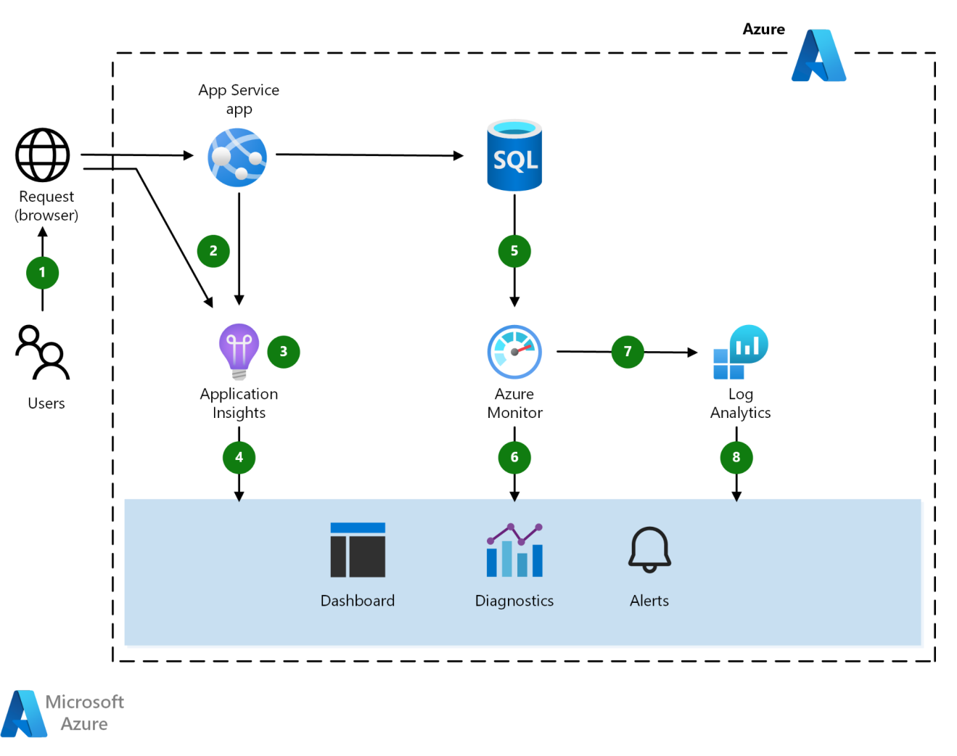

* Some fundamental components are shown in above diagram:
* **Azure App Service**: is a PaaS service for building and hosting apps in managed virtual machines. It provides monitoring of resource usage and app metrics, logging of diagnostic information, and alerts based on metrics.
* **Application Insights** is an extensible Application Performance Management (APM) service for developers and supports multiple platforms. It monitors the application and detects application anomalies. It can also be used for logging, distributed tracing, and custom application metrics. Even better, it creates availability tests for testing your application from different regions.
* **Azure Monitor**: provides base-level infrastructure metrics and logs for most services in Azure. It also offers its data directly into Log Analytics and other services, where you can query and combine it with data from other sources on-premises or in the cloud.
* **Log Analytics**: helps correlate the usage and performance data collected by Application Insights with configuration and performance data across the Azure resources that support the app.

1. **Operation**

***3.1. How does a Web Application work?***

Step 1: The user makes a request to the web server by connecting to the Internet through the application's user interface

Step 2: The web server sends this request to the Web Application Server

Step 3: The Web Application Server executes the requested task, then generates the requested data result

Step 4: The Web Application Server sends those results back to the web server (according to the processed data)

Step 5: The web server carries the requested information to the client (by network-connected devices)

Step 6: The requested information appears on the user screen

***3.2. How does a Web Application work on Azure?***

Step 1: The user interacts with the application

Step 2: The browser and app service emits telemetry.

Step 3: Application Insights collects and analyzes application health, performance, and usage data. Then be sent to developers and administrators to review these analytics.

Step 4: Azure SQL Database emits telemetry.

Step 5: Azure Monitor collects and analyzes infrastructure metrics and quotas.

Step 6: Log Analytics collects and analyzes logs and metrics.

Step 7: Requests are responded to by users.

1. **IMPLEMENTATION**
2. **Topology**

Sơ đồ mô hình

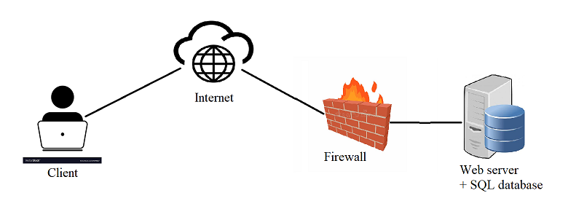

| Name | IP | Service/App |
| --- | --- | --- |
| Web Server | Virtual IP address  (Azure provides itself when creating a web app) | Web service on Azure |
| Client ( Users) | IP of PC test | Use Internet |

1. **Installation**

Step 1: Log in to the Azure portal

Step 2: Click on ***Create a resource*** and select web from the marketplace

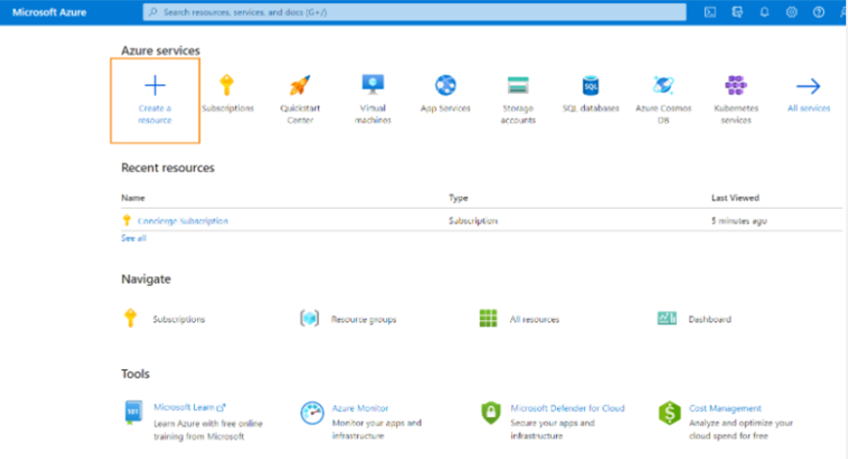

* Click on ***Create*** of ***Web App***

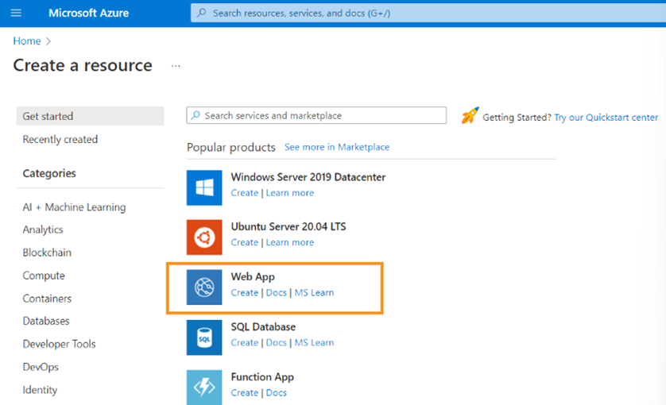

Step 3: Fill in the details in following sessions:

* ***Project details***
* ***Instance details (****App name, Kind of source code, Runtime stack, OS, Region****)***
* App name: will be the hostname for the website - which is unique
* ***App service plan (****Sku & size****)***

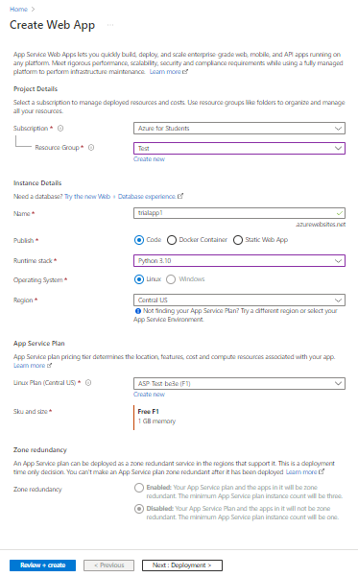

* ***Choose whether to configure Github Workflow or not (****In our case, configuring deployment with GitHub is not supported****)***

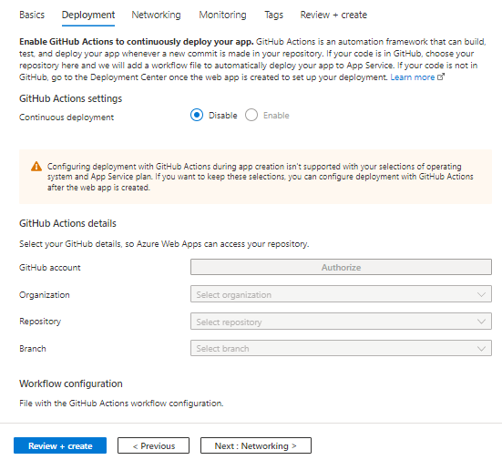

* ***Choose whether to configure Network Injection or not (****In our case, app’s address is open to the Internet and cannot reach into a virtual network by default****)***

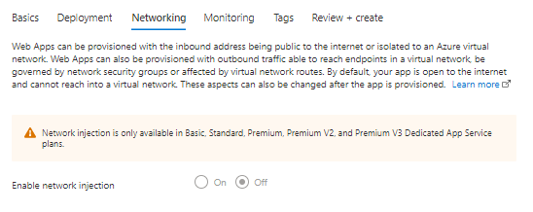

* ***Choose whether to enable Application Insights or not (****In our case, Application Insights is not supported****)***

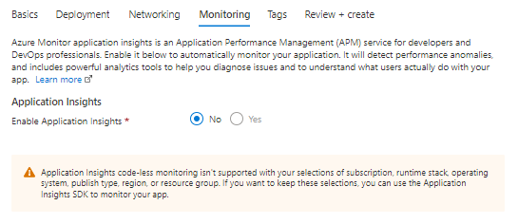

Step 3: ***Review*** the setting and ***create*** App service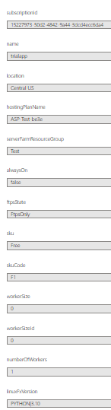

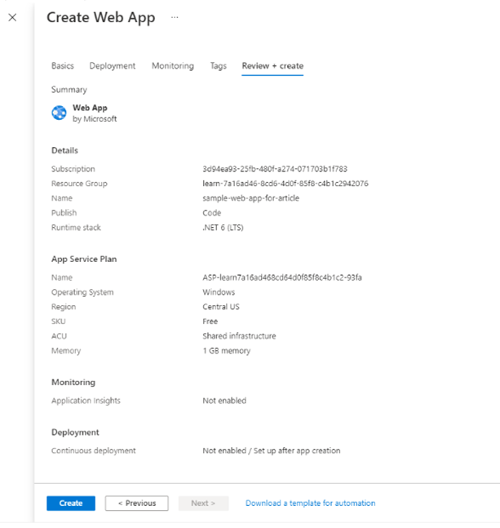

Step 4: Click on the URL that will navigate to the public view of the Web application. But at this time, it didn’t have contents of the web application.

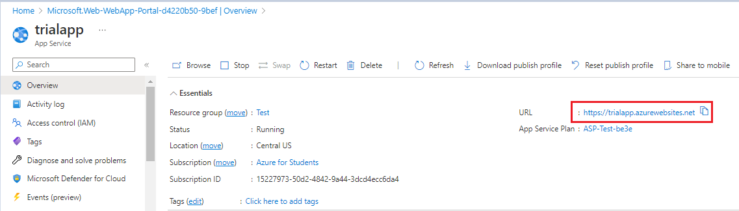

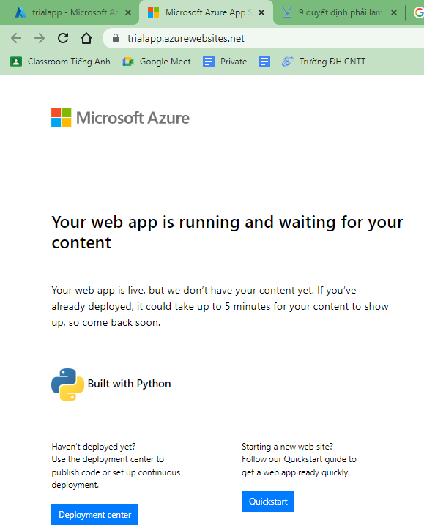

===============

1. **Configuration**

2.3.1. Configure app settings

Step 1: in the Azure portal, search for and select App Services, then select our app

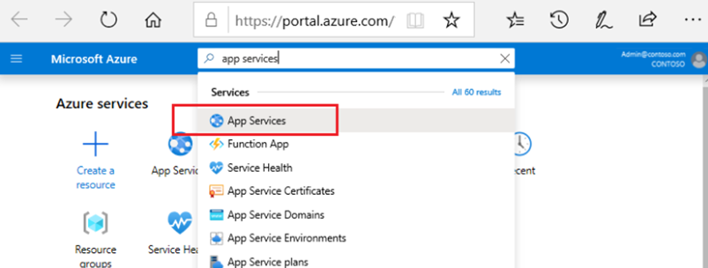

Step 2: in the app’s left menu, select Configuration -> Application settings

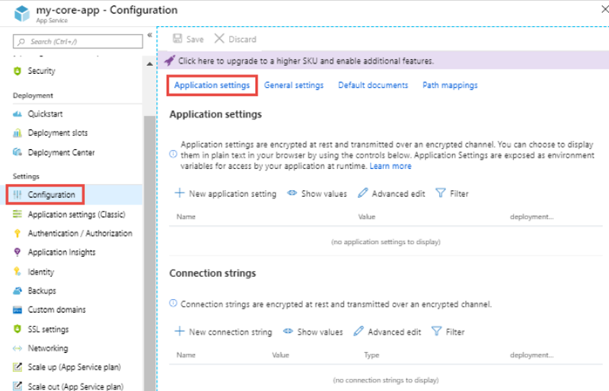

To see a hidden value of an app setting, click its Value field. To see the hidden values

of all app settings, click the Show values button.

1. **RESULT & CONCLUSION**

Appendix

1. Task
2. Self-assessment
3. Answer