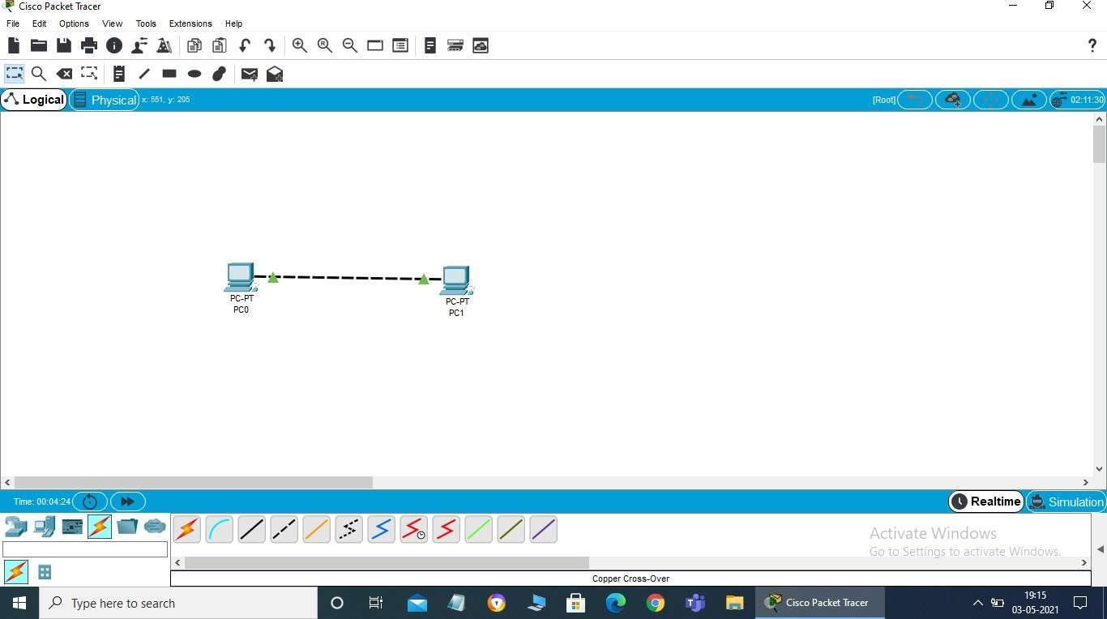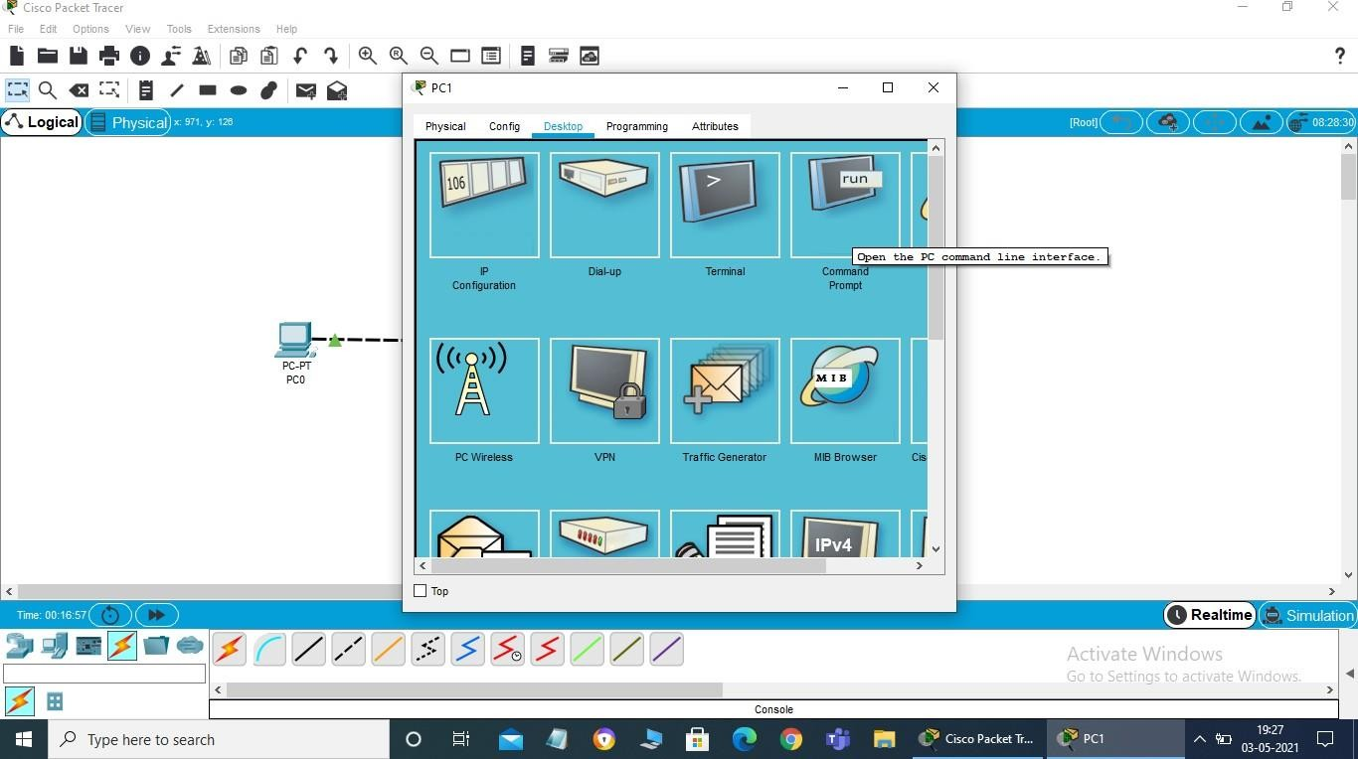

Step1

InBottom LeftSelectEndDevicesandclickonpciconanddraganddrop4pc’s

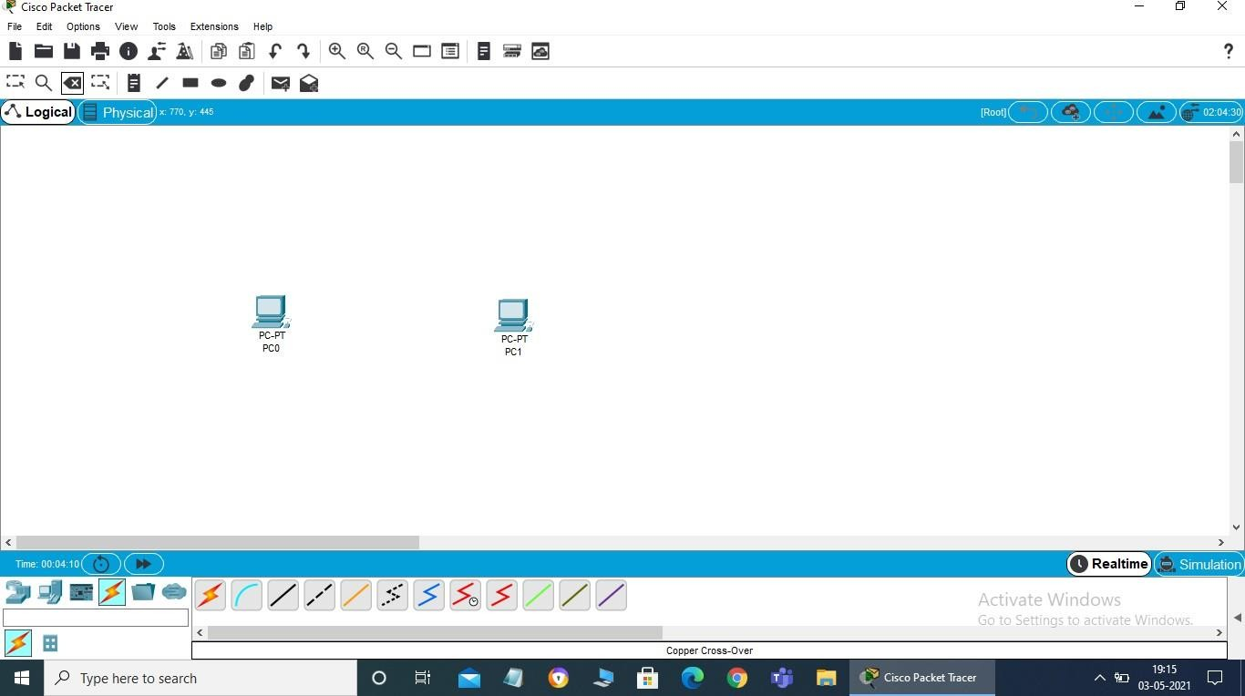

STEP2

Connectboththepcwithcrosscable

STEP3

Right click the 1st pc and click on desktop and then on ip configuration andsince it is static we willwrite the Ip address manually (192.168.10.1) then click on subnet mass it will be(255.255.255.0automaticallydothesamefor thesecondpcIpaddressfor 2ndpc(192.168.10.2)





Act ivate Wind ows

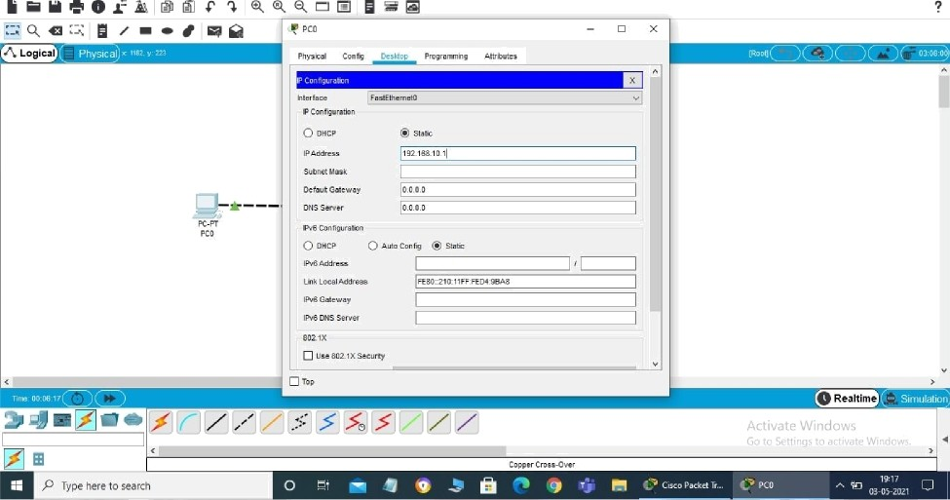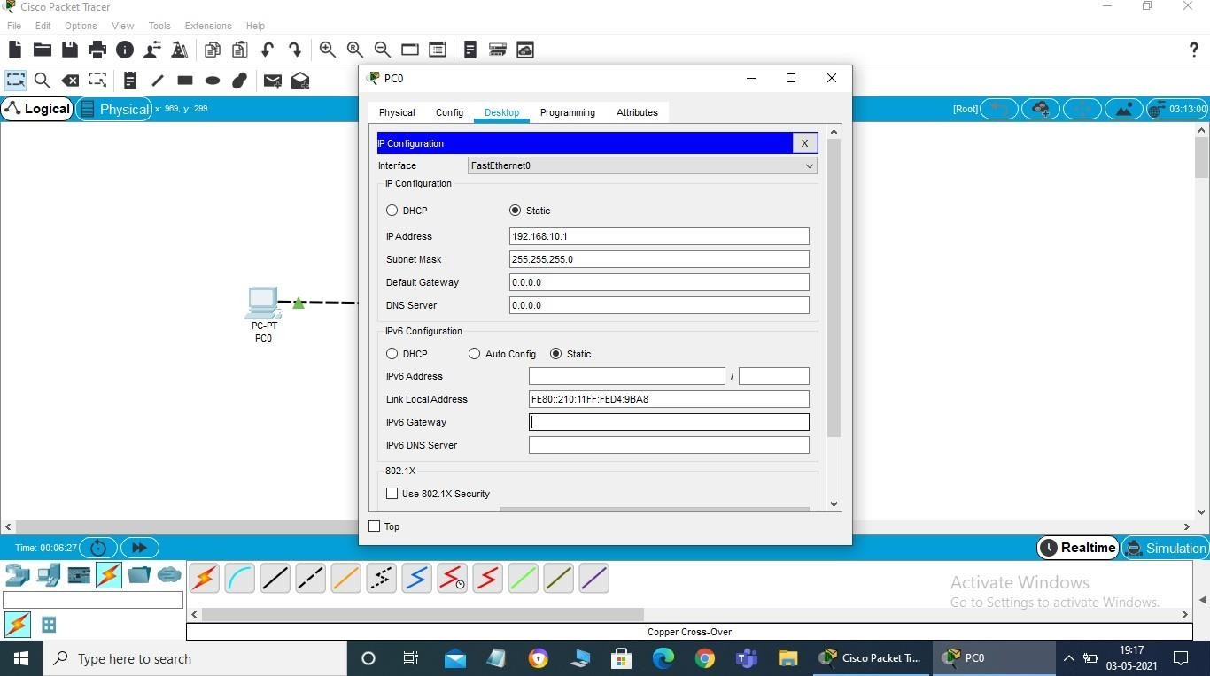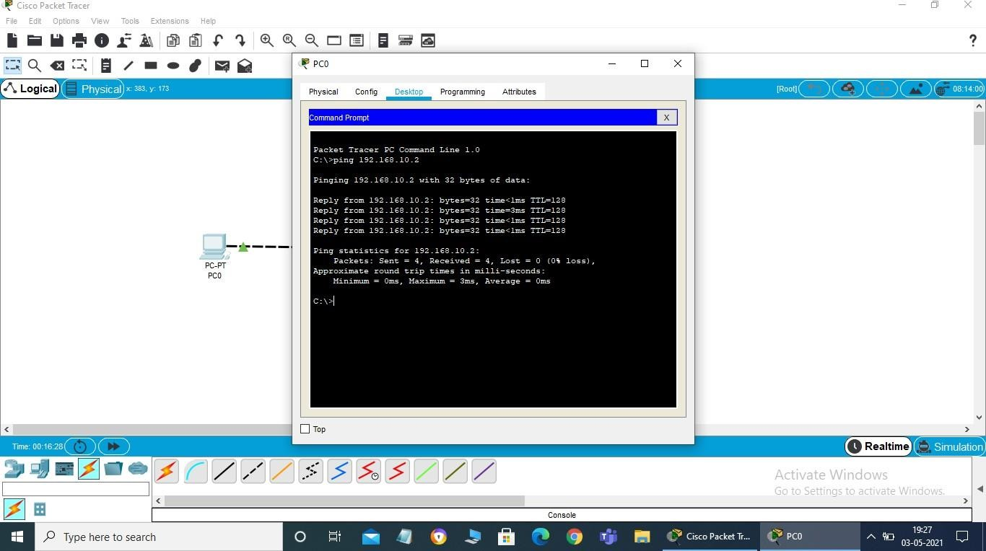

STEP4

Right click both pc one by oneand select command prompt to use ping command to find theconnectivityofboththepc

