**Name: Sagar Bhatia**

**Course: MCA 2 B**

**Question 1:** Design a network with five PCs connect with a switch using a packet tracer.

**Step 1: Establishing a connection between pc1, pc2, pc3 pc4 and pc5.**

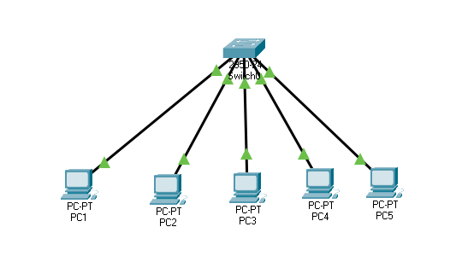

**Step 2: Providing IP address to all the PCs.**

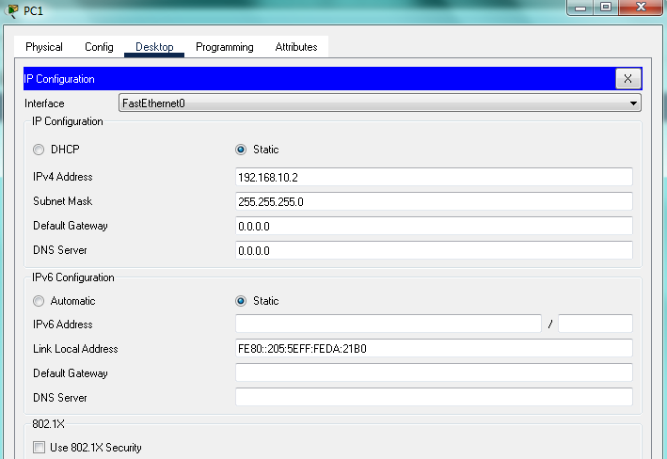

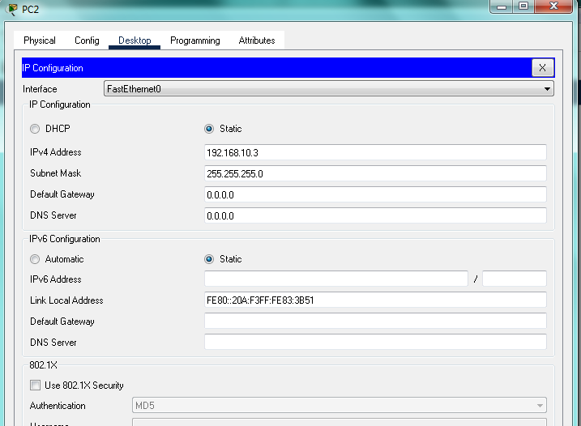

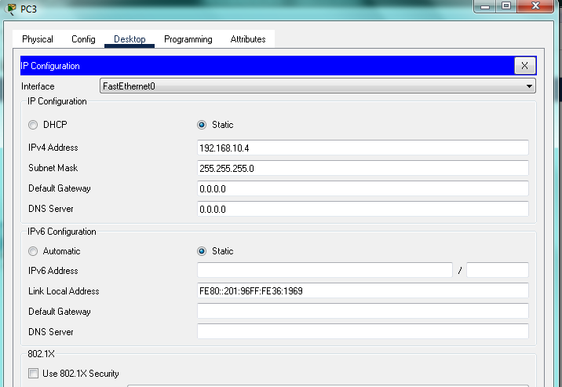

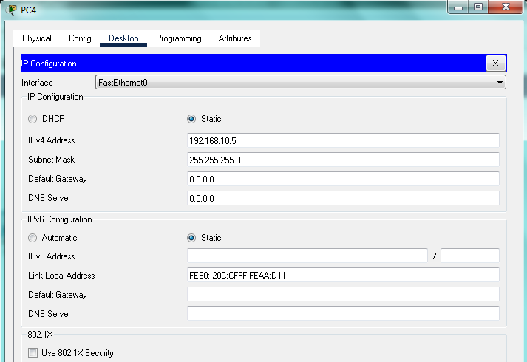

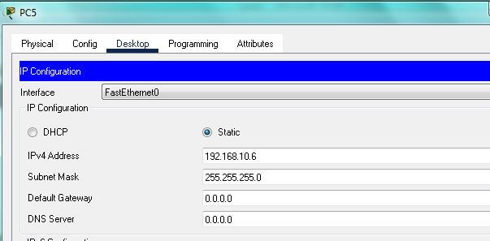

**Step 3: Configuring the IP address and connecting all PC with each other using ping command.**

