**Name: Sagar Bhatia**

**Course: MCA-2-B**

**Question 2:** Design a peer-to-peer network with two PCs.

**Step 1: Establishing a connection between pc0 and pc1.**

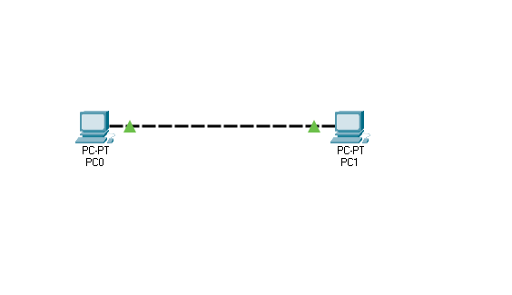

**Step 2: Providing IP address and subnet mask to both the PCs.**

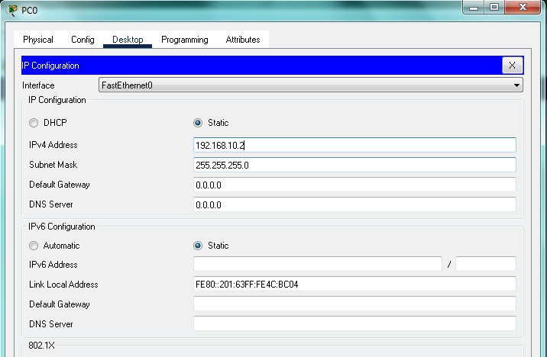

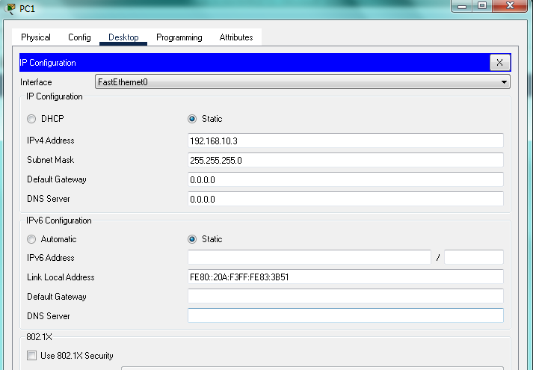

**Step 3: Configuring the IP address of the PCs.**

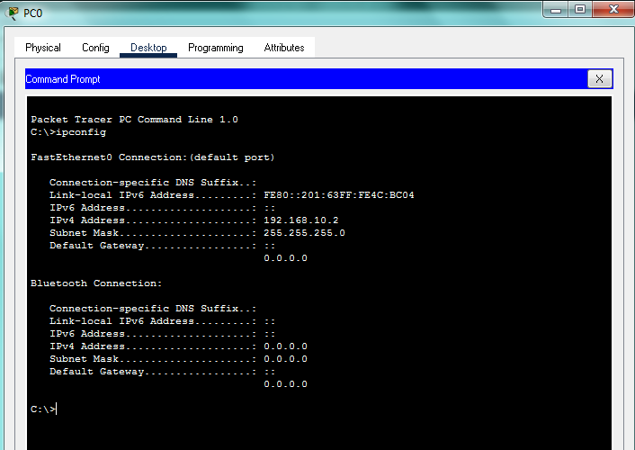

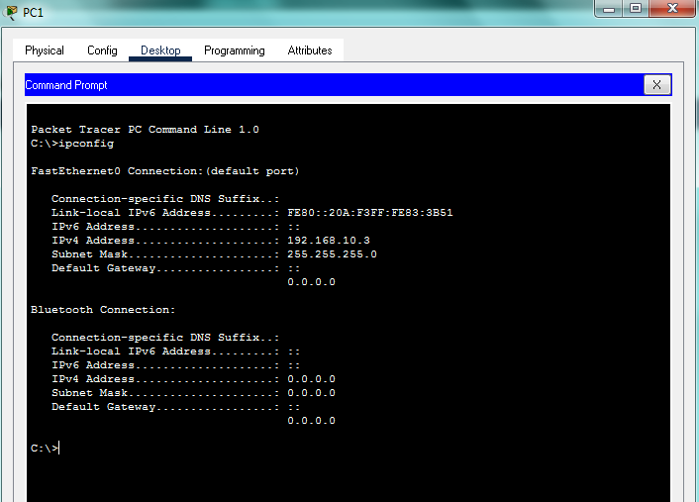

**Step 4: Checking connection from pc0 to pc1 with the help of ping command.**

