NAME:AAKANKSHA BARTHWAL

COURSE-MCA

ROLLNO-1002001

UNIVERSITYROLL NO-20712043

QUESTION 1:

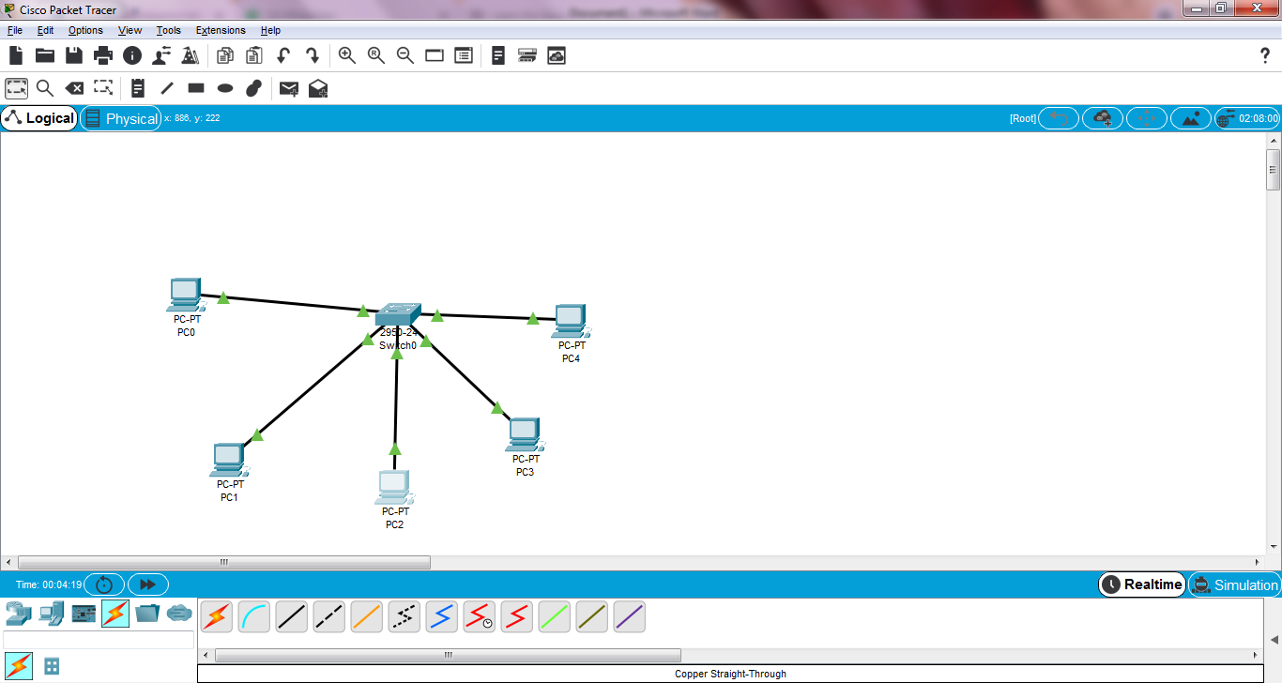

QUESTION 2:

