/\* NAME-AAKANKSHA BARTHWAL

SUBJECT-JAVA PROGRAMMING

ROLL NO-2001001

\*/

// QUESTION 1:

package javaapplication32;

/\*\*

\*

\* @author user

\*/

public class JavaApplication32 {

/\*\*

\* @param args the command line arguments

\*/

public static void main(String[] args) {

System.out.println("Hello World");

// TODO code application logic here

}

}

OUTPUT:

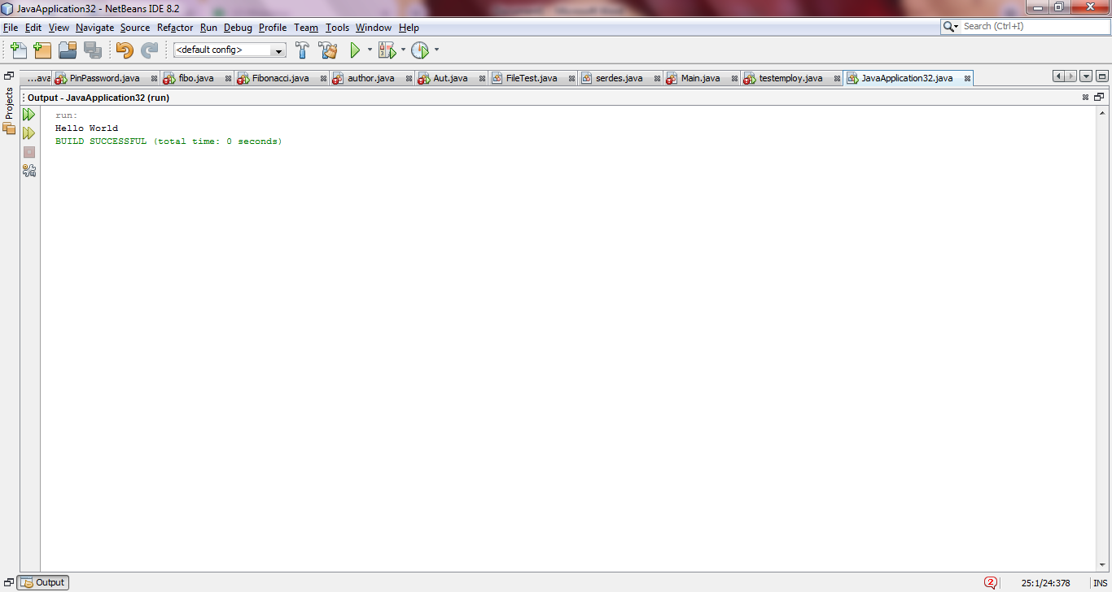

/\* NAME-AAKANKSHA BARTHWAL

SUBJECT-JAVA PROGRAMMING

ROLL NO-2001001

\*/

package javaapplication32;

/\*\*

\*

\* @author user

\*/

public class JavaApplication32 {

/\*\*

\* @param args the command line arguments

\*/

public static void main(String[] args) {

int i=1;

for(i=1;i<=5;i++)

{

System.out.println(i);

// TODO code application logic here

}

}

}

OUTPUT:

