# Name: Shubham Saklani Course: MCA

***Section: B***

***Roll No:2001148***

**Q:2)** Design a peer-to-peer network with two PCs.

## ***Step 1:*** Drag two PCs and connect them using fast ethernet.

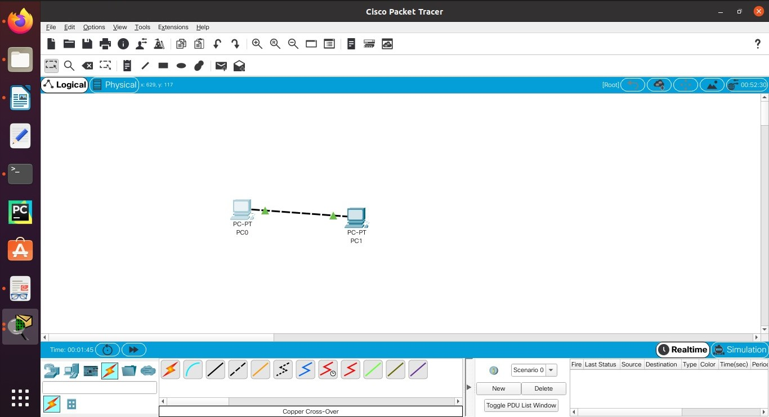

***Step 2:*** Give IP address to first PC by clicking on pc .

Desktop->Ip configuration.

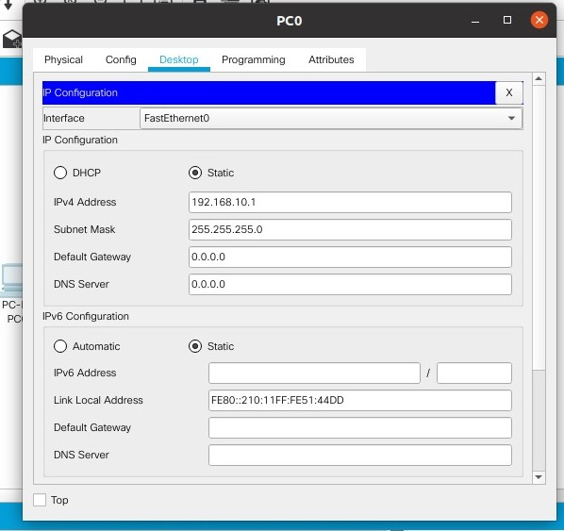

***Step 3:*** Give IP address to second PC by clicking on pc .

Desktop->Ip configuration.

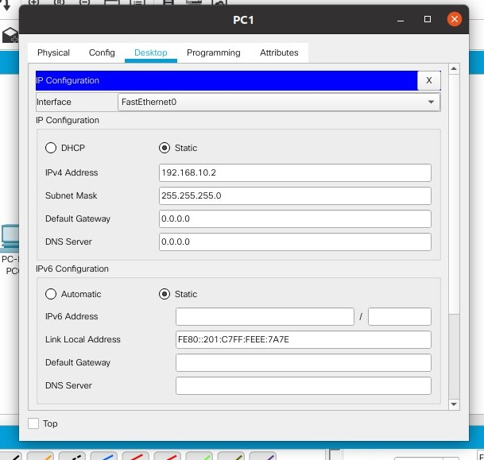

***Step 4:*** Check both PCs are connected or not using “ping” command in command prompt in PT.

