**NAME –RAVINA**

**COURSE-MCA**

**SEC-A**

**ROLL NO- 2001121**

**SUBJECT-MACHINE LEARNING USING PYTHON**

**Lab assignment**

1. Programs on Basics of Python

1. Write a program to use the mathematical operators.

print(10+5)

print(10*5)

print(10/2)

print(10%2)

print(10**2)

print(10//2)

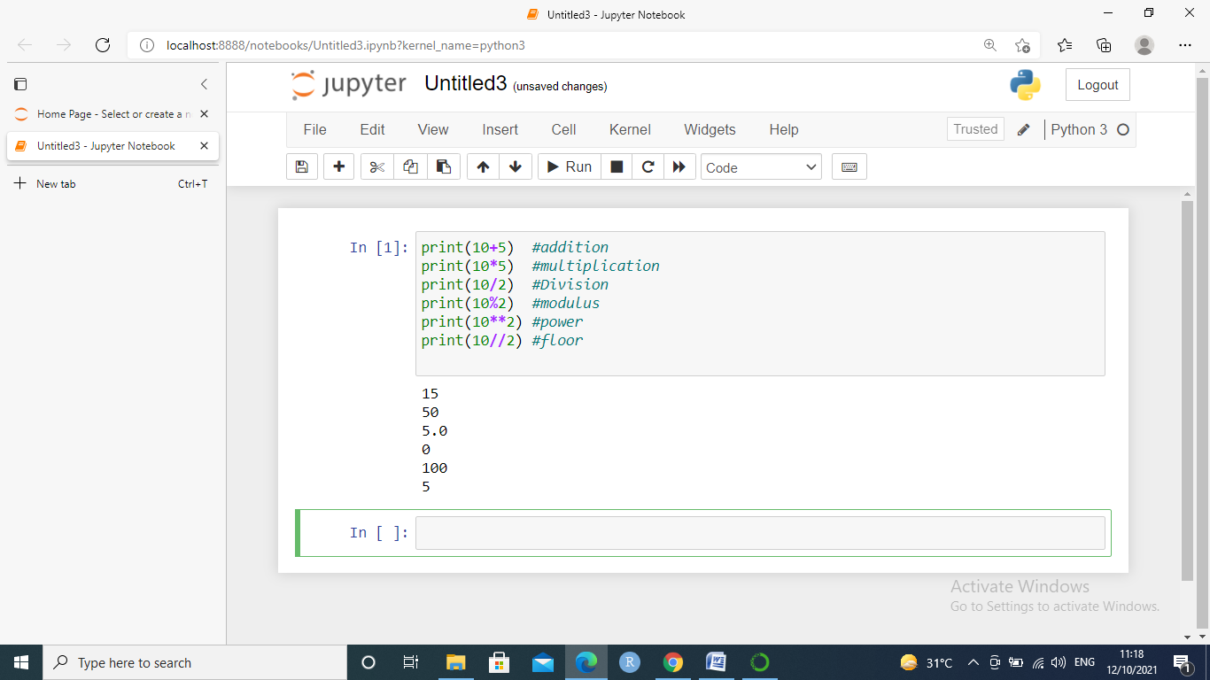

2.write a program to take an input of numbers from the user and print the Fibonacci series to the terminal number.

def fib(n):

a = 0

b = 1

if n == 1:

print(a)

else:

print(a)

print(b)

for i in range(2,n):

c = a + b

a = b

b = c

print(c)

fib(10)

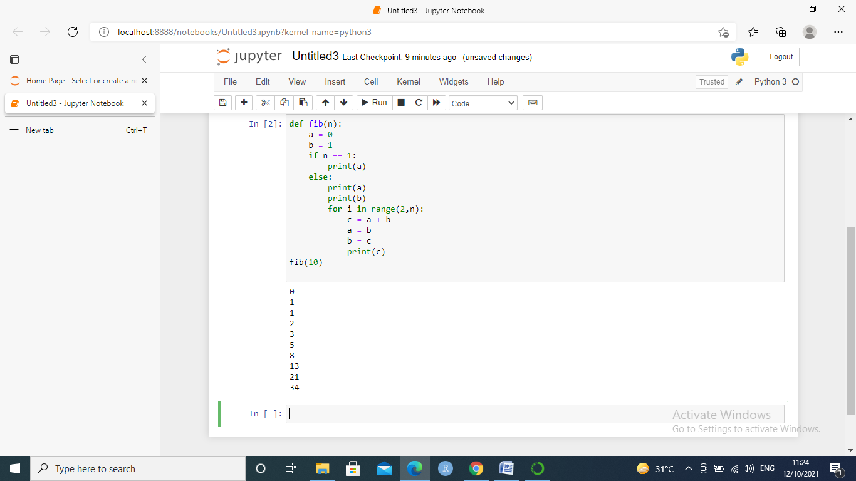

3.Write a program to print the factorial of the number input by the user.

num = int(input("Enter a number: "))

factorial = 1

if num < 0:

print(" Factorial does not exist for negative numbers")

elif num == 0:

print("The factorial of 0 is 1")

else:

for i in range(1,num + 1):

factorial = factorial*i

print("The factorial of",num,"is",factorial)

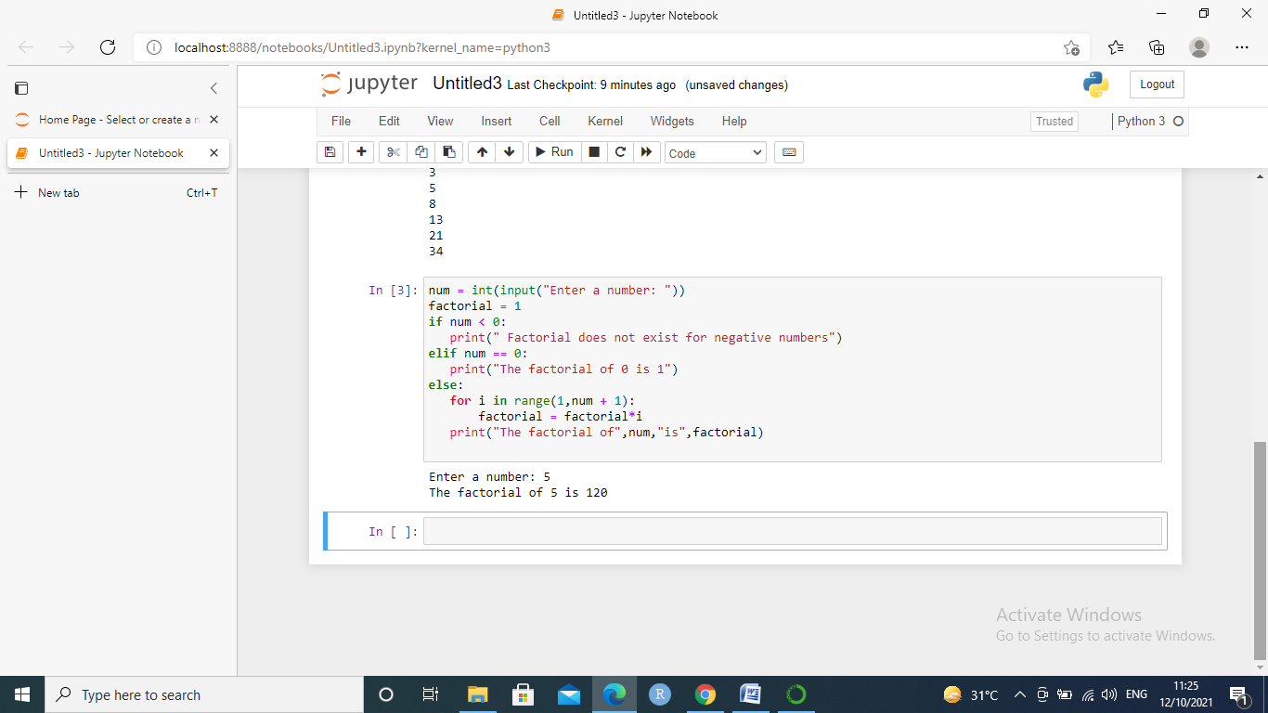

4.Write a program to check whether a given number is a prime number or not using loops.

number = int(input("Enter The Number: "))

if number > 1:

for i in range(2,int(number/2)+1):

if (number % i == 0):

print(number, "is not a Prime Number")

break

else:

print(number,"is a Prime number")

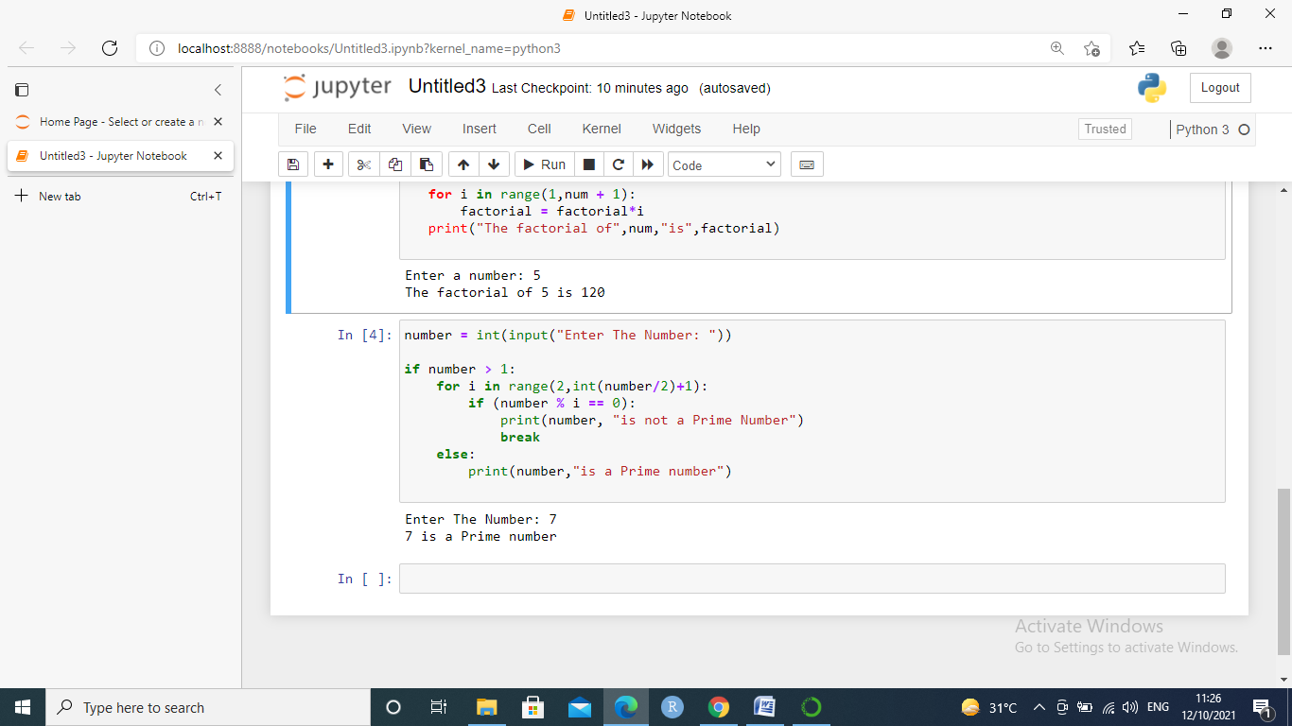

5. Write a program to demonstrate the importing of modules of python.

def display_message():

return "HELLO EVERYONE!"

import test

print(test.display_message())

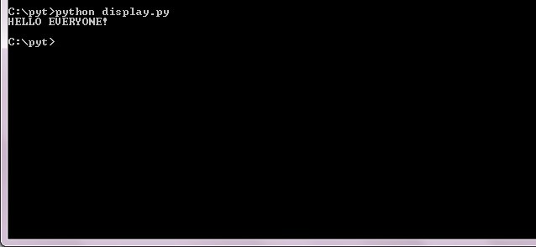

6. Write a program to demonstrate the use of nested if statements.

var = int(input("Enter a number: "))

if var < 200:

print("Input is smaller than 200 ")

if (var==150):

print("Input is smaller than 150 ")

elif (var==100):

print("Input is smaller than 100 ")

elif (var==50):

print("Input is smaller than 50 ")

else:

print("Input is greater than 200 ")

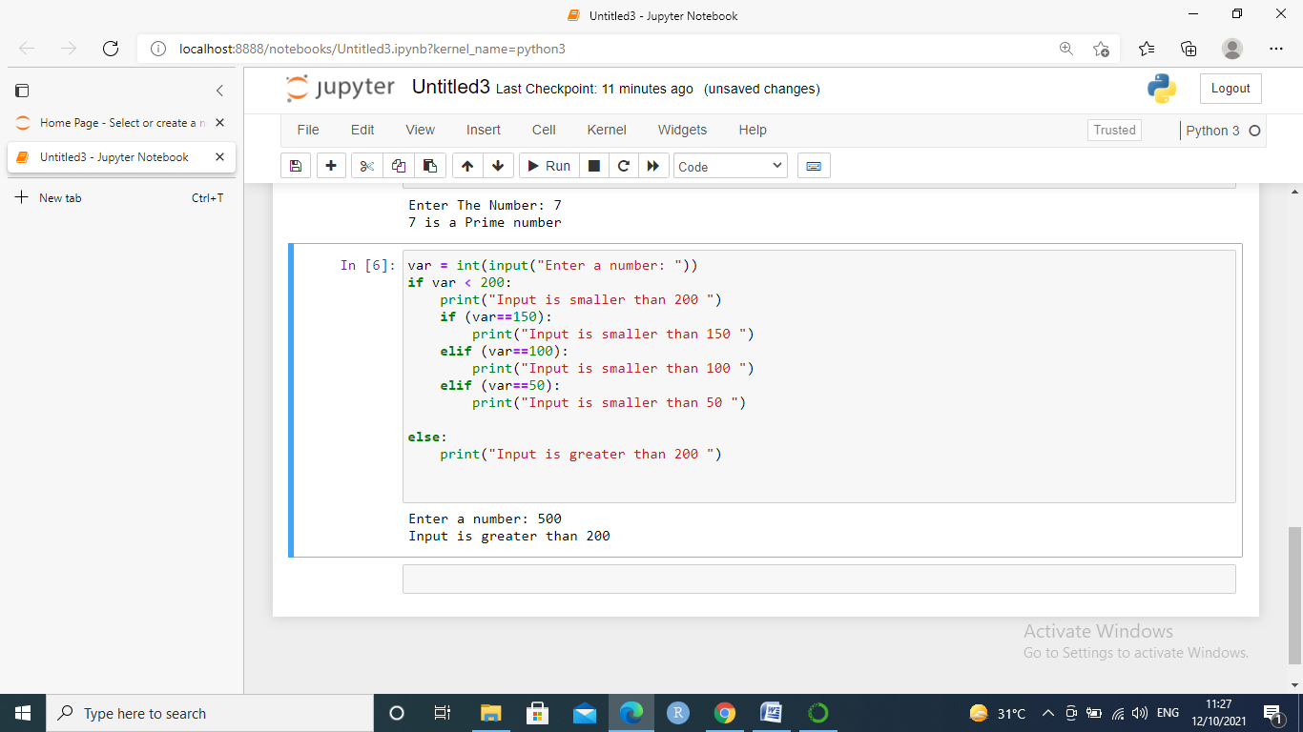

7. Write a program to demonstrate the use of the else clause.

var1 = int(input("Enter value for var1: "))

var2 = int(input("Enter value for var2: "))

if var1:

print("1 - Got a true value")

print(var1)

else:

print ("1 - Got a false value")

print (var1)

if var2:

print ("2 - Got a true value")

print (var2)

else:

print ("2 - Got a false value")

print (var2)

print ("Good bye!")

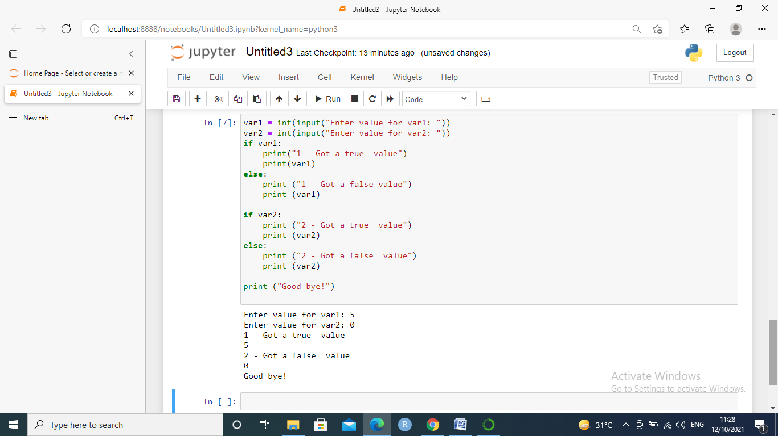

8. Write a program to illustrate the usage of Tuples.

L1=["apple","mango","banana","kiwi"]

L2=["Rose","Lily","Sunflower"]

# appending new elements to the list

L1.append(L2)

print(L1)

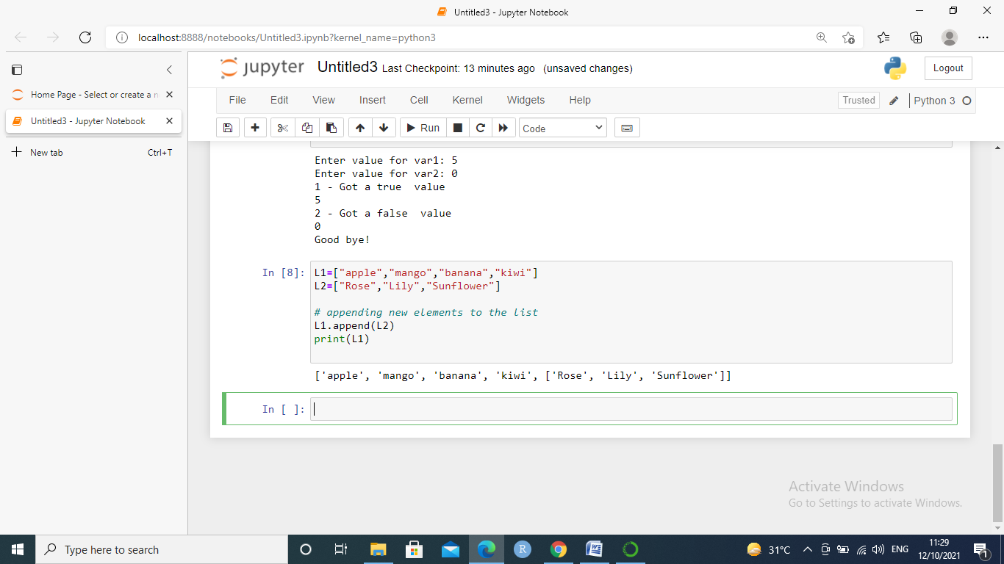

9. Write a program for searching an element and sorting a List.

def search(Li, x):

for i in range(len(Li)):

if Li[i] == x:

return i

return -1

Li=[12,87,34 ,95,67 ,78,39,25,45,56,48,66,99,100]

num = int(input("Enter the number you want to search: "))

result = search(Li,num)

if (result==1):

print(num ,"is at ", result,"th index")

else:

print("The element you want to search is not present in the list.")

print(" ")

print("List before soting: ")

print(Li)

Li.sort()

print("List after sorting: ")

print(Li)

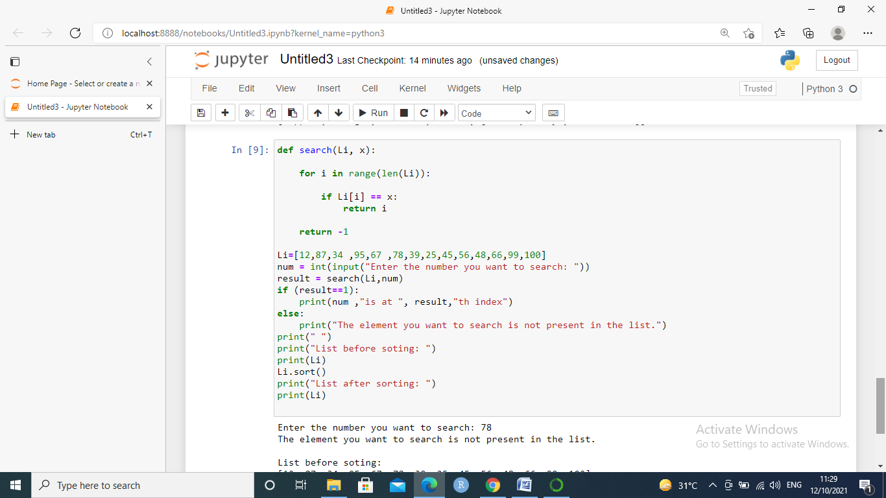

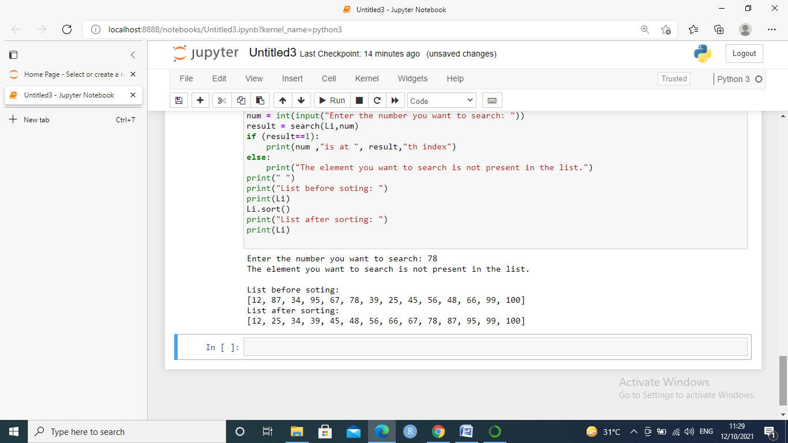

10. Write a program to illustrate the usage of Dictionaries.

dict={}

dict={1:'Monday',2:'Tuesday',3:'Wednesday',4:'Thursday',5:'Friday',6:'Saturday',7:'Sunday'}

print("Type",type(dict))

print(dict)

print(dict[1])

res=dict.get("2")

print(res)

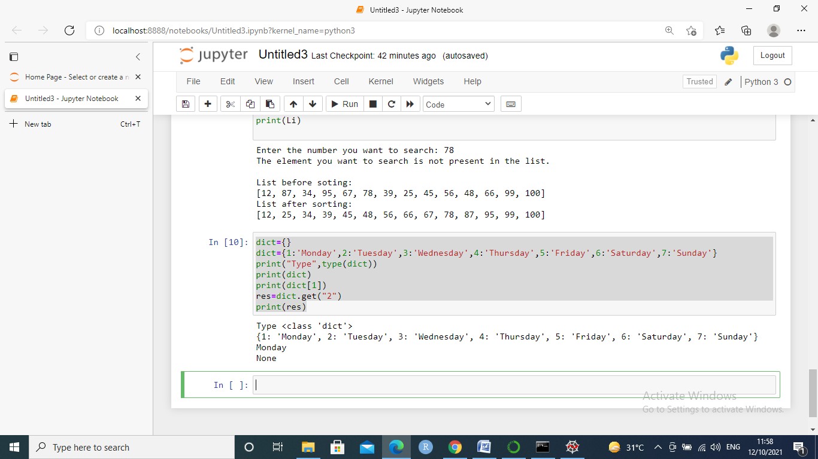

1. Programs on Statistical Concepts and introduction to Linear Algebra using Python

1.Write a program to find the mean. mode and median of the given range of numbers.

#ques1

sum=0

x=[2,3,4,6,2,4,5,6,7,8]

#mean

for i in x:

sum=sum+i

mean=sum/len(x)

print(mean)

#median

n=len(x)

x.sort()

if(n%2==0):

med1=n//2

med2=(n//2)+1

final_median=(x[med1-1]+x[med2-1])/2

else:

final_median=x[n//2]

print(final_median)

#mode

import statistics

mode2=statistics.mode(x)

print(mode2)

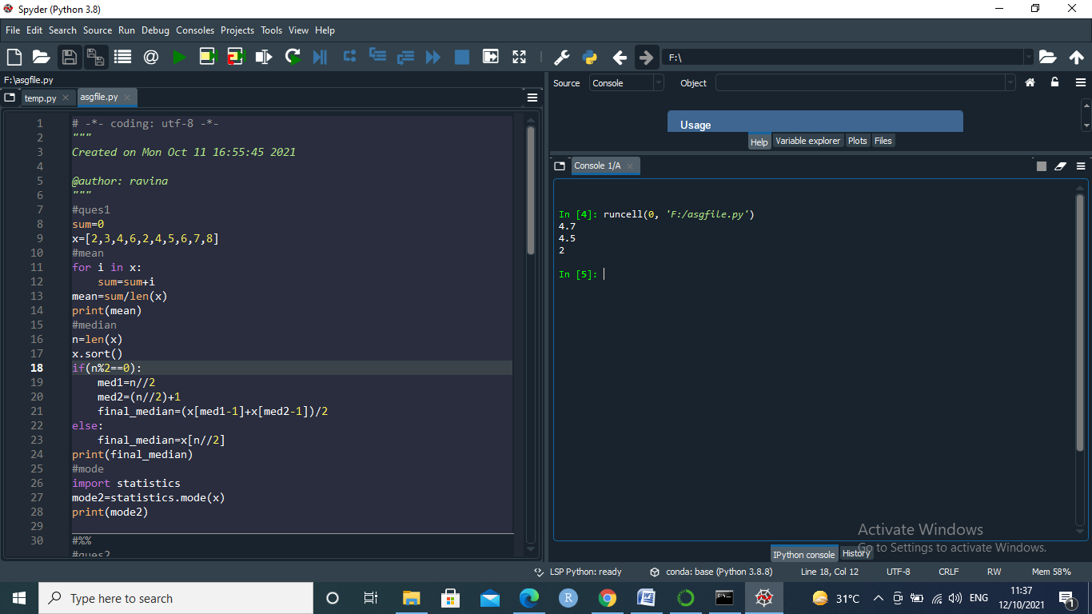

2 Write a program to calculate the standard deviation of a given set of numbers.

observation = [1,5,4,2,0]

sum=0

for i in range(len(observation)):

sum+=observation[i]

mean= sum/len(observation)

sum_of_squared_deviation = 0

for i in range(len(observation)):

sum_of_squared_deviation+=(observation[i]- mean)**2

sd = ((sum_of_squared_deviation)/len(observation))**0.5

print("Standard Deviation of sample is ",sd)

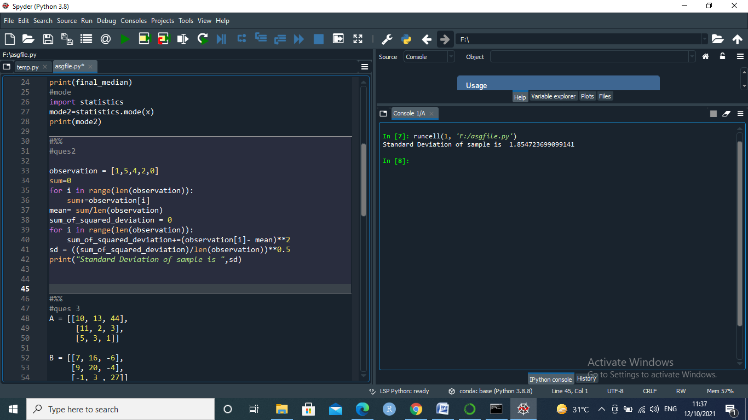

1. Write a program to calculate the addition of two 3x 3 matrices.

#ques 3

A = [[10, 13, 44],

[11, 2, 3],

[5, 3, 1]]

B = [[7, 16, -6],

[9, 20, -4],

[-1, 3 , 27]]

C = [[0,0,0],

[0,0,0],

[0,0,0]]

matrix_length = len(A)

#To Add mat1 and mat2 matrices

for i in range(len(A)):

for k in range(len(B)):

C[i][k] = A[i][k] + B[i][k]

#To Print the matrix

print("The sum of Matrix mat1 and mat2 = ", C)

for i in C:

print (i)

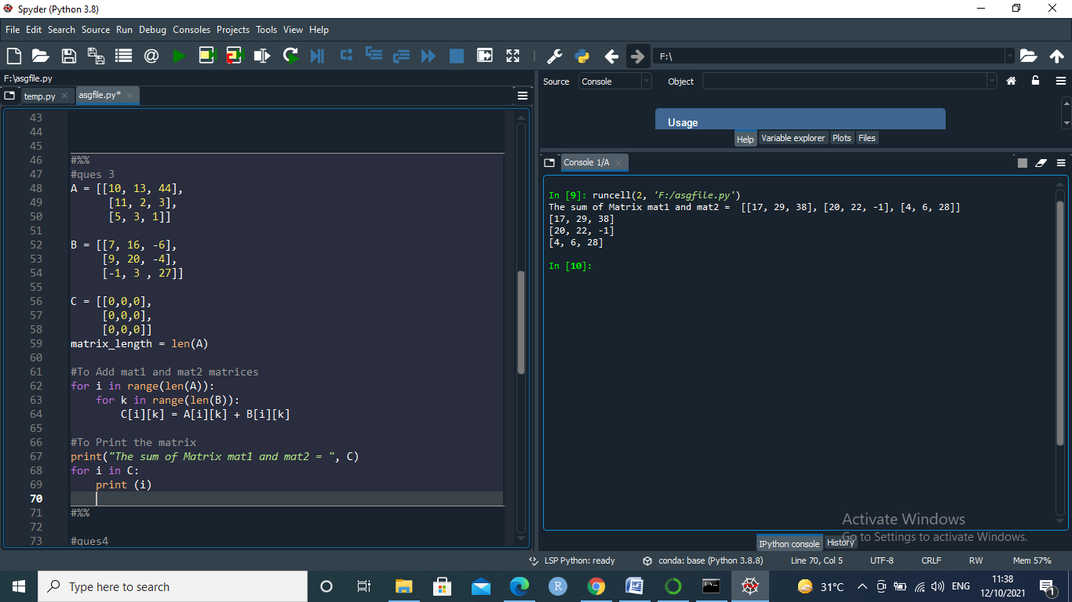

1. Write a program to calculate the multiplication of two 3x 3 matrices.

#ques4

# 3x3 matrix

X = [[12,7,3],

[4 ,5,6],

[7 ,8,9]]

# 3x4 matrix

Y = [[5,8,1,2],

[6,7,3,0],

[4,5,9,1]]

# result is 3x4

result = [[0,0,0,0],

[0,0,0,0],

[0,0,0,0]]

# iterate through rows of X

for i in range(len(X)):

# iterate through columns of Y

for j in range(len(Y[0])):

# iterate through rows of Y

for k in range(len(Y)):

result[i][j] += X[i][k] * Y[k][j]

for r in result:

print(r)

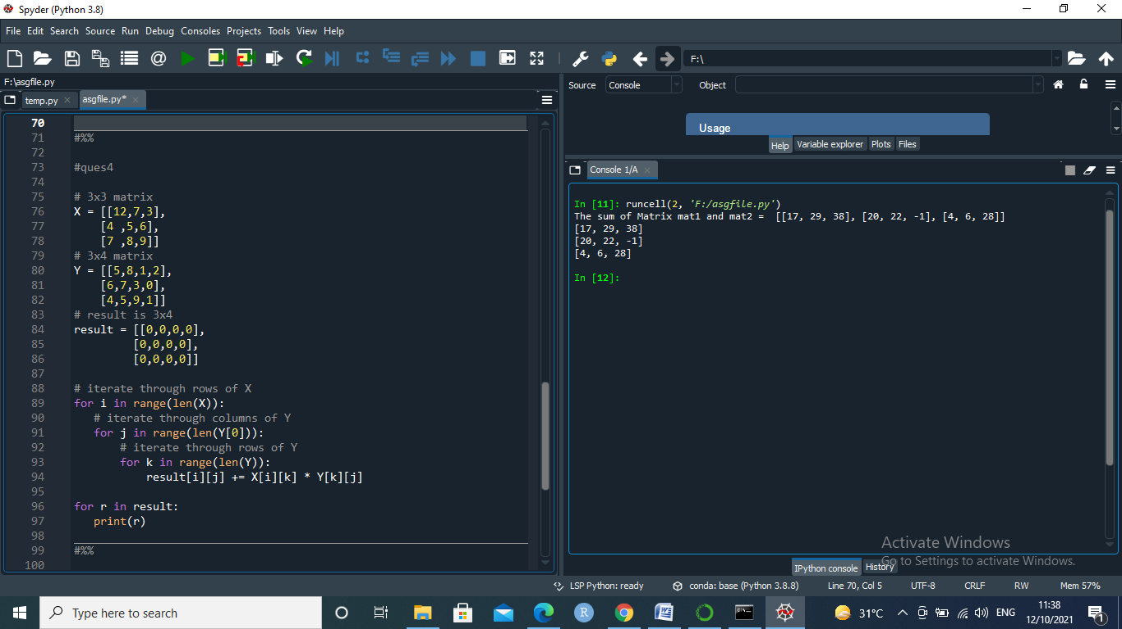

1. Write a program to calculate the inverse of the given matrix.

# ques 5

# Transpose of Matrix

# 3x3 matrix

X = [[12,7,3],

[4 ,5,6],

[7 ,8,9]]

Transpose = [[0,0,0],

[0,0,0],

[0,0,0]]

for i in range(len(A)):

for k in range(len(B)):

Transpose[i][k] = X[k][i]

for t in Transpose:

print(t)

