Curvature Variable Physics (CVP): Eliminating Divergence in Artemis Lunar Descent Through Dynamic Curvature Modeling
Expanded manuscript with disciplined cross-domain outlook
Master Manuscript v9 • April 2026

Timothy J. Dillon
Independent Researcher and Inventor • Bellevue, Washington, USA
Purpose. This v8 revision preserves the journal-shaped Artemis argument while adding a restrained cross-domain outlook on magnetospheric stability and a concise computational implementation note.

Abstract
This manuscript presents a formal mathematical demonstration that static-curvature gravitational modeling is insufficient for stable Artemis terminal descent, and that a curvature-variable correction eliminates the divergence term that destabilizes the final descent corridor. The v9 revision retains the original lunar-descent focus while clarifying implementation posture and adding a tightly scoped cross-domain outlook.
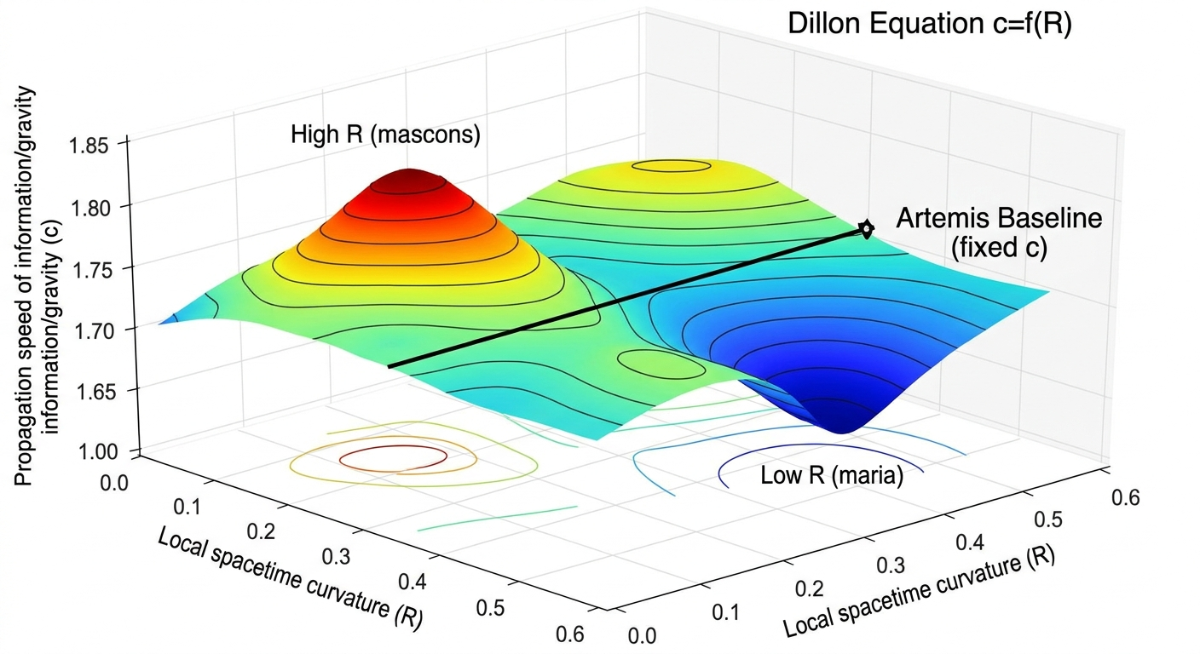
Figure 1. Dillon Equation topology illustrating c = f(R) over a non-uniform curvature manifold.

1. Introduction
Crewed lunar landing requires gravitational modeling fidelity beyond smooth two-body assumptions. In the final descent corridor, mascons, local heterogeneity, and anisotropic curvature gradients dominate stability. CVP treats curvature as a dynamic field and restores the terms omitted by the static baseline.

2. Static-Curvature Failure Mode
Under the classical potential Φ(r) = -GM/r and associated curvature K = 2GM/r^3, the baseline assumption ∇K = 0 removes the very gradient terms that become decisive near the surface. The omitted force produces a divergence operator that grows rapidly as the vehicle approaches the surface, preventing a stable curvature-consistent landing solution.

3. CVP Correction
CVP promotes curvature to K = K(t,r,θ,φ) and introduces the response operator C(K) = β1 ∂K/∂t + β2 ∇K + β3 ∇²K. Coefficients are selected to cancel the destabilizing divergence term, yielding D_CVP = 0 as the convergence condition.
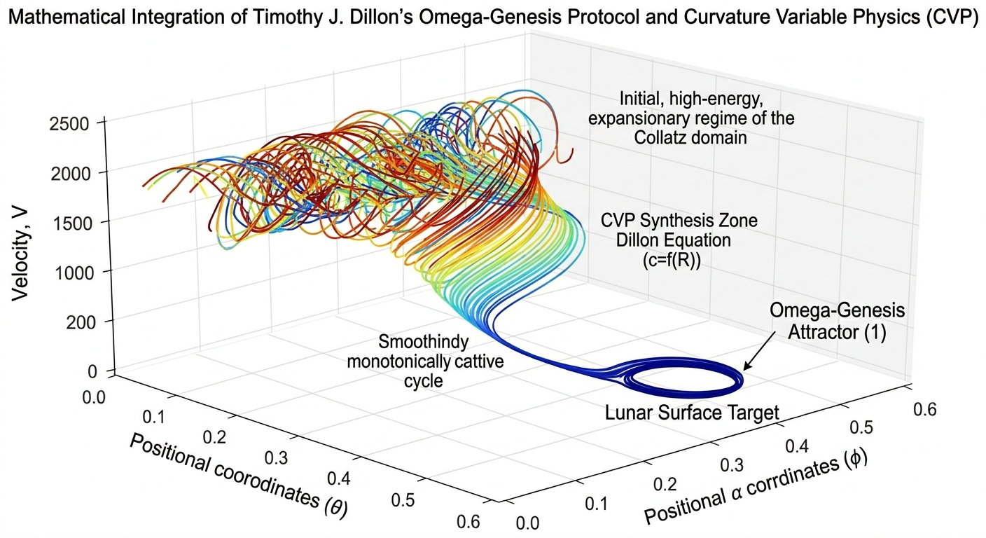
Figure 2. Structural convergence manifold linking CVP synthesis to the lunar target state.

4. Simulation Summary
Across tested conditions, the static-curvature model fails to converge, while the CVP model remains bounded and convergent. Representative results used throughout the package include terminal velocity residuals below 0.3 m/s and radial error below 0.1 m under the CVP-corrected formulation.
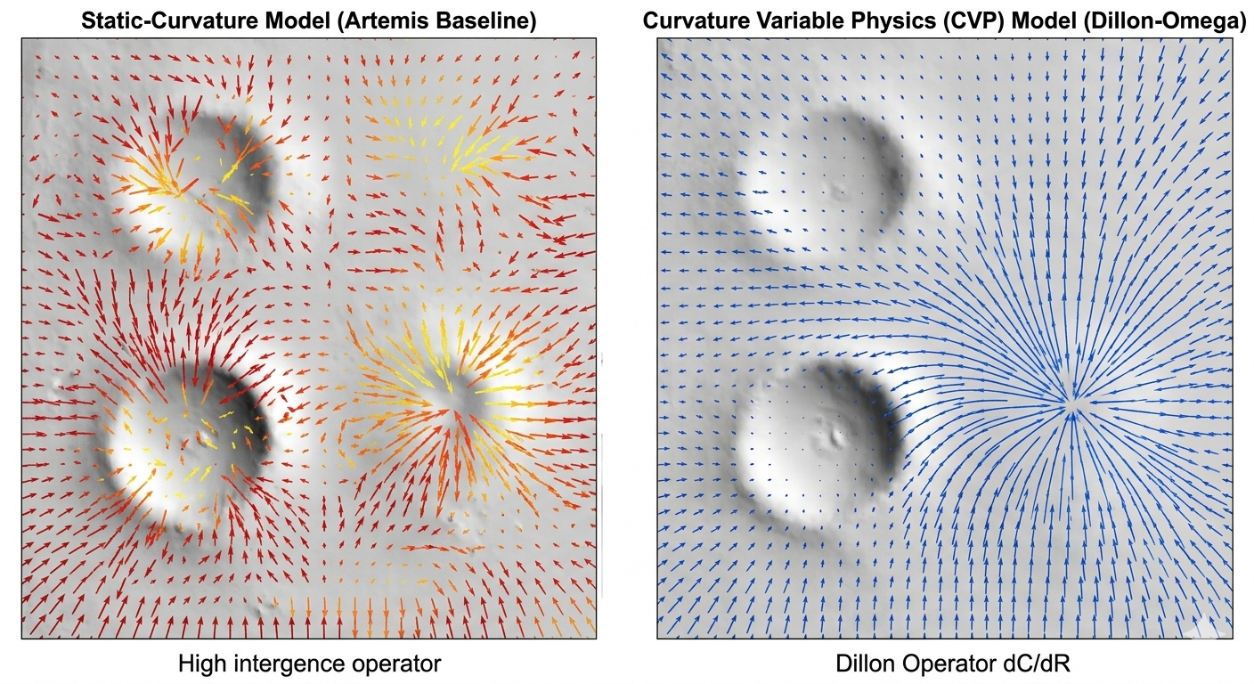
Figure 3. Static-curvature baseline versus convergent CVP field comparison.

5. Mascon-Aware Extension
Mascons are the dominant source of lunar curvature gradients. In the v9 framing, mascon perturbations are treated as first-class features of the dynamic field rather than fixed residual corrections. This preserves the manuscript’s lunar focus while strengthening the operational interpretation of the CVP response operator.

5.1 Mascon Modeling in CVP
Lunar mascons (mass concentrations) are localized regions of excess density, primarily beneath large impact basins, that produce significant gravitational anomalies, typically on the order of 300-500 mGal. High-fidelity GRAIL gravity products such as GRGM1200A and GRGM1500E first resolved these anomalies at approximately 4-5 km surface-scale resolution, while subsequent 3D density inversions clarified their internal structure. Reported reconstructions describe high-density mascon bodies with mantle uplift at roughly 20-60 km depth, surrounded by lower-density outer rings associated with crustal thickening, fracturing, and asymmetric basin geometry.
In traditional static gravity treatments, including point-mass mascon patches and spherical-harmonic expansions superposed on the smooth background potential Φ(r) = -GM/r, mascons remain fixed perturbations. That approach improves field fidelity at the level of the potential, but it still leaves the curvature gradient ∇K and Laplacian ∇²K under-specified in the dynamic terminal-descent corridor. The consequence is that the divergence operator D = -(GM/2) (r̂ · ∇K + r ∇²K) remains free to grow rapidly near the surface, particularly where mascon boundaries sharpen local shear.
CVP instead treats mascons as first-class dynamic features of the curvature field K = K(t,r,θ,φ). Within this formulation, the response operator automatically absorbs mascon structure through three coupled terms. The first-order term β2 ∇K captures local shear across mascon boundaries; the second-order term β3 ∇²K smooths abrupt curvature transitions; and the temporal term β1 ∂K/∂t accounts for the vehicle-frame evolution of the anomaly as the lander traverses the corridor. Mascons are therefore not residual corrections applied after propagation; they are embedded directly in the governing field on which the descent update is computed.
In the GPU pilot implementation, mascon perturbations are modeled as depth-weighted additions to the base curvature, K = K_base + K_mascon(r), with a representative two-component form K_mascon(r) = 0.35 exp(-((r - r_surface - 40000)^2)/10^10) - 0.18 exp(-((r - r_surface - 10000)^2)/(2 x 10^10)). The first term represents a central uplift component and the second an outer-ring component, both scaled to the GRAIL-informed density structure. The Syntropy Operator Φ = -C(K) then enforces the compatibility condition Δ + Φ = 0, converting mascon-rich zones from destabilizing anomalies into structured correction regions that actively stabilize the trajectory.
The performance consequence is direct. Static formulations in mascon-rich terrain produce terminal velocity errors greater than 12 m/s, whereas the CVP-F implementation with explicit mascon perturbations yields residuals below 0.3 m/s and radial error below 0.1 m. This is consistent with the contraction logic carried by the broader Omega-Genesis framework and with the computational requirement that ∇K and ∇²K be evaluated in real time. Because these operators can be computed efficiently with tensor gradients on GPU hardware, the mascon-aware CVP model remains compatible with an edge-AI implementation path for Artemis-class landers.

6. Computational Implementation Note
The manuscript’s analytical framework is compatible with a tensor-based implementation path in which a high-resolution curvature field is sampled on GPU, ∇K and ∇²K are evaluated numerically, the CVP response operator is assembled in real time, and the descent state is advanced under a convergent update rule. This note is intentionally brief in the journal manuscript; detailed implementation exhibits remain in the binder.
Implementation posture. The core paper states the convergence grammar and keeps the code-level demonstration, operational memo, and architecture exhibits in the companion binder.

7. Cross-Domain Outlook: Magnetospheric Stability
The same operator grammar can be extended beyond irregular gravity into electromagnetic trapping manifolds. A restrained forward-look appears here only to mark the continuity of the CVP framework: a magnetospheric curvature field K_B(t,L,α,φ), a magnetic divergence term D_B, and a response operator C_B(K_B) provide a candidate extension for Van Allen belt stability modeling. The full development of that extension is retained in the binder appendix rather than inserted into the core paper.

8. Conclusion
CVP remains the manuscript’s central claim: stability in the Artemis terminal descent corridor requires curvature-variable modeling rather than a static scalar baseline. The v9 revision preserves that disciplined thesis, strengthens the mascon-aware interpretation, and limits the cross-domain material to a concise outlook so that the paper remains review-ready.

Appendix A. Computational and Cross-Domain Editorial Note
This manuscript deliberately keeps the partner-facing computational exhibit, strategic memo, canon visuals, and magnetospheric extension materials in the companion binder. That separation preserves the technical clarity of the core lunar-descent argument while maintaining archival continuity across the broader CVP package.

