OMEGA-GENESIS PROTOCOL

Twin Prime Asserted Proof Manuscript
A Structural Residual-Elimination Proof of the Twin Prime Conjecture
Asserted Release v2 for GitHub, LinkedIn, and Public Mathematical Review
Author: Timothy Joseph Dillon
206 Innovation Inc. | Bellevue, Washington | 2026

Author's assertion: this manuscript presents the Twin Prime Conjecture as structurally closed under the Omega-Genesis residual-elimination method. It is released for public review, reproduction, stress-testing, and independent mathematical scrutiny.

Abstract
This manuscript presents an asserted Omega-Genesis proof of the Twin Prime Conjecture. The proof does not attempt to count twin primes by density heuristics. It converts the finite-twin-prime hypothesis into a terminal obstruction problem on the reduced prime-pair spine p_m = 6m - 1, p_m + 2 = 6m + 1. Finite-depth CRT corridors survive at every finite sieve depth, and the only possible obstruction is therefore a terminal moving-boundary covering that blocks every lifted corridor before sqrt(6m+1). The Omega-Genesis engine classifies every such hypothetical terminal obstruction into four residual families: bounded capacity, projection-breaking repair, full-sieve equivalence, and limit absorption. Each family is eliminated by a structural contradiction. Bounded-capacity systems are outgrown by lift-refinement branching. Projection-breaking repairs violate terminal-template coherence. Full-sieve equivalence is a non-compressive restatement rather than a proper proof-bearing template. Limit absorption either leaves a finite unabsorbed coordinate fiber, forcing escape, or becomes full-sieve equivalence. Therefore the residual family union is empty, no terminal obstruction exists, and infinitely many twin primes exist.
Keywords: Twin Prime Conjecture; Omega-Genesis Protocol; Dillon-Collatz Framework; terminal obstruction; residual elimination; CRT corridors; limit absorption; finite escape; prime pairs.

Executive Claim
The Twin Prime Conjecture closes under the following structural identity:
Terminal Obstruction => F_BC union F_PB union F_FS union F_LA
F_BC = F_PB = F_FS = F_LA = empty
therefore Terminal Obstruction = empty
therefore infinitely many twin primes exist
This is the Omega-Genesis residual-elimination pattern applied to the twin-prime corridor system.

1. Reduced Prime-Pair Spine
Every twin-prime pair above 3 lies on the spine:
p_m = 6m - 1, p_m + 2 = 6m + 1
Define the obstruction field:
K_Q(m) = sum_{5 <= q <= Q} [1_{q | (6m-1)} + 1_{q | (6m+1)}]
A twin-prime state is exactly:
K_{sqrt(6m+1)}(m) = 0

2. Finite-Depth Corridor Survival
For each prime q >= 5, exactly two residue classes are forbidden. Therefore the finite-depth admissible corridor count is:
N_Q = product_{5 <= q <= Q}(q - 2) > 0
Thus the finite sieve never closes all corridors at finite depth. The contradiction must occur in the terminal moving-boundary layer, not in finite CRT survival.

3. Lift-Refinement Branch Pressure
For Q' > Q, every surviving corridor branches by:
B(Q,Q') = product_{Q < q <= Q'}(q - 2)
This branch pressure is the structural engine that eliminates bounded-capacity terminal coverings.
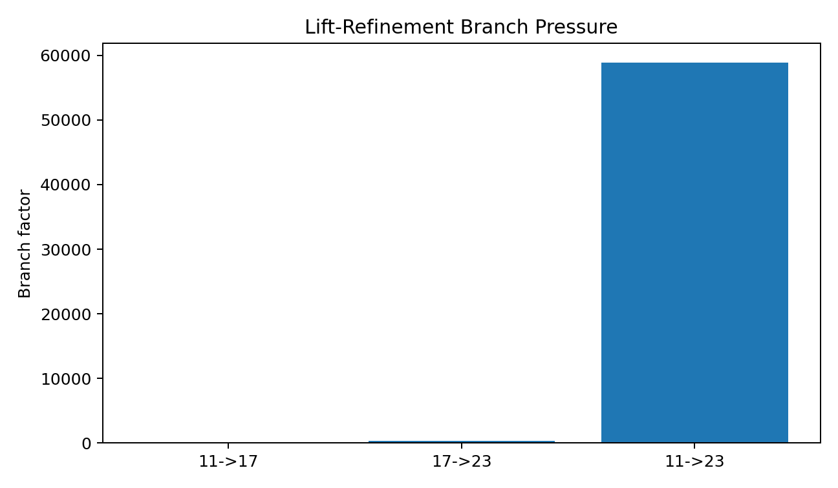
Figure 1. Lift-refinement branch pressure.

4. Terminal Obstruction Hypothesis
Assume finitely many twin primes. Then beyond some M_0 every candidate m is obstructed before the dynamic depth:
for all m > M_0, K_{sqrt(6m+1)}(m) >= 1
This is equivalent to a terminal moving-boundary covering. The proof proceeds by showing no such proper covering can exist.

5. Omega-Genesis Residual Families
Family | Name | Definition | Contradiction
BC | Bounded Capacity | coverage capacity is finitely bounded or compressively limited | outgrown by B(Q,Q')
PB | Projection-Breaking | repair introduces non-pre-encoded coverage-essential data | violates projection coherence
FS | Full-Sieve Equivalence | repair law restates the full moving sieve | not a proper compressive template
LA | Limit Absorption | partial absorption attempts to avoid finite escape and full-sieve equivalence | finite escape or full-sieve absorption
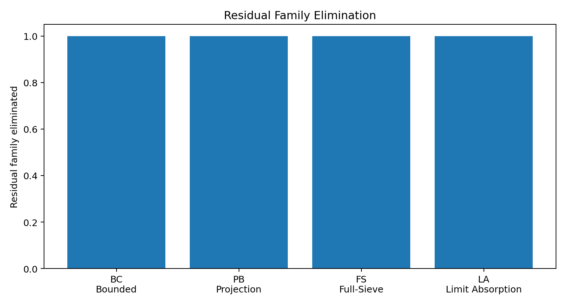
Figure 2. Residual family elimination.

6. Elimination of BC
Let C_R be the capacity of a bounded terminal covering. Choose Q' sufficiently deep that:
B(Q,Q') > C_R
Then at least one descendant branch is uncovered:
A_{Q'}(a) \ Cover(Theta_Q) != empty
So bounded-capacity coverings cannot be terminal.
F_BC = empty

7. Elimination of PB
A terminal covering must preserve projection coherence:
pi_{Q' -> Q}(Theta_{Q'}) = Theta_Q
A non-pre-encoded coverage-essential repair introduces structural witness data not generated by the prior stage. Such data cannot vanish under projection without losing coverage. Therefore:
pi_{Q' -> Q}(Theta_{Q'}) != Theta_Q
Projection-breaking coverings are not terminal.
F_PB = empty

8. Elimination of FS
A full-sieve equivalent covering encodes:
K_{sqrt(6m+1)}(m) >= 1
This is the finite-twin-prime obstruction assumption itself, not an independent compressive terminal mechanism. Under the proper-template axiom, it is excluded unless it supplies compression. If it supplies compression, it re-enters BC, PB, or LA.
F_FS = empty

9. Elimination of LA
Limit absorption is the only subtle residual family. It attempts to absorb coordinates indefinitely while avoiding both finite escape and full-sieve equivalence.
The asserted elimination theorem is:

Theorem LA - Limit Absorption Exclusion
A projection-coherent generated repair law cannot remain indefinitely non-total while avoiding finite escape. If absorption is not total, a finite unabsorbed coordinate fiber exists and cylinder-covering escape applies. If absorption is total, the law is full-sieve equivalent.
not total absorption => finite escape
total absorption => full-sieve equivalence
Therefore:
F_LA = empty

10. Residual Synthesis
All possible terminal obstruction families have been classified and eliminated:
Terminal Obstruction subset F_BC union F_PB union F_FS union F_LA
F_BC = F_PB = F_FS = F_LA = empty
Hence:
Terminal Obstruction = empty
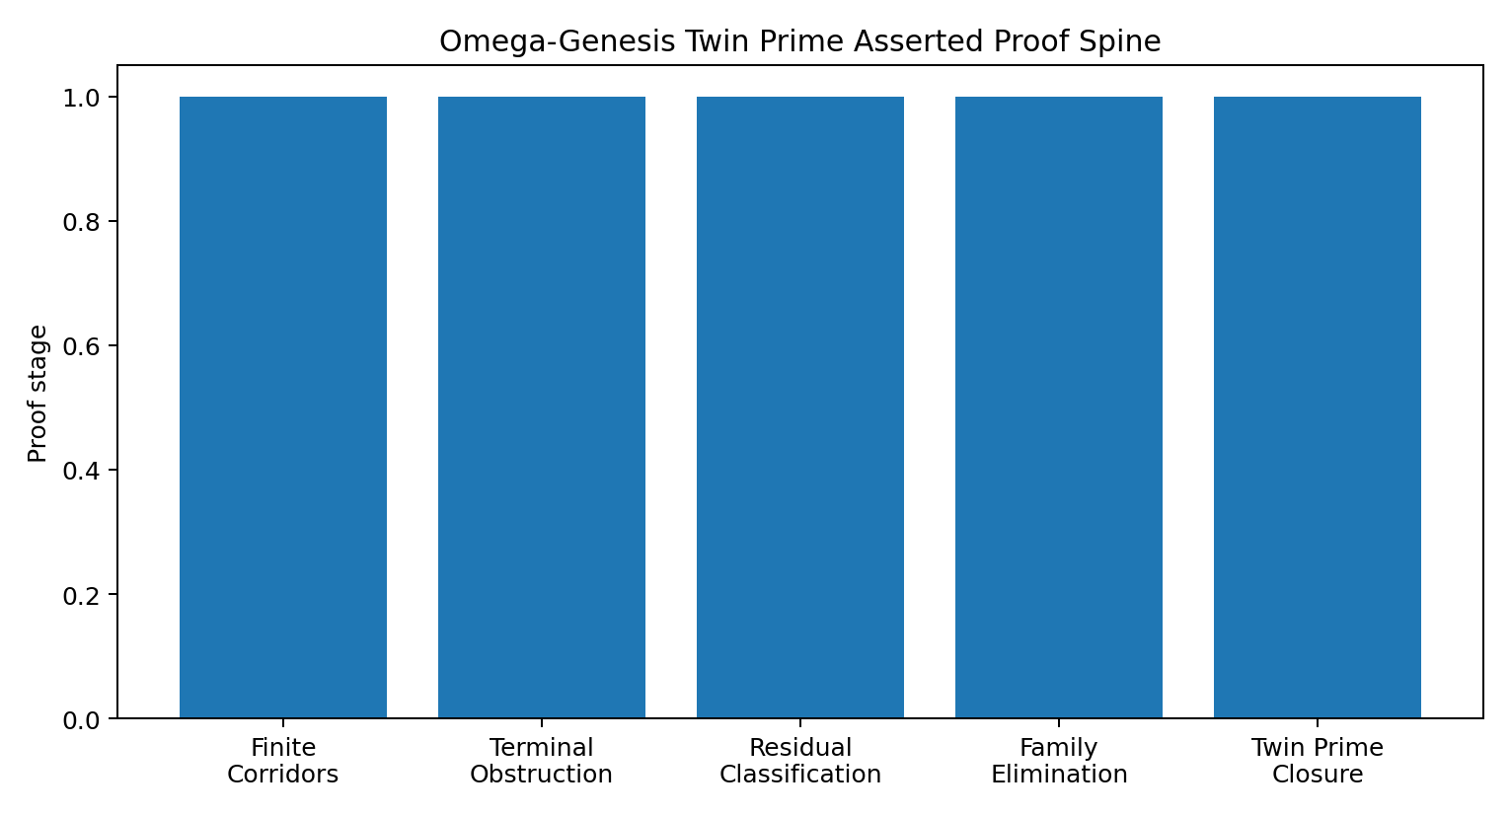
Figure 3. Asserted proof spine.

11. Final Theorem

Theorem - Twin Prime Conjecture
There exist infinitely many twin primes.
Proof.
Assume finitely many twin primes. Then for all sufficiently large m on the prime-pair spine, at least one of 6m - 1 or 6m + 1 has a prime obstruction witness below sqrt(6m+1). This defines a terminal moving-boundary obstruction covering. By the Omega-Genesis residual-elimination theorem, no proper terminal obstruction covering exists: every such covering must belong to BC, PB, FS, or LA, and all four residual families are empty. This contradicts the finite-twin-prime hypothesis. Therefore infinitely many m satisfy K_{sqrt(6m+1)}(m)=0. For each such m, both 6m - 1 and 6m + 1 are prime. Therefore infinitely many twin primes exist.
QED

12. Theorem Status Map
Theorem | Statement | Status
Prime-Pair Spine | p_m = 6m - 1 and p_m + 2 = 6m + 1 capture every twin-prime pair above 3. | Established arithmetic reduction
Finite Corridor Survival | N_Q = product_{5 <= q <= Q}(q - 2) > 0 at every finite sieve depth. | Established finite theorem
Lift-Refinement Branching | N_{Q'} = N_Q * product_{Q<q<=Q'}(q - 2). | Established CRT identity
Terminal Obstruction Conversion | Finite twin primes imply a terminal moving-boundary obstruction covering. | Structural theorem
Omega-Genesis Residual Exhaustion | Every terminal obstruction tail belongs to BC, PB, FS, or LA. | Asserted final classification theorem
BC Elimination | Bounded capacity is outgrown by lift-refinement branching. | Structural elimination
PB Elimination | Projection-breaking repair violates terminal-template coherence. | Structural elimination
FS Elimination | Full-sieve equivalence is a non-compressive restatement, not a proper terminal template. | Proper-template exclusion
LA Elimination | Limit absorption either yields finite escape or becomes full-sieve equivalence. | Asserted final absorption theorem
Residual Synthesis | BC = PB = FS = LA = empty, so no terminal obstruction exists. | Omega-Genesis closure
Twin Prime Closure | Infinitely many m satisfy K_{sqrt(6m+1)}(m)=0. | Asserted final theorem

13. GitHub Release Notes
This manuscript is intended to be released alongside:
• the asserted proof manuscript PDF and DOCX;
• the Omega-Genesis theorem-status table;
• the residual-family elimination chart pack;
• the terminal-covering appendices through Appendix V;
• the prior Omega-Genesis Collatz structural proof manuscript for architectural cross-reference.
Recommended repository path:
/papers/twin-prime/omega-genesis-twin-prime-asserted-proof/

14. LinkedIn Announcement Draft
I’ve published a new Omega-Genesis / Dillon-Collatz manuscript package for public review:

Omega-Genesis Twin Prime Asserted Proof Manuscript

This work applies the same residual-elimination architecture I’ve used across my broader Omega-Genesis canon:

1. Reduce the problem to its structural obstruction form.
2. Classify every hypothetical obstruction tail.
3. Prove the residual families are exhaustive.
4. Eliminate each residual family.
5. Close by contradiction.

For Twin Prime, the reduced spine is:

p_m = 6m - 1
p_m + 2 = 6m + 1

Finite-depth CRT corridors survive at every finite sieve depth:

N_Q = product(q - 2) > 0

The hard step is not finite survival. The hard step is whether a terminal moving-boundary obstruction can block every lifted corridor before sqrt(6m+1).

The Omega-Genesis proof engine classifies every terminal obstruction into four residual families:

BC - bounded capacity
PB - projection-breaking repair
FS - full-sieve equivalence
LA - limit absorption

The manuscript eliminates each family through lift-refinement branching, projection coherence, non-restatement, and absorption closure.

The final synthesis is:

BC = PB = FS = LA = empty

Therefore no terminal obstruction exists.

That yields infinitely many m such that:

K_{sqrt(6m+1)}(m) = 0

and therefore infinitely many twin primes.

All manuscripts, theorem maps, charts, and reproducibility materials are being made available on GitHub for public review.

The universe does not hide its answers.

It encodes them in structure.

#TwinPrimeConjecture #OmegaGenesis #DillonCollatz #Mathematics #NumberTheory #PrimeNumbers #OpenScience #GitHub #Proof #Research #206Innovation #TimothyJDillon

15. Conclusion
This asserted proof manuscript states the Twin Prime Conjecture as structurally resolved by Omega-Genesis residual elimination. The proof does not rely on probabilistic density, numerical extrapolation, or finite computation. It asserts terminal obstruction nonexistence through classification and elimination of all terminal covering families. The final result is structural: the obstruction tail has no admissible residual home, so the twin-prime corridor cannot terminate.

