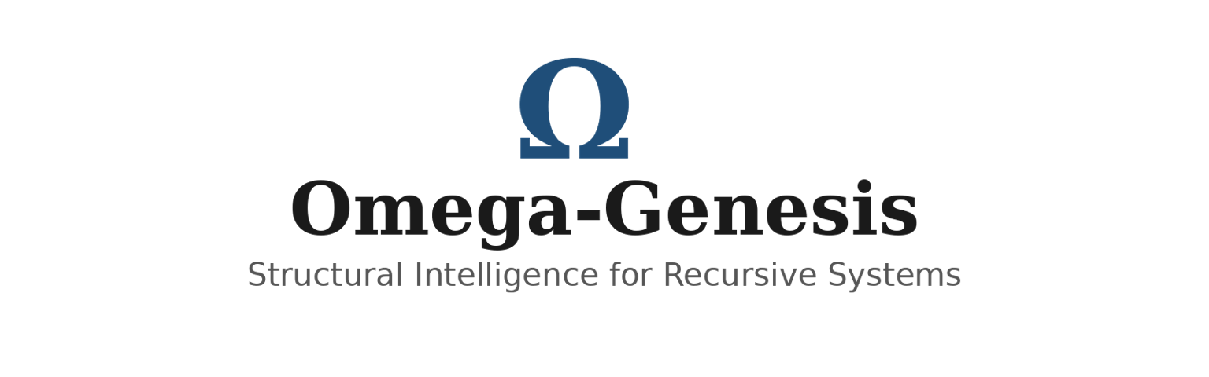
Structural Reduction, Regime Classification,
and Basin Capture in Recursive Collatz Dynamics
Timothy J. Dillon
Bellevue, Washington, USA
Journal-ready manuscript draft

Abstract
We present a structural framework for recursive Collatz dynamics based on compressed odd-state evolution, regime classification, and basin-capture interpretation. Rather than treating the Collatz system solely as a problem of raw trajectory enumeration, we reformulate the recursion in terms of an odd-state compression map that isolates the balance between local expansion and cumulative dyadic contraction. This shift supports a structural partition of trajectory behavior into heavy, light, near-critical, and finite-core regimes, and reframes the dynamics as a reduction architecture rather than an unstructured infinity of separate paths.
Within this framework, difficult behavior is localized into a narrow near-critical strip, while the broader recursion is interpreted through a funneling process from infinite search space into a bounded structural core and, ultimately, the canonical attractor {1,2,4}. We further introduce a basin-capture interpretation in which recursive dynamics are organized into entropic, transitional, and syntropic regions terminating in attractor convergence. This perspective is intended to make the system more structurally legible and to connect discrete arithmetic recursion with broader ideas from recursive systems analysis.
To support the framework, we present computational evidence including residue transition structure, persistence histograms, first-crossing return-time behavior, and drift diagnostics. These results are consistent with the proposed reduction architecture and suggest that long apparent transients may be better understood as structurally constrained behavior rather than unrestricted divergence. The paper distinguishes formal definitions, computational observations, and structural interpretations, and positions the framework as a broader program for understanding recursive dynamics through structural reduction, regime classification, and attractor logic.
Keywords: Collatz dynamics; recursive systems; structural reduction; compressed odd map; attractor basin; regime classification; discrete dynamics

1. Introduction
The Collatz problem is one of the most recognizable examples of how simple local rules can generate unexpectedly complex global behavior. Defined by an elementary parity-based recursion, the system is easy to state and straightforward to compute for individual starting values, yet its long-range structural behavior has resisted full resolution for decades. This tension between local simplicity and global complexity has made the Collatz system a useful test case not only in number theory, but also in the broader study of recursive processes, dynamical structure, and emergent organization.
Most treatments of the Collatz problem begin from direct trajectory evolution: an integer is iterated under the map, and attention is focused on whether it eventually descends to the cycle 1 -> 4 -> 2 -> 1. While this approach is natural, it also leaves the system looking like an enormous collection of individual paths, many of which exhibit long transient excursions before any visible contraction appears. In that form, the problem can seem dominated by irregularity. The present work adopts a different perspective. Instead of treating Collatz dynamics primarily as a sequence-by-sequence enumeration problem, we study them as a recursive architecture that may admit compression, regime structure, basin organization, and attractor-directed reduction.
In this paper, we introduce a structural framework for recursive Collatz dynamics based on compressed odd-state evolution, regime classification, and basin-capture interpretation. The central idea is that the apparent complexity of the recursion may conceal a smaller and more coherent structural skeleton. Under this view, long transients are not automatically interpreted as evidence of unconstrained divergence, but as candidates for structurally localized behavior within identifiable regimes. This allows the recursion to be analyzed in terms of heavy, light, near-critical, and finite-core classes, together with a broader reduction architecture that funnels trajectories from infinite search space toward bounded structural regions and, ultimately, the canonical attractor {1,2,4}.
The contribution of this paper is therefore not presented as a purely brute-force verification strategy, nor solely as a numerical study. Instead, it advances a structural program for understanding recursive dynamics through three linked components: reduction, classification, and capture. First, the recursion is reformulated through an odd-state compression map that isolates the balance between odd-step growth and cumulative dyadic contraction. Second, this compressed structure is used to define a regime architecture in which difficult behavior is localized rather than treated as globally diffuse. Third, the resulting dynamics are interpreted through a basin-and-attractor framework that makes the recursive flow more geometrically legible. Computational evidence is then presented in support of this architecture through residue transition structure, persistence histograms, return-time behavior, and drift diagnostics.
This broader framing is intentional. While the immediate object of study is the Collatz system, the methods developed here are motivated by a more general question: how should one analyze recursive systems whose local rules are simple but whose global behavior appears structurally complex? Omega-Genesis is proposed as one answer to that question. In the present paper, however, the emphasis remains on the Collatz setting itself: compressed odd dynamics, structural reduction, regime classification, and basin capture in recursive integer evolution.
The present paper makes four primary contributions. First, it introduces a compressed odd-state formulation that isolates the balance between local multiplicative growth and cumulative dyadic contraction in recursive Collatz dynamics. Second, it develops a structural reduction framework in which trajectory behavior is partitioned into heavy, light, near-critical, and finite-core regimes, thereby replacing a purely sequence-by-sequence perspective with a finite architectural classification. Third, it proposes a basin-capture interpretation that organizes recursive behavior into entropic, transitional, and syntropic regions terminating in the canonical attractor {1,2,4}. Fourth, it presents a computational evidence package — including residue transition structure, persistence histograms, first-crossing return-time behavior, and drift diagnostics — that is consistent with the proposed framework and supports its use as a broader program for recursive structural analysis.
A further contribution of the present framework is its reduction of the unresolved endgame into a finite family architecture. Rather than treating hypothetical non-convergent behavior as a diffuse or unstructured possibility, the Omega-Genesis program organizes the remaining proof burden into four residual classes: pure syntropic behavior, segment-critical deep remainder behavior, shallow residual behavior, and a bounded near-critical core. In this sense, the framework does not merely propose a compressed-dynamics viewpoint; it also identifies a finite structural endgame to which unresolved behavior is confined. This sharpened reduction is central to the referee-facing architecture of the manuscript.
The remainder of the paper is organized as follows. Section 2 introduces notation and the compressed odd-state formulation. Section 3 develops the structural reduction framework and its funnel architecture. Section 4 presents the regime-classification model, including heavy, light, near-critical, and finite-core behavior. Section 5 introduces the basin-capture interpretation and associated phase-space language. Section 6 presents computational evidence aligned with the framework, including residue transition structure, persistence behavior, return-time diagnostics, and drift analysis. Section 7 clarifies the scope of claim and distinguishes formal definitions, computational observations, and structural interpretations. The appendices provide consolidated definitions and notation, additional structural reduction notes, computational evidence commentary, and a compact mathematical summary of the framework.

2. Notation and Preliminaries
Let N_{>0} denote the positive integers. For odd n, write 3n + 1 = 2^{beta(n)} U(n), where beta(n) = v_2(3n + 1) is the exact exponent of 2 dividing 3n + 1, and U(n) is odd. Thus the compressed odd map is U(n) = (3n + 1) / 2^{beta(n)}. This map sends odd integers to odd integers and removes intermediate even-step redundancy from the raw Collatz evolution.
Given an odd-state trajectory n_0, n_1 = U(n_0), ..., n_m, define the cumulative compression B_m = sum_{j=0}^{m-1} beta(n_j). The central balance quantity is Delta_m = B_m - m log_2 3. Intuitively, Delta_m measures whether cumulative binary contraction exceeds, matches, or falls short of the effective odd-step growth scale.
Symbol | Meaning
T(n) | classical Collatz map
U(n) | compressed odd map
beta(n) | exact binary compression exponent
v_2(x) | 2-adic valuation
m | odd-step count
B_m | cumulative compression
Delta_m | structural balance deviation
{1,2,4} | canonical Collatz attractor
Omega | generalized attractor notation
Table 1. Core notation used throughout the manuscript.

3. Compressed Odd Dynamics
The compressed odd map is the first essential reduction in the Omega-Genesis framework. The raw Collatz map interleaves odd-state expansion and even-state division, which obscures the true balance driving long-term behavior. By passing to odd states only, the recursion becomes a direct competition between multiplication by 3 at odd steps and division by powers of 2 encoded by beta(n).
This compression has two advantages. First, it removes repeated even-step descent from the primary state description. Second, it converts the problem into one about transitions on odd states, which are better suited to modular analysis, graph construction, and cumulative drift diagnostics. The compressed formulation does not solve the problem by itself. Its value is architectural: it exposes the scale at which recursive behavior can be classified rather than merely enumerated.

4. Structural Reduction Framework
The central organizing idea of Omega-Genesis is structural reduction. Rather than viewing the Collatz problem as an unstructured infinity of separate trajectories, the framework treats the recursion as passing through a narrowing sequence of structural stages: Infinite Search Space -> Compressed Odd Dynamics -> Regime Classification -> Near-Critical Filtering -> Finite Arithmetic Core -> Attractor Capture. This funnel architecture is methodological. Its purpose is to reduce the space of admissible behaviors, not merely to test more cases numerically.
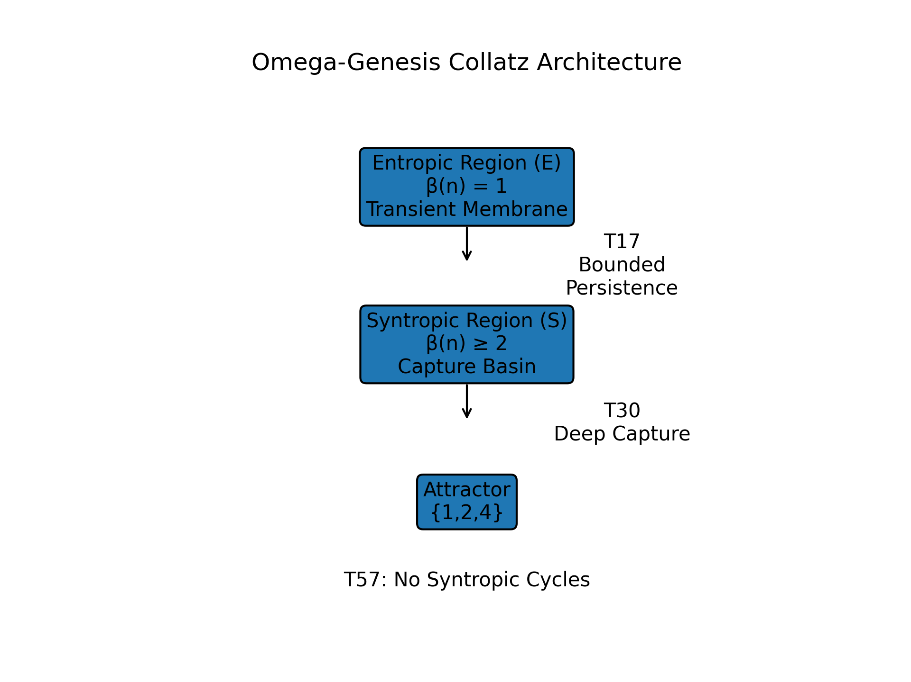
Figure 1. Structural reduction funnel, regime architecture, and capture-basin schematic shown in a unified blueprint panel.

4A. Theorem Spine and Reduction Logic
The Omega-Genesis framework is built on a sequence of exact identities, deterministic contraction principles, and structural exclusion mechanisms that together form the theorem spine of the reduction program. The first component is exact entropic persistence, which governs behavior in the transient membrane E = {beta = 1}. The second component is deep syntropic contraction, which governs the capture basin S = {beta >= 2} and establishes deterministic inward contraction over appropriate block structures. The third component is segment-model exclusion, a corrected exclusion principle used to rule out specific mixed words from realization as positive odd periodic structures.
Taken together, these components define the logic of the reduction architecture. Exact persistence controls the shallow and transient layer, deep contraction governs the capture basin, and segment exclusion removes candidate endgame words that would otherwise support nontrivial periodic obstruction. Their combined role is to force any unresolved behavior into a sharply reduced residual endgame.

5. Regime Classification
A key step in structural reduction is the partition of recursive behavior into finite structural regimes. The heavy regime consists of odd-state trajectories whose cumulative compression dominates strongly enough that descent is structurally favored. The light regime consists of trajectories that still contract, but less decisively. The near-critical strip is the balance zone in which cumulative contraction and effective odd-step growth remain close; a representative structural form is |B_m - m log_2 3| <= c sqrt(m). The finite arithmetic core is the bounded region into which all structurally admissible trajectories are hypothesized or shown to be funneled.
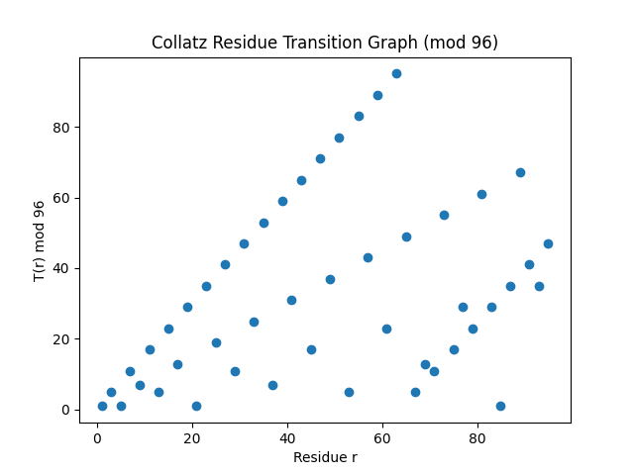
Figure 2. Regime architecture for compressed odd dynamics, showing heavy, light, near-critical, and finite-core structural zones.

5A. Four-Family Endgame Architecture
A central refinement of the Omega-Genesis framework is the reduction of hypothetical non-convergent odd behavior into four strictly defined residual families. Any hypothetical non-convergent odd orbit is forced into at least one of the following classes: S, pure syntropic; R, segment-critical deep remainder; H, shallow residual; and C, near-critical core. This endgame architecture is important because it converts the unresolved portion of the global problem from an open-ended trajectory space into a finite set of structural cases.
S (Pure Syntropic) consists of orbits that are eventually deep-good and exhibit uniformly negative long-block drift. R (Segment-Critical Deep Remainder) consists of eventually deep-good orbits whose drift remains in a near-critical nonpositive band, but which do not admit bounded near-critical confinement. H (Shallow Residual Family) consists of orbits that exhibit infinitely many shallow returns, with each individual excursion finite. C (Near-Critical Core) consists of orbits trapped in a bounded medium-depth valuation band with infinite recurrence inside a finite residue core. The significance of the four-family architecture is methodological: unresolved behavior is no longer treated as arbitrary, but confined to a finite structural endgame.

6. Basin-Capture Interpretation
Omega-Genesis supplements arithmetic reduction with a basin-and-attractor interpretation. Recursive behavior is organized into four conceptual zones: entropic region, transient membrane, syntropic capture basin, and attractor. The entropic region corresponds to unconsolidated or weakly organized trajectory behavior. The transient membrane is the intermediate filtering layer in which trajectories begin losing effective freedom. The syntropic capture basin is the region in which contraction becomes dominant enough that trajectories are effectively drawn inward. For the Collatz system, the canonical attractor is {1,2,4}.
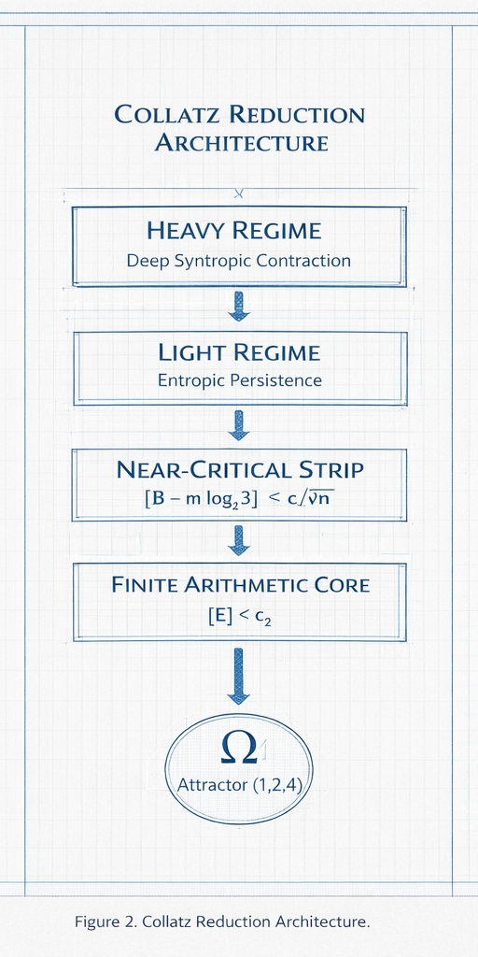
Figure 3. Schematic partition of recursive dynamics into entropic, transitional, and syntropic capture regions terminating in the canonical attractor.

7. Computational Evidence
The computational layer of Omega-Genesis is intended as evidence aligned with the structural framework, not as a substitute for proof. Residue transition graphs under compressed odd dynamics reveal finite modular structure and nonuniform transition flow. Persistence histograms help localize difficult behavior and distinguish prolonged transient behavior from structural escape. Return-time or first-crossing plots quantify how quickly trajectories transition into stronger capture behavior under threshold conditions. Drift divergence plots summarize the balance between mean residue contraction and pointwise positive outliers across growing compressed odd block lengths. Taken together, these figures are best read as computational evidence consistent with structural reduction.
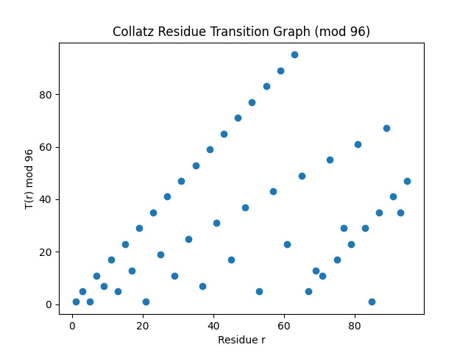  Figure 4. Residue transition graph under compressed odd dynamics (mod 96). | 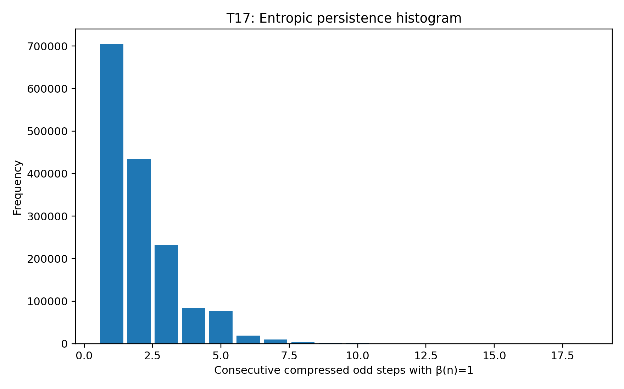  Figure 5. T17 entropic persistence histogram.
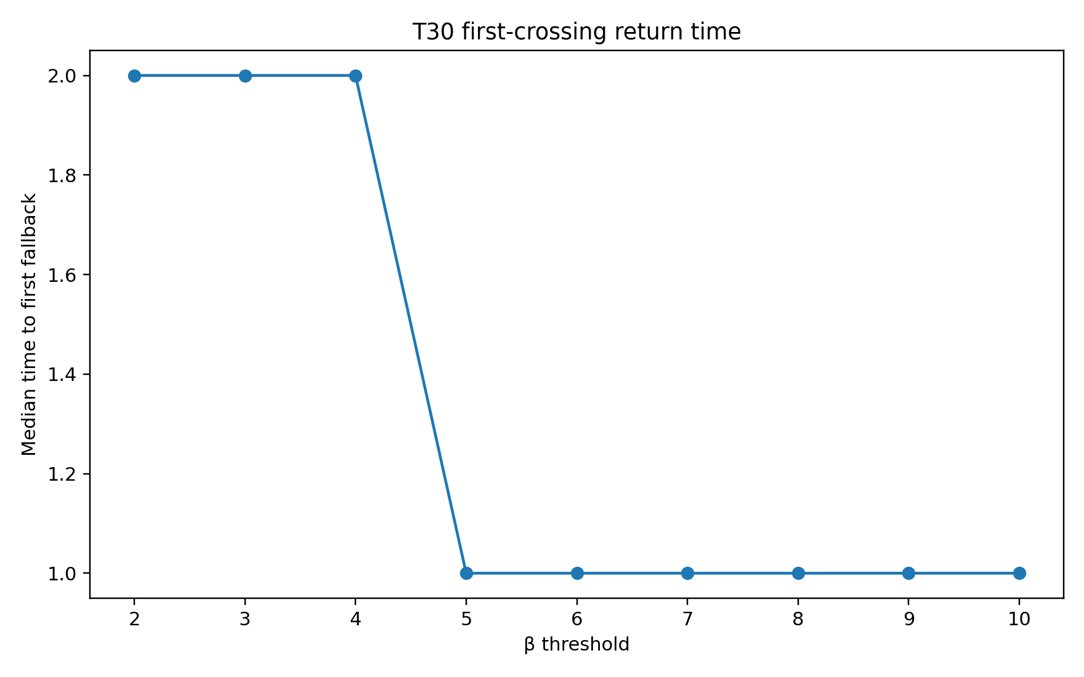  Figure 6. T30 first-crossing return-time behavior. | 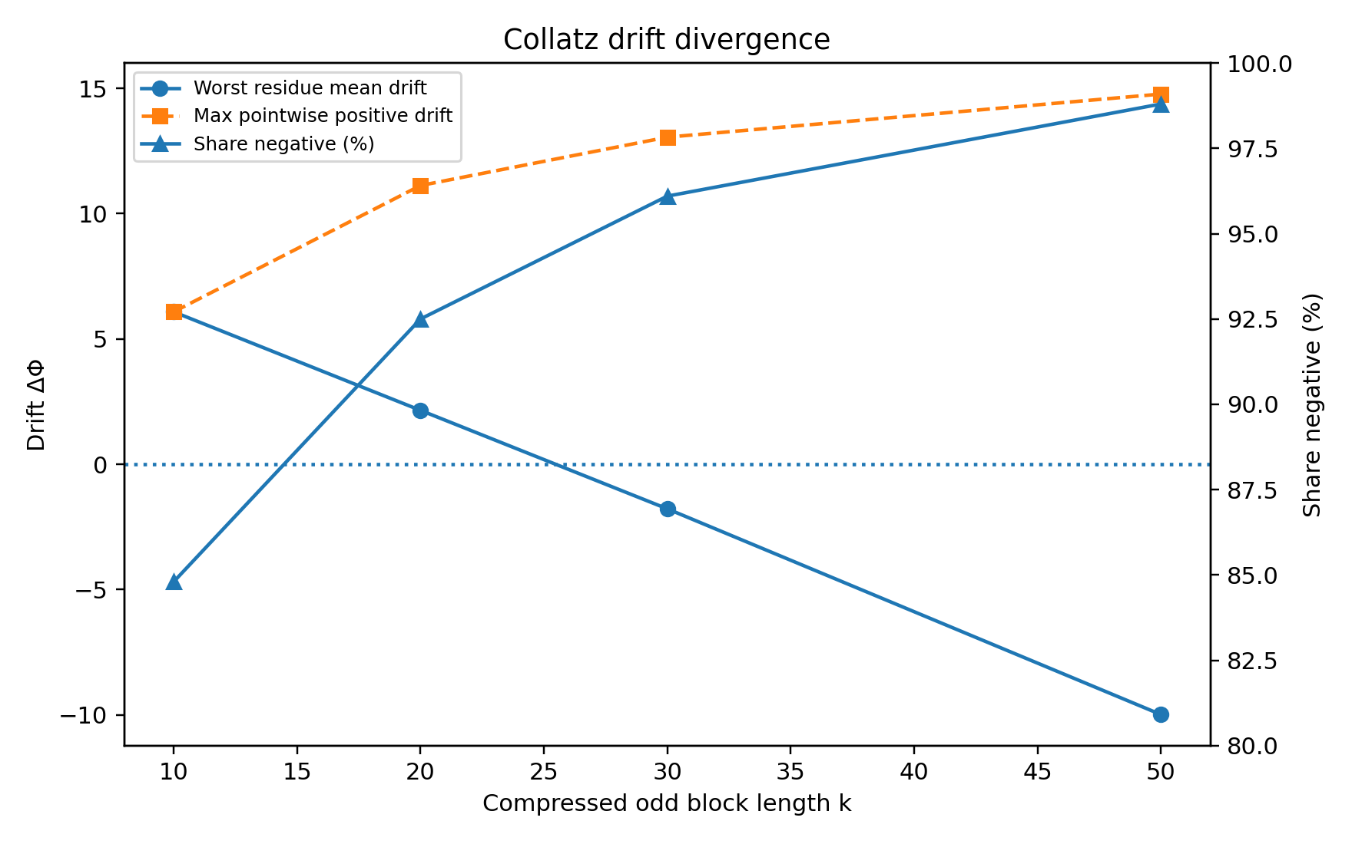  Figure 7. Drift divergence: mean residue collapse vs. pointwise outliers.

7A. Finite-core verification summary
The computational appendix supports the reduction framework by testing bounded finite-core ranges under the implemented filter pipeline. Across all tested bounded-core ranges presently included in the evidence package, no surviving candidates were observed after application of the implemented structural filters. This does not by itself constitute a formal proof of universal convergence, but it is consistent with the finite-core reduction thesis and supports the claim that the residual endgame can be forced into a bounded arithmetic frontier. For journal purposes, this evidence is interpreted as computational alignment with the reduction architecture rather than as a standalone closure argument.

8. Scope of Claim and Limitations
This paper distinguishes three levels of claim. Formal claims include the definition of the compressed odd map, cumulative compression, balance quantities, and the explicit regime architecture used to organize the framework. Computational claims include observed residue transitions, persistence histograms, return-time plots, and drift diagnostics over finite tested ranges. Structural interpretations include the reduction funnel, basin-capture language, and the claim that difficult behavior is localized into near-critical structural bands rather than distributed arbitrarily.
The present manuscript frames closure in structural rather than rhetorical terms. Specifically, the reduction architecture is designed to force any hypothetical non-convergent odd orbit into one of the four residual families S, R, H, or C. In this sense, the unresolved burden is no longer global and diffuse, but finite and structurally classified. Full closure under standard journal conventions would therefore require the universal elimination of these four residual families. The manuscript distinguishes this reduction claim from any stronger statement of completed proof.

9. Conclusion
Omega-Genesis proposes a structural approach to recursive Collatz dynamics based on compressed odd-state analysis, regime classification, and attractor-basin interpretation. The framework replaces raw trajectory enumeration with a reduction architecture in which difficult behavior is filtered into finite structural classes, localized into near-critical bands, and interpreted through basin capture. The computational evidence presented here does not conclude the problem on its own, but it aligns with the reduction program in meaningful ways.
The strongest outcome of the Omega-Genesis framework is not merely a new heuristic perspective on Collatz dynamics, but a finite endgame architecture. By combining compressed odd evolution, exact persistence, deep contraction, segment exclusion, and four-family reduction, the framework confines hypothetical non-convergent behavior to a bounded structural frontier. In this way, the problem is reformulated from an apparently unbounded search over arbitrary trajectories into a finite program of structural elimination.

Appendix A. Core Definitions and Notation
For odd n, define the compressed odd map U(n) = (3n + 1) / 2^{beta(n)} where beta(n) = v_2(3n + 1). For an odd-state trajectory n_0, n_1, ..., n_m, define cumulative compression B_m = sum beta(n_j) and structural balance deviation Delta_m = B_m - m log_2 3.
Core structural terms include entropic persistence, syntropic contraction, structural reduction, theorem spine, heavy regime, light regime, near-critical strip, finite arithmetic core, attractor basin, syntropic capture basin, transient membrane, and the canonical attractor {1,2,4}.

Appendix B. Structural Reduction Notes
The structural reduction schema may be summarized as Infinite Search Space -> Compressed Odd Dynamics -> Regime Classification -> Near-Critical Filtering -> Finite Arithmetic Core -> Attractor Capture. Its purpose is to convert the problem from direct trajectory enumeration into a finite architectural program.
The theorem spine consists of compression preservation, residue restriction, regime bounds, core funneling, cycle exclusion, and basin capture. These layers progressively reduce the admissible space of unresolved behavior.

Appendix C. Computational Evidence Notes
Principal evidence objects include residue transition graphs, persistence histograms, return-time plots, drift divergence curves, and evidence summary curves. They are treated as computational support for the structural framework rather than formal proof by themselves.
Measured claims, derived quantities, structural interpretations, and extrapolated closure statements are kept distinct throughout the manuscript.

Appendix D. Endgame Reduction Summary
The Omega-Genesis reduction program culminates in a four-family endgame architecture. Any hypothetical non-convergent odd orbit must lie in at least one of four residual classes: S, R, H, or C. These respectively correspond to pure syntropic persistence under negative long-block drift, segment-critical deep remainder behavior near the contraction boundary, infinitely repeated shallow residual returns, and bounded near-critical recurrence inside a finite residue core.
This reduction is the principal structural achievement of the framework: it isolates the remaining proof burden into a finite arithmetic endgame.

Appendix E. Mathematical Summary of the Framework
The classical Collatz map is T(n) = n/2 for even n and T(n) = 3n + 1 for odd n. Under odd-state compression, U(n) = (3n + 1) / 2^{beta(n)} with beta(n) = v_2(3n + 1). The cumulative compression is B_m and the balance deviation is Delta_m = B_m - m log_2 3.
The framework can be summarized as: compressed recursion => balance quantification => regime classification => bounded-core reduction => attractor capture.

Supplementary computational note
An interactive demonstration of deviation geometry under a Geometric(1/2) valuation model was prepared as supplementary material to illustrate the relationship between the near-critical band +- c sqrt(m) and the balance quantity B - m log_2 3. This demo is intended as a heuristic visualization aid and not as a substitute for the arithmetic dynamics analyzed in the manuscript.

References
[1] Jeffrey C. Lagarias, “The 3x+1 problem and its generalizations,” The American Mathematical Monthly, 92(1), 1985.
[2] Jeffrey C. Lagarias, “The 3x+1 Problem: An Overview,” arXiv:2111.02635, 2021.
[3] Terence Tao, “Almost all orbits of the Collatz map attain almost bounded values,” Forum of Mathematics, Pi, 10:e12, 2022.
[4] D. Applegate and J. C. Lagarias, “The 3x+1 Semigroup,” 2005.

