CVP Fusion Overlay — Full White Paper
A Device-Agnostic Control and Governance Stack for Repeatable Fusion Progress
Author: Timothy J. Dillon
206 Innovation Inc. • Bellevue, Washington, USA
Date: May 31, 2026

This v2 white paper expands the CVP Fusion Overlay into a partner-reviewable full package: architecture, algorithms, TEVR pipeline, Phase-A gate criteria, module deep dives (P1–P8), and economics.

1. Executive Summary
Fusion progress is gated by repeatable control, not by peak temperature. CVP Fusion Overlay is a device-agnostic control and governance stack: Invariant-driven state I(t), safe-manifold constraints (heat-risk H(t), wall margin, actuator limits), mandatory recovery gates, and TEVR proof bundles for deterministic replay of every claimed improvement. The near-term deliverable is Gate A: demonstrable Π reduction and τ improvement at fixed setpoints with recovery + replay passing. Subsequent phases extend to yield-proxy-visible systems and partner KPIs with multi-day repeatability.

2. Fusion Landscape and Shared Bottlenecks
Across tokamaks, stellarators, pinch systems, and other concepts, the shared bottleneck is instability and turbulence-driven transport. The control system must respond within constraints and produce evidence that improvements are real rather than drift artifacts.

Shared bottlenecks:
- Instability (tearing/locked modes, disruptions)
- Transport losses (turbulence)
- Edge heat / exhaust constraints
- Diagnostics scarcity and drift
- Need for reproducible evidence

3. CVP Fusion Overlay Architecture

Figure A. Architecture
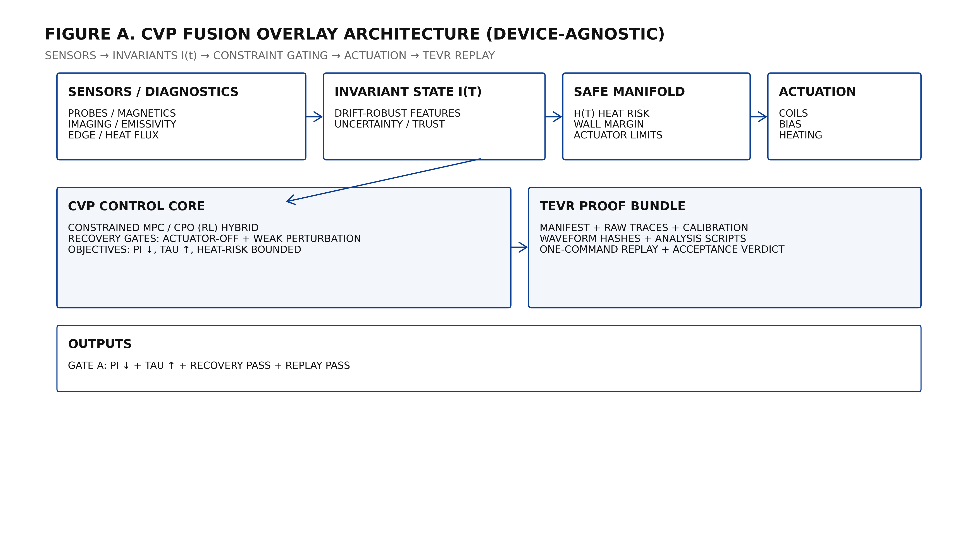

Figure E. Real-time control loop
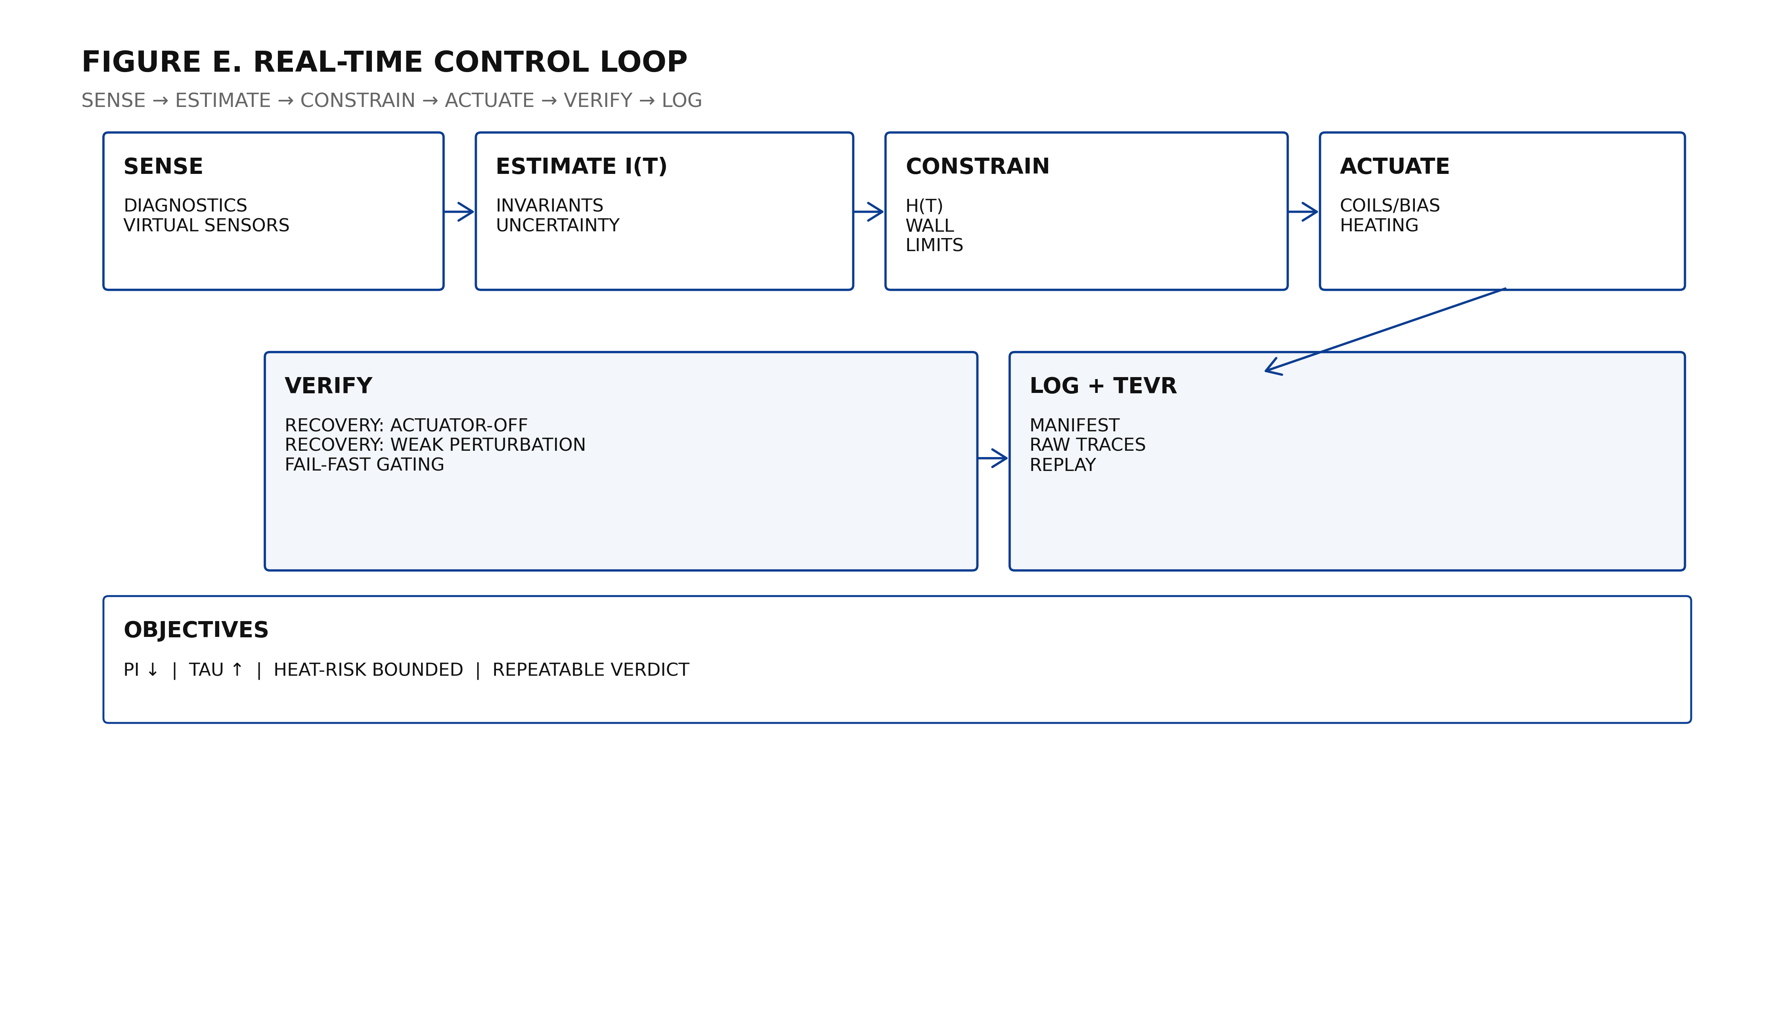

4. Canonical Equation Governance (Locked)
c = local invariant causal speed
c_eff = f(K, R, nabla K, partial_t K) (curvature-conditioned effective propagation)
D(c_eff, h, G_geom) = (delta c_eff / delta G_geom)|_h (formal Dillon Operator)
Public form: D(c_eff, h, G_geom) = (partial c_eff / partial G_geom)|_h
Delta_G c_eff = c_eff - c
Curvature chain: T_mu_nu -> G_geom -> c_eff
Governance: use G_geom (or mathcal G); avoid plain G for the Dillon Operator

Boundary condition: c remains locally invariant. c_eff is an effective propagation variable for curvature-conditioned control/transport modeling.

5. Metrics and Invariants

5.1 Π (band-limited turbulence power)
Π(θ,I)=∫_{f1..f2} PSD(f;θ,I) df with pre-registered PSD parameters and band limits.

5.2 τ (confinement proxy)
Fit I_em(t) ≈ I0 exp(-t/τ)+b. Compare τ baseline vs CVP-on under matched setpoints.

5.3 Heat-risk H(t)
H(t) is a hard constraint, defined as peak heat flux or conservative surrogate in Phase A.

5.4 Invariant state I(t)
I(t) is a drift-robust feature vector with uncertainty/trust weighting to survive sensor dropout and day-to-day changes.

6. Safety, Constraints, and Recovery Gates
- Hard constraints: heat-risk, wall margin, actuator limits, facility interlocks.
- Actuator-off recovery within ε (mandatory).
- Weak-perturbation recovery within ε (mandatory).
- Failure → non-claimable run + drift-gate investigation.

7. TEVR Proof Bundles (Deterministic Replay)

Figure D. TEVR pipeline
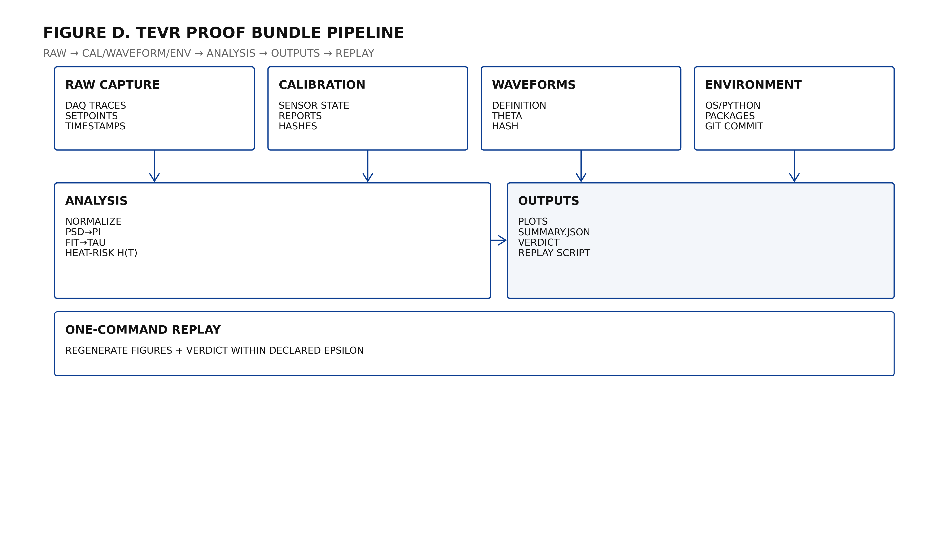

Minimum TEVR contents:
- Manifest (YAML/JSON): run IDs, randomization seed, setpoint hashes, declared ε tolerances.
- Raw traces + metadata + calibration chain.
- Waveform definitions + hashes; analysis scripts + parameters; environment hashes.
- One-command replay script regenerating figures + verdict.

8. Phase-A Validation (Gate A)

Gate A pass criteria (example):
- Π reduction ≥ 20% (CI reported)
- τ improvement beyond ε (or substitute proxy)
- 0 constraint violations
- Actuator-off recovery PASS
- Weak-perturbation recovery PASS
- Replay PASS within ε

9. Modules P1–P8 Deep Dive

Figure B. P1–P8 map
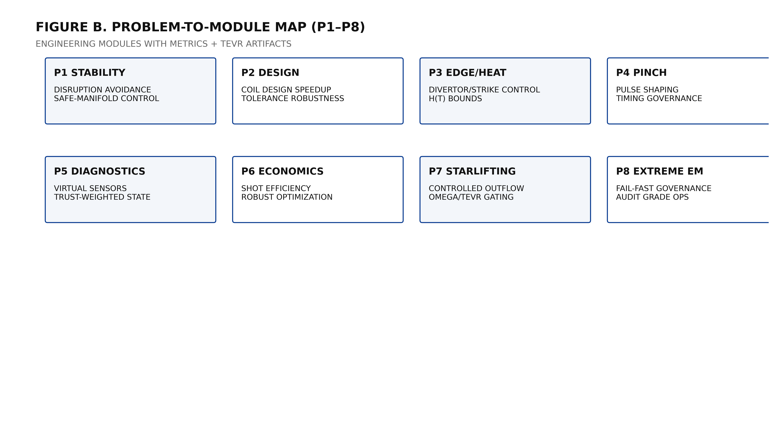

P1 Stability & Disruption Avoidance
- Early warning via I(t) + uncertainty
- Constrained MPC/RL hybrid
- Avoided disruptions + constraint compliance

P2 Design Acceleration
- Robust optimization for coil/field design
- Tolerance sweeps as acceptance tests
- TEVR-proof candidate designs

P3 Edge/Heat
- H(t) minimization under confinement constraints
- Strike-point schedules
- Peak heat reduction + non-regression

P4 Pinch
- Waveform control under dI/dt limits
- Timing governance
- Reduced variance + damage rate

P5 Diagnostics
- Virtual sensors + uncertainty
- Trust-weighted state
- Fallback modes

P6 Economics
- Micro-experiment batching
- Robust objective mean-variance
- Faster time-to-decision

P7 Starlifting
- Long-horizon module under TEVR
- Bounded extraction + safe retreat
- Energy accounting

P8 Extreme EM
- Fail-fast governance
- Topology monitoring
- Audit-grade ops

10. Roadmap and Partner Integration

Figure C. Gates
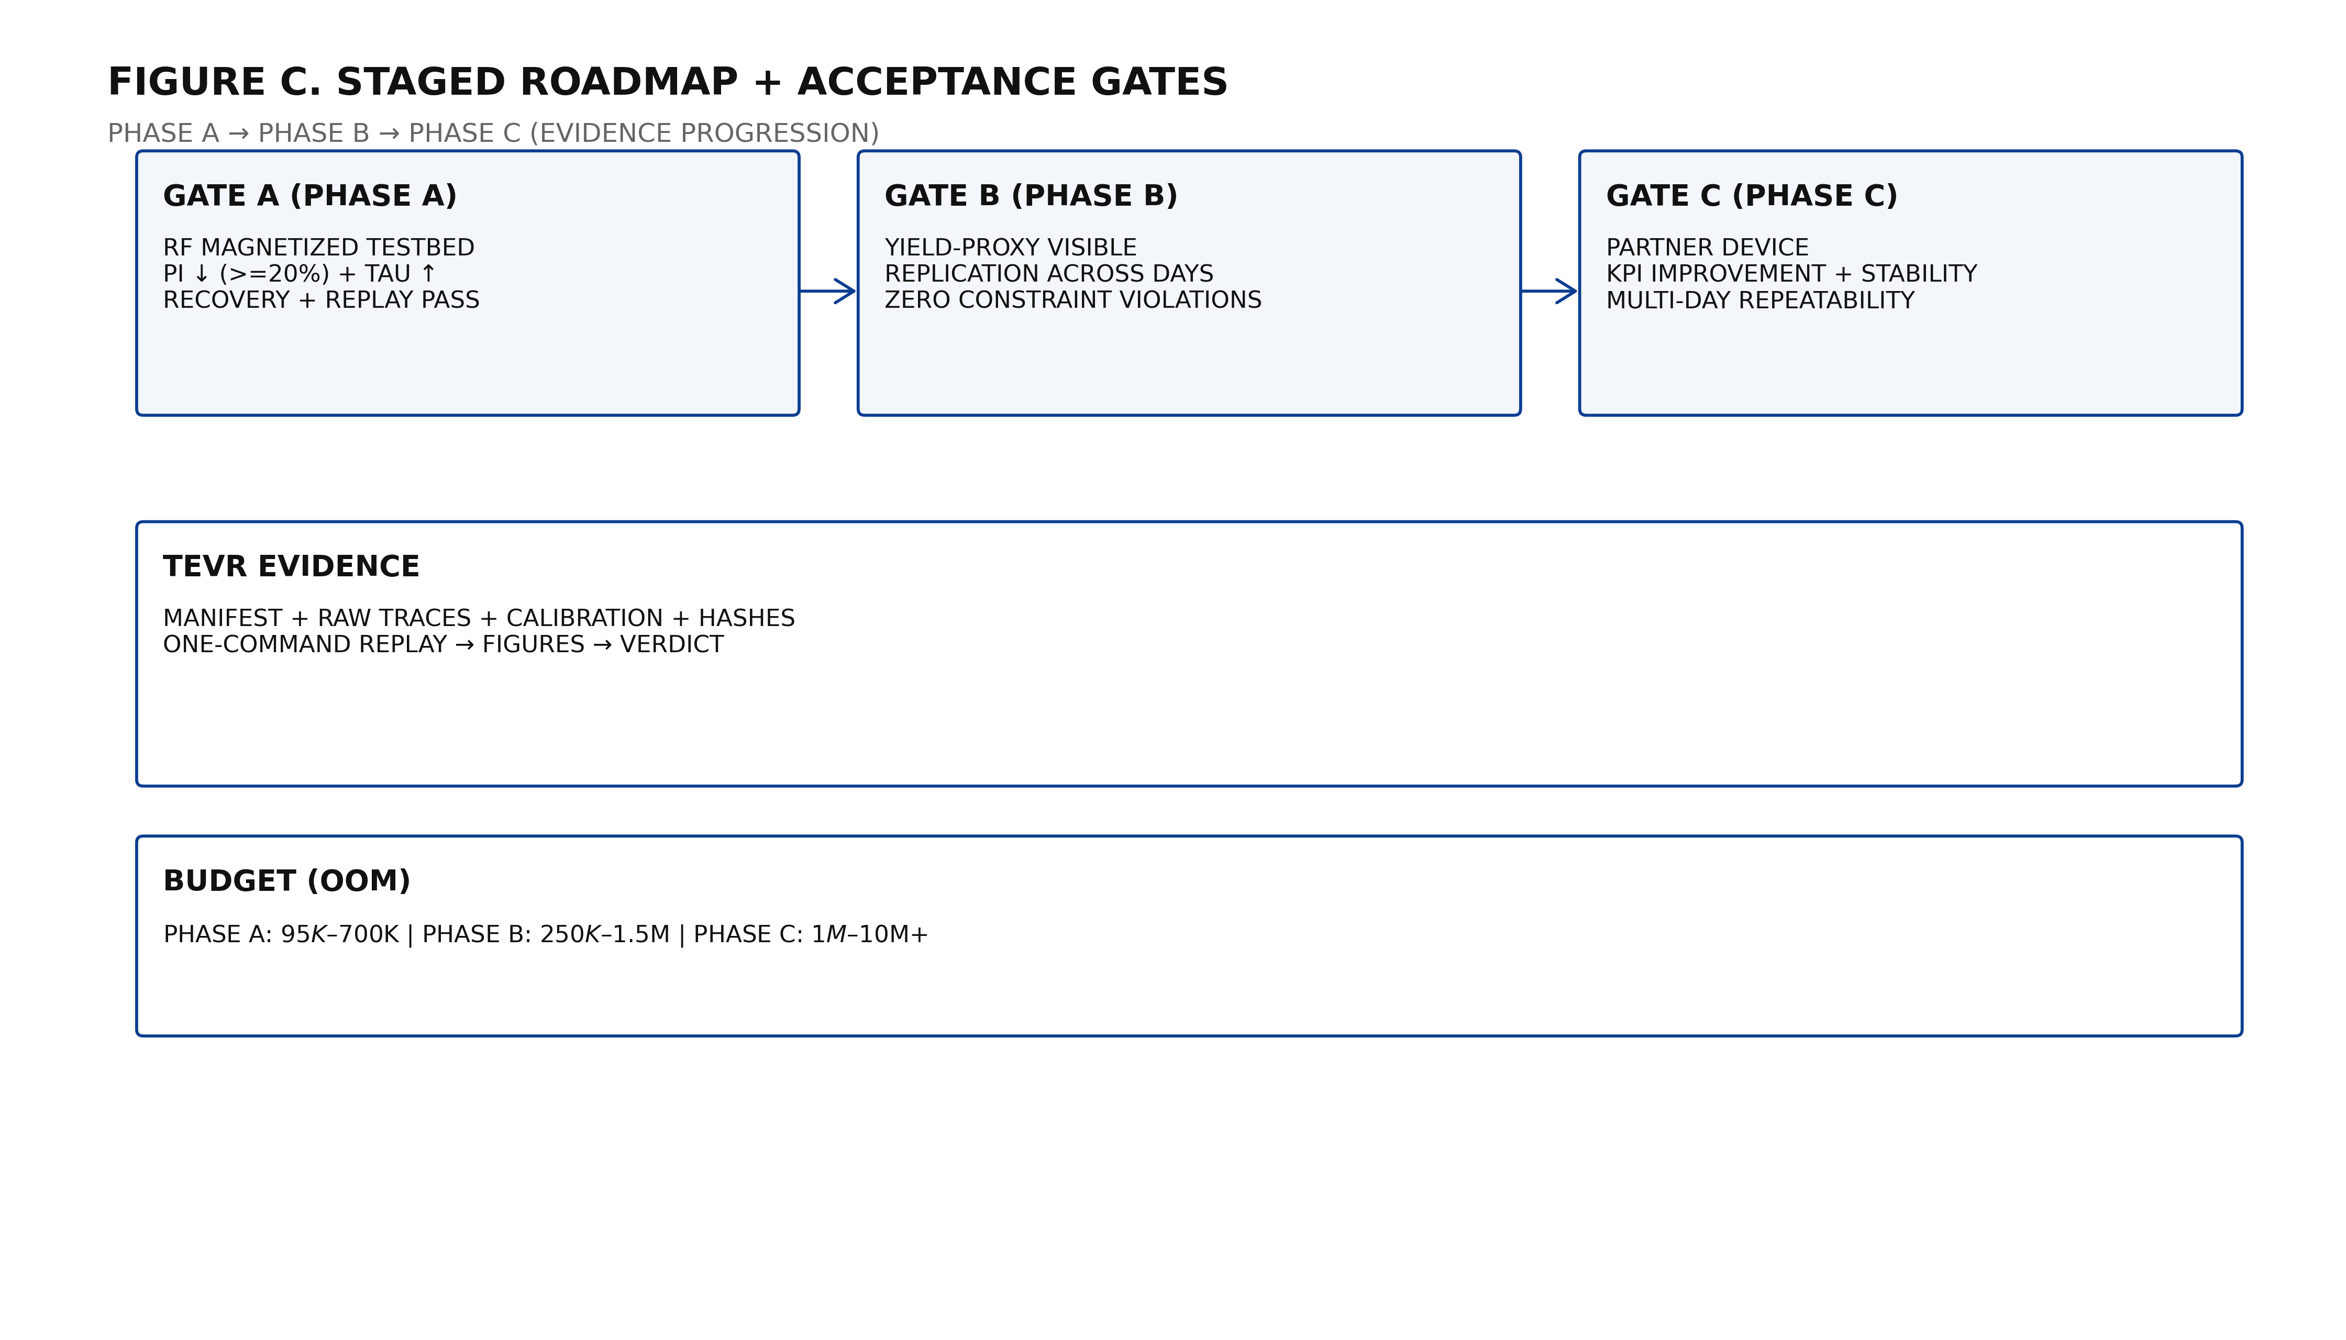
Phase B extends to yield-proxy-visible systems. Phase C integrates as an overlay safety+optimization layer into partner devices.

11. Economics and Business Model

Budget model (order-of-magnitude):
Stage | Budget range | Deliverables
Phase A (8–12 weeks) | $95K–$700K | Gate A report + TEVR bundles + replay tooling
Phase B (3–9 months) | $250K–$1.5M | Yield-proxy replication + safety filter + partner adapter
Phase C (6–24 months) | $1M–$10M+ | Partner KPI improvement + multi-day reproducibility + commercialization
Commercialization: license the overlay stack + TEVR tooling; partner integration services; validation-as-a-service under TEVR standard.

12. Risks and Mitigations
- Drift → interleaved baselines + recovery gates
- Safety → hard constraints + safety filter + interlocks
- Model artifacts → TEVR replay exposes; conservative thresholds
- Integration → adapter layer; start monitoring/safety-filter

Appendix A. Pseudocode (Control + TEVR)
- Sense x(t); estimate I(t) + uncertainty
- Propose u_candidate
- Project to safe set: u_safe = proj_safe(u_candidate)
- Apply u_safe; verify recovery; log TEVR bundle
- Replay: raw→metrics→figures→verdict within ε

