Predictive Quantum Measurement Overlay with 4D Adaptive Electromagnetic Propagation Control
A CVP-Dillon Framework Architecture for Quantum-Memory-Enhanced Precision Measurement, 4D EM Link Control, and Explainable Signal Governance
─────────────────────────────────────────────────────────────────
Timothy J. Dillon
206 Innovation Inc.
Bellevue, Washington, USA
2026
Version 3.1 - Adaptive EM Propagation Control, Quantum Integrity Governance, and Slide Image Appendix
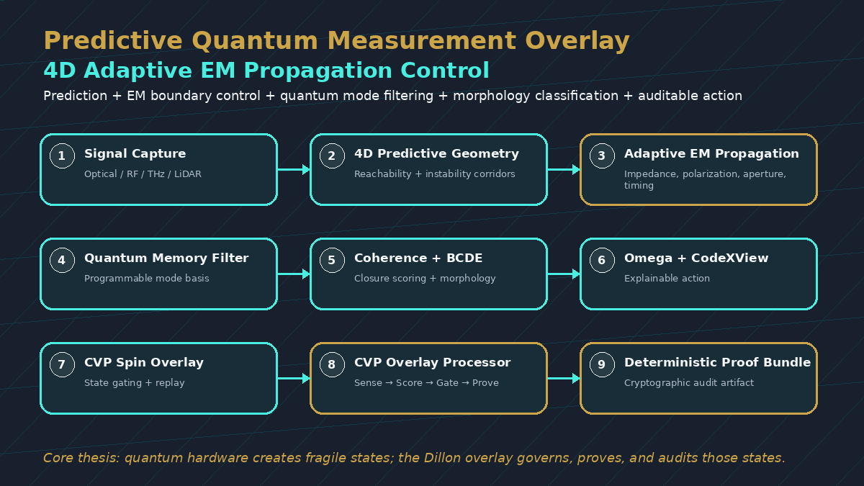
Figure 1. Integrated Predictive Quantum Measurement Overlay (PQMO) stack with 4D Adaptive Electromagnetic Propagation Control.

Abstract
Recent quantum-memory-enhanced optical measurement research demonstrates that programmable quantum memories can function as mode-selective filters for super-resolved frequency estimation. This paper proposes a complementary architecture: the Predictive Quantum Measurement Overlay with 4D Adaptive Electromagnetic Propagation Control. The architecture integrates quantum-memory mode filtering with the Curvature Variable Physics (CVP) / Dillon Equation Framework, 4D Predictive Geometry, adaptive electromagnetic propagation control, Binary Curvature Decoding Engine (BCDE), Omega Protocol classification, CodeXView explainability, and deterministic proof bundles.
The central thesis is that precision measurement should be governed as a four-dimensional information-control problem. A signal is not only detected; it is forecast across temporal reachability corridors, stabilized through electromagnetic boundary control, filtered through quantum memory, scored for coherence, classified by morphology, and routed through explainable action policies. The proposed architecture applies to Doppler LiDAR, spectroscopy, quantum networks, SATCOM, aerospace communications, 6G/7G, Internet of Bio-Nano Things (IoBNT), signal intelligence, and AI-controlled scientific instruments.
Keywords: Curvature Variable Physics; Dillon Equation; 4D Predictive Geometry; Adaptive Electromagnetic Propagation Control; Quantum Memory; Mode Filtering; Doppler LiDAR; Spectroscopy; SATCOM; 6G/7G; IoBNT; Binary Curvature Decoding; CodeXView; Deterministic Replay; Coherence Calculus

1. Executive Thesis
Quantum-memory mode filtering improves what an optical measurement system can physically resolve. The Dillon Framework adds the next layer: what the system should expect, when the signal is lawfully reachable, whether the state is coherent or dispersive, whether the morphology is stable or divergent, and what action should be taken before the measurement becomes operationally trusted.
• Quantum memory filters the mode.
• 4D Predictive Geometry anticipates the signal corridor.
• 4D Adaptive Electromagnetic Propagation Control controls the boundary environment.
• BCDE classifies the signal-state morphology.
• Omega Protocol governs closure, drift, and instability.
• CodeXView explains the result and action decision.

2. Background: Quantum Memory as Programmable Measurement Infrastructure
A recent Oxford-led quantum-memory measurement demonstration reported mode selectivity of 99.6%, crosstalk of 0.34%, resolution of frequency separations as small as one twentieth of linewidth, and up to a 34-fold precision improvement compared with direct detection. The work frames quantum memory not only as storage, but as a programmable quantum sensor for time-frequency measurement.
The implication is architectural: precision measurement can be improved by altering the mode basis before detection. The proposed PQMO-4D EM architecture accepts that breakthrough as the physical measurement layer and adds a predictive, electromagnetic, morphological, and explainable governance stack around it.

3. Canonical Dillon Equation Standard
The framework does not claim that local light speed is broken. Local c remains the invariant causal speed measured in local inertial frames. The framework introduces c_eff as a geometry-conditioned effective propagation variable.
c_eff = f(R)
Public short-form expression.
c_eff = f(K, R, ∇K, ∂tK)
Full CVP propagation expression.
D(c_eff, h, 𝓖) = (∂c_eff / ∂𝓖)|h
Canonical Dillon Operator, where 𝓖 or G_cal denotes gravitational geometry or metric structure, not Newton’s constant.
The central principle is:
The speed limit is not broken; the geometry of propagation is generalized.

4. 4D Predictive Geometry for Measurement Corridors
4D Predictive Geometry makes the forecasting layer explicitly spacetime-aware. In this formulation, prediction is not simply a point estimate about a future state. It is a lawful statement about where and when a system may move through a temporal reachability corridor.
For quantum-memory-enhanced measurement, this changes the question from 'What signal is present?' to 'Which signal states are lawfully reachable, stable, and closure-ready inside the next measurement window?'
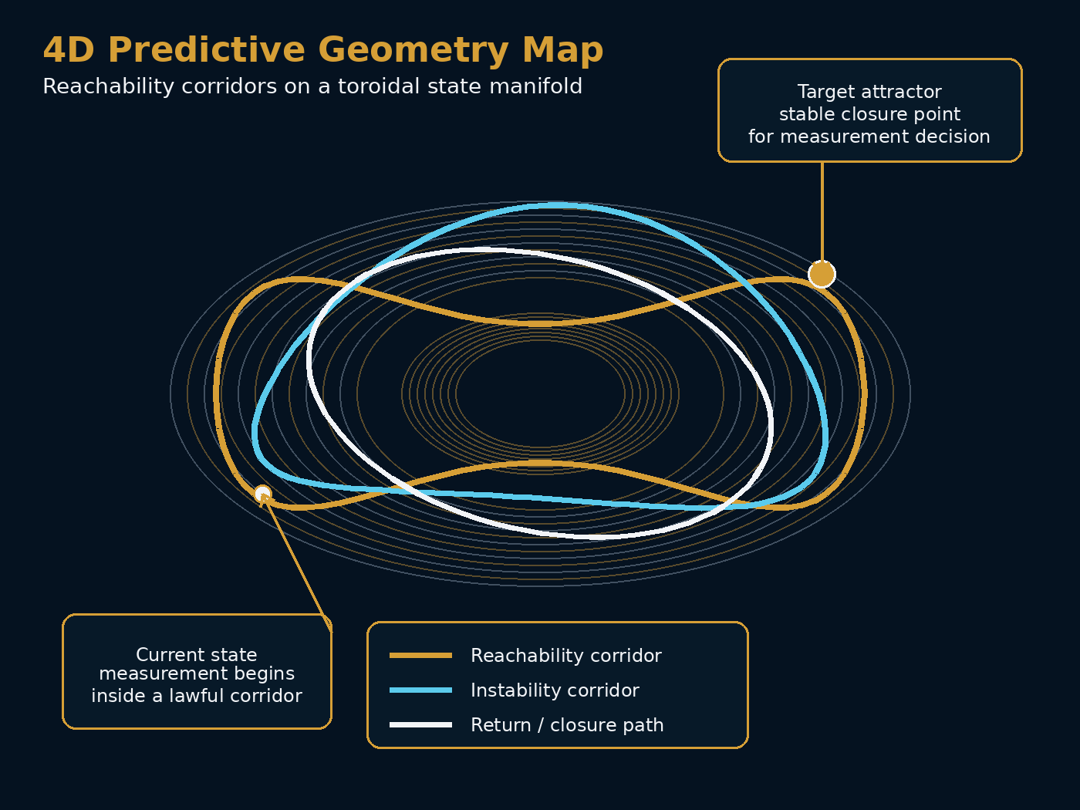
Figure 2. 4D Predictive Geometry map showing reachable corridors and target attractor on a toroidal state manifold.
4D Object | Operational Meaning | Measurement Control Use
Temporal reachability corridor | Lawful spacetime path family from current state to future state | Predict whether a weak signal, return, line, or handoff window can resolve in time
Temporal instability corridor | Spacetime region where drift, leak, blockage, ambiguity, or timing failure becomes likely | Preemptively resample, retune, reroute, or reject
4D attractor forecast | Predicted convergence to a stable measurement basin | Trigger quantum memory capture or closure acceptance at the correct moment
Temporal rigidity threshold | Boundary where continuation becomes inadmissible | Force return, confinement, handoff, or alternate mode basis

5. 4D Adaptive Electromagnetic Propagation Control
Electromagnetic propagation control refers to improving effective link margin or measurement quality by adaptively controlling electromagnetic boundary conditions. Rather than relying only on brute-force power or passive detection, the system adjusts impedance, polarization, aperture grouping, beam steering, and mode-basis selection before predicted degradation occurs.
In aerospace SATCOM, this means forecasting handoff windows, blockage probability, Doppler shift, scan-loss, rain attenuation, and polarization mismatch. In optical and quantum measurement, the same logic can forecast mode mismatch, timing drift, weak-return windows, spectral overlap, and coherence loss.
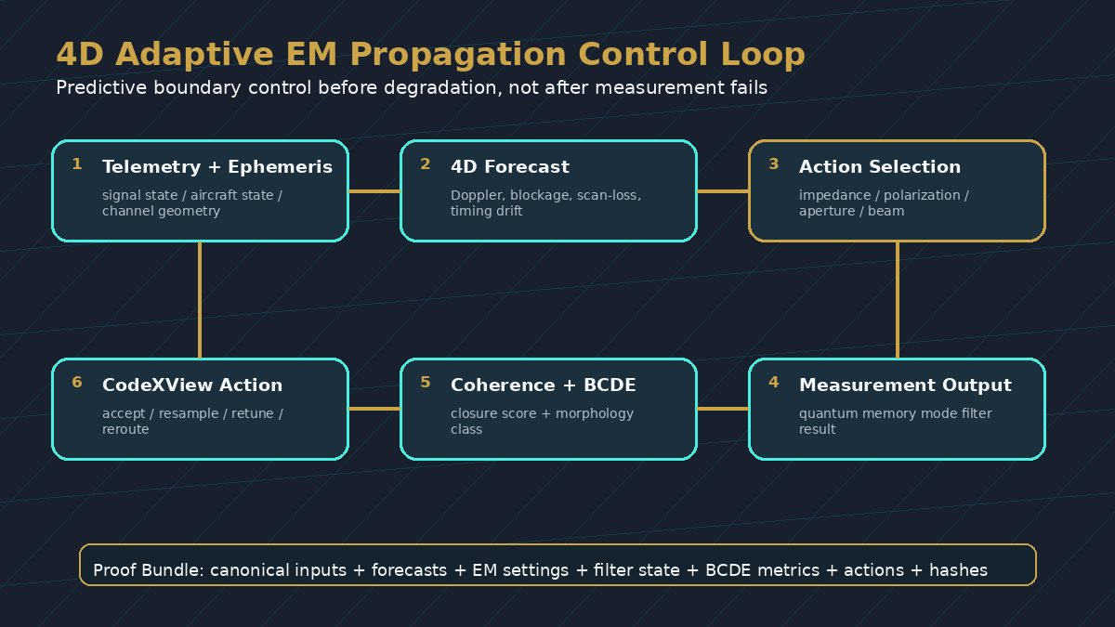
Figure 3. 4D Adaptive Electromagnetic Propagation Control control loop: forecast, retune, filter, classify, act, and replay.

6. Integrated PQMO-4D EM Architecture
Layer 1 - Signal Capture: Receive optical, RF, THz, LiDAR, spectroscopy, quantum-network, SATCOM, or bio-nano signal states.
Layer 2 - 4D Predictive Geometry: Forecast temporal reachability, instability corridors, timing drift, and attractor convergence.
Layer 3 - EM Propagation Control: Retune impedance, polarization, aperture grouping, beam/mode steering, and boundary conditions.
Layer 4 - Quantum Memory Mode Filtering: Use programmable quantum memory to store, retrieve, and filter the optimal time-frequency or spatial mode.
Layer 5 - Syntropy-Dispersion Scoring: Evaluate whether the signal is resolving toward coherence or dispersing toward ambiguity.
Layer 6 - Binary Curvature Decoding: Convert measurement windows into morphology objects and classify activation topology, boundaries, clusters, oscillation, and closure tendency.
Layer 7 - Omega Classification: Assign dormant, return-biased, near-critical, expansive, or closed class.
Layer 8 - CodeXView Action Layer: Produce explainable labels and action decisions: accept, resample, retune, reroute, hold, escalate, or reject.
Layer 9 - Deterministic Proof Bundle: Record inputs, forecasts, configurations, filter settings, classifications, actions, and hashes for replayable audit.

7. Coherence Calculus and Binary Curvature Decoding
The coherence layer evaluates whether a signal state is becoming more structured or more dispersed.
Ω(t) = ∫V [Φ²(x,t) - Δ²(x,t)] dV
A positive coherence trend indicates that the signal is resolving toward a usable measurement state. A negative or unstable trend indicates ambiguity, dispersion, mode mismatch, or a need for resampling.
BCDE converts encoded signal windows into morphology objects. Representative input windows include frequency-bin maps, photon-count sketches, mode-overlap traces, detector event windows, retrieval signatures, spectral-line activation patterns, Doppler return windows, and timing-state vectors.
raw signal → encoded window → morphology metrics → curvature class → Omega class → CodeXView action

8. Application Domains
Doppler LiDAR: Predict weak-return windows, classify multipath behavior, tune memory filter timing, and separate coherent Doppler shifts from edge-divergent noise.
Spectroscopy: Classify spectral windows as coherent line, overlapping doublet, dispersion-dominant region, weak resolving signature, or closed molecular fingerprint.
Quantum Networks: Score memory retrieval drift, route stability, timing mismatch, entanglement windows, and coherence-preserved routes.
Aerospace SATCOM: Predict blockage, scan-loss, Doppler, rain attenuation, and handoff windows; command beam pre-steering, polarization transitions, and aperture regrouping.
6G/7G and IoBNT: Bridge molecular, THz, optical, and RF domains using toroidal refractance, graphene plasmonic coupling, curvature signatures, and physical-layer attestation.
AI-Controlled Scientific Instruments: Govern autonomous instrument decisions by scoring stability, closure readiness, drift, oscillation, expansion pressure, and reproducibility risk.

9. Validation Matrix
Demo | Primary Test | Baseline | Success Metrics
A. Frequency windows | Close-line frequency estimation with drift/noise | Quantum-memory filtering alone | Lower frequency error; fewer resamples; better mode selection
B. Doppler LiDAR | Weak-return and multipath classification | Standard Doppler processing | Improved velocity stability; multipath rejection; explanation quality
C. Spectroscopy | Spectral-window triage before chemical inference | Line fitting and thresholding | Reduced false identifications; overlap detection; repeatability
D. SATCOM link control | Blockage/handoff/scan-loss forecasting | Reactive beam steering | Better link margin; lower transient loss; replayable action logs
E. Quantum network timing | Memory retrieval and route drift | Static route thresholds | Earlier drift detection; improved route stability; coherence preservation
F. CodeXView dashboard | Operator action decisions | Raw confidence scores | Faster decision speed; better auditability; lower ambiguous outputs

10. Productization Pathway
PQMO-4D SDK: Software layer for optical labs, LiDAR systems, spectroscopy, SATCOM testbeds, and quantum-network experiments.
BCDE Signal Governance API: Ingests encoded signal windows and returns morphology class, Omega class, confidence, and action.
CodeXView Scientific Dashboard: Explains measurement states as human-readable cards, alerts, and audit trails.
4D EM Edge Appliance: Low-latency embedded or FPGA-compatible deployment for aerospace, defense, autonomous vehicles, and high-rate field sensing.
Deterministic Proof Bundle Service: Produces signed replay packages for certification, investigation, and scientific reproducibility.

11. Representative Protectable Embodiments
• A method for predictive optical measurement comprising forecasting a temporal signal corridor, selecting an electromagnetic or optical mode configuration, filtering the mode with quantum memory, classifying the resulting signal morphology, and outputting an action decision.
• A system combining 4D predictive geometry, electromagnetic boundary control, quantum-memory mode filtering, BCDE morphology classification, and CodeXView explainability for precision measurement.
• A deterministic proof bundle for measurement decisions including canonicalized inputs, predicted spacetime corridor, EM configuration, memory-filter settings, BCDE metrics, Omega class, action decision, and cryptographic hash.
• A 6G/7G or IoBNT transduction system using toroidal refractance, curvature signatures, and geometry-conditioned propagation to couple molecular, THz, optical, or RF domains.

12. Discussion
The proposed architecture does not compete with quantum-memory precision measurement. It extends it. Quantum memory improves the physical measurement mode; 4D Adaptive Electromagnetic Propagation Control improves the propagation and boundary-control environment; 4D Predictive Geometry improves timing, reachability, and degradation anticipation; Binary Curvature Decoding improves structural interpretation; Omega Classification improves action governance; and CodeXView improves explainability.
The result is a measurement architecture that is predictive, electromagnetic, quantum-memory-enhanced, coherence-governed, morphology-aware, and replayably auditable.

13. Conclusion
Precision measurement is shifting from passive detection to active information-state control. Quantum memory demonstrates that the mode basis can be engineered before measurement. The Dillon Framework adds a 4D predictive and electromagnetic governance layer around that capability.
Filtering improves what the system can measure. Predictive geometry improves what the system expects. Electromagnetic propagation control improves the path environment. Coherence calculus improves what the system trusts. Binary Curvature Decoding improves what the system understands. CodeXView improves what the system can explain.

References and Source Basis
University of Oxford Department of Physics. 'Quantum memory sharpens precision measurements.' Accessed June 2026.
Dillon, Timothy J. Binary Curvature Decoding for Applied Systems. 206 Innovation Inc., 2026.
Dillon, Timothy J. 4D Predictive Geometry: A Spacetime Framework for Curvature-Governed Forecasting, Temporal Reachability, and Structural Trajectory Control. 206 Innovation Inc., 2026.
Dillon, Timothy J. Conformal Aero SATCOM Link Extension Using Adaptive Electromagnetic Propagation Control and 4D Predictive Link Control with Auditable Replay. Draft patent application, 2026.
Dillon, Timothy J. The Dillon Framework 4D Innovation - Full Technical White Paper. 206 Innovation Inc., 2026.
Dillon, Timothy J. Curvature Variable Physics in 6G/7G Internet of Bio-Nano Things. 206 Innovation Inc., 2026.

14. Version 2.1 Integration Addendum
This addendum integrates the review package, slide image set, tightened coherence calculus, prototype Binary Curvature Decoding Engine (BCDE) pipeline, and patent-oriented embodiment language into the Predictive Quantum Measurement Overlay with 4D Adaptive Electromagnetic Propagation Control paper.
The v3.1 goal is to make the paper usable as a technical manuscript, executive briefing document, slide-backed pitch package, and preliminary invention disclosure for follow-on patent drafting.

14.1 External Review Synthesis
The reviewed architecture positions the Oxford quantum-memory breakthrough as the physical mode-filtering layer, then extends it into a broader predictive governance framework grounded in the CVP / Dillon Equation architecture.
The system-level thesis is that precision measurement should be treated as a four-dimensional information-control problem, not merely a detector-performance problem.
• Layer 2 - 4D Predictive Geometry forecasts lawful temporal reachability corridors and temporal instability regions.
• Layer 3 - 4D Adaptive Electromagnetic Propagation Control adaptively tunes impedance, polarization, aperture grouping, beam steering, and boundary conditions before degradation occurs.
• Layer 4 - Quantum Memory Mode Filtering supplies the programmable physical filtering basis.
• Layers 5-8 - Coherence Calculus, BCDE, Omega Classification, and CodeXView convert filtered signals into morphology-aware, explainable action decisions.
• Layer 9 - Deterministic Proof Bundles provide replayable, cryptographically auditable governance for measurement decisions.

14.2 Tightened Coherence Calculus
The earlier compact expression for coherence should be interpreted as net coherent power and its temporal trend rather than as a direct volume integral of a gradient field. The following form is cleaner for implementation and validation.
Define the local coherence density:
ρΩ(x,t) = |Φ(x,t)|² - λΔ²(x,t), λ ≥ 1
Define total coherence:
C(t) = ∫V ρΩ(x,t) dV
Define the actionable coherence rate:
Ω(t) = dC/dt ≈ [C(t + Δt) - C(t)] / Δt
Interpretation: positive Ω(t) indicates that the signal is resolving toward a usable, stable measurement state. Negative, near-zero, or unstable Ω(t) indicates dispersion, mode mismatch, ambiguity, or the need for resampling / retuning.

14.3 Numerical Smoke-Test Result
A small synthetic coherence simulation can be used as an implementation check. In a 50 x 50 toroidal-like frequency-bin / photon-count field, a Gaussian signal peak sharpens while dispersion decays over three time steps. The coherence metric behaves as intended:
• t = 0.0: C(t) ≈ -11.98, indicating strongly dispersive structure.
• t = 1.5: C(t) ≈ -5.11, with Ω ≈ +4.58, indicating resolving structure.
• t = 3.0: C(t) ≈ -1.93, with Ω ≈ +2.12, indicating continued movement toward coherence.
Suggested manuscript sentence: “Coherence is quantified via the excess coherent power C(t) = ∫V [|Φ(x,t)|² - λΔ²(x,t)] dV; the governing rate Ω(t) = dC/dt is positive when the state resolves toward closure and negative when it disperses.”

14.4 Minimal BCDE Prototype Pipeline
The BCDE layer can be prototyped as a compact pipeline that converts raw frequency-bin maps, photon-count sketches, mode-overlap traces, Doppler returns, or quantum-memory retrieval windows into morphology metrics, curvature classes, Omega classes, and recommended actions.
def bcde_encode_pipeline(signal_window, lambda_disp=1.2):
sig = smooth(signal_window)
phi2 = sig ** 2
delta2 = variance_proxy(sig) * lambda_disp
rho = phi2 - delta2

metrics = {
"mean_coherence": mean(rho),
"curvature_mean": mean(laplacian(rho)),
"curvature_std": std(laplacian(rho)),
"num_attractors": count_peaks(mean_axis(rho)),
"oscillation_score": fft_peakiness(sig)
}

curv_class = classify_curvature(metrics)
omega_class = map_to_omega(curv_class)
action = "accept" if omega_class is closed else "resample / retune"

return metrics, curv_class, omega_class, action

14.5 Refined Protectable Embodiments
The v3.1 architecture supports several protectable embodiment families:
• A computer-implemented method for predictive optical or electromagnetic measurement comprising corridor forecasting, EM configuration selection, programmable quantum-memory filtering, coherence scoring, BCDE morphology classification, Omega classification, CodeXView action generation, and deterministic proof-bundle recording.
• A system comprising a 4D Predictive Geometry module, 4D Adaptive Electromagnetic Propagation Control controller, programmable quantum memory mode filter, BCDE engine, Omega Protocol classifier, CodeXView explainability layer, and Deterministic Proof Bundle service.
• A non-transitory computer-readable medium storing instructions that generate a proof bundle containing predicted corridor, EM configuration, quantum-memory settings, BCDE metrics, Omega class, action decision, and cryptographic hash.
• A 6G/7G or Internet-of-Bio-Nano-Things transduction apparatus coupling molecular, THz, optical, or RF domains using toroidal refractance, geometry-conditioned propagation, and curvature-signature morphology classification.

14.6 Slide-Backed Positioning Statement
The slide image set emphasizes the transition from quantum-memory precision to predictive governance. The key phrase for executive positioning is:
Filtering improves what the system can measure; predictive governance improves what the system can trust, explain, and replay.

Appendix A. Slide Image Package
The following slide images are integrated as a visual companion to the paper. They can be reused as an executive briefing sequence for quantum-sensor labs, SATCOM groups, 6G/7G partners, aerospace stakeholders, and research collaborators.


Slide 1. PQMO-4D EM: From Quantum-Memory Precision to Predictive Governance.

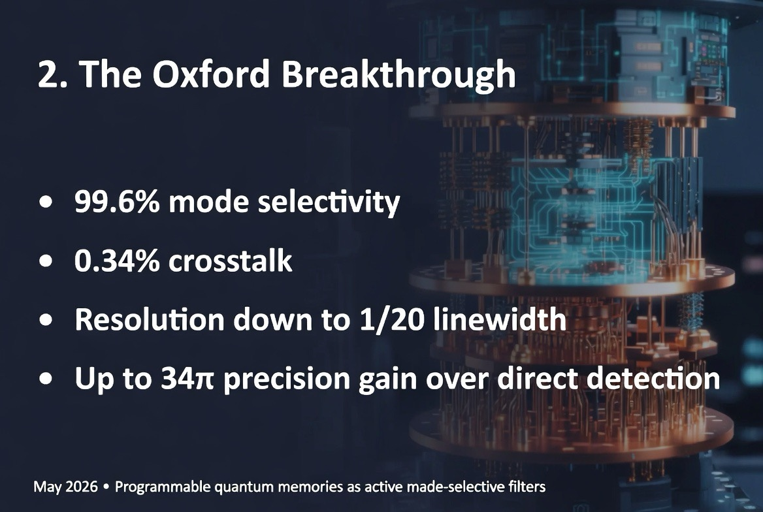
Slide 2. The Oxford Breakthrough: quantum memory as programmable mode-selective filtering.

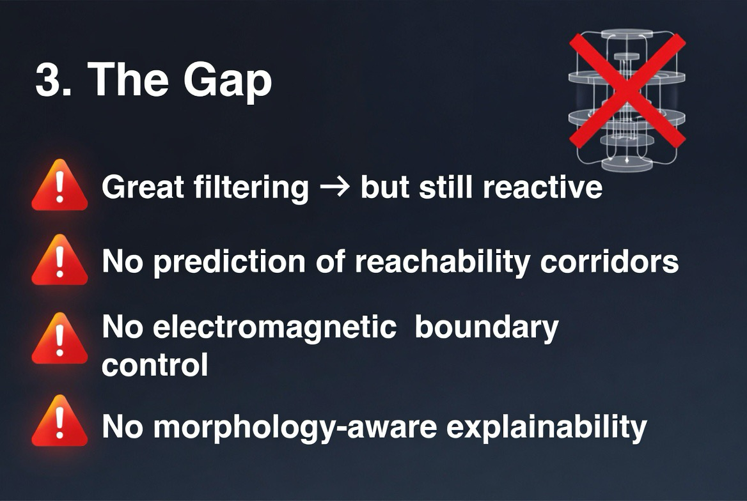
Slide 3. The Gap: filtering remains reactive without prediction, EM boundary control, and morphology-aware explainability.

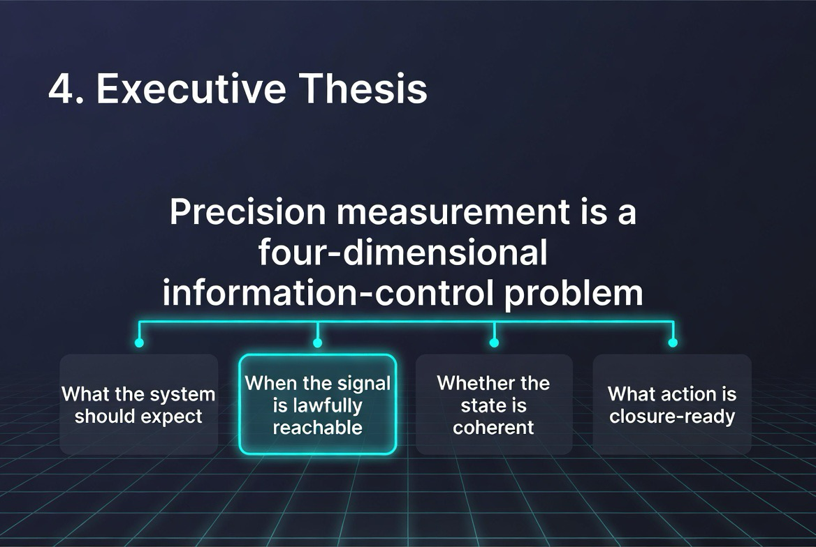
Slide 4. Executive Thesis: precision measurement as a four-dimensional information-control problem.

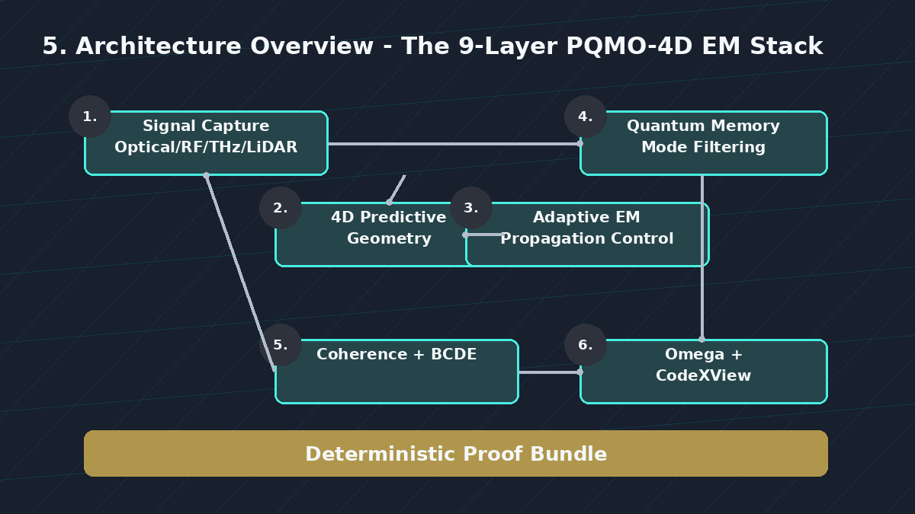
Slide 5. Architecture Overview: the 9-layer PQMO-4D EM stack.

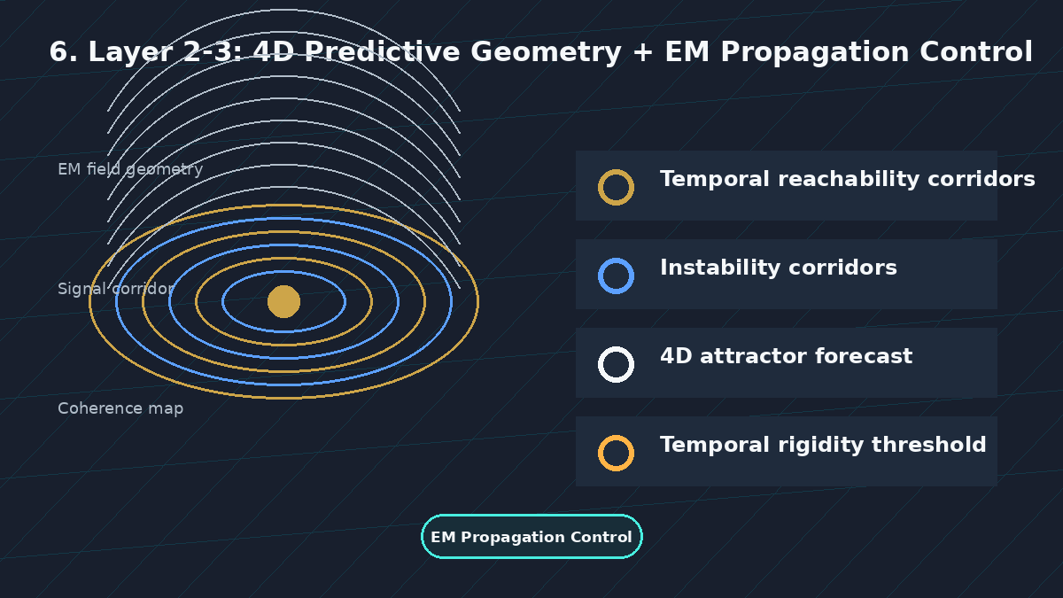
Slide 6. Layers 2-3: 4D Predictive Geometry plus EM Propagation Control.

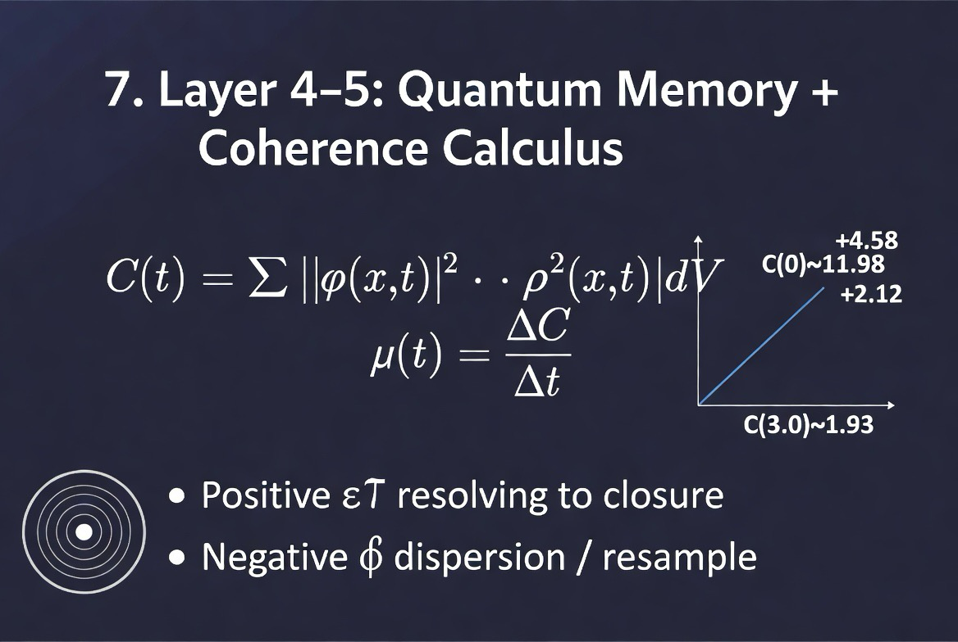
Slide 7. Layers 4-5: Quantum Memory plus Coherence Calculus.

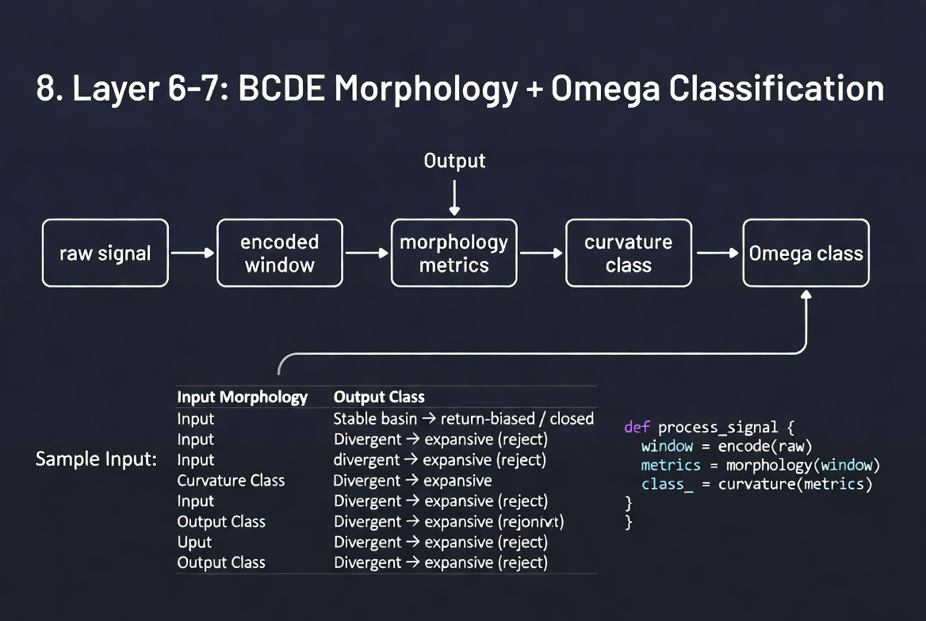
Slide 8. Layers 6-7: BCDE Morphology plus Omega Classification.

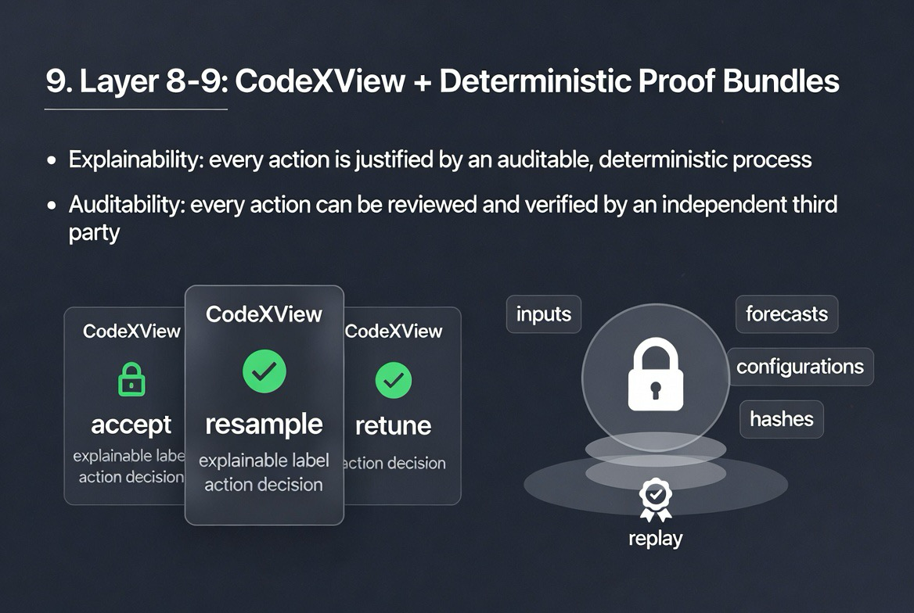
Slide 9. Layers 8-9: CodeXView plus Deterministic Proof Bundles.

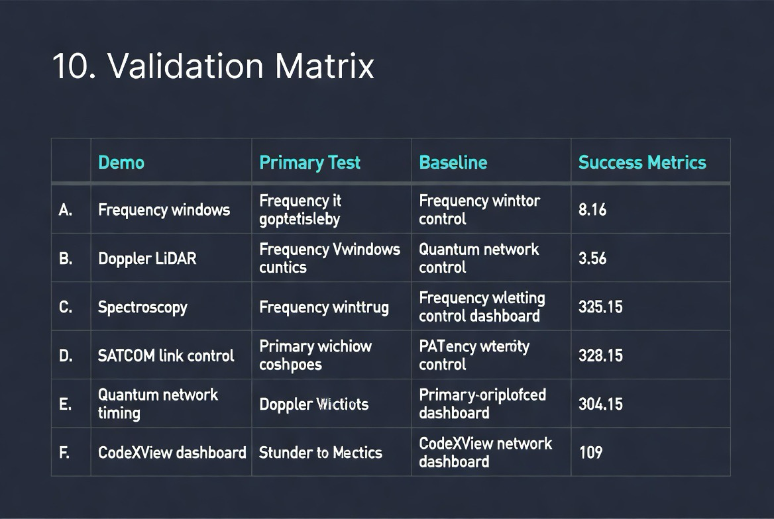
Slide 10. Validation Matrix for v3.1 demonstration package.

Appendix B. Implementation Roadmap
The recommended next sequence is to convert the v3.1 paper into a testable implementation package:
• Create a GitHub repository with /paper, /figures, /notebooks, /src, /data, /demos, and /patent-draft directories.
• Implement the BCDE signal-window prototype for 1D frequency windows and 2D photon-count or spectral maps.
• Build a synthetic validation notebook for the tightened coherence calculus and Ω(t) sign behavior.
• Create a CodeXView dashboard mockup that displays raw signal, quantum-memory filter state, coherence trend, morphology class, Omega class, and recommended action.
• Define the first controlled demonstration around synthetic close-frequency windows, followed by Doppler LiDAR weak-return classification, spectroscopy window triage, SATCOM link-control replay, and quantum-network timing drift.

Part III - CVP Spin Overlay and Quantum Integrity Governance
This v3.1 expansion extends PQMO-4D EM from a quantum-memory measurement architecture into a cross-platform quantum integrity overlay. The expansion integrates DSO-1, CVP Spin Overlay, CVP Overlay Processor, deterministic manifold contraction, and Proof Bundle governance into one architecture for quantum, quantum-classical, AI, GPU, photonic, SATCOM, and high-consequence compute environments.
Core thesis:
- Quantum hardware creates fragile states.
- 4D Predictive Geometry forecasts lawful state corridors.
- 4D Adaptive Electromagnetic Propagation Control stabilizes boundary and propagation conditions.
- CVP Spin Overlay governs state transitions and detects stale propagation.
- CVP Overlay Processor scores integrity, confidence, drift, and risk.
- BCDE and Omega classify signal and machine-state morphology.
- CodeXView explains the decision.
- Proof Bundles make the decision replayable, auditable, and trusted.

21. Expansion Rationale: From Quantum Measurement to Quantum Integrity
The earlier PQMO-4D EM paper focused on precision measurement: optical signals, programmable quantum memory, coherence calculus, BCDE morphology, and deterministic proof. The additional Dillon papers expand the frame from measurement to full quantum and quantum-classical system governance.
The quantum industry is not converging on a single hardware architecture. Instead, it is exploring superconducting qubits, trapped ions, photonic quantum computers, neutral atoms, quantum annealers, topological systems, spin qubits, NV-diamond systems, quantum simulators, analog quantum processors, and hybrid quantum-classical systems.
The physical implementations differ, but their operational fragilities converge: decoherence, drift, timing mismatch, error-state propagation, control-loop instability, thermal sensitivity, nondeterminism, weak replayability, and limited auditability. These shared constraints create the opportunity for a universal overlay layer.
The expanded category is therefore not another qubit type. It is a Quantum Integrity Overlay: a governance plane for coherence, replayability, auditability, state-transition control, and trust across heterogeneous quantum architectures.

22. DSO-1: Curvature-Adaptive Computing Layer
DSO-1, the Dillon Spin Overlay, serves as the curvature-adaptive computing layer of the expanded architecture. It is positioned as an overlay for real-time resonance synchronization, quantum overlay orchestration, geometric memory harmonics, and curvature-variable processing.
In the expanded PQMO-4D EM v3.1 architecture, DSO-1 functions as the state-governance substrate. It does not require replacing the underlying quantum or classical hardware. Instead, it monitors transitions, synchronizes timing, dampens stale propagation, and supplies a curvature-aware control grammar for high-consequence computational states.
This layer is especially relevant for quantum and quantum-classical systems because fragile states do not fail only at the physical qubit layer. They fail across timing loops, controller boundaries, calibration cycles, memory handoffs, routing decisions, and replay gaps.

23. CVP Overlay Processor: Sense, Score, Gate, Prove
The CVP Overlay Processor provides the operational integrity loop for high-consequence compute. Its governing loop is:
Sense → Score → Gate → Prove
Within quantum and quantum-classical systems, this loop can be interpreted as follows:
- Sense: capture multi-layer telemetry across hardware, runtime, protocol boundary, application, and governance layers.
- Score: compute integrity, confidence, drift, and risk scores over normalized state data.
- Gate: enforce actions such as allow, allow+log, slow-path, recompute, sandbox, escrow, deny, or quarantine.
- Prove: generate deterministic Proof Bundles for replay, audit, and independent review.
The key shift is from passive observability to active enforcement. The overlay does not merely report that a quantum-classical workflow failed. It can slow it, recompute it, sandbox it, reject it, or preserve the evidence required to reconstruct it.
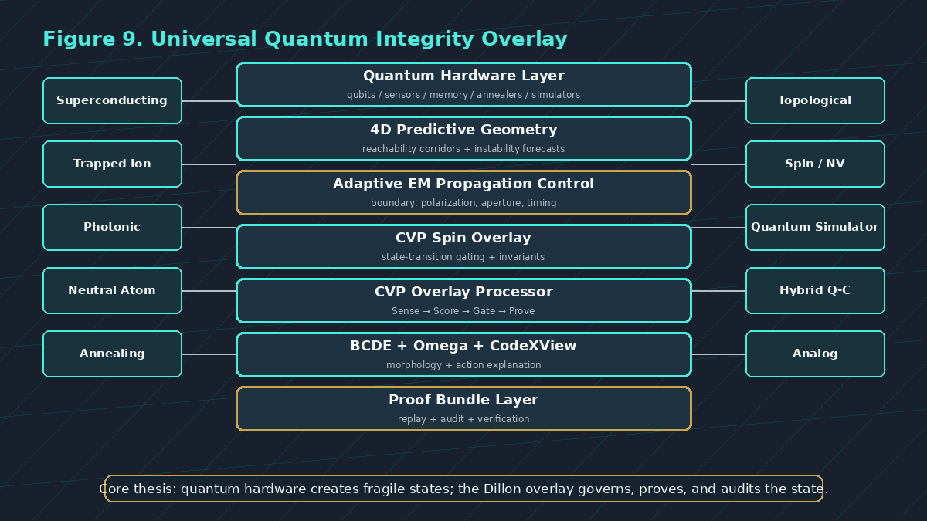
Figure 9. Universal Quantum Integrity Overlay - a cross-architecture governance layer above heterogeneous quantum and quantum-classical systems.

24. CVP Spin Overlay SDK for Quantum-Classical Workloads
The CVP Spin Overlay SDK provides the practical implementation bridge from conceptual overlay architecture to deployable instrumentation. In GPU and quantum-classical contexts, the SDK model includes invariant checks, state-transition gating, stale-state suppression, deterministic replay, Proof Bundle emission, fault-injection measurement gates, and scaling from single-node to multi-GPU or multi-node environments.
For quantum computing, the same SDK pattern can be generalized into a quantum-classical control sidecar:
- instrument quantum controller events and calibration cycles;
- capture quantum-memory or photonic mode-filter traces;
- tag collective or synchronization boundaries;
- detect stale controller state or drifted calibration metadata;
- emit Proof Bundles for high-consequence experiments;
- replay classical controller pathways around quantum runs;
- compare tolerance-bounded replay outputs to policy-defined envelopes.
This creates a realistic path for initial pilots: begin with quantum simulators and hybrid workflows, then extend toward photonic, trapped-ion, neutral-atom, and superconducting control telemetry as partners provide access.

25. Deterministic Manifold Contraction and Structural Integrity Screening
The nonprovisional patent draft introduces a structural integrity screening framework that maps candidate states onto manifold representations, computes rigidity or admissibility metrics, identifies deformation or leak conditions, and reduces non-admissible candidate regions through staged contraction.
In quantum and quantum-classical contexts, this becomes a state-space governance method. Candidate states may include bit sequences, qubit-controller events, measurement windows, calibration snapshots, encrypted blocks, telemetry segments, route states, or replay artifacts. The overlay evaluates whether those states remain admissible within a bounded corridor.
If a state exceeds a rigidity, curvature, leak, deformation, or admissibility threshold, the system can trigger one or more actions:
- contract the candidate region;
- isolate the non-admissible family;
- quarantine the state;
- recompute under deterministic mode;
- escalate to human review;
- reject or deny propagation;
- record a Proof Bundle for replay.
This extends PQMO-4D EM from measurement governance into structural state governance.

26. Cross-Architecture Quantum Overlay Map
The expanded framework can be mapped across major quantum architectures as an overlay rather than a substrate replacement.
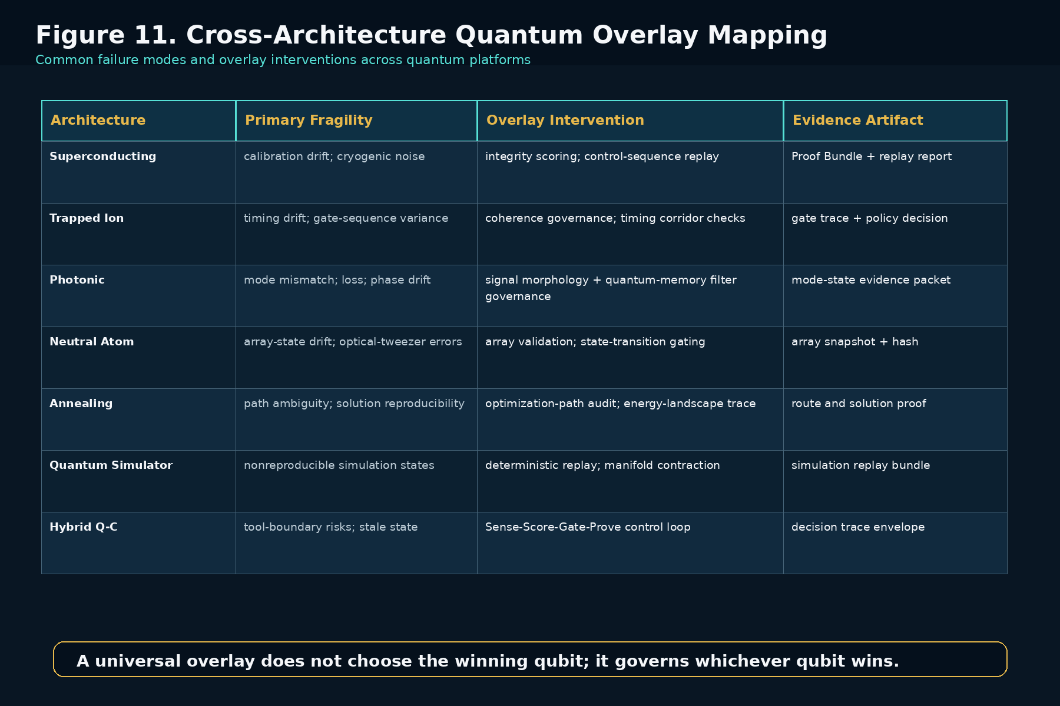
Figure 11. Cross-architecture mapping of common quantum fragilities to overlay interventions and proof artifacts.
Architecture | Shared Fragility | Overlay Intervention | Proof Artifact
Superconducting | calibration drift; cryogenic noise | integrity scoring; control-sequence replay | Proof Bundle + replay report
Trapped ion | timing drift; gate variance | coherence governance; timing corridor checks | gate trace + policy decision
Photonic | mode mismatch; phase loss | signal morphology + mode-filter governance | mode-state evidence packet
Neutral atom | array-state drift | array validation; state-transition gating | array snapshot + hash
Annealing | path ambiguity | optimization-path audit | route and solution proof
Quantum simulator | nonreproducible runs | deterministic replay; manifold contraction | simulation replay bundle
Hybrid quantum-classical | tool-boundary risk; stale state | Sense-Score-Gate-Prove control loop | decision trace envelope

27. Expanded 11-Layer Architecture
The v3.1 architecture expands the earlier 9-layer PQMO-4D EM stack into an 11-layer quantum integrity stack:
- Signal or quantum-state capture: optical, RF, THz, LiDAR, SATCOM, quantum-network, simulator, or controller traces.
- 4D Predictive Geometry: temporal reachability, instability corridors, rigidity thresholds, and attractor forecasts.
- 4D Adaptive Electromagnetic Propagation Control: impedance, polarization, aperture, beam, Doppler, and scan-loss control.
- Quantum Memory / Mode Filtering: programmable mode-selective filtering for precision measurement.
- DSO-1 Curvature-Adaptive Synchronization: resonance synchronization and geometric memory harmonics.
- CVP Spin Overlay: invariant checks, transition gating, stale-state suppression, and replay hooks.
- Coherence Calculus: C(t), Omega(t), resolving versus dispersive state assessment.
- BCDE Morphology Engine: binary or thresholded signal-state classification.
- Omega Classification: dormant, return-biased, near-critical, expansive, or closed-state assignment.
- CodeXView Action Layer: explainable accept, resample, retune, reroute, hold, reject, or quarantine labels.
- Deterministic Proof Bundle: canonical inputs, configurations, scores, actions, hashes, and replay verification.
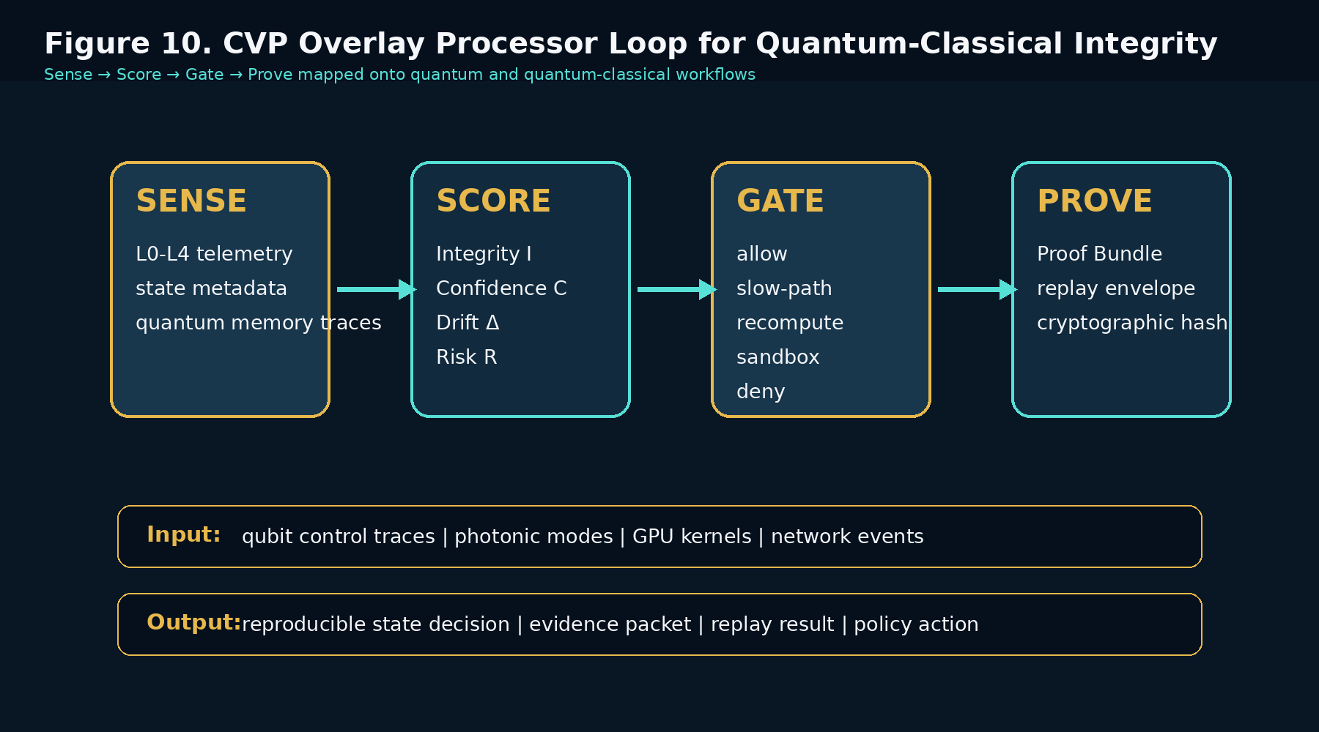
Figure 10. CVP Overlay Processor loop mapped onto quantum and quantum-classical integrity workflows.

28. Proof Bundles as the Trust Primitive
The expanded architecture treats the Proof Bundle as the trust primitive. In high-consequence quantum systems, the output alone is not enough. A defensible system must preserve the evidence path that produced the output.
A quantum or quantum-classical Proof Bundle should include:
- canonicalized inputs and state descriptors;
- hardware and controller configuration snapshots;
- timing markers and synchronization envelopes;
- quantum-memory or photonic filter settings;
- 4D corridor forecast and EM configuration;
- integrity, confidence, drift, and risk scores;
- coherence and morphology metrics;
- Omega class and CodeXView action label;
- policy version and gating action;
- cryptographic hash and replay verification report.
This allows an operator, lab, partner, regulator, or customer to determine not only what result was produced, but how the result was produced, why the system accepted it, and whether it can be independently replayed.

29. Productization: CVP Quantum Overlay Processor
The expanded product category is CVP Quantum Overlay Processor: a cross-platform integrity, coherence, replay, and governance layer for quantum and quantum-classical systems.
Initial product modules may include:
- Quantum Simulator Replay SDK: deterministic replay and Proof Bundles for quantum simulations.
- Hybrid Quantum-Classical Governance Sidecar: policy gating and decision traces for controller/tool boundaries.
- Photonic/Quantum Memory Measurement Overlay: mode-filter governance, morphology classification, and coherence scoring.
- Quantum Network Drift Monitor: route timing, retrieval drift, and synchronization-class evidence bundles.
- GPU + Quantum Workflow Integrity SDK: CUDA/NCCL-style instrumentation for quantum-classical pipelines.
- CodeXView Quantum Dashboard: explainable measurement-state and compute-state cards for operators.
The commercial thesis is not to choose the winning quantum hardware architecture. It is to become the integrity and audit layer that all quantum architectures require before they can be trusted in regulated, autonomous, aerospace, defense, finance, healthcare, or infrastructure workflows.

30. Validation Roadmap for v3.1
The v3.1 roadmap should be evaluated through controlled demonstrations:
Demo | Primary Test | Baseline | Success Metric
A | Quantum simulator replay | uncontrolled simulator run | higher replay success; lower variance
B | Photonic signal-state governance | quantum memory filtering only | lower false accepts; fewer resamples
C | Hybrid Q-C tool boundary | standard orchestration logs | fewer stale-state actions; complete evidence packet
D | GPU + quantum workflow | baseline CUDA/NCCL pipeline | fault injection detection; controlled overhead
E | Quantum network timing drift | passive timing telemetry | earlier drift detection; route stability uplift
F | CodeXView dashboard | raw confidence dashboard | faster operator review; improved auditability

31. Protectable Embodiment Families
The expanded v3.1 architecture supports several protectable embodiment families:
- a cross-architecture quantum integrity overlay that senses, scores, gates, and proves quantum and quantum-classical state transitions;
- a deterministic Proof Bundle generator for quantum measurement, quantum simulation, and quantum-classical workflows;
- a state-transition gating method using integrity, confidence, drift, risk, coherence, morphology, and admissibility scores;
- a deterministic manifold contraction engine for excluding non-admissible quantum or machine-state candidates;
- a CodeXView dashboard that converts quantum-state and signal-state classifications into explainable action labels;
- a GPU/quantum-classical SDK that emits replayable evidence packets from controller, runtime, and accelerator boundaries;
- a 4D EM and quantum-memory measurement overlay for predictive retuning, filtering, classification, and audit.

32. v3.1 Strategic Conclusion
The future of quantum computing may not be decided by a single hardware winner. It may be decided by which quantum systems can be reproduced, audited, governed, integrated, and trusted.
PQMO-4D EM v3.1 therefore extends the Dillon Framework from precision measurement into quantum integrity infrastructure. The expanded platform unifies predictive geometry, adaptive electromagnetic propagation control, quantum memory, DSO-1, CVP Spin Overlay, CVP Overlay Processor, BCDE, CodeXView, and Proof Bundles into one architecture for governed quantum and quantum-classical systems.
The resulting statement is simple:
Quantum computing with proof.
Quantum sensing with governance.
Quantum networks with replay.
Quantum-classical systems with integrity.

References Integrated in v3.1 Expansion
Dillon, T. J. DSO-1 - Smithsonian Capsule: Executive Summary. 206 Innovation Inc., 2026.
Dillon, T. J. CVP Overlay Processor - Deterministic Integrity Scoring, Policy Gating, and Proof Bundles for High-Consequence Compute. 206 Innovation Inc., 2026.
Dillon, T. J. CVP Spin Overlay SDK Pilot Proposal. 206 Innovation Inc., January 30, 2026.
Dillon, T. J. Systems and Methods for Structural Integrity Screening, Deterministic Manifold Contraction, and Secure Data-at-Rest Validation. Draft nonprovisional patent application.
Dillon, T. J. Predictive Quantum Measurement Overlay with 4D Adaptive Electromagnetic Propagation Control. 206 Innovation Inc., 2026.

