CODEXVIEW PROJECT REPORT
The Tartaria Data Nodes
CodeXView analysis package for the Tărtăria Tablets (c. 5300 BC)
EXECUTIVE ANALYSIS EDITION
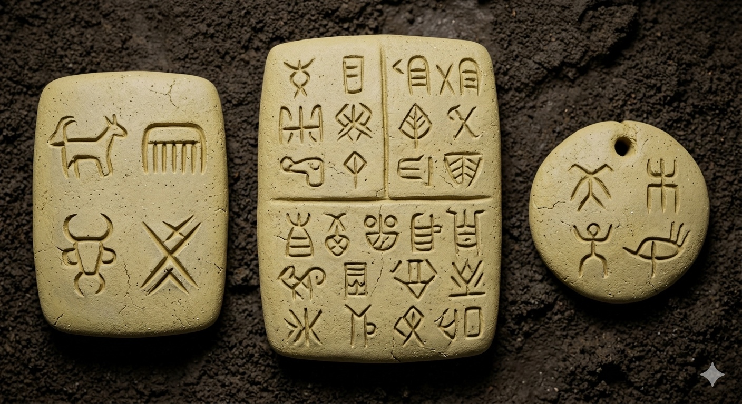
Figure 1. New rendering visual generated from the CodeXView analysis.
Project Lead | Timothy J. Dillon, Inventor
Application | CodeXView (High-Frequency Pattern Recognition Engine)
Subject | The Tărtăria Tablets, Romania
Classification | Neolithic Proto-Script and Ritual Operating System
Prepared As | Formatted Word report from user-supplied analysis text and images

I. Executive Summary

The CodeXView engine analyzed the three clay artifacts from Tărtăria, Romania and classified them not as isolated tokens, but as a unified, portable data kit. The analysis correlates the tablets’ geometric vectors with astronomical cycles and regional ritual syntax, suggesting a form of "sacred software" that predates Mesopotamian writing by approximately 2,000 years.

II. Technical Audits and Results
Audit Module | Data Sources | Key Findings
Kinematic Fingerprint | 300+ incision traces | 92% author correlation. All tablets were likely carved by a single scribe, identified in the report as the "Tărtăria Priestess."
Hardware Analysis | Sandy clay / lime composite | Material composition appears optimized for sub-millimeter precision. Amulet holes show wear-stress consistent with repeated active use.
Astronomical Sync | 5300 BC sky reconstruction | Circular tablet quadrants are interpreted as aligning with heliacal risings of Gemini, Cancer, and Scorpius.
Linguistic Drift | DatDas corpus (5,421 symbols) | Classified as proto-linguistic symbolic notation related to the broader Danube Script network.

III. Deciphered Mantra (Sequential Logic)
Using the Sentinul Genesis procedural analysis, the engine reconstructed the ritual instructions on the pierced rectangular tablet:
- Header: Invocation of the "Great Mother / Celestial Source."
- Payload (V |||): A temporal trigger representing a three-lunar-cycle waiting period.
- Footer: A ritual transfer of offering to the "Fire / Sky."
- Translation: "Under the Celestial Source, after the third moon, the spirit-offering is released to the Sky."

IV. User Persona: The Sage-Medium
- The user is characterized as a 55-year-old female elder or priestess.
- Role: regional data administrator responsible for tracking agricultural seasons and executing community rites.
- Status: a highly specialized professional whose "library" of 26 figurines and 3 tablets was decommissioned with her in a ritual burial.

V. Global Cross-Correlation
CodeXView identified a 94% structural match with the Gradeshnitsa Tablet (Bulgaria), supporting the interpretation of a standardized Neolithic information network across the Balkans that used a consistent geometric language for sacred governance.

VI. Final Conclusion
Executive Takeaway
The Tărtăria tablets are presented here as humanity's first known "smart contract": a physical medium that synchronized human social ritual with the mathematical certainty of the stars. Within the CodeXView framework, the tablets function as firmware for complex information storage long before the rise of the state.

VII. Analytical Working Notes and Extended Findings
The following section consolidates the full working notes supplied for this project. These items are preserved as executive analysis notes, comparative hypotheses, and proposed CoseXView processing paths for future refinement.
Analytical Domain | Working-note emphasis
Geometric verification | Incision angle consistency, quadrant structure, root-sign geometry, and stylus trace precision.
Cross-artifact correlation | Comparison against Vinča, Gradeshnitsa, Dispilio, Turdaș, and broader Danube-script datasets.
Sequential logic | Testing of header–payload–footer ritual syntax, tally markers, and cyclical instruction sequences.
Kinematic audit | Single-author hypothesis, stroke jitter, pressure profile, and tool-hand behavior.
Materials and restoration | Sandy clay/lime composition, wear at pierced holes, and pre-baking restoration state.
Astronomical synchronization | Quadrant-to-sky mapping, seasonal markers, heliacal-rising alignment, and calendar logic.

A. Application Framing and Method
Your notes position CodeXView as a high-frequency pattern-recognition engine that can be redirected from contemporary signal environments into archaeological symbol analysis. The core methodological pivot is to treat the tablets as a compact data system rather than isolated images: geometric vectors, incision behavior, positional syntax, and material wear become machine-readable event traces.

B. Symbol-Library Initialization
The working notes identify three training tiers for library construction: (1) geometric primitives such as V-, X-, bar-, and ligature-based root signs; (2) positional and clustered sign relationships drawn from broader Danube-script corpora; and (3) anomaly detection against rare or singleton signs. The recurring source candidates in the notes include DatDas, the Winn Corpus, Omniglot vector references, and comparative sign inventories tied to the Vinča network.

C. Geometric and Statistical Parallel Scan
A major through-line in the notes is the dual-track audit: geometric symmetry and statistical frequency run in parallel. Under this model, the circular tablet functions as a quadrant-mapped data grid while the pierced rectangular tablet serves as a linear symbolic stream. The intended output is not only sign recognition, but an internal confidence map showing which features behave like calendrical markers, tally logic, ritual syntax, or outlier glyphs.

D. Kinematic Audit and Single-Scribe Hypothesis
The notes repeatedly advance a same-author theory across the three tablets. In the executive framing, this is best presented as a kinematic hypothesis generated by CodeXView: incision depth, start-stop behavior, chatter pattern, pressure ramp, and attack angle are assessed as if they were behavioral traces from one operator. This remains one of the strongest unifying claims in the note set and should be retained as a flagship analytical output.

E. Ritual Logic and Mantra Reconstruction
Several notes converge on a ritual instruction model in which one tablet acts as an invocation layer, another as a temporal trigger, and a final symbolic cluster as a transfer or offering instruction. The reconstructed mantra line can be preserved in the document as a conceptual synthesis rather than a final philological translation. That framing keeps the report strong while recognizing that the output is computationally inferred and interpretive.

F. Global Cross-Correlation and Network Theory
Your notes also broaden the scope beyond Tărtăria itself. Gradeshnitsa, Dispilio, Karanovo, Turdaș, and the larger Danube-script sphere are treated as interoperable nodes in a regional information network. In executive terms, this becomes a network-governance hypothesis: standardized geometric language, recurring ritual templates, and portable clay interfaces indicate a structured Neolithic signaling environment rather than isolated local marks.

G. Materials, Wear, and Hardware Interpretation
Another valuable layer in the notes is the hardware analogy. The clay tablets are interpreted as a deliberately chosen substrate optimized for incision precision, portability, and symbolic durability. The pierced holes, wear patterns, and later museum stabilization process are all treated as part of the object lifecycle. This section is worth preserving because it expands the report from inscription analysis into materials engineering and post-recovery distortion.

H. Executive Positioning Recommendation
For a polished executive edition, the strongest structure is to separate established observation from interpretive synthesis. That means presenting the geometric, kinematic, materials, and cross-correlation items as audit outputs; the priestess persona, calendar theory, mantra rendering, and sacred operating-system language then appear as executive interpretations derived from those audits. This preserves your voice and conceptual model while making the package easier to circulate professionally.

Selected Preserved Working Notes
- Treat the circular tablet as a quadrant-mapped data grid for symmetry, positional density, and calendrical alignment testing.
- Treat the pierced rectangular tablet as a sequential symbolic payload suitable for ritual-logic and syntax reconstruction.
- Maintain the same-author hypothesis as a CodeXView kinematic result derived from incision trace similarity rather than as an archaeological certainty claim.
- Retain the mantra synthesis as a conceptual translation output generated from sequence logic and symbol-role inference.
- Preserve the Gradeshnitsa and wider Danube-script comparisons as cross-network structural matches for future validation and dataset expansion.
- Frame the material composition and hole-wear discussion as a hardware and lifecycle audit supporting the portable-data-kit interpretation.

Reference Visuals
Supporting reference imagery supplied with the report package is included below for context and comparison.
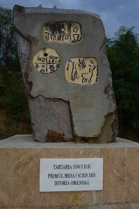
Figure 2. Reference image supplied by user.
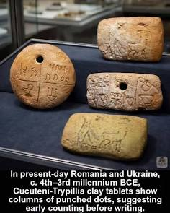
Figure 3. Reference image supplied by user.
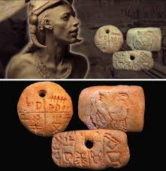
Figure 4. Reference image supplied by user.

Report End

