Navigation and Control of an Unmanned Surface Vessel

Mechatronic Project 488 Progress Report

Author  
LEV Kingwill

20725728

Supervisor: Prof Jaco Versfeld

2022

Plagiarism declaration

I have read and understand the Stellenbosch University Policy on Plagiarism and the definitions of plagiarism and self-plagiarism contained in the Policy [Plagiarism: The use of the ideas or material of others without acknowledgement, or the re-use of one's own previously evaluated or published material without acknowledgement or indication thereof (self-plagiarism or text-recycling)].

I also understand that direct translations are plagiarism, unless accompanied by an appropriate acknowledgement of the source. I also know that verbatim copy that has not been explicitly indicated as such, is plagiarism.

I know that plagiarism is a punishable offence and may be referred to the University's Central Disciplinary Committee (CDC) who has the authority to expel me for such an offence.

I know that plagiarism is harmful for the academic environment and that it has a negative impact on any profession.

Accordingly all quotations and contributions from any source whatsoever (including the internet) have been cited fully (acknowledged); further, all verbatim copies have been expressly indicated as such (e.g. through quotation marks) and the sources are cited fully.

I declare that, except where a source has been cited, the work contained in this assignment is my own work and that I have not previously (in its entirety or in part) submitted it for grading in this module/assignment or another module/assignment.

I declare that have not allowed, and will not allow, anyone to use my work (in paper, graphics, electronic, verbal or any other format) with the intention of passing it off as his/her own work.

I know that a mark of zero may be awarded to assignments with plagiarism and also that no opportunity be given to submit an improved assignment.

Signature:

Name: Student no:

Date:

Executive Summary

|  |
| --- |
| **Title of Project** |
| Navigation and Control of an Unmanned Surface Vessel. |
| **Objectives** |
| The development of an independent navigation and control system that can be implemented on an unmanned surface vessel that uses electrical thrusters for propulsion and steering. |
| **What is new in this project?** |
| A new control system is going to be created to control the power to the thrusters and thereby steer the vessel. Building on this a navigation system will be created so that the vessel can navigate to a designated point autonomously. |
| **If the project is successful, how will it make a difference?** |
| With a successful navigation and control system, the system could be moved to vessels with better range and seafaring ability and these unmanned vessels can be used for research data collection, patrolling and search and rescue. |
| **What contributions have/will other students made/make?** |
| N/A |
| **Which aspects of the project will carry on after completion and why?** |
| For the vessel to be completely autonomous, a further project should add an obstacle avoidance system. This will be beneficial to avoid other sea vessels as well as fixed obstacles such as rocks and shore. |
| **What arrangements have been/will be made to expedite continuation?** |
| All the research and project documents will be archived with the university. |

Table of contents

**Page**

Plagiarism declaration i

Abstract ii

Acknowledgements iii

List of figures v

List of tables vi

List of symbols vii

1 Introduction 1

1.1 Background 1

1.2 Objectives 1

1.3 Motivation 1

2 Literature review 2

2.1 Boats and ships 2

3 Content chapter 3

3.1 Heading level 2 3

3.1.1 Heading level 3 3

4 Conclusions 6

5 References 7

Appendix A Heading for this appendix 8

Appendix B BlaBlaBla 9

List of figures

**Page**

Figure 1: Water plants 3

List of tables

**Page**

Table 1: Acceptable page layouts 2

List of symbols

*A* Wing area

*c* Chord length

** Angle of attack

# Introduction

## Background

As technology has improved over the years, processes and systems have become more automated. Initially factories were replacing manual labour with automated machines but recently companies have been investigating self-driving cars and trucks. All over industries tasks are being automated or done remotely with fewer human involvement.

The ocean is the perfect area for unmanned surface vessels (USV) to be used as many of the issues faced with autonomous land vehicles such as self-driving cars are mitigated by open water. On the open water one gets a 360° of the surroundings of the vehicle and although there can still be high volumes of traffic in certain areas such as commercial shipping lanes, due to the expanse of the ocean these high traffic areas are avoidable. Finally, and probably the most desirable mitigating factor is that where a surface vehicle would need to look where the road surface is to follow it, an ocean vessel can move directly from point to point on any piece of water.

In South Africa there is a growing need to USVs with regards to ocean research and conservation. There has been a growing use of acoustic sensory systems to track dolphins and whales around the world. By combining this with the technology of USVs, a far larger area can be surveyed.

## Objectives

This project will focus on the navigation and propulsion control of the USV. This is the building block of the USV upon which a future project can build by adding an obstacle avoidance system or renewable power sources to keep the USV operational for longer. This project will have the following objectives:

1. Design and manufacture an electric surface vessel.
2. Designing and manufacturing the control system that will give a pilot manual control over the electric surface vessel.
3. Building on the manual control and implementing navigation control so that the electric surface vessel.

## Motivation

Currently the marine community is using these acoustic systems as stationary systems. By using the USV in conjunction with the USV the area that is studied can be greatly increased with fewer acoustic platforms as have been used in passed projects. Furthermore, the technology can be adapted for use in other industries such sonar surveying, defence and search and rescue. The use of USVs is becoming more prominent as a USV can be cheaper to operate and therefore organisations can either save costs in the case of sonar and acoustic research or in the case or marine patrols and search and rescue, USVs can be used to fill up the ranks of vessels and close the possible.

The tasks previously mentioned are often time consuming and the crew of the assigned vessel need time to rest whereas a fully autonomous USV can operate constantly, stopping only to replenish its energy source and with further developments such as solar charging, USVs could begin to operate indefinitely, having to only come in for services or if there is a problem with the system.

# Literature review

## Boats and ships

A ship has a funnel, while a boat does not [Pompies 1652].

# Content chapter

Unless the chapter heading already makes it clear, an introductory paragraph that explains how this chapter contributes to the objectives of the report/project

## Heading level 2

### Heading level 3

#### Deepest heading, only if you cannot do without it

"Text 1" is for normal paragraphs. A blank line is automatically created before each paragraph.

1. "Text 1 Items" for a list that is not automatically numbered.

2. List that is not automatically numbered.

3. List that is not automatically numbered.

"Text 2" is for a paragraph that fits under "Text 1 items".

Waffle waffle

* "Text 1 bullet" for a bulleted list;
* Bullet list item 2;
* "Text 2 bullet" for sub-points
* "Text 2 bullet" for sub-points
* Bullet list item 3.

"Text 2" also fits under "Text 1 bullet".

Table : Acceptable page layouts (manually set "keep with next" in paragraph style for tables)

|  |  |  |
| --- | --- | --- |
| Paper | Margins | |
|  | Left/Right [mm] | Top/Bottom [mm] |
| A4 |  |  |
| A5 |  |  |

An equation must read like part of the text. Some or other strange parameter is given by the following expression (note the full stop after the equation to indicate the end of the sentence):

$A/b=x^{2}/{\left(u+v\right)}^{0.5}$. (1)

In other cases the equation is in the middle of the sentence. Then the paragraph following the equation should start with a small letter. Another strange parameter is given by

$A/b=x^{2}/{\left(u+v\right)}^{0.5}$, (2)

where *y* represents a physical property.

Symbols that represent values of properties should be printed in italics, but SI units and names of functions (e.g. sin, cos and tan) must not be printed in italics. There must be a hard space between a number and its unit, e.g. 120 km. This type of space can be created using "Crtl-Shift-Spacebar".

Create sketches and diagrams in PowerPoint or Visio. Then copy the figure and select "Paste special" to insert it as "Picture (enhanced metafile)". The paragraph containing the figure should use the "Figure" style. If you type "Enter" in the "Figure" style, the next style is automatically "Caption".

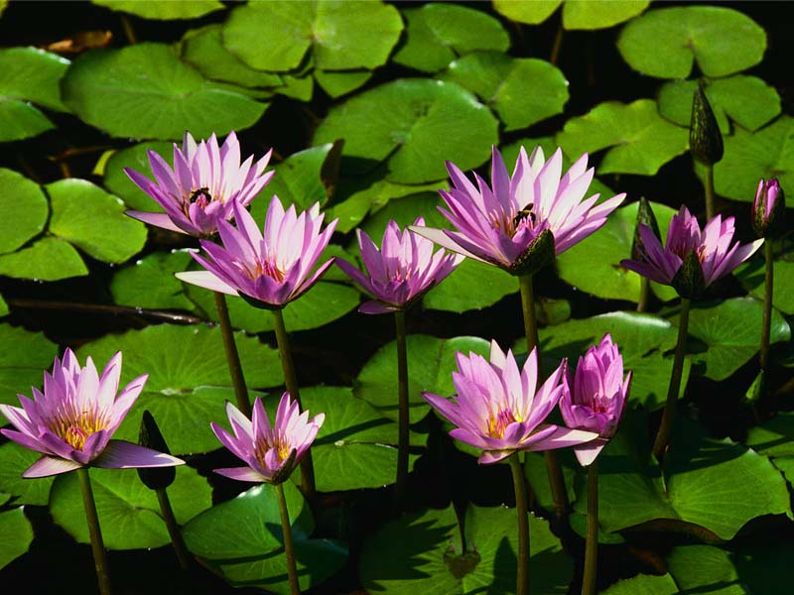

Figure : Water plants

# Conclusions

H

# References

Pompies, P, 1652, *My experiences on the Drommedaris*, 1st ed, Van Riebeeck Publishers, Cape Town.

Heading for this appendix

Bla bla

Note that for appendix headings use styles "Heading 7" and "Heading 8".

Note that all headings must have a title, just as a chapter has a heading

BlaBlaBla

SDCc

Dasqw