Image 1  Tank Overview | 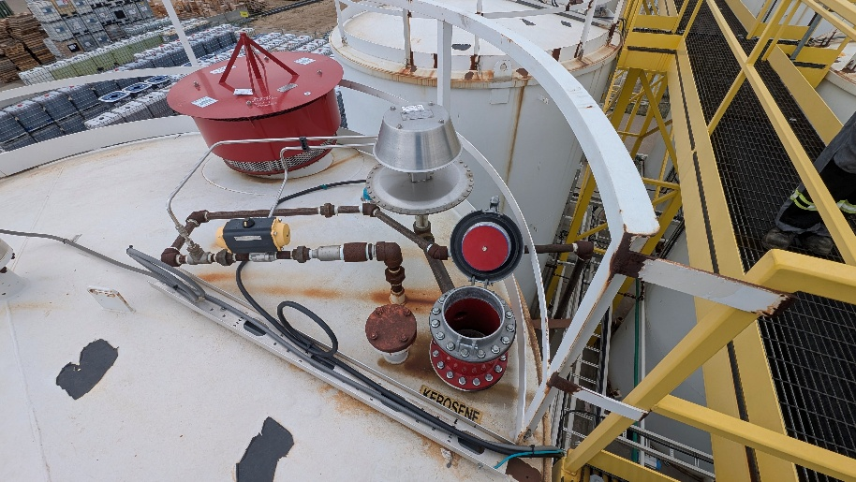
Image 2  Tank Overview | 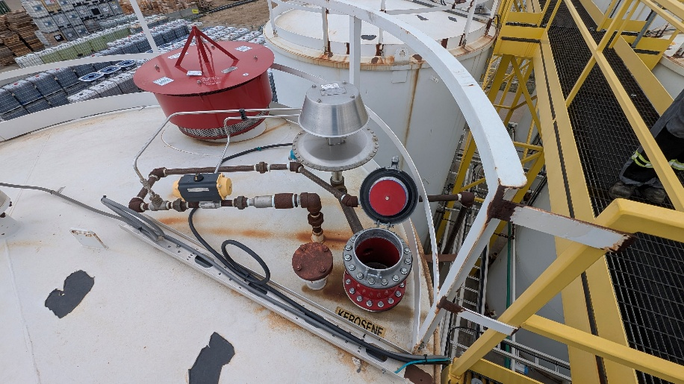
Image 3
Tank Overview

