WEB TECHNOLOGIES FINAL PROJECT

Four Seasons Across China Final Project Report
An interactive website built with pure Python, HTML, CSS, and JavaScript
This report explains the design, implementation, testing, and final result of a four-season interactive website created for the Web Technologies course.
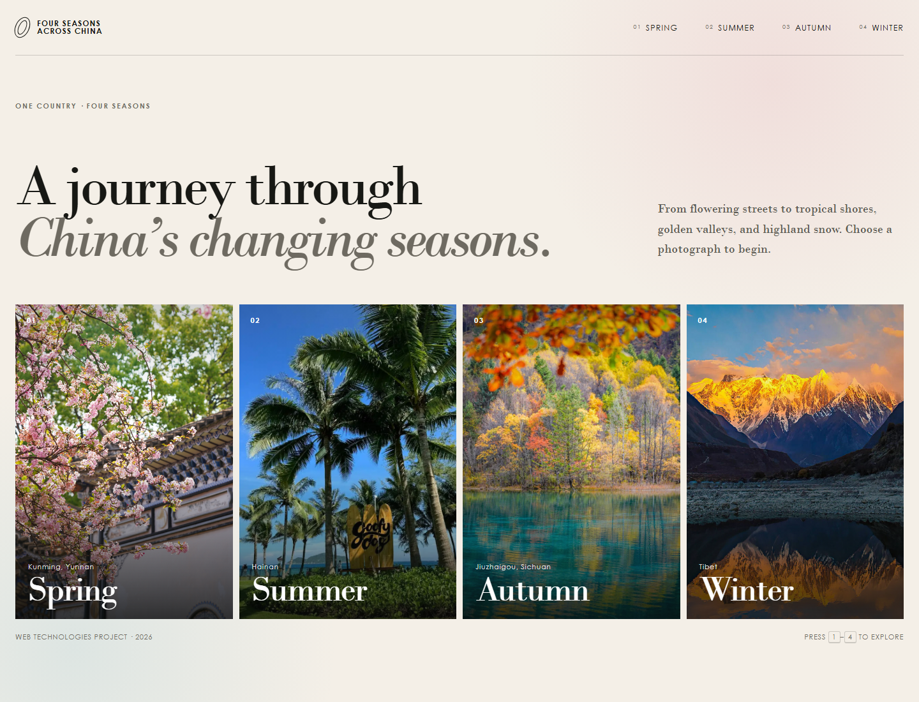
Figure 1. The four-season homepage in the final desktop layout.

Project Overview
Four Seasons Across China is an interactive website created for my Web Technologies final project. The site presents one representative landscape for each season: spring in Kunming, summer in Hainan, autumn in Jiuzhaigou, and winter in Tibet. The homepage gives each season a photographic entry point. Clicking an image opens a larger photograph, an English quotation, and the author's name.
The final version uses Python, HTML, CSS, and JavaScript. Python is implemented with the standard library only. The website does not require Flask, Jinja, a database, or any third-party package. This choice keeps the project easy to run and makes every main part of the request flow visible in a small number of files.

Project Goals
The project has four practical goals:
- Make the main interaction understandable without a long instruction.
- Give each season a distinct visual identity through place, photograph, and colour.
- Use one reusable page structure for all four seasonal pages.
- Practise Python routing, HTML structure, CSS layout, JavaScript interaction, and testing.

Project Content
Each location contributes a different visual signal. The table below summarises the content used on the four seasonal pages.
Season | Location | Visual focus | Author
Spring | Kunming, Yunnan | Cherry blossoms and traditional architecture | Ralph Waldo Emerson
Summer | Hainan | Palm trees, blue sky, and the coast | Sam Keen
Autumn | Jiuzhaigou, Sichuan | Autumn forest reflected in water | Albert Camus
Winter | Tibet | Snow mountains and reflected light | Percy Bysshe Shelley

The page content remains deliberately short. The photograph identifies the landscape, while the quotation gives a brief literary response to the season. This balance keeps the website focused on the image-based interaction.

Website Design
The homepage uses a warm paper background, dark typography, and a four-card image grid. The cards have a strong vertical format so that each photograph remains the main visual element. On hover or keyboard focus, the image enlarges slightly and a small arrow appears. This gives visible feedback before navigation.
Each season page has two main areas on desktop screens. The photograph occupies the larger left area, and the quotation occupies a colour field on the right. Previous and next links at the bottom allow continuous exploration. The layout changes to a single vertical column on smaller screens.
The photographs act as the main navigation. This design follows the original project idea: a simple website in which a visitor clicks an image and enters that season.

User Journey
- The visitor lands on a single page with four clearly labelled season cards.
- The visitor selects a photograph and enters the corresponding season page.
- The visitor reads the quotation, moves to another season, or returns to the overview.
- Keyboard and touch alternatives provide the same movement without requiring a mouse.

System Architecture
The project has three layers. The browser displays the interface, the Python application prepares each response, and local files store the seasonal content and visual assets.
Layer | Responsibility | Implementation
Client | Displays the interface and handles short interactions | HTML, CSS, JavaScript
Python application | Chooses pages, prepares HTML, and serves files | http.server, pathlib
Content | Stores seasonal text and image paths | Python dictionaries and local files

When the browser requests the homepage, Python returns the index template. When it requests /season/spring, Python reads the shared season template, inserts the spring values, and returns the completed page. Requests beginning with /static/ return CSS, JavaScript, or image files with the correct content type.

Python Implementation
All seasonal content is stored in the SEASONS dictionary inside app.py. The dictionary contains the page name, location, image, alternate text, quotation, author, and colours. Adding a new season does not require a separate hand-written page for every route.
def render_template(template_name, values):
template = (TEMPLATE_DIR / template_name).read_text(encoding="utf-8")
for key, value in values.items():
template = template.replace("{{" + key + "}}", str(value))
return template
The render_template function loads an HTML file and replaces placeholders such as {{NAME}} and {{QUOTE}}. Text values are escaped with Python's html.escape before insertion. The SiteHandler class extends BaseHTTPRequestHandler, supports GET and HEAD requests, sets the response type, and checks that static files remain inside the static directory.

Interaction and Accessibility
The site uses JavaScript for small enhancements. Number keys one through four open the corresponding season from the homepage. Arrow keys move between seasons, and Escape returns to the homepage. A horizontal swipe changes seasons on touch screens. Normal links remain available, so the core navigation still works if JavaScript is unavailable.
- Every photograph has descriptive alternative text.
- Cards and links have visible keyboard focus outlines.
- A reduced-motion media query removes most transitions when requested.
- Responsive CSS rearranges the page without separate mobile HTML files.
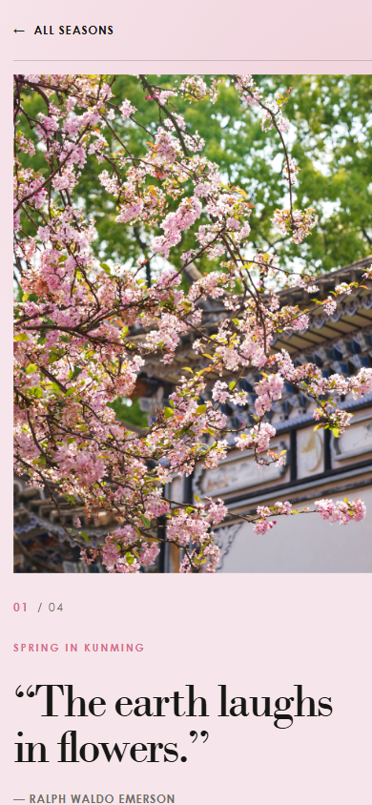
Figure 2. The spring page at a mobile viewport width.
The mobile layout places the photograph first and the quotation below it. Important parts of the image remain visible through object positioning, while the text width and type size change to avoid horizontal scrolling.

Testing and Results
I tested the Python responses and the visual layout. The six automated tests use Python's built-in unittest module and start the actual HTTP server on a temporary local port.
Test | What it checks | Result
Homepage test | All four seasons appear | Passed
Season page tests | All four pages return HTTP 200 | Passed
Invalid route test | Unknown season returns HTTP 404 | Passed
API test | JSON endpoint returns four records | Passed
Static image test | Image returns HTTP 200 and JPEG type | Passed
Health check | Server reports that it is running | Passed

The command python -m unittest discover -s tests -v runs all six tests. I also checked the homepage and all four season pages in a desktop browser and reviewed the season layout at a mobile viewport. The screenshots in this report show the final rendered states.

Design Challenges and Solutions
The first challenge was creating a clear seasonal contrast. A single-location set did not show enough visual change between seasons. Four locations solved this problem while keeping a simple theme: one country and four different seasonal landscapes.
The second challenge was building the site without a framework. A framework can provide routing and templates automatically, but it also hides much of the request flow. The standard-library version keeps the process explicit: inspect the URL, prepare content, and send a status, content type, and response body.
The third challenge was responding to different image dimensions. CSS object-fit and a small set of per-season object positions keep the subject visible while giving the desktop page a consistent visual area.

Conclusion
The final website meets the main project goal: a visitor can understand the four-season structure quickly, click a photograph, and move through the content without unnecessary steps. Python, HTML, CSS, and JavaScript each have a clear role, and every part is small enough to explain during a presentation.
The project is ready to run locally with one Python command and to be uploaded to GitHub. The included deployment configuration allows the same application to be published as a public web service.

