**EFFETCS OF SURFACE GROOVE OVER AN AIRFOIL AT LOW REYNOLDS NUMBER**

P. Madhu Yadav

V. Raghavendra Rao

Bachelors of Technology

(**Aeronautical Engineering**)

From the

**Institute Of Aeronautical Engineering**

Approved by: Dr. B. Aslesha

**ABSTRACT**

The purpose of this research is to determine the airfoil configuration and produce that maximum amount of lift by placing cavity on the airfoil. For this research NACA 0012 airfoil is analysed. A computational fluid dynamics program, ANSYS CFX software are used to perform the analysis. An early prediction in flow separation resulted in an overestimation in drag. At end of the research the conclusions obtained are decrease in drag at various angle of attacks (AOA). The second conclusion is, after performing this research analysis flow separation delays.

**INTRODUCTION**

Many aerodynamic vehicles like Micro aerial vehicles (MAV’s) and Unmanned aerial vehicles (UASV’s) are small range vehicles like 0.1 – 0.5m which have Reynolds number within range 104 to 106, also wind turbines and some other machines use this range of Reynolds number[1]. At the Reynolds number of 50000 airfoil flow gets detached and this flow is known as laminar flow, because of this flow gets detached and vortex along with separation bubble will formed at the trailing edge of an airfoil. For this research analysis of NACA type airfoil is used[1], [2].

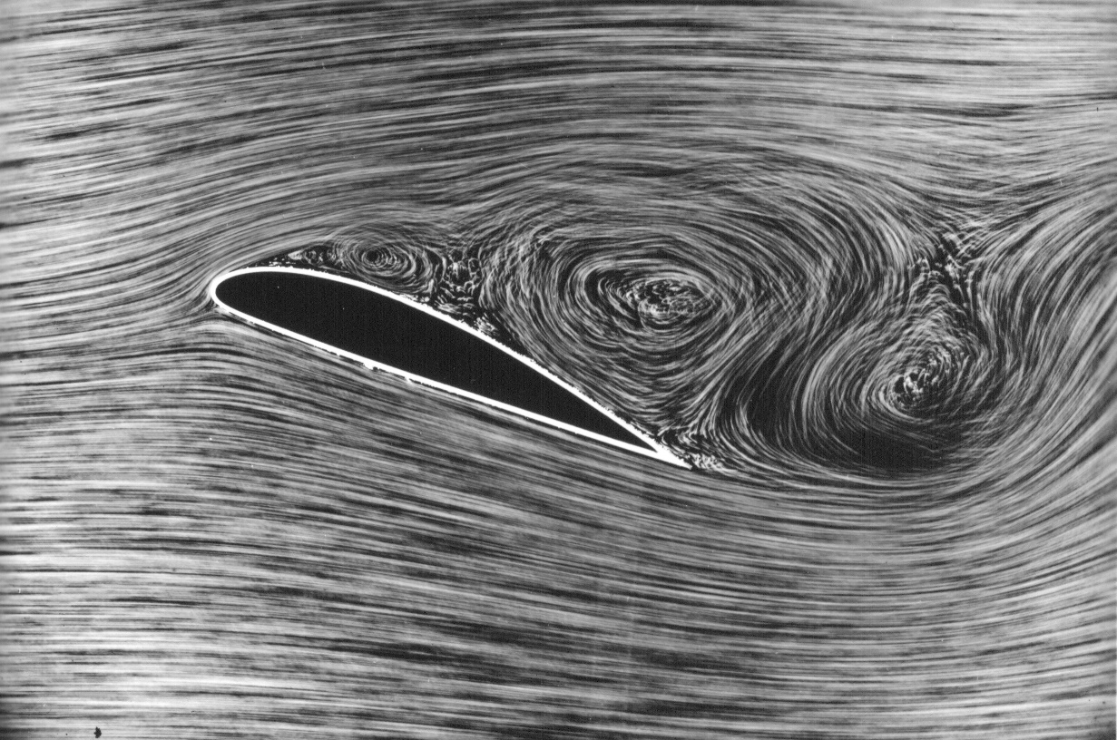

Strouhal number near the wake region lies between 0.45 to 0.5 and at Reynolds number of 50000 many wavelength disturbances take place by which frequency is scaled. As we increase AOA laminar flow separation bubble length and thickness also increases as the separation point moves towards the leading edge.

Cavity is a structural shape which reduces the bubble separation and increases the coefficient of lift (CL) of an airfoil. In this research, a cavity which is in circular shape and centre is taken from a point above the surface of the airfoil which forms a chord on the surface of the airfoil. This cavity is placed at 60% of the chord length and at 0.04c depth on an airfoil. Because of this addition of cavity on airfoil stalling effect decreases and coefficient of lift increases with various AOA (ex: 2, 4, 6, 8, 10…...). In an experimental study of NACA 0025, it was found that as the Re is lowered from 1.5 × 105 to 1.0 ×105, the separated shear layer fails to reattach to the airfoil surface. This indicates the deterioration of the aerodynamic performance of airfoils at low Reynolds numbers. Even for the Clark-Y airfoil, which is designed for a good low Re performance, the l/d ratio deteriorates dramatically as the Re is reduced to 75,000. This degradation in performance is again caused by the failure of the shear layer to reattach. A detailed numerical study to understand the aerodynamics of various airfoils at low Reynolds numbers was done by Winslow et al. Besides re-establishing a nonlinear lift curve behaviour at low Reynolds numbers for NACA 0012, they suggested a reduction of about 46% in the maximum lift coefficient for Re between 105 and 104, due to the inability of the prematurely separated flow to reattach[1].

The complex aerodynamic phenomena at lower Reynolds numbers have inspired many researchers to study and understand various flow control mechanisms. Mainly, there are two types of flow control mechanisms, viz., passive flow control mechanism and active flow control mechanism[2]. In the passive flow control mechanism, flow is controlled through non-energy consuming devices like vortex generators, flaps, and slots[1], [3]. However, in an active flow control mechanism, external power is required to control the flow. These control mechanisms help to delay the flow separation that leads to delay in the stall, increment in lift-to-drag (l/d) ratio and trapping of vortices[1].

**LITERATURE REVIEW**

Despite the researches, the concept of trapped

vortices are very beneficial, to achieve a high lift-to-drag ratio and to avoid vortex shedding. Plenty of research has been done with rectangular cavities on the flat surfaces, and a very few articles are available for airfoil with cavities, trapped vortex cell (TVC) and dimples especially at low Reynolds numbers. The main motive of these cavities/dimples is to attach the separated flow by a strong vortex fastened in a cavity. Some of the researchers have studied the effect of trapped vortex cell on the aerodynamics of airfoils. VortexCell2050 is a European project designed to study the actively controlled vortex cell. The trapped vortex cell technique is used on thick airfoil to enhance the lift, reduce drag, and hence enhance the l/d ratio. The cavity with distributed suction (SALL) was found to be the best compromise in terms of aerodynamic performances and energy or power needed to realize the control. Taherian in 2016 examined the unsteady flow field after the Riso airfoil with the thick blunt trailing edge and base cavity. From the results, it was found that with an increase in the Reynolds number, there is an alteration in the length of the wake, and favourable reductions in drag were reported for this configuration. In an experimental and computational analysis of flow over NACA 0018 airfoil without and with a cavity at Reynolds number 20,000, it was found the l/d ratio of the airfoil with a cavity is higher compared with clean configuration. In another numerical study, it was found that an optimal cavity configuration degrades the performance of an airfoil at low AOAs; however, as the AOA is increased to α = 12°, the performance is improved. The study found that the wingtip vortex azimuthal velocity, circulation, and turbulent intensity in trailing edge vortex are significantly dropped, however, with a penalty of a slight reduction in l/d ratio.

Seo and hung studied the effect of semi-circular arc groove of various depths and at various locations and reported that selected groove configurations can enhance the aerodynamic efficiency of the wind turbine blade by up to 15.3% for a Reynolds number of 360,000. Ma et al. also reported similar improvements of 3–15% in the performance of a blade for a horizontal axis wind turbine, with concavity placed near the trailing edge.

**RESULT**

After simulation of NACA 0012 airfoil in ANSYS workbench 18.1 the results observed are better compared with the results of airfoil which does not have cavity. The lift on airfoil has increased and flow separation has also been delayed because of chord shape cavity placed at 6%c and lift coffecient has increased upto 20%.

When flow separation delays bubble formation at trailing edge also will decreased which decreases the fuel consumption which increases the range of aircraft.

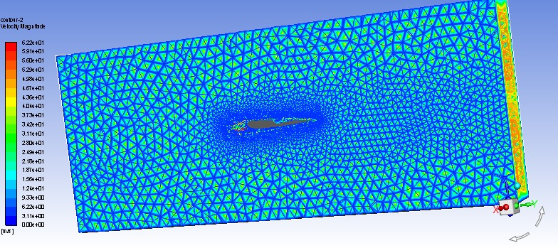

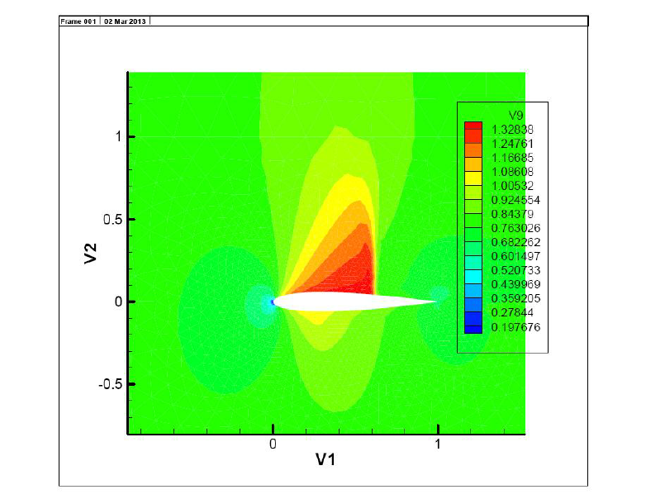

Pressure contours for naca 0012

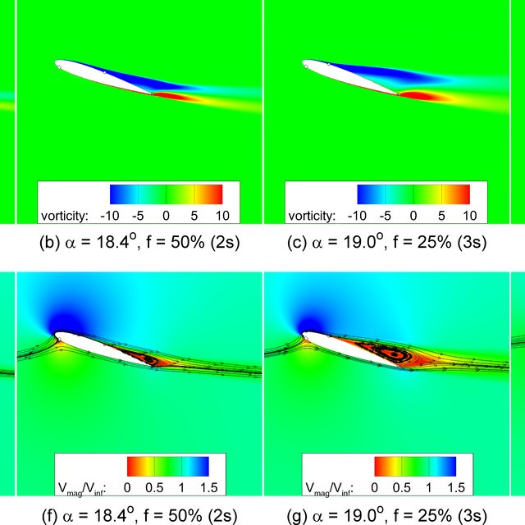

Velocity contours

