Map

Each Map object has the following attributes

Booleans:

1 )Path North

2) Path South

3 )Path East

4 )Path West

Number of Zombies (need to set a range)

Goody Pack

These correspond to the routes out of the map.

There are 17 different tiles. A list of the tiles will be created, with the exception of Dead End and Border.

1x + - 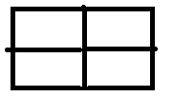 - a

4x T (rotate through 90 degrees)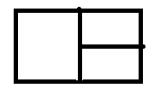-b,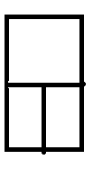-c, 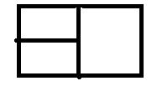-d,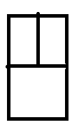-e,

4xL (rotate through 90 degrees)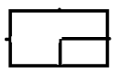-f, -g , 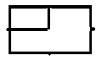-h , 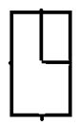-i

4x Dead End 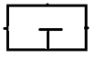-j, 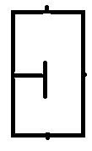-k, 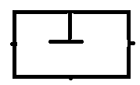-l, 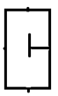-m

2xI - 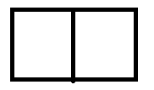-n, 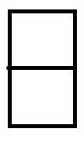-o

1x Fog Of War. This tiles is considered to have all entry points. 

1xborder. This tile has no entry points. 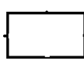

The playable map is 5x5 tiles, the programmed map is 7x7, with an edge of Border. This is to prevent a player moving off the map. Border tiles will be in position (1,1) through (1,7),( 2,1), (2,7), (3,1),(3,7),(4,1),(4,7),(5,1),(5,7),(6,1),(6,7) and (7,1) through (7,7)

When a new map tile is uncovered, the player moves to tile (x,y). Tiles at position (x, y+1), (x, y-1), (x+1, y) and (x-1, y) are checked for paths. A copy of the tile list is created, called newTileList

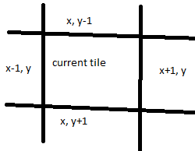

If x,y+1 has Path North = false, any tiles that would lead there would be removed. From newTileList, tiles a, b, d, e, h, i, l and n are all removed, leaving a the list is [c,f,g,j,k,m,o].

Tile x, y-1 is checked for path south. If false, tiles c, f, g, and j are removed from the list. A, b, d, and n would also be removed, however this has already occurred.

The other tiles are checked in a similar nature, and a random tile from those remaining in the list is chosen as the new map tile.

Zombies – Tiles need to have a range of zombies for when the player enters them. I suggest a random number between 0 and 4. The number of zombies must be able to be changed, to accommodate for when the player kills a zombie, or when a new one is added due to player exploration.

Each time the player moves to a new tile, a zombie is added to a tile already uncovered. May need to do some small hacking, so that now zombies appear on the starting tile when the game loads.

Goody Pack – Contains health, bullets and upgrades. A list containing the possibilities may be easiest. Have

Health (random int 1-3) –A,

Ammo(random int 1-3) –B

Gun Upgrade – C

Melee Upgrade –D.

The list would be the power set of A, B, C, D. Once an upgrade is acquired, the relevant option would be removed. For example, once the gun upgrade is obtained, the list becomes the power set of A, B, D.

A goody pack should not be on every map tile. I suggest a 50% chance, maybe less. Simple call a random integer, and if the int is even, a goody pack is created on the tile, and picked up automatically by the player. These goody packs are never replenished, and only appear when the tile is uncovered, unlike zombies