From Condition Assessment to State-Evolution Control: A Critical Review and Dual-Loop Framework for Intelligent Railway Infrastructure O&M

Abstract:
The global expansion of high-speed and heavy-haul railway networks has shifted the industry focus from large-scale construction to long-term sustainable operation and maintenance (O&M). However, traditional O&M models face critical bottlenecks, including the "spatial-temporal blind spots" in macroscopic inspections, the "surface-only" limitation of sensing technologies, and the reactive nature of maintenance decision-making. This paper provides a systematic review of the transition from traditional maintenance to an AI-empowered "State Evolution" philosophy. First, we analyze the inherent constraints of existing systems in perception, assessment, and execution. Second, an engineering-oriented dual-loop top-level architecture is proposed: the first loop constitutes an AI-driven full-process intelligent O&M closed loop, ensuring comprehensive perception and holistic health characterization; while the second loop serves as a precision intervention loop, leveraging AI agents and automated robotics for targeted execution. The feasibility of this framework is demonstrated through practical engineering case studies, including the Dazhun Heavy-Haul Railway and the development of multi-sensor integrated inspection robots. These cases illustrate a paradigm shift from "evaluating current states" to "predicting future deterioration". Finally, this study outlines future trajectories for AI integration, providing a theoretical and practical roadmap for the next generation of intelligent railway O&M systems.

Keywords: Railway Infrastructure; Intelligent Operation and Maintenance; State Evolution; Artificial Intelligence; Predictive Maintenance.

Introduction
Railway systems worldwide are entering a maintenance-dominated era in which high-speed railways, heavy-haul corridors and urban rail networks must deliver higher availability with ageing assets, rising traffic density and tighter safety margins. The central challenge is no longer only how to build new infrastructure, but how to control lifecycle cost and safety risk while existing networks remain in continuous service.
Large railway networks in Asia, Europe, North America and rapidly urbanizing regions all face the same transition from expansion to asset stewardship. China provides an important large-scale example because its high-speed network combines exceptional mileage, high traffic intensity and diverse operating environments; however, the maintenance problem addressed in this review is international: dense railway systems must detect rare defects, interpret coupled infrastructure states and intervene within short possession windows.
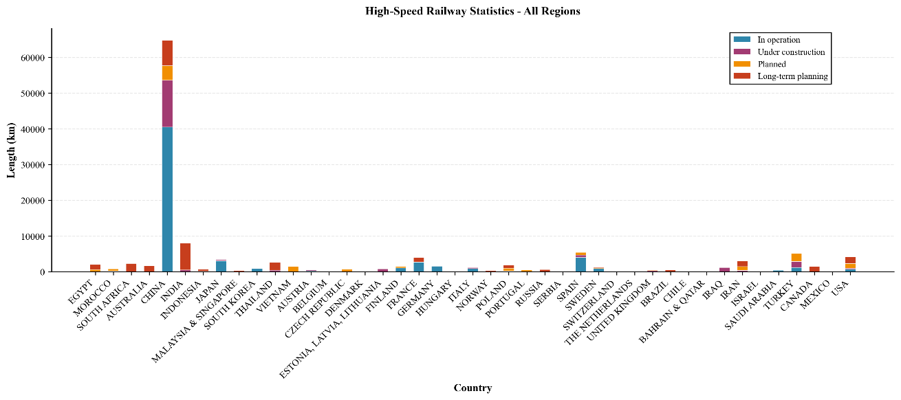
Figure 1 Global high-speed rail network scale as background for lifecycle O&M pressure
The operational difficulty arises from four intrinsic features of railway infrastructure: it is a large-scale linear asset exposed to heterogeneous geology and climate; its condition is governed by strong wheel-rail-structure coupling; defects are sparse, stochastic and often hidden beneath surface geometry; and maintenance can be performed only within limited possession windows. These features make railway O&M a lifecycle control problem rather than a simple inspection problem.
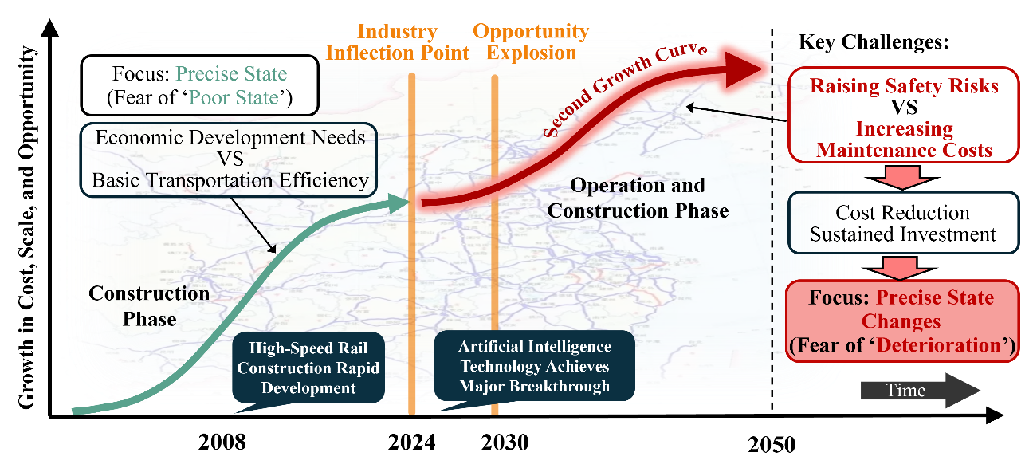
Figure 2 Evolution of the railway industry's primary challenge: The pathway to predictive maintenance empowered by AI and state evolution philosophy
This shift changes the role of intelligent technologies. AI, digital sensing and robotic systems are valuable only when they close the chain from observation to engineering action: perception must feed physical-state assessment, assessment must support deterioration prediction, prediction must lead to optimized maintenance decisions, and the executed intervention must be verified by feedback measurement.
To characterize the research landscape at the intersection of railway infrastructure O&M and artificial intelligence, this review combines bibliometric mapping with critical synthesis. A bibliometric search was conducted in the Scopus database, targeting publications that jointly addressed railway infrastructure, operation and maintenance, and intelligent technologies. The search terms combined four groups of keywords: railway systems (“railway”, “railroad”, “high-speed railway”, “heavy-haul railway”), infrastructure assets (“track”, “bridge”, “tunnel”, “subgrade”, “ballast”, “slab track”, “fastening”), O&M activities (“inspection”, “condition monitoring”, “maintenance”, “predictive maintenance”, “asset management”), and intelligent technologies (“artificial intelligence”, “machine learning”, “deep learning”, “digital twin”, “robot”, “large language model”, “agent”). The search was last updated in June 2026 and was used to identify publication trends, citation growth, and major research concentrations in this field.
As shown in Figure 3, the application of AI technology in railway O&M has experienced rapid growth over the past decade. The annual number of publications follows an exponential growth trajectory, with a fitted curve equation of and a coefficient of determination of . Prior to 2013, research in this interdisciplinary field progressed at a relatively steady pace; however, with the rapid development of deep learning, big data analytics, and intelligent sensing technologies, the number of related publications began to increase sharply after 2015. Cumulative citations have also grown substantially, indicating the increasing influence of this topic in both academic research and engineering practice.
For the qualitative synthesis, the bibliometric corpus was further screened and supplemented by backward and forward citation tracing. Studies were retained if they addressed railway infrastructure sensing and inspection, condition assessment, track geometry degradation, rail and ballast defects, predictive maintenance, maintenance planning and scheduling, data-driven or physics-informed modelling, digital twins, AI-enabled decision support, robotic inspection or maintenance, or post-maintenance verification. Studies focusing mainly on rolling stock, signalling, train control, passenger service, or generic algorithm development without a clear railway infrastructure O&M application were excluded from the main synthesis. In addition, highly relevant standards, books, technical reports, and foundational AI studies were included where they supported the conceptual framework or methodological discussion.
Existing reviews have made important contributions on individual sensing technologies, specific assets, defect detection methods and AI algorithms. What remains underdeveloped is a system-level framework that follows the complete O&M chain from perception to assessment, decision optimization, physical execution and feedback verification. This review therefore positions intelligent railway infrastructure O&M as a dual closed-loop system rather than as a catalogue of separate techniques.
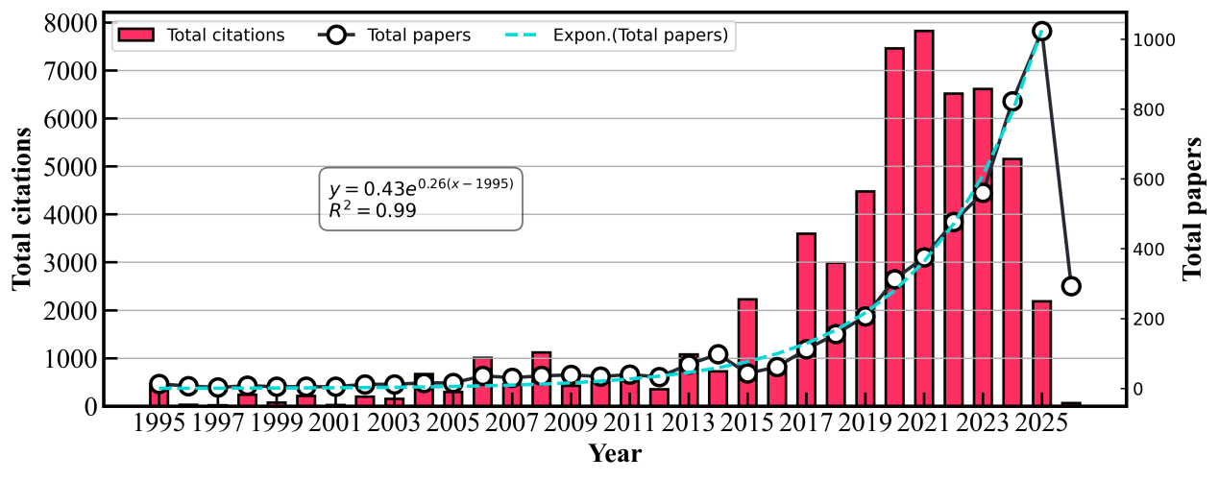
Figure 3 Trends in Annual Publications and Citations of AI in the Field of Railway Operations and Maintenance

Railway Lines and Their Unique Features

The Unique Characteristics of Railway Lines
As a critical component of the nation’s transportation infrastructure, railway lines possess an irreplaceable uniqueness due to their operating environment and load characteristics:
- Long-distance, large-scale linear projects that traverse complex geological and climatic zones. The modern high-speed rail network spans a vast area, and individual train trips are lengthy. For example, the Lanzhou-Xinjiang Railway in China spans a total length of 2,423 kilometers, traversing extremely complex and diverse terrain—including the Gobi Desert and mountain gorges—and is constantly exposed to harsh weather conditions such as extreme temperature fluctuations and frequent sandstorms (Luan and Liu, 2025). This vast geographical and climatic diversity poses severe environmental challenges for the railway infrastructure.
- The direct medium for wheel-rail interaction, with extremely high safety sensitivity. Railway tracks are directly subjected to the immense dynamic forces generated by high-speed trains. Even the slightest defect in the track geometry or physical properties can be significantly amplified by the high-speed interaction between the wheels and the rails, which not only causes severe system vibrations but also poses a direct threat to train safety and passenger comfort. In the past few years, train derailments caused by severe track defects have occurred in many parts of the world (Ouyang et al., 2010; Kim and Yoon, 2013) , clearly demonstrating the critical safety implications of track defects.
- The distribution of diseases exhibits significant spatial randomness and discontinuity. The occurrence of railway track defects does not follow a uniform distribution pattern. It is influenced by local factors such as variations in subgrade settlement, structural discontinuities at switches and transition sections, and specific maintenance histories (Nabochenko et al., 2019; Wang, Liu and Euston, 2023a). Track geometric irregularities typically exhibit a high degree of spatial randomness and diverse short-wavelength discrete characteristics (Jin et al., 2025).
- The disease spreads rapidly, and current detection methods have “blind spots”. Under the combined effects of high speeds and heavy loads, the track substructure—such as the ballast—deteriorates at an extremely rapid rate. At the same time, extreme weather conditions can easily trigger sudden structural failures, such as thermal separation at the track slab interfaces caused by high summer temperatures (Davies and Andrews, 2021), or frost heave in the subgrade caused by low winter temperatures. However, existing comprehensive inspection trains or manual inspections are conducted at limited intervals (such as every two weeks or once a month), making it highly likely that monitoring blind spots will arise during the intervals between inspections. In addition, the growing number of overnight trains that depart in the evening and arrive in the morning creates a serious conflict with the traditional nighttime maintenance window (12:00 a.m.–6:00 a.m.), further limiting the time and space available for track inspection and maintenance (T. Zhang et al., 2025).

Railway Lines
Railway tracks are highly complex linear structures primarily composed of the track superstructure and substructure. Depending on the type of track structure, there are significant differences in their components and mechanisms of condition evolution. They are mainly classified into ballasted and ballastless tracks.
Ballasted Track: the superstructure of a ballasted track primarily consists of rails (which provide guidance and bear the load), the fastening system (which connects the rails to the sleepers), and sleepers (which anchor the rails to the subgrade). The substructure, meanwhile, comprises granular layers such as ballast, sub-ballast, subgrade, and embankment. (Sun et al., 2023a; Koohmishi et al., 2024a). It should be noted that, depending on the perspective, the ballast layer can be classified as part of either the superstructure (Indraratna et al., 2016; Christos N. Pygidis, 2022) or the substructure (Selig and Waters, 1994; Christos N. Pygidis, 2022). Within railway granular ballast, ballast is the most vulnerable component and also plays a key role in adjusting track geometry (Koohmishi et al., 2024a). Under the high-frequency cyclic loads of trains, ballast is highly susceptible to initial compaction, aggregate fragmentation, and deformation-induced degradation. Combined with the intrusion of contaminants such as coal dust, this further exacerbates permanent deformation, directly leading to track geometric irregularities and subsequently accelerating the deterioration of other components (Liu and Xiao, 2010; Huang and Tutumluer, 2011; Lee et al., 2018; Meng et al., 2020).
Ballastless Track: Ballastless tracks offer good overall structural stability; the ballast layer has been eliminated and replaced with a solid foundation consisting of concrete track slabs, a cement-asphalt mortar layer, and a concrete base (Gautier, 2015; Grützmacher, Kang and Marx, 2025). However, the ride quality of ballastless tracks depends heavily on the precise condition of the fastening system (including fasteners and elastic pads). Due to the lack of elastic adjustment provided by ballast, maintenance can only be performed through millimeter-level track adjustments by modifying the thickness of the pads and the position of the fasteners at each sleeper; moreover, because of the strong physical coupling constraints between adjacent fasteners, the scope for adjustment is extremely limited (Sun et al., 2023a).

Research Contribution
Currently, there is a wealth of literature reviewing the application of AI technology in the railway field. We have reviewed comprehensive articles discussing the application of AI technology in the railway sector over the past four years. As shown in Table 1, these articles cover a wide range of topics, including both specialized studies focused on track defect detection and maintenance, as well as comprehensive reviews that provide an overview of the entire field. However, unlike previous reviews that focused on summarizing AI algorithms and technological applications, the objective of this paper is not merely to list the current state of AI applications in the railway sector, but rather to conduct an in-depth analysis of the underlying limitations of existing O&M systems and to explore practical engineering scenarios for the effective implementation of AI technology.
Table 1. Previous review articles on AI-based methods application for railway
Ref | Data Type | Focused Area | Number of Papers | Time Period
(Peinado Gonzalo et al., 2022a) | Dynamic measurement data, traffic/load data, maintenance records | Track geometric condition monitoring, deterioration prediction and maintenance | 182 | 2002-2022
(Tang et al., 2022) | Vehicle sensor data, audio, vibration signals, LiDAR point clouds, etc. | Maintenance and inspection, traffic planning, safety and security, autonomous driving, etc. | 141 | 2010-2020
(Aela, Chi, et al., 2024) | Unmanned Aerial Vehicle imaging, LiDAR, infrared thermal imaging, and multispectral sensors data | Inspection and monitoring | 115 | 2000-2024
(Aela, Cai, et al., 2024) | Visual data such as images, videos, X-rays, thermal imagery, LiDAR, and digital image processing | Condition monitoring and defect detection of superstructures | 124 | 2009-2023
(Koohmishi et al., 2024b) | Ground-penetrating radar and interferometric synthetic aperture radar data | Monitoring, assessment, and maintenance of substructures | 154 | 2008-2023
(Rahman et al., 2024a) | Distributed acoustic sensing data, fiber optic sensing data | Railway structural inspection and monitoring | 145 | 2002-2024
(Khajehdezfuly, Azizipour and Kaewunruen, 2025) | Images, videos, acceleration signals, acoustic data, ground-penetrating radar, InSAR, etc. | Inspection, monitoring, fault detection, and predictive maintenance | 517 | 2005-2025
(Olivier et al., 2025) | Images, 3D point clouds, video, laser scanning | Visual inspection and monitoring of railway assets | 191 | 2000-2025
(Zhang, Zhang and Dinavahi, 2025) | Machine learning and data related to advanced transportation systems | Fault diagnosis, state estimation, condition monitoring | 124 | 2014-2023
(Zhang et al., 2026) | 3D point cloud data | Intelligent monitoring, digital twins, and maintenance of railway infrastructure | 234 | 2000-2024
Table 1b. Coverage matrix of previous railway AI/O&M reviews and the present dual-loop review
Technology | State variable measured | Operational role | What it enables | What it misses / uncertainty | Dual-loop requirement | Field case
Eddy current testing | Rail-surface and near-surface electromagnetic response | Local precision inspection | Fast screening of surface rolling-contact fatigue and conductive defects | Sensitive to lift-off, roughness, contamination and non-conductive defects | Use as confirmatory evidence after network alerts; report uncertainty before repair decisions | No
Magnetic flux leakage | Magnetic-field disturbance from rail surface or near-surface discontinuities | Local precision inspection | High-sensitivity detection of rail discontinuities at inspection speed | Affected by rust, oil, magnetization history and defect orientation | Fuse with visual/ultrasonic evidence before classifying repairable defect geometry | No
Visual inspection | Surface appearance of rails, fasteners, sleepers and visible components | Network survey and local inspection | Scalable defect localization, documentation and asset inventory | Cannot observe subsurface damage; affected by lighting, occlusion, weather and label bias | Convert detections into asset-level work orders with confidence scores and human/robot verification | No
Ultrasonic testing | Internal acoustic reflections from cracks, breaks and inclusions | Local precision diagnosis | Quantifies internal rail defects and supports safety-critical acceptance decisions | Blind zones, coupling condition, speed constraints and incomplete cross-section coverage | Provide defect size/depth uncertainty and trigger repair or speed restriction only with traceable thresholds | No
Ground penetrating radar | Dielectric contrast linked to ballast fouling, voids, moisture and slab/subgrade interfaces | Corridor-scale substructure survey plus targeted diagnosis | Reveals hidden causal parameters behind repeated geometry defects | Multipath scattering, moisture sensitivity, blurred boundaries and interpretation dependence | Link subsurface causes to deterioration forecasts and select tamping, cleaning, drainage or slab repair actions | No
On-board vibration/acoustic sensing | Vehicle dynamic response and wheel-rail noise induced by track irregularity and local defects | High-frequency network census | Low-cost continuous screening and trend monitoring using in-service trains | Inverse mapping is ill-posed; speed, load, vehicle condition and environment confound signals | Use uncertainty-aware inverse models to generate prioritized alerts for the second precision loop | No
DAS/fibre-optic sensing | Distributed strain/acoustic signatures along trackside fibres | Continuous corridor monitoring | Captures train passages, impacts, intrusion events and evolving dynamic anomalies | Signal interpretation depends on cable coupling, soil condition and noise environment | Transform event streams into localized, confidence-ranked maintenance triggers | No
InSAR/GNSS absolute measurement | Long-wavelength displacement, settlement and geospatial alignment | Network-scale deformation monitoring | Identifies slow deformation and transition-zone settlement over large areas | Temporal decorrelation, tunnel/urban signal loss and limited sensitivity to short-wave defects | Anchor multi-source data to stable spatial coordinates for lifecycle tracking | No
LiDAR/point cloud | 3D geometry of track corridor, ballast profile, clearances and visible assets | Survey, inventory and local reconstruction | Supports digital twins, clearance checks and geometry-aware robotic localization | Occlusion, registration drift, density variation and weak subsurface observability | Provide object-level geometry for decision optimization and executable robotic maintenance | No
Zhang et al. (2026) | Yes | Yes | Partial | No | Partial | No
This review | Yes | Yes | Yes | Yes | Yes | Yes
The matrix clarifies that prior reviews mainly emphasize sensing, monitoring, assessment or AI algorithms, whereas this review explicitly connects decision optimization, physical/robotic execution, lifecycle feedback and field validation within a dual closed-loop O&M architecture.

Research Objectives
This paper pursues four objectives: (1) To systematically review and analyze the inherent limitations of traditional railway operation and maintenance systems in areas such as perception, assessment, and execution. (2) To propose and justify a dual-loop intelligent O&M architecture that integrates an AI-driven decision loop — spanning the full infrastructure lifecycle — with a highly automated physical execution loop. (3) To evaluate the feasibility and performance of the proposed architecture through engineering case studies drawn from operational long-distance railway lines. (4) To identify open research challenges and outline a development roadmap for AI-driven intelligent O&M in large-scale railway networks.

Section Description
The subsequent sections of this paper are organized as follows: Section 2 analyzes the inherent limitations of existing railway operation and maintenance systems, discussing bottlenecks in current sensing, precise measurement, condition assessment, and traditional maintenance methods. Section 3 elaborates on the design logic and key technologies of the “dual-loop” intelligent operation and maintenance system, including the artificial intelligence decision-making loop covering the entire lifecycle and the highly automated precise execution loop. Section 4 evaluates the deployment and performance of the AI methods reviewed in Section 3 through engineering case studies drawn from operational railway lines. Finally, Section 5 summarizes the main research conclusions of this paper and outlines future development directions in the field of intelligent railway O&M.

Systemic Bottlenecks in Existing Railway O&M Systems
This section reframes the literature around O&M bottlenecks rather than around isolated technologies. For each sensing or decision method, the review asks four questions: what state variable it measures, what maintenance function it enables, what uncertainty or blind spot it leaves, and what the dual closed-loop system requires to convert the observation into verified intervention.

Perception

Precision Measurement Bottlenecks: Observability, Uncertainty and Actionability
Precision measurement technologies should be evaluated by their contribution to an O&M loop, not only by their physical principle. A useful method must identify the state variable being observed, indicate whether it supports network-level census or local precision diagnosis, quantify uncertainty, and clarify whether its output can be translated into a maintenance action.
Table 2. Precision detection technologies evaluated against dual-loop O&M requirements
Technology | Detection Target | Principle | Advantages | Limitations | Key References
Eddy Current Testing | Rail surface defects | Electromagnetic induction | Non-contact, high speed | Applicable to conductive surfaces only, sensitive to rail surface roughness | (Peng,Jianping, 2017)
Magnetic Flux Leakage | Rail surface / near-surface | Magnetic field distortion | High sensitivity | Susceptible to rust and oil contamination, accuracy fluctuates | (Wang et al., 2023)
Visual Inspection | Rail surface, fasteners | Image recognition | Intuitive, recordable, scalable | Cannot detect subsurface defects, sensitive to illumination and occlusion | (Zhang,Xiangyang and Luo,Jiangping, 2021)
Ultrasonic Testing | Internal cracks, rail breaks | Acoustic wave reflection | High penetration, high sensitivity | Incomplete cross-sectional coverage, blind zones, low speed | (Han，Xue and Su，Huilong, 2021)
Ground Penetrating Radar | Ballast fouling, voids under slab | Electromagnetic wave reflection | Continuous acquisition, non-destructive | Multi-path effects from granular media, relies on manual interpretation | (Wang，Shilei et al., 2023)
Absolute Measurement (GNSS/InSAR) | Long-wave irregularity, spatial coordinates | Inertial navigation and control network | High absolute accuracy | Extremely low speed (0.3-0.5 km/h), GPS signal loss in tunnels/urban areas | (Y. Wang et al., 2024)
Chord Measurement | Medium/short-wave irregularity | Relative displacement | High speed (>3 km/h), cost-effective | TICE error accumulation, results depend on chord length selection | (YAZAWA and TAKESHITA, 2002)
Among them, surface defects such as rail surface damage, slab track cracks, and missing fastening systems can be explicitly detected via visual inspection or various types of sensing signals including images, giving rise to a series of non-contact, non-destructive precision detection technologies such as eddy current testing (Peng,Jianping, 2017), magnetic flux leakage testing (Wang et al., 2023), and visual inspection (Zhang,Xiangyang and Luo,Jiangping, 2021). The limitations of each single-source method are summarized in Table 2. In brief: eddy current testing is restricted to conductive surfaces and is sensitive to rail roughness; magnetic flux leakage is susceptible to rust and surface contamination; visual inspection cannot resolve subsurface damage or provide depth information. These individual limitations motivate multi-source fusion approaches.
Obviously, defect detection methods based on a single data source suffer from a high missed detection rate, which will inevitably cause continuous degradation of the dynamic performance of rails, worsen train running quality, and even induce potential safety hazards. With long-term service of line infrastructures, deep-seated defects such as rail fractures, ballast consolidation, and subgrade voids will occur in track structures. These hidden defects lack obvious external characteristics at the initial formation stage; if not identified in a timely manner, they will accumulate under long-term dynamic loads and trigger abrupt changes in structural stiffness or even local instability. Most precision measurement technologies for such conditions rely on non-destructive non-contact testing methods such as radar or electromagnetic waves to obtain "indirect signals" reflecting structural states. For example, in the detection of internal rail defects, ultrasonic testing (Han，Xue and Su，Huilong, 2021) is one of the most widely used non-destructive testing methods at present, with advantages including strong penetration capability, high sensitivity, low cost, rapid detection, and harmlessness to human bodies. Ultrasonic testing exploits differential sound-wave propagation to locate and size internal defects (Hu,Jinping and Ren,Jianping, 2006). Current limitations — low precision in vehicle-mounted systems, low speed in portable units, and incomplete cross-sectional coverage — are detailed in Table 2.
In ballast detection, ground penetrating radar (GPR) is one of the important means for detecting the internal conditions of slab tracks or ballast layers. It features rapid detection, non-destructiveness, and continuous data acquisition; vehicle-mounted GPR further offers the advantages of simple operation, high detection speed, and no interference with train operation, effectively solving the difficulty in rapidly and continuously acquiring ballast condition data for existing lines (Wang，Shilei et al., 2023). Its fundamental principle is that a transmitting antenna emits electromagnetic waves into the ballast; when the waves encounter regions with different dielectric properties, reflection and scattering occur, and a receiving antenna records the relevant signals to form A-scan and B-scan data. The basic condition of the ballast is then judged by analyzing differences in the data (Huang,Xing, 2022). Meanwhile, relevant explorations mainly focus on ballast cleanliness, interlayer structures, and local defect identification. Signal feature and data processing methods such as time-frequency analysis (Yu and Wang, 2016), machine learning(Hao, 2009), and deep learning (Xu, Zhang and Sun, 2021) have been successively introduced into the interactive process of "structural defect characteristics–radar signal processing", promoting the gradual extension of related technologies toward refined perception of multiple types of internal conditions of ballast layers.
GPR limitations include multi-path effects from ballast granular media, reliance on manual signal interpretation, and blurred defect boundaries in slab-track applications — see Table 2 for a structured comparison.
The interaction of the above two types of defects manifests as track alignment deviation and deterioration of track geometry on the line, causing irreversible damage to line infrastructure operations and potential operational risks. As the most intuitive indicators reflecting the overall condition of long-distance lines, the measurement of track geometry and irregularities is critical. At present, a relatively mature technical system for broadband track smoothness perception has been developed. For example, absolute measurement technology (Y. Wang et al., 2024) takes the operation and maintenance control network—one of the high-speed railway inspection and control networks—as a reference benchmark. Through the collaboration of "CPIII control points–total station–track inspection vehicle", it can accurately acquire multi-dimensional information such as spatial coordinates, track geometry deviation, and long-wave irregularities, but its measurement speed is generally 0.3~0.5 km/h. To further improve the efficiency of this technical approach, a series of new technologies have been derived, including self-levelling-free total stations, GNSS/InSAR integrated inertial navigation measurement (Parizzi, Gonzalez and Brcic, 2020), etc.
In addition, relative measurement technology based on the chord measurement method indirectly characterizes the actual track irregularity state through the relative positional relationship between different points on the measuring chord, enabling compatibility with shorter wavelength ranges. Since it does not require acquisition of absolute spatial coordinates, its maximum measurement speed can generally reach more than 3 km/h (YAZAWA and TAKESHITA, 2002). It is generally classified into three categories: mid-chord , eccentric chord , and multi-point chord , covering detection objects such as rail corrugation, joint irregularities, and medium-short wavelength irregularities.

Network-Level General Survey Bottlenecks
In the context of modern railway infrastructure management, "census measurement" refers to the long-term, long-distance, and full-life-cycle inspection of the track network. This macroscopic evaluation is predominantly executed by dedicated Track Geometry Cars or Track Recording Vehicles, which provide continuous, high-speed, and non-destructive evaluations of the track's condition. While macroscopic census techniques provide essential network-level health screening, their architecture is not designed for localized, microscopic diagnostics. As networks evolve toward higher traffic densities and heavier axle loads, four systemic limitation categories have emerged — summarized in Table 2 and Figure 5. These vulnerabilities not only compromise the reliability of track assessments but also severely hinder the transition toward proactive maintenance. Through a comprehensive review of existing literature, the inadequacies of current macroscopic census technologies can be systematically deconstructed across four critical dimensions: spatiotemporal resolution constraints, physical sensing disconnects, data aggregation flaws, and the resultant reactive maintenance trap.
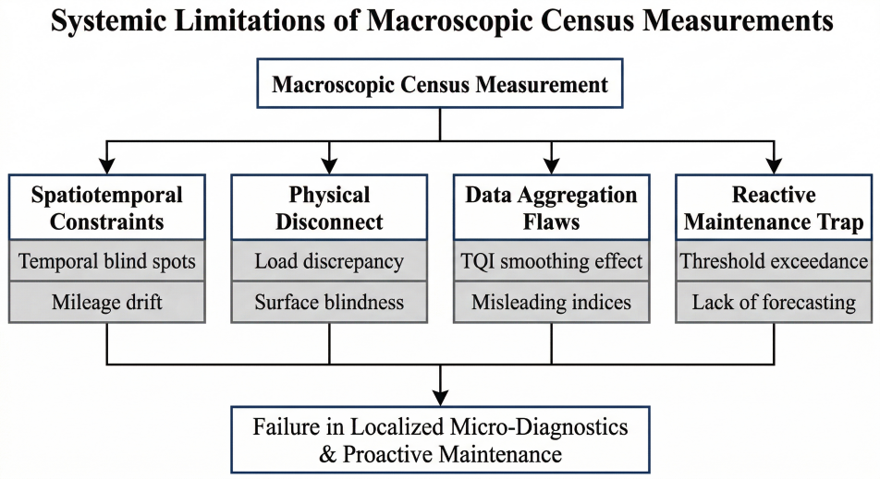
Figure 4 The theoretical framework of systemic limitations in macroscopic census measurements
Spatiotemporal Resolution Constraints. Running dedicated TRVs is operationally expensive and disruptive, forcing a constant conflict between safety inspections and commercial train services. These specialized vehicles require exclusive "track possessions," forcing infrastructure managers into a constant conflict between conducting safety inspections and maintaining profitable, regular commercial train services (Paixão, Fortunato and Calçada, 2019; Malekjafarian et al., 2023). Consequently, the frequency of network-wide census inspections is severely compressed. In reality, large-scale networks—such as the Dutch railway system—often limit these inspections to merely twice a year (Wang, Chang and Markine, 2018).
This extremely low-frequency paradigm inherently restricts census data to isolated, short-term "static snapshots," creating massive temporal blind spots. Track degradation is rarely a perfectly slow, linear process; it frequently manifests as rapid track degradation or sudden damages induced by extreme dynamic loads, severe weather, or sudden material fatigue (Malekjafarian et al., 2023). Because census measurements leave months-long gaps between consecutive inspections, they are fundamentally incapable of continuously monitoring active dynamic damage or providing early warnings for these sudden, highly critical localized failures (Shi et al., 2018).
Spatially, the macroscopic approach completely fails to support accurate full-life-cycle tracking of localized defects due to inherent positioning errors. Long-distance inspections rely heavily on mileage encoders and GPS, both of which are highly susceptible to wheel slip, route variations (e.g., changing lanes), and signal losses in tunnels or urban canyons (Wang et al., 2018). This vulnerability inevitably introduces cumulative "mileage drift" and spatial desynchronization across different batches of census data (Guo et al., 2025). Without absolute spatial synchronization, it is impossible to accurately evaluate the localized degradation rate of a specific defect over its lifecycle. Consequently, a defect recorded in one census might be misidentified as an entirely new defect in the next, rendering long-term historical census data virtually useless for precise micro-maintenance (Wang et al., 2018).
Physical Sensing Disconnect. A critical load discrepancy exists between inspection vehicles (typically ~5 t axle load) and in-service trains (12–16 t). Standard inspection vehicles typically apply axle loads (e.g., 5 tonnes) that are significantly lighter than those of in-service passenger or heavy-haul freight trains (e.g., 12–16 tonnes). This severe load deficit means that structural defects highly sensitive to extreme dynamic loading—such as localized track stiffness degradation and dynamic settlement—remain unexcited and uncompressed during the census, leading to massive underestimations of the actual danger (OBrien et al., 2018).
Furthermore, traditional census sensors primarily scan the surface geometry of the rail head. This "surface blindness" means the system only records the ultimate symptoms of degradation, remaining completely blind to the underlying structural root causes, such as localized subgrade settlement, poor drainage, or ballast fouling (Zarembski, Grissom and Euston, 2014; Wang, Liu and Euston, 2023b). This physical sensing blind spot becomes exceptionally catastrophic at critical structural nodes, such as bridge-to-subgrade transition zones and switches and crossings (S&C). In transition zones, abrupt variations in vertical stiffness generate extreme dynamic impacts that damage track components long before surface geometry thresholds are breached (Heydari, 2024). Similarly, at complex S&C nodes, the inherent geometric discontinuities (physical gaps in the rail) not only render conventional automated sensors (e.g., eddy current or image recognition) ineffective, but also completely confound dynamic sensors, which struggle to separate normal structural gap impacts from actual defect-induced vibrations (Wei et al., 2017). By ignoring the true operational conditions and actual wheel-rail dynamic interactions, static geometry census fails to accurately quantify the state of these high-degradation nodes, forcing a reliance on inefficient manual visual inspections (Milosevic et al., 2022a).
Data Aggregation Flaws. High data volume does not equate to diagnostic accuracy: true defects are extremely sparse within the data, and macroscopic aggregation into indices such as TQI introduces a smoothing effect that masks localized failures. As railway mileage expands, single-node computing architectures face severe processing bottlenecks, causing unacceptable delays in generating track quality reports for frontline maintenance (Guo et al., 2025). More critically, the data collected is overwhelmingly imbalanced; the vast majority of the track is healthy, meaning true localized defects are extremely "sparse" within the data ocean (Hou, Zhao and Yang, 2023; Kim, Fernández-Bobadilla and Chen, 2023). This extreme sparsity, coupled with the sensors' vulnerability to environmental noise (e.g., sunlight, rain, electromagnetic interference) and the lack of precise physical labels, heavily degrades the reliability of automated machine learning classifiers, often necessitating slow and highly subjective expert interpretation (Hou, Zhao and Yang, 2023; Guo et al., 2025).
To manage this data explosion, industry practices mathematically aggregate track measurements into macroscopic indicators, such as the Track Quality Index (TQI), over fixed spatial segments (e.g., 200 meters). However, this macroscopic aggregation creates a dangerous "smoothing effect" that forcibly dilutes continuous defect boundaries and masks severe localized spot failures (Fontul et al., 2016; Sharma et al., 2018). Furthermore, census systems generally evaluate defects of different wavelengths (e.g., long-wave track settlement and short-wave dipped joints) in total isolation. This arbitrary mathematical separation completely ignores the catastrophic "dynamic coupling amplification effects" that occur when these multi-wavelength defects overlap spatially, leading to severe misjudgments in maintenance priorities (Kaewunruen and Chiengson, 2018). The widespread use of chord measurement methods further exacerbates this by introducing Track Irregularity Conversion Errors (TICE), where the same physical defect yields entirely different severity scores depending on the chord's starting position (OBrien et al., 2018; Sun et al., 2023b). Ultimately, as El-khateeb et al dramatically highlight, a "normal" overall macroscopic condition index can be highly misleading—it often projects a false sense of security while successfully burying the imminent failure of a localized critical component, such as a severely deteriorated sleeper(2021).
Reactive Maintenance Trap. The cumulative effect of the three limitations above traps census-based systems in a threshold-exceedance model: interventions are triggered only after safety limits are breached. Because census data lacks the capability to continuously capture subsurface causal parameters (like ballast fouling and thickness), it is fundamentally devoid of true "forecasting power" (Yurlov et al., 2019). Consequently, interventions are almost exclusively triggered after safety limits have been breached, forcing infrastructure managers into a reactive ("wait until it degrades and then fix it") rather than proactive maintenance paradigm(Zarembski, Grissom and Euston, 2014).
Even when maintenance is initiated based on census alarms, the macroscopic nature of the data causes severe discrepancies during physical execution. Macroscopic maintenance planning often treats the track as a series of isolated points, completely ignoring the microscopic physical coupling constraints of adjacent track components, such as the stress linkage between adjacent fasteners (Sun et al., 2023b). Furthermore, blindly conducting localized interventions based purely on surface geometry alarms without addressing the underlying structural cause—such as aggressively tamping a section of track suffering from severe subgrade settlement—not only wastes immense resources but can mechanically accelerate track deterioration and ballast wear (Fontul et al., 2016).
Table 3 Systemic Limitations of Macroscopic Census Measurement Systems: Mechanisms, Consequences, and Supporting Evidence
Limitation Dimension | Core Mechanism | Engineering Blind Spots & Consequences | Quantitative Evidence | Key References
Spatiotemporal Resolution Constraints | Very low inspection frequency，cumulative mileage drift | Month-scale temporal blind zones; lifecycle tracking of local defects fails | Dutch railways inspected only twice per year; GPS signal loss in tunnels/urban areas causes cumulative drift | (Wang, Chang and Markine, 2018), (Malekjafarian et al., 2023).
Physical Sensing Disconnect | Axle load deficit (~5 t vs. 12-16 t in service); surface geometry only | Dynamic stiffness defects missed; subgrade/ballast root causes invisible | Load discrepancy causes severe underestimation of structural response; stiffness discontinuities at transitions cause damage before geometric limits are exceeded | (OBrien et al., 2018), (Zarembski, Grissom and Euston, 2014; Wang, Liu and Euston, 2023b).
Data Aggregation Flaws | Severely imbalanced data; TQI spatial smoothing effect | Algorithm performance degrades; localized severe defects masked by macroscopic indices | TQI reads "normal" while local sleepers are severely degraded; extreme sparsity reduces classifier reliability | (Guo et al., 2025), (Hou, Zhao and Yang, 2023; Kim, Fernández-Bobadilla and Chen, 2023)
Multi-wavelength Coupling Neglect | Defects at different wavelengths assessed independently; chord-based TICE error | Dynamic coupling amplification ignored; maintenance priority misjudged | Same defect yields different severity scores depending on chord start point | (OBrien et al., 2018; Sun et al., 2023b)
Reactive Maintenance Trap | Threshold-triggered response only; microscopic coupling constraints ignored | No predictive capability; passive maintenance; localized interventions accelerate degradation | Tamping without subgrade treatment accelerates ballast wear; blind local interventions waste resources | (Zarembski, Grissom and Euston, 2014)
In conclusion, macroscopic census measurements remain indispensable for network-level screening, but they do not by themselves close the O&M loop. Their outputs must be connected to targeted precision diagnosis, uncertainty-aware deterioration prediction and executable maintenance decisions; otherwise, the system remains trapped in delayed threshold exceedance and weakly verified intervention.

Assessment and Decision-making

Track Status Assessment
Condition assessment is the interface between raw perception and maintenance action. The key question is not whether an algorithm can classify a defect, but whether the assessment converts heterogeneous observations into decision-ready variables such as physical state, confidence level, deterioration trend, threshold-exceedance probability and repairable engineering object.
Railways are the backbone of modern transportation systems, and the integrity of their infrastructure directly affects operational safety and transportation efficiency. According to statistics, infrastructure failures—including broken rails, ballast settlement, and bridge damage—are among the leading causes of railway accidents(Bianchi et al., 2025a). Traditional periodic manual inspections are no longer sufficient to meet the inspection needs of modern high-density, high-speed rail networks; as a result, automated, continuous, and intelligent condition assessment technologies have become a hot topic of research. The scope of railway condition assessment encompasses track structures (rails, fasteners, sleepers, ballast, and subgrade), bridge and tunnel structures, as well as functional equipment such as overhead contact systems and turnouts. The objectives of such assessments can be categorized into three areas: defect detection, condition grading, and degradation trend prediction, which correspond to the three maintenance strategies of reactive repair, condition-based maintenance, and predictive maintenance, respectively(Bris-Peñalver, Verdecia-Peña and Alonso, 2026a).
Building on these reviews, this section emphasizes what existing methods still miss from a closed-loop O&M perspective: causal observability, spatial-temporal alignment, uncertainty quantification, lifecycle prediction, decision optimization and feedback after physical intervention.
- Track Geometry Condition Assessment
The core task of evaluating track geometry inspection data is to convert multidimensional measurements into quantifiable condition ratings to support maintenance decisions. Among the most widely used metrics are the Track Quality Index (TQI) and the Track Geometry Index (TGI), both of which are quantitative indicators that assess the condition of railway tracks by evaluating multiple geometric parameters (Safari Tarbozagh et al., 2026). The core significance of these two types of metrics lies in condensing the geometric dispersion of spatial distribution into a single management metric, thereby enabling the prioritized allocation of maintenance resources.
However, the degradation of the geometric condition is also related to changes in the support conditions of the ballast and subgrade; relying solely on the TQI or TGI makes it difficult to distinguish between different degradation mechanisms. Morais et al. (2023) proposed a method for assessing the condition of railway track supports based on modal analysis of the natural frequencies of multi-unit systems. This approach utilizes tools for monitoring and analyzing the natural frequencies of specific sections of the railway track to obtain information regarding the condition of the track support system—particularly the subgrade. By incorporating tensor decomposition analysis, Woldemariam and Attoh-Okine (2025) developed a joint model of multi-cycle geometric data and subgrade performance indicators, identifying spatial correlation degradation patterns that cannot be captured by the scalar TQI statistic—such as cyclic exceedances in specific mileage sections—and revealing the physical mechanism of localized support instability rather than global uniform degradation.
- Internal Rail Defect Assessment
The objective of analyzing ultrasonic testing signals is to extract information regarding the location, size, and type of defects from the echo sequence, thereby establishing a quantitative mapping from “signal anomalies” to “defect grades.” Phased Array Ultrasonic Testing (PAUT) uses electronic scanning to cover multiple incidence angles in a single excitation; its S/B/C scan images directly display the distribution of reflection amplitudes within the cross-section, providing a richer information source for defect geometric reconstruction than single-probe A-scan testing (Garcia and Zhang, 2006; Phrommahakul et al., 2025).
Deep learning methods have significantly improved the efficiency of automated ultrasound image assessment(Islam and Olm, 2024; Lu et al., 2024). Related studies have demonstrated that the adoption of deep learning models enables the efficient and accurate identification of defects in track components in real-world scenarios, thereby helping to enhance the level of automated monitoring and maintenance of railway infrastructure.
- Wheel–Rail Dynamic Condition Assessment
Vehicle-track dynamic models are widely used to analyze the response of the wheel-rail interface, axle boxes, or the vehicle body in order to assess track conditions and detect surface defects in the rails, or to analyze vertical and lateral wheel-rail forces based on the vehicle’s response (Yang et al., 2026). Early rail dynamics models were largely based on the theory of continuous elastic beams, simplifying the rail to an Euler-Bernoulli beam or a Timoshenko beam. These models combined a discrete elastic support model to simulate the track-bed support system and used analytical methods to solve for the coupled vibration response of heavy-haul vehicles and the track. For example, Chen et al. (2022) developed a vehicle-track coupled dynamic model capable of detecting track irregularities, ballast settlement, and fastener damage, thereby assessing the extent of track deterioration.
In addition to developing dynamic models, data-driven methods are also frequently employed to evaluate track conditions. Perrin et al. (2015) constructed a four-dimensional random field model of track irregularities to extract the probability density characteristics of vehicle responses. Masoomi and Jalili (2017) further developed a vehicle dynamics model that accounts for nonlinear suspension, revealing the statistical effects of random road irregularities on the system’s dynamic response.
However, purely data-driven methods for condition assessment and service life prediction generally suffer from insurmountable “black box” limitations. On the one hand, data models rely heavily on massive amounts of comprehensive, high-quality historical labeled data. In the complex and ever-changing operational environment of heavy-haul railways, where models must contend with severe noise interference, rare failures with small sample sizes, and unknown operating conditions, their generalization capabilities and robustness often face severe challenges. On the other hand, when performing feature extraction and trend inference, simple machine learning, deep neural networks, or large language models are completely detached from the inherent mechanical evolution mechanisms of the track system. This results in models that not only lack clear physical interpretability, but whose assessment decisions may even violate basic laws of dynamics and energy conservation. In the latter part of this section, we will explore a method for assessing the service condition of railway tracks based on a physical-information neural network (PINN).

Decision and Execution Bottlenecks
The main O&M bottleneck is the gap between digital diagnosis and executable field intervention. Railway decisions must specify where to intervene, when the possession window is available, which repair action is physically appropriate, how resources are allocated, and how post-maintenance measurement verifies whether the intervention changed the infrastructure state as intended.
From the perspective of technological evolution, one of the most significant changes in railway O&M lies in the transformation of data acquisition methods. Traditional maintenance mainly depends on manual patrols, periodic inspection vehicles, and field experience records, which often results in low-frequency, weakly structured, and fragmented data. These limitations make it difficult to support real-time diagnosis and long-term degradation prediction. In recent years, track inspection vehicles, onboard vibration sensors, wayside monitoring systems, machine vision, unmanned aerial vehicles, LiDAR, and Internet of Things devices have been increasingly applied to the monitoring of tracks, turnouts, bridges, tunnels, overhead contact systems, and rolling stock (Sedghi et al., 2021a). As a result, railway O&M data have become multi-source, heterogeneous, high-frequency, and strongly coupled in both space and time. More frequent, automated, and standardized inspection methods can improve the repeatability, consistency, and usability of maintenance data, thereby providing a foundation for machine learning and predictive maintenance (Bris-Peñalver, Verdecia-Peña and Alonso, 2026b).
In terms of condition diagnosis and health assessment, machine learning and deep learning methods have been widely used in railway track geometry degradation prediction, rail defect detection, turnout fault diagnosis, rolling stock anomaly detection, and overhead contact system condition assessment (Bai et al., 2015; Falamarzi, Moridpour and Nazem, 2019). Existing studies generally focus on data sources such as track geometry measurements, vibration responses, and image-based inspection data. Commonly used methods include support vector machines, random forests, artificial neural networks, deep learning models, and genetic algorithms(Mohammadi and He, 2022; Rodríguez-Hernández et al., 2025a). Compared with traditional statistical models, data-driven methods are capable of extracting complex degradation patterns from historical data. However, they still face several challenges, including unstable data quality, imbalanced samples, insufficient model interpretability, and limited generalization ability across different lines and operating conditions(Bris-Peñalver, Verdecia-Peña and Alonso, 2026b). For track geometry degradation prediction, machine learning has become an important research direction, but its engineering application still depends on high-quality historical inspection data, reasonable feature construction, and effective linkage between inspection records and maintenance records (Yingying Liao et al., 2022).
In the field of maintenance planning and scheduling, railway O&M needs to answer not only “where the fault is” and “when it may occur”, but also “when to maintain”, “how to maintain”, “which tasks should be prioritized”, and “which resources should be assigned”. Since railway maintenance is usually constrained by maintenance windows, line capacity, construction resources, equipment accessibility, and train operation plans, maintenance decision-making has typical characteristics of combinatorial optimization (Sedghi et al., 2021a). Existing studies have regarded railway track maintenance planning and scheduling as a multi-level decision-making problem, involving strategic asset renewal, tactical maintenance task arrangement, and operational scheduling of maintenance windows, personnel, and equipment. Although optimization models, heuristic algorithms, and decision support frameworks have been widely adopted, further improvements are still needed in terms of multi-component coupling, dynamic uncertainty, and practical engineering feasibility (Bressi, Santos and Losa, 2021).
With the development of digital technologies, railway O&M is evolving from single-equipment condition prediction toward system-level asset management. Digital O&M is not simply the electronic transformation of paper-based records. Instead, it integrates equipment condition, maintenance history, operation plans, risk levels, and resource allocation into a unified information framework through technologies such as big data, the Internet of Things, artificial intelligence, BIM/GIS, and digital twins (Rodríguez-Hernández et al., 2025b). Digital technologies can support the integration of condition monitoring, fault prediction, maintenance optimization, and strategic asset management. However, their effective implementation depends not only on algorithms, but also on railway organizational processes, technical standards, and asset management objectives. This indicates that the key to intelligent railway O&M is not merely improving model accuracy, but establishing a closed-loop management process involving condition perception, risk assessment, maintenance decision-making, and operational feedback .
In recent years, digital twin technology has been regarded as an important development direction for intelligent railway O&M. A digital twin can connect the physical railway system, real-time monitoring data, degradation models, and maintenance decision models, thereby providing a dynamic simulation environment for condition inference, fault warning, and maintenance scheme evaluation (Mutlu and Kaewunruen, 2026). Nevertheless, many current railway digital twin studies still remain at the level of digital representation or one-way monitoring platforms. A truly interactive, self-correcting, and closed-loop digital twin system has not yet been fully realized. In addition, although sustainability is frequently emphasized in railway maintenance studies, quantitative evaluation of green indicators such as carbon emissions, energy consumption, and environmental benefits remains insufficient.

From Knowledge Clusters to Closed-Loop Gaps
Railway maintenance research has developed along two connected lines. The first line is a safety-governed engineering tradition: track condition is measured, compared with management or safety thresholds, and translated into inspection, repair, renewal or traffic-control actions. The second line is a model-supported decision tradition: degradation, recovery, risk and cost are estimated so that maintenance can be prioritized and scheduled more effectively. These traditions should not be treated as opposing paradigms. In railway infrastructure, a maintenance decision remains accountable only when it can be related to standards, asset condition, train-running safety, work possession, and post-work verification. Consequently, the literature is best read as a gradual movement from condition description to state evolution and from planning intent to executable intervention(Figure 1).
For long-distance railways, the key difficulty is that the asset is linear, geographically exposed, heterogeneous in track form and support condition, and strongly constrained by traffic windows. Network-level inspection can reveal where the state may be abnormal, but it often cannot determine the local physical cause, the exact repair boundary, or the expected repair effect. The present section therefore reviews existing research in four compact groups. Section 2.3.1 discusses safety governance and planning logic; Section 2.3.2 reviews predictive-maintenance pipelines; Section 2.3.3 summarizes deterioration and restoration mechanisms; and Section 2.3.4 examines component-specific and execution-oriented research. This arrangement separates what the literature has already established from the second-loop concept proposed later in Section 3.2.
Two remarks are necessary before the detailed review. First, existing maintenance research is highly mature in measurement, modelling and optimization, but the maturity is uneven across the maintenance chain. Inspection vehicles, geometry standards, degradation models and scheduling optimization have reached an advanced stage, while automated local repair and effect verification are still less developed. Second, the literature often uses the same term, predictive maintenance, for different decision levels. Some studies predict the next exceedance of a geometry threshold; others estimate component failure risk, remaining useful life, work cost or renewal timing. In this review, these outputs are interpreted according to their position in the O&M chain. A forecast that ranks sections belongs to network-level maintenance management; a forecast that chooses a local repair action and verifies its effect belongs to precision maintenance. This distinction is used consistently in the following subsections.

Safety governance, condition indices and maintenance planning
Railway maintenance is first a safety-governed activity. Geometry quality, rail integrity, support condition and component state are not simply descriptive variables; they are operational control variables linked to derailment risk, ride quality, traffic speed, comfort, availability and long-term asset cost. The traditional foundation of this governance is the use of track geometry parameters such as gauge, alignment, longitudinal level, cross-level and twist. These parameters are measurable at network scale and can be processed into isolated-defect indicators, standard deviations over fixed lengths, or composite quality indices. Early work on track-quality indices already showed that geometry statistics can summarize large sections, monitor degradation, and support maintenance-of-way planning (Hamid and Gross, 1981) Later studies developed statistical geometry indices based on field distributions and parameter weights, reinforcing the role of geometry as the most practical maintenance language(Sadeghi, 2010).
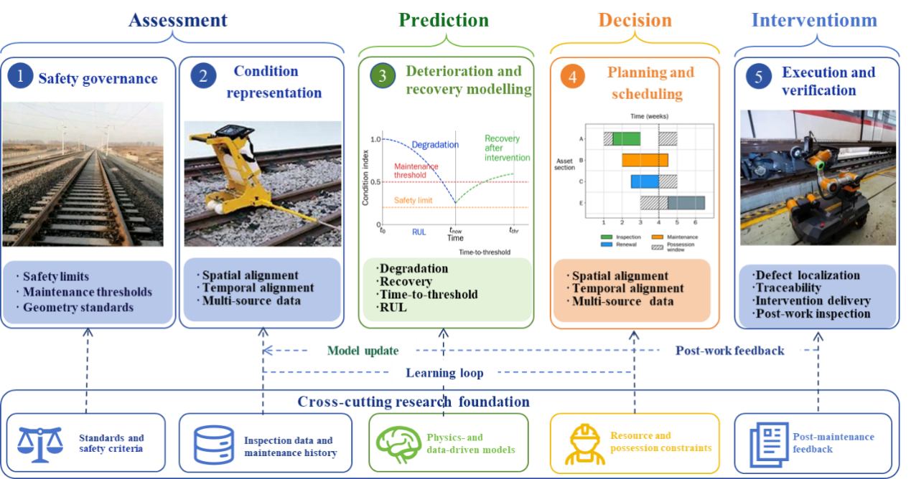
Figure 5 Existing research landscape of railway infrastructure maintenance: from safety governance to executable intervention
Modern standards keep this logic but make it more explicit. The EN 13848 series defines track geometry parameters, measurement characteristics and quality levels, including alert, intervention and immediate-action limits for geometric deviations (European Committee for Standardization, 2017). Chinese high-speed railway research similarly emphasizes the combined use of infrastructure-side management values and train-side safety limits. (Lu and Cai, 2020) argue that high-speed railway safety management should link the management value of track irregularity with train safety limits derived from dynamic criteria. This point matters because it prevents the maintenance system from becoming a purely statistical exercise: a small-looking irregularity may be relevant if it excites a vehicle-track dynamic response, whereas a larger deviation may be manageable when dynamic response and structural context are benign.
The same safety logic explains why railway decision-making remains hierarchical. Planning determines what work is required, where it is required, and how urgent it is. Scheduling converts that intent into feasible work packages under possession, resource, machine, crew and timetable constraints. (Sedghi et al., 2021b) show that the planning-scheduling distinction cannot be reduced only to time horizon; it also depends on the content of the decision, from maintenance interval selection and resource definition to possession allocation. For large-scale railway O&M, this distinction is crucial. A degraded section may be technically eligible for intervention long before the operator can obtain a possession window, assign a tamping or grinding machine, and coordinate adjacent tasks. Thus, maintenance intelligence is not only the ability to predict deterioration; it is also the ability to transform risk-ranked needs into auditable, deliverable work.
The limitation of this body of research is not that it is too conservative, but that it often stops at threshold crossing and work-list generation. Section-based indices are effective for governance, but they can hide short local defects, transition-zone deterioration, or component-specific mechanisms. Standards provide accountability, but they do not by themselves identify why a recurring geometry defect returns after repeated tamping. Planning and scheduling models improve cost and possession use, but many remain weakly coupled to field execution and post-work verification. These limitations motivate a two-layer view: existing research provides the first layer of safe and consistent maintenance governance, while future precision maintenance must add a second layer that closes the local intervention loop.
Table 4 Existing studies on safety governance and maintenance decision-making
Research topic | Core focus | Maintenance implication | References
Safety-limit governance | Train safety limits and track thresholds | Defines when intervention is required | (Lu and Cai, 2020)
Track geometry indices | TQI and geometry parameters | Supports network-scale condition control | (Soleimanmeigouni, Ahmadi and Kumar, 2018)
High-speed railway standards | Speed class and management unit | Links geometry limits to standards | (Ren et al., 2021)
Structural pathology | Settlement, voiding, debonding | Explains hidden causes of defects | (Shang et al., 2021)
Planning and scheduling | Work need versus work feasibility | Converts diagnosis into executable tasks | (Sedghi et al., 2021b)
Execution-aware decisions | Location, possession, verification | Makes maintenance traceable and auditable | (Binder, Mezhuyev and Tschandl, 2023)

2.3.2 Data-to-decision pipelines and predictive maintenance models
Predictive maintenance in railway infrastructure is not a single algorithmic task. It is a data-to-decision pipeline that converts heterogeneous observations into condition states, forecasts, work priorities and intervention rules. Reviews in the railway domain consistently distinguish between defect detection, diagnosis or classification, prognosis, and maintenance-decision coupling (Davari et al., 2021; Binder, Mezhuyev and Tschandl, 2023; Bianchi et al., 2025c). In track applications, the data sources include geometry measurements, ultrasonic testing, visual inspection, GPR, wayside monitoring, axle-load records, maintenance logs, traffic history, environmental exposure, and manually written inspection reports. This heterogeneity is useful, but it creates practical problems: the data are collected at different sampling rates, spatial resolutions and coordinate systems, and the labels used for model training are often indirect operational labels rather than true physical failure labels.
The first task is therefore alignment. Spatial alignment maps observations to a stable decision unit, such as a 200 m geometry unit, a rail segment, a switch, a level crossing or a transition-zone boundary. Temporal alignment links the current condition to deterioration history, cumulative tonnage, environmental events, previous repairs and post-maintenance recovery. Without these alignment steps, predictive models may appear accurate in statistical terms while remaining unusable for maintenance. For example, a model that forecasts deterioration over fixed equal-length sections may overlook a local transition-zone dip; a model that ignores previous tamping may overestimate the durability of restored geometry. Reviews of track geometry degradation and machine-learning prediction repeatedly emphasize that track quality is shaped by traffic, structure, maintenance history and local context (Higgins and Liu, 2018; Soleimanmeigouni, Ahmadi and Kumar, 2018; Y. Liao et al., 2022).
Methodologically, the literature can be grouped into four families. Statistical and stochastic models use regression, Markov chains, Weibull distributions, Wiener or Gamma processes, Bayesian methods and Monte Carlo simulation to represent deterioration and intervention timing. These models remain valuable because they are interpretable and can handle uncertainty. (Quiroga and Schnieder, 2012) and (Audley and Andrews, 2013) demonstrate how stochastic simulation and Petri-net formulations can represent track degradation, inspection, tamping and renewal as interacting processes. Machine-learning models, including random forests, support vector machines, neural networks and hybrid deep-learning architectures, have become more prominent as inspection datasets grow; (Y. Liao et al., 2022) review these models for track geometry degradation prediction. Physics-based and simulation-based models remain essential where labels are scarce but the vehicle-track mechanism is understood. Finally, hybrid models combine data-driven prediction with physical constraints or digital-twin simulation, a direction increasingly emphasized in recent railway infrastructure monitoring research (Bianchi et al., 2025c).
The most useful predictive outputs are not abstract accuracy scores. They are decision-ready quantities such as probability of threshold exceedance, time-to-limit, remaining useful life, defect recurrence risk, and prioritized work lists. (Caetano and Teixeira, 2016) show this principle in ballast tamping by linking degradation forecasting to a reliability-cost maintenance model. (Binder, Mezhuyev and Tschandl, 2023) similarly describes predictive maintenance as most deployable when it uses already available operational, inspection and maintenance data to support planning and scheduling rather than replace inspection. The implication is important for this review: predictive maintenance belongs primarily to the first closed loop when it screens and prioritizes the network; it enters the second loop only when the forecast is converted into a local repair target, an action, and a measurable acceptance criterion.
Table 5 Existing studies on data-to-decision pipelines and predictive maintenance
Research topic | Core focus | Maintenance implication | References
Multi-source data fusion | Geometry, logs, traffic, environment | Builds decision-ready condition states | (Davari et al., 2021)
Spatial alignment | Segments, sections, assets | Matches data with work units | (Peinado Gonzalo et al., 2022b)
Temporal alignment | Degradation and intervention history | Enables trend-based prediction | (Caetano and Teixeira, 2016)
Practical labels | Risk class, threshold exceedance, RUL | Avoids dependence on rare failure labels | (Bianchi et al., 2025c)
Prognostic modelling | Stochastic, ML, physics-based models | Estimates deterioration and timing | (Quiroga and Schnieder, 2012)
Decision coupling | Worklists and intervention triggers | Links prediction to maintenance planning | (Binder, Mezhuyev and Tschandl, 2023)

2.3.3 Track deterioration, restoration and state evolution
The dominant state variable in track maintenance is geometry, but geometry is an effect rather than a complete cause. Geometry deterioration expresses how the rail-fastener-sleeper-support system evolves under repeated wheel loading, environmental exposure and previous interventions. In ballasted track, the central mechanism is the gradual loss of uniform support. Ballast settlement, particle breakage, abrasion, fouling, drainage degradation and subgrade weakening change the stiffness and damping of the track bed, leading to longitudinal-level and alignment irregularities. In this setting, tamping remains the main corrective operation because it directly restores sleeper support and rail position. Yet the recovery is imperfect and temporary. (Audley and Andrews, 2013) found that traffic speed and maintenance history affect subsequent deterioration and that tamping can damage ballast. This is why modern maintenance models treat tamping not as a reset to an as-new state, but as an intervention with limited and path-dependent recovery.
Slab and ballastless tracks follow a different maintenance logic. They are designed to avoid routine ballast rearrangement and to preserve high smoothness, but their defects are often related to structural interfaces, support conditions and environmental effects. (Ren et al., 2021) review Chinese high-speed slab-track research and highlight issues such as service performance evolution, damage maintenance standards, repair technologies and the need to evaluate maintenance effects. In slab systems, a geometry irregularity can correspond to concealed debonding, voiding, uneven settlement, frost heave, thermal deformation or interlayer degradation. Studies on CRTS III slab track under frost heave show that foundation deformation can lead to slab-track deformation and damage evolution (Cai et al., 2021). Hence the maintenance question is not simply whether a geometry threshold has been exceeded, but whether the observed geometry is a symptom of a deeper support or interface problem.
Rail and wheel-rail interface deterioration add another mechanism. Wear, corrugation, rolling contact fatigue, squats, head checks and profile evolution affect contact stress, dynamic loading, noise and vibration. Rail grinding and profile maintenance are therefore not only surface operations; they regulate the dynamic interaction that drives downstream track damage. Numerical wear-model reviews describe a standard chain in which multibody vehicle-track dynamics generates contact forces and creepages, contact mechanics resolves stresses, a wear law estimates material loss, and iterative profile updating predicts future profile evolution (Bosso, Magelli and Zampieri, 2022). Corrugation assessment based on wheel-rail forces and rail-grinding needs has also been studied as a way to connect measurement to grinding decisions (Niu et al., 2023).
Transition zones and discrete assets are another major source of state evolution. Bridges, culverts, tunnels, level crossings, turnouts and slab-ballast interfaces generate abrupt changes in stiffness, support condition or geometry. The resulting dynamic amplification produces differential settlement, local geometry loss and recurring maintenance demand. (Shang et al., 2021) argue that discrete rail assets require systems-thinking maintenance because they are short, numerous, heterogeneous and locally degraded, while (Shang et al., 2023) show how level crossings and associated transition zones can be optimized through surrogate-assisted dynamic design. The message for maintenance is clear: recurring defects should not be treated only by repeated geometry correction. Effective state-evolution management must identify whether the root cause lies in ballast fouling, sleeper support, rail profile, slab interface, drainage, stiffness transition or component failure.
Table 6 Existing studies on track deterioration, recovery, and intervention effects
Object of study | Core focus | Maintenance implication | References
Ballasted track | Settlement and ballast degradation | Explains recurring geometry defects | (Guo, 2021)
Tamping recovery | Imperfect post-work recovery | Requires recovery modelling | (Audley and Andrews, 2013)
Section-level degradation | Traffic, environment, history | Supports time-to-threshold prediction | (Soleimanmeigouni, Ahmadi and Kumar, 2018)
Slab track | Interface and support-layer defects | Links geometry to hidden damage | (Ren et al., 2021)
Transition zones | Local stiffness variation | Highlights localized deterioration | (Shang et al., 2021)
Wheel–rail interface | Wear, corrugation, profile evolution | Supports grinding strategy | (Bosso, Magelli and Zampieri, 2022)

2.3.4 Robotics and automated execution in railway maintenance
The fourth research direction concerns the physical execution of maintenance tasks. Compared with condition monitoring, deterioration modelling, and maintenance planning, automated execution remains the least mature part of railway infrastructure maintenance. Most existing systems can identify defects, rank risks, or support planning decisions, but the final intervention is still frequently performed by human crews or large maintenance machines under strict possession-window constraints. This creates a practical discontinuity in the data-to-maintenance chain: defects may be detected and prioritized digitally, while the repair action itself remains manual, weakly traceable, and difficult to verify in a closed-loop manner.
Recent autonomous railway platforms indicate a transition from inspection-centered automation toward execution-oriented maintenance. (J. Li et al., 2024) present a Railway Inspection and Maintenance Vehicle that integrates GPS, IMU, wheel encoders, LiDAR, depth camera, environmental camera, ROS2-based processing, remote monitoring, and emergency stop mechanisms. Although the reported validation mainly focuses on ultrasonic inspection, the system is important because it provides a modular mobile carrier for railway tasks. In other words, its value is not only defect sensing, but also the possibility of carrying different payloads, navigating along the rail corridor, and linking inspection data with field action. Such platforms provide the hardware basis for future automated intervention, particularly when local measurement, positioning, and task-specific tools can be integrated into the same vehicle.
Task-specific maintenance robots provide a more direct example of automated execution. (Guo, Zhang and Qi, 2019) develop a rail-fastener installation robot that combines visual recognition, sensor-based bolt localization, automatic feeding, manipulator control, and electric-wrench fastening under PLC control. This system is narrow in task scope, but it is highly relevant for precision maintenance because it demonstrates the full chain from perception to positioning and physical action. Fastener work is also a representative case of railway maintenance automation: the task is repetitive, spatially regular, safety-critical, and requires controlled torque or fastening quality. This makes it suitable for early robotic deployment before broader, less structured maintenance tasks can be automated.
Mobile manipulation is therefore a key bridge between inspection platforms and real repair robots. (Rahman et al., 2023) note that railway inspection technologies are more mature than robotic repair technologies, and that mobile manipulators are still rarely deployed in railway track maintenance. The difficulty lies not only in mechanical design but also in the railway working environment. Maintenance robots must operate under vibration, ballast unevenness, limited clearance, weather exposure, electromagnetic interference, strict safety requirements, and tight possession windows. They must also handle tools, materials, fasteners, or rail components with reliable localization and quality assurance. For this reason, future robotic maintenance is more likely to begin with constrained, task-specific operations rather than fully general autonomous repair.
Human-in-the-loop automation is another important path. Augmented reality and digital guidance technologies can support maintenance by providing visual instructions, spatial registration, and diagnostic guidance to operators. (Koh et al., 2020) show that AR-based maintenance for robots commonly relies on tracking, registration, and visual guidance, although many applications remain laboratory-based. In railway maintenance, such methods may be useful as transitional technologies. Before full robotic autonomy becomes reliable, AR-assisted execution can improve field consistency, reduce training demand, and connect human repair actions with digital work orders and inspection records. It also supports supervised automation, where a human operator monitors or confirms robotic action rather than performing the entire task manually.
Embodied AI provides the conceptual basis for more advanced robotic maintenance. (Sun et al., 2024) describe embodied intelligence as the integration of perception, cognition, and behavior through physical interaction with the environment. (Zheng et al., 2025) similarly organize embodied AI around perception, decision-making, and execution. These frameworks are relevant because railway maintenance robots cannot be treated as simple actuators. They must perceive the local track state, interpret the repair target, select an action strategy, execute it physically, and evaluate the resulting change. Object-centric robotic manipulation research further shows that reliable execution depends on pose estimation, affordance learning, policy learning, and task-oriented manipulation (Zheng et al., 2025). These capabilities are directly relevant to fine maintenance actions such as fastening, tool positioning, component replacement, surface treatment, and local adjustment.
Overall, the current literature suggests that railway maintenance automation is moving toward human-supervised, task-constrained, and verification-based robotics. The immediate goal is not unrestricted autonomy, but the formation of executable maintenance units: a robot or robotic platform should be able to reach the target site, localize the defect, perform a specific repair, measure the result, and report whether the intervention satisfies acceptance criteria. This execution logic is closely aligned with the second closed loop proposed in this review, where precision maintenance is realized through repeated measurement, decision, control, and re-measurement rather than through one-off repair.
Table 7 Existing studies on robotics and automated execution for railway maintenance
Technology direction | Core capability | Execution implication | References
Autonomous railway platforms | Localization, sensing, modular payloads | Provides mobile carriers for inspection and local intervention | (Rahman et al., 2023)
Task-specific repair robots | Recognition, positioning, feeding, fastening | Demonstrates automated execution for repetitive component tasks | (Guo, Zhang and Qi, 2019)
Mobile manipulators | Mobility, tool handling, local manipulation | Bridges inspection platforms and physical repair | (Zheng et al., 2025)
AR-assisted maintenance | Visual guidance, tracking, registration | Supports human-in-the-loop repair and field instruction | (Koh et al., 2020)
Embodied AI frameworks | Perception, decision-making, execution | Provides the conceptual basis for closed-loop robotic action | (Sun et al., 2024)
Verification-based automation | Post-work sensing, acceptance, feedback | Shifts robots from open-loop action to quality-assured repair | (J. Li et al., 2024)

Construction of the "Dual Closed-Loop" Intelligent O&M System
Confronting the core contradiction in railway infrastructure O&M — the inherent tension between full-network condition perception over large-scale line systems and the demands of precision, targeted maintenance execution — this paper proposes a "Dual Closed-Loop" architecture as the organizing framework for intelligent O&M.
The system comprises two functionally complementary and hierarchically progressive loops. The First Loop uses in-service commercial trains as sensing platforms; through continuous acquisition of on-board vibration and noise signals combined with AI-based inverse mapping models, it achieves low-cost, high-frequency dynamic condition census of the entire track network, with large model-assisted decision-making generating maintenance intervention commands — forming a full-process intelligent closed loop of "general sensing → condition assessment → decision output." The Second Loop takes precision inspection equipment as its data source; by fusing multi-source heterogeneous data from wideband geometric measurement, ground-penetrating radar, and distributed ground sensing networks, it achieves precise characterization of anomalous segments, and relies on unmanned precision maintenance technology to physically execute maintenance commands at high accuracy — forming an execution-layer closed loop of "precision sensing → precision maintenance → effect verification" .
The two loops operate in concert: the First Loop handles full-network screening and maintenance scheduling, while the Second Loop handles targeted diagnosis and precision execution, together achieving full-chain closure of intelligent railway O&M from sensing through decision-making to physical execution.
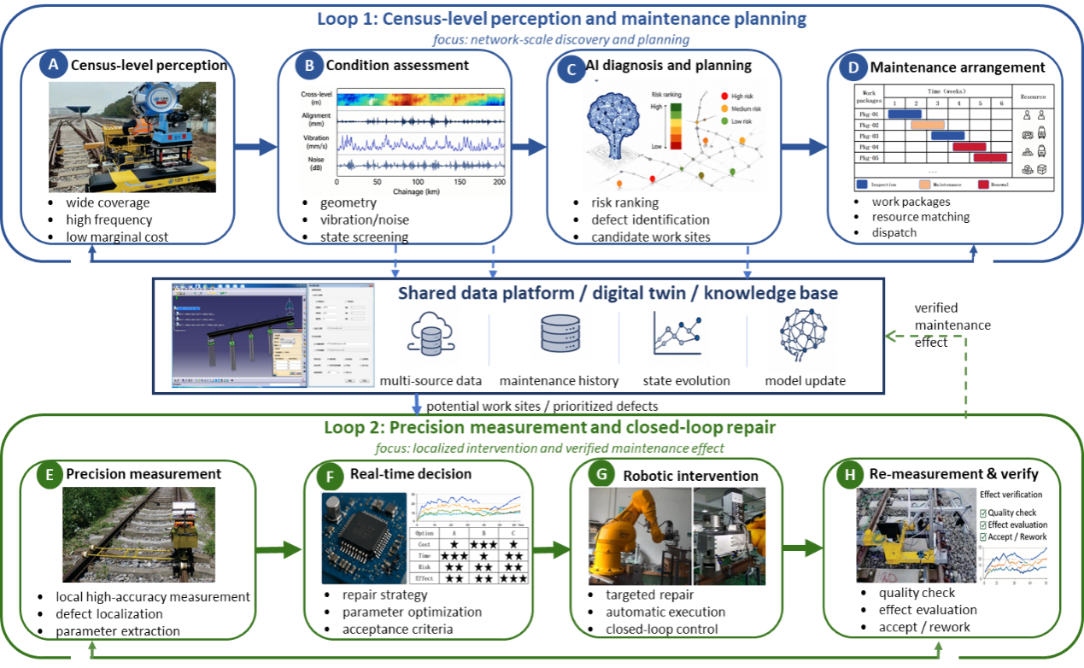
Figure 6 Dual-loop architecture for intelligent railway infrastructure O&M: from census-level perception to precision maintenance

The First Loop: AI-Driven Full-Process Intelligent O&M Closed Loop
The core concept of the First Loop is to leverage the existing operational trajectories of in-service trains distributed across the railway network, transforming ordinary commercial vehicles into mobile sensing platforms with full-network coverage, achieving continuous and comprehensive track condition census at minimal marginal cost. This loop is supported by three progressively integrated technical modules: first, a multi-level vibration-noise sensing system combining IMUs and acoustic sensing establishes a high-quality onboard perception framework; second, deep generative learning methods address inevitable data gaps and noise through imputation and enhancement; and finally, AI-based inverse mapping models solve the core inverse problem of translating vehicle dynamic responses into track excitation states — converting vibration signals into track irregularity features that directly support O&M decision-making. Following condition assessment, the First Loop further incorporates a large language model-based intelligent decision-making module that transforms assessment outputs into structured maintenance scheduling commands, achieving full-chain closure across sensing, assessment, and decision-making.
- Sensing Technology Enhancement
To address the inherent limitations of intermittent inspections by specialized Track Geometry Cars (TGCs), which often fail to capture the rapid deterioration of track quality in high-density railway networks, the first loop of the intelligent O&M system introduces a continuous general survey technology based on operational trains. A fundamental prerequisite for this technology is the utilization of vehicles operating under constant speed, constant load, and consistent operational states (referred to as "isostates"). These isostates minimize the non-linear uncertainties in vehicle-track coupled dynamics, providing a stable "baseline" for the long-term trend analysis of track health. This sensing enhancement is realized through a transition from isolated sensor measurements to a multi-dimensional, pervasive perception framework that integrates hierarchical vibration, inertial references, and acoustic signals.
The core of this architecture is the multi-level vibration sensing system, which utilizes the vehicle’s mechanical structure as a natural transducer. Different vehicle components exhibit distinct filtering characteristics that correlate with specific track irregularity wavelengths. Axle Box Acceleration is directly coupled with the wheel-rail interface, making it exceptionally sensitive to high-frequency impacts. It is the primary data source for diagnosing rail surface defects and short-wavelength irregularities, such as squats, insulated joint failures, and rail corrugation(Molodova, Li and Dollevoet, 2011; Salvador et al., 2016) . However, the extreme vibration environment of the axle box often introduces high-frequency noise and integration drift, which can obscure geometric trends(Real Herráiz et al., 2012). To bridge this gap, bogie and car body accelerations are integrated into the system. While the primary and secondary suspension systems filter out high-frequency content, these sensors provide high-fidelity data for medium-to-long wavelength irregularities . Such data is critical for monitoring large-scale infrastructure changes, including subgrade settlement, bridge pier tilt, and slab track deformation(Li et al., 2020; Wang et al., 2021) .
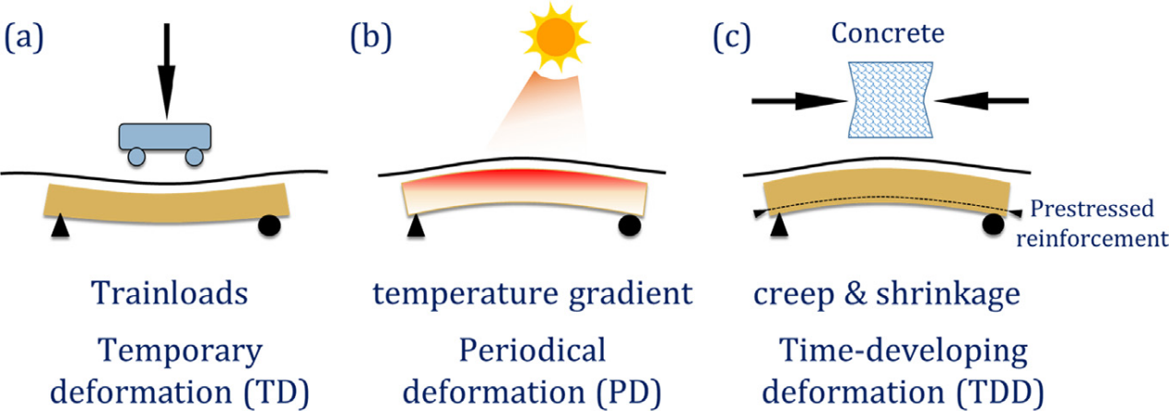
Figure 8. Three major extrinsic factors that lead to bridge deflection or camber, including dynamic trainload, vertical temperature gradient, and creep &
shrinkage of concrete.
To further enhance the precision of spatial trajectory reconstruction, Inertial Measurement Units (IMUs) are incorporated to provide high-precision angular velocity data (e.g., pitch, roll, and yaw rates). Pure acceleration-based methods often suffer from signal-to-noise ratio degradation at low frequencies or during low-speed operations. The introduction of gyroscopic sensors allows for the compensation of these low-frequency errors. For instance, the bogie yaw rate has been demonstrated to be significantly more robust than lateral acceleration for estimating track alignment and gauge-related irregularities when the train operates at velocities as low as 10 m/s (Weston et al., 2007). By applying complementary filtering or Kalman filtering to fuse acceleration and angular velocity, the sensing system can accurately decouple the vehicle's attitude from the track's true geometry, enabling a precise mapping of the "absolute" track profile across a broad spectrum of wavelengths (Escalona, 2016).
Lastly, the fusion of acoustic sensing adds a non-contact diagnostic dimension to the general survey. Acoustic signals, such as wheel-rail interaction noise and interior carriage noise, possess extremely high sampling rates, allowing for the identification of micro-scale surface degradations that may not yet have triggered significant vibration responses. Advanced signal processing techniques, such as wavelet packet energy analysis and 1D-CNN-based feature extraction, have enabled the quantification of rail corrugation and wheel flats with high accuracy (Wei et al., 2022; Xie et al., 2022). This synergy of multi-level vibration, inertial navigation, and acoustic perception creates a robust, "all-weather" sensing layer, ensuring that the continuous general survey can provide comprehensive and reliable track state information for subsequent AI-driven assessment.
- Data Imputation and Enhancement
Within the framework of continuous general survey technology based on on-board vibration-noise sensing, the efficacy of downstream diagnostic models is fundamentally bottlenecked by raw data quality. Despite the deployment of advanced sensor networks across large-scale railway infrastructures, continuous signal acquisition is inevitably compromised by harsh dynamic environments, transient communication latencies, and sensor degradation. This disruption leads to highly fragmented and intrinsically imbalanced datasets. Consequently, establishing a robust data preprocessing pipeline is a critical prerequisite for reliable intelligent operation and maintenance (O&M). This pipeline specifically encompasses data imputation to rectify missing sensor observations and data enhancement to amplify rare fault signatures. The evolution of these methodologies reflects a continuous drive to capture the complex spatiotemporal dynamics of railway systems.
Under Missing Completely at Random (MCAR) or Missing at Random (MAR) assumptions, early data imputation typically relied on simple mean substitution or linear interpolation. To mitigate the bias of these univariate methods, multivariate statistical frameworks like Multiple Imputation by Chained Equations (MICE) (Buuren and Groothuis-Oudshoorn, 2011) were widely adopted. In transportation domains, foundational machine learning algorithms have demonstrated significant efficacy; for instance, Probabilistic Principal Component Analysis (PPCA) effectively recovers missing traffic flow data by extracting linear feature correlations (Qu et al., 2009). Additionally, the non-parametric MissForest algorithm (Stekhoven and Bühlmann, 2012) excels in handling mixed-type data without strict distributional assumptions. However, these fundamental approaches inherently rely on linear or local proximity assumptions, rendering them inadequate for capturing the highly non-linear, multidimensional dependencies within complex railway sensor networks.
To address these multidimensional dependencies, matrix factorization initially emerged to reconstruct missing values by extracting latent low-rank structures from highly sparse datasets(Koren, Bell and Volinsky, 2009). Because intelligent transportation data naturally encompass complex spatiotemporal dimensions—such as spatial nodes, time intervals, and sensor features—they inherently form multidimensional tensors rather than two-dimensional matrices. Consequently, low-rank tensor factorization extends this paradigm to preserve global topological properties across multiple modes, effectively capturing multi-way correlations for missing traffic volume imputation(Giancarlo, 2018). Nevertheless, their reliance on static rank assumptions restricts their adaptability to highly non-linear spatiotemporal shifts.
To capture such complex non-linear dynamics, deep recurrent and graph-based architectures have superseded static factorization models. Bidirectional recurrent neural networks directly learn missing values within the sequence graph, effectively modeling temporal decay and dynamic missing patterns in time series(Cao et al., 2018). Concurrently, inductive graph neural networks have advanced spatial-temporal kriging by leveraging the complex topological structures of transportation networks to infer data at unobserved spatial nodes(Wu et al., 2020). Despite their strong predictive capabilities, these models inherently rely on discrete time steps. This discrete nature poses significant challenges when addressing the irregularly sampled or continuously missing high-speed railway sensor signals, demanding a shift from discrete models to continuous-time dynamics.
To overcome the constraints of discrete time steps, Neural Ordinary Differential Equations (Neural ODEs) offer a paradigm shift by modeling latent states as continuous-time dynamics. This continuous formulation is particularly adept at handling irregularly sampled data caused by transient communication failures in high-speed railways. Latent ODEs pioneered this approach by naturally interpolating missing values without requiring artificial time alignment(Rubanova, Chen and Duvenaud, 2019). Furthermore, Neural Controlled Differential Equations (NCDEs) extended this capability to process continuous incoming data streams (Kidger et al., 2020). In intelligent transportation, integrating continuous temporal CDEs with spatial graph networks has successfully resolved irregular traffic sensor failures(Choi et al., 2021). While highly effective for continuous temporal modeling, these dynamic systems do not explicitly capture the complex, underlying probability distributions of missing values, necessitating the introduction of deep generative frameworks.
To explicitly capture these complex underlying probability distributions, deep generative frameworks—most notably Generative Adversarial Networks (GANs)—have been widely adopted. Unlike deterministic systems, generative approaches reconstruct missing values by learning the non-linear data distribution within a latent space. The pioneering Generative Adversarial Imputation Nets (GAIN) introduced an adversarial mechanism where a generator imputes missing components while a discriminator distinguishes them from observed data(Yoon, Jordon and Schaar, 2018). Within railway condition monitoring, customized GAN architectures have been successfully deployed to recover missing multi-sensor data from rolling stock and mechanical bearings, significantly enhancing diagnostic reliability(X. Wang et al., 2025). However, GAN-based imputation frequently suffers from training instability and mode collapse, highlighting the critical need for more stable and tractable probabilistic generative paradigms.
To address the instability of adversarial training, diffusion models have recently emerged as the state-of-the-art probabilistic paradigm for data imputation. By defining a forward noise-injection process and learning a parameterized reverse denoising trajectory, these models offer highly stable and tractable generation. Conditional Score-based Diffusion Models (CSDI) pioneered this approach by probabilistically imputing time-series data through a conditional denoising mechanism(Tashiro et al., 2021). This process is particularly advantageous for complex, high-dimensional transportation networks. Recently, conditional diffusion frameworks have been tailored to reconstruct missing continuous multi-sensor signals in high-speed trains, demonstrating superior distributional fidelity compared to previous baselines(Yang et al., 2025). While these advanced imputation techniques successfully restore data completeness, the inherent scarcity of critical fault samples in real-world railway operations necessitates the complementary integration of data enhancement strategies.
While high-fidelity data imputation is critical for restoring the continuity of sensor networks, data enhancement is equally indispensable for the intelligent operation and maintenance of large-scale railway infrastructures. Imputation methodologies primarily address the random missingness of observations but cannot overcome the inherent scarcity and severe class imbalance of critical fault events. In real-world railway operations, anomalous conditions occur infrequently, resulting in a pronounced long-tail distribution. Therefore, generating synthetic fault samples to enrich the minority feature space is essential for training robust diagnostic models.To mitigate this extreme class imbalance, heuristic resampling techniques were initially adopted. Instead of merely duplicating rare samples, the Synthetic Minority Over-sampling Technique (SMOTE) generates synthetic instances by interpolating along feature-space line segments joining nearest neighbors(Chawla et al., 2002). Subsequently, the Adaptive Synthetic (ADASYN) approach dynamically generates more data for harder-to-learn minority examples, adaptively shifting the decision boundary(He et al., 2008). In railway engineering, these interpolation techniques are widely utilized; for instance, modified SMOTE algorithms have successfully balanced sparse defect datasets to improve the fault diagnosis of railway turnout systems(Li et al., 2022). Nevertheless, when applied to the highly non-linear fault boundaries of complex railway components, these linear strategies often introduce noisy synthetic artifacts, necessitating the shift towards more sophisticated signal-level transformations.
To overcome linear interpolation artifacts, signal-level transformations and feature mixing strategies directly manipulate continuous time-series data to simulate diverse operating conditions. Techniques such as adding Gaussian noise or time-stretching physically alter original sensor signals, while the mix-up approach improves model generalization by interpolating both features and labels to smooth decision boundaries(Zhang et al., 2018). Within railway condition monitoring, these model-independent augmentations have proven highly effective for diagnosing faults in critical rotating machinery under variable dynamic loads(Lyu et al., 2022). Nevertheless, because signal warping and feature mixing primarily recombine existing observations rather than generating entirely new, high-fidelity fault distributions, capturing the highly complex non-linearities of rare railway defects necessitates a transition to advanced deep generative modeling.
To synthesize entirely new, high-fidelity fault distributions, Generative Adversarial Networks (GANs) have become the cornerstone of advanced data enhancement. By optimizing an adversarial mechanism, conditional GANs, such as CTGAN, effectively model non-Gaussian and discrete data without relying on prior structural assumptions(Xu et al., 2019). In railway engineering, customized GANs are increasingly deployed to synthesize realistic samples of extreme minority classes, specifically generating artificial railway track irregularities to augment sparse diagnostic datasets(Bobadilla and Martin, 2024). However, while standard GANs excel given moderate sample sizes, they frequently suffer from mode collapse and degraded feature boundaries when trained under extremely limited data regimes, driving the adoption of contrastive learning and diffusion models.
To overcome mode collapse in extremely limited data regimes, contrastive learning and diffusion architectures have been introduced to stabilize feature synthesis. Contrastive learning enhances generative networks by explicitly maximizing latent distances between distinct classes, thereby sharpening decision boundaries. In railway applications, contrastive GANs have successfully synthesized rare rail surface defects, preventing training instability when real samples are exceptionally scarce(Du, Gao and Li, 2023). Concurrently, diffusion models have transitioned from data imputation to augmentation. Frameworks such as TabDDPM (Kotelnikov et al., 2024) synthesize high-fidelity structural data through stable iterative denoising, outperforming standard GANs with minimal prior observations. Nevertheless, applying these highly complex probabilistic models directly to extensive, multivariate railway sensor signals necessitates their integration with advanced sequential representation architectures.
To effectively process extensive, multivariate sensor sequences, Transformer-based architectures have redefined data enhancement paradigms. By leveraging self-attention mechanisms, Transformers capture long-range temporal dependencies without relying on localized receptive fields. To enhance sequence representations under limited supervision, frameworks have been designed to intentionally mask and reconstruct segments of multivariate time series, thereby extracting robust generalized features(Zerveas et al., 2020). In intelligent railway operation and maintenance, this paradigm elegantly addresses severe fault sample shortages. Notably, recent approaches integrating Convolutional Transformers with pseudo-synthetic data generation algorithms have significantly improved the fault diagnosis accuracy of complex railway turnout systems(Fu et al., 2024). Ultimately, these attention-driven enhancement strategies provide the requisite high-dimensional feature fidelity to support robust, large-scale predictive maintenance.
In summary, the evolution of data imputation and enhancement strategies provides a comprehensive solution to the inherent data imperfections of on-board vibration-noise sensing systems. The progression from foundational statistical interpolations to state-of-the-art continuous dynamics and generative architectures ensures the extraction of high-fidelity, balanced feature spaces from chaotic sensor streams. By strictly reconstructing missing temporal dynamics and artificially synthesizing minority fault representations, these advanced methodologies bridge the critical gap between raw hardware perception and actionable intelligence. Ultimately, this stabilized and enriched data foundation paves the way for the subsequent deployment of advanced AI-based inverse mapping models and large-scale assessment frameworks in railway predictive maintenance.
Table 8. Methodological evolution of data imputation and enhancement in railway intelligent O&M
Category | Representative Models | Adaptability to Continuous On-Board Vibration-Noise Sensing
Data Imputation | Statistical & Factorization Baselines  (MICE, MissForest, Tensor Factorization) | Rectifies static or mildly dynamic missingness in discrete multi-sensor data arrays.
 | Spatiotemporal & Continuous Dynamics  (RNN/GNN, Neural ODEs/NCDEs) | Directly handles irregularly sampled signals caused by transient communication failures without requiring artificial time alignment.
 | Probabilistic Generative Frameworks  (GAIN, CSDI / Diffusion Models) | Reconstructs non-linear distributions of multi-sensor signals with state-of-the-art distributional fidelity and stable denoising.
Data Enhancement | Heuristic Resampling & Signal Warping  (SMOTE, Mixup, Time-stretching) | Simulates diverse operating conditions by interpolating features or adding physical noise to existing sensor signals.
 | Deep Generative Synthesis  (CTGAN, Contrastive GANs) | Generates entirely new, high-fidelity minority classes without prior structural assumptions.
 | Transformer & Advanced Sequential Architectures  (TabDDPM, Convolutional Transformers) | Captures long-range temporal dependencies and reconstructs masked segments in extensive, multivariate continuous time series.

- AI-Based Inverse Mapping Model
The fundamental operating premise of on-board vibration and noise sensing systems is, in essence, an inverse problem. The physical forward process—from track geometric irregularities and structural defects to the vehicle’s dynamic response—can be approximately described by a vehicle-track coupled dynamic model; however, the inverse path—reconstructing track conditions from measured vibration and acoustic signals—is inherently ill-defined. The one-to-many nature of this mapping implies that, under different operating speeds, vehicle states, and environmental conditions, various combinations of track defects may produce nearly identical onboard response characteristics. Traditional physics-based inverse analysis strategies (such as iterative finite element model refinement) are extremely computationally expensive at the scale of a continuous network-wide survey, and are highly sensitive to modeling uncertainties. The maturity of deep learning has opened up a fundamentally different path: AI-based inverse mapping models directly learn the complex nonlinear mapping relationships between sensor observations and track conditions from the data, replacing explicit physical inversion with statistical surrogate models, resulting in an inference cost that is virtually negligible. Such models have now become an indispensable algorithmic bridge between the raw outputs of onboard sensor systems and the actionable track condition information required for intelligent operations and maintenance.
The core challenge in realizing the full diagnostic potential of on-board vibration and noise sensing systems lies not only in accurate signal processing but also in solving an inherently ill-posed inverse problem: reconstructing the spatially distributed mechanical state of the track from the integrated, coupled dynamic response measured at the vehicle body. The physical forward process is well characterized: track geometric irregularities, local stiffness deficiencies, and rail surface defects each excite characteristic dynamic modes in the vehicle-track coupled system, and their effects can be measured at multiple locations on the vehicle in the form of acceleration, velocity, or acoustic signatures. However, the challenge in the inverse direction is far more daunting. The observed vehicle body response is the result of complex convolution of multiple track excitation sources, filtered through the frequency-selective dynamics of the vehicle suspension and wheel-axle system, and further disturbed by wheel out-of-roundness, aerodynamic loads, and measurement noise. Consequently, under different operating speeds and vehicle configurations, various combinations of track defects may produce nearly identical on-board signatures, rendering the mapping relationship inherently non-unique. Classic physics-based inversion strategies (such as iterative finite element model refinement or Kalman filter-based state estimation) are either computationally prohibitively expensive at the scale of a full-network continuous survey or require idealized linear structural assumptions—assumptions that are difficult to justify in the presence of contact nonlinearities and spatially heterogeneous track characteristics. These limitations form the core motivation for AI-based inverse mapping: learning effective inverse operators directly from data without requiring explicit analytical forms—since the underlying physics itself cannot provide such forms.
Previous AI-based inverse mapping methods have established a rich set of learnable solutions for this problem. For example, end-to-end deep neural networks that map vehicle body acceleration to track mass index (Ma et al., 2019), multi-scale convolutional architectures for defect classification (Acikgoz and Korkmaz, 2023; Y. Wang et al., 2025), and multi-task frameworks for jointly estimating track parameters (C. Li et al., 2024; Pu et al., 2024) collectively demonstrate that the wheel-rail–vehicle dynamic transfer chain encodes track state information sufficient to support data-driven inversion. However, the gap between laboratory-scale proof-of-concept and full-network operational deployment remains vast, and bridging this gap requires a fundamental reevaluation of how inverse mapping models are designed, trained, and validated.
At the same time, the most significant structural limitation of the current generation of inverse mapping models is their implicit assumption of stationarity. Every supervised learning model implicitly encodes a prior distribution regarding the joint distribution of input signals and output track states observed during training. When a model trained on summer data from flat terrain is deployed on a winter mountain slope line, the mechanics of wheel-rail contact, the thermal behavior of ballast, and the aerodynamic load spectrum will all shift simultaneously—and the trained mapping model will confuse track conditions with these operational effects, losing calibration accuracy in a systematic manner that is difficult to detect in the absence of ground truth. This issue is not marginal but fundamental: the entire value proposition of on-board continuous sensing hinges on the ability of models calibrated during dedicated measurement periods to generalize to daily passenger operations under all conditions.
A promising research direction to address this challenge lies in domain-adversarial training frameworks, which explicitly decouple track-state-dependent features from operational-condition-dependent confounding factors, training models to generate representations capable of predicting track states while maintaining invariance to speed, vehicle load, and seasonal factors. Complementing this, meta-learning approaches—which train models on a task distribution rather than a single task—offer the potential for rapid, low-data-requirement adaptation to new operational conditions or previously unencountered track geometries, thereby significantly reducing the need for re-calibration data when deploying models to new network segments. The construction of standardized, cross-network benchmark datasets capable of capturing the full diversity of operational conditions across multiple railway systems will serve as an indispensable foundational project for advancing and fairly evaluating the aforementioned adaptive strategies.
Equally critical and equally unresolved is the fact that virtually all deployed inverse mapping systems lack quantification of uncertainty. Current models provide only point estimates without confidence intervals—whether for predicted track quality indices, classified defect types, or reconstructed stiffness fields—and thus offer no basis for maintenance decision-makers to distinguish between high-confidence diagnostic conclusions and unreliable extrapolations for out-of-distribution inputs. This is unacceptable in safety-critical infrastructure scenarios: tamping operations triggered by overconfident, degraded predictions waste maintenance budgets and disrupt traffic; while sections of the road misclassified as healthy due to false confidence pose safety hazards. The field must advance toward probabilistic inverse mapping, incorporating a posterior distribution with each output to honestly characterize aleatory uncertainty—irreducible noise in sensor observations—and epistemic uncertainty—the model’s lack of knowledge in regions of the input space where training data coverage is insufficient. Deep ensemble learning, Monte Carlo Dropout, Bayesian neural networks, and conformal prediction all offer viable approximations to this ideal, each presenting different trade-offs between calibration quality, computational cost, and deployment complexity. Among these, conformal prediction is particularly attractive for operational deployment because it provides guarantees of coverage with limited samples without requiring distribution assumptions, enabling maintenance engineers to use prediction intervals that are statistically valid regardless of the underlying model architecture. Integrating uncertainty-aware outputs into the decision-making layer—where the predicted state distribution is propagated through a risk model to generate maintenance recommendations with explicit confidence levels—represents a decisive leap from AI-based diagnostic tools to AI-based decision support systems.
PINN offers a structurally distinct and theoretically grounded approach to simultaneously address the aforementioned challenges. By directly embedding the partial differential equations governing track-structure dynamicsinto the training loss as physical residual terms (Ding et al., 2024; Q. Wang et al., 2024), PINNs impose continuous structural consistency constraints across the entire spatio-temporal domain rather than merely at discrete training points. In the inverse configuration, unknown physical parameters—such as foundation stiffness distribution, ballast damping coefficients, or local damage indices—are treated as additional trainable variables and recovered in tandem with the response field by minimizing a data-physical joint loss.
This framework possesses several properties directly relevant to operations: physical residuals serve as a powerful regularization mechanism under sparse sensor conditions, enabling reliable parameter identification from data with a measurement density far lower than that required by purely data-driven methods; the recovered parameters can be interpreted directly as physical quantities rather than abstract latent variables; physical constraints implicitly encode prior knowledge about structural behavior, partially mitigating distribution shifts by anchoring the model to physical laws that hold regardless of operational conditions (Haghighat et al., 2021; Xu and Darve, 2021).
Despite these advantages, the application of PINN to large-scale railway inverse problems remains in its infancy and faces non-trivial obstacles. A significant challenge that cannot be overlooked is that the contact mechanics at the wheel-rail interface exhibit strong nonlinearity, velocity dependence, and spatial randomness, making it difficult to express them in a compact PDE form. The spatial non-stationarity of real-world track characteristics at scales far smaller than standard measurement segment lengths makes it difficult to justify the assumption of a smoothly parameterized PDE domain. The computational cost of evaluating higher-order spatial and temporal derivatives via automatic differentiation on large-scale rail network length datasets remains a practical obstacle to deployment. A promising research frontier lies in hierarchical hybrid architectures: a PINN component constrains the dynamic response at the single-sleeper-spacing scale, where physical mechanisms are well-understood, coupled with a data-driven component that learns effective large-scale spatial statistical patterns of stiffness and damage distribution from historical network-wide records. In this architecture, physical constraints are no longer universal hard constraints but rather scale-specific regularization mechanisms—most stringent where the physical model is most accurate, and most lenient where data-driven learning can compensate for modeling uncertainties.
Table 9. Core Challenges in AI-Based Inverse Mapping
Challenge | Description | Current/Future Responses
Ill-posedness | Non-uniqueness and lack of stability in solutions | Introduce physical prior knowledge and multi-task constraints
Distribution shift | Model fails due to data distribution discrepancy between training and testing | Domain-adversarial training, meta-learning, and continuous adaptation
Labeling scarcity | Lack of sufficient labeled training data | Leverage unlabeled data, physical guidance, foundational knowledge
No uncertainty | Lack of quantified predictive confidence and error bounds | Bayesian DL, deep ensembles, conformal prediction
Real-time gap | High computational cost and latency for real-time inference | Model compression, event-triggered, edge AI, streaming architectures
Senction-level Silo | Segmentation of knowledge or data into isolated domains | Graph neural networks, digital twin integration

Looking to the long-term future, the most transformative advancement will be the emergence of spatially consistent, network-wide inverse mapping—a fundamental leap from estimating the state of isolated track segments to maintaining a continuously updated, physically consistent dynamic model of the entire railway network. No matter how accurate a single-segment model may be, it is structurally incapable of capturing phenomena that inherently belong to the network level: the spatial propagation of ballast degradation fronts from high-stress locations to adjacent sections; the load redistribution effect where local stiffness defects transfer excess dynamic loads to neighboring track units; or the systematic interaction patterns between adjacent maintenance interventions, where tamping at one location may shift the degradation gradient to an adjacent untreated section. Network-wide inverse mapping requires an architecture natively operating on a graph representation of the railway network, where nodes represent track sections or discrete infrastructure units, and edges encode physical coupling relationships and spatial adjacencies. Graph neural networks—trained to propagate physical constraints and uncertainty estimates between spatially connected nodes while assimilating heterogeneous data streams (records from periodic inspection train passes, continuous IoT sensor data, maintenance event logs, and historical weather and load data)— —provides a natural computational foundation for this network state estimation problem. The integration of a digital twin framework—with a continuously updated railway computational model serving as a dynamic prior for inversion—further enhances the physical consistency of the reconstructed state and supports prospective simulation of the consequences of candidate maintenance interventions prior to their implementation. This convergence of physically constrained deep learning, spatio-temporal graph neural networks, Bayesian state estimation, and digital twin infrastructure defines the long-term research frontier toward which current AI-based inverse mapping advancements are gradually converging, and represents the direction in which the field should deliberately direct its methodological investments.

Assessment Technology Based on AI Large Models
With the continuous expansion of high-speed railway, urban rail transit, and heavy-haul railway networks, railway systems are gradually shifting from traditional experience-driven maintenance management toward data-driven, knowledge-driven, and intelligent decision-making paradigms. Railway operation and maintenance scenarios are characterized by complex equipment types, variable operating environments, strict safety constraints, and severe consequences of failures. These scenarios involve multiple subsystems, including rolling stock, track structures, turnouts, signalling systems, communication systems, catenary systems, bridges, tunnels, slopes, and dispatching control. During long-term operation, railway systems accumulate large amounts of multi-source heterogeneous data, including sensor monitoring data, inspection images and videos, equipment maintenance records, fault reports, accident reports, regulations, standards, dispatching logs, and emergency response documents. These data include not only structured time-series information but also a large amount of unstructured text, image, and multimodal information. Therefore, how to effectively organize, understand, extract knowledge from, and transform these data into maintenance and safety decisions has become an important issue in railway intelligent operation and maintenance. Figure 9 illustrates the technical route for transforming general-purpose large models into reliable railway-specific intelligent systems, including foundation model selection, railway domain adaptation, reliability enhancement through retrieval and knowledge grounding, and final deployment in railway operation and maintenance applications.
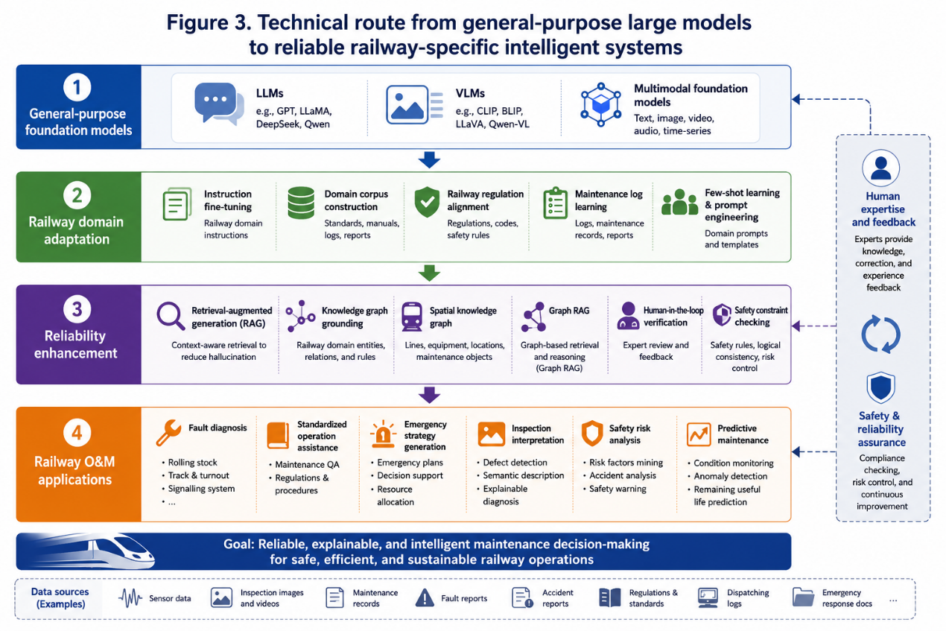
Figure 9 Technical route from general-purpose large models to reliable railway-specific intelligent systems
Large language models have strong natural language understanding, contextual reasoning, and human-computer interaction capabilities, providing new methods for railway professional text processing and fault diagnosis. Peng (Peng et al., 2025) proposed RFD-LLM, a large language model for fault diagnosis of railway vehicle onboard controllers. For high-speed train equipment diagnosis, Zhang (Z. Zhang et al., 2025) proposed “Bogie Doctor”, which uses deep learning to analyze high-speed train maintenance logs and realize automated fault diagnosis of bogies. Miao (Miao, Wu and Zhang, 2025) further combined knowledge graphs with large language models and proposed a Graph RAG-based method for train bogie fault diagnosis. Chen (Chen et al., 2025) developed an intelligent question-answering system for railway locomotive maintenance standardization, using large language models to retrieve and answer questions related to maintenance standards, operating procedures, and regulatory clauses. Li et al. proposed an intelligent human-computer interactive training assistant system for rail systems to improve the efficiency of railway personnel training and knowledge acquisition (Li et al., 2025). These studies show that large language models can be used not only for fault diagnosis but also for railway knowledge services, personnel training, and standardized operation assistance.
Although general-purpose large language models have strong language generation capabilities, they may suffer from knowledge gaps, inconsistency with railway regulations, and hallucinations in professional railway scenarios. To improve the reliability of model outputs, retrieval-augmented generation and knowledge graphs have become important supporting technologies for railway large model applications. Zheng (W. Zheng et al., 2026) proposed CARAG, a context-aware retrieval-augmented generation framework for railway operation and maintenance question answering. The framework introduces a spatial knowledge graph to represent spatial relationships among railway lines, equipment, and maintenance objects. Wang (Wang et al., 2026) proposed an instruction fine-tuning and retrieval-augmented generation framework for intelligent defect diagnosis and maintenance decision support in high-speed railway turnouts. Wang (Wang Xianghao et al., 2026) also proposed an intelligent generation method for railway emergency response strategies based on knowledge retrieval enhancement, combining emergency response knowledge with generative models to assist in generating railway emergency handling plans. Knowledge graphs have also been widely used for knowledge acquisition and dynamic updating in low-annotation railway scenarios. Cai (Cai et al., 2026) proposed a unified LLM-KG framework for low-annotation urban rail transit signal system operation, focusing on knowledge acquisition and dynamic updating.
Tang (Tang et al., 2026) proposed LoFT-CLIP, a few-shot anomaly detection method for railway fasteners based on large vision-language models, which alleviates the problem of insufficient abnormal fastener samples. Zhan (Zhan, Wu and Ma, 2025) investigated the optimization of large railway vision models for efficient in-context learning, aiming to improve model adaptability and inference efficiency in railway inspection tasks. Zheng (X. Zheng et al., 2026) proposed a generation-based defect detection system for rail transit infrastructure, and further studied a railway side slope hazard detection system based on generative models. For visual diagnosis of rolling stock systems, Zhang (Zhang, Wang and You, 2025) proposed GFIA, which applies vision-language models to fault image analysis of train bogie transmission systems, realizing semantic description and diagnostic interpretation of fault images. Chen (Chen Yong, An Zhuoaobo, and Zhou Jianyu, 2025) proposed a semantic description method for high-speed railway catenary insulator defects based on diffusion model detection. These studies show that multimodal models can transform image detection results into more interpretable semantic information, thereby improving the explainability of inspection results and the efficiency of human-machine collaboration.
In addition to static defect detection, railway operational safety also requires real-time perception of dynamic scenarios. Huang(Huang and Deng, 2025) proposed a method that combines multi-agent cooperative large language models with an edge stream processing engine for real-time tracking of railway intruders]. Kang (Kang, Yang and Choi, 2026) proposed RAISA, a vision-based intelligent safety guidance agent for railway operations using modular prompt-orchestrated reasoning. Wang (Wang, 2025) proposed HTFN, a hybrid deep reinforcement learning framework for UAV-based railway inspection with DeepSeek integration, aiming to improve the decision-making capability of UAV inspection tasks.
Railway maintenance tasks show strong spatiotemporal coupling characteristics and are influenced by historical operation data, weather, holidays, urban activities, network structure, and unexpected events. In dispatching and risk control, Zhao (Zhao and Liu, 2025) proposed a high-speed train operational risk prevention and control model based on a large language model.
Railway safety management relies heavily on accident reports, fault reports, regulatory standards, and test cases. Traditional text analysis methods often depend on manual annotation and keyword matching, making it difficult to fully mine the deep relationships among accident causes, risk factors, and human error mechanisms. In recent years, language models have gradually been applied to railway safety text analysis and regulation-related testing tasks. Hong (Hong, Clifton and Nelson, 2024) proposed a data-driven conceptual framework for understanding the nature of hazards in railway accidents. Irshad and Walsh (Irshad and Walsh, 2026) used language models to learn from aviation and railway accident reports, focusing on human errors and error mechanisms. Li and Zeng (Li and Zeng, 2026) extracted and analyzed causative words from metro safety event texts, helping identify key causal factors in safety events. These studies show that language models can extract risk factors from large amounts of accident and safety event texts and assist safety managers in experience summarization and risk warning.
Predictive maintenance is an important component of railway intelligent operation and maintenance. Its core objective is to formulate appropriate maintenance strategies before failures occur based on equipment condition and degradation trends. With the development of multi-source data and artificial intelligence, railway predictive maintenance is moving toward multimodal perception, streaming data analysis, and explainable decision-making. Garcia-Mendez (Garcia-Mendez et al., 2025) proposed an explainable machine learning framework for railway predictive maintenance using data streams from the metro operator of Portugal, emphasizing model explainability and engineering applicability in actual operational data streams. Siahkouhi (Siahkouhi et al., 2026) studied AI-assisted fibre optic sensing frameworks for automated monitoring of railway infrastructure, demonstrating the potential of distributed fibre optic sensing and intelligent analysis in railway infrastructure condition monitoring. Martinez (Martinez et al., 2025) systematically reviewed the application of physics-informed neural networks in structural analysis and monitoring of railway bridges, showing that combining physical constraints with data-driven models is an important direction for improving model reliability. Kang (Kang et al., 2026) proposed an attention-based multimodal anomaly detection method for high-speed train control systems, integrating multi-source signals for control system anomaly identification.
Table 10 summarizes representative studies from the perspectives of application tasks and technical approaches.
Table 10 Mapping between representative studies, technical methods, and railway O&M tasks
Task | LLM | VLM | RAG | KG | RL | XAI / PINN
Fault diagnosis | Peng; Zhang | Zhang C. | Miao | Miao
Maintenance QA | Chen |  | Zheng W. | Zheng W.
Defect detection |  | Tang; Zhan
Emergency response | Wang X. |  | Wang X.
Real-time safety | Huang; Kang | Kang |  |  | Wang
Predictive maintenance |  |  |  |  |  | Garcia-Mendez; Martinez; Siahkouhi

The Second Closed Loop: Precision Maintenance and Verified Intervention
The second closed loop should be understood as a precision-maintenance loop rather than as a general robotics loop. In the proposed dual-loop architecture(Figure 2), the first loop supplies broad coverage: it observes long mileage, detects abnormal state evolution, ranks risk, and identifies candidate work sites. The second loop is activated only after such a candidate has been identified. Its purpose is not to inspect the whole network again, but to transform a warning into a local repair target, execute an intervention with controllable parameters, and verify the effect through remeasurement. This is the conceptual shift from “knowing that a section is deteriorating” to “knowing exactly what to repair, how to repair it, and whether the repair has changed the state as expected.”
This definition also clarifies why the second loop should be evaluated differently from the first. The first loop is judged by coverage, frequency, sensitivity to state evolution, false-alarm control, and economic scalability. The second loop is judged by localization accuracy, diagnostic confidence, repair-boundary definition, parameter controllability, safety assurance, and measured repair effectiveness. A second-loop system that only adds high-resolution inspection is incomplete, because it does not close the maintenance action. Likewise, an autonomous machine that can perform a repair but cannot verify the resulting state is only an automated tool, not a closed-loop maintenance system. The defining property of the second loop is verified intervention.
The planning view behind this loop is therefore deliberately engineering-oriented. It does not assume that general-purpose embodied intelligence can immediately replace railway maintenance crews. Instead, it treats intelligence as a layered capability embedded into a conservative safety regime. The lower layer provides precision localization, high-resolution measurement and tool feedback. The middle layer converts local state into repair parameters and acceptance criteria. The upper layer preserves human authorization, rule traceability and maintenance accountability. This arrangement is compatible with the railway context, where local autonomy is useful only when it remains auditable and recoverable under possession-window, traffic-safety and asset-management constraints.
Four design principles follow. First, the loop must be target-specific: each task should define its own measurable state, action variable and acceptance criterion. Second, the loop must be coordinate-consistent: pre-repair measurement, execution and post-repair verification must refer to the same mileage and asset object. Third, the loop must be effect-oriented: success should be judged by state change and durability, not merely by work completion. Fourth, the loop must be incrementally deployable: early systems should focus on bounded tasks such as rail-profile correction, fastener intervention, local geometry restoration or ballast-condition verification before moving toward broader autonomous repair.

From network alert to repairable engineering object
The first step of the second loop is to convert a network-level alert into a repairable engineering object. A first-loop model may detect abnormal vibration, noise, track geometry, rail corrugation, stiffness variation, fastener anomaly or state-evolution rate over a relatively broad interval. Such an output is valuable for screening, but it is not yet a repair instruction. A repair instruction requires a much tighter definition: the target asset, the mileage position, the defect boundary, the dominant mechanism, the intervention type, the action parameters and the acceptance test. The second loop therefore begins at the point where condition monitoring becomes repair specification.
This conversion requires spatial precision. A maintenance site must be mapped to a mileage coordinate, track, rail side or component identity. For linear assets, even a small coordinate mismatch can lead to ineffective repair or misleading verification. A geometry dip may have a boundary of only tens of metres; a corrugation problem may vary by wavelength band and rail side; a loose-fastener cluster may be discontinuous; a slab-support problem may be invisible on the surface but associated with a narrow support zone. The system must therefore express the defect not as an abstract risk score but as a geometric and component-level object that can be revisited.
The conversion also requires diagnostic precision. Many railway defects are symptoms of deeper mechanisms. A local irregularity may result from ballast fouling, drainage failure, hanging sleepers, transition-zone stiffness mismatch, subgrade frost heave or slab-interface voiding. Repeatedly correcting the visible geometry without addressing the cause may improve short-term measurement values while increasing long-term recurrence. In the second loop, the target object should therefore include a causal hypothesis. The hypothesis need not be perfect, but it must be explicit enough to guide the choice between tamping, grinding, cleaning, tightening, replacement, grouting, drainage improvement or structural reinforcement.
Finally, the conversion requires action precision. A repair category is not sufficient. Tamping requires lift and lining values; grinding requires depth, pass pattern and profile target; fastener intervention requires torque or replacement criteria; ballast cleaning requires depth and boundary; slab repair requires injection or local structural treatment parameters. The second loop becomes meaningful only when the system can connect the measured state to such controllable action variables. This is the main difference between precision maintenance and enhanced diagnosis.

Precision measurement and local state representation
Precision measurement is the local state factory of the second loop. It differs from the screening function of the first loop in scale, purpose and tolerance. Screening seeks high coverage and low marginal cost; precision measurement seeks repeatability, calibration and actionability. Its product should be a compact local state representation that a decision module, machine operator or robot can use directly. For railway line maintenance, this representation may include local geometry amplitude, spatial frequency, rail-profile deviation, corrugation depth, fastener status, ballast or support indicator, environmental condition, track-side identity, uncertainty and historical recurrence. The key requirement is that the state vector should be both physically meaningful and executable.
A practical second-loop measurement system should combine three levels. The first is high-resolution surface measurement, including track geometry, rail profile, corrugation, surface defect and component-position sensing. This level defines the visible target and the required boundary of action. The second is support-condition or subsurface diagnosis, such as ballast fouling, voids, moisture or weak support zones. This level helps distinguish symptoms from causes. The third is dynamic or contextual measurement, including acceleration, strain, temperature, axle-load context and local response under operating conditions. This level is especially important at transition zones, where measured geometry alone may underestimate the mechanism that causes repeated deterioration.
The central algorithmic problem is not only feature extraction but mileage alignment. The same target must be recoverable across the first-loop alert, local precision measurement, tool execution and post-repair remeasurement. This requires fusion of odometry, inertial sensing, GNSS or BeiDou when available, known track features, digital track maps, signal matching and machine-specific offsets. The issue is often treated as a preprocessing step, but in precision maintenance it is a core safety function. If before-after data cannot be proven to refer to the same object, the system cannot claim that the intervention changed the state.
The local state representation should also include uncertainty. Railway maintenance is performed under time pressure, outdoor conditions and imperfect measurement. A precise-looking number without uncertainty can be misleading. For example, a predicted corrugation depth, ballast fouling index or slab-support anomaly should be accompanied by a confidence measure, data-source trace and recommended confirmation method. This makes the system more robust in deployment because it can distinguish between cases suitable for automatic action, cases requiring human confirmation, and cases requiring additional measurement before repair.

Real-time decision-making and controllable intervention
The decision module of the second loop should be local, real-time and intervention-oriented. Its role is not to generate an annual maintenance plan; that remains the task of the maintenance-management system and the first loop. The second-loop decision module answers immediate questions: what is the dominant maintenance object, what action should be taken, what parameters should be used, what risk should be controlled during execution, and what measured result will count as successful repair. This decision is narrower than network optimization but technically more demanding because it is tied to a physical operation.
A robust local decision should combine four sources of reasoning. Standards and management rules define the safety envelope and acceptance thresholds. Expert rules encode the causal knowledge of track engineers, such as when repeated tamping is unlikely to solve a transition-zone problem. Predictive models estimate recurrence and intervention durability. Local measurement provides the immediate state and action boundary. The result should not be a black-box command. It should be an auditable recommendation that includes the state evidence, confidence level, selected action, process parameters, acceptance criterion and fallback action. In safety-critical contexts, the system should be allowed to recommend human review instead of forced autonomy.
The action model should be expressed as a state-action-effect tuple. The state contains the local features and their uncertainty; the action contains the repair type and process parameters; the effect contains the target before-after change and the expected durability. This tuple is useful for two reasons. Operationally, it tells the machine or crew what to do and how to verify it. Scientifically, it creates a rare but valuable dataset: pre-repair state, executed action, process log, post-repair state and later recurrence. Such paired intervention data are more useful for future learning than isolated inspection data because they record how the infrastructure responds to maintenance.
Controllable intervention requires process feedback. For grinding, this may include actual removal depth, post-profile error and thermal or surface-quality constraints. For tamping, it may include lift, lining, compaction and residual geometry deviation. For fastener work, it may include target localization, torque, tool angle and visual confirmation. For ballast or slab support treatment, it may include injected volume, pressure response, subsurface change and local geometry recovery. The common requirement is that the machine should not only receive a command; it should report what was actually delivered. This delivery record is the bridge between decision and verification.
The second loop also changes the meaning of optimization. In conventional planning, optimization often means minimizing cost, possession time or expected risk at the network level. In precision maintenance, optimization is local and effect-based: choose the smallest safe intervention that changes the state sufficiently and durably. This principle is important because over-intervention may waste possession time and damage materials, while under-intervention may produce rapid recurrence. The second loop should therefore learn not only where to intervene, but also how much intervention is enough.

Robotic execution, verification feedback and deployment roadmap
Robotic execution is a necessary enabler for the mature second loop, but it should not dominate the concept. The immediate goal is not a fully general railway repair robot. The credible path is task-constrained automation: autonomous or remotely supervised mobility, high-precision localization, specialized sensing payloads, constrained tool modules, process monitoring, human authorization and post-work verification. Existing autonomous railway platforms already show that localization, obstacle detection, remote monitoring and modular payload integration can be achieved in railway environments (Li et al., 2024). These platforms can become carriers for second-loop measurement and intervention modules, provided that the repair task is well bounded and the safety case is explicit.
The same incremental logic applies to intervention tools. Fastener automation is a useful example because the target is discrete, the operation is bounded, and the endpoint can be measured by torque and visual confirmation. The rail-fastener installation robot developed by Guo combines visual recognition, bolt localization, manipulator feeding and electric-wrench fastening. The broader significance of such a system is not that it solves all maintenance tasks, but that it demonstrates the structure of a feasible precision-repair module: identify the component, localize the target, execute a controlled action, and verify the endpoint. Similar task-specific modules can be developed for rail grinding assistance, local profile correction, bolt and fastener inspection, small-part replacement, and targeted measurement after tamping or cleaning.
Embodied intelligence should therefore be introduced selectively. The useful capabilities are active perception, target reacquisition, force-aware control, tool-state monitoring and safe adaptive correction. A robot may reposition a sensor to reduce occlusion, remeasure after tool contact, adjust a trajectory, stop when force exceeds a safe envelope, or request human review when uncertainty is too high. These capabilities are consistent with the general embodied-intelligence view that perception, decision and action should be integrated in an interactive physical environment. For railway deployment, however, the autonomy must be constrained by engineering rules, tool limits, possession conditions and traceable safety logic.
Remeasurement is the closure condition of the second loop. After the intervention, the system must measure the same target again using the same coordinate reference or a calibrated equivalent. The remeasurement should answer four questions: was the target reached, did the state change as intended, does the residual state satisfy the acceptance criterion, and should another local correction be performed? This makes maintenance evidence-based at the action level. A conventional work record may show that a grinding, tamping or fastening job was completed. A closed-loop record shows the pre-repair state, the selected action, the delivered process parameters, the post-repair state and the decision about acceptance or rework.
A realistic deployment roadmap can be divided into four stages. The first stage is human-in-the-loop precision measurement, where candidate sites from the first loop are remeasured locally and converted into repairable objects. The second stage is decision support, where the system recommends action parameters and acceptance criteria while engineers retain approval authority. The third stage is semi-automated execution, where specialized machines or robots execute bounded operations under human supervision and report process data. The fourth stage is closed-loop learning, where repeated state-action-effect records are used to improve local decisions, quantify repair durability and update the first-loop state-evolution models. This roadmap avoids premature full autonomy while still moving decisively toward precise, auditable and self-improving maintenance.
In this sense, the second loop is the mechanism that turns state evolution into state control. The first loop tells the operator where the infrastructure is changing and where risk may accumulate. The second loop intervenes at selected sites, measures the local object in higher resolution, chooses a controllable action, verifies the effect and records the result. Over time, this architecture should reduce repeated symptom treatment, improve the traceability of maintenance decisions, and create a high-quality intervention dataset. Its value is not only automation; it is the ability to make railway maintenance more precise, explainable and learnable.

Case Studies

International Cases: Implementation Forms and Open Problems of the Dual-Loop Architecture
The domestic cases discussed above demonstrate how line-scale inspection, multi-source diagnosis and robotic equipment can be organized within an intelligent operation and maintenance (O&M) framework. International practice provides a complementary perspective. Rather than presenting a fully autonomous system in which every step has already been closed, recent international studies show that the constituent functions of the proposed dual-loop architecture have emerged at different spatial scales and levels of maturity. Corridor-scale distributed sensing, train-borne monitoring, asset-specific instrumentation, multi-source condition inference, predictive maintenance economics and feedback-oriented physical intervention have all been tested on operational railway lines or representative field assets. These cases are therefore reviewed here according to their roles in the O&M chain, rather than as isolated demonstrations of individual technologies.
The domestic cases discussed above demonstrate how line-scale inspection, multi-source diagnosis and robotic equipment can be organized within an intelligent operation and maintenance (O&M) framework. International practice provides a complementary perspective. Rather than presenting a fully autonomous system in which every step has already been closed, recent international studies show that the constituent functions of the proposed dual-loop architecture have emerged at different spatial scales and levels of maturity. Corridor-scale distributed sensing, train-borne monitoring, asset-specific instrumentation, multi-source condition inference, predictive maintenance economics and feedback-oriented physical intervention have all been tested on operational railway lines or representative field assets. These cases are therefore reviewed here according to their roles in the O&M chain, rather than as isolated demonstrations of individual technologies.

From Periodic Inspection to Multi-Scale and Transferable Perception
The perception link of intelligent railway O&M is evolving along two complementary directions. The first is an increase in spatial and temporal coverage, represented by distributed sensing and train-borne monitoring. The second is an increase in asset specificity, represented by permanently instrumented switches and crossings. Together, these developments respond to the limitations of periodic inspection vehicles: although such vehicles provide accurate geometry measurements, they only observe the line at discrete times and cannot continuously capture rapid deterioration or short-lived abnormal events.
At the corridor scale, distributed acoustic sensing (DAS) converts an optical fiber into a spatially distributed vibration sensor. The review by Rahman et al. (2024) shows that railroad DAS research has expanded from train tracking and external-event detection toward structural health monitoring, defect detection and condition diagnosis. Its engineering significance lies in its ability to provide long-range and quasi-continuous measurements without installing a dense array of independent point sensors. Within the first loop, DAS can serve as a background perception layer that identifies abnormal sections and triggers higher-resolution inspection. This forms a hierarchical process in which continuous but indirect sensing is followed by targeted geometry measurement, ground-penetrating radar, local visual inspection or robotic examination.
The application boundary of DAS is equally important. Acoustic and vibration signatures depend on train type, speed, axle load, fiber location, cable-soil coupling and environmental noise. The technology therefore detects changes in the response field more readily than it identifies a unique structural cause. This distinction prevents continuous sensing from being equated with a completed diagnostic loop. Corridor-scale DAS is most valuable when used to prioritize reinspection and when its outputs are fused with asset, vehicle and maintenance databases.
Train-borne drive-by monitoring provides another route to increasing observation frequency because in-service or regularly operating vehicles can repeatedly sample the track. However, vibration features measured on one line often follow a different distribution on another line owing to changes in vehicle condition, speed, track form and operating environment. Ghiasi et al. (2025) addressed this problem through an unsupervised domain-adaptation framework for drive-by diagnosis of track geometry defects. A classifier constructed from a labelled source line was transferred to an unlabelled target line, and the framework was evaluated using field measurements from high-speed trains operating on four different lines across twelve domain-adaptation tasks. The study therefore moves beyond line-specific classification and directly addresses a practical obstacle to network-scale deployment: a model cannot realistically be relabelled and retrained from the beginning for every new line.
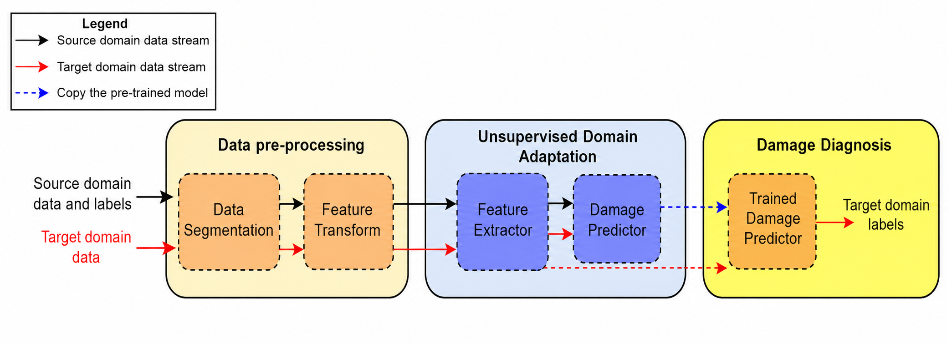
Figure 11 The schematic of the proposed UDA framework for drive-by railway track monitoring(Ghiasi et al., 2025)
This case adds a necessary generalization layer to the perception-assessment loop. The objective is no longer only to collect more data, but to make knowledge learned from one operating domain usable in another. Domain adaptation partially reduces the distribution gap between lines, yet it does not remove the need for engineering validation. Changes in defect definitions, maintenance standards, sensor layouts and vehicle-track interaction can still produce incorrect transfer. Consequently, cross-line transfer should be combined with uncertainty estimation and a mechanism for requesting target-line labels when model confidence is insufficient.
At the asset scale, Milosevic et al. (2022) combined sleeper-mounted accelerometers, three-dimensional geometry scans and multi-body vehicle-track simulations for six in situ crossing panels. The proposed condition indicator was calculated from track responses in a wavelength-related frequency band and exhibited a strong relationship with simulated vertical wheel-rail contact force under different crossing and track conditions. This case is significant because it links a measurable dynamic response to a physically meaningful interaction quantity. It therefore provides more diagnostic value than an isolated acceleration threshold.
The measured-simulated comparison also exposes the limitations of the current implementation. The scanned crossing regions were shorter than the full dynamic interaction zone, and measured accelerations contained excitation sources not represented in the model, including long-wavelength irregularities, wheel out-of-roundness and conditions outside the scanned area. Calibration was more successful for sleeper displacement than for velocity and acceleration. These findings are not weaknesses to be hidden; they illustrate the role of open-loop uncertainty in real railway applications. A physics-assisted monitoring system must continuously update its boundary conditions and quantify the discrepancy between the model and the measured asset before its indicator can be used to trigger maintenance automatically.
The studies by Rahman et al. (2024), Ghiasi et al. (2025) and Milosevic et al. (2022) can thus be read as a connected sequence. DAS expands temporal and spatial coverage, drive-by monitoring uses operational vehicles to acquire repeated line-scale responses, domain adaptation supports knowledge transfer between lines, and asset-specific sensing supplies local diagnostic resolution. Together they define a multi-scale perception architecture. The unresolved issue is how to coordinate these levels so that a weak corridor-scale anomaly can initiate targeted inspection, obtain a mechanism-oriented diagnosis and produce an executable work order.

From Geometric Exceedance to Condition Interpretation and State Evolution
After perception, the next requirement is to transform measured abnormalities into infrastructure states. Conventional geometry inspection is highly effective for identifying where alignment, level, gauge or twist exceed specified limits. Nevertheless, the measured geometry is the combined consequence of the rail, fasteners, sleepers, ballast, subgrade, drainage, environmental exposure and maintenance history. Intelligent assessment must therefore progress from threshold exceedance to component inference, hidden-state diagnosis and evolution modelling.
Sresakoolchai and Kaewunruen (2022) demonstrated the first stage of this progression by combining track geometry measurements, component-defect records and track-profile data. Their case covered a 30-km section measured at one-foot intervals over four years from 2016 to 2019. Supervised models were used to identify rail, rail-joint, fastener and switch-and-crossing defects, while clustering and association-rule analysis were used to explore relationships among defect types and track characteristics. The best-performing deep neural network achieved approximately 94% accuracy. More important than the individual accuracy value is the change in the function of the data: geometry records collected for quality assessment were reused to infer component-level conditions that would otherwise require additional manual inspection.
This form of data reuse can increase the value of existing inspection systems without requiring immediate replacement of the sensing platform. However, it also shifts the bottleneck toward data governance. Component-defect labels must be spatially synchronized with geometry records, and differences in inspection timing can introduce false associations. Rare but safety-critical defects may be underrepresented, while high aggregate accuracy can conceal poor sensitivity for individual classes. The model output should therefore be interpreted as diagnostic evidence for targeted reinspection rather than as an autonomous maintenance command.
Wang, Liu and Euston (2023) extended geometry-based interpretation further by integrating track geometry defects with substructure and operational information on a passenger railroad in the United States. Their framework combined GPR-derived ballast-condition variables, rail-seat abrasion, traffic density, track class, curvature and maintenance-related information to estimate the risk of geometry-defect occurrence. This case changes the diagnostic question from "which component defect accompanies the measured geometry?" to "which underlying support and operating conditions make geometry defects more likely?" It therefore represents a transition from component classification to hidden-state and risk interpretation.
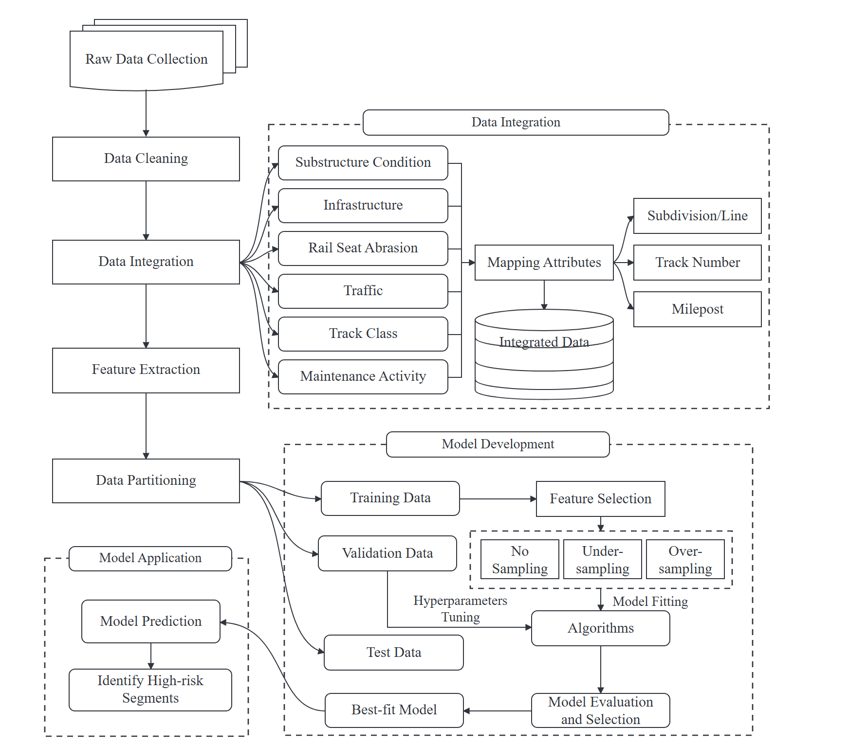
Figure 12 The Framework for Estimation of Track Geometry Defect Risk(Wang, Liu and Euston, 2023)
The integration framework in Wang et al. is particularly relevant to the proposed first loop because it shows that data fusion is not merely the concatenation of sensor channels. Geometry, GPR, rail-seat abrasion, traffic and track-class data possess different spatial resolutions and reference systems. They must be segmented, registered and converted into consistent features before a data-driven risk model can be established. The case thus provides an engineering counterpart to the multi-source fusion concept discussed earlier in this paper.
The residual limitation is causal ambiguity. A geometry defect may result from ballast fouling, local stiffness variation, rail-seat abrasion, drainage failure or interacting causes. A predictive model can identify statistical risk without proving a unique deterioration mechanism. Consequently, its output should be used to guide additional inspection and maintenance prioritization. The precision intervention loop requires one further step: converting a high-risk section into a justified treatment type, such as tamping, ballast cleaning, drainage improvement, sleeper treatment or subgrade reinforcement.
Environmental cases broaden the concept of hidden state from structural condition to external forcing. Roghani (2021) investigated a frost-susceptible track section over the winter-spring periods of 2019 and 2020 using thermistors, total-station surveys and track geometry measurements. The observations linked freezing-degree days, frost penetration, track-surface deformation and changes in profile and alignment roughness. The study showed that freeze-thaw cycling can alter both the magnitude and spatial distribution of track deformation, particularly near geotechnically sensitive features such as culverts.
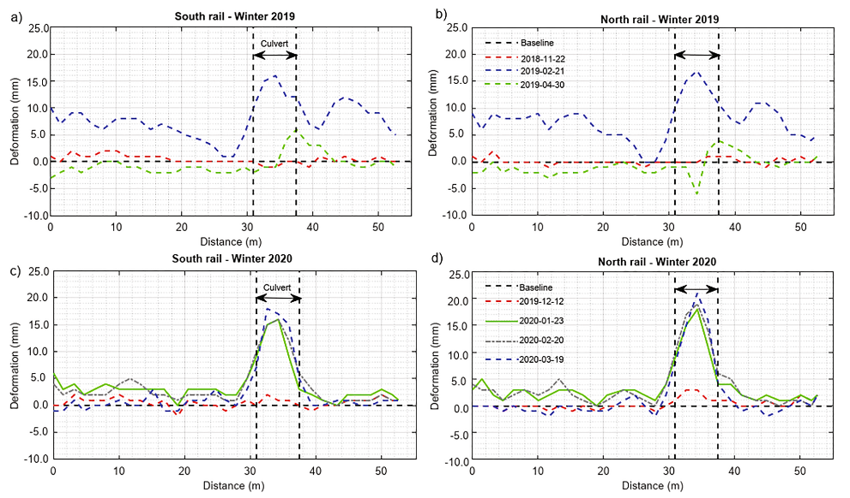
Figure 13 Plots show track surface deformation measured by using total station(Roghani, 2021)
This field evidence has two implications for state-evolution modelling. First, deterioration cannot always be represented by a stationary curve derived only from historical geometry measurements. The evolution law changes when moisture, frost depth and temperature cycles change. Second, prediction confidence should vary with environmental conditions. During a period of rapid thaw or exceptional temperature fluctuation, a model trained on ordinary operating data should express greater uncertainty and trigger denser observation.
Kampczyk and Dybeł (2021) provide a related asset-scale example through their turnout-oriented digital-twin foundation. Their monitoring station integrated an external sensor into an S49 rail and recorded rail-head temperature together with ambient temperature, humidity and light. Although the implementation does not yet constitute a complete operational digital twin, it demonstrates that environmental boundary conditions must form part of the asset-state representation. A turnout twin based only on nominal geometry would omit variables capable of explaining thermal expansion, measurement variation and weather-dependent deterioration.
The above cases form a coherent assessment chain. Geometry data can first be used to infer component defects, then integrated with substructure and operational variables to estimate deterioration risk, and finally interpreted within changing environmental boundary conditions. This progression is central to the "state evolution" philosophy: the objective is not only to describe the current track geometry, but to determine which mechanism is active, how confidently it has been identified and how the condition may evolve under future traffic and environmental loading.

From Predictive Decision-Making to Physical Intervention and Feedback
The output of state assessment has operational value only when it changes maintenance action. This requires a transition from diagnosis to timing, treatment selection and resource allocation. It also requires post-intervention monitoring, because an intelligent O&M system must learn whether the selected treatment changed the subsequent deterioration trajectory.
Praticò and Fedele (2025) examined the economic logic of railway predictive maintenance by comparing renewal, reactive maintenance and proactive maintenance under different degradation curves and sensing-system cost scenarios. Their analysis emphasizes that a higher intervention frequency is not automatically preferable. The optimal strategy depends on the shape of the degradation curve, the condition level at intervention, the resulting recovery and the cost of sensing and maintenance. The study therefore supplies an important decision layer between condition prediction and physical execution.
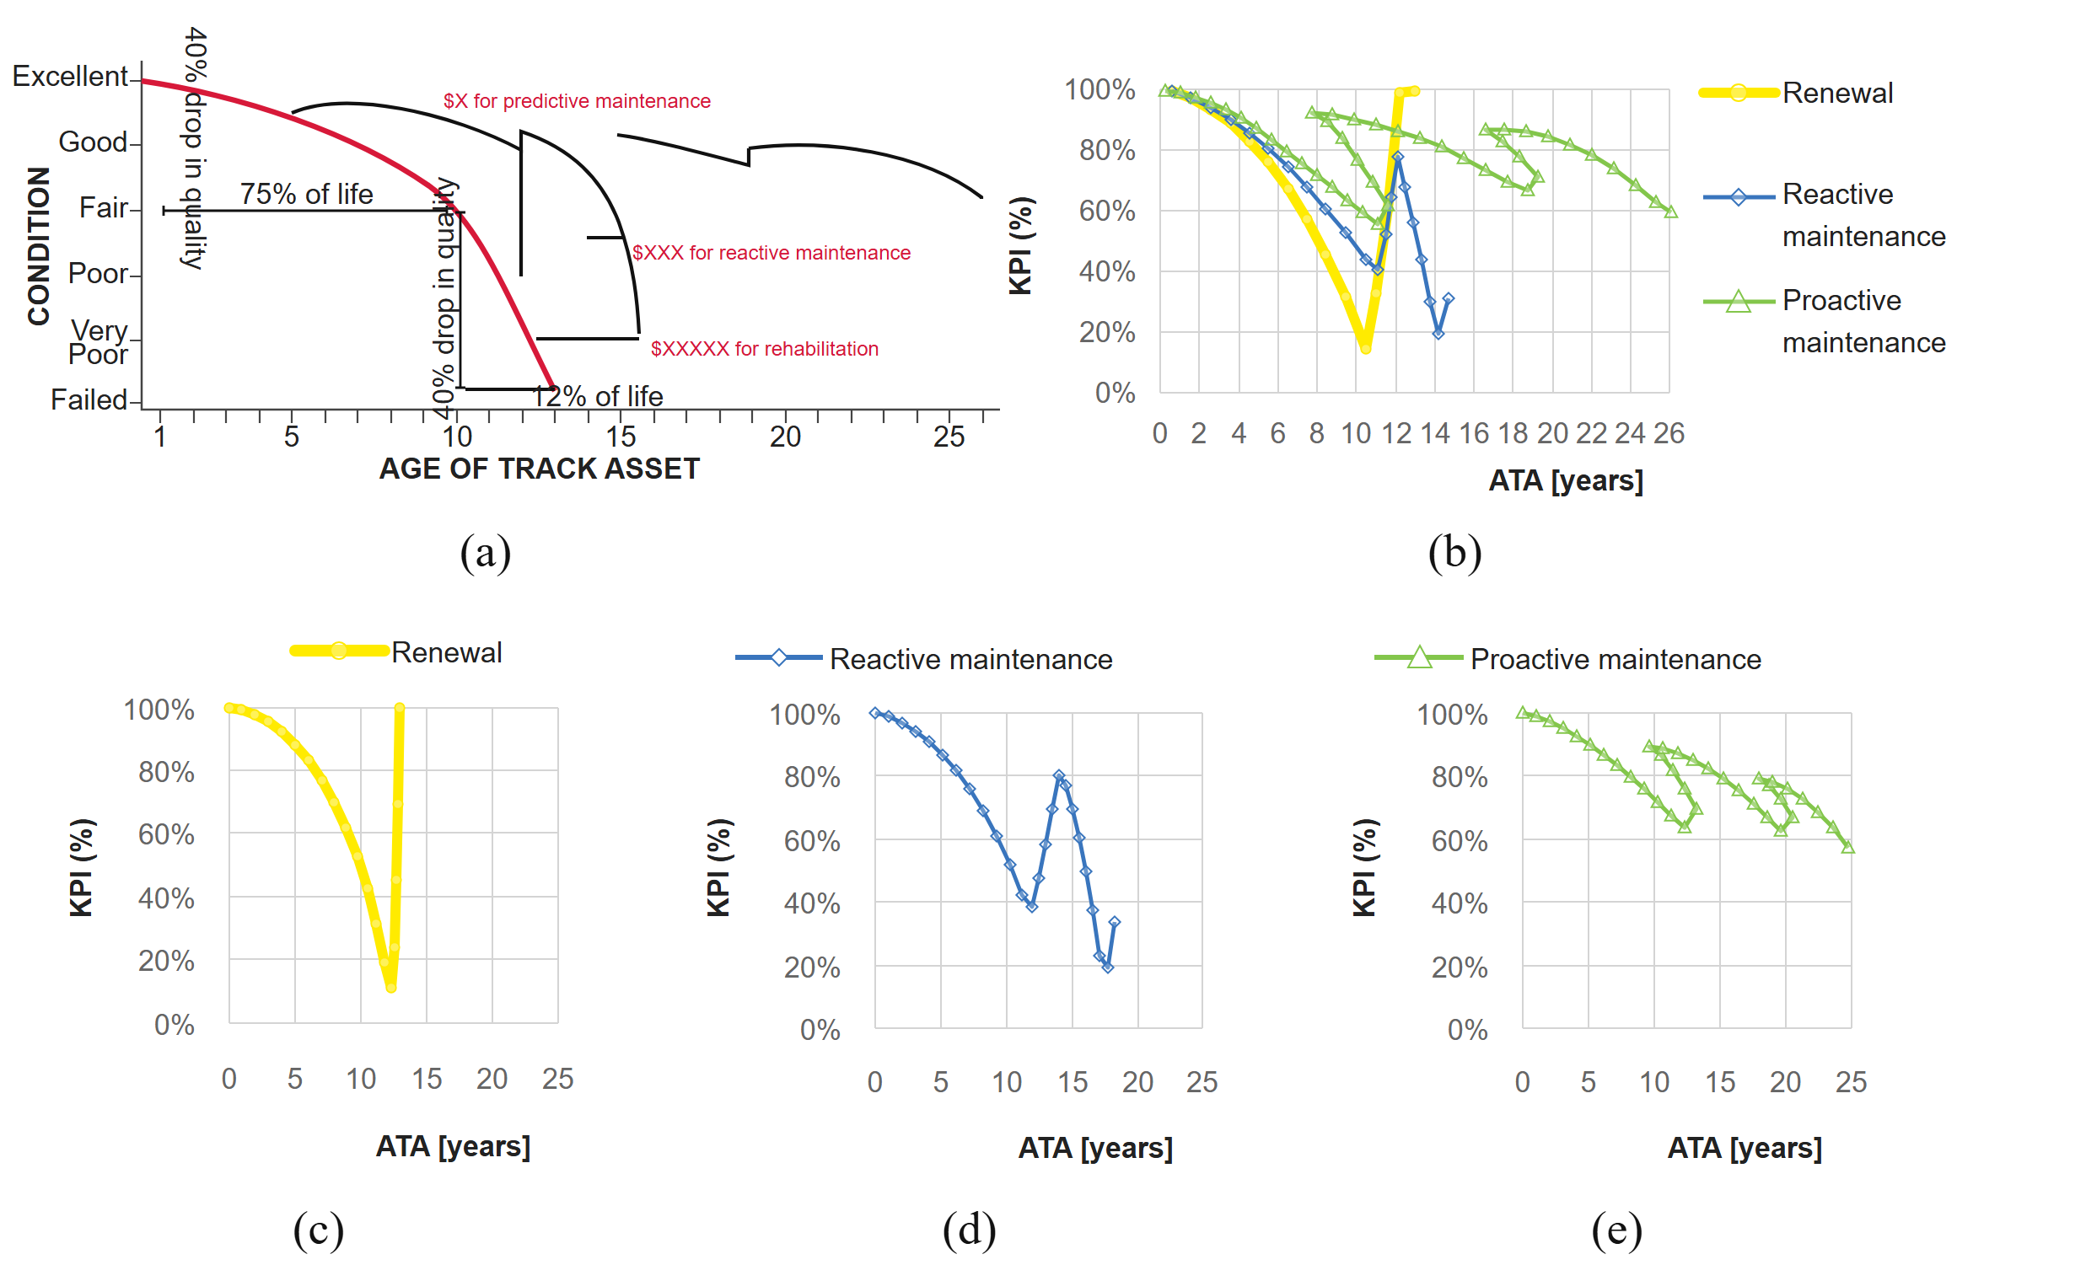
Figure 14 (a) Railway track condition as a function of maintenance strategy and Age of the Track Asset (ATA) ; (b) main types of degradation curves (Key Performance Indicator, KPI, vs. Age of the track Asset, ATA): (c) overall view, (d) without maintenance, (e) with reactive maintenance, and (d) with proactive maintenance(Praticò and Fedele, 2025)
Within the first loop, the contribution of this analysis is to convert "earlier detection" into a constrained maintenance decision. Continuous sensing has a cost, false alarms create unnecessary intervention, and premature maintenance can consume resources without producing proportional performance gains. Conversely, delayed intervention can accelerate deterioration and increase renewal costs. Predictive maintenance should therefore optimize the expected long-term outcome rather than minimize a single condition indicator. In practical deployment, the economic model must be connected with line availability, maintenance-window constraints, safety risk and the measured effectiveness of alternative treatments.
Fischer (2022) provides field evidence for the intervention and feedback side of the architecture. The study examined geogrid reinforcement on a test section of Hungarian mainline No. 1 between Kelenföld and the Hegyeshalom state border. The site was established in 2010, and its geometry was monitored through rail-head levelling from 2010 to 2014 and recording-car measurements from 2010 to 2021. Different geogrid and control subsections enabled the long-term comparison of geometry deterioration under accumulated traffic and repeated maintenance.
This case is more than an example of a reinforcement material. In the dual-loop context, it illustrates how a physical intervention can be evaluated by its influence on the future state trajectory. The maintenance action is not treated as the end of the process. Instead, subsequent geometry measurements are used to compare deterioration phases, traffic accumulation and the performance of treated and untreated sections. This is the type of feedback required to update deterioration models and future treatment selection.
The field evidence also demonstrates why intervention assessment is difficult. Drainage condition, water pockets, precipitation, ballast screening, traffic accumulation and repeated tamping all influence the measured geometry. A simple before-and-after comparison may therefore attribute too much of the observed change to the intervention itself. A closed-loop system should maintain a structured record of treatment type, location, date, environmental condition, traffic exposure and post-maintenance response. Such records would allow the maintenance model to distinguish immediate geometry recovery from long-term deterioration reduction.
Praticò and Fedele (2025) and Fischer (2022) together connect the two sides of the second loop. The former asks when predictive maintenance is economically justified, whereas the latter shows how the long-term effect of a physical intervention can be measured. The remaining integration task is to connect predicted risk and cost-benefit analysis to a specific executable treatment and then return the measured outcome to the model. Without this feedback, predictive maintenance remains a planning concept rather than a learning closed loop.

Heavy-Haul Railway Lines—China's Dazhun Line
Among various types of railway lines, heavy-haul railways undertake the long-distance transportation of bulk energy and materials, and are characterized by typical operational features of heavy axle load, high-density traffic operation, and large transport volume. The wheel-rail forces borne by the line structure are far higher than those of ordinary passenger and freight railways, leading to faster structural deterioration rate, more rapid defect development, and significantly higher difficulty and pressure of O&M management and control than ordinary railway lines. The core contradictions between the construction period and the O&M period are more prominently manifested, making heavy-haul railways the core engineering scenario for verifying new concepts and technologies of railway O&M. This paper presents the engineering case of the Dazhun Heavy-Haul Railway. Aiming at the pain points of the traditional O&M mode under long-term high-intensity operation, this case constructs a dual closed-loop intelligent O&M system of "general survey - decision making - precision maintenance" centered on state evolution. It not only provides a complete engineering technical path to solve the core management and control problems in the O&M period of heavy-haul railways, but also offers a practical implementable paradigm and theoretical reference for the innovation of O&M modes in the global railway industry during the transition from the construction period to the O&M period.
The Dazhun Railway is a Class I single-track heavy-haul electrified railway, with a total length of 264 km for the main line and 24 stations along the entire line. The line traverses an area with extremely complex geological conditions, passing through unfavorable geological sections such as dense goaf areas of coal mines, soft soil strata, and saline soil strata. Meanwhile, the line is located in a region with harsh climatic conditions, where the maximum diurnal temperature difference can exceed 20℃, the annual average temperature difference reaches 34℃, the extreme annual temperature range is close to 70℃, the minimum temperature can drop to -30℃, and the maximum temperature can reach 40℃. The schematic diagram of its operation environment is shown in Figure 11. The Dazhun Railway has undergone multiple ten-thousand-ton capacity expansion and reconstruction projects as well as second-line construction, resulting in continuous improvement of its transport capacity. At present, its annual transport capacity has reached 230 million tons. The sustained hundred-million-ton level high-intensity operation has kept the track structure under the action of cyclic loading with heavy axle load for a long time, and the deterioration of service performance has become increasingly prominent. This has greatly aggravated a series of problems such as train operation instability, operation speed limitation, and elevated traffic safety risks. During long-term line O&M practices, it has been found that the track defects of the Dazhun Railway are complex and diverse, mainly concentrated in rail spalling, sleeper cracks, ballast whitening, and loosening and failure of components. Among them, rail damage is dominated by transverse fissures, bolt hole cracks, wear, spalling, and side wear, and more than 80% of rail damage is concentrated in small-radius curve sections with a radius ranging from 400 m to 1000 m, which is highly consistent with the line operation conditions and horizontal and vertical profile characteristics.
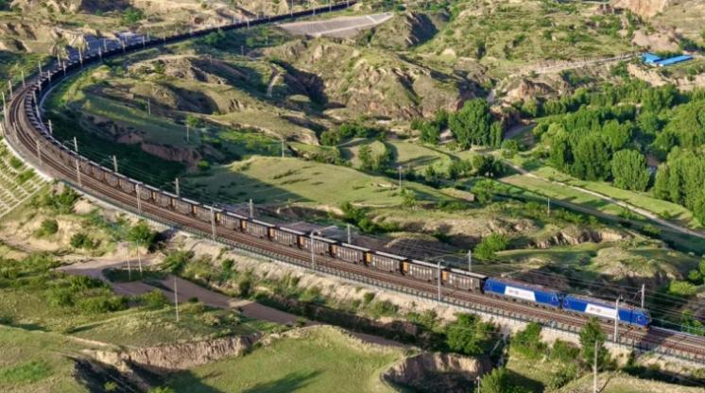
Figure 15. Operation Environment of the Dazhun Railway
The traditional O&M mode adopted by the line mainly relies on monthly inspection by track inspection vehicles, daily manual inspection via on-board monitoring devices, and manual static inspection during maintenance skylights for track state detection. This type of detection mode can only capture the static state of the line at a single time node, and cannot realize continuous tracking and dynamic monitoring of the track state deterioration process, let alone advance prediction of the deterioration trend of the line state. Emergency disposal and maintenance can only be carried out after the defects occur, or even develop to a level that affects traffic safety, which is highly prone to safety risks caused by delayed maintenance. Meanwhile, the time-based planned maintenance mode cannot formulate differentiated maintenance strategies according to the actual service state and deterioration rate of different sections of the line, and can only implement unified maintenance across the entire line in accordance with a fixed cycle. This easily leads to "over-maintenance" in sections with favorable state, which not only causes waste of O&M resources and pushes up the full-life cycle O&M cost of the line, but may also damage the original stable state of the track structure due to excessive maintenance. For key sections with fast deterioration rate and high risks, "under-maintenance" is prone to occur, which cannot timely curb the development of defects, eventually leading to the evolution of minor defects into major structural damage and further aggravating safety risks.
Aiming at the above core pain points, the Dazhun Railway has constructed a brand-new intelligent O&M system with the overall goal of solving the problems of line operation safety and intelligent O&M, and realizing condition-based maintenance centered on state evolution. The core concept of the new O&M system is to shift the focus of O&M work from "evaluating whether the current state meets the standards" to "predicting whether the future state will deteriorate", which directly responds to the core demand of preventing and controlling state deterioration during the O&M period. The system has established a dual closed-loop intelligent O&M mode of "general survey - decision making - precision maintenance". Through the integration of multi-dimensional sensing technology, big data analysis, artificial intelligence and digital twin technology, a complete closed loop of data acquisition, centralized management, intelligent analysis, decision application, and feedback optimization is formed.
As the data foundation of the system, the general survey link realizes comprehensive and continuous capture of the track structure state through vehicle-mounted Beidou vibration-noise integrated monitoring terminals, static track measuring instruments, and trackside distributed rail creep displacement observers. It forms a multi-source data acquisition matrix for track state covering dynamic and static, real-time and offline conditions, providing basic data support for subsequent analysis and decision-making.
To accurately grasp the evolution law of track state and fundamentally solve the core O&M contradiction of "fear of state deterioration", the Dazhun Railway has constructed a full-dimensional system of state assessment and intelligent decision-making models focusing on the evolution law of service performance and deterioration and damage mechanism of the track structure. It has realized the core leap from "current state evaluation" to "evolution trend prediction", which is also the core link of the entire intelligent O&M system.
The system first established a comprehensive characterization system for the service state of heavy-haul railway track structures, and deeply revealed the characterization methods, evolution laws and damage mechanisms of three typical defects, namely track geometric irregularity, rail corrugation and ballast fouling, under dynamic operation conditions. A research system of deterioration mechanism covering the full track structure including rails and ballast has been formed, laying a solid theoretical foundation for state evolution prediction. On this basis, the system constructed a comprehensive evaluation index system for track state covering multi-physical parameters based on vibration and noise signals, and put forward multi-dimensional evaluation criteria centered on "static state" and "dynamic driving performance" respectively. The dynamic indicators mainly characterize the dynamic response of the track structure under train load, including vehicle-mounted acceleration, frequency domain modal parameters and wheel load reduction rate, while the static indicators focus on basic state parameters such as track geometry and material properties. The combination of the two realizes quantitative hierarchical assessment of the track structure state under complex environments. Figure 12 shows the architecture diagram of the multi-task deep learning model for rail corrugation parameter prediction.
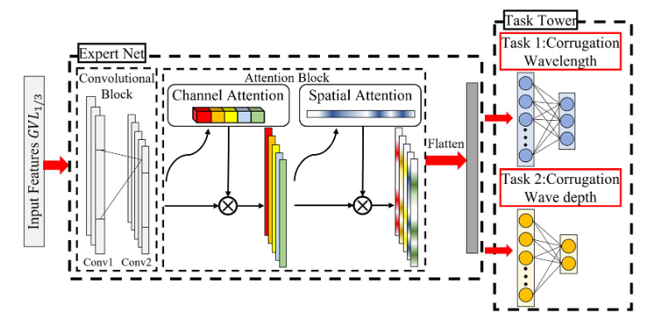
Figure 16. Rail Corrugation Prediction Model
Aiming at different types of defects and structural deterioration characteristics of heavy-haul railway tracks, the system has separately developed intelligent decision-making technologies for special precision maintenance operations, forming full-scene precision maintenance decision-making capabilities covering rail grinding, ballast tamping and cleaning, and precision adjustment of track alignment and position. In terms of rail grinding O&M, the system constructed an intelligent decision-making mechanism for rail grinding cycle based on the estimation results of the remaining service life of rails. The decision-making logic is established with the current state of the rail, life degradation trend and safety risk boundary as the main line, and acceptable risk thresholds are set in combination with multiple safety evaluation indicators such as wheel-rail impact acceleration and contact stress. Three types of decision suggestions, namely "Immediate Grinding", "Scheduled Grinding" and "No Grinding Required", are output (as shown in Figure 13). Meanwhile, the effect of different grinding strategies on rail life extension and risk suppression is quantified, realizing precise decision-making of grinding timing, grinding depth and grinding frequency, and solving the industry pain points of under-grinding and over-grinding under the traditional fixed-cycle grinding mode.
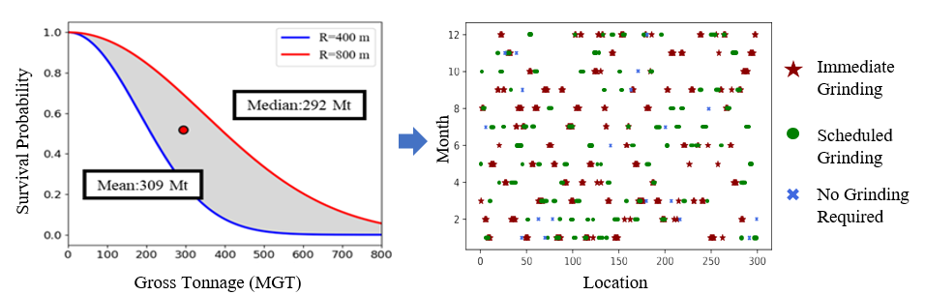
Figure 17. Decision-Making Scheme for Grinding Cycle
In terms of ballasted track bed O&M, the system established a multi-field coupled, multi-source heterogeneous ballast state sensing system. Through the fusion analysis of vehicle-mounted vibration and noise data, laser point cloud data of ballast section, high-definition image data and internal acceleration sensing data, comprehensive identification of ballast fouling, contamination and elasticity deterioration is realized. On this basis, a decision-making model for ballast tamping and cleaning operations was constructed based on deep reinforcement learning theory (as shown in Figure 14). Based on the predicted geometric recovery, the dynamic optimization of operation timing, operation intensity and resource allocation is realized by constructing a "state-action-reward" framework. Meanwhile, with the remaining service life of track units as the core indicator, a maintenance resource allocation strategy under different operation modes is formulated. The optimal operation sections and operation schemes are determined with the number and duration of maintenance skylights as constraints, realizing efficient and dynamic decision-making of tamping and cleaning cycles.
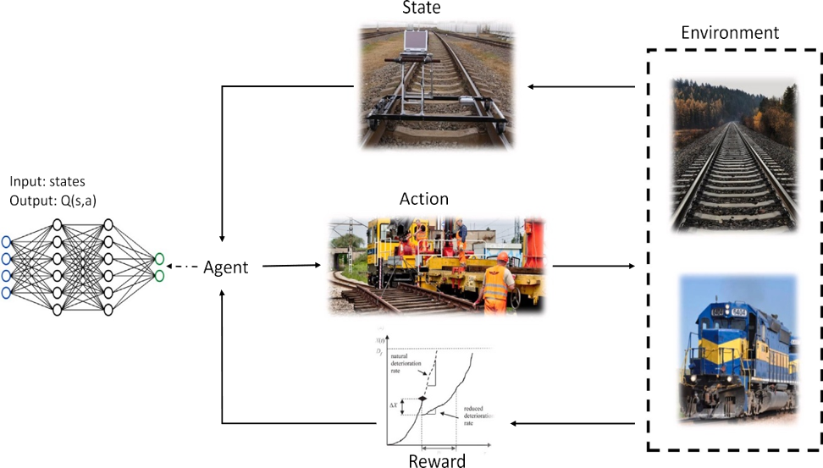
Figure 18. Decision-Making Model for Ballast Tamping and Cleaning Operations
In terms of track alignment maintenance, the system proposed a multi-objective design method for track precision adjustment schemes applicable to different scenarios such as daily precision maintenance, periodic overhaul, and speed-up precision adjustment. A design framework for track geometry maintenance schemes was constructed based on physics-informed neural networks, combined with constraint models of multiple track geometric parameters including standard management specifications, irregularity amplitude, and remaining adjustable amount. Aiming at the different objectives of "precise control of over-limit irregularities with minimized human and material costs" for daily precision maintenance and "optimization of overall line smoothness with reasonable adjustment cost" for line overhaul, the optimal balance between the dual objectives of "minimum adjustment amount" and "optimal Track Quality Index (TQI)" is achieved, realizing automatic and intelligent generation of multi-objective precision maintenance schemes for track alignment and position.
To ensure the stable operation of the dual closed-loop system of "general survey - decision making - precision maintenance", the Dazhun Railway has simultaneously constructed a data middle platform and a digital twin system for intelligent O&M of heavy-haul railway tracks (as shown in Figure 15), providing full-process technical support for the O&M concept centered on state evolution. In terms of data middle platform construction, the system integrates data from newly developed equipment including Beidou vibration-noise integrated monitoring terminals, static geometry general survey measuring instruments, and rail creep observers, as well as data resources from existing systems including track inspection vehicles, flaw detection trolleys, and permanent way management systems, providing high-quality, full-cycle data assets for the analysis of track state evolution laws and the training of life prediction models. In terms of digital twin system construction, the system takes the Building Information Modeling (BIM) model of the track structure as the base, combines with Geographic Information System (GIS) geographic information, and constructs a digital mapping highly consistent with the physical track, realizing dynamic update and visual presentation of the track state. The system has also built a complete knowledge graph of track service state. Adopting a combination of top-down and bottom-up approaches, it first defines the schema layer to determine the core concepts and correlation relationships such as track structure, service state, defect type, and O&M events, and then fills the data layer in the form of "entity-relationship-attribute" triples, constructing a complete knowledge network of track service state and providing visual simulation and deduction capabilities for the prediction of track state evolution. Ultimately, the digital twin system presents the track state assessment results, deterioration trend prediction, and O&M decision-making schemes to O&M personnel in an intuitive form through a 3D visual interface, forming a new O&M mode for heavy-haul railways.
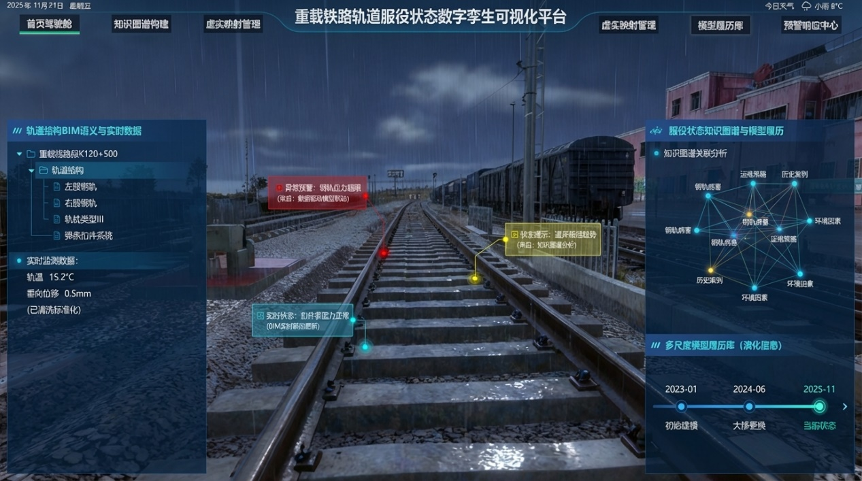
Figure 19. Digital Twin Visualization Platform for Heavy-Haul Railway Track Service State
Centering on the core contradiction of the railway industry in the long-term O&M period, the Dazhun Railway case has realized the fundamental transformation of heavy-haul railway track O&M from post-event disposal to pre-event prediction, from extensive maintenance to precision maintenance, and from time-based maintenance to condition-based maintenance through the construction of the dual closed-loop system of "general survey - decision making - precision maintenance" with the O&M concept centered on state evolution. This case embodies a mature and implementable intelligent O&M technology system for heavy-haul railways, and provides a replicable and scalable engineering practice path for the historic transformation of the global railway industry from the large-scale construction period to the long-term large-scale O&M period.

Examples of Kilometer-Scale Long-Span Bridges

Data Fusion and Imputation for Railway–Bridge Monitoring Systems
In integrated railway–bridge monitoring systems for high-speed railways, multi-source data—including track geometry inspection, train dynamic response, and bridge structural health monitoring—form a critical basis for infrastructure condition assessment and maintenance decision-making; however, due to sensor deployment limitations, communication interruptions, equipment failures, and maintenance activities, missing data are pervasive and significantly degrade data quality and reliability, thereby constraining downstream tasks such as condition prediction and damage identification. In practice, missing data generally exhibit two patterns: random missing (RM), characterized by sporadic and independent data loss caused by transient disturbances (e.g., signal interference or packet loss), and non-random missing (NM), involving continuous data gaps arising from sensor outages, power failures, or planned maintenance, often forming “blackout” periods. To address these challenges, a low-rank autoregressive tensor completion method is adopted to reconstruct incomplete multi-source monitoring data by representing correlated railway–bridge measurements as a third-order tensor and jointly modeling global spatial–temporal coherence and local temporal dynamics; specifically, the low-rank constraint captures intrinsic redundancy and cross-sensor correlations, while the autoregressive component enforces temporal consistency within individual sensor sequences, and the resulting optimization problem is efficiently solved via the alternating direction method of multipliers (ADMM) under data fidelity constraints. The approach is evaluated using hourly multi-sensor data over a 59-day period, with missingness simulated under RM (20% and 40%) and NM scenarios involving full-day data gaps; results show that reconstruction errors increase with higher missing ratios, and that RM cases consistently achieve lower errors than NM cases due to the greater difficulty of recovering long contiguous gaps, although temporal regularization provides reasonable extrapolation capability. Overall, the method achieves reconstruction accuracies exceeding 90% at 20% missing rates and above 75% at 40%, demonstrates strong robustness in handling blackout-type missing data, and maintains high computational efficiency through GPU-based parallelization, confirming its effectiveness and scalability for large-scale spatiotemporal data imputation in railway–bridge monitoring applications.
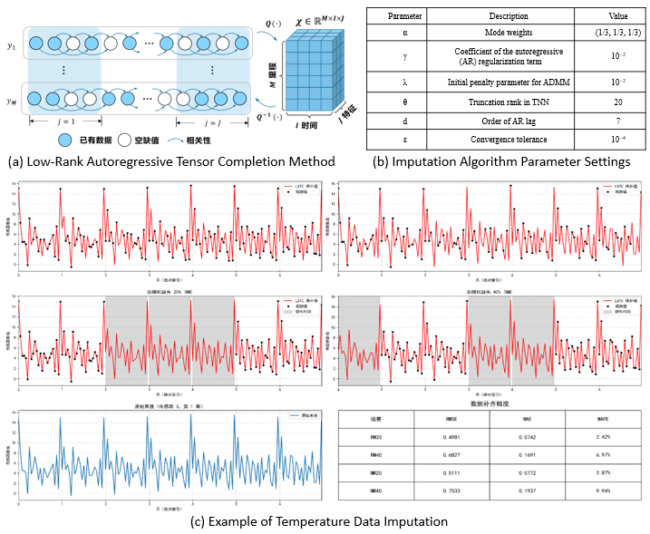
Figure 20 Comparison of data imputation methods and their effects

Line-Bridge Dynamic Data Mileage Correction
In absolute static inspection, the measured vertical profile mainly reflects the discrepancy between the designed and actual bridge alignment, and as bridge deflection increases with span length, the relatively small amplitude of track vertical irregularities is easily masked by the bridge geometry. Moreover, environmental influences such as temperature variation and wind loads lead to significant differences between static and dynamic inspection waveforms. In contrast, gauge signals obtained from static and dynamic measurements exhibit higher consistency and stability; therefore, static gauge data are commonly adopted as the reference, with gauge selected as the correction channel. Using a macro-micro mileage correction model to calibrate dynamic inspection data, as shown in the figure. Macroscopic mileage alignment is typically performed using a sliding-window strategy, in which the Pearson correlation coefficient is employed as the similarity metric. The dynamic matching window is slid along the signal at the sampling interval, while the search is constrained by centering on the static window mileage and limiting the range to twice the window length to avoid long-distance mismatches and ensure data integrity. After macroscopic alignment, microscopic correction is introduced to further refine local correspondence. Rather than performing point-wise matching, which is highly sensitive to noise, the signal is segmented based on extremum points, and the data between adjacent local maxima and minima are defined as extremum segments that serve as basic matching units, effectively suppressing noise while preserving waveform characteristics. Because corresponding extremum segments in static and dynamic data often contain different numbers of sampling points, direct one-to-one matching is infeasible; therefore, each segment is abstracted into a high-dimensional feature vector to enable similarity comparison. For extremum point matching, a reference extremum point and its adjacent segments are selected from the static data, and candidate extremum points in the dynamic data are identified within a local neighborhood. The cosine similarity between the corresponding extremum segments is then calculated, and the dynamic extremum point yielding the maximum similarity is selected as the final match, thereby achieving refined local alignment between static and dynamic inspection data.
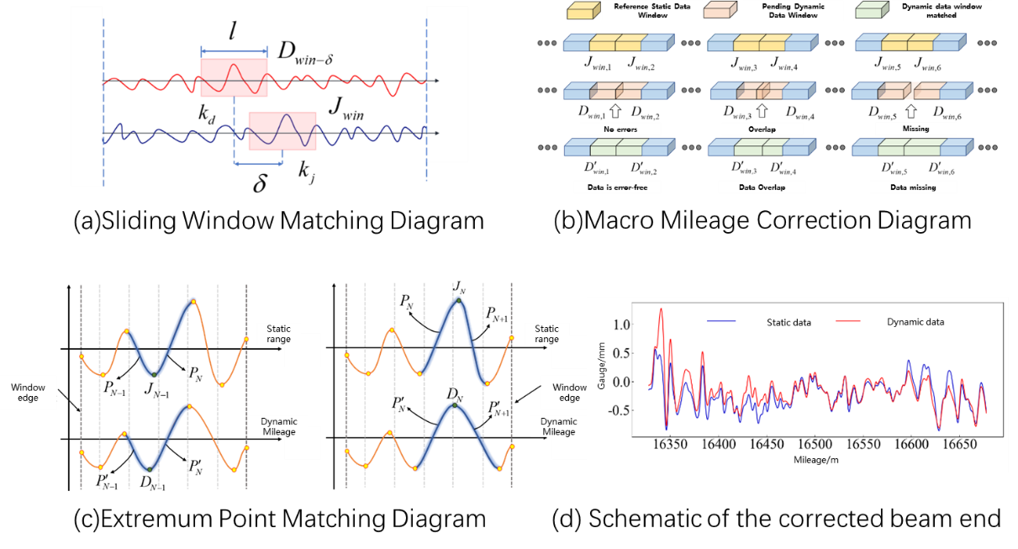
Figure 21 Relative mileage correction algorithm and comparison before and after correction

Multi-Source Data Fusion Analysis for Beams
To achieve high-precision diagnosis of the service condition of bridge-end expansion devices, prior exploratory analysis of high-dimensional and nonlinear monitoring data is indispensable, as the absence of an a priori understanding of intrinsic data structures and fault representation patterns undermines both the physical interpretability and data-driven validity of subsequent diagnostic models. Accordingly, t-distributed stochastic neighbor embedding (t-SNE) clustering and Tucker tensor decomposition are adopted as essential prerequisite steps for damage identification. From an instantaneous-state perspective, t-SNE-based manifold learning demonstrates a distinguishable mapping between monitoring data and bridge-end structural irregularities, thereby providing data-level evidence for the feasibility of explicit state evaluation models. From a temporal-correlation perspective, Tucker tensor decomposition further reveals that critical faults such as jamming are not manifested as isolated anomalies in individual sensor readings, but rather as fundamental alterations in the correlation patterns among multi-source monitoring parameters. The monitoring state of a bridge-end rail expansion regulator at time t can be represented by a high-dimensional vector composed of multiple sensor measurements; however, excessive dimensionality leads to increased computational burden, overfitting risks, and limited visualization capability. Linear dimensionality reduction methods, such as principal component analysis (PCA), often fail to preserve nonlinear structures and show weak discriminative performance. In contrast, t-SNE effectively captures both linear and nonlinear relationships by converting pairwise distances into conditional probabilities and fitting low-dimensional distributions to high-dimensional data via gradient-based optimization, resulting in more clearly separated clusters that facilitate subsequent clustering-based interpretation. Validation using dynamic inspection data collected between August 2022 and December 2023 confirms that t-SNE-based clustering provides clear discrimination among irregularity characteristics, particularly for gauge-related features. Furthermore, a multi-source data fusion framework combining Kolmogorov–Arnold Networks (KAN) with attention mechanisms is introduced to analyze parameter mapping relationships and identify damage. KAN decomposes complex multivariate functions into interpretable univariate components, enabling explicit mathematical representation of the mapping between monitoring parameters and key performance indicators, while attention mechanisms enhance the modeling of global dependencies. By establishing normal-state mapping relationships between bridge-end monitoring parameters and expansion regulator displacement indicators, abnormal correlation patterns induced by jamming faults can be effectively identified, providing a robust basis for service-state assessment.
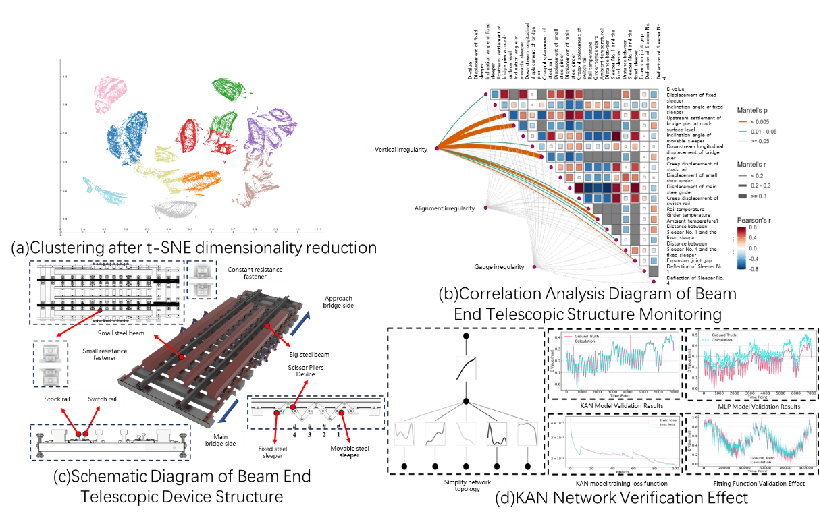
Figure 22 Fusion analysis of multi-source inspection and monitoring data

TQI Prediction for Kilometer-Scale Bridges
For kilometer-scale bridges, the long-term condition of the track structure directly impacts operational safety and ride comfort, with the Track Quality Index (TQI) serving as a key indicator of track geometry. Accurate prediction of TQI dynamics is essential for effective maintenance planning and prolonging structural service life. TQI data exhibit strong temporal dependencies, reflecting both gradual deterioration from cumulative operational effects—such as bridge creep and ballast degradation—and periodic influences from seasonal temperature variations, thermal expansion, and maintenance operations, resulting in nonlinear and non-stationary behavior. To address these complexities, a hybrid Prophet–Transformer (P-T) model is employed. The Prophet component decomposes each segment’s time series into trend, seasonal, and special-event components, automatically capturing long-term tendencies, monthly periodicity, and effects of maintenance or extreme events, while managing outliers flexibly. The Transformer then models residual errors from Prophet forecasts, using the residual deviation ratio as an additional feature to enhance the representation of nonlinear patterns and temporal dependencies, effectively creating a richer two-dimensional input space for learning complex relationships. Kilometer-scale bridges are divided into physically meaningful segments—including main span ends, midspan continuous beams, transition spans, and tower-constrained areas—to reflect spatial heterogeneity in TQI evolution. For each segment, monthly TQI data from 2021–2022 are used for training, and 2023 data are reserved for validation, ensuring independent segment-specific modeling. Rolling-window validation demonstrates that the P-T hybrid model achieves high predictive performance across all segments, with overall accuracy exceeding 95% and peak accuracies above 98% for most segments. Slightly lower accuracy near expansion joints and tower-constrained zones is attributed to higher local nonlinearity and structural complexity; nevertheless, performance remains robust. By integrating macro-scale trend extraction with fine-grained temporal feature learning, this approach provides a scalable, accurate framework for TQI prediction on kilometer-scale bridges, supporting precise segment-level maintenance and condition management decisions.
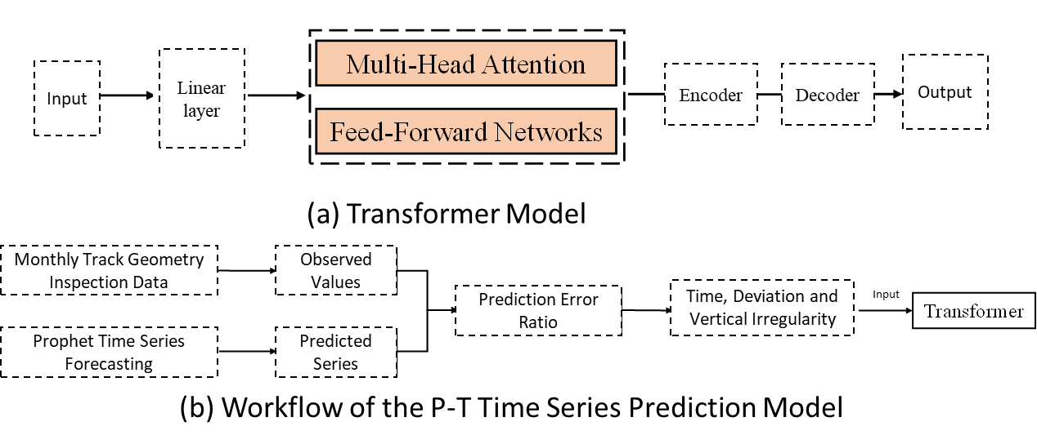
Figure 23 Workflow of the TQI prediction algorithm

Example of General Survey- Track Irregularity Census Technology Based on On-Board Vibration and Noise Sensing
In the "dual closed-loop" logic for constructing a new intelligent railway operation and maintenance system, census serves as the foundation and prerequisite. Its core objective is to achieve rapid, efficient, low-cost, and full-coverage preliminary screening of the service status of tracks across massive railway lines, so as to address the pain point of "fragmented sensing" and provide a data basis for subsequent precise decision-making and maintenance. While traditional dynamic inspection vehicles feature high efficiency, they are limited in quantity and high in cost, making it impossible to realize high-frequency, all-weather universal inspection. Static inspection, on the other hand, suffers from low efficiency and can hardly meet the operation requirements of long mileage and high density. Therefore, the development of on-board intelligent sensing technology based on in-service trains, which converts a large number of operating trains into "mobile sensors", has become a key path to break through the bottlenecks of current railway operation and maintenance.
This section systematically reviews the core research achievements of track vertical irregularity census technology based on multi-source on-board vibration and noise data. This research systematically addresses the key scientific and technical challenges, including the nonlinear mapping between on-board vibration and noise data of in-service trains and track irregularity service status, insufficient model generalization performance under small-scale labeled data, and poor engineering adaptability of detection results. A full-chain technical system covering data acquisition, intelligent inversion to decision support is constructed, which provides systematic theoretical support and an engineerable technical path for the implementation of the census link in the intelligent operation and maintenance system.

From Dedicated Inspection to Universal Sensing: A Fundamental Shift in Census Detection Philosophy
One of the core theoretical contributions of this research is the explicit proposal of a new census concept: "rapid identification of the service status of track irregularity using multi-source in-carriage vibration and noise data generated during the operation of in-service trains". The advantages of this concept are reflected in two aspects. The first is the fundamental transformation of the inspection subject, that is, the inspection task is shifted from expensive dedicated track inspection vehicles to a large number of high-speed electric multiple units (EMUs) and metro trains shuttling on the rail network daily. This makes high-frequency, low-cost full-coverage inspection possible, and promotes the leap from "regular physical examination" to "real-time health monitoring". The second is the innovation of sensing means: instead of relying on traditional dedicated precision sensors such as lasers, cameras or inertial navigation, low-cost and easy-to-install intelligent sensors installed in the carriage of in-service trains (such as the intelligent ride-along monitor independently developed by the research team) are used to collect "accompanying" data including car-body vibration acceleration and in-carriage noise. Although these data are not as direct as precision measurement data, they contain rich information on track status, and feature extremely low acquisition cost and easy large-scale deployment.

Deep Integration of Physics and Data: Resolving the Contradiction Between "Quality and Quantity" of Census Data
There is a complex nonlinear mapping relationship between the on-board vibration and noise data collected based on in-service trains and the track irregularity excitation. Meanwhile, in railway engineering scenarios, the high acquisition cost, small sample size and limited working condition coverage of labeled measured data are the core scientific problems restricting the accuracy and generalization performance of on-board inspection models. The research ingeniously constructs a "physics-data fusion" method combining physical models and data models, which effectively solves the contradiction between "quality and quantity" of data and provides core algorithm support for high-precision census.
Establishing a high-fidelity physical model to generate sufficient training data is the primary step to address the shortage of measured data. To compensate for the limitations of measured data and explore the inherent physical relationship between excitation and response, the team first established a vehicle-track coupled vibration and noise simulation model. The model can simulate the vehicle vibration and noise response under arbitrary track irregularity conditions, and generate massive, diverse and labeled simulation data as the "knowledge source" for model training. Among them, the vehicle-track rigid-flexible coupled dynamic model not only considers the multi-rigid-body vehicle model and flexible track (Timoshenko beam), but also introduces the flexible wheelset model. The finite element model (FEM) of the wheelset is simplified through Guyan reduction theory, as shown in Table 11. On the premise of ensuring the calculation accuracy, the accurate simulation of medium and high frequency wheel-rail vibration is realized. In addition, based on the three-dimensional spatial wave equation and implicit transient analysis method, the research established an acoustic model of wheelset vibration and noise, which can solve the transient response of the sound field under the action of wheelset vibration (Figure 20). This provides a physical basis for the subsequent identification of short-wave track irregularities (such as rail corrugation) using in-carriage noise data. Through the above physical models, the researchers can simulate simulation data sets under various working conditions including track irregularities with different wavelengths and amplitudes, providing abundant samples for the training of subsequent data models.
Table 11 Frequency Comparison of the Model Before and After Reduction
Order | Frequency Before Reduction/Hz | Frequency After Reduction/Hz | Error | Vibration Mode
7 | 88.9 | 88.8 | 0.1% | Axial Torsion (Y-direction)
8、9 | 103.2 | 102.9 | 0.3% | First-order Bending of the Axle (XOY, ZOY Planes)
10、11 | 167.4 | 167.2 | 0.1% | Second-order Bending of the Axle (XOY, ZOY Planes)
12 | 267.5 | 266.9 | 0.2% | Symmetric Umbrella Mode of Wheel
13、14 | 302.2 | 301.6 | 0.2% | Third-order Bending of the Axle (XOY, ZOY Planes)
15 | 390.7 | 389.1 | 0.4% | Anti-symmetric Umbrella Mode of Wheel
16、17 | 426.4 | 423.8 | 0.6% | First-order Bending of Wheel
18、19 | 427.0 | 425.3 | 0.4% | First-order Bending of Wheel
20、21 | 536.5 | 534.4 | 0.4% | Fourth-order Bending of the Axle (XOY, ZOY Planes)
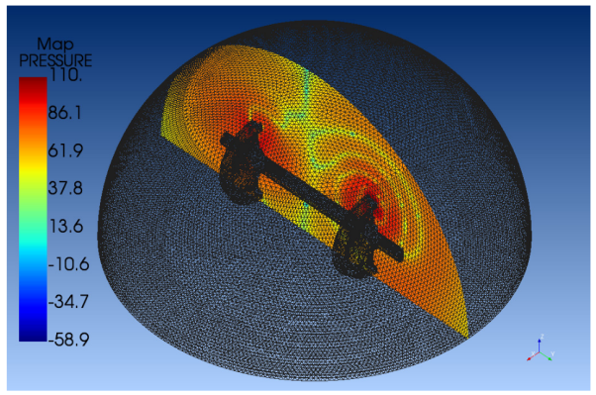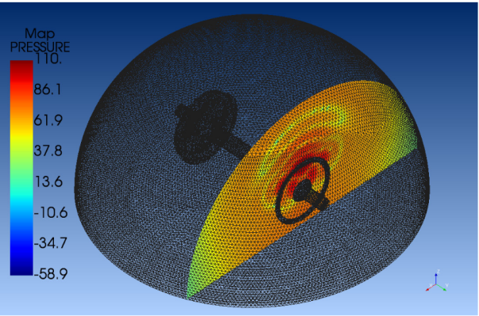
Figure 24 Transient Acoustic Solution Result (Left: ZOY Section; Right: ZOX Section)(Li, Chenzhong, 2026)
Developing an intelligent inversion model to achieve accurate mapping from response to excitation is the key to converting massive simulation data into practical technology. Targeted deep learning models are developed for different application scenarios. For the identification of medium and long wave (2-120m) track vertical irregularity in high-speed railways, the research proposes an Extended Auto-Encoder (EAE) neural network model as shown in Figure 21. The model has an ingenious structure: it compresses track irregularity information using an auto-encoder, then establishes the mapping between car-body acceleration and the compressed low-dimensional features through an estimator network, and finally decodes and reconstructs the irregularity waveform. This design effectively reduces the difficulty of direct end-to-end learning, and improves the robustness and generalization performance of the model. In the verification of measured data under different working conditions such as bridge, tunnel and subgrade sections, the EAE model performs significantly better than the traditional Convolutional Neural Network (CNN). As shown in Table 12, under the training of measured data, the Mean Absolute Percentage Error (MAPE) of the EAE model is 23% lower than that of the CNN model on average; after the introduction of physics-data fusion, its MAPE is as low as 1%~2%, demonstrating excellent waveform identification accuracy.
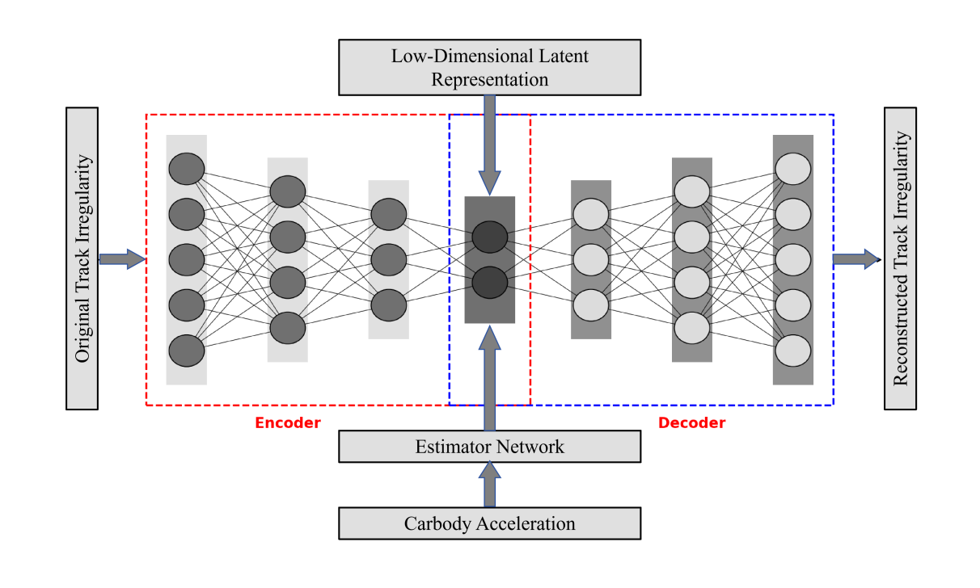
Figure 25 Structure Diagram of the Extended Auto-Encoder Network
Table 12 Comparison of Test Metrics of Different Models(Li, Chenzhong, 2026)
 | CNN |  | EAE
 | Trained with Measured Data | With Physics-Data Fusion | Trained with Measured Data | With Physics-Data Fusion
RMSE | 0.1 | 0.05 | 0.17 | 0.02
R² | -0.15 | 0.53 | -0.05 | 0.87
MAPE | 7.83% | 4.67% | 6.31% | 2.03%
C | 0.48 | 0.55 | 0.86 | 0.83
W | 0.85 | 0.92 | 0.86 | 0.97
E | 0.91 | 0.95 | 0.45 | 0.94
CWE | 0.75 | 0.81 | 0.72 | 0.91
For the identification of short-wave (10-300mm) rail corrugation in metro lines, the research proposes a multi-task learning neural network model with hard parameter sharing (Corrugation Detection Network, CD-Net, as shown in Figure 12). The model takes the fusion features of on-board vibration and noise (1/3 octave band GVL) as input, and simultaneously outputs the wavelength classification of corrugation (30-100mm short wave, 100-300mm medium wave) and wave depth regression. Trained with measured data, the CD-Net model adopting UW or GradNorm strategy can achieve an F1-score of over 0.96 for wavelength classification, and reduce the MAPE of wave depth regression to below 5%, which is far superior to the single-task learning model (F1=0.762, MAPE=12%). This fully demonstrates the great potential of multi-source data fusion and multi-task learning in the fine identification of short-wave irregularities.
Furthermore, this section establishes a Multi-gate Mixture of Experts (MMOE) network and a Progressive Layered Extraction (PLE) network. Both neural network models are multi-task learning frameworks designed based on CD-Net, incorporating a soft parameter sharing mechanism.
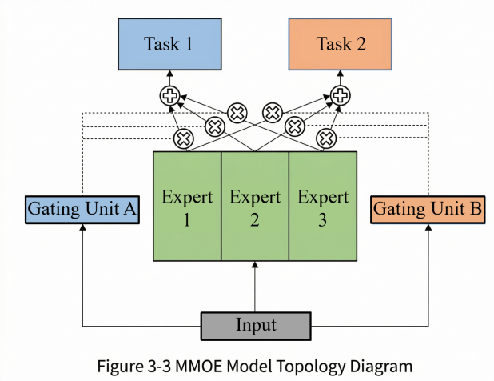
Figure 26 MMOE Model topology diagram
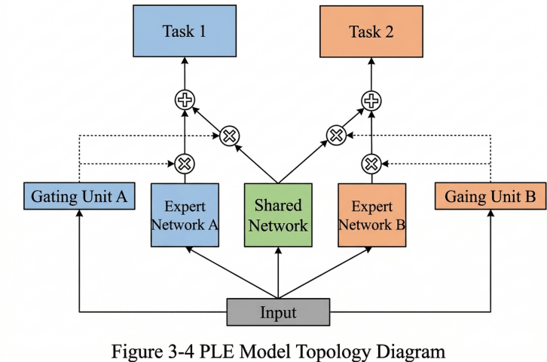
Figure 27 PLE Model topology diagram(Li, Chenzhong, 2026)

From Point Estimation to Interval Estimation: Improving the Reliability and Decision-Making Value of Census Results
Most traditional track irregularity inversion models output results in the form of point estimation, which cannot quantify the uncertainty of model prediction and can hardly meet the risk control requirements of railway operation and maintenance decision-making. The research introduces Bayesian Deep Learning (BDL) into track irregularity identification, and approximates variational inference through the Monte Carlo Dropout method, successfully realizing interval estimation of track irregularity. This innovation enables the output of the model to be no longer a single waveform, but an estimation range including confidence intervals, providing richer information for decision makers. When the estimation interval is narrow and covers the real value, it indicates that the model's evaluation result for this section is relatively certain; when the estimation interval is wide, it means that the model has great uncertainty, and recheck combined with more information (such as precision measurement) is required. More importantly, interval estimation makes operation and maintenance decision-making more conservative and reliable.
In bridge sections, the EAE model after physics-data fusion achieves a Coverage Width Error (CWE) of 0.91 for interval estimation, which is much higher than 0.81 of the CNN model. This means that the EAE model can not only accurately estimate the irregularity waveform, but also give a high-confidence prediction interval, effectively avoiding the risk of missed detection caused by underestimated point estimation results.
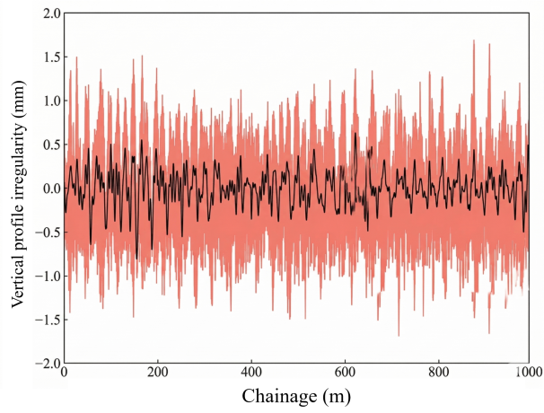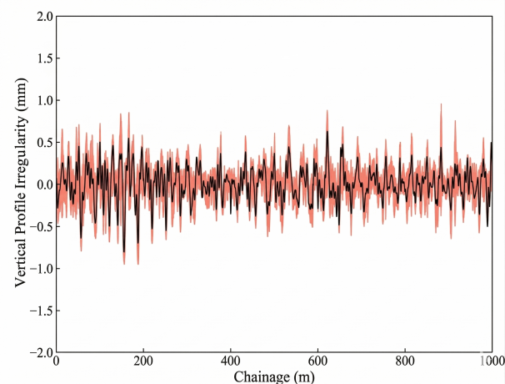
Figure 28 Interval estimation results of track vertical profile irregularity in bridge sections based on the CNN(left) and EAE(right) model after data-physics fusion (Li, Chenzhong, 2026)

Software and Hardware Integrated System: Realizing the Engineering Implementation of Census Technology
Theoretical algorithms ultimately require a physical carrier to serve practical operation and maintenance work. The research team independently developed an intelligent ride-along monitor device as shown in Figure 26, which is used to collect car-body vibration acceleration and in-carriage noise sound pressure data. Through the shaking table sweep frequency test and repeated field tests in metro carriages, it is verified that the intelligent ride-along monitor has excellent frequency response characteristics and high data acquisition stability, which can meet the requirements of engineering applications.
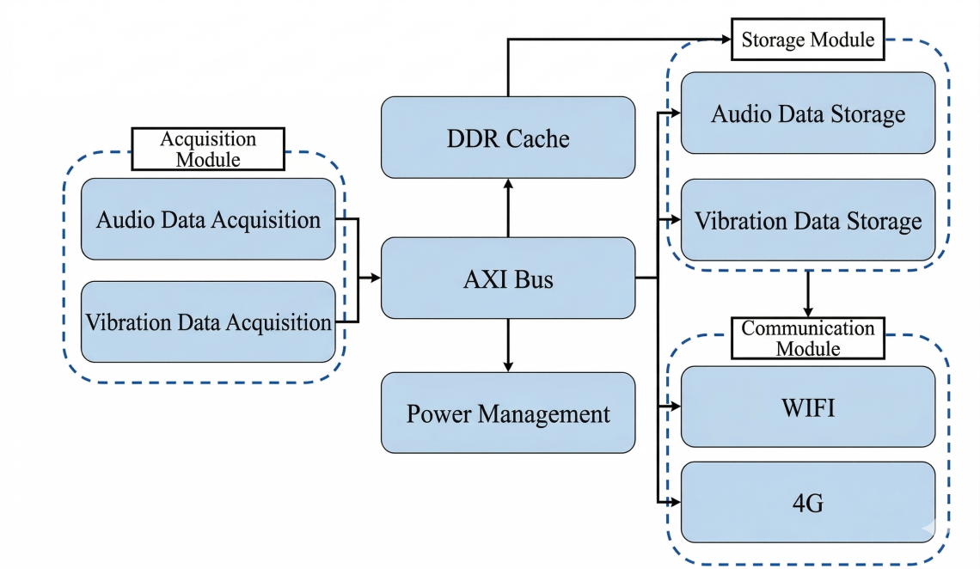
Figure 29 Schematic diagram of the internal logic of the intelligent inspection device (Li, Chenzhong, 2026)
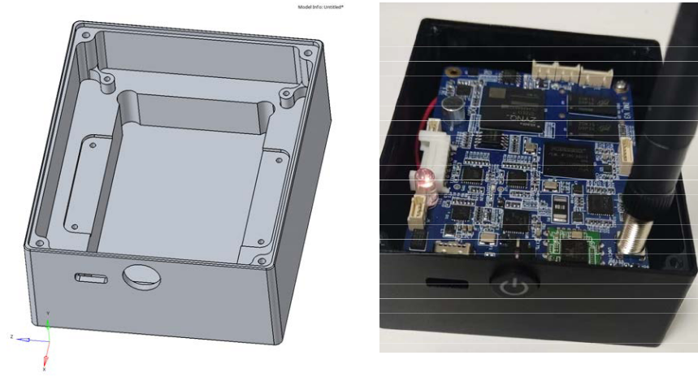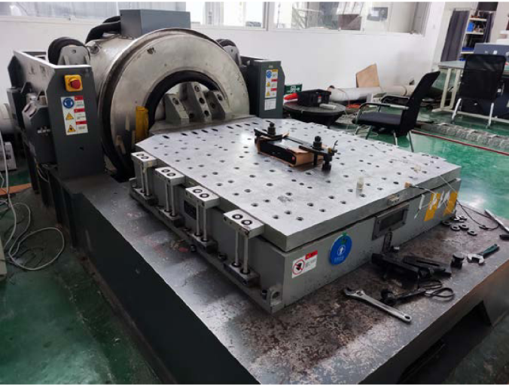
Figure 30 Intelligent Ride-Along Monitor Developed by the Research Team and Shaking Table Sweep Frequency Test (Li, Chenzhong, 2026)
Figure 27 display the spectrograms of the shaking table input data and the data collected by the intelligent inspection device during the frequency sweep test, respectively. It can be observed that the spectrogram of the data collected by the intelligent inspection device is basically consistent with that of the shaking table input data, maintaining a high degree of agreement with the designed experimental conditions. This verifies that the intelligent inspection device possesses excellent frequency response characteristics for acceleration data collection, ensuring accurate data acquisition.
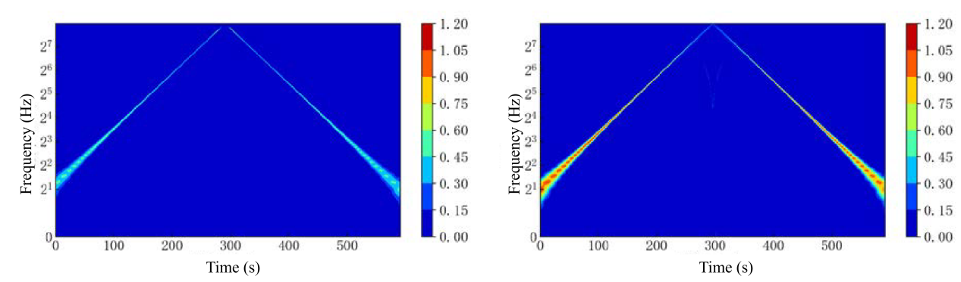
Figure 31 Spectrograms of the shaking table input data (left) and the data collected by the intelligent inspection device (right) (Li, Chenzhong, 2026)
A supporting big data operation and maintenance platform is developed, which can realize cloud storage, map-based visualization, historical data management of on-board vibration and noise data, and preliminary analysis of track status. The platform converts the massive raw vibration and noise data collected by the intelligent ride-along monitor into intuitive heat maps and trend charts, providing operation and maintenance managers with a convenient tool for data access and preliminary judgment, and enabling the census results based on data to truly enter the operation and maintenance decision-making process.
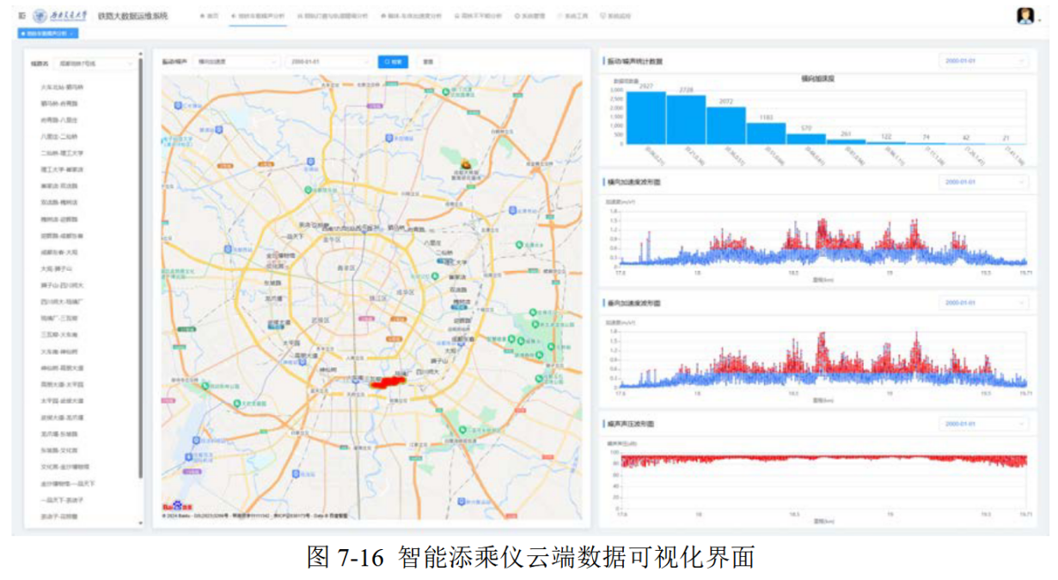
Figure 32 Cloud-based data visualization interface of the intelligent inspection device (Li, Chenzhong, 2026)

Inspection Robot

Research Background and Research Purpose
With the gradual transformation of the railway industry from the large-scale construction stage to the long-term safe operation and maintenance stage, the rail, as the core bearing component of railway transportation, its operation state detection and maintenance quality are directly related to the safety, stability and efficiency of railway transportation. Therefore, the demand for intelligent, efficient and precise rail inspection and maintenance in the industry has become increasingly prominent. Traditional manual inspection methods are affected by various factors such as the operator's skill level, sense of responsibility, fatigue and on-site environment (such as bad weather and complex terrain), which not only result in low inspection efficiency and high labor costs, but also make it difficult to effectively integrate and conduct linkage analysis of multi-source detection data, leading to problems such as missed inspection and false inspection. Single-function inspection equipment, on the other hand, has limitations such as limited detection dimensions, poor data compatibility and inability to achieve full-process detection coverage. Neither of them can meet the actual needs of full-process intelligent operation and maintenance including rail defect localization, detection, measurement and evaluation, nor can they support the development trend of intelligent transformation of railway operation and maintenance. In response to the above industry pain points and research gaps, research teams in the field of rail intelligent operation and maintenance have focused on relevant technological breakthroughs, and combined with the core needs of the "Dual Closed-Loop" intelligent operation and maintenance system proposed in this paper, developed a multi-sensor integrated track self-inspection robot, which is used as the core implementation carrier of the "Dual Closed-Loop" intelligent operation and maintenance system to mainly solve the key technical problems of synchronous acquisition and high-precision integration of multi-source data in rail inspection. The core function of the robot is to realize high-precision, comprehensive and synchronous collection of rail status data, providing reliable and comprehensive data support for the full-process operation and maintenance decision-making of the "Dual Closed-Loop" system, and helping railway operation and maintenance transform from "passive emergency repair" to "proactive prediction and precise operation and maintenance", which is also the core original intention of the robot's research and development. At the same time, the research and development and application of this case can directly support the core viewpoint of "intelligent equipment empowering the upgrading of railway operation and maintenance" proposed in this paper, providing solid empirical support for the research conclusions of the paper.

Overall Design of the Robot
To adapt to the needs of rail intelligent inspection and effectively support the landing application of the "Dual Closed-Loop" intelligent operation and maintenance system proposed in this paper, the overall design of the robot adopts the design concept of modularization, lightweight and high adaptability, with the core research and development goal clearly defined as "providing stable and accurate multi-source data support for the 'Dual Closed-Loop' system". Based on this goal, the robot is integrally designed into two core parts: a mobile carrier platform and a multi-source data acquisition system. This modular design scheme is determined after multiple rounds of scheme demonstration and optimization, which not only facilitates the disassembly, transportation and on-site deployment of the equipment, reduces the operation difficulty of maintenance personnel, but also can flexibly adjust the sensor configuration according to the actual needs of on-site inspection and the data acquisition requirements of the "Dual Closed-Loop" system, improving the versatility and scalability of the equipment, and solving the problem that traditional inspection equipment has fixed functions and is difficult to adapt to different operation and maintenance scenarios. Among them, the core of the mobile carrier platform design is to ensure the stable operation of the robot in complex track environments and provide reliable mobile support for data acquisition. For this reason, a lightweight symmetrical hollow frame structure is adopted, which not only balances structural stability and portability, but also effectively reduces the impact of the robot's own weight on the track. To adapt to the operation needs of tracks of different types, the platform is equipped with high-strength load-bearing wheels and adaptively adjustable limit mechanisms. By optimizing the telescopic logic of the limit mechanisms, they can flexibly expand and contract according to changes in rail gauge, ensuring that the robot can run stably on tracks of different types and working conditions, avoiding operation deviations caused by differences in track specifications, and ensuring the stability of data acquisition. The driving system selects high-performance hub motors, and realizes stable and constant speed driving of the robot by optimizing the motor control algorithm, which can not only meet the needs of efficient inspection and shorten the inspection cycle, but also facilitate maintenance personnel to follow up operations on site and handle equipment abnormalities in a timely manner, providing convenient support for the on-site operation and maintenance link of the "Dual Closed-Loop" system. This series of designs are targeted research and development carried out in combination with the actual rail inspection scenarios and the needs of the "Dual Closed-Loop" system, directly serving the intelligent operation and maintenance concept proposed in the paper.

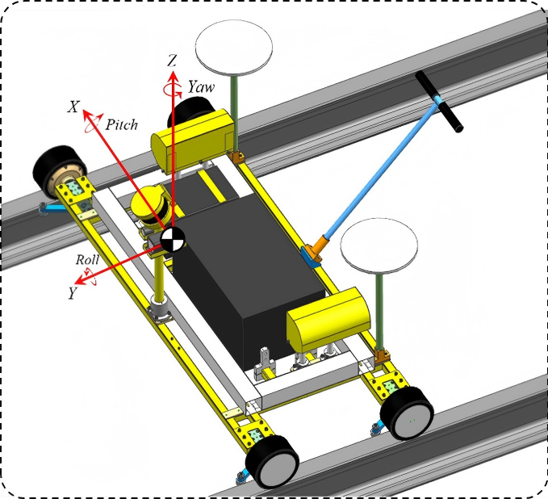
Figure 33. Rail Self-Inspection Robot

Design and Development of Multi-Source Data Acquisition System
The multi-source data acquisition system is the core functional module of the robot, and its performance directly determines the accuracy and comprehensiveness of data acquisition, thus affecting the scientificity of the decision-making of the "Dual Closed-Loop" intelligent operation and maintenance system. For this reason, the core of the system's research and development is positioned as "multi-sensor collaboration, high-precision acquisition, and real-time processing and fusion" to meet the full-dimensional needs of the "Dual Closed-Loop" system for rail status data. The system selects a high-performance embedded computing unit as the core control unit, which is determined to have strong parallel computing capabilities and real-time data processing capabilities after multiple rounds of test and selection, and can realize synchronous reception, real-time processing and fusion analysis of multi-sensor data, solving the problems of low processing efficiency and large data delay of traditional data acquisition systems. To realize full-dimensional acquisition of rail status data, the system integrates various high-precision sensors, including laser radar, line laser profile scanner, combined navigation system, industrial camera and inline odometer. The selection of each sensor is strictly tested and demonstrated to ensure its stable performance and complementary functions, which can cover all key dimensions of rail status detection: laser radar is used to quickly obtain 3D spatial information of the rail surrounding environment, providing data support for the environmental perception link of the "Dual Closed-Loop" system; line laser profile scanner is used to accurately capture the rail cross-sectional profile and wear details, providing core data for rail defect detection and status evaluation; combined navigation system is used to real-time obtain the precise position information of the robot, providing reliable support for defect localization, ensuring that the "Dual Closed-Loop" system can accurately locate the defect position and carry out subsequent operation and maintenance work; industrial camera is used to collect rail surface images to assist in identifying subtle defects on the rail surface; inline odometer is used to assist in positioning, improving the position accuracy of the robot. Through optimizing the installation layout of sensors and data transmission protocols, the collaborative work of various sensors is realized, fully ensuring the accuracy and comprehensiveness of data acquisition, and providing core data support for the full-process application of the "Dual Closed-Loop" intelligent operation and maintenance system. The design and development achievements directly support the research viewpoint of "multi-source data fusion empowering intelligent operation and maintenance" in this paper.
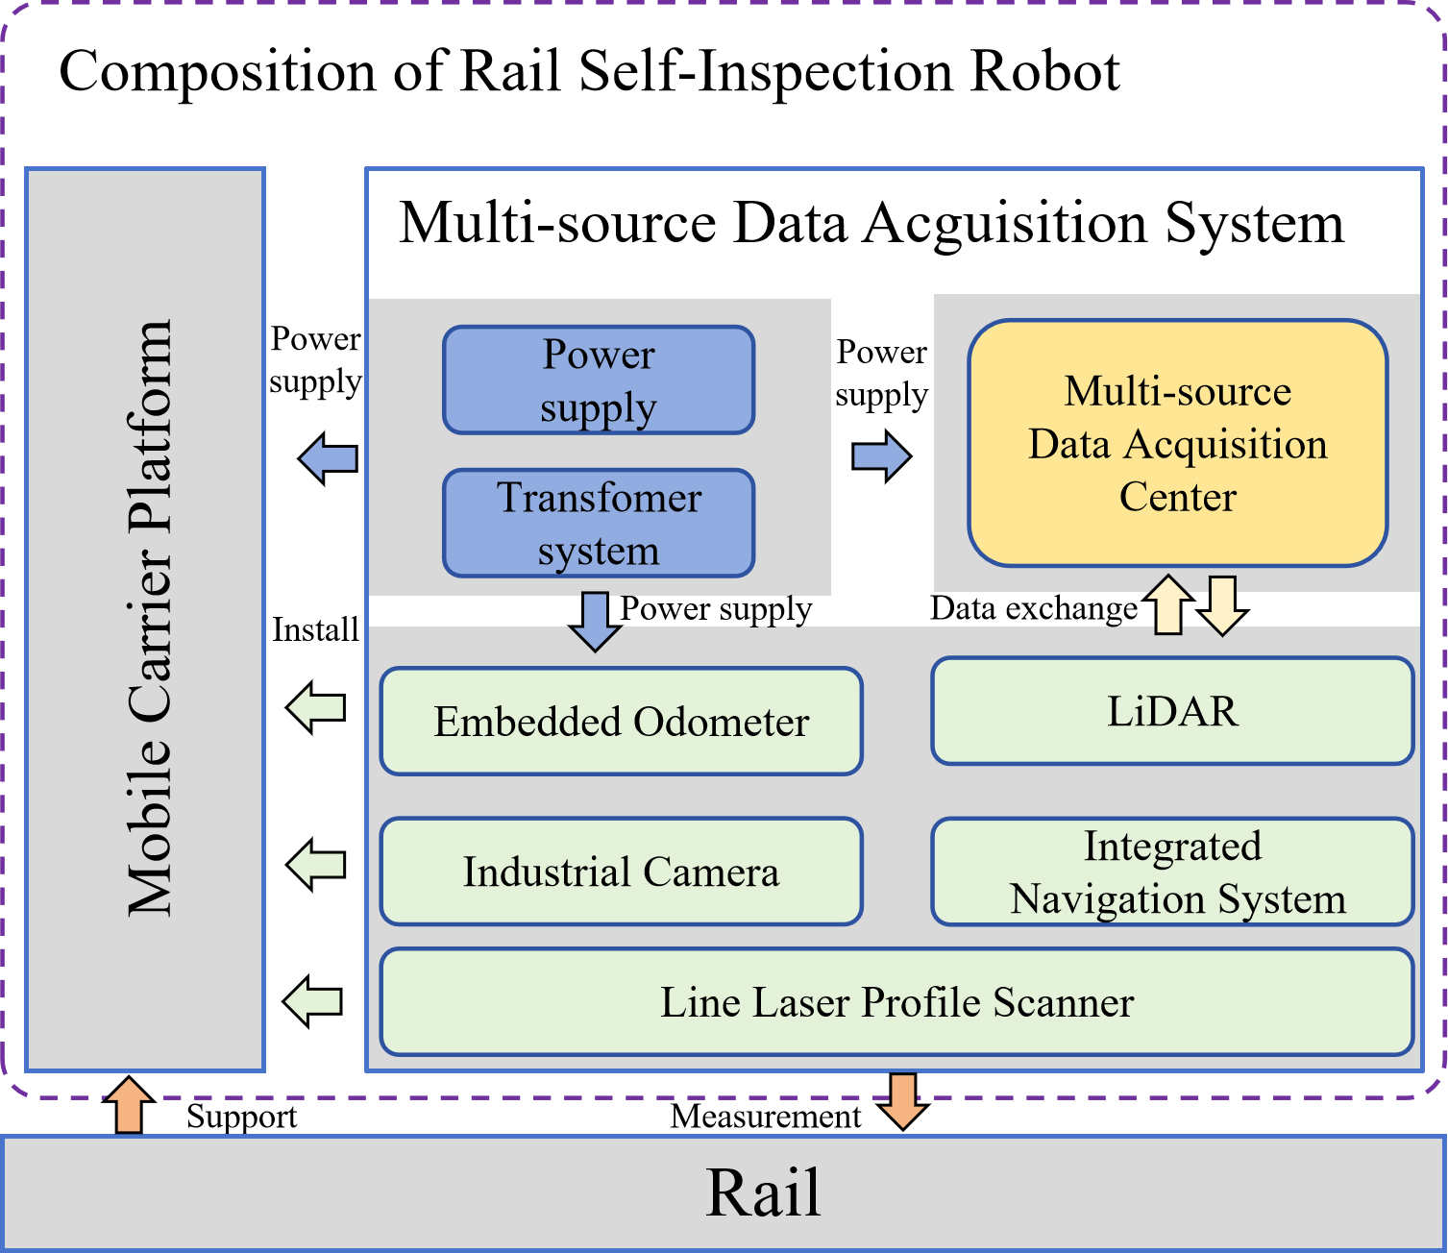
Figure 34. Composition of Rail Self-Inspection Robot

Multi-Sensor Integration Framework and Experimental Verification
The synchronization and consistency of multi-source data are the key to ensuring the accuracy of data fusion, and also the premise for the "Dual Closed-Loop" intelligent operation and maintenance system to achieve accurate decision-making. Aiming at the key technical problems such as time asynchrony and spatial misalignment in the process of multi-sensor data fusion, relevant research and development work has focused on technological breakthroughs, and built a multi-sensor integration framework based on the ROS system, which effectively solves the above technical bottlenecks and lays a solid foundation for data fusion analysis. This technological innovation further supports the technical research content of this paper. In terms of time synchronization, a professional synchronization mechanism is adopted to add unified timestamps to various sensor data. At the same time, to solve the problem of timestamp misalignment caused by differences in sampling frequencies of different sensors, an interpolation algorithm is designed and adopted to accurately correct the timestamps, realizing precise time synchronization of multi-source data, ensuring that data collected by different sensors can correspond to the same inspection moment, and improving the accuracy of data fusion. In terms of spatial calibration, a large number of calibration experiments are carried out to complete the internal parameter calibration of each sensor and the external parameter calibration between sensors. By optimizing the calibration method, the calibration accuracy is improved, making it much lower than the industry standard, fully meeting the requirements of data fusion accuracy, and ensuring that data collected by different types of sensors such as laser radar, camera and inertial navigation can be accurately aligned in the same spatial coordinate system, providing reliable guarantee for subsequent data fusion analysis. To verify the feasibility and practicality of the robot and provide empirical support for the research conclusions of this paper, a series of systematic experimental verifications are carried out. The experimental scenarios cover different types of test tracks and actual operating lines, including various rail gauges, different operating conditions and complex environmental scenarios, comprehensively simulating the actual situation of on-site rail inspection. During the experiment, the data acquisition stability, battery life, environmental adaptability and data support capability of the robot are focused on testing. The experimental results show that the robot can stably collect various types of rail status data, its battery life can meet the continuity requirements of on-site rail inspection, it has strong environmental adaptability, and can run stably in complex track environments.

Application Value of the Robot and Its Support for the Paper
More importantly, the multi-source data collected by the robot can effectively support the full-process application of the "Dual Closed-Loop" intelligent operation and maintenance system, which is not only the core goal of the robot's research and development, but also the key to its support for the content of this paper. Specifically, the high-precision point cloud data and image data collected by the robot can provide reliable support for the semantic map construction and combined positioning links of the "Dual Closed-Loop" system, realizing high-precision positioning and ensuring that the system can accurately grasp the spatial position information of the rail. The rail cross-sectional profile data and surface image data collected can support the system to carry out rail wear state recognition and robust defect detection, timely find various potential defects of the rail, and provide core data for the detection and early warning link of the "Dual Closed-Loop" system. The defect characteristic data collected can provide accurate support for risk assessment based on vehicle-track coupling dynamics, helping the system to accurately predict the risk of rail defects and provide a scientific basis for operation and maintenance decision-making. In addition, verified by experimental comparison, compared with traditional inspection methods and single-function inspection equipment, the robot has significant advantages in inspection efficiency, detection accuracy, data comprehensiveness and other aspects, which can effectively improve the efficiency and accuracy of rail inspection and maintenance, and further confirm the feasibility and superiority of the "Dual Closed-Loop" intelligent operation and maintenance system proposed in this paper. In summary, the multi-sensor integrated track self-inspection robot has effectively solved the key problems of synchronous acquisition and high-precision integration of multi-source data in rail inspection through targeted design, research and development and experimental verification. Its modular design and stable performance can adapt to complex track environments, and can provide comprehensive and high-precision data support for the "Dual Closed-Loop" intelligent operation and maintenance system. At the same time, the research and development and application of this case provide solid empirical support for the research viewpoint of rail intelligent operation and maintenance in this paper, confirm the application value of intelligent equipment in the field of rail operation and maintenance, and promote the development of intelligent transformation of railway operation and maintenance, which is also the core significance of the development of work related to this case.

Conclusion
In conclusion, this paper provides a comprehensive synthesis of the evolving paradigms governing the intelligent operation and maintenance of large-scale railway infrastructures. As global rail networks transition from a phase of intensive construction to one of long-term sustainable asset management, the inherent limitations of traditional maintenance models have become increasingly apparent. These constraints include spatial-temporal blind spots in macroscopic monitoring, the superficial nature of existing sensing technologies, and the inherent lag of reactive decision making, all of which necessitate a fundamental shift toward more proactive AI driven strategies to ensure the safety and reliability of complex railway systems.
To address these critical bottlenecks, this study has proposed a pioneering top-level architecture rooted in the "State Evolution" philosophy. This framework is characterized by two synergetic and continuous cycles that bridge the gap between abstract data and physical maintenance. The first cycle, an AI-driven full-process intelligent O&M closed loop, integrates wideband geometric perception with multi-source feature fusion to achieve a holistic characterization of infrastructure health. Complementing this, the second cycle serves as a precision intervention loop, utilizing AI agents and autonomous robotic systems to translate diagnostic insights into targeted, high-precision physical interventions, thereby optimizing resource allocation and extending system longevity.
The practical utility of this dual-loop architecture is illustrated through real-world applications. Specifically, the implementation of track-coupled dynamics monitoring on the Dazhun Heavy-Haul Railway and the development of multi-sensor integrated inspection robots demonstrate a successful paradigm shift from "evaluating current states" to "predicting future deterioration." These case studies suggest that the proposed framework not only enhances the accuracy of fault detection but also provides a robust, scalable roadmap for integrating advanced artificial intelligence into the demanding and unstructured environments of heavy-haul and high-speed rail operations.
Looking ahead, the evolution of intelligent railway O&M will be driven by the deep convergence of several frontier technologies. The integration of domain-specific multimodal large models will be essential for enhancing the interpretive power and robustness of the intelligent O&M closed loop, while the advancement of embodied intelligence will further refine the execution capabilities of the precision intervention loop. Furthermore, the development of high-fidelity digital twins will enable real-time simulation of complex degradation processes, allowing for the optimization of predictive maintenance schedules before physical failures occur. Collectively, the theoretical framework and practical pathways outlined in this paper establish a strategic foundation for the next generation of resilient, autonomous, and sustainable railway infrastructure management systems.

Reference
Acikgoz, H. and Korkmaz, D. (2023) “MSRConvNet: Classification of railway track defects using multi-scale residual convolutional neural network,” Engineering Applications of Artificial Intelligence, 121, p. 105965. Available at: https://doi.org/10.1016/j.engappai.2023.105965.
Aela, P., Chi, H.-L., et al. (2024) “UAV-based studies in railway infrastructure monitoring,” Automation in Construction, 167. Available at: https://doi.org/10.1016/j.autcon.2024.105714.
Aela, P., Cai, J., et al. (2024) “Vision-based monitoring of railway superstructure: A review,” Construction and Building Materials, 442, p. 137385. Available at: https://doi.org/10.1016/j.conbuildmat.2024.137385.
Audley, M. and Andrews, J.D. (2013) “The effects of tamping on railway track geometry degradation,” Proceedings of the Institution of Mechanical Engineers, Part F: Journal of Rail and Rapid Transit, 227(4), pp. 376–391. Available at: https://doi.org/10.1177/0954409713480439.
Bai, L. et al. (2015) “Markov-based model for the prediction of railway track irregularities,” PROCEEDINGS OF THE INSTITUTION OF MECHANICAL ENGINEERS PART F-JOURNAL OF RAIL AND RAPID TRANSIT, 229(2), pp. 150–159. Available at: https://doi.org/10.1177/0954409713503460.
Bianchi, G. et al. (2025a) “Systematic review railway infrastructure monitoring: From classic techniques to predictive maintenance,” Advances in Mechanical Engineering, 17(1), p. 16878132241285631. Available at: https://doi.org/10.1177/16878132241285631.
Bianchi, G. et al. (2025b) “Systematic review railway infrastructure monitoring: From classic techniques to predictive maintenance,” Advances in Mechanical Engineering, 17(1), p. 16878132241285631. Available at: https://doi.org/10.1177/16878132241285631.
Bianchi, G. et al. (2025c) “Systematic review railway infrastructure monitoring: From classic techniques to predictive maintenance,” Advances in Mechanical Engineering, 17(1), p. 16878132241285631. Available at: https://doi.org/10.1177/16878132241285631.
Binder, M., Mezhuyev, V. and Tschandl, M. (2023) “Predictive Maintenance for Railway Domain: A Systematic Literature Review,” IEEE Engineering Management Review, 51(2), pp. 120–140. Available at: https://doi.org/10.1109/EMR.2023.3262282.
Bobadilla, H.A.F. and Martin, U. (2024) “GAN-based Data Augmentation of Railway Track Irregularities for Fault Diagnosis,” 2024 International Joint Conference on Neural Networks (IJCNN). 2024 International Joint Conference on Neural Networks (IJCNN), pp. 1–9. Available at: https://doi.org/10.1109/IJCNN60899.2024.10651483.
Bosso, N., Magelli, M. and Zampieri, N. (2022) “Simulation of wheel and rail profile wear: a review of numerical models,” Railway Engineering Science, 30(4), pp. 403–436.
Bressi, S., Santos, J. and Losa, M. (2021) “Optimization of maintenance strategies for railway track-bed considering probabilistic degradation models and different reliability levels,” Reliability Engineering & System Safety, 207, p. 107359. Available at: https://doi.org/10.1016/j.ress.2020.107359.
Bris-Peñalver, F.J., Verdecia-Peña, R. and Alonso, J.I. (2026a) “A survey of AI-enabled predictive maintenance for railway infrastructure: Models, data sources, and research challenges,” Sensors (Basel, Switzerland), 26(3), p. 906. Available at: https://doi.org/10.3390/s26030906.
Bris-Peñalver, F.J., Verdecia-Peña, R. and Alonso, J.I. (2026b) “A Survey of AI-Enabled Predictive Maintenance for Railway Infrastructure: Models, Data Sources, and Research Challenges,” Sensors, 26(3), p. 906.
Buuren, S. van and Groothuis-Oudshoorn, K. (2011) “mice: Multivariate Imputation by Chained Equations in R,” Journal of Statistical Software, 45, pp. 1–67. Available at: https://doi.org/10.18637/jss.v045.i03.
Caetano, L.F. and Teixeira, P.F. (2016) “Predictive maintenance model for ballast tamping,” Journal of Transportation Engineering, 142(4), p. 04016006. Available at: https://doi.org/10.1061/(ASCE)TE.1943-5436.0000825.
Cai, W. et al. (2026) “A unified LLM-KG framework for low-annotation urban rail transit signal system operation: knowledge acquisition and dynamic update,” ADVANCED ENGINEERING INFORMATICS, 71. Available at: https://doi.org/10.1016/j.aei.2026.104327.
Cai, X. et al. (2021) “Deformation Law and Control Limit of CRTSIII Slab Track under Subgrade Frost Heave,” Applied Sciences, 11(8), p. 3520. Available at: https://doi.org/10.3390/app11083520.
Cao, W. et al. (2018) “BRITS: Bidirectional Recurrent Imputation for Time Series.” arXiv. Available at: https://doi.org/10.48550/arXiv.1805.10572.
Chawla, N.V. et al. (2002) “SMOTE: Synthetic Minority Over-sampling Technique,” Journal of Artificial Intelligence Research, 16, pp. 321–357. Available at: https://doi.org/10.1613/jair.953.
Chen, A. et al. (2025) “LLM-based intelligent Q&A system for railway locomotive maintenance standardization,” SCIENTIFIC REPORTS, 15(1). Available at: https://doi.org/10.1038/s41598-025-96130-3.
Chen, M. et al. (2022) “Vibration-based damage detection of rail fastener using fully convolutional networks,” Vehicle System Dynamics, 60(7), pp. 2191–2210. Available at: https://doi.org/10.1080/00423114.2021.1896010.
Chen Yong, An Zhuoaobo, and Zhou Jianyu (2025) “Semantic Description Method of High-Speed Railway Contact Net Insulator Defects Based on Diffusion Model Detection,” Transactions of China Electrotechnical Society, 40(13), pp. 4100–4111.
Choi, J. et al. (2021) “Graph Neural Controlled Differential Equations for Traffic Forecasting.” arXiv. Available at: https://doi.org/10.48550/arXiv.2112.03558.
Christos N. Pygidis (2022) Railway Transpportation Systems: Design, Construction and Operation. Second Edition. Boca Raton: CRC Press.
Davari, N. et al. (2021) “A Survey on Data-Driven Predictive Maintenance for the Railway Industry,” Sensors, 21(17), p. 5739. Available at: https://doi.org/10.3390/s21175739.
Davies, B. and Andrews, J. (2021) “The impact of summer heatwaves on railway track geometry maintenance,” Proceedings of the Institution of Mechanical Engineers, Part F: Journal of Rail and Rapid Transit, 235(9), pp. 1158–1171. Available at: https://doi.org/10.1177/0954409720984292.
Ding, W. et al. (2024) “Solving coupled differential equation groups using PINO-CDE,” Mechanical Systems and Signal Processing, 208, p. 111014. Available at: https://doi.org/10.1016/j.ymssp.2023.111014.
Du, Z., Gao, L. and Li, X. (2023) “A New Contrastive GAN With Data Augmentation for Surface Defect Recognition Under Limited Data,” IEEE Transactions on Instrumentation and Measurement, 72, pp. 1–13. Available at: https://doi.org/10.1109/TIM.2022.3232649.
El-khateeb, L. et al. (2021) “A hybrid multi-criteria decision making model for defect-based condition assessment of railway infrastructure,” Sustainability, 13(13), p. 7186. Available at: https://doi.org/10.3390/su13137186.
Escalona, J.L. (2016) “Vertical track geometry monitoring using inertial sensors and complementary filters,” International Design Engineering Technical Conferences and Computers and Information in Engineering Conference. American Society of Mechanical Engineers, p. V006T09A034. Available at: https://asmedigitalcollection.asme.org/IDETC-CIE/proceedings-abstract/IDETC-CIE2016/50183/258999 (Accessed: April 3, 2026).
European Committee for Standardization (2017) “Railway applications – Track – Track geometry quality: EN 13848-1 and EN 13848-5.” Brussels.
Falamarzi, A., Moridpour, S. and Nazem, M. (2019) “Development of a tram track degradation prediction model based on the acceleration data,” STRUCTURE AND INFRASTRUCTURE ENGINEERING, 15(10), pp. 1308–1318. Available at: https://doi.org/10.1080/15732479.2019.1615963.
Fischer, S. (2022) “Geogrid reinforcement of ballasted railway superstructure for stabilization of the railway track geometry – A case study,” Geotextiles and Geomembranes, 50(5), pp. 1036–1051. Available at: https://doi.org/10.1016/j.geotexmem.2022.05.005.
Fontul, S. et al. (2016) “Railways track characterization using ground penetrating radar,” Procedia Engineering, 143, pp. 1193–1200. Available at: https://doi.org/10.1016/j.proeng.2016.06.120.
Fu, Y. et al. (2024) “A fault diagnosis method for railway turnout systems based on Convolution Transformer through data augmentation.” Research Square. Available at: https://doi.org/10.21203/rs.3.rs-3969643/v1.
Garcia, G. and Zhang, J. (2006) “Application of ultrasonic phased arrays for rail flaw inspection.” Available at: https://trid.trb.org/View/809374 (Accessed: April 2, 2026).
Garcia-Mendez, S. et al. (2025) “An explainable machine learning framework for railway predictive maintenance using data streams from the metro operator of Portugal,” SCIENTIFIC REPORTS, 15(1). Available at: https://doi.org/10.1038/s41598-025-08084-1.
Gautier, P.-E. (2015) “Slab track: Review of existing systems and optimization potentials including very high speed,” Construction and Building Materials, 92, pp. 9–15. Available at: https://doi.org/10.1016/j.conbuildmat.2015.03.102.
Ghiasi, R. et al. (2025) “Unsupervised domain adaptation for drive-by condition monitoring of multiple railway tracks,” Engineering Applications of Artificial Intelligence, 139, p. 109516. Available at: https://doi.org/10.1016/j.engappai.2024.109516.
Giancarlo, P. (2018) “A Low-Rank Tensor Model for Imputation of Missing Vehicular Traffic Volume,” IEEE Transactions on Vehicular Technology, PP, pp. 1–1. Available at: https://doi.org/10.1109/TVT.2018.2833505.
Grützmacher, F., Kang, C. and Marx, S. (2025) “Historical development of ballastless track systems in germany,” Construction and Building Materials, 458, p. 139564. Available at: https://doi.org/10.1016/j.conbuildmat.2024.139564.
Guo, J. et al. (2025) “A parallel method for assessing track segment quality in railway maintenance,” Proceedings of the Institution of Mechanical Engineers, Part F: Journal of Rail and Rapid Transit, 239(6), pp. 459–469. Available at: https://doi.org/10.1177/09544097251329148.
Guo, S., Zhang, G. and Qi, C. (2019) “A Robot for Automatic Installation of Rail Fasteners,” Proceedings of the 2019 International Conference on Robotics, Intelligent Control and Artificial Intelligence. RICAI 2019: 2019 International Conference on Robotics, Intelligent Control and Artificial Intelligence, Shanghai China: ACM, pp. 77–82. Available at: https://doi.org/10.1145/3366194.3366208.
Guo, Y. (2021) “Review of ballast track tamping: Mechanism, challenges and solutions.”
Haghighat, E. et al. (2021) “A physics-informed deep learning framework for inversion and surrogate modeling in solid mechanics,” Computer Methods in Applied Mechanics and Engineering, 379, p. 113741. Available at: https://doi.org/10.1016/j.cma.2021.113741.
Hamid, A. and Gross, A. (1981) “Track-quality indices and track-degradation models for maintenance-of-way planning,” Transportation Research Record, 802, pp. 2–8.
Han，Xue and Su，Huilong (2021) “Research on Key Technologies of Autonomous Ultrasonic System for Rail Flaw Detection Vehicle,” Southern Agricultural Machinery, 52(4), pp. 9–10.
Hao, W. (2009) “Real-time Automatic Ultrasonic Rail Damage Detection and Classification System Based on SVM,” Journal of University of Chinese Academy of Sciences, 26(4), p. 517. Available at: https://doi.org/10.7523/j.issn.2095-6134.2009.4.013.
He, H. et al. (2008) “ADASYN: Adaptive synthetic sampling approach for imbalanced learning,” 2008 IEEE International Joint Conference on Neural Networks (IEEE World Congress on Computational Intelligence). 2008 IEEE International Joint Conference on Neural Networks (IEEE World Congress on Computational Intelligence), pp. 1322–1328. Available at: https://doi.org/10.1109/IJCNN.2008.4633969.
Heydari, H. (2024) “Evaluating the dynamic behavior of railway-bridge transition zone: numerical and field measurements,” Canadian Journal of Civil Engineering, 51(4), pp. 399–408. Available at: https://doi.org/10.1139/cjce-2022-0453.
Higgins, C. and Liu, X. (2018) “Modeling of track geometry degradation and decisions on safety and maintenance: A literature review and possible future research directions,” Proceedings of the Institution of Mechanical Engineers, Part F: Journal of Rail and Rapid Transit, 232(5), pp. 1385–1397. Available at: https://doi.org/10.1177/0954409717721870.
Hong, W.-T., Clifton, G. and Nelson, J.D. (2024) “A data-driven conceptual framework for understanding the nature of hazards in railway accidents,” TRANSPORT POLICY, 152, pp. 102–117. Available at: https://doi.org/10.1016/j.tranpol.2024.05.007.
Hou, Z., Zhao, W. and Yang, Y. (2023) “Identification of railway subgrade defects based on ground penetrating radar,” Scientific Reports, 13(1), p. 6030. Available at: https://doi.org/10.1038/s41598-023-33278-w.
Huang, H. and Tutumluer, E. (2011) “Discrete element modeling for fouled railroad ballast,” Construction and Building Materials, 25(8), pp. 3306–3312. Available at: https://doi.org/10.1016/j.conbuildmat.2011.03.019.
Huang, W. and Deng, X. (2025) “Real-time tracking railway intruders using multiple-agent cooperated large language models with edge stream processing engine,” JOURNAL OF NETWORK AND COMPUTER APPLICATIONS, 242. Available at: https://doi.org/10.1016/j.jnca.2025.104231.
Huang,Xing (2022) “Rapid non-destructive testing method for ballast defects in ballasted railway track bed using ground-penetrating radar,” railway construction, 62(3), pp. 61–65.
Hu,Jinping and Ren,Jianping (2006) “Application of ultrasonic waves in rail flaw detection,” Shanxi Electronic Technology, (3), pp. 52–53.
Indraratna, B. et al. (2016) “Performance improvement of rail track substructure using artificial inclusions – experimental and numerical studies,” Transportation Geotechnics, 8, pp. 69–85. Available at: https://doi.org/10.1016/j.trgeo.2016.04.001.
International Union of Railways (2024) HIGH SPEED LINES IN THE WORLD 2023 (Summary).
Irshad, L. and Walsh, H.S. (2026) “Learning From Accident Reports Using Language Models: Human Errors and Error Mechanisms in Aviation and Railway Accidents,” JOURNAL OF COMPUTING AND INFORMATION SCIENCE IN ENGINEERING, 26(1). Available at: https://doi.org/10.1115/1.4070042.
Islam, M.A. and Olm, G. (2024) “Deep learning techniques to detect rail indications from ultrasonic data for automated rail monitoring and maintenance,” Ultrasonics, 140, p. 107314. Available at: https://doi.org/10.1016/j.ultras.2024.107314.
Jin, Z. et al. (2025) “Estimating track geometry irregularities from in-service train accelerations using deep learning,” Automation in Construction, 173, p. 106114. Available at: https://doi.org/10.1016/j.autcon.2025.106114.
Kaewunruen, S. and Chiengson, C. (2018) “Railway track inspection and maintenance priorities due to dynamic coupling effects of dipped rails and differential track settlements,” Engineering Failure Analysis, 93, pp. 157–171. Available at: https://doi.org/10.1016/j.engfailanal.2018.07.009.
Kampczyk, A. and Dybeł, K. (2021) “The Fundamental Approach of the Digital Twin Application in Railway Turnouts with Innovative Monitoring of Weather Conditions,” Sensors, 21(17), p. 5757. Available at: https://doi.org/10.3390/s21175757.
Kang, K.H., Yang, K.O. and Choi, J.W. (2026) “RAISA: A Vision-Based Intelligent Safety Guidance Agent for Railway Operations via Modular Prompt-Orchestrated Reasoning,” IEEE OPEN JOURNAL OF INTELLIGENT TRANSPORTATION SYSTEMS, 7, pp. 600–614. Available at: https://doi.org/10.1109/OJITS.2026.3664788.
Kang, R. et al. (2026) “Multimodal anomaly detection for high-speed train control system based on attention mechanism,” JOURNAL OF SUPERCOMPUTING, 82(4). Available at: https://doi.org/10.1007/s11227-025-08141-6.
Khajehdezfuly, A., Azizipour, H. and Kaewunruen, S. (2025) “A review of applications of AI in monitoring, inspection, and maintenance of railway tracks,” Journal of Industrial Information Integration, 48. Available at: https://doi.org/10.1016/j.jii.2025.101005.
Kidger, P. et al. (2020) “Neural Controlled Differential Equations for Irregular Time Series.” arXiv. Available at: https://doi.org/10.48550/arXiv.2005.08926.
Kim, D.S. and Yoon, W.C. (2013) “An accident causation model for the railway industry: Application of the model to 80 rail accident investigation reports from the UK,” Safety Science, 60, pp. 57–68. Available at: https://doi.org/10.1016/j.ssci.2013.06.010.
Kim, E., Fernández-Bobadilla, H.A. and Chen, X. (2023) “Data augmentation for fault classification of railway track irregularities in track-vehicle scale model,” 2023 IEEE SENSORS. 2023 IEEE SENSORS, Vienna, Austria: IEEE, pp. 1–4. Available at: https://doi.org/10.1109/SENSORS56945.2023.10324866.
Koh, Y.S. et al. (2020) “A REVIEW ON AUGMENTED REALITY TRACKING METHODS FOR MAINTENANCE OF ROBOTS,” Jurnal Teknologi, 83(1), pp. 37–43. Available at: https://doi.org/10.11113/jurnalteknologi.v83.14907.
Koohmishi, M. et al. (2024a) “Advancing railway track health monitoring: Integrating GPR, InSAR and machine learning for enhanced asset management,” Automation in Construction, 162, p. 105378. Available at: https://doi.org/10.1016/j.autcon.2024.105378.
Koohmishi, M. et al. (2024b) “Advancing railway track health monitoring: Integrating GPR, InSAR and machine learning for enhanced asset management,” Automation in Construction, 162. Available at: https://doi.org/10.1016/j.autcon.2024.105378.
Koren, Y., Bell, R. and Volinsky, C. (2009) “Matrix Factorization Techniques for Recommender Systems,” Computer, 42(8), pp. 30–37. Available at: https://doi.org/10.1109/MC.2009.263.
Kotelnikov, A. et al. (2024) “TabDDPM: Modelling Tabular Data with Diffusion Models.” Available at: https://doi.org/10.5555/3618408.3619133.
Lee, I. et al. (2018) “Effect of groundwater level variation on residual settlement of korean high-speed railway on soft ground,” KSCE Journal of Civil Engineering, 22(9), pp. 3312–3320. Available at: https://doi.org/10.1007/s12205-017-0472-6.
Li, C. et al. (2020) “Spatial–Temporal Model to Identify the Deformation of Underlying High-Speed Railway Infrastructure,” Journal of Transportation Engineering, Part A: Systems, 146(8), p. 04020084. Available at: https://doi.org/10.1061/JTEPBS.0000408.
Li, C. et al. (2024) “A multitask learning method for rail corrugation detection using in-vehicle responses and noise data,” IEEE Transactions on Intelligent Transportation Systems, 25(6), pp. 5045–5058. Available at: https://doi.org/10.1109/TITS.2023.3334290.
Li, Chenzhong (2026) Research of Railway Track Longitudinal Irregularity Recognition Method by Integrating Multi-Source Data from Onboard Vehicles. Doctoral Dissertation. Southwest Jiaotong University. Available at: https://doi.org/10.27414/d.cnki.gxnju.2024.000115.
Li, J. et al. (2024) “Smart railways: the design and construction of an autonomous inspection and maintenance vehicle,” Procedia CIRP, 128, pp. 61–65. Available at: https://doi.org/10.1016/j.procir.2024.03.003.
Li, M. et al. (2022) “A Fault-Diagnosis Method for Railway Turnout Systems Based on Improved Autoencoder and Data Augmentation,” Sensors, 22(23). Available at: https://doi.org/10.3390/s22239438.
Li, M. and Zeng, Y. (2026) “Causative word extraction and analysis based on text data of metro safety events,” PROCEEDINGS OF THE INSTITUTION OF MECHANICAL ENGINEERS PART O-JOURNAL OF RISK AND RELIABILITY, 240(1), pp. 358–371. Available at: https://doi.org/10.1177/1748006X251338899.
Li, Y. et al. (2025) “Intelligent human-computer interactive training assistant system for rail systems,” HIGH-SPEED RAILWAY, 3(1), pp. 64–77. Available at: https://doi.org/10.1016/j.hspr.2025.02.001.
Liao, Yingying et al. (2022) “Prediction models for railway track geometry degradation using machine learning methods: a review,” Sensors, 22(19), p. 7275.
Liao, Y. et al. (2022) “Prediction Models for Railway Track Geometry Degradation Using Machine Learning Methods: A Review,” Sensors, 22(19), p. 7275. Available at: https://doi.org/10.3390/s22197275.
Liu, J. and Xiao, J. (2010) “Experimental study on the stability of railroad silt subgrade with increasing train speed,” Journal of Geotechnical and Geoenvironmental Engineering, 136(6), pp. 833–841. Available at: https://doi.org/10.1061/(ASCE)GT.1943-5606.0000282.
Lu, C. and Cai, C. (2020) “Overview on safety management and maintenance of high-speed railway in China,” Transportation Geotechnics, 25, p. 100397. Available at: https://doi.org/10.1016/j.trgeo.2020.100397.
Lu, X.L. et al. (2024) “Hybrid physics machine learning for ultrasonic field guided 3D generation and reconstruction of rail defects,” NDT & E International, 146, p. 103174. Available at: https://doi.org/10.1016/j.ndteint.2024.103174.
Luan, R. and Liu, R. (2025) “Risk assessment model for railway track maintenance operations based on combined weights and nonlinear FCE,” Applied Sciences, 15(13). Available at: https://doi.org/10.3390/app15137614.
Lyu, P. et al. (2022) “A novel model-independent data augmentation method for fault diagnosis in smart manufacturing,” Procedia CIRP, 107, pp. 949–954. Available at: https://doi.org/10.1016/j.procir.2022.05.090.
Ma, S. et al. (2019) “Deep learning for track quality evaluation of high-speed railway based on vehicle-body vibration prediction,” IEEE Access, 7, pp. 185099–185107. Available at: https://doi.org/10.1109/ACCESS.2019.2960537.
Malekjafarian, A. et al. (2023) “A machine-learning-based approach for railway track monitoring using acceleration measured on an In-service train,” Sensors, 23(17), p. 7568. Available at: https://doi.org/10.3390/s23177568.
Martinez, Y. et al. (2025) “Physics-Informed Neural Networks for the Structural Analysis and Monitoring of Railway Bridges: A Systematic Review,” MATHEMATICS, 13(10). Available at: https://doi.org/10.3390/math13101571.
Masoomi, M. and Jalili, M.M. (2017) “Non-linear vibration analysis of a 2-DOF railway vehicle model under random rail excitation,” Proceedings of the Institution of Mechanical Engineers, Part K: Journal of Multi-body Dynamics, 231(4), pp. 591–607. Available at: https://doi.org/10.1177/1464419316679554.
Meng, Z. et al. (2020) “Experimental study of the microstructure of loess on its macroscopic geotechnical properties of the baozhong railway subgrade in ningxia, China,” Bulletin of Engineering Geology and the Environment, 79(9), pp. 4829–4840. Available at: https://doi.org/10.1007/s10064-020-01816-9.
Miao, R., Wu, T. and Zhang, Z. (2025) “Graph RAG-based fault diagnosis for train bogies using knowledge graphs and large language model,” KNOWLEDGE-BASED SYSTEMS, 331. Available at: https://doi.org/10.1016/j.knosys.2025.114855.
Milosevic, M.D.G. et al. (2022a) “Condition monitoring of railway crossing geometry via measured and simulated track responses,” Sensors, 22(3), p. 1012. Available at: https://doi.org/10.3390/s22031012.
Milosevic, M.D.G. et al. (2022b) “Condition Monitoring of Railway Crossing Geometry via Measured and Simulated Track Responses,” Sensors, 22(3), p. 1012. Available at: https://doi.org/10.3390/s22031012.
Ministry of Transport of the People’s Republic of China (2025) 2024 Railway Statistics Bulletin.
Mohammadi, R. and He, Q. (2022) “A deep reinforcement learning approach for rail renewal and maintenance planning,” Reliability Engineering & System Safety, 225, p. 108615. Available at: https://doi.org/10.1016/j.ress.2022.108615.
Molodova, M., Li, Z. and Dollevoet, R. (2011) “Axle box acceleration: Measurement and simulation for detection of short track defects,” Wear, 271(1–2), pp. 349–356.
Morais, J. et al. (2023) “Railway track support condition assessment — methodology validation using numerical simulations,” Engineering Failure Analysis, 152, p. 107483. Available at: https://doi.org/10.1016/j.engfailanal.2023.107483.
Mutlu, U. and Kaewunruen, S. (2026) “Digitalised Predictive Maintenance in Railways: A Systematic Review of AI, BIM, and Digital Twins,” Infrastructures, 11(3), p. 87.
Nabochenko, O. et al. (2019) “Studying the railroad track geometry deterioration as a result of an uneven subsidence of the ballast layer,” Eastern-European Journal of Enterprise Technologies, 1(7 (97)), pp. 50–59. Available at: https://doi.org/10.15587/1729-4061.2019.154864.
Niu, L. et al. (2023) “An assessment method of rail corrugation based on wheel–rail vertical force and its application for rail grinding,” Journal of Civil Structural Health Monitoring, 13, pp. 1131–1150. Available at: https://doi.org/10.1007/s13349-023-00700-w.
OBrien, E.J. et al. (2018) “Determination of railway track longitudinal profile using measured inertial response of an in-service railway vehicle,” Structural Health Monitoring, 17(6), pp. 1425–1440. Available at: https://doi.org/10.1177/1475921717744479.
Olivier, B. et al. (2025) “A review of computer vision for railways,” IEEE Transactions on Intelligent Transportation Systems, 26(7), pp. 11034–11065. Available at: https://doi.org/10.1109/TITS.2025.3552011.
Ouyang, M. et al. (2010) “STAMP-based analysis on the railway accident and accident spreading: Taking the China–jiaoji railway accident for example,” Safety Science, 48(5), pp. 544–555. Available at: https://doi.org/10.1016/j.ssci.2010.01.002.
Paixão, A., Fortunato, E. and Calçada, R. (2019) “Smartphone’s sensing capabilities for on-board railway track monitoring: structural performance and geometrical degradation assessment,” Advances in Civil Engineering. Edited by D. Rizos, 2019(1), p. 1729153. Available at: https://doi.org/10.1155/2019/1729153.
Parizzi, A., Gonzalez, F.R. and Brcic, R. (2020) “A Covariance-Based Approach to Merging InSAR and GNSS Displacement Rate Measurements,” Remote Sensing, 12(2). Available at: https://doi.org/10.3390/rs12020300.
Peinado Gonzalo, A. et al. (2022a) “Review of data analytics for condition monitoring of railway track geometry,” IEEE Transactions on Intelligent Transportation Systems, 23(12), pp. 22737–22754. Available at: https://doi.org/10.1109/TITS.2022.3214121.
Peinado Gonzalo, A. et al. (2022b) “Review of Data Analytics for Condition Monitoring of Railway Track Geometry,” IEEE Transactions on Intelligent Transportation Systems, 23(12), pp. 22737–22754. Available at: https://doi.org/10.1109/TITS.2022.3214121.
Peng, C. et al. (2025) “Adaptive fault diagnosis of railway vehicle on-board controller with large language models,” APPLIED SOFT COMPUTING, 185. Available at: https://doi.org/10.1016/j.asoc.2025.113919.
Peng,Jianping (2017) Research on the method of detecting rolling contact fatigue of railway rails using eddy current pulse thermal imaging. PhD thesis. Southwest Jiaotong University. Available at: https://kns.cnki.net/KCMS/detail/detail.aspx?dbcode=CDFD&dbname=CDFDLAST2017&filename=1017022393.nh (Accessed: April 3, 2026).
Perrin, G. et al. (2015) “Quantification of the influence of the track geometry variability on the train dynamics,” Mechanical Systems and Signal Processing, 60–61, pp. 945–957. Available at: https://doi.org/10.1016/j.ymssp.2015.01.004.
Phrommahakul, N. et al. (2025) “Detection of rail defects using phased array ultrasonic technique,” E3S Web of Conferences, 602. Available at: https://doi.org/10.1051/e3sconf/202560201009.
Praticò, F.G. and Fedele, R. (2025) “Exploring the paradigm of railway predictive maintenance,” Structure and Infrastructure Engineering, 0(0), pp. 1–12. Available at: https://doi.org/10.1080/15732479.2025.2596714.
Pu, H. et al. (2024) “Multi-task deep learning methods for determining railway major technical standards,” IEEE Transactions on Intelligent Transportation Systems, 25(6), pp. 5904–5918. Available at: https://doi.org/10.1109/TITS.2023.3338146.
Qu, L. et al. (2009) “PPCA-Based Missing Data Imputation for Traffic Flow Volume: A Systematical Approach,” IEEE Transactions on Intelligent Transportation Systems, 10(3), pp. 512–522. Available at: https://doi.org/10.1109/TITS.2009.2026312.
Quiroga, L.M. and Schnieder, E. (2012) “Monte Carlo simulation of railway track geometry deterioration and restoration,” Proceedings of the Institution of Mechanical Engineers, Part O: Journal of Risk and Reliability, 226(3), pp. 274–282. Available at: https://doi.org/10.1177/1748006X11418422.
Rahman, M. et al. (2023) “A Review on the Prospects of Mobile Manipulators for Smart Maintenance of Railway Track,” Applied Sciences, 13(11), p. 6484. Available at: https://doi.org/10.3390/app13116484.
Rahman, M.A. et al. (2024a) “A review of distributed acoustic sensing applications for railroad condition monitoring,” Mechanical Systems and Signal Processing, 208, p. 110983. Available at: https://doi.org/10.1016/j.ymssp.2023.110983.
Rahman, M.A. et al. (2024b) “A review of distributed acoustic sensing applications for railroad condition monitoring,” Mechanical Systems and Signal Processing, 208, p. 110983. Available at: https://doi.org/10.1016/j.ymssp.2023.110983.
Real Herráiz, J.I. et al. (2012) “Development of a system to obtain vertical track geometry measuring axle-box accelerations from in-service trains,” Journal of Vibroengineering, 14(2), pp. 813–826.
Ren, J. et al. (2021) “Design theories and maintenance technologies of slab tracks for high-speed railways in China: a review,” Transportation Safety and Environment, 3(4), p. tdab024. Available at: https://doi.org/10.1093/tse/tdab024.
Rodríguez-Hernández, M. et al. (2025a) “Digitalization as an Enabler in Railway Maintenance: A Review from ‘The International Union of Railways Asset Management Framework’ Perspective,” Infrastructures, 10(4). Available at: https://doi.org/10.3390/infrastructures10040096.
Rodríguez-Hernández, M. et al. (2025b) “Digitalization as an enabler in railway maintenance: A review from ‘The International Union of Railways Asset Management Framework’ perspective,” Infrastructures, 10(4), p. 96.
Roghani, A. (2021) “Quantifying the effect of freeze-thaw cycles on track surface deformation and degradation of railway track geometry; Case study,” Transportation Geotechnics, 30, p. 100601. Available at: https://doi.org/10.1016/j.trgeo.2021.100601.
Rubanova, Y., Chen, R.T.Q. and Duvenaud, D. (2019) “Latent ODEs for Irregularly-Sampled Time Series.” arXiv. Available at: https://doi.org/10.48550/arXiv.1907.03907.
Sadeghi, J. (2010) “Development of railway track geometry indexes based on statistical distribution of geometry data,” Journal of Transportation Engineering, 136(8), pp. 693–700. Available at: https://doi.org/10.1061/(ASCE)0733-947X(2010)136:8(693).
Safari Tarbozagh, A. et al. (2026) “Railway track geometry degradation: A review of prediction methods,” Results in Engineering, 29. Available at: https://doi.org/10.1016/j.rineng.2026.109583.
Salvador, P. et al. (2016) “Axlebox accelerations: Their acquisition and time–frequency characterisation for railway track monitoring purposes,” Measurement, 82, pp. 301–312.
Sedghi, M. et al. (2021a) “A taxonomy of railway track maintenance planning and scheduling: A review and research trends,” Reliability Engineering & System Safety, 215, p. 107827. Available at: https://doi.org/10.1016/j.ress.2021.107827.
Sedghi, M. et al. (2021b) “A taxonomy of railway track maintenance planning and scheduling: A review and research trends,” Reliability Engineering & System Safety, 215, p. 107827. Available at: https://doi.org/10.1016/j.ress.2021.107827.
Selig, E.T. and Waters, J.M. (1994) Track geotechnology and substructure management. Thomas Telford.
Shang, Y. et al. (2021) “Systems thinking approach for improving maintenance management of discrete rail assets: a review and future perspectives,” Structure and Infrastructure Engineering, 19(2), pp. 197–215. Available at: https://doi.org/10.1080/15732479.2021.1936569.
Shang, Y. et al. (2023) “Systems thinking approach for improving maintenance management of discrete rail assets: a review and future perspectives,” Structure and Infrastructure Engineering, 19(2), pp. 197–215. Available at: https://doi.org/10.1080/15732479.2021.1936569.
Sharma, S. et al. (2018) “Data-driven optimization of railway maintenance for track geometry,” Transportation Research Part C: Emerging Technologies, 90, pp. 34–58. Available at: https://doi.org/10.1016/j.trc.2018.02.019.
Shi, S. et al. (2018) “Quantitative monitoring of brittle fatigue crack growth in railway steel using acoustic emission,” Proceedings of the Institution of Mechanical Engineers, Part F: Journal of Rail and Rapid Transit, 232(4), pp. 1211–1224. Available at: https://doi.org/10.1177/0954409717711292.
Siahkouhi, M. et al. (2026) “AI-assisted fibre optic sensing frameworks for automated monitoring of railway infrastructure,” JOURNAL OF INFRASTRUCTURE INTELLIGENCE AND RESILIENCE, 5(2). Available at: https://doi.org/10.1016/j.iintel.2026.100214.
Soleimanmeigouni, I., Ahmadi, A. and Kumar, U. (2018) “Track geometry degradation and maintenance modelling: A review,” Proceedings of the Institution of Mechanical Engineers, Part F: Journal of Rail and Rapid Transit, 232(1), pp. 73–102. Available at: https://doi.org/10.1177/0954409716657849.
Sresakoolchai, J. and Kaewunruen, S. (2022) “Railway defect detection based on track geometry using supervised and unsupervised machine learning,” Structural Health Monitoring, 21(4), pp. 1757–1767. Available at: https://doi.org/10.1177/14759217211044492.
Stekhoven, D.J. and Bühlmann, P. (2012) “MissForest--non-parametric missing value imputation for mixed-type data,” Bioinformatics, 28(1), pp. 112–118. Available at: https://doi.org/10.1093/bioinformatics/btr597.
Sun, F. et al. (2024) “A Comprehensive Survey on Embodied Intelligence: Advancements, Challenges, and Future Perspectives,” CAAI Artificial Intelligence Research, p. 9150042. Available at: https://doi.org/10.26599/AIR.2024.9150042.
Sun, H. et al. (2023a) “High-speed railway track maintenance and irregularity rectification with coupling physical constraint of adjacent fasteners,” Construction and Building Materials, 382, p. 131281. Available at: https://doi.org/10.1016/j.conbuildmat.2023.131281.
Sun, H. et al. (2023b) “High-speed railway track maintenance and irregularity rectification with coupling physical constraint of adjacent fasteners,” Construction and Building Materials, 382, p. 131281. Available at: https://doi.org/10.1016/j.conbuildmat.2023.131281.
Tang, B. et al. (2026) “LoFT-CLIP: Few-shot anomaly detection for railway fasteners based on large vision-language models☆,” PATTERN RECOGNITION, 180. Available at: https://doi.org/10.1016/j.patcog.2026.114099.
Tang, R. et al. (2022) “A literature review of artificial intelligence applications in railway systems,” Transportation Research Part C: Emerging Technologies, 140, p. 103679. Available at: https://doi.org/10.1016/j.trc.2022.103679.
Tashiro, Y. et al. (2021) “CSDI: Conditional Score-based Diffusion Models for Probabilistic Time Series Imputation.” arXiv. Available at: https://doi.org/10.48550/arXiv.2107.03502.
Wang, C. (2025) “HTFN: A Hybrid Deep Reinforcement Learning Framework for UAV-Based Railway Inspection With Deepseek Integration,” IEEE ACCESS, 13, pp. 196821–196835. Available at: https://doi.org/10.1109/ACCESS.2025.3634110.
Wang, H., Chang, L. and Markine, V. (2018) “Structural health monitoring of railway transition zones using satellite radar data,” Sensors, 18(2), p. 413. Available at: https://doi.org/10.3390/s18020413.
Wang, Q. et al. (2024) “A branched fourier neural operator for efficient calculation of vehicle–track spatially coupled dynamics.” Available at: https://doi.org/10.1111/mice.13367.
Wang, X. et al. (2025) “Generative adversarial learning for missing data imputation,” Neural Computing and Applications, 37(3), pp. 1403–1416. Available at: https://doi.org/10.1007/s00521-024-10652-x.
Wang, X., Liu, X. and Euston, T.L. (2023a) “Relationship between track geometry defect occurrence and substructure condition: A case study on one passenger railroad in the united states,” Construction and Building Materials, 365, p. 130066. Available at: https://doi.org/10.1016/j.conbuildmat.2022.130066.
Wang, X., Liu, X. and Euston, T.L. (2023b) “Relationship between track geometry defect occurrence and substructure condition: a case study on one passenger railroad in the United States,” Construction and Building Materials, 365, p. 130066. Available at: https://doi.org/10.1016/j.conbuildmat.2022.130066.
Wang, X., Liu, X. and Euston, T.L. (2023c) “Relationship between track geometry defect occurrence and substructure condition: A case study on one passenger railroad in the United States,” Construction and Building Materials, 365, p. 130066. Available at: https://doi.org/10.1016/j.conbuildmat.2022.130066.
Wang Xianghao et al. (2026) “Intelligent Generation Method of Railway Emergency Disposal Strategy Based on Knowledge Retrieval Enhancement,” China Railway Science, 47(1), pp. 233–243.
Wang, Y. et al. (2018) “Position synchronization for track geometry inspection data via big-data fusion and incremental learning,” Transportation Research Part C: Emerging Technologies, 93, pp. 544–565. Available at: https://doi.org/10.1016/j.trc.2018.06.018.
Wang, Y. et al. (2021) “Assessment and prediction of high speed railway bridge long-term deformation based on track geometry inspection big data,” Mechanical Systems and Signal Processing, 158, p. 107749.
Wang, Y. et al. (2024) “Development of track geometry inspection equipment for high-speed comprehensive inspection train in China,” Railway Sciences, 3(6), pp. 673–683. Available at: https://doi.org/10.1108/RS-08-2024-0030.
Wang, Y. et al. (2025) “On-board detection of rail corrugation using improved convolutional block attention mechanism,” Engineering Applications of Artificial Intelligence, 146, p. 110349. Available at: https://doi.org/10.1016/j.engappai.2025.110349.
Wang, Y. et al. (2026) “An instruction fine-tuning and retrieval-augmented generation framework for intelligent defect diagnosis and maintenance decision support in high-speed railway turnouts,” COMPUTER-AIDED CIVIL AND INFRASTRUCTURE ENGINEERING, 49. Available at: https://doi.org/10.1016/j.cacaie.2026.100098.
Wang, Yi et al. (2023) “Rail Magnetic Flux Leakage Detection and Data Analysis Based on Double-Track Flaw Detection Vehicle,” Processes, 11(4). Available at: https://doi.org/10.3390/pr11041024.
Wang，Shilei et al. (2023) “Research and Application Progress of Radar Detection Technology for Railway Crushed Stone Track Bed,” Journal of Railway Engineering, 45(2), pp. 116–126.
Wei, Z. et al. (2017) “Evaluating degradation at railway crossings using axle box acceleration measurements,” Sensors, 17(10), p. 2236. Available at: https://doi.org/10.3390/s17102236.
Wei, Z. et al. (2022) “Carriage interior noise-based inspection for rail corrugation on high-speed railway track,” Applied Acoustics, 196, p. 108881.
Weston, P.F. et al. (2007) “Monitoring lateral track irregularity from in-service railway vehicles,” Proceedings of the Institution of Mechanical Engineers, Part F: Journal of Rail and Rapid Transit, 221(1), pp. 89–100. Available at: https://doi.org/10.1243/0954409JRRT64.
Woldemariam, P. and Attoh-Okine, N. (2025) “Multiway analytics applied to railway track geometry and ballast conditions,” ASCE-ASME Journal of Risk and Uncertainty in Engineering Systems, Part A: Civil Engineering, 11(1), p. 04024079. Available at: https://doi.org/10.1061/AJRUA6.RUENG-1367.
Wu, Y. et al. (2020) “Inductive Graph Neural Networks for Spatiotemporal Kriging.” arXiv. Available at: https://doi.org/10.48550/arXiv.2006.07527.
Xie, Q. et al. (2022) “Rail corrugation detection using one-dimensional convolution neural network and data-driven method,” Measurement, 200, p. 111624.
Xu, J., Zhang, J. and Sun, W. (2021) “Recognition of the typical distress in concrete pavement based on GPR and 1D-CNN,” Remote Sensing, 13(12), p. 2375.
Xu, K. and Darve, E. (2021) “Solving inverse problems in stochastic models using deep neural networks and adversarial training,” Computer Methods in Applied Mechanics and Engineering, 384, p. 113976. Available at: https://doi.org/10.1016/j.cma.2021.113976.
Xu, L. et al. (2019) “Modeling Tabular data using Conditional GAN.” arXiv. Available at: https://doi.org/10.48550/arXiv.1907.00503.
Yang, N. et al. (2026) “A hybrid diagnosis method for rail service status based on the analysis of wheel–rail dynamics behavior with a PDVRD model,” Expert Systems with Applications, 299, p. 130011. Available at: https://doi.org/10.1016/j.eswa.2025.130011.
Yang, Z. et al. (2025) “Conditional Time Series Diffusion Model for High-Speed Train Multi-Sensor Signals Imputation,” IEEE Transactions on Intelligent Transportation Systems, 26(8), pp. 12518–12531. Available at: https://doi.org/10.1109/TITS.2025.3557088.
YAZAWA, E. and TAKESHITA, K. (2002) “Development of measurement device of track irregularity using inertial mid-chord offset method,” Quarterly Report of RTRI, 43(3), pp. 125–130.
Yoon, J., Jordon, J. and Schaar, M. van der (2018) “GAIN: Missing Data Imputation using Generative Adversarial Nets.” arXiv. Available at: https://doi.org/10.48550/arXiv.1806.02920.
Yu, G. and Wang, X. (2016) “Ultrasonic signal processing using wavelet transform for automatic rail defect detection,” 2016 International Forum on Management, Education and Information Technology Application. Atlantis Press, pp. 678–681. Available at: https://www.atlantis-press.com/proceedings/ifmeita-16/25850430 (Accessed: April 3, 2026).
Yurlov, D. et al. (2019) “Probabilistic approach for development of track geometry defects as a function of ground penetrating radar measurements,” Transportation Infrastructure Geotechnology, 6(1), pp. 1–20. Available at: https://doi.org/10.1007/s40515-018-0066-x.
Zarembski, A.M., Grissom, G.T. and Euston, T.L. (2014) “On the use of ballast inspection technology for the management of track substructure,” Transportation Infrastructure Geotechnology, 1(1), pp. 83–109. Available at: https://doi.org/10.1007/s40515-014-0004-5.
Zerveas, G. et al. (2020) “A Transformer-based Framework for Multivariate Time Series Representation Learning.” arXiv. Available at: https://doi.org/10.48550/arXiv.2010.02803.
Zhan, X., Wu, X. and Ma, H. (2025) “Optimizing Large Railway Vision Models for Efficient In-Context Learning,” IEEE ACCESS, 13, pp. 74735–74745. Available at: https://doi.org/10.1109/ACCESS.2025.3563890.
Zhang, C., Wang, Y. and You, X. (2025) “GFIA: Generative Fault Image Analysis via vision-language model its application to train bogie transmission system,” JOURNAL OF VISUAL COMMUNICATION AND IMAGE REPRESENTATION, 111. Available at: https://doi.org/10.1016/j.jvcir.2025.104482.
Zhang, H. et al. (2018) “mixup: Beyond Empirical Risk Minimization.” arXiv. Available at: https://doi.org/10.48550/arXiv.1710.09412.
Zhang, T. et al. (2025) “A linear programming joint optimization model of overnight train timetabling and maintenance planning on high-speed railway,” Scientific Reports, 15(1), p. 42073. Available at: https://doi.org/10.1038/s41598-025-26026-9.
Zhang, Y. et al. (2026) “From point clouds to predictive maintenance: A review of intelligent railway infrastructure monitoring,” Sensors, 26(4). Available at: https://doi.org/10.3390/s26041131.
Zhang, Y., Zhang, S. and Dinavahi, V. (2025) “A survey of machine learning applications in advanced transportation systems: Trends, techniques, and future directions,” eTransportation, 24. Available at: https://doi.org/10.1016/j.etran.2025.100417.
Zhang, Z. et al. (2025) “Bogie doctor: Automated fault diagnosis in high-speed trains via deep learning-based maintenance log analysis,” ENGINEERING APPLICATIONS OF ARTIFICIAL INTELLIGENCE, 162. Available at: https://doi.org/10.1016/j.engappai.2025.112683.
Zhang,Xiangyang and Luo,Jiangping (2021) “Integrated Intelligent Inspection System for Rail Flaw Detection Vehicle,” locomotive electric transmission, (1), pp. 133–137. Available at: https://doi.org/10.13890/j.issn.1000-128x.2021.01.024.
Zhao, Y. and Liu, S. (2025) “A High-speed Train Operational Risk Prevention and Control Model Based on a Large Language Model,” STUDIES IN INFORMATICS AND CONTROL, 34(3). Available at: https://doi.org/10.24846/v34i3y202506.
Zheng, W. et al. (2026) “CARAG: Context-Aware Retrieval-Augmented Generation for Railway Operation and Maintenance Question Answering over Spatial Knowledge Graph,” ISPRS INTERNATIONAL JOURNAL OF GEO-INFORMATION, 15(2). Available at: https://doi.org/10.3390/ijgi15020078.
Zheng, X. et al. (2026) “A generation-based defect detection system for rail transit infrastructure,” HIGH-SPEED RAILWAY, 4(1), pp. 1–9. Available at: https://doi.org/10.1016/j.hspr.2025.09.004.
Zheng, Y. et al. (2025) “A Survey of Embodied Learning for Object-centric Robotic Manipulation,” Machine Intelligence Research, 22(4), pp. 588–626. Available at: https://doi.org/10.1007/s11633-025-1542-8.

