**1.REACTJS APPLICATION:**

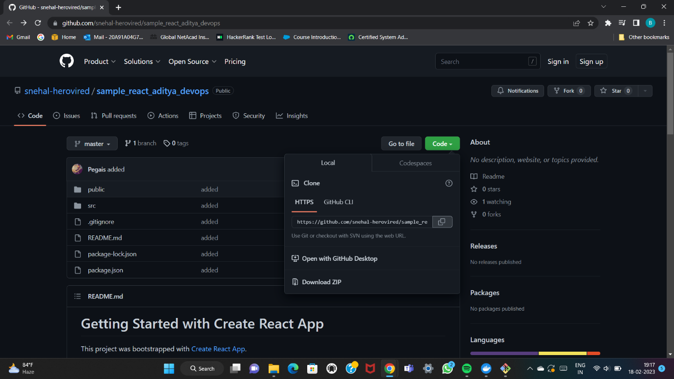

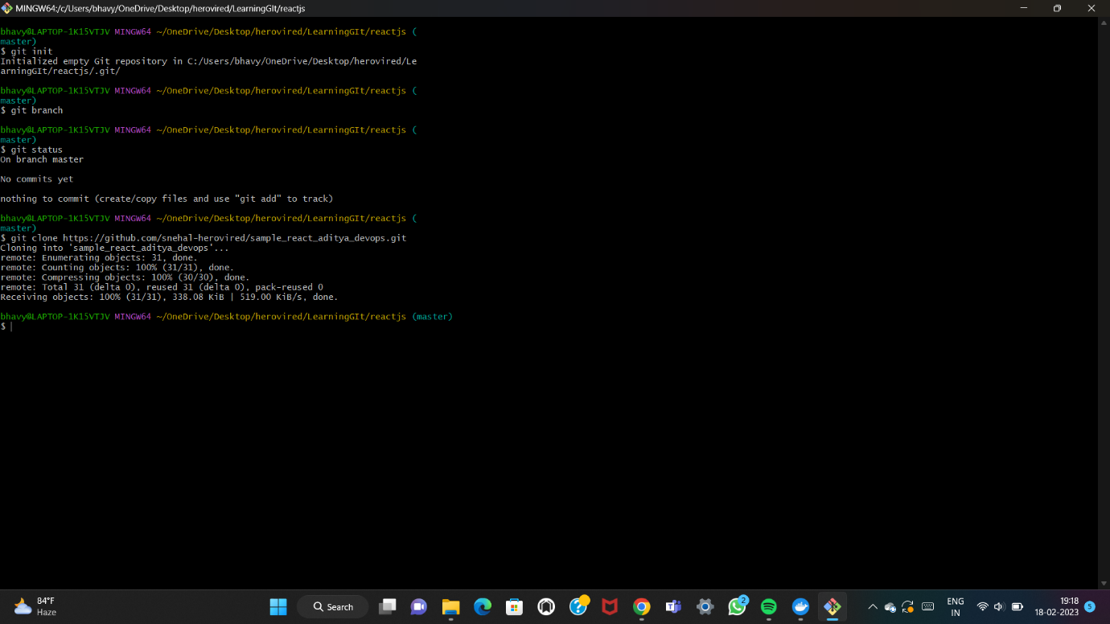

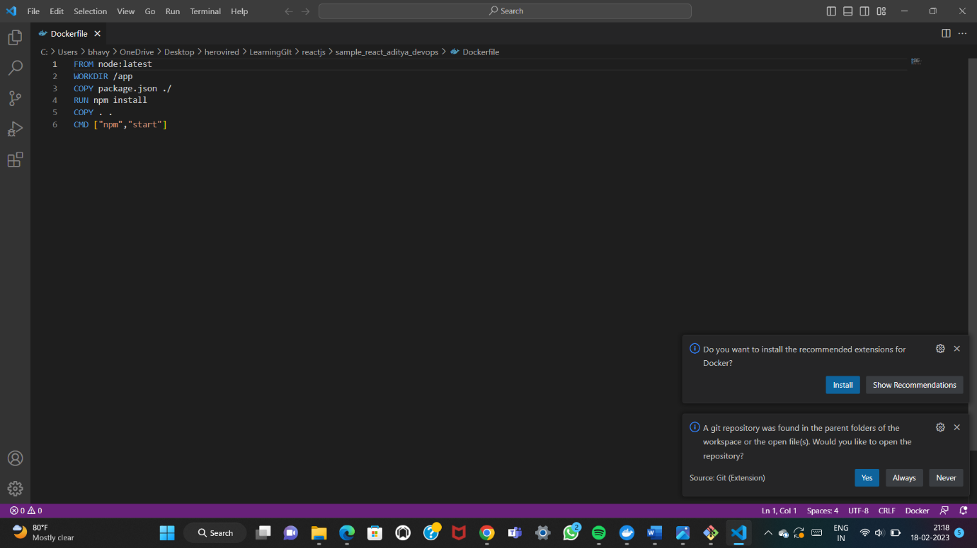

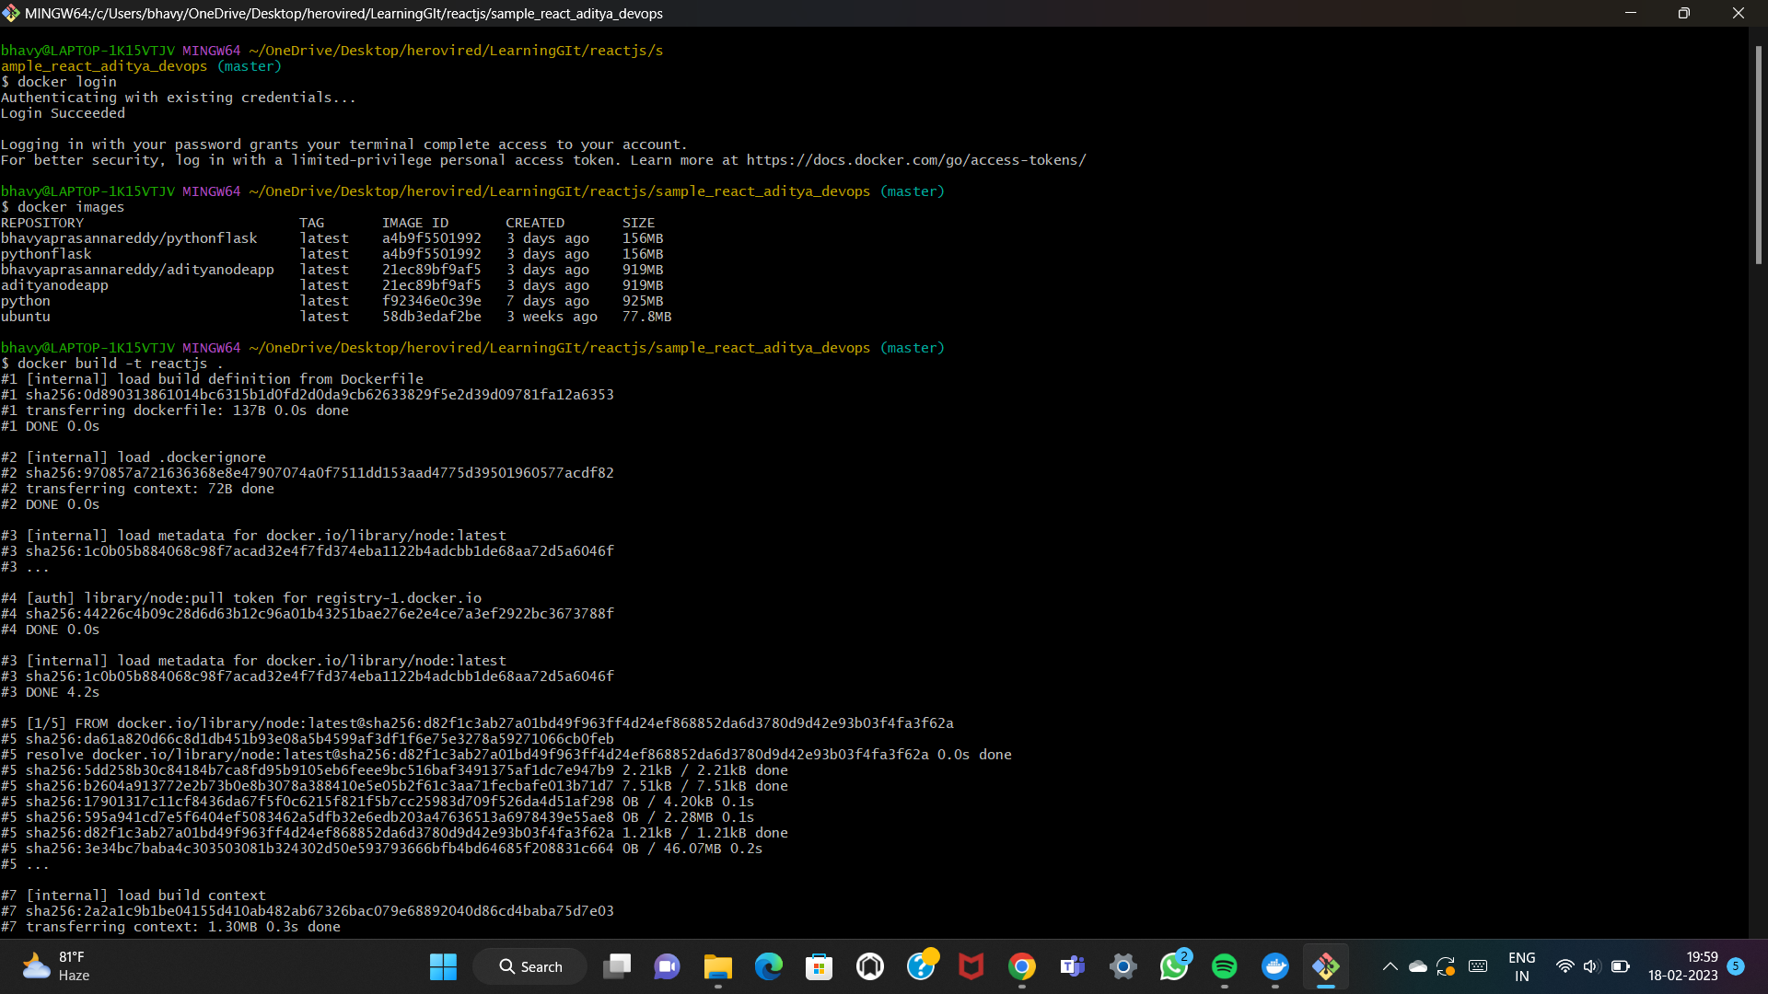

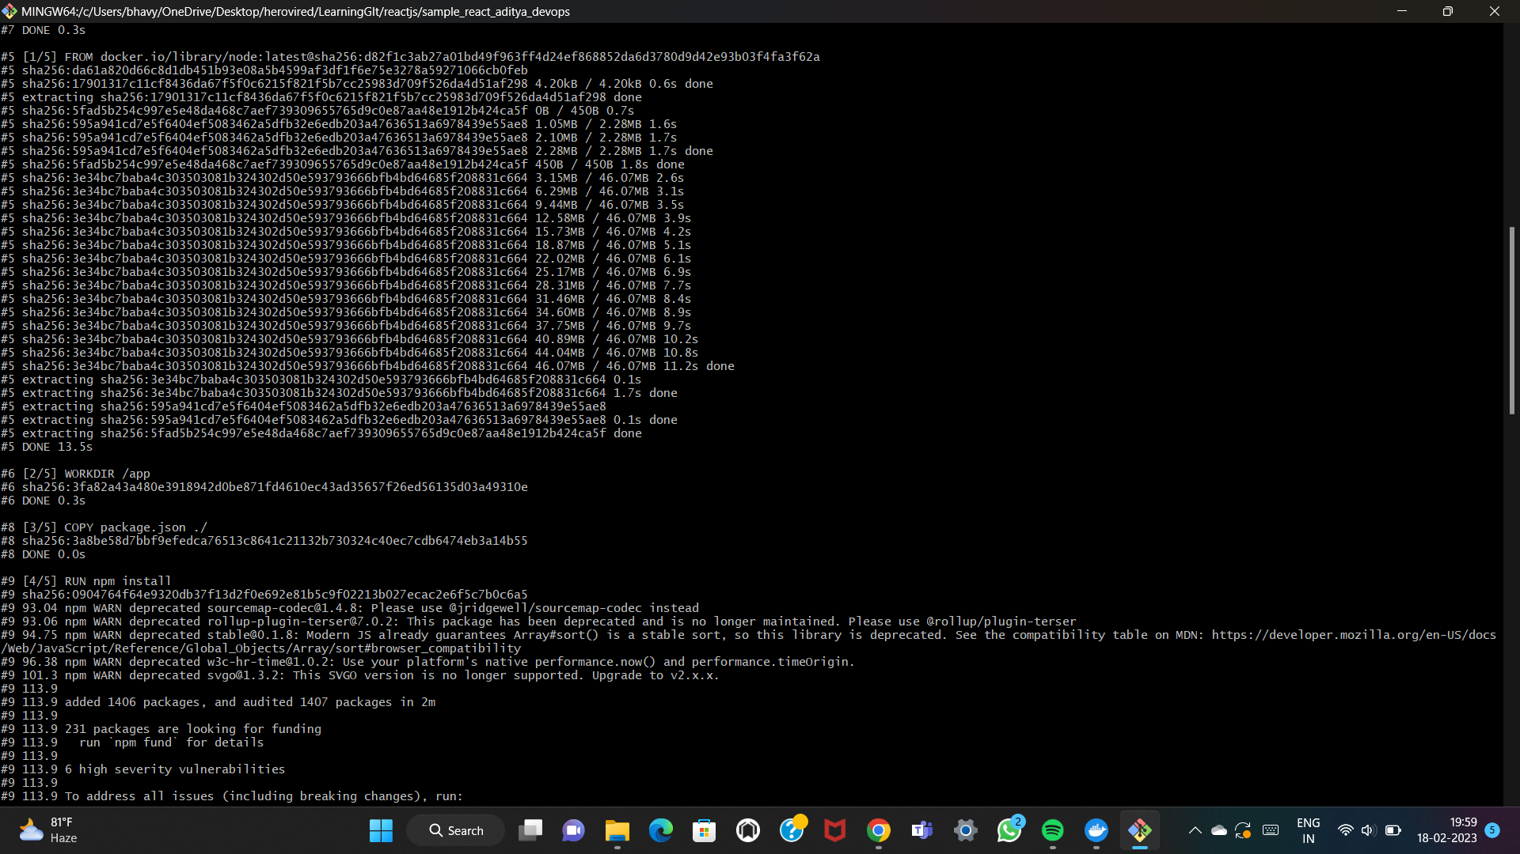

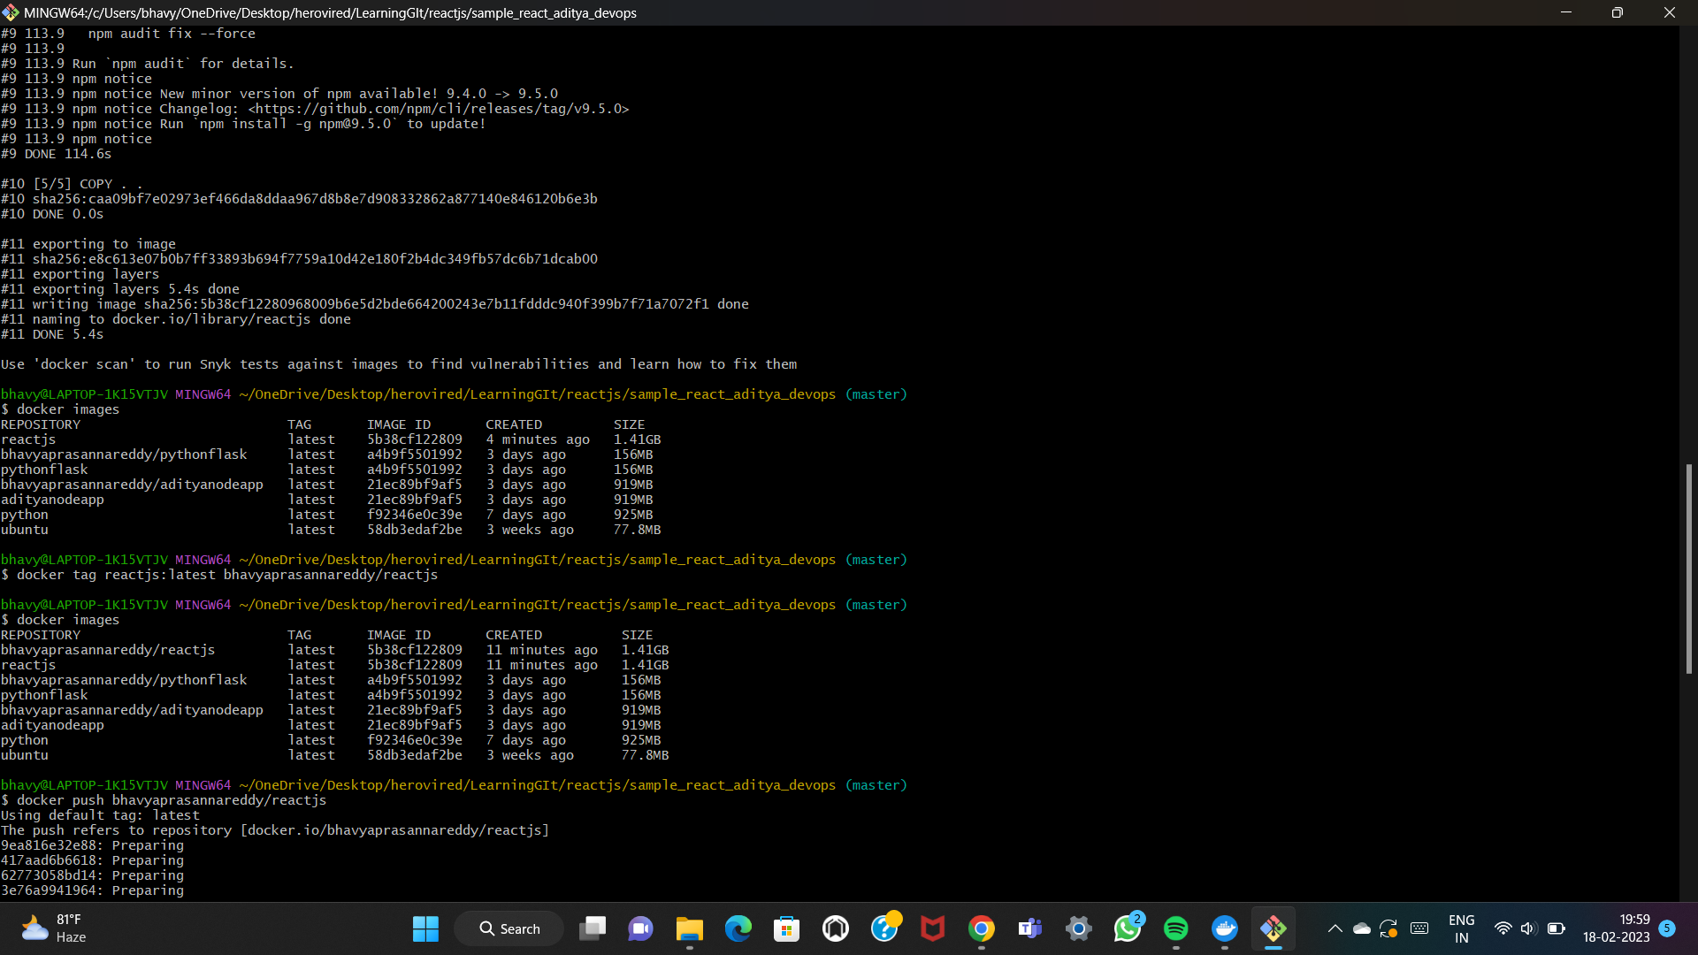

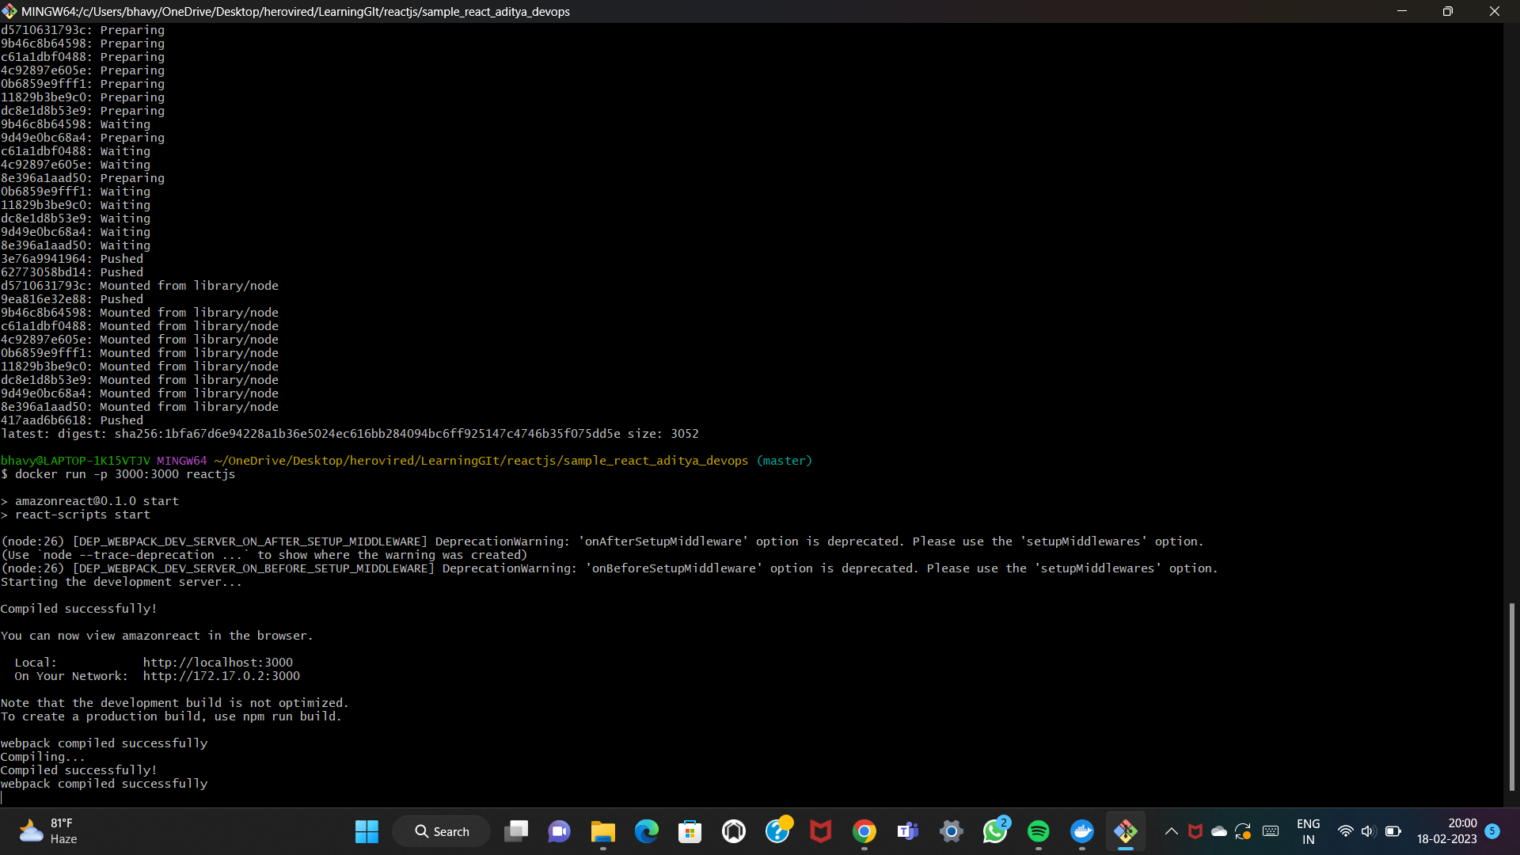

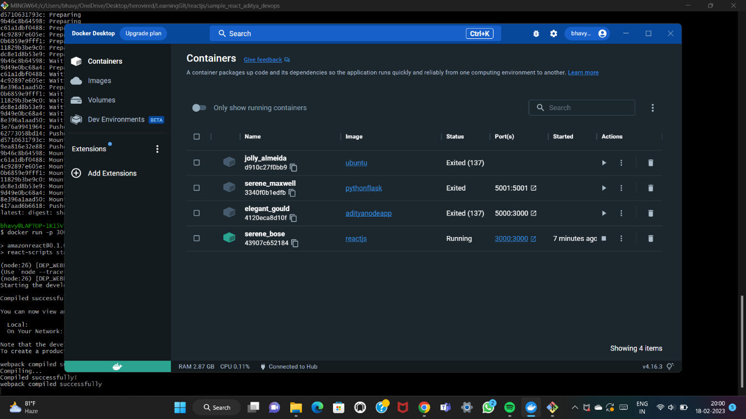

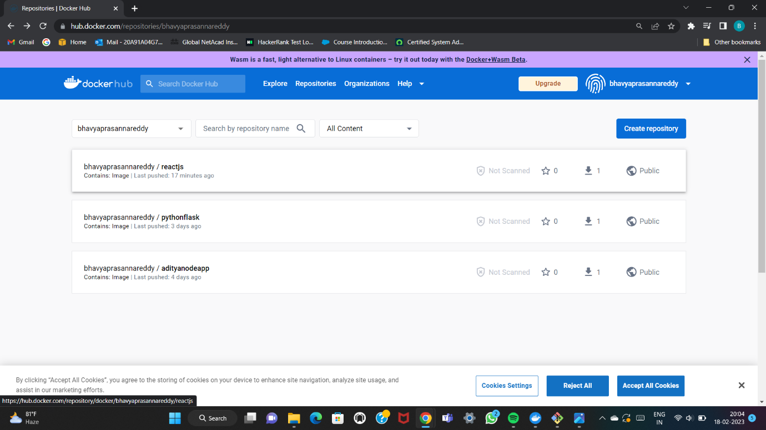

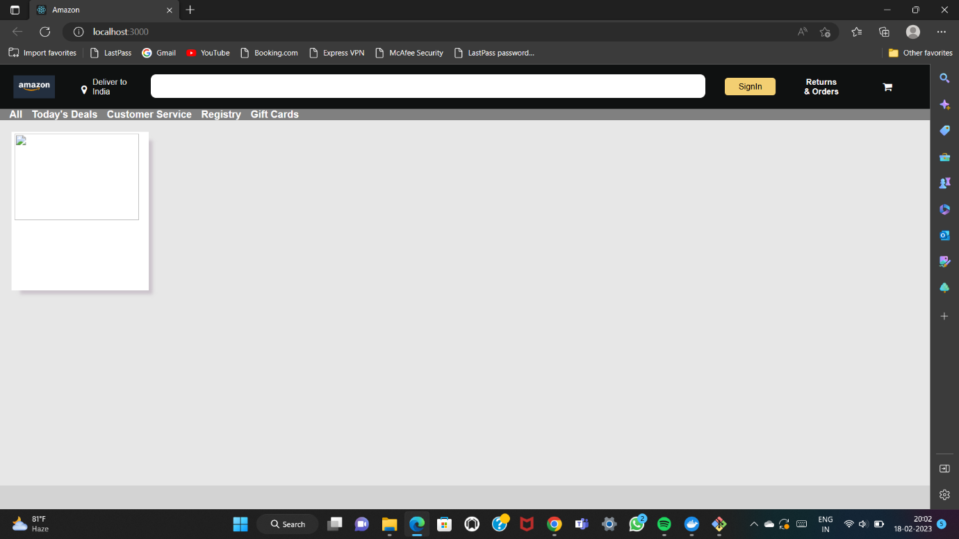

**2. CI-CD PIPELINE:**

CI-CD stands for Continuous integration/continuous deployment which is a software engineering practice that helps teams to collaborate better and improve their overall software.

Continuous integration (CI) requires frequent commits to a shared repository, and tries to prevent all of these by encouraging small and frequent code updates. When a code is committed to a repository, it can be built and tested against setup workflows to ensure that the code does not introduce any errors.

Whereas Continuous deployment, code changes are automatically deployed/released to a testing or production environment as soon as they are merged. In continuous deployment, everything happens automatically.

**ROLE OF JENKINS:**

Jenkins is an open-source free automation tool used to build and test software projects. The tool makes it painless for developers to integrate changes to the project. Jenkins' primary focus is to keep track of the version control system and initiate and monitor a build system if there are any changes.

Jenkins can help to improve the quality of your software by providing a continuous integration and continuous delivery (CI/CD) pipeline. As it is an online interface it is simple to set up and configure. It also includes error checks and a built-in help feature. And it is simple to configure via the web interface after installing it.

